Output:
Output for home page:
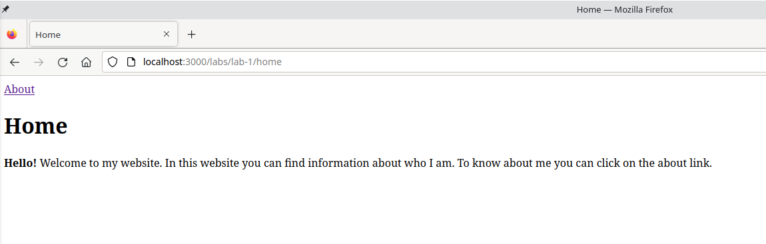
Output for about page:
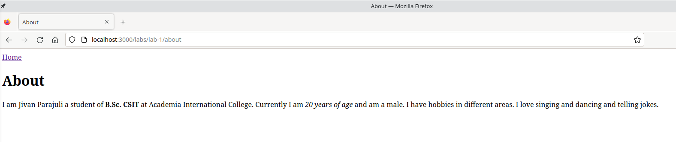

Conclusion:
Hence, the objective of this lab to learn about HTML elements was completed successfully.

