Outputs:
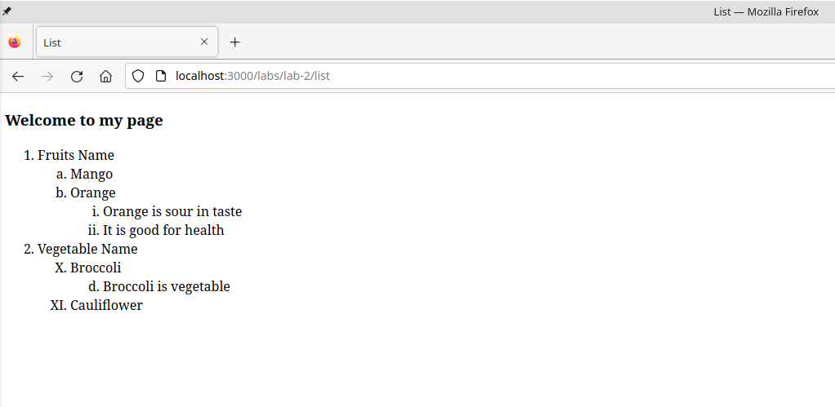

Conclusion:
Hence, the objective of this lab to learn about HTML list tags was completed successfully.

