Outputs:
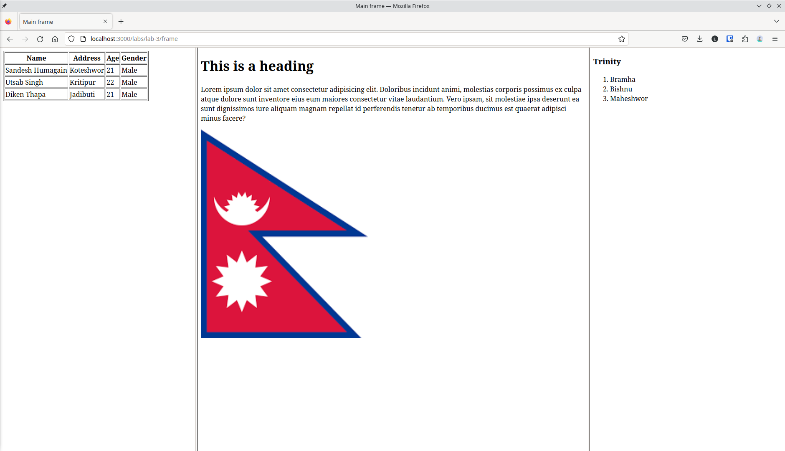

Conclusion:
Hence the objective of this lab to learn about HTML frame was completed successfully using HTML5.

