Output:
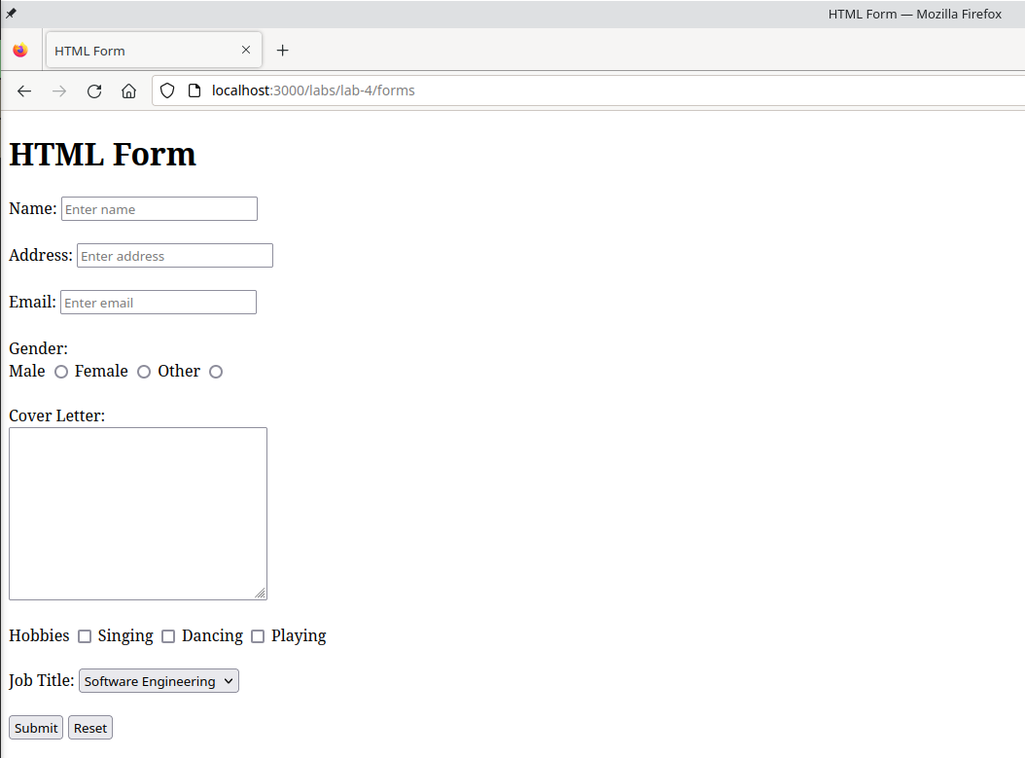

Conclusion:
Hence, the objective of this lab to learn about HTML5 form and various input types was completed successfully.

