Outputs:
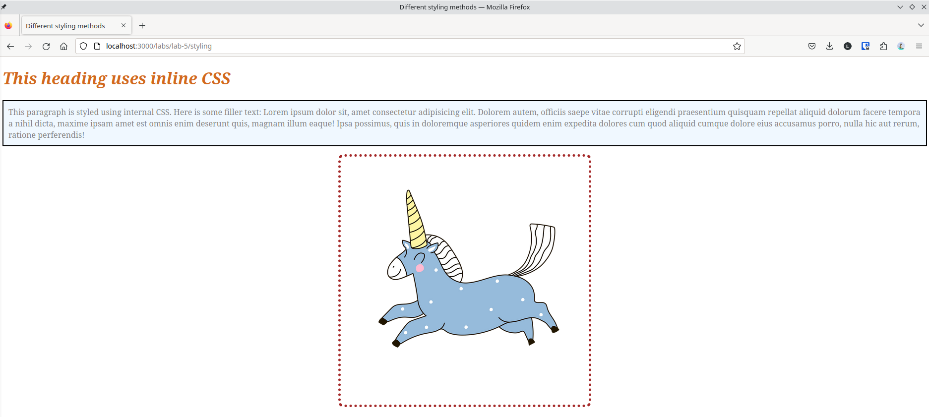Figure 1: webpage of styling.html

Conclusion:c
Hence, the objectives of this lab to learn about inline, internal and external CSS were completed successfully.

