Outputs:
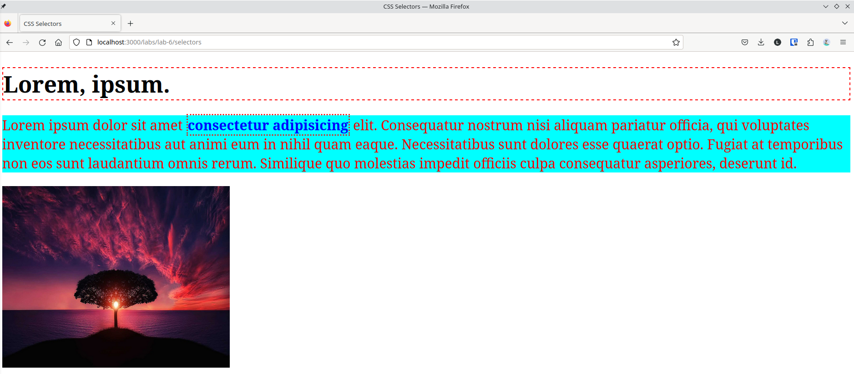Figure 1: webpage for selectors.html

Conclusion:
Hence, the objectives of this lab to learn about different CSS selectors were completed successfully.

