Outputs:
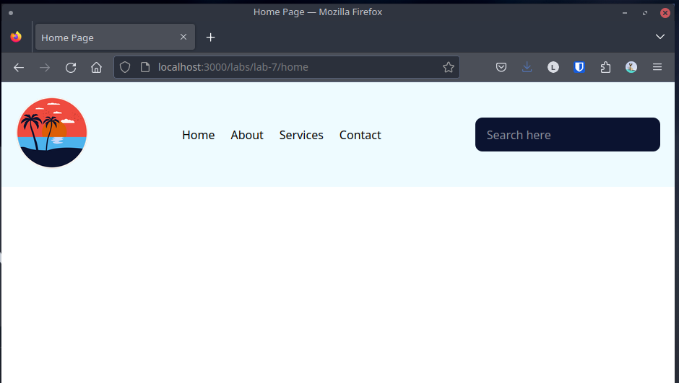Figure 1: Home page with navigation bar (home.html)

Conclusion:
Hence, the objectives of this lab to learn about navigation bars and their creation were completed successfully.

