Outputs:
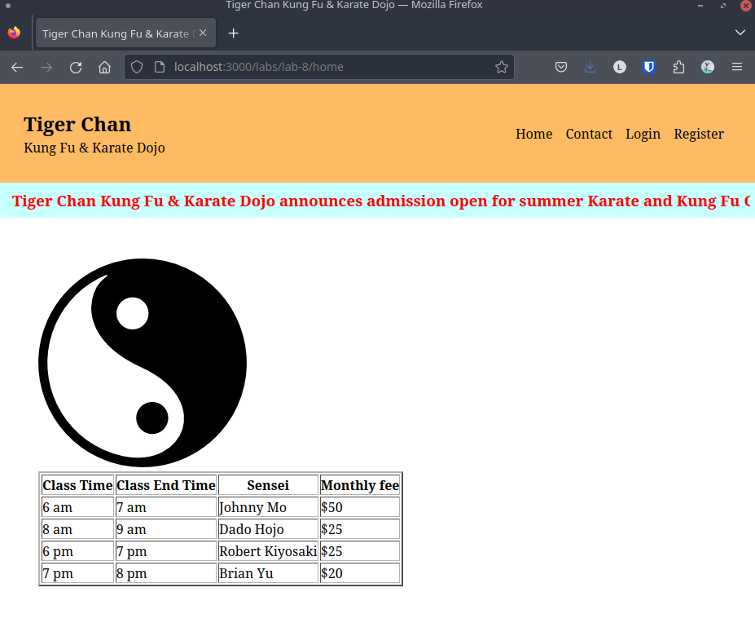Figure 1: Home page (home.html)
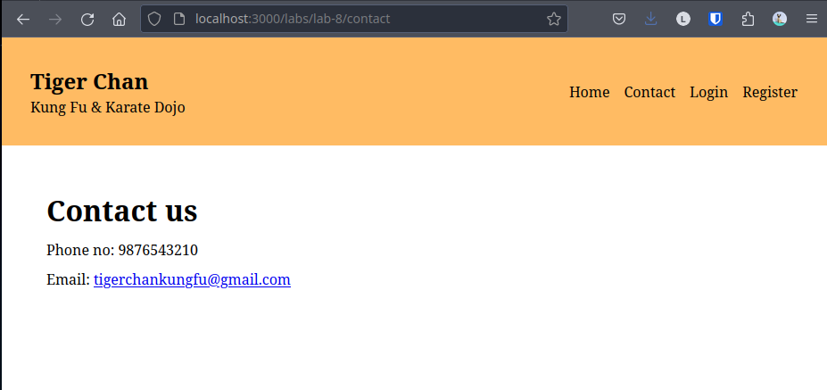Figure 2: Contact page (contact.html)
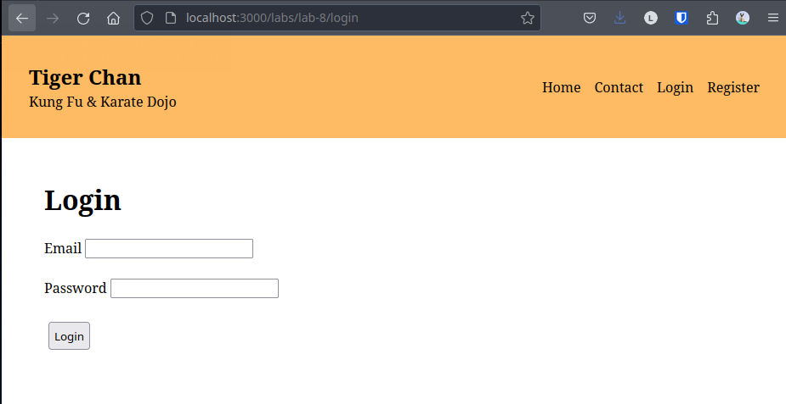Figure 3: Login page (login.html)

Conclusion:
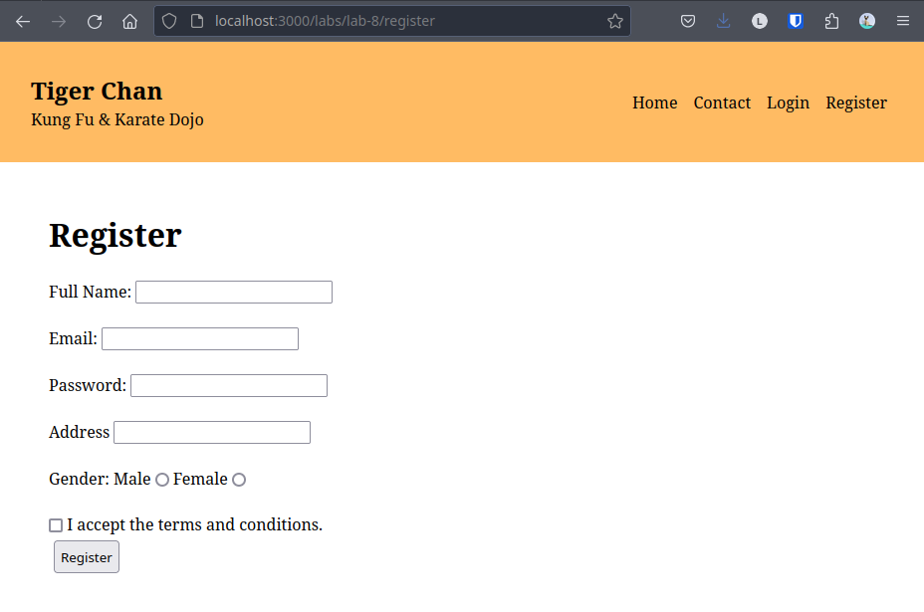Figure 4: Register page (register.html)
Hence, the objectives of this lab to create static web pages and link them were completed successfully.

