Outputs:
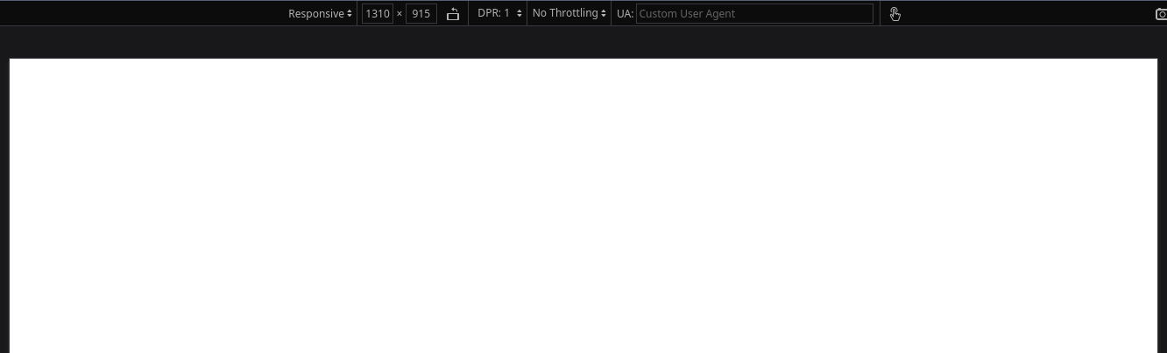Figure 1: Page color when view port width exceeds 1200px
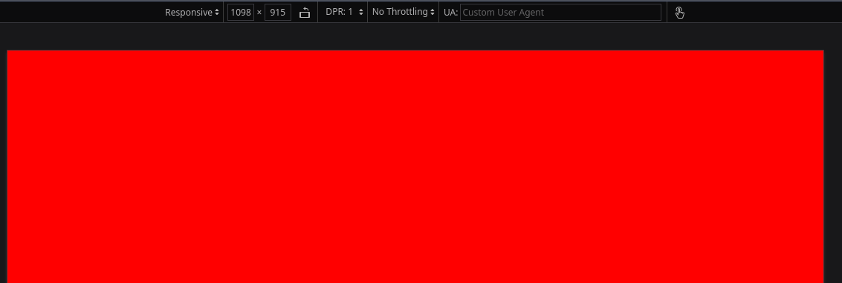Figure 2: Page color when view port width between 800 and 1200 pixels
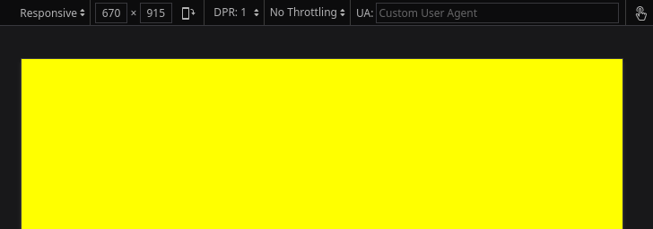Figure 3: Page color when view port width between 500 and 799 pixels

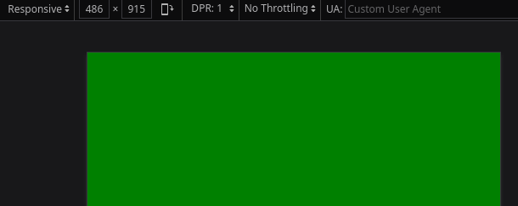Figure 4: Page color when view port width less than 499 pixels

Conclusion:
Hence, the objectives of this lab to learn about media query and responsive design were completed successfully.

