Team
2024-11-29
library(tidyverse)
## ── Attaching core tidyverse packages ──────────────────────── tidyverse 2.0.0 ──
## ✔ dplyr 1.1.4 ✔ readr 2.1.5
## ✔ forcats 1.0.0 ✔ stringr 1.5.1
## ✔ ggplot2 3.5.1 ✔ tibble 3.2.1
## ✔ lubridate 1.9.3 ✔ tidyr 1.3.1
## ✔ purrr 1.0.2
## ── Conflicts ────────────────────────────────────────── tidyverse_conflicts() ──
## ✖ dplyr::filter() masks stats::filter()
## ✖ dplyr::lag() masks stats::lag()
## ℹ Use the conflicted package (<http://conflicted.r-lib.org/>) to force all conflicts to become errors
library(dplyr)
data_fin = read.csv("/Users/seungwon/Library/Mobile Documents/com~apple~CloudDocs/Graphics data/data_fin.csv", fileEncoding = "EUC-KR")
head(data_fin)
## year month day rent_office_number age time distinct fine.dust ultra.fine.dust
## 1 2022 8 1 112 ~10 59 Mapo 12.05000 7.666667
## 2 2022 8 1 112 ~10 59 Mapo 10.58333 5.208333
## 3 2022 8 1 145 ~10 8 Mapo 12.05000 7.666667
## 4 2022 8 1 145 ~10 8 Mapo 10.58333 5.208333
## 5 2022 8 1 487 ~10 9 Mapo 12.05000 7.666667
## 6 2022 8 1 487 ~10 9 Mapo 10.58333 5.208333
## max min average max_date min_date gap avg_max avg_min
## 1 32.9 16.1 25.7 2022.8.4 2022.8.28 16.8 28.9 23.1
## 2 32.9 16.1 25.7 2022.8.4 2022.8.28 16.8 28.9 23.1
## 3 32.9 16.1 25.7 2022.8.4 2022.8.28 16.8 28.9 23.1
## 4 32.9 16.1 25.7 2022.8.4 2022.8.28 16.8 28.9 23.1
## 5 32.9 16.1 25.7 2022.8.4 2022.8.28 16.8 28.9 23.1
## 6 32.9 16.1 25.7 2022.8.4 2022.8.28 16.8 28.9 23.1
summary(data_fin)
## year month day rent_office_number
## Min. :2022 Min. :8.000 Min. : 1.0 Min. : 102
## 1st Qu.:2022 1st Qu.:8.000 1st Qu.:10.0 1st Qu.: 148
## Median :2022 Median :9.000 Median :17.0 Median : 411
## Mean :2022 Mean :8.543 Mean :16.6 Mean :1362
## 3rd Qu.:2022 3rd Qu.:9.000 3rd Qu.:24.0 3rd Qu.:3111
## Max. :2022 Max. :9.000 Max. :31.0 Max. :5503
##
## age time distinct fine.dust
## Length:571756 Min. : 0.00 Length:571756 Min. : 3.409
## Class :character 1st Qu.: 13.00 Class :character 1st Qu.:14.727
## Mode :character Median : 33.00 Mode :character Median :19.292
## Mean : 58.31 Mean :19.827
## 3rd Qu.: 74.00 3rd Qu.:22.167
## Max. :5398.00 Max. :60.542
## NA's :5812
## ultra.fine.dust max min average
## Min. : 1.375 Min. :32.50 Min. :12.30 Min. :22.40
## 1st Qu.: 7.208 1st Qu.:32.50 1st Qu.:12.30 1st Qu.:22.40
## Median : 9.458 Median :32.50 Median :12.30 Median :22.40
## Mean :11.183 Mean :32.68 Mean :14.04 Mean :23.91
## 3rd Qu.:12.833 3rd Qu.:32.90 3rd Qu.:16.10 3rd Qu.:25.70
## Max. :48.000 Max. :32.90 Max. :16.10 Max. :25.70
## NA's :5812
## max_date min_date gap avg_max
## Length:571756 Length:571756 Min. :16.80 Min. :27.20
## Class :character Class :character 1st Qu.:16.80 1st Qu.:27.20
## Mode :character Mode :character Median :20.20 Median :27.20
## Mean :18.65 Mean :27.98
## 3rd Qu.:20.20 3rd Qu.:28.90
## Max. :20.20 Max. :28.90
##
## avg_min
## Min. :18.20
## 1st Qu.:18.20
## Median :18.20
## Mean :20.44
## 3rd Qu.:23.10
## Max. :23.10
##

구별 따릉이 이용 비교
data_fin %>%
group_by(distinct) %>%
summarise(count = n()) %>%
ggplot(aes(distinct, count, fill = count)) + geom_bar(stat = "identity")
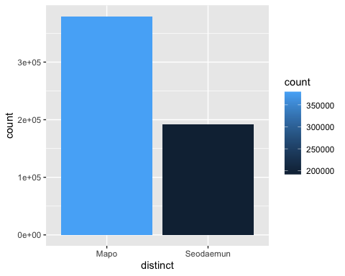

구별 따릉이 (이용 / 인구) 비교
People = tibble(Mapo = 362006, Seodaemun = 303912)
data_distinct = data_fin %>%
group_by(distinct) %>%
summarise(count = n())
people = People %>% pivot_longer(c("Mapo", "Seodaemun"), names_to = "distinct", values_to = "Population")
data_distinct %>% left_join(people) %>% mutate(ratio = count / Population ) %>%
ggplot(aes(distinct, ratio, fill = ratio)) + geom_bar(stat = "identity")
## Joining with `by = join_by(distinct)`
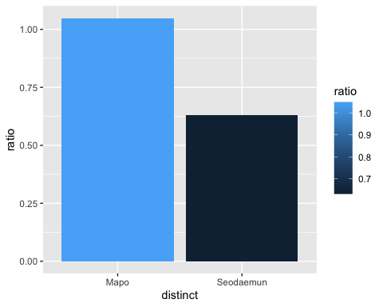

연속형 변수끼리 상관관계 분석
data_date = data_fin %>%
group_by(year, month, day) %>%
mutate(n=n())
library(GGally)
## Registered S3 method overwritten by 'GGally':
## method from
## +.gg ggplot2
ggpairs(data_date[,c(6,8,9,10,11,12,15,16,17)])
## Warning in ggally_statistic(data = data, mapping = mapping, na.rm = na.rm, :
## Removed 5812 rows containing missing values
## Warning in ggally_statistic(data = data, mapping = mapping, na.rm = na.rm, :
## Removed 5812 rows containing missing values
## Warning: Removed 5812 rows containing missing values or values outside the scale range
## (`geom_point()`).
## Warning: Removed 5812 rows containing non-finite outside the scale range
## (`stat_density()`).
## Warning in ggally_statistic(data = data, mapping = mapping, na.rm = na.rm, :
## Removed 5812 rows containing missing values
## Warning in ggally_statistic(data = data, mapping = mapping, na.rm = na.rm, :
## Removed 5812 rows containing missing values
## Warning in ggally_statistic(data = data, mapping = mapping, na.rm = na.rm, :
## Removed 5812 rows containing missing values
## Warning in ggally_statistic(data = data, mapping = mapping, na.rm = na.rm, :
## Removed 5812 rows containing missing values
## Warning in ggally_statistic(data = data, mapping = mapping, na.rm = na.rm, :
## Removed 5812 rows containing missing values
## Warning in ggally_statistic(data = data, mapping = mapping, na.rm = na.rm, :
## Removed 5812 rows containing missing values
## Warning in ggally_statistic(data = data, mapping = mapping, na.rm = na.rm, :
## Removed 5812 rows containing missing values
## Warning: Removed 5812 rows containing missing values or values outside the scale range
## (`geom_point()`).
## Removed 5812 rows containing missing values or values outside the scale range
## (`geom_point()`).
## Warning: Removed 5812 rows containing non-finite outside the scale range
## (`stat_density()`).
## Warning in ggally_statistic(data = data, mapping = mapping, na.rm = na.rm, :
## Removed 5812 rows containing missing values
## Warning in ggally_statistic(data = data, mapping = mapping, na.rm = na.rm, :
## Removed 5812 rows containing missing values
## Warning in ggally_statistic(data = data, mapping = mapping, na.rm = na.rm, :
## Removed 5812 rows containing missing values
## Warning in ggally_statistic(data = data, mapping = mapping, na.rm = na.rm, :
## Removed 5812 rows containing missing values
## Warning in ggally_statistic(data = data, mapping = mapping, na.rm = na.rm, :
## Removed 5812 rows containing missing values
## Warning in ggally_statistic(data = data, mapping = mapping, na.rm = na.rm, :
## Removed 5812 rows containing missing values
## Warning: Removed 5812 rows containing missing values or values outside the scale range
## (`geom_point()`).
## Removed 5812 rows containing missing values or values outside the scale range
## (`geom_point()`).
## Removed 5812 rows containing missing values or values outside the scale range
## (`geom_point()`).
## Removed 5812 rows containing missing values or values outside the scale range
## (`geom_point()`).
## Removed 5812 rows containing missing values or values outside the scale range
## (`geom_point()`).
## Removed 5812 rows containing missing values or values outside the scale range
## (`geom_point()`).
## Removed 5812 rows containing missing values or values outside the scale range
## (`geom_point()`).
## Removed 5812 rows containing missing values or values outside the scale range
## (`geom_point()`).
## Removed 5812 rows containing missing values or values outside the scale range
## (`geom_point()`).
## Removed 5812 rows containing missing values or values outside the scale range
## (`geom_point()`).
## Removed 5812 rows containing missing values or values outside the scale range
## (`geom_point()`).
## Removed 5812 rows containing missing values or values outside the scale range
## (`geom_point()`).
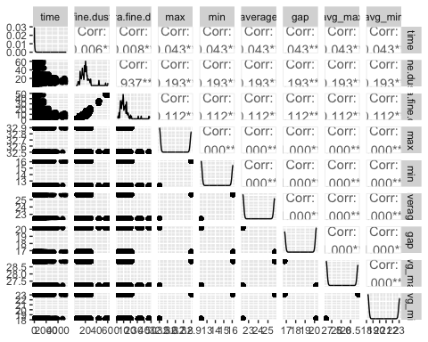

연령대에 따른 따릉이 이용 비교
# NA 제거
data_nona = data_fin %>% filter(!is.na(age))
data_nona$age = as.factor(data_nona$age)
data_nona %>%
group_by(age) %>%
count() %>%
ggplot(aes(age, n)) + geom_bar(stat = "identity")
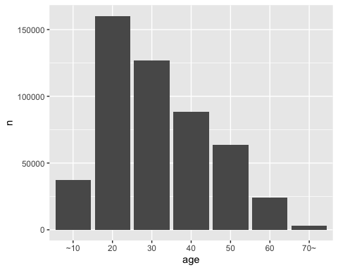
data_nona %>%
group_by(age) %>%
count() %>%
ggplot(aes(x="", y = n, fill = age)) + geom_bar(stat = "identity") + coord_polar("y")
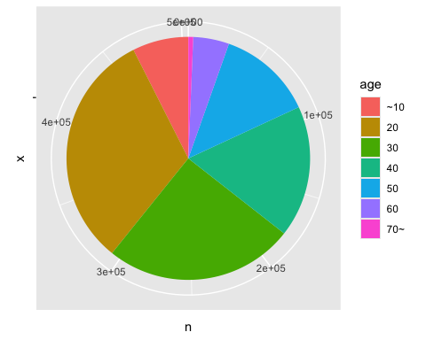

변수 분석_fine.dust & ultra.fine.dust
data_fin %>%
ggplot(aes(fine.dust, ultra.fine.dust)) + geom_point(size = 0.6) + geom_smooth(method = "lm")
## `geom_smooth()` using formula = 'y ~ x'
## Warning: Removed 5812 rows containing non-finite outside the scale range
## (`stat_smooth()`).
## Warning: Removed 5812 rows containing missing values or values outside the scale range
## (`geom_point()`).
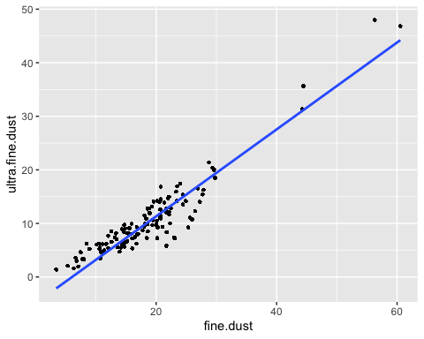

미세먼지에 따른 따릉이 이용변화
data_fin %>%
group_by(month, fine.dust) %>%
count() %>%
ggplot(aes(fine.dust, n, color = month)) + geom_point() + geom_smooth(method = "lm")
## `geom_smooth()` using formula = 'y ~ x'
## Warning: Removed 1 row containing non-finite outside the scale range
## (`stat_smooth()`).
## Warning: The following aesthetics were dropped during statistical transformation:
## colour.
## ℹ This can happen when ggplot fails to infer the correct grouping structure in
## the data.
## ℹ Did you forget to specify a `group` aesthetic or to convert a numerical
## variable into a factor?
## Warning: Removed 1 row containing missing values or values outside the scale range
## (`geom_point()`).
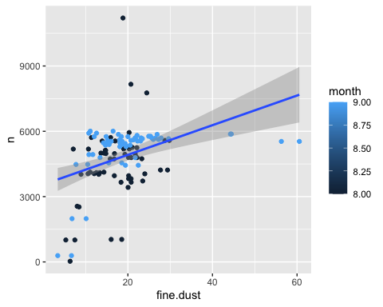
data_fin %>%
group_by(month, ultra.fine.dust) %>%
count() %>%
ggplot(aes(ultra.fine.dust, n, color = month)) + geom_point() + geom_smooth(method = "lm")
## `geom_smooth()` using formula = 'y ~ x'
## Warning: Removed 1 row containing non-finite outside the scale range
## (`stat_smooth()`).
## Warning: The following aesthetics were dropped during statistical transformation:
## colour.
## ℹ This can happen when ggplot fails to infer the correct grouping structure in
## the data.
## ℹ Did you forget to specify a `group` aesthetic or to convert a numerical
## variable into a factor?
## Warning: Removed 1 row containing missing values or values outside the scale range
## (`geom_point()`).
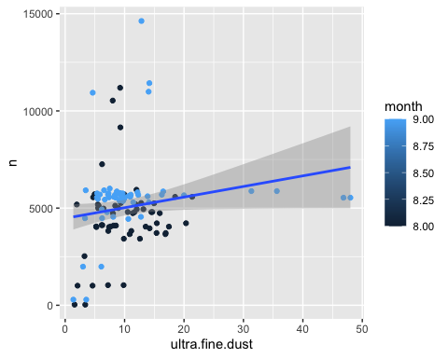 # 월별 미세먼지, 초미세먼지 비교
data_fin %>%
group_by(year, month) %>%
ggplot(aes(factor(month), fine.dust))+ geom_violin() + geom_boxplot(width = 0.3)
## Warning: Removed 5812 rows containing non-finite outside the scale range
## (`stat_ydensity()`).
## Warning: Removed 5812 rows containing non-finite outside the scale range
## (`stat_boxplot()`).
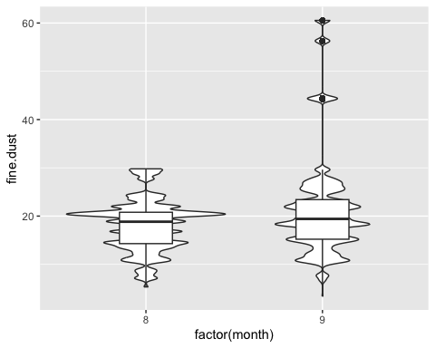
data_fin %>%
group_by(year, month) %>%
ggplot(aes(factor(month), ultra.fine.dust)) + geom_violin() + geom_boxplot(width = 0.3)
## Warning: Removed 5812 rows containing non-finite outside the scale range
## (`stat_ydensity()`).
## Warning: Removed 5812 rows containing non-finite outside the scale range
## (`stat_boxplot()`).
