1202
Yunju Jeong
2024-12-02
library(tidyverse)
library(ggplot2)
data <- read.csv("C:/Users/jeong/iCloudDrive/Graphics data/data_daRjo.csv")
rain <- read.csv("C:/Users/jeong/iCloudDrive/Graphics data/2022_rain.csv")
temp <- read.csv("C:/yunju/TEMP/TEMP2024/graphics/project/2022_weather.csv")
rain[is.na(rain)] <- 0
temp[is.na(temp)] <- 26.8
data <- data %>% select(-max, -min, -average, -gap, -avg_max, -avg_min)
temp$date <- sub("^\\s+", "", temp$date)
rain = rain %>% separate(date, into=c("year","month","day"),convert=TRUE)
temp = temp %>% separate(date, into=c("year","month","day"),convert=TRUE)
## Warning: Expected 3 pieces. Missing pieces filled with `NA` in 1 rows [62].
data <- data %>% left_join(rain) %>% left_join(temp)
## Joining with `by = join_by(year, month, day)`
## Joining with `by = join_by(year, month, day)`
library(tidyverse)
data = data %>%
mutate(fine_dust_level = case_when(
fine.dust <= 15 ~ "good",
fine.dust <= 35 ~ "so so",
fine.dust <= 75 ~ "bad",
TRUE ~ "worst"),
)
dim(data)[1]
## [1] 571756
data = data %>%
mutate(
fine_dust_level = factor(fine_dust_level, levels = c("worst", "bad", "so so", "good"))
)
data %>% group_by(fine_dust_level) %>% count() %>% mutate(ratio = n/571756) %>% ggplot(aes(fine_dust_level,ratio)) + geom_bar(stat="identity")
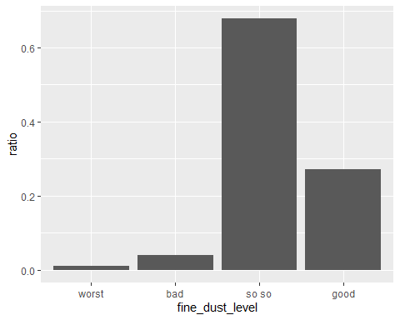
total_days <- data %>%
group_by(year, month, day, fine_dust_level) %>%
summarise(count = n(), .groups = "drop") %>%
group_by(fine_dust_level) %>%
summarise(total_days = n(), .groups = "drop")
total_days
## # A tibble: 4 × 2
## fine_dust_level total_days
## <fct> <int>
## 1 worst 1
## 2 bad 2
## 3 so so 43
## 4 good 23
total_days %>% ggplot(aes(fine_dust_level,total_days)) + geom_bar(stat="identity")
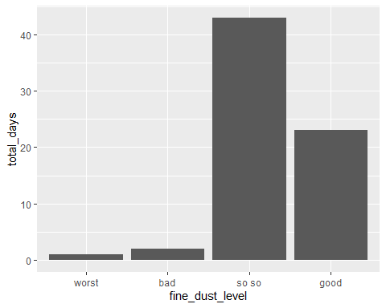
data %>%
group_by(fine_dust_level) %>%
summarise(count=n()) %>%
left_join(total_days) %>%
mutate(ratio = count/total_days) %>%
ggplot(aes(fine_dust_level,ratio)) +
geom_bar(stat="identity")
## Joining with `by = join_by(fine_dust_level)`
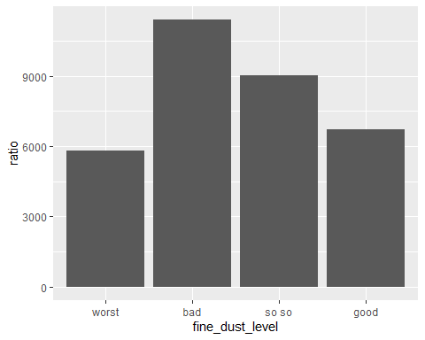
data_worst <- data %>%
filter(fine_dust_level=="worst") %>%
group_by(year,month,day,distinct) %>%
summarise(count=n(), average_ = mean(average),
rain = mean(rainfall))
## `summarise()` has grouped output by 'year', 'month', 'day'. You can override
## using the `.groups` argument.
data_worst
## # A tibble: 2 × 7
## # Groups: year, month, day [1]
## year month day distinct count average_ rain
## <int> <int> <int> <chr> <int> <dbl> <dbl>
## 1 2022 9 25 Mapo 3836 19.6 0
## 2 2022 9 25 Seod 1976 19.6 0
## 강수량이 5mm 이상인 날의 비율
dim(data_worst %>% filter(rain>5)) [1] / dim(data_worst)[1]
## [1] 0
data_bad <- data %>%
filter(fine_dust_level=="bad") %>%
group_by(year,month,day,distinct) %>%
summarise(count=n(), average_ = mean(average),
rain = mean(rainfall))
## `summarise()` has grouped output by 'year', 'month', 'day'. You can override
## using the `.groups` argument.
data_bad
## # A tibble: 4 × 7
## # Groups: year, month, day [2]
## year month day distinct count average_ rain
## <int> <int> <int> <chr> <int> <dbl> <dbl>
## 1 2022 9 29 Mapo 7396 20.4 0
## 2 2022 9 29 Seod 3674 20.4 0
## 3 2022 9 30 Mapo 7862 20.7 0
## 4 2022 9 30 Seod 3886 20.7 0
## 강수량이 5mm 이상인 날의 비율
dim(data_bad %>% filter(rain>5)) [1] / dim(data_bad)[1]
## [1] 0
- fine_dust_level이 bad인 경우 -> 강수량이 0이기 때문에 따릉이 사용량이 많은 것으로 예측할 수 있음
data_so <- data %>%
filter(fine_dust_level=="so so") %>%
group_by(year,month,day,distinct) %>%
summarise(count=n(), average_ = mean(average),
rain = mean(rainfall))
## `summarise()` has grouped output by 'year', 'month', 'day'. You can override
## using the `.groups` argument.
head(data_so)
## # A tibble: 6 × 7
## # Groups: year, month, day [3]
## year month day distinct count average_ rain
## <int> <int> <int> <chr> <int> <dbl> <dbl>
## 1 2022 8 3 Mapo 5016 27.1 51.1
## 2 2022 8 3 Seod 2302 27.1 51.1
## 3 2022 8 5 Mapo 3338 29.4 0
## 4 2022 8 5 Seod 1638 29.4 0
## 5 2022 8 6 Mapo 5626 28.7 13.6
## 6 2022 8 6 Seod 2816 28.7 13.6
## 강수량이 5mm 이상인 날의 비율
dim(data_so %>% filter(rain>5)) [1] / dim(data_so)[1]
## [1] 0.1395349
data_good <- data %>%
filter(fine_dust_level=="good") %>%
group_by(year,month,day,distinct) %>%
summarise(count=n(), average_ = mean(average),
rain = mean(rainfall))
## `summarise()` has grouped output by 'year', 'month', 'day'. You can override
## using the `.groups` argument.
head(data_good)
## # A tibble: 6 × 7
## # Groups: year, month, day [3]
## year month day distinct count average_ rain
## <int> <int> <int> <chr> <int> <dbl> <dbl>
## 1 2022 8 1 Mapo 5466 28.6 30
## 2 2022 8 1 Seod 2640 28.6 30
## 3 2022 8 2 Mapo 3408 26.8 33.5
## 4 2022 8 2 Seod 1644 26.8 33.5
## 5 2022 8 4 Mapo 6594 28.9 0
## 6 2022 8 4 Seod 3406 28.9 0
## 강수량이 5mm 이상인 날의 비율
dim(data_good %>% filter(rain>5)) [1] / dim(data_good)[1]
## [1] 0.3913043
- fine_dust_level이 good인 경우, 다른 level에 비해 비가 오는 날이 많아 비교적 따릉이 사용량이 적게 나타나는 것으로 예측할 수 있음
data_winter <- read.csv("C:/Users/jeong/iCloudDrive/Graphics data/data_winter.csv")
head(data_winter)
## date age exercise carbon distance time temp_avg temp_max temp_min
## 1 2022-10-01 10 58.21 0.49 2100.00 22 20.9 27.6 14.4
## 2 2022-10-01 10 56.28 0.52 2256.02 16 20.9 27.6 14.4
## 3 2022-10-01 10 50.29 0.35 1530.00 14 20.9 27.6 14.4
## 4 2022-10-01 10 36.84 0.40 1733.11 13 20.9 27.6 14.4
## 5 2022-10-01 10 140.22 1.19 5131.70 32 20.9 27.6 14.4
## 6 2022-10-01 10 240.26 2.39 10267.77 116 20.9 27.6 14.4
## temp_gap
## 1 13.2
## 2 13.2
## 3 13.2
## 4 13.2
## 5 13.2
## 6 13.2
data_winter$date = as.Date(data_winter$date)
head(data_winter)
## date age exercise carbon distance time temp_avg temp_max temp_min
## 1 2022-10-01 10 58.21 0.49 2100.00 22 20.9 27.6 14.4
## 2 2022-10-01 10 56.28 0.52 2256.02 16 20.9 27.6 14.4
## 3 2022-10-01 10 50.29 0.35 1530.00 14 20.9 27.6 14.4
## 4 2022-10-01 10 36.84 0.40 1733.11 13 20.9 27.6 14.4
## 5 2022-10-01 10 140.22 1.19 5131.70 32 20.9 27.6 14.4
## 6 2022-10-01 10 240.26 2.39 10267.77 116 20.9 27.6 14.4
## temp_gap
## 1 13.2
## 2 13.2
## 3 13.2
## 4 13.2
## 5 13.2
## 6 13.2
## 기타 -> NA로 바꾸기
data_winter <- data_winter %>%
mutate(age = ifelse(age == "기타", NA, age))
data_winter <- data_winter %>% filter(!is.na(data_winter$date))
summary(data_winter)
## date age exercise carbon
## Min. :2022-10-01 Length:4946542 Length:4946542 Length:4946542
## 1st Qu.:2022-10-20 Class :character Class :character Class :character
## Median :2022-11-07 Mode :character Mode :character Mode :character
## Mean :2022-11-09
## 3rd Qu.:2022-11-27
## Max. :2022-12-31
## distance time temp_avg temp_max
## Min. : 0 Min. : 0.00 Min. :-11.800 Min. :-8.60
## 1st Qu.: 1249 1st Qu.: 10.00 1st Qu.: 6.500 1st Qu.:11.90
## Median : 2605 Median : 22.00 Median : 11.100 Median :16.60
## Mean : 4654 Mean : 41.16 Mean : 9.326 Mean :14.54
## 3rd Qu.: 5664 3rd Qu.: 53.00 3rd Qu.: 14.000 3rd Qu.:20.50
## Max. :464791 Max. :4189.00 Max. : 21.400 Max. :27.60
## temp_min temp_gap
## Min. :-13.700 Min. : 3.700
## 1st Qu.: 1.000 1st Qu.: 7.800
## Median : 6.800 Median : 9.300
## Mean : 5.026 Mean : 9.517
## 3rd Qu.: 10.200 3rd Qu.:11.200
## Max. : 17.500 Max. :16.600
sum(is.na(data_winter$age))
## [1] 563310
data_winter %>% group_by(date) %>%
summarise(n=n()) %>%
ggplot(aes(date,n)) + geom_line()
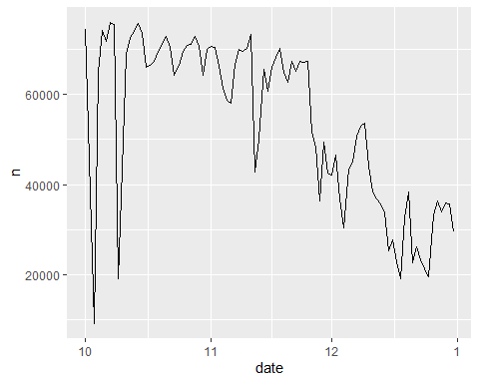
- data_winter 기온
data_winter %>% group_by(date) %>%
summarise(gap = mean(temp_gap),
avg = mean(temp_avg),
max = mean(temp_max),
min = mean(temp_min)) %>%
ggplot() +
geom_line(aes(date,min), color="blue") +
geom_line(aes(date,max), color="red") +
geom_line(aes(date,avg))
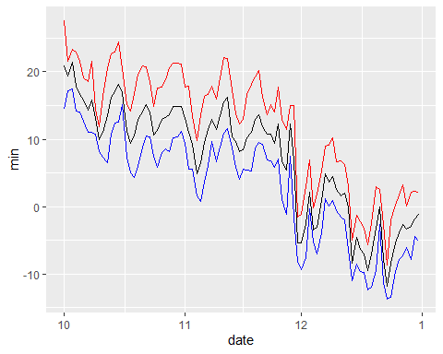
data_winter %>% group_by(date) %>%
summarise(temp_max = mean(temp_max,na.rm=TRUE)) %>%
filter(temp_max>20) %>% arrange(desc(temp_max))
## # A tibble: 20 × 2
## date temp_max
## <date> <dbl>
## 1 2022-10-01 27.6
## 2 2022-10-15 24.4
## 3 2022-10-03 23.4
## 4 2022-10-04 23
## 5 2022-10-14 23
## 6 2022-10-13 22.7
## 7 2022-11-11 22.1
## 8 2022-11-12 22
## 9 2022-10-02 21.6
## 10 2022-10-05 21.6
## 11 2022-10-08 21.6
## 12 2022-10-29 21.3
## 13 2022-10-30 21.3
## 14 2022-10-31 21.1
## 15 2022-10-21 20.9
## 16 2022-10-22 20.8
## 17 2022-10-12 20.6
## 18 2022-10-28 20.6
## 19 2022-10-16 20.5
## 20 2022-11-20 20.2
## peak -> 10/15, 11/11, 11/12
- 일교차 분포, outlier
data_winter %>%
group_by(date) %>%
summarise(gap=mean(temp_gap)) %>%
ggplot(aes(gap)) + geom_histogram(binwidth=0.5)
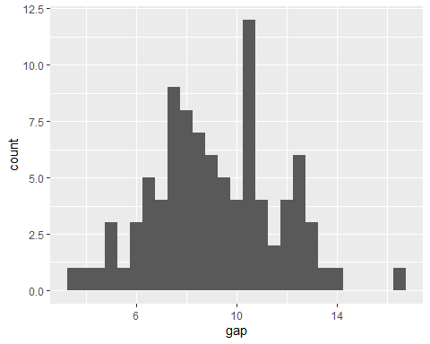
data_winter %>%
group_by(date) %>%
summarise(gap=mean(temp_gap)) %>%
ggplot(aes(gap)) + geom_histogram(binwidth=0.25)
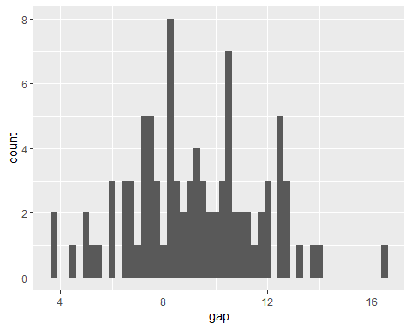
data_winter %>%
group_by(date) %>%
summarise(gap=mean(temp_gap)) %>%
filter(gap>16)
## # A tibble: 1 × 2
## date gap
## <date> <dbl>
## 1 2022-11-29 16.6
- 일교차에 따른 따릉이 사용량 변화
data_winter %>%
group_by(date) %>%
summarise(count=n(),gap=mean(temp_gap)) %>%
ggplot(aes(gap,count)) + geom_point() + geom_smooth(method='lm') + xlim(4,15)
## `geom_smooth()` using formula = 'y ~ x'
## Warning: Removed 3 rows containing non-finite outside the scale range
## (`stat_smooth()`).
## Warning: Removed 3 rows containing missing values or values outside the scale range
## (`geom_point()`).
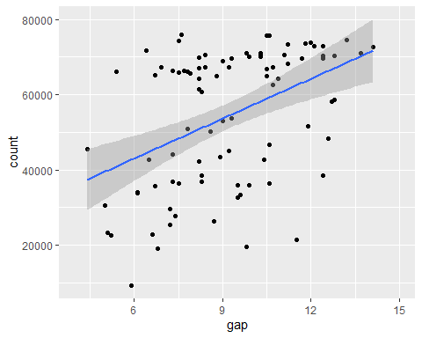
data_gap <- data_winter %>%
group_by(date) %>%
summarise(count=n(),gap=mean(temp_gap)) %>%
filter(gap<16)
result <- cor.test(data_gap$count, data_gap$gap)
print(result)
##
## Pearson's product-moment correlation
##
## data: data_gap$count and data_gap$gap
## t = 4.9781, df = 89, p-value = 3.119e-06
## alternative hypothesis: true correlation is not equal to 0
## 95 percent confidence interval:
## 0.2884665 0.6136521
## sample estimates:
## cor
## 0.4666864
- 평균 기온에 따른 따릉이 사용량 변화
data_winter %>% group_by(date) %>%
summarise(n=n(),
avg = mean(temp_avg)) %>%
ggplot(aes(n,avg)) + geom_point()
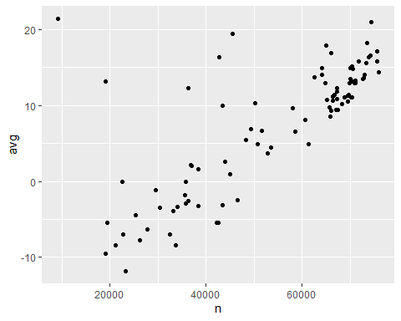
data_avg <- data_winter %>%
group_by(date) %>%
summarise(count=n(),avg=mean(temp_avg))
result <- cor.test(data_avg$count, data_avg$avg)
print(result)
##
## Pearson's product-moment correlation
##
## data: data_avg$count and data_avg$avg
## t = 10.784, df = 90, p-value < 2.2e-16
## alternative hypothesis: true correlation is not equal to 0
## 95 percent confidence interval:
## 0.6452241 0.8282647
## sample estimates:
## cor
## 0.7508185
data <- data %>%
rename(temp_avg = average)
data_avg <- data %>%
mutate(date = as.Date(paste(year,month,day,sep="-"))) %>%
select(date,temp_avg)
data_winter_avg <- data_winter %>% select(date, temp_avg)
temp_avg <- rbind(data_avg, data_winter_avg)
temp_avg <- temp_avg %>% group_by(date) %>%
summarise(count=n(), temp_avg = mean(temp_avg)) %>%
mutate(season = case_when(
temp_avg <= 10 ~ "winter",
temp_avg <= 23 ~ "fall",
TRUE ~ "summer"))
data_winter_avg %>% group_by(date) %>%
summarise(count=n(), temp_avg = mean(temp_avg)) %>%
mutate(season = case_when(
temp_avg <= 10 ~ "winter",
temp_avg <= 23 ~ "fall",
TRUE ~ "summer")) %>% ggplot(aes(count, temp_avg)) + geom_point(aes(color=season))
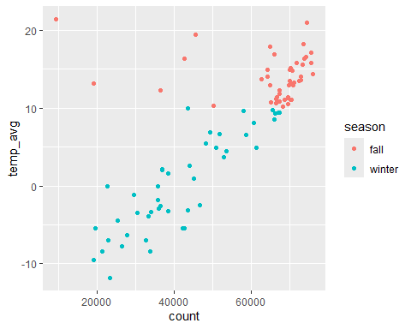
ggplot(temp_avg,aes(count, temp_avg)) + geom_point(aes(color=season))
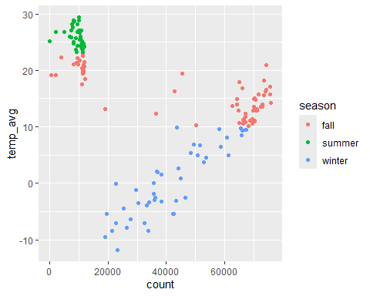
temp_avg %>% filter(count<5000)
## # A tibble: 5 × 4
## date count temp_avg season
## <date> <int> <dbl> <chr>
## 1 2022-08-08 2068 26.8 summer
## 2 2022-08-09 60 25.1 summer
## 3 2022-08-30 2016 19.1 fall
## 4 2022-09-04 3974 22.3 fall
## 5 2022-09-05 580 19.2 fall
temp_avg[temp_avg$count<15000,] ## 8월 1일 - 9월 30일 , 10월 3일
## # A tibble: 62 × 4
## date count temp_avg season
## <date> <int> <dbl> <chr>
## 1 2022-08-01 8106 28.6 summer
## 2 2022-08-02 5052 26.8 summer
## 3 2022-08-03 7318 27.1 summer
## 4 2022-08-04 10000 28.9 summer
## 5 2022-08-05 9952 29.4 summer
## 6 2022-08-06 8442 28.7 summer
## 7 2022-08-07 8092 28.9 summer
## 8 2022-08-08 2068 26.8 summer
## 9 2022-08-09 60 25.1 summer
## 10 2022-08-10 8248 24.7 summer
## # ℹ 52 more rows
temp_avg[temp_avg$count>15000,] ## 10월 1일 - 12월 31일
## # A tibble: 91 × 4
## date count temp_avg season
## <date> <int> <dbl> <chr>
## 1 2022-10-01 74423 20.9 fall
## 2 2022-10-02 45511 19.4 fall
## 3 2022-10-04 64996 17.9 fall
## 4 2022-10-05 74253 16.6 fall
## 5 2022-10-06 71791 15.8 fall
## 6 2022-10-07 75986 14.3 fall
## 7 2022-10-08 75612 15.8 fall
## 8 2022-10-09 19088 13.1 fall
## 9 2022-10-10 43503 9.9 winter
## 10 2022-10-11 68827 11.1 fall
## # ℹ 81 more rows
- distance
data_winter %>% ggplot(aes(distance)) + geom_freqpoly(binwidth=10) + scale_x_continuous(labels = scales::comma) + scale_y_continuous(labels = scales::comma) + xlim(0,100000)
## Scale for x is already present.
## Adding another scale for x, which will replace the existing scale.
## Warning: Removed 554 rows containing non-finite outside the scale range
## (`stat_bin()`).
## Warning: Removed 2 rows containing missing values or values outside the scale range
## (`geom_path()`).
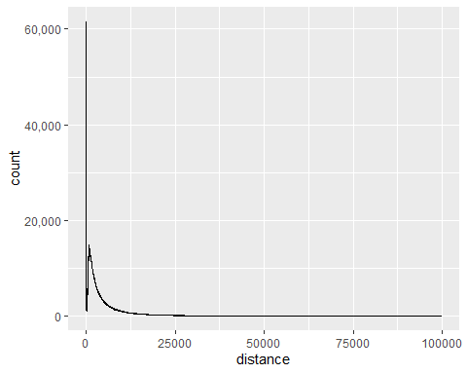
summary(data_winter$distance)
## Min. 1st Qu. Median Mean 3rd Qu. Max.
## 0 1249 2605 4654 5664 464791
- 자전거 속력 60부터 말이 안 돼
10-30km/h
-> 30000m/h
->500m/m
data_winter <- data_winter %>% mutate(velocity = ifelse(time == 0, NA, distance / time), na.rm=TRUE)
head(data_winter[is.na(data_winter$velocity),])
## date age exercise carbon distance time temp_avg temp_max temp_min
## 4066 2022-10-01 30 0.00 0.00 0.00 0 20.9 27.6 14.4
## 5695 2022-10-01 40 0.00 0.00 0.00 0 20.9 27.6 14.4
## 5840 2022-10-01 40 0.00 0.00 0.00 0 20.9 27.6 14.4
## 8953 2022-10-01 <NA> 3.37 0.03 141.89 0 20.9 27.6 14.4
## 10172 2022-10-01 20 2.86 0.03 111.20 0 20.9 27.6 14.4
## 11071 2022-10-01 20 0.00 0.00 0.00 0 20.9 27.6 14.4
## temp_gap velocity na.rm
## 4066 13.2 NA TRUE
## 5695 13.2 NA TRUE
## 5840 13.2 NA TRUE
## 8953 13.2 NA TRUE
## 10172 13.2 NA TRUE
## 11071 13.2 NA TRUE
summary(data_winter$time)
## Min. 1st Qu. Median Mean 3rd Qu. Max.
## 0.00 10.00 22.00 41.16 53.00 4189.00
data_filtered <- data_winter %>% filter(velocity<500, 170<velocity)
data_filtered %>% ggplot(aes(distance)) + geom_freqpoly() + scale_x_continuous(labels = scales::comma) + scale_y_continuous(labels = scales::comma)
## `stat_bin()` using `bins = 30`. Pick better value with `binwidth`.
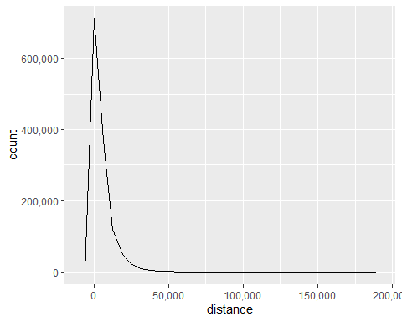
summary(data_filtered$distance)
## Min. 1st Qu. Median Mean 3rd Qu. Max.
## 176 1229 2654 5140 6455 182945
head(data_filtered[(data_filtered$distance) < (440+(440-253.1)*1.5),])
## date age exercise carbon distance time temp_avg temp_max temp_min
## 3 2022-10-01 10 14.93 0.13 580.00 2 20.9 27.6 14.4
## 12 2022-10-01 10 15.12 0.14 587.48 3 20.9 27.6 14.4
## 16 2022-10-01 10 9.49 0.12 532.29 3 20.9 27.6 14.4
## 24 2022-10-01 10 9.02 0.08 350.43 2 20.9 27.6 14.4
## 30 2022-10-01 10 14.42 0.16 700.42 3 20.9 27.6 14.4
## 35 2022-10-01 10 10.71 0.13 540.67 3 20.9 27.6 14.4
## temp_gap velocity na.rm
## 3 13.2 290.0000 TRUE
## 12 13.2 195.8267 TRUE
## 16 13.2 177.4300 TRUE
## 24 13.2 175.2150 TRUE
## 30 13.2 233.4733 TRUE
## 35 13.2 180.2233 TRUE
data_winter %>% filter(velocity<500) %>% ggplot(aes(distance)) + geom_boxplot() + scale_x_continuous(labels = scales::comma) + scale_y_continuous(labels = scales::comma) + coord_flip()
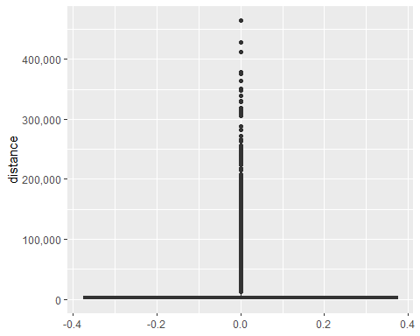
data <- data %>% select(-fine_dust_level)
data<- data %>%mutate(
date = as.Date(paste(year,month,day,sep="-")),
rent_office_number = as.factor(rent_office_number),
age = as.factor(age),
distinct = as.factor(distinct)
) %>% select(-year,-month,-day)
head(data)
## rent_office_number age time distinct fine.dust ultra.fine.dust max_date
## 1 112 10 59 Mapo 12.05000 7.666667 2022.8.4
## 2 112 10 59 Mapo 10.58333 5.208333 2022.8.4
## 3 145 10 8 Mapo 12.05000 7.666667 2022.8.4
## 4 145 10 8 Mapo 10.58333 5.208333 2022.8.4
## 5 487 10 9 Mapo 12.05000 7.666667 2022.8.4
## 6 487 10 9 Mapo 10.58333 5.208333 2022.8.4
## min_date rainfall temp_avg min max date
## 1 2022.8.28 30 28.6 25.4 32.4 2022-08-01
## 2 2022.8.28 30 28.6 25.4 32.4 2022-08-01
## 3 2022.8.28 30 28.6 25.4 32.4 2022-08-01
## 4 2022.8.28 30 28.6 25.4 32.4 2022-08-01
## 5 2022.8.28 30 28.6 25.4 32.4 2022-08-01
## 6 2022.8.28 30 28.6 25.4 32.4 2022-08-01
summary(data)
## rent_office_number age time distinct
## 4217 : 9448 20 :160300 Min. : 0.00 Mapo:379736
## 117 : 6280 30 :126912 1st Qu.: 13.00 Seod:192020
## 113 : 5806 40 : 88276 Median : 33.00
## 147 : 5744 50 : 63862 Mean : 58.31
## 418 : 5532 10 : 37488 3rd Qu.: 74.00
## 419 : 5502 (Other): 27284 Max. :5398.00
## (Other):533444 NA's : 67634
## fine.dust ultra.fine.dust max_date min_date
## Min. : 3.409 Min. : 1.375 Length:571756 Length:571756
## 1st Qu.:14.727 1st Qu.: 7.208 Class :character Class :character
## Median :19.292 Median : 9.458 Mode :character Mode :character
## Mean :19.827 Mean :11.183
## 3rd Qu.:22.167 3rd Qu.:12.833
## Max. :60.542 Max. :48.000
## NA's :5812 NA's :5812
## rainfall temp_avg min max
## Min. : 0.000 Min. :17.50 Min. :12.30 Min. :20.30
## 1st Qu.: 0.000 1st Qu.:21.00 1st Qu.:16.70 1st Qu.:26.30
## Median : 0.000 Median :24.30 Median :20.50 Median :28.40
## Mean : 5.444 Mean :23.93 Mean :20.29 Mean :28.23
## 3rd Qu.: 2.200 3rd Qu.:26.00 3rd Qu.:23.30 3rd Qu.:30.20
## Max. :129.600 Max. :29.40 Max. :27.40 Max. :32.90
##
## date
## Min. :2022-08-01
## 1st Qu.:2022-08-19
## Median :2022-09-03
## Mean :2022-09-02
## 3rd Qu.:2022-09-18
## Max. :2022-09-30
##
data %>% ggplot(aes(date,temp_avg)) + geom_line()
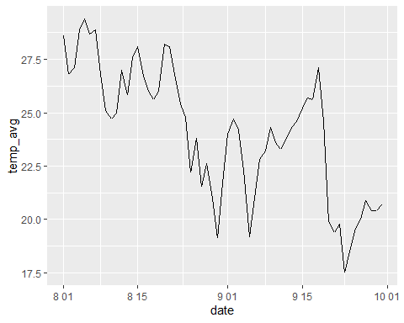
data %>% mutate(
weekday = weekdays(date, abbreviate=TRUE),
weekday = factor(weekday, levels=c("일","월","화","수","목","금","토")),
month = as.numeric(date-as.Date("2022-07-31"))%/%31+8) %>%
group_by(month,weekday) %>%
count() %>%
ggplot(aes(weekday,n,group=month,color=factor(month))) +
geom_line()
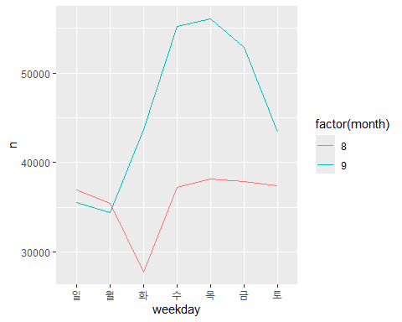
data %>% mutate(
weekday = weekdays(date, abbreviate=TRUE),
weekday = factor(weekday, levels=c("일","월","화","수","목","금","토")),
month = as.numeric(date-as.Date("2022-07-31"))%/%31+8) %>%
filter(month == 8, weekday == "화") %>%
group_by(date) %>% summarise(
fine.dust = mean(fine.dust),
temp_avg = mean(temp_avg),
rainfall = mean(rainfall)
)
## # A tibble: 5 × 4
## date fine.dust temp_avg rainfall
## <date> <dbl> <dbl> <dbl>
## 1 2022-08-02 8.22 26.8 33.5
## 2 2022-08-09 7.17 25.1 123.
## 3 2022-08-16 19.7 26.7 0
## 4 2022-08-23 14.7 25.4 2.2
## 5 2022-08-30 6.39 19.1 35.8
data_winter <- read.csv("C:/Users/jeong/iCloudDrive/Graphics data/winterdata.csv")
data_winter <- data_winter %>% select(-weekday)
data_winter <- data_winter %>% mutate(
rent_office_number = as.factor(rent_office_number),
age = as.factor(age),
exercise = as.integer(exercise),
carbon = as.integer(carbon),
date = as.Date(date)
)
## Warning: There were 2 warnings in `mutate()`.
## The first warning was:
## ℹ In argument: `exercise = as.integer(exercise)`.
## Caused by warning:
## ! 강제형변환에 의해 생성된 NA 입니다
## ℹ Run `dplyr::last_dplyr_warnings()` to see the 1 remaining warning.
summary(data_winter)
## date rent_office_number age exercise
## Min. :2022-10-01 4217 : 11432 20 :205114 Min. : 0
## 1st Qu.:2022-10-20 113 : 8706 30 :166740 1st Qu.: 33
## Median :2022-11-07 117 : 7464 40 :119152 Median : 73
## Mean :2022-11-09 419 : 7326 50 : 87556 Mean : 135
## 3rd Qu.:2022-11-26 4233 : 7244 10 : 45962 3rd Qu.: 164
## Max. :2022-12-31 3010 : 7170 (Other): 34446 Max. :8785
## (Other):686342 NA's : 76714 NA's :1592
## carbon distance time temp_avg
## Min. : 0.0000 Min. : 0 Min. : 0.00 Min. :-11.800
## 1st Qu.: 0.0000 1st Qu.: 1295 1st Qu.: 10.00 1st Qu.: 6.500
## Median : 0.0000 Median : 2792 Median : 24.00 Median : 11.200
## Mean : 0.7625 Mean : 5102 Mean : 44.75 Mean : 9.463
## 3rd Qu.: 1.0000 3rd Qu.: 6254 3rd Qu.: 57.00 3rd Qu.: 14.000
## Max. :87.0000 Max. :378658 Max. :3555.00 Max. : 21.400
## NA's :1592
## temp_max temp_min temp_gap fine.dust
## Min. :-8.60 Min. :-13.700 Min. : 3.70 Min. : 6.375
## 1st Qu.:11.90 1st Qu.: 1.000 1st Qu.: 7.80 1st Qu.: 20.636
## Median :16.60 Median : 6.800 Median : 9.30 Median : 27.583
## Mean :14.69 Mean : 5.161 Mean : 9.53 Mean : 30.734
## 3rd Qu.:20.50 3rd Qu.: 10.200 3rd Qu.:11.20 3rd Qu.: 37.583
## Max. :27.60 Max. : 17.500 Max. :16.60 Max. :194.696
##
## ultra.fine.dust rainfall
## Min. : 1.208 Min. : 0.000
## 1st Qu.: 9.833 1st Qu.: 0.000
## Median :15.958 Median : 0.000
## Mean :18.029 Mean : 1.302
## 3rd Qu.:25.042 3rd Qu.: 0.000
## Max. :60.542 Max. :76.000
##
library(GGally)
#ggpairs(data_winter[8:14])
range(data_winter$temp_avg)
## [1] -11.8 21.4
data_winter %>% ggplot(aes(x=cut_width(temp_avg,2),y=exercise)) + geom_bar(stat="identity") + xlab("temp_avg")
## Warning: Removed 1592 rows containing missing values or values outside the scale range
## (`geom_bar()`).
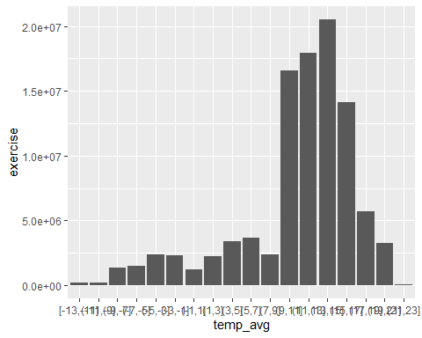
data_winter %>% group_by(date) %>%
summarise(exercise_mean = mean(exercise, na.rm=TRUE),
distance_mean = mean(distance,na.rm=TRUE),
n = n()) %>% ggplot(aes(exercise_mean, distance_mean)) + geom_point()
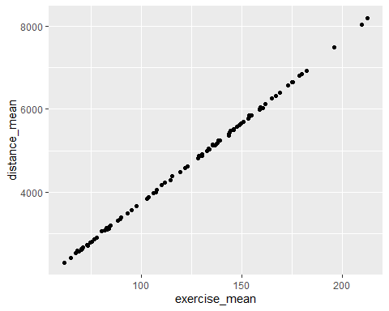
peak_date <- as.Date(c("2022-10-15","2022-11-11","2022-11-12"))
data_winter %>% filter(date %in% peak_date) %>%
group_by(date) %>%
summarise(
exercise=mean(exercise,na.rm=TRUE), carbon=mean(carbon,na.rm=TRUE),
distance = mean(distance), time = mean(time), temp_avg = mean(temp_avg),
temp_max = mean(temp_max), temp_min = mean(temp_min), temp_gap = mean(temp_gap),
fine.dust = mean(fine.dust), rainfall = mean(rainfall)
)
## # A tibble: 3 × 11
## date exercise carbon distance time temp_avg temp_max temp_min temp_gap
## <date> <dbl> <dbl> <dbl> <dbl> <dbl> <dbl> <dbl> <dbl>
## 1 2022-10-15 196. 1.29 7486. 68.8 18.2 24.4 12.6 11.8
## 2 2022-11-11 144. 0.837 5441. 46.3 15.6 22.1 10.9 11.2
## 3 2022-11-12 110. 0.548 4166. 36.7 16.3 22 11.6 10.4
## # ℹ 2 more variables: fine.dust <dbl>, rainfall <dbl>
data_winter %>% mutate(
weekday = weekdays(date, abbreviate=TRUE),
weekday = factor(weekday, levels=c("일","월","화","수","목","금","토")),
month = as.numeric(date-as.Date("2022-07-31"))%/%31+8) %>%
group_by(month,weekday) %>%
count() %>%
ggplot(aes(weekday,n,group=month,color=factor(month))) +
geom_line()
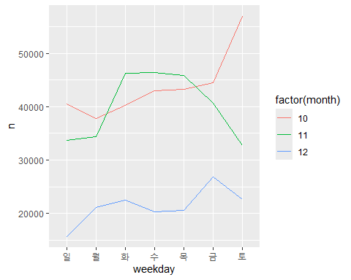
data_winter %>% mutate(
weekday = weekdays(date, abbreviate=TRUE),
weekday = factor(weekday, levels=c("일","월","화","수","목","금","토")),
month = as.numeric(date-as.Date("2022-07-31"))%/%31+8) %>%
filter(month == 10, weekday=="토") %>%
group_by(date) %>% summarise(
fine.dust = mean(fine.dust),
temp_avg = mean(temp_avg),
rainfall = mean(rainfall)
)
## # A tibble: 5 × 4
## date fine.dust temp_avg rainfall
## <date> <dbl> <dbl> <dbl>
## 1 2022-10-01 45.1 20.9 0
## 2 2022-10-08 9.02 15.8 0
## 3 2022-10-15 29.0 18.2 0
## 4 2022-10-22 39.7 15.1 0
## 5 2022-10-29 20.8 14.8 0
data_winter %>% mutate(
weekday = weekdays(date, abbreviate=TRUE),
weekday = factor(weekday, levels=c("일","월","화","수","목","금","토")),
month = as.numeric(date-as.Date("2022-07-31"))%/%31+8) %>%
filter(month == 10) %>% group_by(date) %>%
summarise(rainfall = mean(rainfall),
temp_avg = mean(temp_avg))
## # A tibble: 31 × 3
## date rainfall temp_avg
## <date> <dbl> <dbl>
## 1 2022-10-01 0 20.9
## 2 2022-10-02 15.8 19.4
## 3 2022-10-03 76 21.4
## 4 2022-10-04 11.8 17.9
## 5 2022-10-05 0.1 16.6
## 6 2022-10-06 0 15.8
## 7 2022-10-07 0 14.3
## 8 2022-10-08 0 15.8
## 9 2022-10-09 20.4 13.1
## 10 2022-10-10 0 9.9
## # ℹ 21 more rows
data_winter %>% mutate(
weekday = weekdays(date, abbreviate=TRUE),
weekday = factor(weekday, levels=c("일","월","화","수","목","금","토")),
month = as.numeric(date-as.Date("2022-07-31"))%/%31+8) %>%
filter(month == 10) %>% group_by(weekday) %>%
summarise(mean = mean(temp_avg),
max = mean(temp_max),
min = mean(temp_min))
## # A tibble: 7 × 4
## weekday mean max min
## <fct> <dbl> <dbl> <dbl>
## 1 일 15.8 20.0 12.8
## 2 월 12.2 16.4 8.93
## 3 화 12.4 17.8 8.10
## 4 수 13.4 19.3 8.33
## 5 목 14.6 20.1 9.55
## 6 금 14.8 20.8 10.1
## 7 토 17.0 23.2 11.8

