1208 팀플
Jiwon Lee
2024-12-08
library(tidyverse)
## ── Attaching core tidyverse packages ──────────────────────── tidyverse 2.0.0 ──
## ✔ dplyr 1.1.4 ✔ readr 2.1.5
## ✔ forcats 1.0.0 ✔ stringr 1.5.1
## ✔ ggplot2 3.5.1 ✔ tibble 3.2.1
## ✔ lubridate 1.9.3 ✔ tidyr 1.3.1
## ✔ purrr 1.0.2
## ── Conflicts ────────────────────────────────────────── tidyverse_conflicts() ──
## ✖ dplyr::filter() masks stats::filter()
## ✖ dplyr::lag() masks stats::lag()
## ℹ Use the conflicted package (<http://conflicted.r-lib.org/>) to force all conflicts to become errors
library(GGally)
## Registered S3 method overwritten by 'GGally':
## method from
## +.gg ggplot2
library(reshape2)
##
## Attaching package: 'reshape2'
##
## The following object is masked from 'package:tidyr':
##
## smiths
library(gridExtra)
##
## Attaching package: 'gridExtra'
##
## The following object is masked from 'package:dplyr':
##
## combine
data <- read.csv("/Users/jiwon/Desktop/2024Graphics/winterdata.csv")
head(data)
## date rent_office_number age exercise carbon distance time temp_avg
## 1 2022-10-01 108 10 58.21 0.49 2100.00 22 20.9
## 2 2022-10-01 108 10 58.21 0.49 2100.00 22 20.9
## 3 2022-10-01 109 10 128.56 0.94 4058.20 28 20.9
## 4 2022-10-01 109 10 128.56 0.94 4058.20 28 20.9
## 5 2022-10-01 111 10 76.44 0.83 3574.47 19 20.9
## 6 2022-10-01 111 10 76.44 0.83 3574.47 19 20.9
## temp_max temp_min temp_gap weekday fine.dust ultra.fine.dust rainfall
## 1 27.6 14.4 13.2 Sat 47.83333 35.45833 0
## 2 27.6 14.4 13.2 Sat 42.45833 30.95833 0
## 3 27.6 14.4 13.2 Sat 47.83333 35.45833 0
## 4 27.6 14.4 13.2 Sat 42.45833 30.95833 0
## 5 27.6 14.4 13.2 Sat 47.83333 35.45833 0
## 6 27.6 14.4 13.2 Sat 42.45833 30.95833 0

data$age = as.factor(data$age)
data$weekday = as.factor(data$weekday)
data$rent_office_number = as.factor(data$rent_office_number)
data = data %>%
mutate(district = ifelse(rent_office_number %in% c(115, 117, 123, 128, 131, 133, 134, 135, 137, 138, 139, 140, 141, 159, 160, 161, 162, 163, 164, 165, 166, 167, 169, 170, 171, 173, 175, 176, 177, 178, 179, 180, 188, 191, 192, 194, 195, 196, 198, 3100, 3101, 3102, 3103, 3104, 3105, 3107, 3109, 3110, 3111, 3113, 3114, 3115, 3116, 3117, 3119, 3120, 3121, 3122, 3123, 3125, 3126, 3127, 3128, 3129, 3130, 3131, 3132, 3133, 3134, 4253, 4255, 4262, 4264, 4265, 4266, 4267, 4269, 4270, 4271, 4272, 4273, 4274), "Sdm", "Mapo"))
data$district = as.factor(data$district)
table(data$age)
##
## 10 20 30 40 50 60 70대이상
## 45962 205114 166740 119152 87556 30856 3590
data$age <- as.character(data$age)
data$age <- ifelse(as.character(data$age) == "70대이상", "70", as.character(data$age))
data$age = as.factor(data$age)
table(data$age)
##
## 10 20 30 40 50 60 70
## 45962 205114 166740 119152 87556 30856 3590

summary(data)
## date rent_office_number age exercise
## Length:735684 4217 : 11432 20 :205114 Length:735684
## Class :character 113 : 8706 30 :166740 Class :character
## Mode :character 117 : 7464 40 :119152 Mode :character
## 419 : 7326 50 : 87556
## 4233 : 7244 10 : 45962
## 3010 : 7170 (Other): 34446
## (Other):686342 NA's : 76714
## carbon distance time temp_avg
## Length:735684 Min. : 0 Min. : 0.00 Min. :-11.800
## Class :character 1st Qu.: 1295 1st Qu.: 10.00 1st Qu.: 6.500
## Mode :character Median : 2792 Median : 24.00 Median : 11.200
## Mean : 5102 Mean : 44.75 Mean : 9.463
## 3rd Qu.: 6254 3rd Qu.: 57.00 3rd Qu.: 14.000
## Max. :378658 Max. :3555.00 Max. : 21.400
##
## temp_max temp_min temp_gap weekday
## Min. :-8.60 Min. :-13.700 Min. : 3.70 Fri:111874
## 1st Qu.:11.90 1st Qu.: 1.000 1st Qu.: 7.80 Mon: 93258
## Median :16.60 Median : 6.800 Median : 9.30 Sat:112318
## Mean :14.69 Mean : 5.161 Mean : 9.53 Sun: 89838
## 3rd Qu.:20.50 3rd Qu.: 10.200 3rd Qu.:11.20 Thu:109684
## Max. :27.60 Max. : 17.500 Max. :16.60 Tue:108974
## Wed:109738
## fine.dust ultra.fine.dust rainfall district
## Min. : 6.375 Min. : 1.208 Min. : 0.000 Mapo:489430
## 1st Qu.: 20.636 1st Qu.: 9.833 1st Qu.: 0.000 Sdm :246254
## Median : 27.583 Median :15.958 Median : 0.000
## Mean : 30.734 Mean :18.029 Mean : 1.302
## 3rd Qu.: 37.583 3rd Qu.:25.042 3rd Qu.: 0.000
## Max. :194.696 Max. :60.542 Max. :76.000
##

“date” “rent_office_number” “age”

“exercise” “carbon” “distance”

“time” “temp_avg” “temp_max”

“temp_min” “temp_gap” “weekday”

“fine.dust” “ultra.fine.dust” “rainfall”
data %>%
count(date) %>%
arrange(desc(n)) %>%
head(n=10)
## date n
## 1 2022-10-08 12238
## 2 2022-10-15 11640
## 3 2022-10-01 11478
## 4 2022-10-07 11458
## 5 2022-10-14 11430
## 6 2022-10-13 11132
## 7 2022-10-05 11130
## 8 2022-11-11 11108
## 9 2022-10-22 10932
## 10 2022-10-21 10928

변수분석
data$date = as.Date(data$date)
head(data)
## date rent_office_number age exercise carbon distance time temp_avg
## 1 2022-10-01 108 10 58.21 0.49 2100.00 22 20.9
## 2 2022-10-01 108 10 58.21 0.49 2100.00 22 20.9
## 3 2022-10-01 109 10 128.56 0.94 4058.20 28 20.9
## 4 2022-10-01 109 10 128.56 0.94 4058.20 28 20.9
## 5 2022-10-01 111 10 76.44 0.83 3574.47 19 20.9
## 6 2022-10-01 111 10 76.44 0.83 3574.47 19 20.9
## temp_max temp_min temp_gap weekday fine.dust ultra.fine.dust rainfall
## 1 27.6 14.4 13.2 Sat 47.83333 35.45833 0
## 2 27.6 14.4 13.2 Sat 42.45833 30.95833 0
## 3 27.6 14.4 13.2 Sat 47.83333 35.45833 0
## 4 27.6 14.4 13.2 Sat 42.45833 30.95833 0
## 5 27.6 14.4 13.2 Sat 47.83333 35.45833 0
## 6 27.6 14.4 13.2 Sat 42.45833 30.95833 0
## district
## 1 Mapo
## 2 Mapo
## 3 Mapo
## 4 Mapo
## 5 Mapo
## 6 Mapo
ggplot(data, aes(date)) +
geom_freqpoly()
## `stat_bin()` using `bins = 30`. Pick better value with `binwidth`.
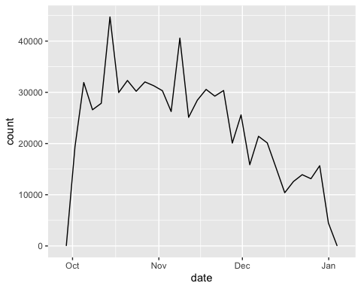
ggplot(data, aes(date)) +
geom_freqpoly(binwidth = 1)
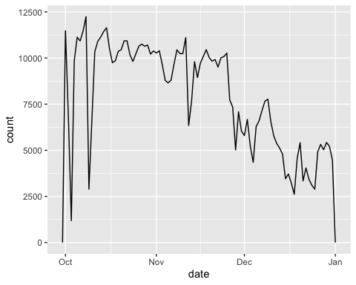
ggplot(data, aes(date)) +
geom_freqpoly(binwidth = 0.9)
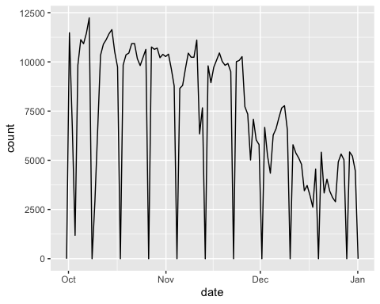
data %>%
filter(!is.na(age)) %>%
ggplot(aes(x = age)) +
geom_bar() +
ggtitle("Distribution of Age") +
xlab("Age") +
ylab("Count") +
theme(axis.text.x = element_text(hjust = 1))
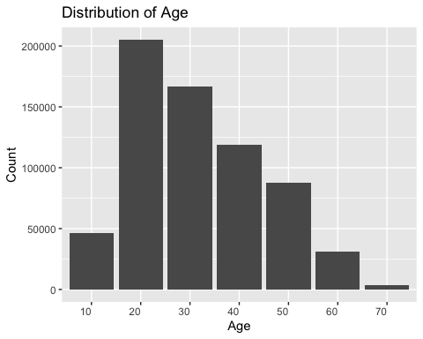
data$weekday <- factor(data$weekday, levels = c("Mon", "Tue", "Wed", "Thu", "Fri", "Sat", "Sun"))
# Weekday별 Distance 평균 계산하고 시각화
data %>%
group_by(weekday) %>%
summarise(mean_distance = mean(distance, na.rm = TRUE)) %>%
ggplot(aes(weekday, mean_distance)) +
geom_bar(stat = "identity", fill = "skyblue") +
ggtitle("Average Distance by Weekday") +
xlab("Weekday") +
ylab("Average Distance")
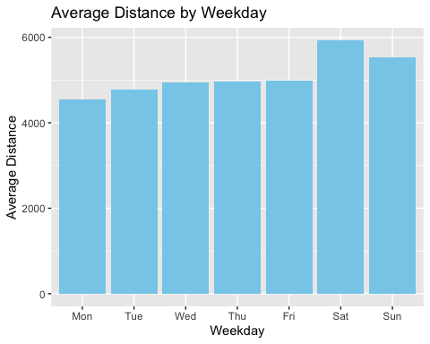
data %>%
filter(!is.na(age)) %>%
ggplot(aes(age, time)) +
geom_point(alpha = 0.3)
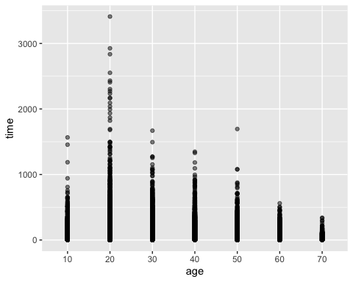
data %>%
select(distance, time, temp_avg, fine.dust) %>%
ggpairs(
lower = list(continuous = wrap("points", size = 0.5, alpha = 0.3)),
diag = list(continuous = wrap("densityDiag")),
upper = list(continuous = wrap("cor", size = 4)))
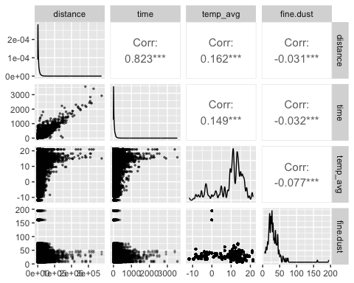
# Fine Dust와 Distance 산점도
data %>%
filter(!is.na(age)) %>%
ggplot(aes(fine.dust, distance)) +
geom_point(aes(color = age), alpha = 0.5, size = 0.5) +
ggtitle("Fine Dust vs Distance") +
xlab("Fine Dust") +
ylab("Distance (km)") +
scale_y_continuous(labels = function(x) x / 1000)
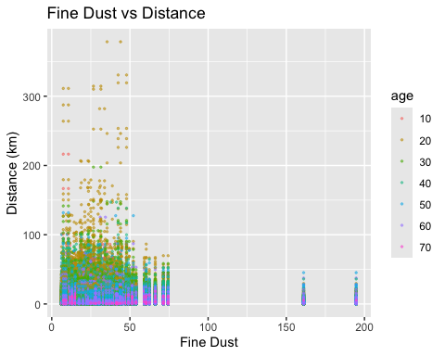
cor_matrix <- cor(data %>% select(distance, time, temp_avg, fine.dust), use = "complete.obs")
melted_cor_matrix <- melt(cor_matrix)
ggplot(melted_cor_matrix, aes(x = Var1, y = Var2, fill = value)) +
geom_tile() +
scale_fill_gradient2(low = "blue", high = "red", mid = "white", midpoint = 0) +
theme_minimal() +
ggtitle("Correlation Heatmap") +
xlab("") + ylab("")
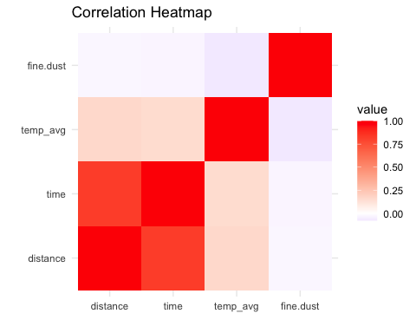
plots <- list()
variables <- c("distance", "time", "temp_avg", "fine.dust")
for (i in 1:(length(variables) - 1)) {
for (j in (i + 1):length(variables)) {
plots[[length(plots) + 1]] <- ggplot(data, aes_string(x = variables[i], y = variables[j])) +
geom_point(alpha = 0.3, size =0.5) +
theme_minimal() +
xlab(variables[i]) + ylab(variables[j])
}
}
## Warning: `aes_string()` was deprecated in ggplot2 3.0.0.
## ℹ Please use tidy evaluation idioms with `aes()`.
## ℹ See also `vignette("ggplot2-in-packages")` for more information.
## This warning is displayed once every 8 hours.
## Call `lifecycle::last_lifecycle_warnings()` to see where this warning was
## generated.
do.call(grid.arrange, c(plots, ncol = 2))
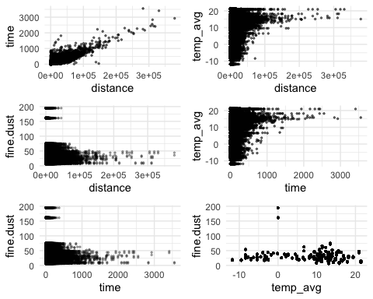
ggplot(data, aes(weekday, distance)) +
geom_point(size = 0.7, alpha = 0.3) +
geom_violin(size = 0.5) +
xlab("Weekday") + ylab("Distance (km)") +
scale_y_continuous(labels = function(x) x / 1000)
## Warning: Using `size` aesthetic for lines was deprecated in ggplot2 3.4.0.
## ℹ Please use `linewidth` instead.
## This warning is displayed once every 8 hours.
## Call `lifecycle::last_lifecycle_warnings()` to see where this warning was
## generated.
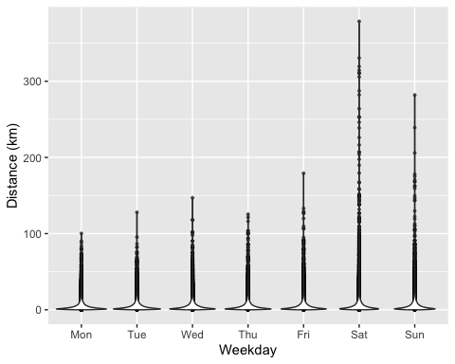
ggplot(data, aes(weekday, distance)) +
geom_line() +
xlab("Weekday") + ylab("Distance (km)") +
scale_y_continuous(labels = function(x) x / 1000)
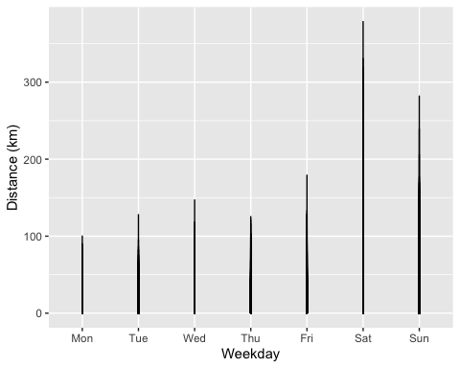
data %>%
filter(!is.na(age)) %>%
ggplot(aes(age, time)) +
geom_boxplot()
