팀플
library(tidyverse)
## ── Attaching core tidyverse packages ──────────────────────── tidyverse 2.0.0 ──
## ✔ dplyr 1.1.4 ✔ readr 2.1.5
## ✔ forcats 1.0.0 ✔ stringr 1.5.1
## ✔ ggplot2 3.5.1 ✔ tibble 3.2.1
## ✔ lubridate 1.9.3 ✔ tidyr 1.3.1
## ✔ purrr 1.0.2
## ── Conflicts ────────────────────────────────────────── tidyverse_conflicts() ──
## ✖ dplyr::filter() masks stats::filter()
## ✖ dplyr::lag() masks stats::lag()
## ℹ Use the conflicted package (<http://conflicted.r-lib.org/>) to force all conflicts to become errors
library(dplyr)
library(readr)
Sys.setlocale("LC_TIME", "ko_KR.UTF-8")
## [1] "ko_KR.UTF-8"
Data = read.csv("/Users/jiwon/Desktop/Graphics data/data_fin.csv", fileEncoding = "EUC-KR")
Data %>%
count(age)
## age n
## 1 20 160300
## 2 30 126912
## 3 40 88276
## 4 50 63862
## 5 60 24020
## 6 70~ 3264
## 7 ~10 37488
## 8 <NA> 67634
- year, month, day: 연, 월, 일
- age : 이용자 연령대 (10 : ~10대, 20 : 20대, … , 70 : 70대 이상)
- time : 따릉이 건별 이용 시간
- distinct : 따릉이 대여소가 위치한 자치구(Mapo : 마포구, Seod : 서대문구)
- fine.dust :
- ultra.fine.dust :
- max : 월별 최고기온
- min : 월별 최저기온
- avg_max :
- avg_min :
- max_date : 월별로 최고기온을 기록한 날짜
- min_date : 월별로 최저기온을 기록한 날짜
- gap : 월별 일교차(최고기온 - 최저기온)
범주형 : distinct, age, year, month, day 연속형 :
[1] “year” “month” “day” “rent_office_number” “age”
[6] “time” “distinct” “fine.dust” “ultra.fine.dust” “max”
[11] “min” “average” “max_date” “min_date” “gap”
[16] “avg_max” “avg_min”
Data = read.csv("/Users/jiwon/Desktop/Graphics data/data_daRjo.csv")
head(Data)
## year month day rent_office_number age time distinct fine.dust ultra.fine.dust
## 1 2022 8 1 112 10 59 Mapo 12.05000 7.666667
## 2 2022 8 1 112 10 59 Mapo 10.58333 5.208333
## 3 2022 8 1 145 10 8 Mapo 12.05000 7.666667
## 4 2022 8 1 145 10 8 Mapo 10.58333 5.208333
## 5 2022 8 1 487 10 9 Mapo 12.05000 7.666667
## 6 2022 8 1 487 10 9 Mapo 10.58333 5.208333
## max min average max_date min_date gap avg_max avg_min
## 1 32.9 16.1 25.7 2022.8.4 2022.8.28 16.8 28.9 23.1
## 2 32.9 16.1 25.7 2022.8.4 2022.8.28 16.8 28.9 23.1
## 3 32.9 16.1 25.7 2022.8.4 2022.8.28 16.8 28.9 23.1
## 4 32.9 16.1 25.7 2022.8.4 2022.8.28 16.8 28.9 23.1
## 5 32.9 16.1 25.7 2022.8.4 2022.8.28 16.8 28.9 23.1
## 6 32.9 16.1 25.7 2022.8.4 2022.8.28 16.8 28.9 23.1
Data = Data %>%
mutate(date = as.Date(paste(year, month, day, sep= "-")))
Data = Data %>%
select(date, age:avg_min, everything())
head(Data)
## date age time distinct fine.dust ultra.fine.dust max min average
## 1 2022-08-01 10 59 Mapo 12.05000 7.666667 32.9 16.1 25.7
## 2 2022-08-01 10 59 Mapo 10.58333 5.208333 32.9 16.1 25.7
## 3 2022-08-01 10 8 Mapo 12.05000 7.666667 32.9 16.1 25.7
## 4 2022-08-01 10 8 Mapo 10.58333 5.208333 32.9 16.1 25.7
## 5 2022-08-01 10 9 Mapo 12.05000 7.666667 32.9 16.1 25.7
## 6 2022-08-01 10 9 Mapo 10.58333 5.208333 32.9 16.1 25.7
## max_date min_date gap avg_max avg_min year month day rent_office_number
## 1 2022.8.4 2022.8.28 16.8 28.9 23.1 2022 8 1 112
## 2 2022.8.4 2022.8.28 16.8 28.9 23.1 2022 8 1 112
## 3 2022.8.4 2022.8.28 16.8 28.9 23.1 2022 8 1 145
## 4 2022.8.4 2022.8.28 16.8 28.9 23.1 2022 8 1 145
## 5 2022.8.4 2022.8.28 16.8 28.9 23.1 2022 8 1 487
## 6 2022.8.4 2022.8.28 16.8 28.9 23.1 2022 8 1 487
Data = Data %>%
mutate(
weekday = weekdays(date, abbreviate = TRUE),
weekday = factor(weekday, levels = c("월", "화", "수", "목", "금", "토", "일"))
) %>% select(date, weekday, age:avg_min, everything())
head(Data)
## date weekday age time distinct fine.dust ultra.fine.dust max min
## 1 2022-08-01 월 10 59 Mapo 12.05000 7.666667 32.9 16.1
## 2 2022-08-01 월 10 59 Mapo 10.58333 5.208333 32.9 16.1
## 3 2022-08-01 월 10 8 Mapo 12.05000 7.666667 32.9 16.1
## 4 2022-08-01 월 10 8 Mapo 10.58333 5.208333 32.9 16.1
## 5 2022-08-01 월 10 9 Mapo 12.05000 7.666667 32.9 16.1
## 6 2022-08-01 월 10 9 Mapo 10.58333 5.208333 32.9 16.1
## average max_date min_date gap avg_max avg_min year month day
## 1 25.7 2022.8.4 2022.8.28 16.8 28.9 23.1 2022 8 1
## 2 25.7 2022.8.4 2022.8.28 16.8 28.9 23.1 2022 8 1
## 3 25.7 2022.8.4 2022.8.28 16.8 28.9 23.1 2022 8 1
## 4 25.7 2022.8.4 2022.8.28 16.8 28.9 23.1 2022 8 1
## 5 25.7 2022.8.4 2022.8.28 16.8 28.9 23.1 2022 8 1
## 6 25.7 2022.8.4 2022.8.28 16.8 28.9 23.1 2022 8 1
## rent_office_number
## 1 112
## 2 112
## 3 145
## 4 145
## 5 487
## 6 487
Data %>%
ggplot(aes(date)) +
geom_freqpoly(binwidth = 0.5)
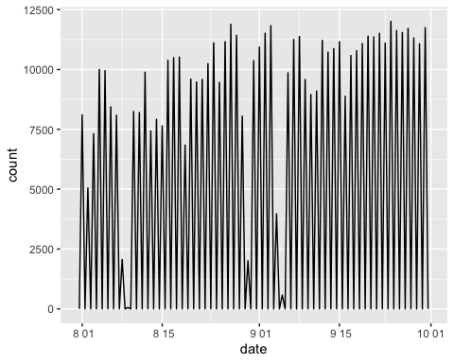
# 비오는날....?
Data %>%
group_by(weekday) %>%
ggplot(aes(weekday)) +
geom_bar()
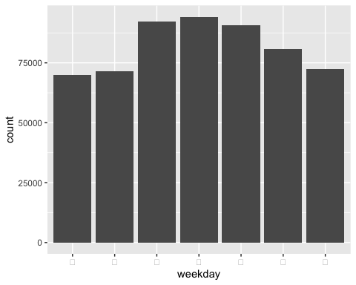
Data = Data %>%
mutate(fine_dust_level = case_when(
fine.dust <= 15 ~ "good",
fine.dust <= 35 ~ "so so",
fine.dust <= 75 ~ "bad",
TRUE ~ "worst"),
)
Data = Data %>%
mutate(
fine_dust_level = factor(fine_dust_level, levels = c("worst", "bad", "so so", "good"))
)
dust_distribution = Data %>%
group_by(fine_dust_level) %>%
summarise(count = n())
ggplot(dust_distribution, aes(fine_dust_level, count)) +
geom_bar(stat="identity") +
scale_y_continuous(labels = scales::comma) +
xlab("Fine Dust Level")
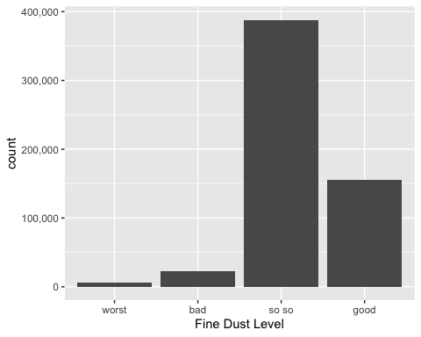
각 미세먼지 범주별 빈도수 조사해서 분석하기

