Turn-Based Battle Design Document

High level description

* Turn based battles take place whenever you accept a quest.
* In the battle, you and your party (up to 3 others, so at most 4 total) fight against a group of monsters (at most 4 total).
* If either side loses all of its members, the game ends.
* If the user’s team has won, then they get the loot rewards from the quest.

Game flow

* At the very beginning of the battle, the turn order is decided by relative speed. This turn order stays constant throughout the battle. For example, if there are 4 user players and 3 monsters (7 actors total), then every turn sequence takes 7 turns where each actor goes exactly once in the same order every time.
  + Note: unlike a lot of modern turn based RPGs, this means that even if an actor has twice the speed of another, that DOES NOT mean that they get to move two times every time the slower ator moves once. Each actor only and always gets one move per turn sequence.
* All actors start with 1 action point (see stats) and players start with 100 health (monsters may have varying health).
* When it is someone’s turn, the HUD opens up (see HUD section) and gives the player 4 actions:
  + ATTACK (cost = [varies]): Opens another sub menu giving possible attack options:
    - STRIKE (cost = 1): Basic attack. Does damage equal to 1\*attack stat.
    - DAZE (cost = 2): Strategic attack. Reduces target’s action points by 2.
    - BACK: go back to previous menu.
  + CHARGE (cost = 0): Increases user’s action points by 1.
  + GUARD (cost = 1): Defend your team by blocking the next attack any enemy makes. You take the hit instead.
  + Special (actual name below) (cost = 4): Special move based on player’s highest stat:
    - If attack is highest: CRASH: Does 4\*attack.
    - If defense: BOLSTER: Heal self by (total stat sum)/2.
    - If speed: PREPARE: Increase attack and defense by 0.25\*speed for the rest of the battle.
* After an action is taken, the user gains ceiling(speed%10) action points (even if they chose CHARGE), and their turn ends.
* The next turn is decided by the turn order.

Stats

* Action points: all players use action points to perform actions. Actors naturally gain action points based on their speed at the end of their turn.
* Attack: Determines how much damage is done during offensive actions (formulas given in actions).
* Defense: Reduces damage taken from offensive actions (DOES NOT reduce action point loss from DAZE). Final damage = damage\*(1-(0.02\*defense)). (If defense is greater than 50, damage becomes negative, so put bound?)
* Speed: Determines turn order and how many actions points are regained at the end of their turns.
* Equipment types: Certain equipment types give special advantages:
  + Weapons:
    - [if no weapon equipped]: Gain 1 extra action point at the end of your turn.
    - Sword: STRIKE does 2.25\*attack instead of 1 times, but costs 2 action points to use.
    - Staff: DAZE only costs 1 action point, but STRIKE only does 0.5\*attack.
    - Dagger: STRIKE does 0.25\*attack, but doesn’t cost any action points.
    - Crossbow: STRIKE deals 0.25\*attack to all enemies.
    - Hammer: DAZE reduces action points by 4, but costs 3 action points to use.
    - Wand: Special ability only costs 3 action points, but user cannot use STRIKE.
  + Off-hands:
    - [if no off-hand equipped]: CHARGE gives 2 actions points instead of 1.
    - Shield: While in GUARD, take 25% less damage (after calculating damage reduction from defense normally).
    - Tome: At the end of each turn, a random stat increases by 1.
    - Explosives: Double attack, but all damaging moves deal equal damage to yourself.
* Armor: Don’t have any special effect; already too complicated.
* Stat totals/relative amounts: Stat total shouldn’t go over 40~30. Individual stats shouldn’t go too far over 20.

HUD

* Very minimal HUD, similar in style to the pokemon games. Bottom third/fourth of the screen dedicated to menu, with one part being text instructions and the other being menu buttons. Top half has just the enemies (like Mother games), with names, health, and action points of enemies above their heads. Just above the bottom menu are the health/action points/names of the players.
* Navigating options can be done either by a cursor or by mouse clicks (whichever is easier to implement, probably mouse clicks?).

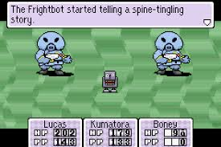

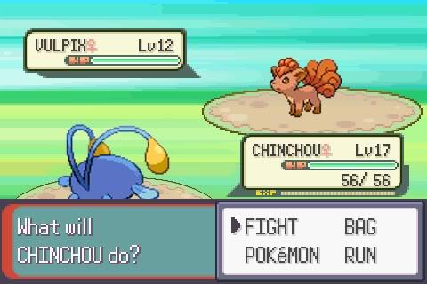

* On this first HUD menu, the options are ATTACK, GUARD, CHARGE, and ‘Special’ (see game flow) with the cost in action points listed right beside.
* On selecting ATTACK, a sub-menu is opened up listing the attack options.
  + After selecting one of the options, the user can select which enemy to target.
  + After selecting an enemy, attack ‘animation’ plays. Enemy being hit flashes to indicate that it was hit, and health is reduced.
* On selecting GUARD, guard ‘animation’ plays. Put a shield icon over the nameplate of the person who’s guarding.
* On selecting CHARGE, charge ‘animation’ plays, the user’s action points increase.
* On selecting your special:
  + CRASH: Select enemy to attack, display that enemy was hit (same as STRIKE).
  + BOLSTER: Increase character’s health.
  + PREPARE: Increase character’s stats.
* If it’s the enemy’s turn, bottom menu just says ‘enemy’s turn’.
  + Enemies just flash when taking an action.

Actor representation

* Monsters just have their own unique sprites.
* Players don’t need sprites obviously since they aren’t shown. Their little name plates will show their status.
* When it’s a player’s turn, either highlight the nameplate, or put a cursor, etc.
* When it’s an enemy’s turn, we can do the same.

Enemy logic

* Two options:

1. Enemies act and behave just like players (but with different starting health, no equipment, and set stats).
2. Enemies act very differently (just have one or two moves, set stats and abilities, etc).

* Option 2 would definitely be simpler, and would not detract from the strategy of the game if the enemies are designed well. However, each enemy has to be individually designed then (I (James) still think this might be the way to go though).