Solutions for homework 1 (Due October 5, 2003)

- Excluded middle laws:
Given a fuzzy set 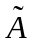 with a triangular membership function as follows:
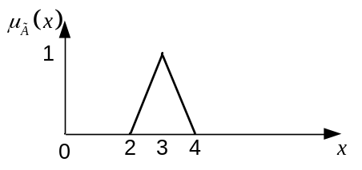
Fig 1. Triangular membership function.

  - Derive 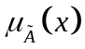 as a mathematical equation.
By using a generic linear equation in the form of 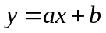, we can easily have as follows:
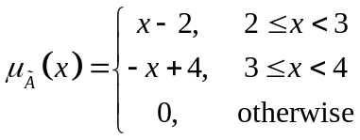

  - Draw a new membership function based on Fig. 1 to show that excluded middle laws are not valid for fuzzy sets.
Law of excluded middle:
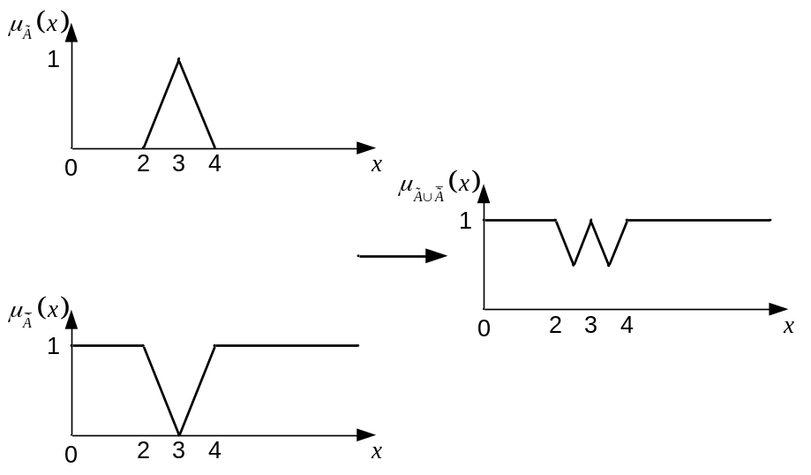
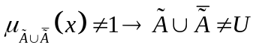
Law of contradiction:
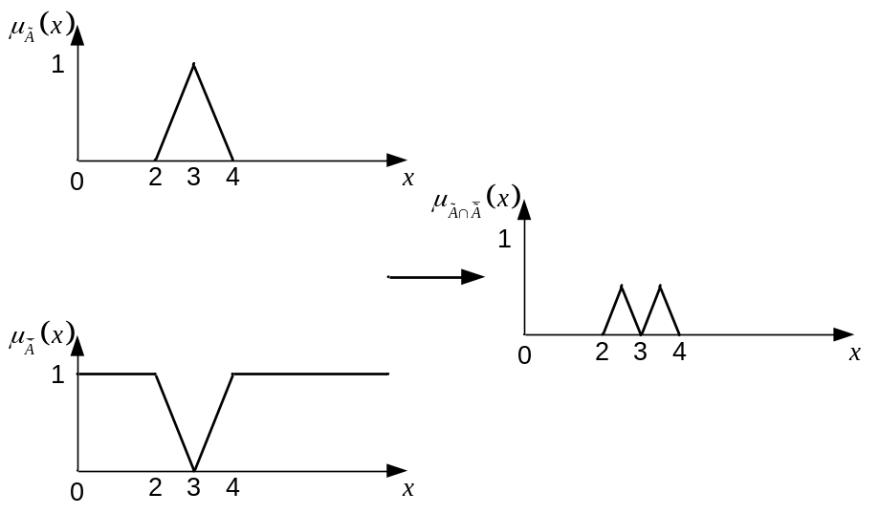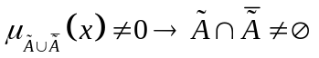

- Convexity:
Given a fuzzy set with a following membership function:
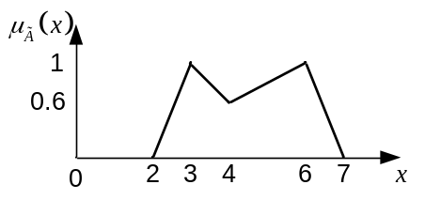
Fig 2. Nonconvex membership function.

  - Derive as a mathematical equation.
Similar to 1 (a), we can derive the membership function as:
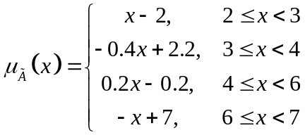

  - Show that this membership function is nonconvex based on:
To show that this function is nonconvex, let 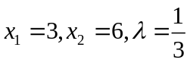.
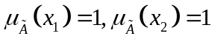 and 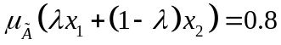
Since 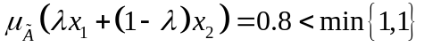, thus is nonconvex.

  - If you define “medium speed of a car” as a fuzzy set, should the membership function of “medium speed” be convex or nonconvex ? Explain your idea.
This membership function should be convex because
- Form of a membership function:
Given a general shape of a trapezoidal membership function as follows:
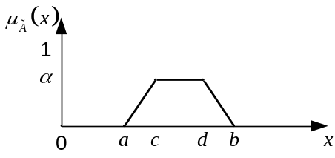
Fig. 3. Trapezoidal membership function.
Derive a closed (general) form of .

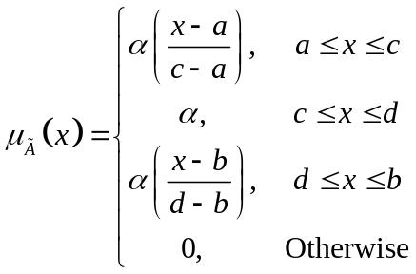

- You are asked to select an implementation technology for a numerical processor. Computation throughput is directly related to clock speed. Assume that all implementations will be in the same family (e.g., CMOS). You are considering whether the design should be implemented using medium-scale integration (MSI) with discrete parts, field-programmable array parts (FPGA), or multichip modules (MCM). Define the universe of potential clock speeds as 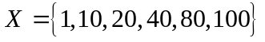 MHz; and define MSI, FPGA, and MCM as fuzzy sets of clock frequencies that should be implemented in each of these technologies. The following table defines the membership values for each of the three fuzzy sets. Note: The assignments made in this table reflect only the operational speed capability per cost ratio and do not include other factors.

Clock frequency, MHz | MSI | FPGA | MCM
1 | 1 | 0.3 | 0
10 | 0.7 | 1 | 0
20 | 0.4 | 1 | 0.5
40 | 0 | 0.5 | 0.7
80 | 0 | 0.2 | 1
100 | 0 | 0 | 1

Representing the three sets as 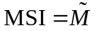, 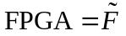, and 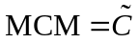, find the following:
  - 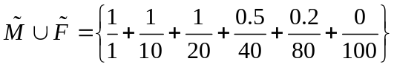
  - 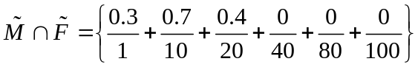
  - 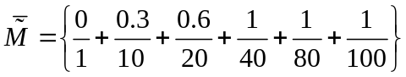
  - 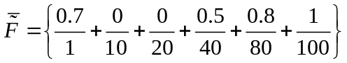
  - 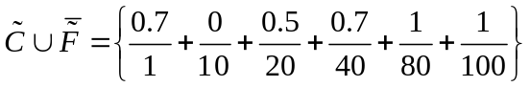
  - 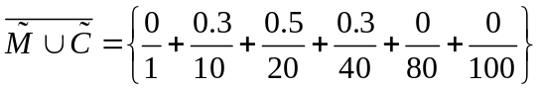
  - 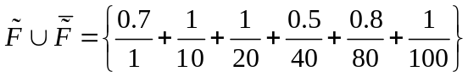
  - 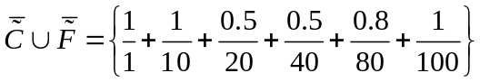
  - 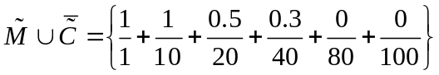
  - 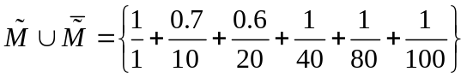

- Consider a local area network of interconnected workstations that communicate using Ethernet protocols at a maximum rate of 10 Mbit/s. Traffic rates on the network can be expressed as the peak value of the total bandwidth (BW) used; and the two fuzzy variables, “Quiet” and “Congested,” can be used to describe the perceived loading of the LAN. If the discrete universal set 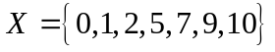 represents bandwidth usage, then the membership grades of these elements in the fuzzy sets Quiet 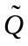 and Congested 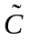 are as shown in the table and in Fig. 4.

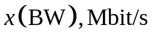 | 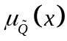 | 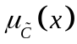
0 | 1.0 | 0.0
1 | 1.0 | 0.0
2 | 0.8 | 0.0
5 | 0.3 | 0.4
7 | 0.1 | 0.6
9 | 0.0 | 0.8
10 | 0.0 | 1.0
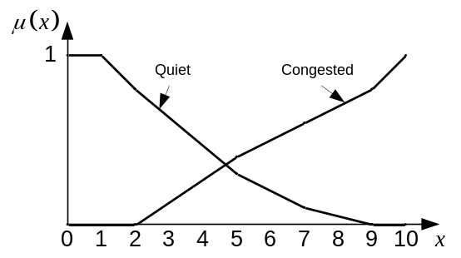
Fig. 4. Membership functions of “Quiet” and “Congested”.
For these two fuzzy sets, find the union, intersection, complement of each, difference 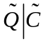, both De Morgan’s laws, and both excluded middle laws, (a) graphically and (b) numerically.
