**SE Tools Exercise**

Team 8

**Contents**

**The program used 1**

**UML : Star UML 1**

**Results 1**

**Discussion 1**

**Unit Test : JUnit 5 1**

**Results 1**

**Discussion 1**

**Source Codes 1**

**The program used**

open-sourced codes

https://github.com/rokon12/Simple-Calculator.git

**Unit Test : JUnit 5**

**Results**

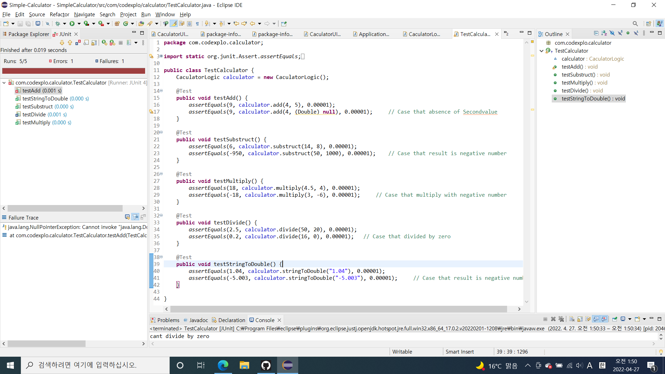

Tested 10 cases in 5 methods.

1 Error and 1 Failure is detected.

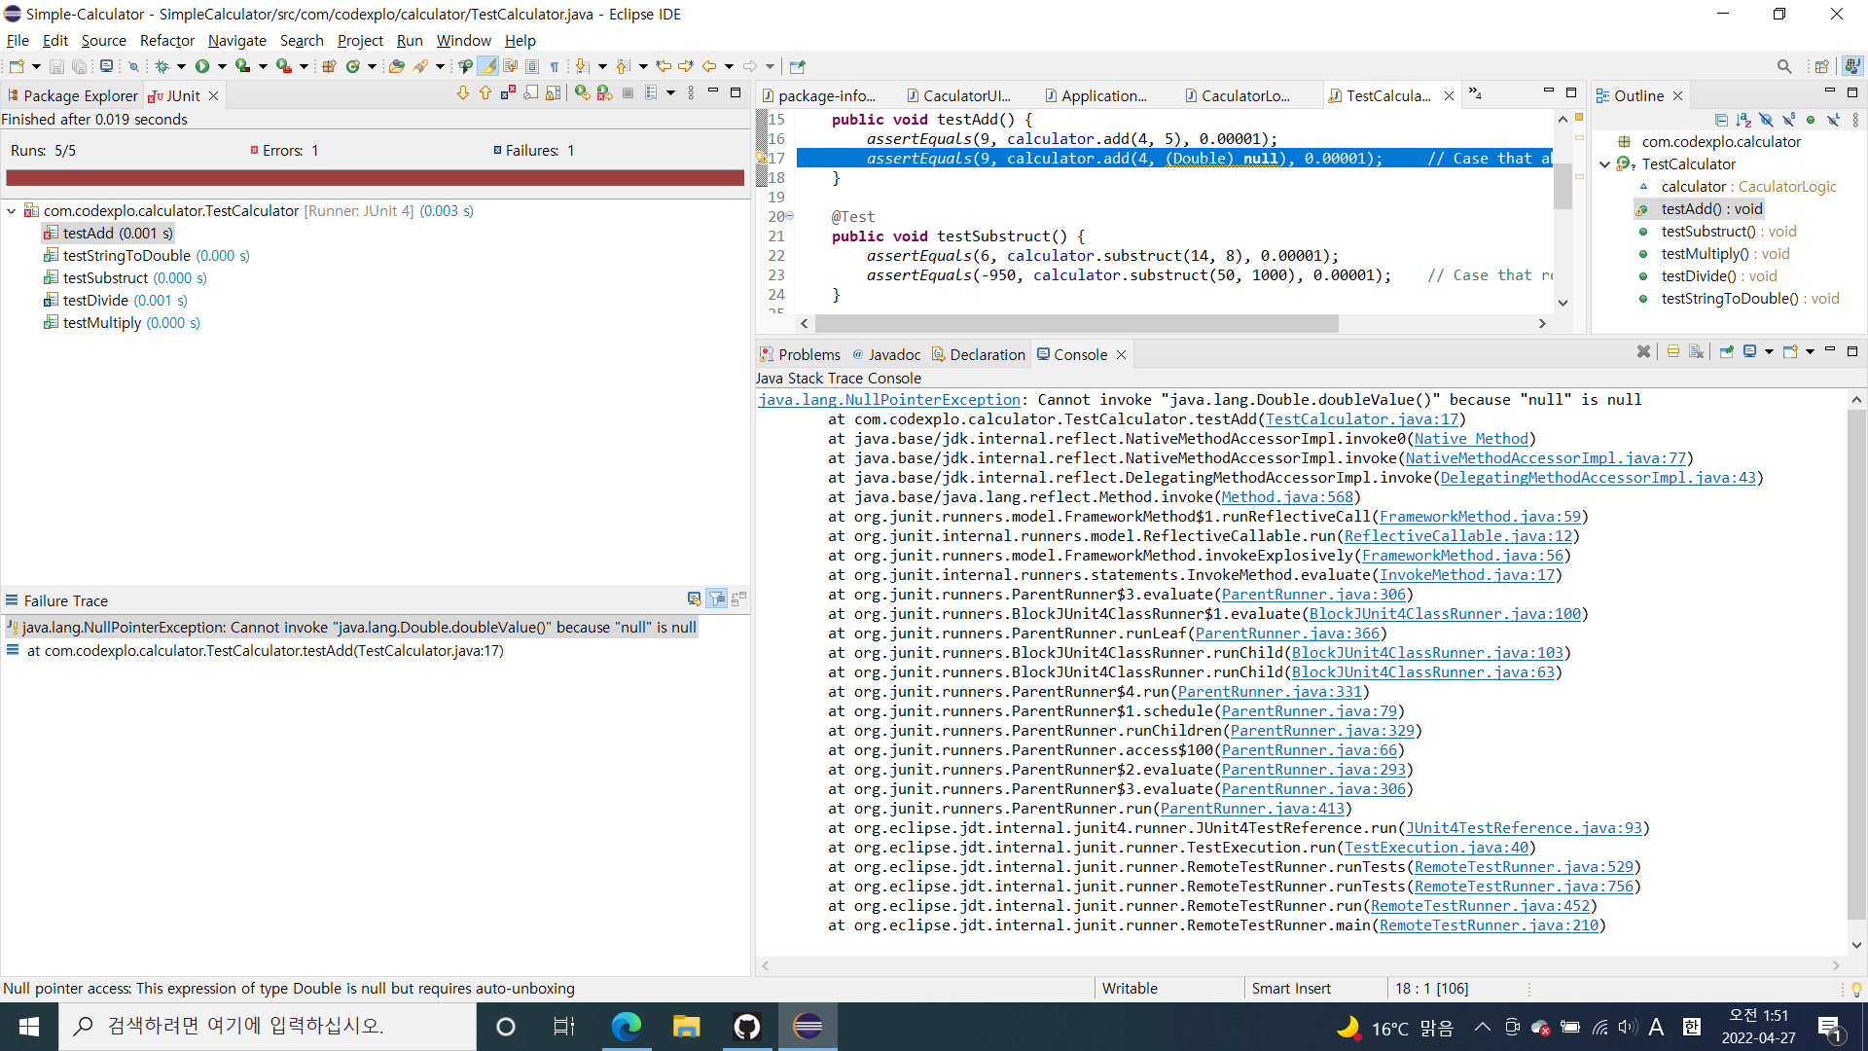

Error : java.lang.NullPointerException: Cannot invoke "java.lang.Double.doubleValue()" because "null" is null

* Error occur when user click “=” after operator without second Value.
* So We should fix it.

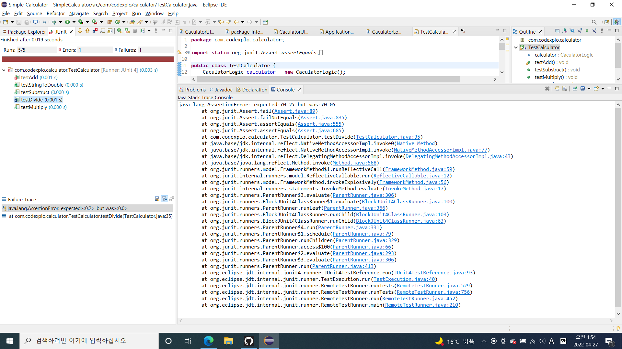

Failure : java.lang.AssertionError: expected:<0.2> but was:<0.0>

* Divided by 0 Error handling with if… else…

**Discussion**

**Source Codes**