#If you have only one monitor, you don’t need this script, just use shortcut:

Windows button + prt scr and the screenshot will be taken and stored in c:/user/yourname/Pictures/Screenshots folder

#This is autohotkey script to enable taking screenshot and storing the screenshots to selected folder automatically

#The script have following features:

#Shortcut: Alt+a to take screenshot from the primary screen

#Shortcut: Alt+b to take screenshot from the secondary screen

#Shortcut: Ctr alt+ Mouse move to take screenshot from the mouse moving covered area

#See section: How to change shortcut to change shortcuts to your choice

Glossary:

ScriptFolder: The folder you copy the scripts to

ScreenshotFolder: The folder you store the screenshots to

PrimaryScreen: Screen with number 1

SecondaryScreen: Screen with number 2

*ScreenScaleFactor: The number of the scaling setting in display setting/100

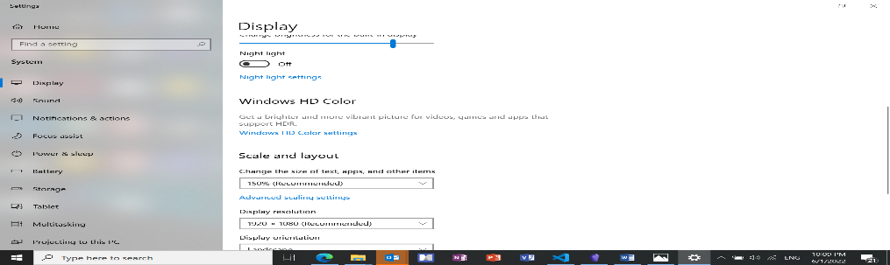

1. Copy the script

Copy the whole folder to ScriptFolder where you like. But must with write permission.

2. Adjust parameter due to your local environment

Open the script “screenshot.ahk” in ScriptFolder with your favorite editor and adjust the *ScreenScaleFactor with your local settings. Otherwise the size of the screenshot will not be correct.

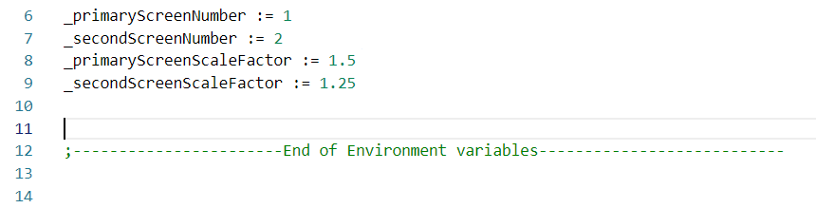

3. Run the script

Open context menu from the screenshot.ahk and change the “open with” to AutoHotkeyU64.exe in the ScriptFolder.

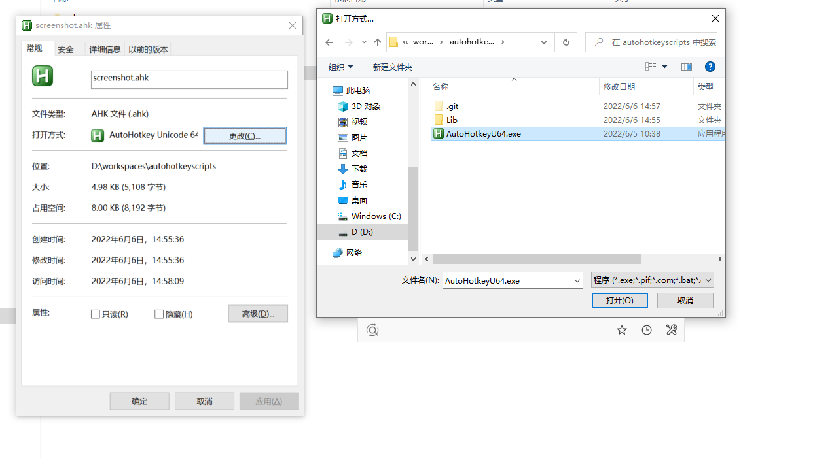

Double click on screenshot.ahk, the script will be started.

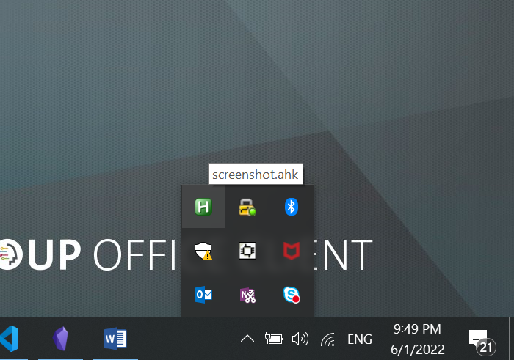

If the script runs at the very first time, the file selector window will be displayed to let you choose the folder in which the screenshots will be stored.

The ScreenshotFolder’s name will be stored in config.ini file in ScriptFolder

4. Stop the script

Context menu from the icon and click exit

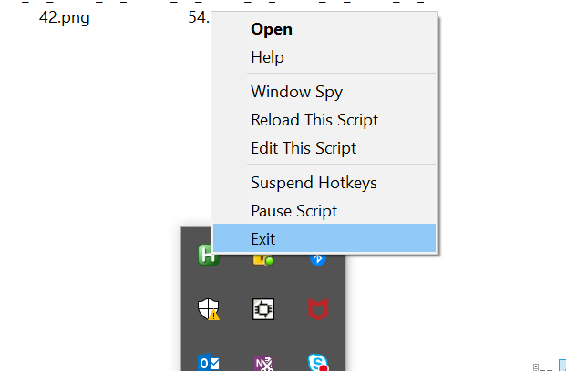

4. Reload the script

If you change anything in the script, you must reload the script. Click the “Reload This Script” from context menu (see picture above)

5. Run the script automatically in windows startup

Create Shortcut to screenshot.ahk in ScriptFolder and move the shortcut to folder C:\Users\yourname\AppData\Roaming\Microsoft\Windows\Start Menu\Programs\Startup

Then the script will be started while windows startup

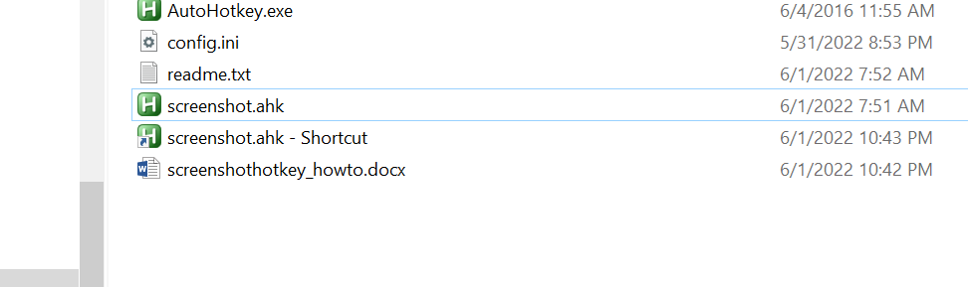

6. Change the ScreenshotFolder

Just delete the config.ini file in ScriptFolder and reload/rerun the script. Or open the config.ini file set the value from key “screenshotsfolder” to your choise and reload/rerun the script

7. Change the hotkeys

Get the hotkey string or name from official autohotkey help doc and change the hotkeys in the script.