# Python programming – Coursework

The coursework consists of two parts:

1. Create an interesting application using Python, which should have:
   1. 2+ classes with attributes and methods
   2. 2+ functions
   3. Interaction between classes – methods from one class accepting as parameter objects of another

All classes should be in different files and there should be one file “main.py" which demonstrates your application.

1. Achieve 3+ stars in Python language in [www.hackerrank.com](http://www.hackerrank.com). Create an account and go to the language proficiency for python and solve challenges. When you’re done you should have a badge inside your profile. For each challenge you solve copy the solution code and create a .py file for it with the name of the challenge. (If a challenge has name “Hello World” -> hello_world.py)

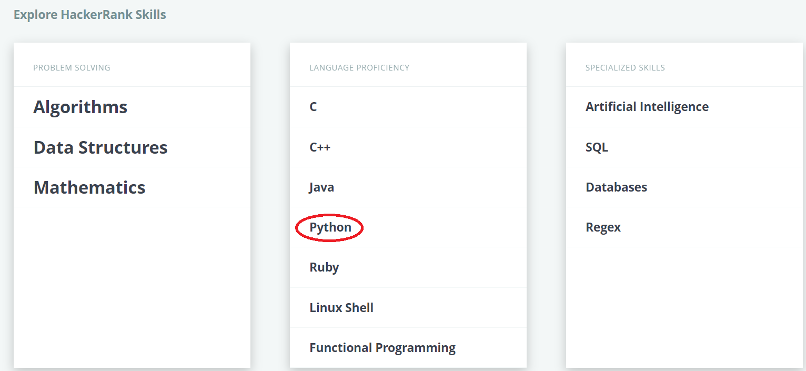

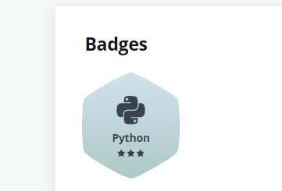

For both parts you should save your .py files and upload them to [www.github.com](http://www.github.com).  
Your repository should be named: “Python-Coursework-2019".

Your folder structure should look like this:

* application
  + main.py
  + class1.py
  + class2.py
  + …
* hacker_rank_challenges
  + challenge_name.py
  + another_challenge_name.py

- Folders

- Python files