JIYA ARORA 24BAI10034

CRUD OPERATIONS:(MYSQL)
package CRUD;
import java.sql.Connection;
import java.sql.PreparedStatement;
import java.sql.ResultSet;

public class CRUD_Test {

public void create_data(String sl_no,String name,String email){
DB_Connection obj_DB_Connection=new DB_Connection();
Connection connection=obj_DB_Connection.get_connection();
PreparedStatement ps=null;
try {
String query="insert into student(sl_no,name,email) values (?,?,?)";;
ps=connection.prepareStatement(query);
ps.setString(1, sl_no);
ps.setString(2, name);
ps.setString(3, email);
System.out.println(ps);
ps.executeUpdate();
} catch (Exception e) {

System.out.println(e);
}
}

public void read_data(String sl_no) {
DB_Connection obj_DB_Connection = new DB_Connection();
Connection connection = obj_DB_Connection.get_connection();
PreparedStatement ps = null;
ResultSet rs = null;

try {
String query = "SELECT * FROM student WHERE sl_no = ?";
ps = connection.prepareStatement(query);

ps.setString(1, sl_no);

System.out.println(ps);

rs = ps.executeQuery();

if (rs.next()) {
System.out.println("Sl no - " + rs.getString("sl_no"));
System.out.println("Name - " + rs.getString("name"));
System.out.println("Email - " + rs.getString("email"));
} else {
System.out.println("No record found for sl_no: " + sl_no);
}

} catch (Exception e) {
System.out.println(e);
}
}
//
public void update_data(String sl_no,String new_sl_no,String name,String email){
DB_Connection obj_DB_Connection=new DB_Connection();
Connection connection=obj_DB_Connection.get_connection();
PreparedStatement ps=null;
try {
String query="update student set sl_no=?,name=?,email=? where sl_no=?";
ps=connection.prepareStatement(query);
ps.setString(1, new_sl_no);
ps.setString(2, name);
ps.setString(3, email);
ps.setString(4, sl_no);
System.out.println(ps);
ps.executeUpdate();
} catch (Exception e) {
System.out.println(e);
}
}
//
public void delete_data(String sl_no){
DB_Connection obj_DB_Connection=new DB_Connection();
Connection connection=obj_DB_Connection.get_connection();
PreparedStatement ps=null;
try {
String query="delete from student where sl_no=?";
ps=connection.prepareStatement(query);
ps.setString(1, sl_no);
System.out.println(ps);
ps.executeUpdate();
} catch (Exception e) {
System.out.println(e);
}

}
public void alter_table() {
DB_Connection obj_DB_Connection = new DB_Connection();
Connection connection = obj_DB_Connection.get_connection();
PreparedStatement ps = null;

try {
String query = "alter table student ADD City VARCHAR(20)";
ps = connection.prepareStatement(query);

System.out.println(ps);

ps.executeUpdate();
System.out.println("Column added successfully.");

} catch (Exception e) {
System.out.println(e);
}
}

public void truncate_data() {
DB_Connection obj_DB_Connection = new DB_Connection();
Connection connection = obj_DB_Connection.get_connection();
PreparedStatement ps = null;

try {
String query = "truncate table student";
ps = connection.prepareStatement(query);

System.out.println(ps);

ps.executeUpdate();
System.out.println("All records deleted successfully.");

} catch (Exception e) {
System.out.println(e);
}
}

public static void main(String[] args) {
CRUD_Test objTest=new CRUD_Test();
//insert data
objTest.create_data("1", "jinu", "jinu@gmail.com");
objTest.create_data("2", "jawad", "jawad@gmail.com");
// read data
objTest.read_data("2");
//update data
objTest.update_data("2", "22", "jawad2", "jawad2@gmail");
//delete data
objTest.delete_data("1");
objTest.alter_table();
objTest.truncate_data();
}
}
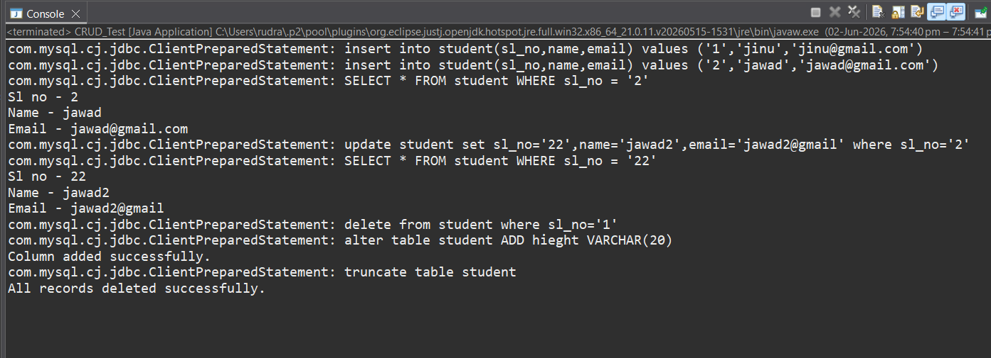

MongoDB Connection:
package mongodb2;

import com.mongodb.MongoClient;
import com.mongodb.client.MongoDatabase;

public class Test1 {

public static void main(String[] args) {

MongoClient mongoClient =
new MongoClient("localhost", 27017);

MongoDatabase database =
mongoClient.getDatabase("student_db");

System.out.println("Connected Successfully");
System.out.println(database.getName());
}
}
