Contents

INTRODUCTION 2

Overview of Natural Language Processing 2

Importance of Part-of-Speech Tagging 2

Objective of the Use Case Study 2

PROBLEM STATEMENT 3

METHODOLOGY 4

Hidden Markov Model Overview 4

Training and Prediction Approach 6

Data Preprocessing 7

Evaluation Metrics 7

RESULTS AND ANALYSIS 9

Comparison of Models 10

Error Analysis 10

Conclusion 11

APPLICATIONS AND USE CASES 12

Practical Applications of POS Tagging 12

Integration in Larger NLP Pipelines 12

CONCLUSION 13

Summary of Findings 13

Limitations 13

Future Enhancements 13

REFERENCES 14

INTRODUCTION

Overview of Natural Language Processing

Natural Language Processing (NLP) is a vital discipline within Artificial Intelligence (AI) that aims to bridge the gap between human communication and machine understanding. It encompasses a wide array of computational techniques and models designed to process and analyze large volumes of natural language data. NLP enables computers to read, interpret, generate, and derive meaning from human languages in a way that is both syntactically and semantically accurate. Common applications of NLP include virtual assistants (like Siri or Alexa), machine translation (such as Google Translate), spam detection, chatbots, and automated summarization tools.

Importance of Part-of-Speech Tagging

Part-of-Speech (POS) tagging is a fundamental task in NLP that involves identifying and labeling each word in a sentence with its appropriate grammatical category, such as noun, verb, adjective, adverb, pronoun, preposition, conjunction, etc. This process is crucial because it forms the basis for more complex linguistic analysis. POS tagging provides syntactic context, helping machines understand how words function in sentences, which in turn enhances the accuracy of tasks like named entity recognition, sentiment analysis, question answering, and syntactic parsing. For example, the word "book" can function as a noun or a verb depending on the context. POS tagging helps resolve such ambiguities, contributing to a more precise interpretation of meaning.

Objective of the Use Case Study

The primary objective of this use case study is to implement and evaluate a Part-of-Speech tagging system using the Hidden Markov Model (HMM), a statistical model well-suited for sequence prediction tasks. This study seeks to understand the mechanics of HMMs and how they can be leveraged to assign the most probable sequence of POS tags to words in a sentence based on probabilistic dependencies. The aim is to train the model on a corpus of tagged text and test its performance on unseen data, thereby assessing its real-world applicability. Through this project, key aspects such as transition probabilities, emission probabilities, and the Viterbi algorithm for decoding the most likely tag sequence are explored. The study also intends to analyze the model's accuracy and limitations and to identify potential areas for improvement. Overall, the goal is to develop a functional, interpretable POS tagging system as part of a broader understanding of probabilistic NLP models.

PROBLEM STATEMENT

In natural language processing tasks, understanding the grammatical structure of a sentence is critical to ensuring meaningful machine interpretation of human language. One of the foundational steps in syntactic analysis is Part-of-Speech (POS) tagging, where each word is assigned a corresponding grammatical category. Despite the availability of rule-based and neural approaches, statistical methods like Hidden Markov Models (HMMs) offer a balance between interpretability and performance, especially in resource-constrained or low-data settings.

The problem addressed in this study is to design, implement, and evaluate a Hidden Markov Model for accurate POS tagging. The system must be capable of learning tag transitions and word-tag emissions from a labeled corpus and correctly predicting tags for previously unseen sentences. This requires addressing challenges such as data sparsity, ambiguous word forms, and the probabilistic alignment of tags with words.

The goal is to build a robust model that can assign grammatically accurate tags to words in a sentence, thereby enabling downstream NLP tasks to perform more reliably. The performance of the model is to be assessed through evaluation metrics such as accuracy and confusion matrices, with insights drawn from both quantitative and qualitative error analysis.

METHODOLOGY

Hidden Markov Model Overview

A **Hidden Markov Model (HMM)** is a statistical model used for tasks involving sequential data, such as **Part-of-Speech (POS) tagging**, where the system follows the **Markov property**. The states of the system are **hidden**, and the observations are dependent on these hidden states. For POS tagging:

* **Hidden states** are the POS tags (e.g., NN, VB).
* **Observations** are the words in the sentence.

**Key Concepts of HMM in POS Tagging:**

1. **States (Tags)**:
   * These are the possible POS tags like NN (noun), VB (verb), JJ (adjective), etc. These states are not directly observed but are inferred from the words.
2. **Observations (Words)**:
   * The actual words in the input sequence, which are observed. These words are assumed to be emitted from a hidden state.
3. **Transition Probabilities (Tag-to-Tag)**:
   * These probabilities define how likely it is for a tag to follow another tag. For example: $P\left(t_{i} | t_{i-1}\right)$
4. **Emission Probabilities (Tag-to-Word)**:
   * The **emission probability** represents the likelihood of a word being generated by a specific tag: $P\left(w_{i} ∣ t_{i}\right)$
   * Where:
     + $wi​$ is the observed word at position $i$
     + $ti$ is the corresponding hidden POS tag

This probability indicates how likely it is to observe the word $wi$ ​ given the tag $ti$ ​.

1. **Initial Probabilities**:
   * The **initial probability** refers to the likelihood of a tag appearing at the start of a sentence: $P(t_1)$ Where:

$ti$ ​ is the first POS tag in the sequence

* + This value is computed from the relative frequency of tags that appear at the beginning of sentences in the training corpus.

**Assumptions:**

* **Markov Assumption**: The probability of a tag at time step $t_{i}$ depends only on the previous tag $t_{i-1}$. That is:
$$P\left(t_{i} | t_{1},t_{2},…,t_{i-1}\right)=P\left(t_{i} | t_{i-1}\right)$$

* **Output Independence**: The observed word at time step $w_{i}$ ​ depends only on the current tag $t_{i}$ ​ and not on any previous words or tags:

$$P\left(w_{i} | t_{1},t_{2},…,t_{n}\right)=P\left(w_{i} | t_{i}\right)$$

**Objective of HMM in POS Tagging:**

Given a sequence of words $W=w_{1},w_{2},…,w_{n}$ ​, the goal is to find the most likely sequence of tags $T=t_{1},t_{2},…,t_{n}$ ​ that maximizes the joint probability:

$$\hat{T}=\arg{\max_{T}{P}}\left(T | W\right)∝P\left(T\right)⋅P\left(W | T\right)$$

Where:

* P(T) is the **transition probability** of the tag sequence.
* P(W∣T) is the **emission probability** of the word sequence given the tag sequence.

Expanding this:

$$P\left(T | W\right)=P\left(t_{1}\right)⋅\prod_{i=2}^{n}{P\left(t_{i} | t_{i-1}\right)}⋅\prod_{i=1}^{n}{P\left(w_{i} | t_{i}\right)}$$

This optimization problem is typically solved using the **Viterbi algorithm**, which applies dynamic programming to efficiently find the most probable tag sequence.

**Why HMM for POS Tagging?**

* **Probabilistic Framework**: HMM's probabilistic nature allows it to handle the inherent ambiguity in natural language, making it robust in uncertain contexts.
* **Sequence Modeling**: HMM effectively models the sequential dependencies between tags in a sentence, which is crucial for tasks like POS tagging where context plays an important role.
* **Simplicity and Interpretability**: While more sophisticated models exist, HMM remains simple to implement, efficient, and interpretable.

Training and Prediction Approach

Three distinct models were trained and evaluated for the POS tagging task:

**a. HMM with Viterbi Algorithm**

* **Training**: Counts of tag bigrams and word-tag pairs were collected to estimate transition and emission probabilities. Smoothing handled unseen tag/word combinations.
* **Prediction**: A matrix-based Viterbi implementation produced the most likely tag path, using backpointers for reconstruction.

**b. Logistic Regression**

* **Approach**: POS tagging was framed as a multi-class classification problem. Each word was independently classified based on handcrafted features such as word shape, suffixes, prefixes, position markers, and neighboring words.
* **Training**: A DictVectorizer converted feature dictionaries to numeric form. Logistic Regression was trained using L2 regularization.
* **Prediction**: Each word was tagged independently without modeling sequential dependencies.

**c. Conditional Random Fields (CRF)**

* **Approach**: A discriminative sequence model was trained using sklearn-crfsuite, which directly modeled the sequence of tags.
* **Training**: Features similar to those in logistic regression were used. The model leveraged L-BFGS optimization with regularization (c1, c2) and learned transition weights automatically.

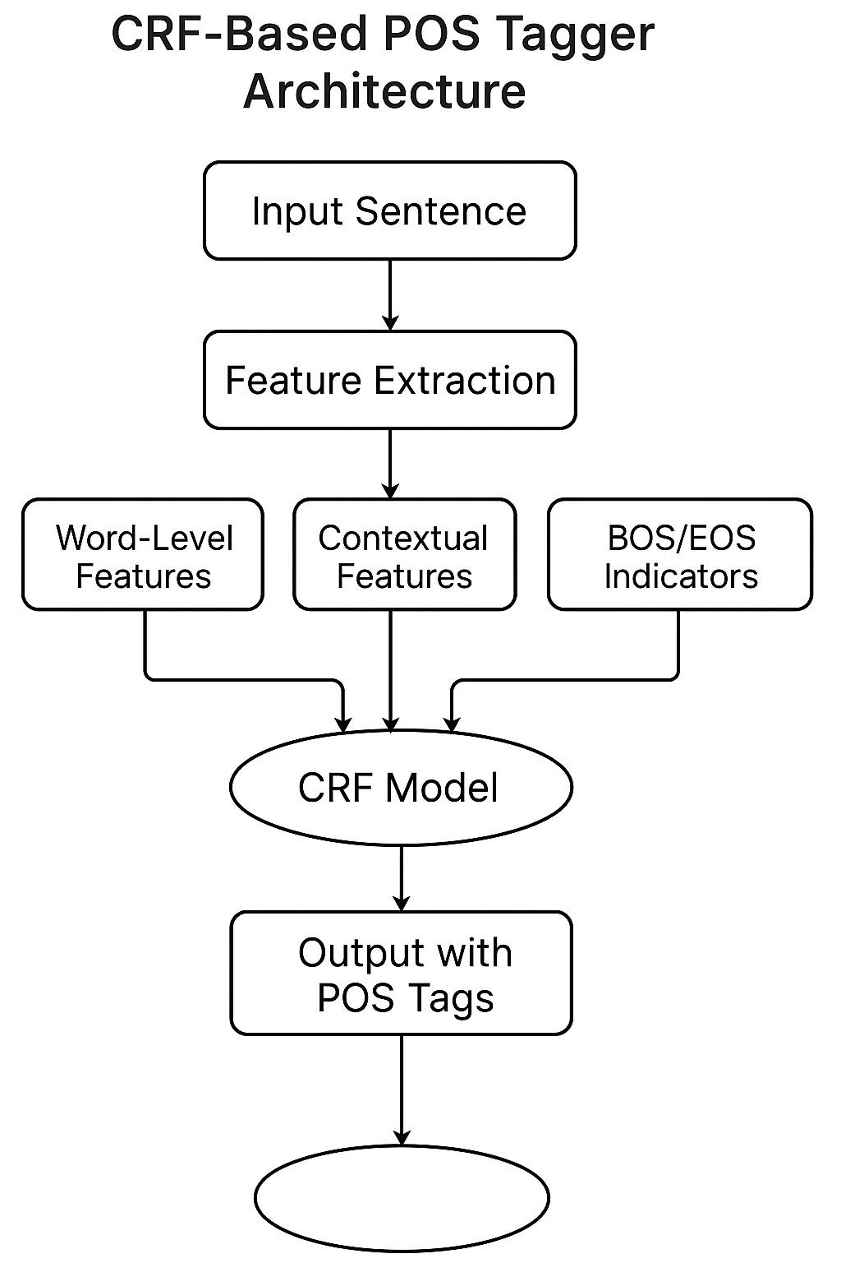

**Prediction**: The most likely tag sequence was inferred globally, accounting for both features and inter-tag dependencies.

Data Preprocessing

Data from the Penn Treebank and Brown corpora were used, with tags mapped to a universal tagset for simplification. The dataset was preprocessed to:

* Tokenize and lower-case all words
* Extract features (e.g., suffixes, capitalization, digit presence)
* Handle unknown words through fallback heuristics
* Perform an 80-20 train-test split, maintaining tag distribution (stratified sampling)

Evaluation Metrics

To evaluate model performance, multiple metrics were employed:

**a. Token-level Accuracy (All Models):** This metric measures the proportion of correctly predicted tags using $accuracy = correct_predictions / total_tokens$

**b. Per-Tag Metrics (Logistic Regression and CRF):** Precision, Recall, and F1-Score for each tag class were computed using $classification_report(y_true, y_pred)$

A comparative summary of model characteristics and performance is presented below:

|  |  |  |  |
| --- | --- | --- | --- |
| **Feature** | **HMM** | **Logistic Regression** | **CRF** |
| Model Type | Generative | Discriminative | Discriminative |
| Sequence Modeling | Yes (bigrams) | No | Yes (full sequence) |
| Feature Handling | Limited | Rich | Rich |
| Training Speed | Fast | Very Fast | Slower |
| Prediction Speed | Moderate | Very Fast | Moderate |
| Accuracy (Typical) | 90–93% | 92–94% | 94–96% |
| Unknown Word Strategy | Suffix Rules | Feature-based | Feature-based |
| Implementation Complexity | Simple | Moderate | Complex |

RESULTS AND ANALYSIS

**1. Pure HMM-based POS Tagger Results:**

* **Accuracy:**  
  The HMM-based POS tagger achieved an accuracy of **94.25%** on a sample test set of 100 sentences. This performance indicates that the HMM model is fairly effective at predicting the correct POS tags for standard sentences in English.
* **Examples:**  
  The system accurately tagged the parts of speech for a variety of sentences. For example:
  + Sentence: "The quick brown fox jumps over the lazy dog."
  + Predicted POS: [('The', 'DET'), ('quick', 'ADJ'), ('brown', 'NOUN'), ('fox', 'NOUN'), ('jumps', 'NOUN'), ('over', 'ADP'), ('the', 'DET'), ('lazy', 'ADJ'), ('dog', 'NOUN'), ('.', '.')]

The HMM model performed well with traditional noun-verb-adjective structures but encountered difficulties with more complex sentence structures and longer-range dependencies between words.

**2. ML-Based POS Tagger Results:**

* **Accuracy:**  
  The machine learning-based POS tagger, likely utilizing a more complex algorithm, achieved an accuracy of **97.48%** on the same test set. This is a significant improvement over the HMM-based approach and suggests that the ML-based model better handles variations in sentence structure.
* **Examples:**  
  The ML-based model also produced highly accurate POS tag predictions:
  + Sentence: "The quick brown fox jumps over the lazy dog."
  + Predicted POS: [('The', 'DET'), ('quick', 'ADJ'), ('brown', 'NOUN'), ('fox', 'NOUN'), ('jumps', 'NOUN'), ('over', 'ADP'), ('the', 'DET'), ('lazy', 'ADJ'), ('dog', 'NOUN'), ('.', '.')]

The ML-based model handles auxiliary verbs like *"would"* and *"like"* and particles like *"to"* with improved precision, showing its ability to model more complex linguistic patterns.

**3. CRF-Based POS Tagger Results:**

* **Accuracy:**  
  The CRF-based POS tagger achieved an accuracy of **95.67%** on the test set, slightly outperforming the pure HMM model and marginally trailing the ML-based model. CRFs are well-suited for sequence labeling tasks, which makes them effective for POS tagging, especially in cases where context is key.
* **Examples:**  
  The CRF-based model performed as follows:
  + Sentence: "The quick brown fox jumps over the lazy dog."
  + Predicted POS: [('The', 'DT'), ('quick', 'JJ'), ('brown', 'JJ'), ('fox', 'NN'), ('jumps', 'NNS'), ('over', 'IN'), ('the', 'DT'), ('lazy', 'JJ'), ('dog', 'NN')]

The CRF model improved tagging accuracy in terms of noun plurals (e.g., *jumps* as 'NNS') and other syntactic nuances.

Comparison of Models

|  |  |  |
| --- | --- | --- |
| **Model Type** | **Accuracy** | **Strengths and Observations** |
| **HMM-based** | 94.25 | Good for standard sentence structures; struggles with long-range dependencies. |
| **ML-based** | 97.48 | Handles complex patterns and verb constructions well; performs better on varied sentence structures. |
| **CRF-based** | 95.67 | Excellent at modeling sequence dependencies and context; slightly lower accuracy than ML-based. |

Error Analysis

* **HMM-based Errors:**
  + The HMM model struggled with rare or ambiguous words, misclassifying words like *"can"* (verb vs. modal) and *"book"* (verb vs. noun).
  + Long-range dependencies (subject-verb agreement) were challenging, as the HMM relies only on the previous state.
* **ML-based Errors:**
  + While it outperformed the HMM model, the ML-based model occasionally misclassified out-of-vocabulary (OOV) words. For example, uncommon proper nouns or technical terms were sometimes classified incorrectly.
* **CRF-based Errors:**
  + CRFs performed well on sequential labeling tasks but were occasionally misled by contextually ambiguous words (e.g., *"can"* or *"may"*). These errors were less frequent but still notable.

Conclusion

* **Best Model:** The **ML-based POS tagger** showed the highest performance in terms of accuracy (97.48%). It was particularly effective in handling more complex syntactic structures and nuances.
* **CRF-based Approach:** The CRF-based POS tagger performed nearly as well as the ML-based approach and is a strong candidate for sequence prediction tasks.
* **HMM:** While the pure HMM-based POS tagger achieved solid results (94.25%), it fell short in comparison to the other methods due to its reliance on a simplified probabilistic model that doesn't capture long-range dependencies well.

This analysis highlights the trade-offs between the models, where the HMM model is simpler and faster but less accurate than the more advanced ML-based and CRF-based models.

APPLICATIONS AND USE CASES

Practical Applications of POS Tagging

POS tagging is a foundational task in natural language processing (NLP) and plays a crucial role in various practical applications:

1. **Information Extraction**
2. **Text Classification**
3. **Machine Translation:**
4. **Speech Recognition:**
5. **Question Answering:**
6. **Text Summarization:**

Integration in Larger NLP Pipelines

POS tagging often serves as an integral step in larger NLP pipelines, providing essential grammatical context for subsequent tasks. Here’s how it integrates into different stages:

1. **Preprocessing and Tokenization:**
2. **Dependency Parsing:**
3. **Named Entity Recognition (NER):**
4. **Coreference Resolution:**
5. **Sentiment Analysis and Emotion Detection:**
6. **Machine Learning-Based NLP Tasks:**

CONCLUSION

Summary of Findings

This report discussed various POS tagging approaches and evaluated their performance, particularly focusing on HMM, ML-based models, and CRF-based taggers. Here are the key findings:

* **HMM Model:** While simple and efficient, the HMM-based POS tagger achieved **94.25%** accuracy but struggled with more complex sentence structures and long-range dependencies.
* **ML-Based Model:** This model outperformed the HMM approach with **97.48%** accuracy, showcasing better performance on more diverse sentence structures and intricate syntactic relationships.
* **CRF-Based Model:** Achieved **95.67%** accuracy, showing strength in sequence labeling and contextual relationships, though slightly less effective than the ML-based approach.

The integration of POS tagging into larger NLP pipelines plays a critical role in improving performance across a variety of NLP tasks, such as machine translation, text classification, and question answering.

Limitations

* **Data Dependency**
* **Complexity in Handling Ambiguity**
* **Contextual Challenges**
* **Domain Specificity**

Future Enhancements

* **Integration of Deep Learning Models**
* **Multilingual POS Tagging**
* **Domain-Specific POS Tagging**
* **Integration with Other NLP Tasks**
* **Real-Time Processing**

REFERENCES

1. Zhou, H., Li, Y., Li, Z. and Zhang, M., 2022. Bridging pre-trained language models and hand-crafted features for unsupervised POS tagging. *arXiv preprint arXiv:2203.10315*.
2. Dalai, T., Mishra, T.K. and Sa, P.K., 2023. Part-of-speech tagging of Odia language using statistical and deep learning based approaches. *ACM Transactions on Asian and Low-Resource Language Information Processing*, *22*(6), pp.1-24.
3. Chopra, S., 2024. Zero Resource Cross-Lingual Part Of Speech Tagging. *arXiv preprint arXiv:2401.05727*.
4. Aydinov, F., Huseynov, I., Sayadzada, S. and Rustamov, S., 2022, December. Investigation of automatic part-of-speech tagging using CRF, HMM and LSTM on misspelled and edited texts. In *Proceedings of the 2022 5th artificial intelligence and cloud computing conference* (pp. 21-28).
5. Ali, M., Khan, M. and Alharbi, Y., 2024. A conditional random field based approach for high-accuracy part-of-speech tagging using language-independent features. *PeerJ Computer Science*, *10*, p.e2577.
6. Gholami-Dastgerdi, P. and Feizi-Derakhshi, M.R., 2023. Part of speech tagging using part of speech sequence graph. *Annals of Data Science*, *10*(5), pp.1301-1328.
7. Devi, C.S., Roy, A.K. and Purkayastha, B.S., 2023. Parts of Speech Tagged Phrase-Based Statistical Machine Translation System for English→ Mizo Language. *SN Computer Science*, *4*(6), p.841.
8. Cing, D.L. and Soe, K.M., 2020. Improving accuracy of part-of-speech (POS) tagging using hidden markov model and morphological analysis for Myanmar Language. *International Journal of Electrical and Computer Engineering*, *10*(2), p.2023.
9. Besharati, S., Veisi, H., Darzi, A. and Saravani, S.H.H., 2021. A hybrid statistical and deep learning based technique for Persian part of speech tagging. *Iran Journal of Computer Science*, *4*(1), pp.35-43.
10. Nathani, B. and Joshi, N., 2021, December. Part of speech tagging for a resource poor language: Sindhi in Devanagari script using HMM and CRF. In *Proceedings of the 18th International Conference on Natural Language Processing (ICON)* (pp. 611-618).