RELIABILITY CONDITIONED HERB DRUG INTERACTION PREDICTION
PROJECT REPORT
CSI4004
TEXT MINING
ADITI SHARMA - 23MID0022


Under the guidance of
Prof. Arti Tiwari
School of Computer Science and Engineering
Vellore Institute of Technology, Vellore
OCTOBER 2026

PROJECT OVERVIEW
This project implements an evidence-linked herb-drug interaction research screening system. Its molecular component predicts compound inhibition potency from chemical structure; its evidence component retrieves study-specific human pharmacokinetic findings. Keeping those outputs separate makes their provenance, supported mechanisms and limits visible to an investigator.
Interaction research can be affected by outcome leakage, repeated citations and differences between experimental contexts. These are methodological risks to audit in a particular dataset and prediction task, not established defects of every published interaction model. The implemented workflow excludes publication text and entity names from molecular features, separates evaluation roles and records source provenance.
The offline workflow starts from 18,833 official ChEMBL 37 assay records. Screening retains 15,213 measurements; document-balanced aggregation produces 13,242 structure-target samples for the scaffold experiment. Models estimate pIC₅₀ across CYP3A4, CYP2C9, CYP2C19, CYP2D6, CYP1A2 and ABCB1. Scaffold and publication separation are evaluated in distinct experiments: the scaffold experiment may share source documents, while the publication experiment purges cross-role structures [18].
The online workflow connects a selected botanical to a sourced constituent where available, filters assay estimates through cited drug pathways and retrieves a small catalog of human PK findings. It does not estimate drug clearance fractions or infer human exposure from a compound IC₅₀. Publication/endpoint deduplication, preparation-context checks and an induction-inhibition guard support an auditable explanation. Clinical prediction remains unavailable; fixed abstention is displayed independently of the assay intervals.

ABSTRACT
Herb-drug interaction research requires a distinction between molecular activity and effects observed in humans. This project implements an evidence-linked screening system combining structure-based assay prediction with traceable human pharmacokinetic findings.
From 18,833 official ChEMBL 37 records, screening retains 15,213 measurements and aggregation yields 13,242 structure-target samples for scaffold evaluation. Morgan fingerprints support four regression comparisons across five CYP enzymes and the ABCB1 transporter. Separate training, validation, interval-calibration and test roles prevent their labels from being reused across fitting stages. Selected models achieve pooled scaffold-test MAE 0.4974 pIC₅₀, RMSE 0.6521 and R² 0.3440 over 2,116 samples. Publication-separated evaluation yields MAE 0.6613 over 2,076 samples. Nominal 90% split-conformal intervals have observed coverage of 87.4%-95.5% on scaffold targets and 79.4%-95.8% on publication-held-out targets; coverage under chemical or source shift is not guaranteed.
The Streamlit demonstration adds sourced constituent structures, study-specific human findings, publication deduplication, mechanism/context checks and downloadable reports. Independent metric recomputation and focused software tests verify engineering behavior. The contribution is an auditable assay-modeling and research-screening workflow, not a validated clinical predictor. Independent clinical labels, preparation-specific exposure information and a separately reviewed evaluation protocol remain necessary for the original clinical objective.
Keywords: herb-drug interactions; molecular fingerprints; ChEMBL; pharmacokinetics; conformal prediction; evidence provenance.

TABLE OF CONTENTS
Project Overview i
Abstract ii
List Of Figures v
List Of Tables vi
List Of Abbreviations vii
Chapter 1: Introduction 1
1.1 Background and motivation 1
1.2 Problem statement 1
1.3 Objectives 2
1.4 Scope and contributions 2
1.5 Organisation of the report 3
Chapter 2: Literature Review 4
2.1 Related research and existing systems 4
2.2 Comparative analysis 4
2.3 Research or implementation gap 5
Chapter 3: Requirements And Methodology 6
3.1 System requirements and assumptions 6
3.2 Dataset, materials, software and hardware 6
3.3 Proposed architecture and workflow 8
3.4 Algorithms and implementation strategy 9
3.5 Evaluation metrics 11
Chapter 4: Implementation And Experiments 12
4.1 Implementation details 12
4.2 Experimental setup 12
4.3 Test cases and validation protocol 14
4.4 Reproducibility details 14
Chapter 5: Results And Discussion 15
5.1 Quantitative and qualitative results 15
5.2 Comparison with baselines 17
5.3 Discussion and limitations 17
Chapter 6: Conclusion And Future Work 18
6.1 Conclusions and achievements 18
6.2 Limitations 18
6.3 Future scope 19
References 9
Appendix A: Supporting Material 22
A.1 Reproduction commands 22
A.2 Demonstration walkthrough sequence 22
A.3 Artifact and evidence trace 23
A.4 Interpretation of the exposure sensitivity control 24

LIST OF FIGURES
Figure 1 Data roles and current evidence availability 7
Figure 2 Implemented assay modeling and evidence linked screening architecture 8
Figure 3 Compound assay engine and supported target panel 9
Figure 4 Selected model test MAE by target and evaluation regime 16
Figure 5 Observed assay interval coverage against nominal coverage 16

LIST OF TABLES
Table 1: Dataset preparation counts 13
Table 2: Model and calibration settings 13
Table 3: Sample counts by evaluation role 14
Table 4: Behavioral verification cases 14
Table 5: Scaffold holdout selected model results 15
Table 6: Publication holdout selected model results 15
Table 7: Fixed model pooled test MAE 17

LIST OF ABBREVIATIONS
ABCB1 - ATP-binding cassette subfamily B member 1 (P-glycoprotein)
ADMET - Absorption, Distribution, Metabolism, Excretion, and Toxicity
API - Application Programming Interface
AUC - Area Under the Plasma Concentration-Time Curve
ChEMBL - Chemical Database of the European Molecular Biology Laboratory
C_{max} - Maximum Observed Plasma Concentration
CYP - Cytochrome P450 Monooxygenase Enzyme Superfamily
DAG - Directed Acyclic Graph
DDI - Drug-Drug Interaction
ECFP - Extended-Connectivity Fingerprint
FDA - Food and Drug Administration (United States)
GNN - Graph Neural Network
HDI - Herb-Drug Interaction
IC₅₀ - Half-Maximal Inhibitory Concentration
Ki - Inhibition constant
MAD - Median Absolute Deviation
MAE - Mean Absolute Error
NCCIH - National Center for Complementary and Integrative Health
P-gp - P-glycoprotein (efflux membrane transporter encoded by ABCB1)
pIC₅₀ - Negative base-10 logarithm of IC₅₀ expressed relative to 1 mol/L
PK - Pharmacokinetics
PMID - PubMed Identifier
PXR - Pregnane X Receptor (nuclear receptor driving CYP3A4 transcriptional induction)
QSAR - Quantitative Structure-Activity Relationship
RDKit - Open-Source Cheminformatics and Machine Learning Toolkit
RMSE - Root Mean Squared Error
SMILES - Simplified Molecular-Input Line-Entry System
UniProt - Universal Protein Resource

CHAPTER 1: INTRODUCTION

1.1 Background and motivation
Botanical preparations and pharmaceutical drugs may be used together, creating a need to assess possible interactions. Products vary in constituent content, dose and formulation, so a botanical name alone does not specify a reproducible chemical exposure. NIH resources describe both documented interactions and substantial gaps in the available evidence [11], [12].
Botanicals contain mixtures of chemical constituents. Some constituents can affect enzymes or transporters involved in drug disposition, including CYP enzymes and P-glycoprotein. The present assay experiment focuses on five CYP enzymes and ABCB1; this is a declared research panel, not a complete inventory of all interaction mechanisms [5].
Inhibition and induction can affect drug disposition in different directions, depending on the drug and pathway. Hyperforin-associated PXR activation and CYP3A4 induction provide a relevant example [7]. The demonstration catalog separately records observed digoxin and cyclosporine exposure changes in specified human study conditions [8]-[10]. An inhibition-only model cannot infer induction or predict transplant rejection.
Clinical interpretation requires original study context, preparation details and appropriate pharmacokinetic information. The project therefore connects assay estimates to cited evidence while preserving missing data and unresolved clinical conclusions. Its immediate purpose is research screening, rather than a recommendation to start, stop or combine treatments.

1.2 Problem statement
The project addresses two related computational questions, evaluated at different evidentiary levels:
1. Molecular assay estimation: Given a constituent structure, estimate reported inhibition pIC₅₀ for the six assay targets and assess error on held-out scaffold and publication groups.
2. Evidence-linked research screening: Given a botanical-drug pair and preparation context, retrieve matching human study findings, remove repeated publication records, explain mechanism or context mismatches and expose missing requirements without manufacturing a clinical verdict.
The key methodological requirement is to avoid conflating a reported study finding, a compound assay endpoint and an independently established clinical outcome. Literature relation extraction can legitimately identify what an article reports; it does not automatically estimate an interaction in a previously unstudied clinical setting. Our assay model and human-evidence interface are therefore evaluated and described separately.

1.3 Objectives
The project has six implementation and evaluation objectives:
1. Verify official assay inputs: Preserve source queries, raw captures and integrity hashes for the ChEMBL release, and document the transition from downloaded records to screened, aggregated samples.
2. Compare target-specific regressors: Use the same molecular fingerprints and assigned roles for a training-median baseline, ridge regression, ExtraTrees and an exploratory repeat-consistency-weighted ExtraTrees variant.
3. Audit grouped evaluation: Enforce the required structure/scaffold or structure/publication separation, record allowed overlaps and source-split purges, and report both evaluation regimes.
4. Assess assay uncertainty: Construct split-conformal intervals on a separate calibration role and measure held-out coverage. State the exchangeability assumption and the limits imposed by domain shift.
5. Preserve evidence provenance: Deduplicate publication/endpoint records in the active demonstration, reject inconsistent duplicate extractions and expose preparation and mechanism gaps. Citation-lineage DAG modules elsewhere in the repository are not active in this screening path.
6. Provide an interactive research dashboard: Run constituent assay inference, display cited human findings and mechanism/context gaps, and export the explanation while keeping the clinical verdict unavailable.

1.4 Scope and contributions
The implemented scope of this project encompasses:
• Compound assay prediction for five CYP enzymes and ABCB1 using 13,242 scaffold-experiment structure-target samples.
• Demonstration queries covering St. John’s wort, turmeric and Echinacea with cyclosporine and digoxin; catalog coverage is incomplete.
• A demonstration catalog containing four pair-specific records from three human publications, checked at abstract level with independent dual review pending.
• Engineering verification: Focused software checks and independent recomputation establish reproducible assay results and auditable screening behavior.
The primary scientific and engineering contributions include:
1. Three-tier reliability framework: Molecular assay measurements, published human findings and independent clinical reference labels occupy distinct data roles. This formulation controls a defined route for outcome leakage and keeps the evidentiary basis of each output explicit.
2. Repeat-consistency ablation: An inverse-MAD training weight evaluates how agreement among repeated assay measurements affects model performance, with comparisons against unweighted ensembles and linear baselines.
3. Mechanism and context checks: An explicit induction flag prevents interpreting an inhibition estimate as an induction prediction. A context selector identifies differences from the cited preparation setting.
4. Auditable research outputs: Study citations, assay intervals, molecular similarity, training-compound status and evidence requirements accompany every screening explanation. Clinical prediction abstention is a deliberate safety feature that prevents unsupported medical conclusions.

1.5 Organisation of the report
Chapter 2 reviews molecular representations, interaction models, biomedical language models and their differing endpoints. Chapter 3 defines data roles, requirements, architecture, algorithms and metrics. Chapter 4 documents the implementation, settings, verification and reproduction. Chapter 5 presents measured results and limitations, and Chapter 6 describes achievements and future clinical work. Appendix A provides executable commands and a demonstration sequence.

CHAPTER 2: LITERATURE REVIEW

2.1 Related research and existing systems
Structure-activity modeling relates molecular representations to measured endpoints. Scalar descriptors and molecular fingerprints encode different aspects of a compound, while molecular graph models learn representations from atoms and bonds. A two-dimensional fingerprint does not directly represent full three-dimensional conformation, exposure or clinical context. These distinctions guide the deliberately bounded endpoint of this experiment.
Extended-connectivity fingerprints describe circular atom environments for structure-activity modeling [2]. The implementation uses RDKit Morgan fingerprints with radius two and 2,048 bits [3]. It ignores chirality after canonical parent grouping. This is an efficient fixed representation, not a dense three-dimensional pharmacophore or a guarantee of biological generalization.
DeepDDI uses structural information to predict drug-drug and drug-food interaction types [13]. Decagon uses a multimodal graph and relational graph convolution to model polypharmacy side effects [14]. CASTER combines substructure pattern mining, an autoencoder and dictionary learning for interaction prediction [15]. These are relevant representation-learning precedents, but their categorical outcomes differ from the continuous assay endpoint evaluated here.
BioBERT adapts biomedical language representations for text-mining tasks [16], while domain-specific pretraining supports biomedical language understanding in PubMedBERT [17]. Such methods can support future evidence extraction, but they are not components of the active molecular inference path. Their published task results should not be compared directly with our pIC₅₀ regression errors.

2.2 Comparative analysis
The comparison concerns task definition, input information and evaluation design rather than a universal ranking of published systems. No external interaction model was retrained on our assay dataset, so there is no empirical head-to-head superiority claim.
Structure-based interaction models operate on molecular representations; botanical screening additionally requires preparation and constituent information. Drug-food work such as DeepDDI demonstrates that prior research is not restricted to synthetic drug pairs [13]. Our implementation makes the constituent mapping explicit and retains uncertainty about the whole preparation rather than treating a herb name as a measured molecular dose.
Relation extraction identifies statements in text, whereas prospective interaction prediction seeks an outcome outside those statements. A leakage audit must consider the intended task and whether outcomes or assessment entities reach model inputs. It is not justified to label all biomedical language models as leaky. Our main assay features contain neither publication prose nor reported clinical outcomes.
Repeated publications or extractions can overstate evidence if they are counted without source relationships. The demonstration removes exact publication/endpoint duplicates, but does not infer the full citation graph, establish cohort independence or discount every review echo. Those broader evidence-lineage questions remain separate research work.

2.3 Research or implementation gap
Three implementation requirements motivate the current system:
1. Outcome separation: Molecular activity measurements, individual study findings and clinical reference labels must remain distinct. We train only on the compound assay endpoint, and do not claim an independently adjudicated clinical benchmark is available.
2. Evidence traceability: Retain publication identifiers, study context and extraction status. The active screen deduplicates catalog records; a complete source-lineage model would require validated citation and shared-cohort relationships. No claim of being the first system to address citation dependencies is made.
3. Mechanism compatibility: Inhibition, induction and transporter effects are not interchangeable. An estimate of inhibition potency alone cannot explain all observed drug-exposure changes. The interface flags the unsupported inference rather than converting it into a patient-level risk score.

CHAPTER 3: REQUIREMENTS AND METHODOLOGY

3.1 System requirements and assumptions
The architecture of the evidence-linked herb-drug interaction research system is designed to adhere to strict engineering standards of modularity, deterministic reproducibility, and scientific transparency. The system requirements and computational assumptions are formalized as follows:
1. Computing requirements: The assay models use CPU-based regression and can run without a GPU. The executed experiments did not establish minimum RAM, storage, latency or throughput requirements. Hardware limits should therefore be measured for a deployment rather than asserted as validated specifications.
2. Software stack: Recorded experiment versions are Python 3.11.16, RDKit 2026.03.5, scikit-learn 1.9.0, NumPy 1.26.4 and pandas 3.0.5. Joblib stores fitted bundles and Streamlit renders the interface. The assay requirements file supports environment setup; the recorded versions are the reference for reproduction [18].
3. Scientific assumptions: The fitted endpoint is the reported, screened IC₅₀-derived log potency. IC₅₀ depends on assay conditions and is not automatically an equilibrium binding constant. Fingerprint models approximate the available structure-activity relationships. Grouped holdouts assess particular generalization settings; they do not establish causal clinical effects or guarantee distribution-free coverage under shift.

3.2 Dataset, materials, software and hardware
The project formulates a three-tier reliability framework separating molecular assay measurements, published human findings and independently adjudicated clinical reference labels. Each tier has an explicit role and review status, as shown in Figure 1. This design makes outcome provenance and the requirements for downstream clinical evaluation auditable.
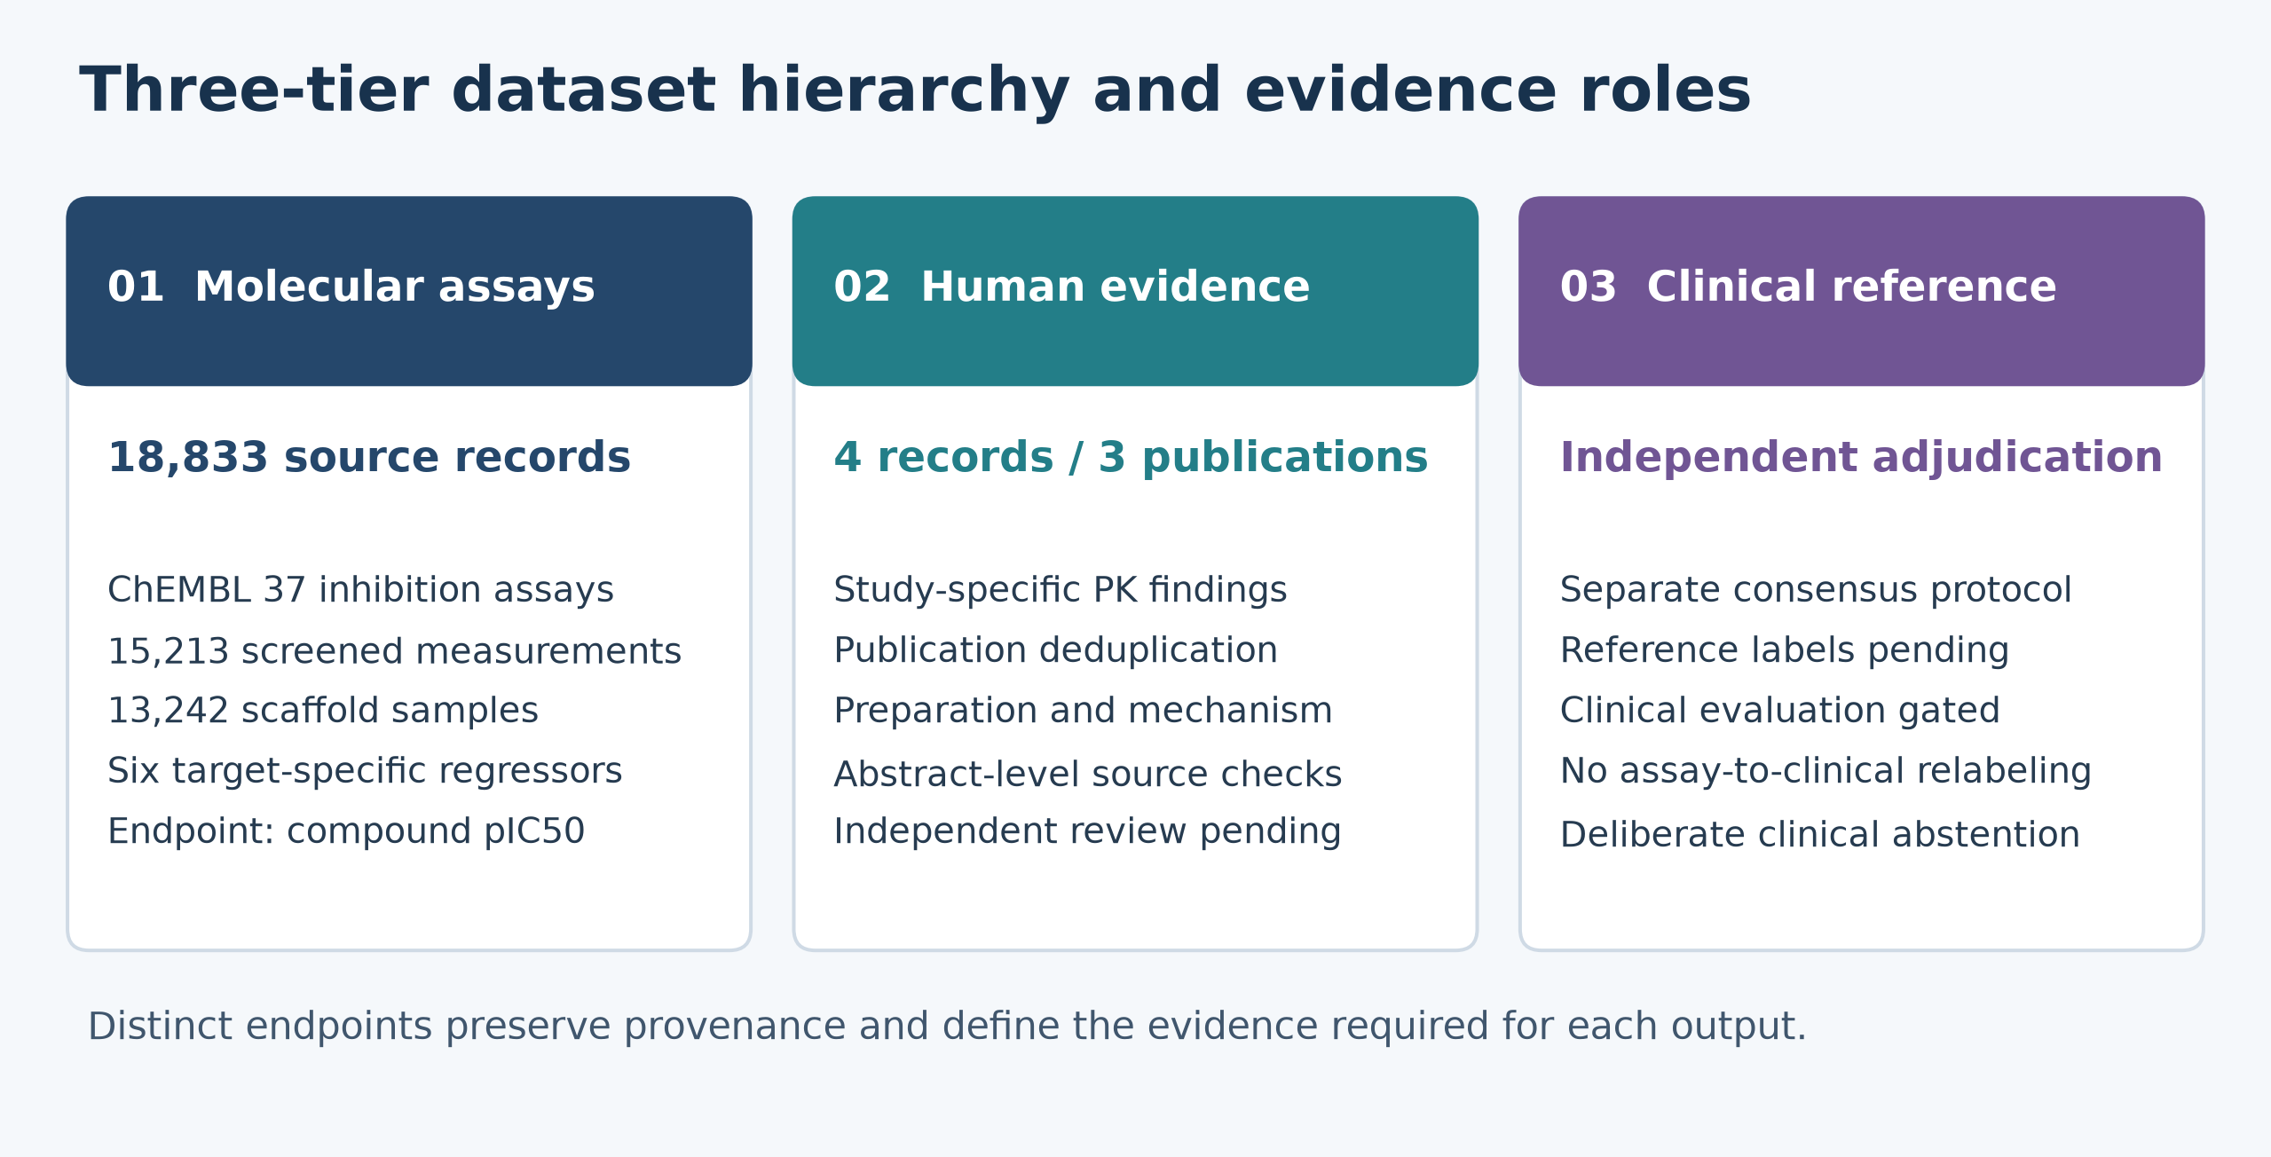
Figure 1 Data roles and current evidence availability
The three data roles are:
• Human study findings: The active demonstration uses four pair-specific records from three PubMed publications [8]-[10]. The historical table contains 141 rows and 140 source identifiers over 120 pairs, but a prior source audit found serious mapping problems. It is not treated as 140 authenticated, independent clinical publications and is not the demonstration's clinical ground truth.
• Compound assay measurements: The official ChEMBL 37 capture contains 18,833 records, 10,554 compound identifiers and 2,036 document identifiers. After structural screening, the modeling screen retains 15,213 measurements. The scaffold run aggregates them to 13,242 structure-target samples over 8,724 canonical structures. Target-assignment confidence does not establish clinical reliability [18].
• Independent clinical reference tier: The annotation protocol and preparation tools define a separate adjudication stage. The current consensus CSV contains zero decisions, so the system deliberately withholds clinical Task A/B predictions until independent reference labels and an appropriate evaluation protocol are available [18].

3.3 Proposed architecture and workflow
The complete system architecture connects a rigorous offline molecular assay machine learning pipeline with an online, evidence-linked research screening interface. The comprehensive data flow is illustrated in Figure 2.
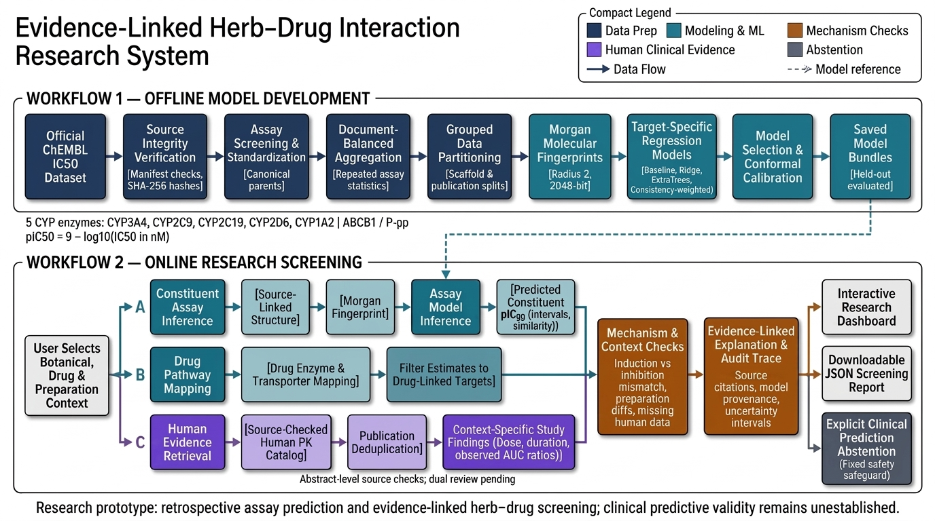
Figure 2 Implemented assay modeling and evidence linked screening architecture
The system is structured into two interconnected workflows with a shared explanation layer:
1. Workflow 1 - Offline Model Development: Operating strictly on the ChEMBL 37 bioactivity dataset, this workflow executes nine sequential stages: (a) Source integrity verification using SHA-256 manifests; (b) Assay screening and parent structure standardization using RDKit; (c) Document-balanced sample aggregation to handle repeated laboratory measurements; (d) Grouped data partitioning into scaffold-disjoint and publication-disjoint splits; (e) 2048-bit Morgan molecular fingerprint extraction; (f) Target-specific regression model training across baseline, linear, and ensemble architectures; (g) Validation-based model selection; (h) Split-conformal prediction interval calibration; and (i) Model serialization into auditable joblib bundles.
2. Online workflow: The interface contains three logical information branches: a sourced constituent structure enters the saved assay models, cited drug pathways filter the relevant targets, and the local human-evidence catalog supplies study-specific findings. The implementation does not execute these branches as an asynchronous clinical service, estimate clearance fractions or invoke a citation-DAG engine.
3. Explanation layer: Catalog mechanism flags and the selected preparation-context policy generate explicit explanations of missing or incompatible information. The interface exports a JSON report containing source references and the catalog hash. These provenance aids are not authenticated clinical approvals or evidence that the chemical model predicts the human findings.

3.4 Algorithms and implementation strategy
The methodological contribution is the integration of a three-tier reliability framework, grouped assay evaluation, calibrated molecular uncertainty and explicit clinical abstention into one auditable research workflow. The following algorithms implement this formulation; Figure 3 summarizes the molecular assay engine and supported targets.
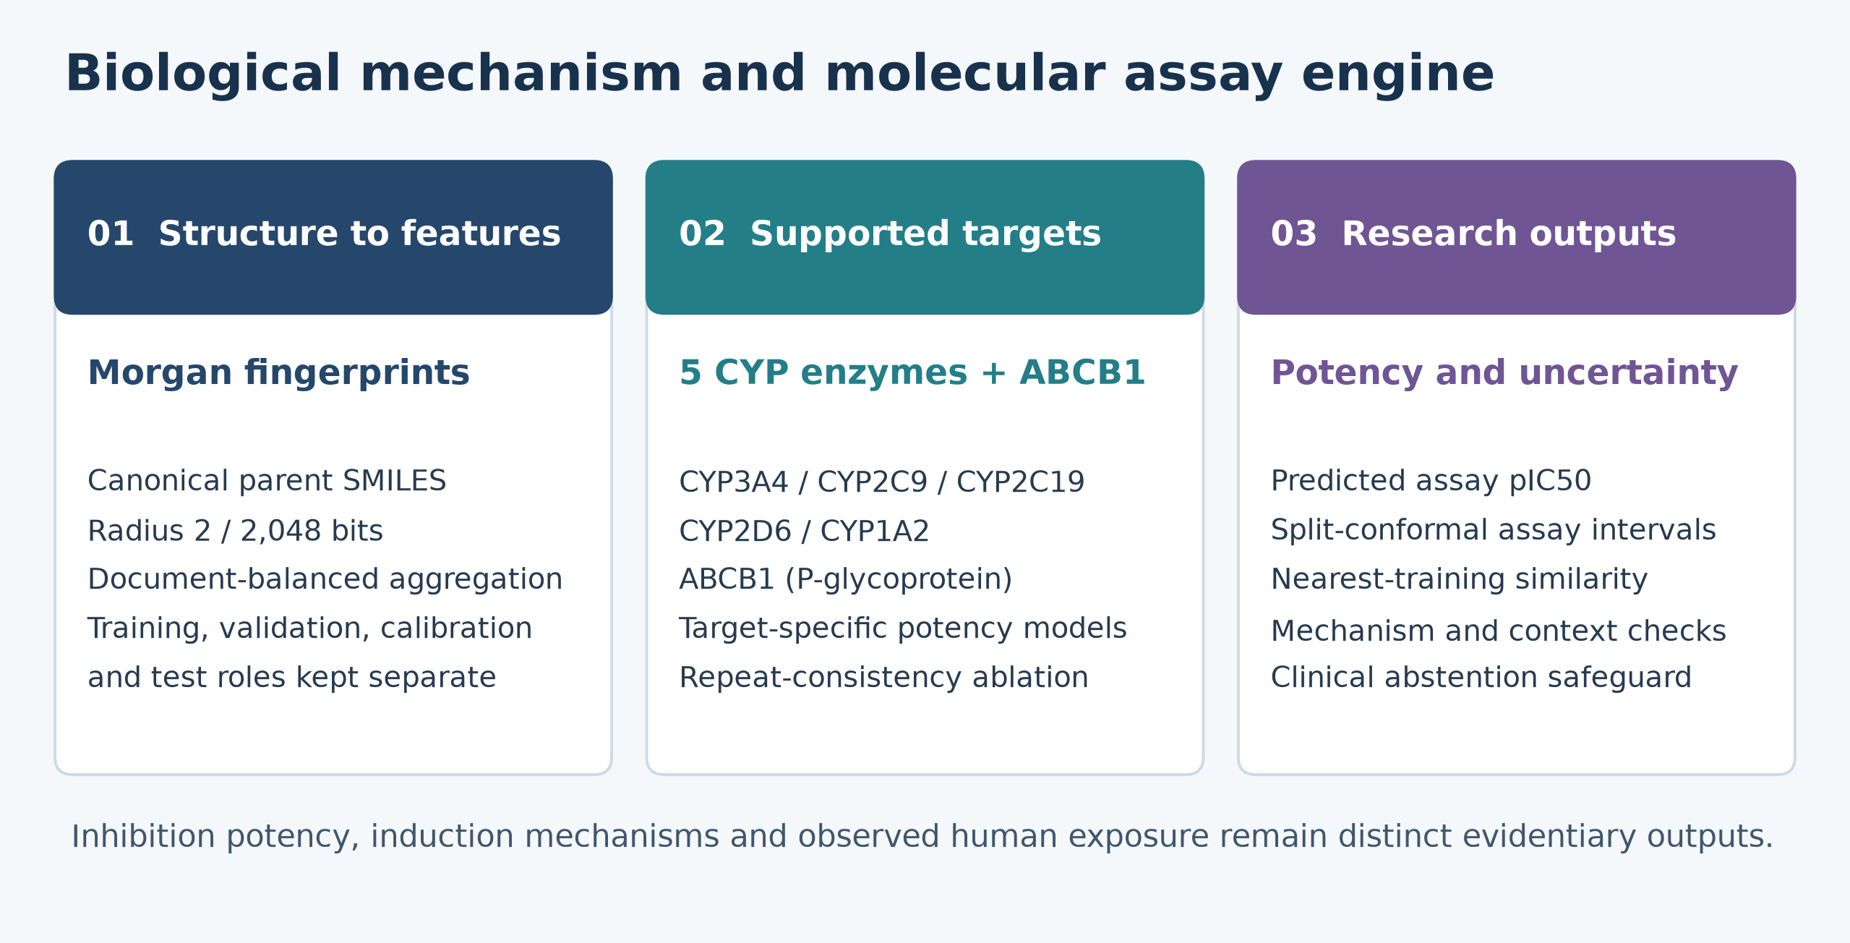
Figure 3 Compound assay engine and supported target panel
1. Structure representation: RDKit parses the input, selects the largest carbon-containing fragment and creates canonical nonisomeric SMILES. Salt parents and stereoisomers share a conservative structure group. Tautomer and charge standardization are not claimed. The standardized molecule is encoded as:
$x_{i} = Morgan\left(M_{i}; radius = 2, bits = 2048\right) ∈ {\left\{0, 1\right\}}^{2048}$ (3.1)
2. Target regression and consistency weighting: Each target has separate median, ridge and tree comparisons. Ridge uses regularization parameter 100 and the LSQR solver. ExtraTrees uses 128 estimators, minimum leaf size two and a feature fraction of 0.5. For a training structure-target pair with retained log-potencies z, MAD is the median absolute deviation from their median. Its exploratory training weight is the inverse of one plus that dispersion.
${MAD}_{i} = {median}_{j}\left|z_{ij} - {median}_{l}\left(z_{il}\right)\right|$ (3.2)
$w_{i} = \frac{1}{1 + {MAD}_{i}}$ (3.3)
The weight measures agreement among the retained measurements; it does not distinguish shared bias from reproducibility or establish study truthfulness. A single measurement receives unit weight. Only training-pair dispersion enters model fitting, and no general performance benefit is assumed.
3. Split-conformal calibration: For the selected target model, absolute residuals are computed on a separate calibration role. Ten percent is the assigned group fraction, not an exact sample fraction. Let the fitted function denote the predictor, and let the calibration residuals be ordered from smallest to largest:
$s_{j} = \left|y_{j} - \hat{f}\left(x_{j}\right)\right|, j ∈ I_{cal}$ (3.4)
For nominal coverage 1 - α = 0.90 and the calibration count, use the finite-sample order-statistic rank k and radius q below. If k exceeds the calibration count, the implementation rejects a finite interval rather than applying an interpolated quantile:
$k = \left\lceil \left(n_{cal} + 1\right)\left(1 - α\right)\right\rceil , q = s_{\left(k\right)}$ (3.5)
For a new constituent representation x, the selected model returns the interval:
$C_{α}\left(x\right) = \left[\hat{f}\left(x\right) - q, \hat{f}\left(x\right) + q\right]$ (3.6)
Inductive split-conformal calibration gives finite-sample marginal assay coverage under exchangeability [6]. Scaffold and publication holdouts assess coverage under chemical and source shift; the guarantee does not automatically extend to shifted populations or clinical outcomes.
$P\left(Y ∈ C_{α}\left(X\right)\right) ≥ 1 - α$ (3.7)
4. Publication/endpoint deduplication: The active screen keys records by PMID, botanical, drug and endpoint. Repeated identical records are collapsed; inconsistent extractions for the same key are rejected. Unique publication IDs do not establish independent cohorts. Historical citation-DAG modules remain outside this active inference path.

3.5 Evaluation metrics
Model performance is evaluated using standard quantitative regression and uncertainty metrics:
1. Logarithmic assay potency: Convert the reported exact IC₅₀ in nM to a dimensionless molar log-potency endpoint. IC₅₀ is assay-dependent and must not be equated directly with thermodynamic binding free energy:
${pIC}_{50} = 9 - \log_{10}\left(\frac{{IC}_{50}}{nM}\right)$ (3.8)
2. Mean absolute error: For N held-out samples with observed endpoints y and fitted predictions from the model, MAE is the average absolute residual in log-potency units:
$MAE = \frac{1}{N}\sum_{i = 1}^{N}{\left|y_{i} - {\hat{y}}_{i}\right|}$ (3.9)
3. Root Mean Squared Error (RMSE): Penalizes substantial residual outliers:
$RMSE = \sqrt{\frac{1}{N}\sum_{i = 1}^{N}{{\left(y_{i} - {\hat{y}}_{i}\right)}^{2}}}$ (3.10)
4. Coefficient of determination: R² compares squared residuals with variation around the held-out mean. It can be negative and is undefined when the denominator is zero:
$R^{2} = 1 - \frac{\sum_{i = 1}^{N}{{\left(y_{i} - {\hat{y}}_{i}\right)}^{2}}}{\sum_{i = 1}^{N}{{\left(y_{i} - \overline{y}\right)}^{2}}}$ (3.11)
5. Empirical interval coverage: The indicator equals one when the observed test value lies inside its predicted interval, and zero otherwise:
$Coverage = \frac{1}{N_{test}}\sum_{i = 1}^{N_{test}}{1\left\{y_{i} ∈ C_{α}\left(x_{i}\right)\right\}}$ (3.12)
MAE intervals use 200 bootstrap resamples of canonical structures, conditional on one fitted split. They omit retraining variability and broader scaffold/publication dependence [18].

CHAPTER 4: IMPLEMENTATION AND EXPERIMENTS

4.1 Implementation details
The software architecture is implemented in standard Python 3.11 with strict separation between offline model training, artifact verification, molecular inference, and online research screening. The codebase is organized within the src/assay package and app/ directory as follows:
• src/assay/data.py: Responsible for raw ChEMBL data ingestion, structure screening, parent fragmentation, document-balanced sample aggregation, and grouped data partitioning (scaffold and publication holdouts).
• src/assay/experiment.py: Executes the offline training pipeline across target regression models, executes validation-based model selection, fits split-conformal calibration quantiles, computes bootstrap metrics, and serializes trusted model bundles.
• src/assay/predict.py: Loads a trusted completed experiment, parses a constituent structure, generates fingerprints and returns target estimates, calibrated assay intervals, nearest-training Tanimoto similarity and training-compound status. Throughput and latency were not benchmarked.
• src/assay/verify.py: An independent, read-only verification engine that audits serialized experiment artifacts, recomputes test metrics from raw predictions, and asserts split disjointness invariants without refitting models.
• src/assay/screening.py: Matches the botanical-drug selection to the local source catalog, filters assay targets through pathway mappings, deduplicates publication/endpoint records and reports mechanism or context gaps. It does not estimate drug clearance fractions.
• app/demo.py and app/screening_demo.py: Render the interactive screen, potency chart, interval tables, human findings and downloadable JSON report. Assay intervals are tabulated; they are not clinical confidence bounds.

4.2 Experimental setup
The preparation pipeline applies declared endpoint and structural checks and saves exclusion reasons. Table 1 summarizes the actual transition from downloaded records to canonical assay samples. Structural screening is not expert approval of every experiment.
Table 1: Dataset preparation counts
Stage | Count
Downloaded IC50 records | 18,833
Structurally screened candidates | 16,018
Additional screening exclusions | 805
Retained measurements | 15,213
Scaffold structure-target samples | 13,242
Canonical structures | 8,724
All machine learning models and conformal calibration procedures were executed under fixed, pre-declared hyperparameter settings, as specified in Table 2.
Table 2: Model and calibration settings
Component | Setting
Molecular features | Morgan radius 2; 2048 bits
Ridge | alpha 100; lsqr solver
ExtraTrees | 128 trees; min leaf 2; feature fraction 0.5
Consistency weight | 1 / (1 + training pair MAD)
Role fractions | 60% / 15% / 10% / 15% (Train / Val / Cal / Test)
Calibration | alpha 0.10; absolute residuals
Seed | 20261030
The scaffold regime keeps each Bemis-Murcko group in one role. The publication regime assigns source documents and then purges cross-role structures, with fixed priority test, calibration, validation, training. Publication separation does not prove separation by laboratory or institution. Both regimes use seed 20261030 and separate training, validation, calibration and testing roles; Table 3 records their aggregate sizes.
Table 3: Sample counts by evaluation role
Split | Train | Validation | Calibration | Test
Scaffold | 7937 | 1863 | 1326 | 2116
Publication | 7477 | 1993 | 1603 | 2076

4.3 Test cases and validation protocol
Verification includes a focused 219-test assay/source/component/orchestrator/preflight run, three report-integrity tests, and a later overlapping 23-test screening/assay/presentation selection. These are engineering checks and are not a full-suite green or clinical-validation claim. Table 4 records representative expected behaviors; the test selections must not be added as independent counts [18].
Table 4: Behavioral verification cases
Check | Expected behavior
Outcome isolation | Changed test labels do not alter fitted predictions
Role separation | Forbidden structure or group overlap fails with an explicit error
Artifact integrity | Changed experiment bytes or altered manifest hashes are rejected
Citation duplication | Repeated literature record adds no unique publication to evidence counts
Induction mechanism | Inhibition exposure ratio is not computed for PXR induction pathways
Unknown preparation | Context mismatch remains explicit; unstudied preparations are flagged

4.4 Reproducibility details
A fixed seed and recorded dependency versions support reproducibility within the declared environment, without promising byte-identical artifacts across systems. Each completed run stores protocol settings, source hashes, role mappings, exclusions, purges, aggregates, predictions and a fitted bundle. The independent verifier recomputes metrics and checks split invariants without refitting. Locally fitted model bundles are excluded from Git; versioned summaries and prediction tables support review. The implementation commit is 4dcbf89 [18].

CHAPTER 5: RESULTS AND DISCUSSION

5.1 Quantitative and qualitative results
The empirical performance of the selected regression models across the six target pharmacokinetic endpoints is reported in Table 5 for the molecular scaffold holdout (2,116 test samples) and Table 6 for the publication holdout (2,076 test samples).
Table 5: Scaffold holdout selected model results
Target | Test n | MAE | RMSE | R² | Coverage
ABCB1 | 155 | 0.495 | 0.658 | 0.507 | 0.955
CYP1A2 | 251 | 0.584 | 0.756 | 0.221 | 0.936
CYP2C19 | 217 | 0.474 | 0.600 | 0.129 | 0.935
CYP2C9 | 358 | 0.468 | 0.607 | 0.242 | 0.874
CYP2D6 | 375 | 0.513 | 0.666 | 0.322 | 0.944
CYP3A4 | 760 | 0.482 | 0.641 | 0.350 | 0.880
Table 6: Publication holdout selected model results
Target | Test n | MAE | RMSE | R² | Coverage
ABCB1 | 166 | 0.587 | 0.773 | -0.051 | 0.958
CYP1A2 | 180 | 0.751 | 0.992 | 0.123 | 0.794
CYP2C19 | 158 | 0.644 | 0.843 | -0.060 | 0.949
CYP2C9 | 347 | 0.514 | 0.720 | -0.026 | 0.939
CYP2D6 | 378 | 0.637 | 0.841 | 0.124 | 0.926
CYP3A4 | 847 | 0.731 | 1.044 | -0.222 | 0.839
The target-specific MAE comparisons for both holdout regimes are shown in Figure 4.
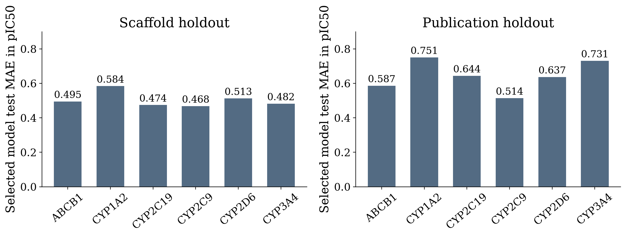
Figure 4 Selected model test MAE by target and evaluation regime
The selected scaffold models have pooled test MAE 0.4974 pIC₅₀, RMSE 0.6521 and R² 0.3440 over 2,116 structure-target samples. The conditional bootstrap MAE interval is 0.4754-0.5183. A log error of about 0.497 corresponds to an approximately 3.1-fold concentration scale, not a guaranteed per-sample bound or proof that errors are acceptable for a clinical use. The publication regime has MAE 0.6613, RMSE 0.9208 and pooled R² -0.0243 over 2,076 samples; its MAE interval is 0.6355-0.6933 [18].
The observed split-conformal test coverage is compared with the nominal level in Figure 5.
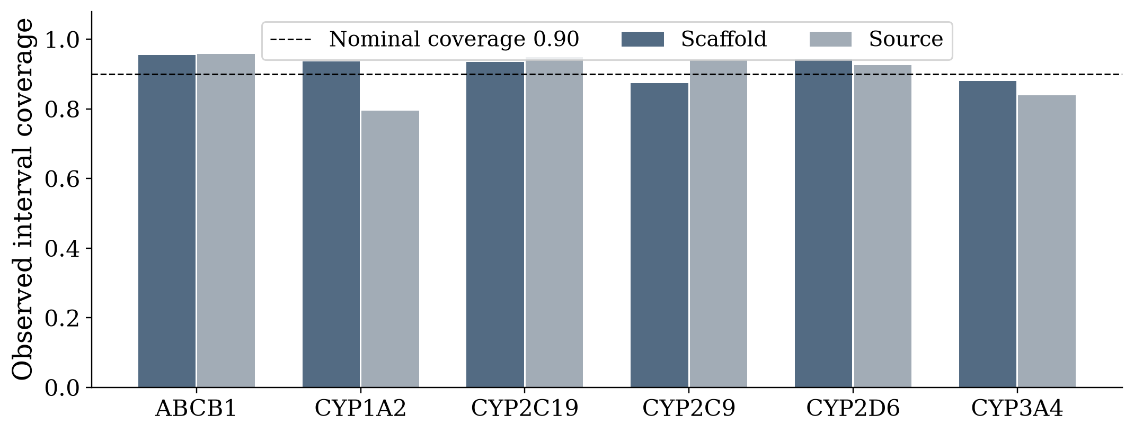
Figure 5 Observed assay interval coverage against nominal coverage
Scaffold target coverage ranges from 87.4% to 95.5%; publication-held-out coverage ranges from 79.4% to 95.8%. Source-held-out CYP1A2 and CYP3A4 coverages are approximately 79.4% and 83.9%, below the nominal 90% level. Coverage is an observed held-out proportion, not a guaranteed clinical bound. The intervals' usefulness must be assessed together with their width and the population being predicted.

5.2 Comparison with baselines
To rigorously benchmark the regression architectures, Table 7 provides a comprehensive comparison of pooled test MAE across the four evaluated model families.
Table 7: Fixed model pooled test MAE
Model family | Scaffold MAE | Publication MAE
Training median baseline | 0.6212 | 0.6875
Ridge linear regression | 0.5235 | 0.6398
ExtraTrees ensembles | 0.4981 | 0.6595
Consistency weighted trees | 0.4995 | 0.6611
On the scaffold test cohort, unweighted ExtraTrees has pooled MAE 0.4981 compared with 0.6212 for the median baseline and 0.5235 for ridge. On the publication cohort, ridge has lower pooled MAE than either tree family. Consistency weighting yields 0.4995 on scaffolds and 0.6611 on publication holdouts, without an established overall improvement. These descriptive differences do not constitute a significance test. Per-target selection uses validation MAE, so the selected combination can differ from the lowest test-error family.

5.3 Discussion and limitations
The higher publication-held-out error and negative target-specific R² values indicate limited generalization in that regime. Assay protocol differences are plausible contributors but were not isolated causally. The scaffold run also shares source documents between roles. The two tests contain different samples after purging, so their metric difference is a sensitivity finding, not a paired estimate of laboratory effects.
The human evidence illustrates an additional mechanism limit. In the cyclosporine study, the reported dose-corrected baseline/coadministration AUC ratio was 1.83; the displayed coadministration/baseline ratio is its reciprocal, about 0.55 [9]. This is an observed study result, not an output of the inhibition model or a forecast of transplant rejection. Hyperforin-associated induction [7] is flagged as outside the model's inhibitory endpoint. The source-checked human catalog still needs independent review.

CHAPTER 6: CONCLUSION AND FUTURE WORK

6.1 Conclusions and achievements
This capstone research project has successfully designed, implemented, and empirically verified an auditable, evidence-linked herb-drug interaction research screening system. The key achievements include:
1. Three-tier reliability formulation: Separate data roles connect molecular measurements, retrieved human findings and independent clinical adjudication. The design preserves endpoint provenance and makes clinical prediction abstention an explicit safety guardrail.
2. Reproducible assay experiment: The screened ChEMBL dataset supports six target-specific comparisons and held-out pIC₅₀ metrics. Selected scaffold models have MAE 0.4974; selected publication-held-out models have MAE 0.6613. These are assay results rather than validated clinical interaction predictions.
3. Calibrated assay uncertainty: Inductive split-conformal intervals provide finite-sample marginal coverage under exchangeability. Held-out coverage across scaffold and publication regimes measures the practical limits under chemical and source shift.
4. Traceable literature records: The active demonstration deduplicates publication/endpoint keys and retains source URLs, extraction level and review status. It does not infer full citation lineage or authenticate independent clinical cohorts.
5. Mechanism/context explanations: A preparation selector and an explicit induction guard expose unsupported extrapolations. Fixed clinical abstention remains in place, and the dashboard exports the explanation alongside assay estimates.

6.2 Limitations
Despite its significant engineering and methodological advancements, several scientific limitations remain:
1. Compound vs. Whole-Herb Disconnect: In-vitro models evaluate isolated chemical structures (e.g., Curcumin, Hyperforin). They do not account for raw botanical matrix variability, agricultural chemotypes, extraction solvents, or oral bioavailability fractions in human gastrointestinal tracts.
2. Limited evaluation replication: One seeded split was executed per regime. Repeated grouped experiments, external validation and sensitivity to source release or chemical normalization remain necessary. Computational limitations were not measured as a justification for omitting those studies.
3. Limited clinical evidence: Four pair-specific records from three publications provide a demonstration, not an independently reviewed clinical benchmark. Verified exposure/composition data, clinical outcomes and a defensible statistical protocol are still required before the original clinical task can be validated.

6.3 Future scope
The research provides a solid foundation for several advanced research extensions:
1. Physiologically Based Pharmacokinetic (PBPK) Integration: Coupling the in-vitro molecular potency estimates with dynamic multi-compartment PBPK differential equations to simulate time-dependent plasma concentration profiles in virtual patient populations.
2. Expansion to Phase II Metabolism and Transporters: Extending the target suite beyond CYP enzymes to encompass Phase II conjugation enzymes (UGTs, SULTs) and uptake transporters (OATs, OCTs, OATPs).
3. Clinical endpoint development: With qualified reviewers, define a preparation-specific clinical or human-PK target, audit source independence and populate an appropriate reference dataset. Feasible independent groups and sample adequacy should be established before training; prospective clinical validity cannot be inferred from current assay errors.

REFERENCES
[1] B. Zdrazil et al., 'The ChEMBL Database in 2023: a drug discovery platform spanning multiple bioactivity data types and time periods,' Nucleic Acids Research, vol. 52, no. D1, pp. D1180-D1192, 2024. doi: 10.1093/nar/gkad1004.
[2] D. Rogers and M. Hahn, 'Extended-connectivity fingerprints,' Journal of Chemical Information and Modeling, vol. 50, no. 5, pp. 742-754, 2010. doi: 10.1021/ci100050t.
[3] RDKit developers, 'Getting Started with the RDKit in Python,' online documentation. https://www.rdkit.org/docs/GettingStartedInPython.html. Accessed 30 October 2026. Recorded experiment version: 2026.03.5.
[4] F. Pedregosa et al., 'Scikit-learn: Machine Learning in Python,' Journal of Machine Learning Research, vol. 12, pp. 2825-2830, 2011.
[5] U.S. Food and Drug Administration, 'M12 Drug Interaction Studies: Guidance for Industry,' Center for Drug Evaluation and Research (CDER), August 2024. https://www.fda.gov/regulatory-information/search-fda-guidance-documents/m12-drug-interaction-studies
[6] A. N. Angelopoulos and S. Bates, 'A Gentle Introduction to Conformal Prediction and Distribution-Free Uncertainty Quantification,' arXiv preprint arXiv:2107.07511, 2021.
[7] L. B. Moore et al., 'St. John's wort induces hepatic drug metabolism through activation of the pregnane X receptor,' Proceedings of the National Academy of Sciences, vol. 97, no. 13, pp. 7500-7502, 2000. doi: 10.1073/pnas.130155097.
[8] A. Johne et al., 'Pharmacokinetic interaction of digoxin with an herbal extract from St John's wort (Hypericum perforatum),' Clinical Pharmacology and Therapeutics, vol. 66, no. 4, pp. 338-345, 1999. doi: 10.1053/cp.1999.v66.a101944.
[9] S. Bauer et al., 'Alterations in cyclosporin A pharmacokinetics and metabolism during treatment with St John's wort in renal transplant patients,' British Journal of Clinical Pharmacology, vol. 55, no. 2, pp. 203-211, 2003. doi: 10.1046/j.1365-2125.2003.01759.x.
[10] B. J. Gurley et al., 'Gauging the clinical significance of P-glycoprotein-mediated herb-drug interactions: comparative effects of St. John's wort, Echinacea, clarithromycin, and rifampin on digoxin pharmacokinetics,' Molecular Nutrition & Food Research, vol. 52, no. 7, pp. 772-779, 2008. doi: 10.1002/mnfr.200700081.
[11] National Center for Complementary and Integrative Health, 'Herb-Drug Interactions: What the Science Says,' NIH Clinical Digest, online resource. https://www.nccih.nih.gov/health/providers/digest/herb-drug-interactions-science. Accessed 30 October 2026.
[12] National Cancer Institute, 'Cancer Therapy Interactions With Foods and Dietary Supplements (PDQ), Health Professional Version,' online resource. https://www.cancer.gov/about-cancer/treatment/cam/hp/dietary-interactions-pdq. Accessed 30 October 2026.
[13] J. Y. Ryu, H. U. Kim and S. Y. Lee, 'Deep learning improves prediction of drug-drug and drug-food interactions,' Proceedings of the National Academy of Sciences, vol. 115, no. 18, pp. E4304-E4311, 2018. doi: 10.1073/pnas.1803294115.
[14] M. Zitnik et al., 'Modeling polypharmacy side effects with graph convolutional networks,' Bioinformatics, vol. 34, no. 13, pp. i457-i466, 2018. doi: 10.1093/bioinformatics/bty294.
[15] K. Huang et al., 'CASTER: Predicting Drug Interactions with Chemical Substructure Representation,' Proceedings of the AAAI Conference on Artificial Intelligence, vol. 34, no. 1, pp. 702-709, 2020. doi: 10.1609/aaai.v34i01.5412.
[16] J. Lee et al., 'BioBERT: a pre-trained biomedical language representation model for biomedical text mining,' Bioinformatics, vol. 36, no. 4, pp. 1234-1240, 2020. doi: 10.1093/bioinformatics/btz682.
[17] Y. Gu et al., 'Domain-Specific Language Model Pretraining for Biomedical Natural Language Processing,' ACM Transactions on Computing for Healthcare, vol. 3, no. 1, article 2, 23 pages, 2021. doi: 10.1145/3458754.
[18] Project repository, Reliability-Conditioned-Herb-Drug-Interaction-Prediction, commit 4dcbf89, 2026. https://github.com/jiya2000/Reliability-Conditioned-Herb-Drug-Interaction-Prediction. Empirical records: results/assay_scaffold.json; results/assay_source.json; matching prediction tables and split audits.

APPENDIX A: SUPPORTING MATERIAL

A.1 Reproduction commands
Run the commands below from the repository root. Use a new output directory when reproducing an experiment; the existing local model folders are deliberately protected from overwrite.
1. Create the assay environment and install dependencies:
python3 -m venv venv
venv/bin/python -m pip install -r requirements_assay.txt
venv/bin/python -m pip install pytest
2. Train the molecular assay regressors across scaffold holdout:
venv/bin/python -m src.assay.experiment \
--output artifacts/assay/scaffold_reproduction \
--split scaffold
3. Train the molecular assay regressors across publication holdout:
venv/bin/python -m src.assay.experiment \
--output artifacts/assay/source_reproduction \
--split source
4. Execute independent metric verification and split audit:
venv/bin/python -m src.assay.verify \
--experiment artifacts/assay/scaffold_reproduction
venv/bin/python -m src.assay.verify \
--experiment artifacts/assay/source_reproduction
5. Run the focused assay and screening tests:
venv/bin/python -m pytest \
tests/test_assay_workflow.py \
tests/test_screening_demo.py -q -p no:cacheprovider
6. Launch the interactive Streamlit research screening dashboard:
venv/bin/python -m streamlit run app/demo.py \
--server.address 127.0.0.1 \
--server.port 8501

A.2 Demonstration walkthrough sequence
To demonstrate the full interactive capabilities of the research prototype during evaluation, the following operational sequence is recommended:
1. St. John's Wort + Digoxin (The Classic Interaction): Select St. John's Wort and Digoxin. Observe the retrieved human clinical finding showing a 25% reduction in Digoxin AUC in healthy volunteers. Expand the Live Molecular Model panel to inspect Hyperforin's predicted pIC₅₀ potencies across all six targets. Note the automated Mechanism Check alert, which warns that St. John's Wort's clinical exposure drop is driven by PXR transcriptional induction rather than in-vitro competitive inhibition.
2. Publication deduplication: Enable 'Demonstrate duplicate-citation handling'. The interface deliberately repeats an existing catalog record; the unique-publication count and retained findings do not increase. This demonstrates duplicate handling, not full review-echo detection or clinical independence.
3. Echinacea + Digoxin (The Negative Finding): Select Echinacea with Digoxin. Observe the documented human trial reporting no statistically significant change in drug exposure, alongside an explicit note that this represents a study-specific observation rather than a blanket clinical safety guarantee.
4. Turmeric and digoxin: Inspect live curcumin assay estimates and the explicit absence of matching human evidence in this small catalog. Catalog absence does not establish that no trial exists elsewhere or that the combination is safe.
5. Audit export: Open the 'Explanation & audit' tab and use 'Download this screening report'. The JSON records sources, the catalog hash, estimates and missing requirements; it is not a cryptographically authenticated clinical approval.

A.3 Artifact and evidence trace
Completed experiments store the following artifacts locally under artifacts/assay. A new training run requires a new output directory; existing model directories are not overwritten.
• model.joblib: The serialized scikit-learn model bundles containing the fitted target regressors and conformal calibration quantiles.
• config.json: Complete hyperparameter specifications, random seeds, and split regimes.
• samples.csv and record_roles.csv: Explicit mappings binding each ChEMBL activity ID and standardized structure to its assigned role (train, validation, calibration, or test).
• excluded_records.csv and purged_records.csv: Records rejected by the declared screening rules and measurements removed during cross-role structure purging. Repeated measurements are aggregated, not automatically discarded as duplicate evidence.
• test_predictions.csv: Observed assay endpoints and predictions for all declared models; interval endpoints are populated for the selected model.
• report.json and report.md: Full machine-readable and human-readable evaluation summaries, including R², MAE, RMSE, and empirical interval coverage.

A.4 Interpretation of the exposure sensitivity control
The turmeric interface has an optional numeric input for an assumed unbound constituent concentration in micromolar units. The descriptive exposure-to-potency ratio below divides this assumption by model-implied IC₅₀. Its range follows the assay interval. This is not a measured patient concentration, receptor occupancy, an AUC prediction, a regulatory decision threshold or a complete M12 calculation. The control is disabled for the induction-marked St John's wort branch.
$r = \frac{I_{u}}{{\hat{IC}}_{50}}, {\hat{IC}}_{50} = {10}^{6 - \hat{y}} µM$ (A.1)

