RELIABILITY CONDITIONED HERB DRUG INTERACTION PREDICTION
A CAPSTONE PROJECT REPORTnSubmitted in partial fulfillment of the requirements for the degree ofnBACHELOR OF TECHNOLOGYninnCOMPUTER SCIENCE AND ENGINEERING
[COURSE CODE] – [COURSE NAME]
Submitted by:n[TEAM MEMBER 1 – REGISTRATION NUMBER]n[TEAM MEMBER 2 – REGISTRATION NUMBER]n[TEAM MEMBER 3 – REGISTRATION NUMBER]

Under the kind guidance ofn[GUIDE / PROFESSOR NAME]nSchool of Computer Science and EngineeringnVellore Institute of Technology, Vellore - 632014, Tamil Nadu, IndianOCTOBER 2026

PROJECT OVERVIEW
This capstone project implements an evidence-linked herb–drug interaction (HDI) research screening and decision-support system designed to address the pervasive challenge of data leakage, citation echo chambers, and mechanistic opacity in computational healthcare. In clinical practice, millions of patients concurrently consume botanical dietary supplements alongside essential pharmaceutical drugs. Unlike regulated pharmaceutical agents, herbal preparations are complex natural chemical mixtures whose in-vivo disposition, metabolic enzyme modulation, and pharmacokinetic consequences are rarely evaluated in formal clinical trials prior to commercial distribution. Consequently, clinicians and pharmacologists must navigate a fragmented, noisy, and occasionally contradictory body of biomedical literature to identify potential co-administration hazards.
Conventional biomedical machine learning models developed for Drug-Drug Interaction (DDI) and Herb-Drug Interaction (HDI) prediction frequently suffer from catastrophic methodological shortcuts. Most prominent architectures utilize end-to-end biomedical text classification or monolithic graph neural networks that extract representations from published PubMed abstracts while simultaneously deriving ground-truth interaction labels from those identical texts. This creates severe circular target leakage: the model merely memorizes the co-occurrence of herb and drug nomenclature in scientific prose rather than learning generalizable biochemical or pharmacological principles. Furthermore, naive evidence aggregation algorithms treat repeated review articles as independent confirmatory trials, drastically inflating evidentiary confidence through citation echo bias.
To resolve these fundamental deficiencies, our project establishes a rigorous, decoupled, two-stage computational framework. In the first stage (Offline Model Development), we isolate the biochemical foundation of interaction prediction by training target-specific molecular regressors directly on 18,833 in-vitro bioactivity assays curated from the official European Molecular Biology Laboratory (EMBL-EBI) ChEMBL 37 database. These models predict the quantitative inhibition potency (pIC50) of botanical chemical constituents across five primary human Cytochrome P450 enzymes (CYP3A4, CYP2C9, CYP2C19, CYP2D6, CYP1A2) and the ABCB1 (P-glycoprotein) cellular efflux transporter. Crucially, the offline models are evaluated under strict molecular scaffold-disjoint and publication-disjoint partitioning protocols, ensuring that test molecules share neither chemical core scaffolds nor laboratory origin with training instances.
In the second stage (Online Research Screening), the system couples these verified molecular bioactivity estimates with an auditable clinical evidence appraisal pipeline. When an investigator queries an herb–drug pair, the system identifies the drug's metabolic clearance fraction, maps the herb's known active constituents, retrieves deduplicated human pharmacokinetic clinical trials, and subjects the combination to explicit mechanism-reconciliation checks. If an herb acts through enzyme induction via pregnane X receptor (PXR) transcription rather than in-vitro competitive inhibition, the system flags the biological contradiction. Where human evidence is incomplete or uncertain, split-conformal prediction intervals are displayed, and the system enforces a fail-closed clinical abstention safeguard. The complete pipeline is operationalized through a Streamlit interactive research dashboard and verifiable JSON audit exports, providing an auditable, transparent decision-support tool for pharmacological researchers.

ABSTRACT
Herb–drug interaction (HDI) prediction is a vital domain in computational pharmacovigilance, yet existing machine learning methodologies are severely compromised by circular ground-truth leakage and uncritical literature aggregation. This project presents the design, implementation, and empirical evaluation of an auditable, evidence-linked herb–drug interaction research system that cleanly decouples molecular-level bioactivity modeling from clinical evidence appraisal.
We curate an experimental benchmark comprising 18,833 laboratory assay measurements from EMBL-EBI ChEMBL 37, standardizing chemical representations through RDKit canonical SMILES and computing 2048-bit Morgan molecular fingerprints (radius 2). Document-balanced sample aggregation yields 13,242 unique structure–target training instances across five human Cytochrome P450 enzymes (CYP3A4, CYP2C9, CYP2C19, CYP2D6, CYP1A2) and the ABCB1 transporter. We develop and benchmark four target-specific regression architectures: training median baseline, Ridge linear regression, ExtraTrees ensembles, and a novel repeat-consistency weighted ExtraTrees model. Evaluated under strict Bemis-Murcko scaffold-disjoint partitioning, our selected models achieve a pooled test Mean Absolute Error (MAE) of 0.4974 pIC50 (RMSE 0.6521, R² 0.3440) across 2,116 held-out molecular samples. Under a rigorous publication-disjoint holdout across 2,076 samples, the system achieves an MAE of 0.6611 pIC50, transparently exposing the distribution shifts inherent in cross-laboratory generalization. Split-conformal calibration guarantees empirical interval coverage of 87.4%–95.8% across targets at a nominal 90% confidence level.
In the online screening tier, the system integrates these trained models with a Citation Directed Acyclic Graph (DAG) deduplication engine, collapsing redundant literature echoes to prevent evidence inflation. It incorporates biological mechanism-reconciliation guards to detect divergences between in-vitro inhibition and human PXR-mediated induction (exemplified by Hypericum perforatum and Cyclosporine), while enforcing fail-closed abstention when clinical trial data is absent. Verified by a comprehensive suite of 222 automated software invariant tests and rendered via an interactive Streamlit dashboard, this project delivers an auditable, scientifically sound foundation for computational natural product pharmacovigilance.
Keywords: Herb–drug interactions; molecular fingerprints; ChEMBL; pharmacokinetics; conformal prediction; Citation DAG; data leakage prevention; CYP450 enzymes; P-glycoprotein.

TABLE OF CONTENTS
Project overview ................................................................... ii
Abstract .......................................................................... iii
List of figures .................................................................... vi
List of tables .................................................................... vii
List of abbreviations ............................................................ viii
Chapter 1 Introduction .............................................................. 1
1.1 Background and motivation ................................................... 1
1.2 Problem statement ........................................................... 3
1.3 Objectives .................................................................. 4
1.4 Scope and contributions ..................................................... 5
1.5 Organisation of the report .................................................. 6
Chapter 2 Literature review ......................................................... 7
2.1 Related research and existing systems ....................................... 7
2.2 Comparative analysis ........................................................ 9
2.3 Research or implementation gap ............................................. 11
Chapter 3 Requirements and methodology ............................................. 13
3.1 System requirements and assumptions ........................................ 13
3.2 Dataset, materials, software and hardware .................................. 14
3.3 Proposed architecture and workflow ......................................... 18
3.4 Algorithms and implementation strategy ..................................... 21
3.5 Evaluation metrics ......................................................... 24
Chapter 4 Implementation and experiments ........................................... 26
4.1 Implementation details ..................................................... 26
4.2 Experimental setup ......................................................... 28
4.3 Test cases and validation protocol ......................................... 30
4.4 Reproducibility details .................................................... 32
Chapter 5 Results and discussion ................................................... 34
5.1 Quantitative and qualitative results ....................................... 34
5.2 Comparison with baselines .................................................. 37
5.3 Discussion and limitations ................................................. 39
Chapter 6 Conclusion and future work ............................................... 42
6.1 Conclusions and achievements ............................................... 42
6.2 Limitations ................................................................ 43
6.3 Future scope ............................................................... 44
References ......................................................................... 46
Appendix A Supporting material ..................................................... 49
A.1 Reproduction commands ...................................................... 49
A.2 Demonstration sequence ..................................................... 50
A.3 Artifact and evidence trace ................................................ 51
A.4 Interpretation of exposure sensitivity control ............................. 52
Optional: Individual contribution statement ........................................ 53

LIST OF FIGURES
Figure 1: Three-tier dataset architecture separating clinical literature, in-vitro assays, and consensus ground truth ................................... 15
Figure 2: Evidence-linked herb–drug interaction research system architecture across offline and online workflows ................................... 19
Figure 3: Target identification and data mapping process across FDA regulatory guidance, drug monographs, and runtime filtering ................................... 21
Figure 4: Table 2 biological mechanism and molecular assay engine across 6 FDA metabolic pathways ................................... 24
Figure 5: Four-way grouped Bemis–Murcko scaffold data partitioning and split-conformal uncertainty calibration workflow ................................... 29
Figure 6: Selected model Mean Absolute Error (MAE) by target across scaffold and publication holdout splits ................................... 38
Figure 7: Empirical split-conformal prediction interval coverage across targets compared to 90% nominal level ................................... 40
Figure 8: Model selection architecture and comparative benchmark across baseline and ensemble families ................................... 42

LIST OF TABLES
Table 1: Dataset preparation counts from raw ChEMBL 37 download to canonical samples .................................... 16
Table 2: Fixed machine learning model and conformal calibration hyperparameter settings .................................... 20
Table 3: Aggregated sample counts by evaluation role across scaffold and publication splits .................................... 27
Table 4: Behavioral software verification cases and expected system invariants .................................... 31
Table 5: Scaffold holdout selected model results across six target endpoints .................................... 35
Table 6: Publication holdout selected model results across six target endpoints .................................... 36
Table 7: Fixed model pooled test MAE comparisons across baseline and ensemble families .................................... 37

LIST OF ABBREVIATIONS
ABCB1 — ATP-Binding Cassette Transporter Subfamily B Member 1 (also known as P-glycoprotein)
ADMET — Absorption, Distribution, Metabolism, Excretion, and Toxicity
API — Application Programming Interface
AUC — Area Under the Plasma Concentration–Time Curve
ChEMBL — Chemical Database of the European Molecular Biology Laboratory
Cmax — Maximum Observed Plasma Concentration
CYP — Cytochrome P450 Monooxygenase Enzyme Superfamily
DAG — Directed Acyclic Graph
DDI — Drug–Drug Interaction
ECFP — Extended-Connectivity Fingerprint
FDA — Food and Drug Administration (United States)
GNN — Graph Neural Network
HDI — Herb–Drug Interaction
IC50 — Half-Maximal Inhibitory Concentration
Ki — Inhibition Constant / Binding Affinity
MAD — Median Absolute Deviation
MAE — Mean Absolute Error
NCCIH — National Center for Complementary and Integrative Health
P-gp — P-glycoprotein (efflux membrane transporter encoded by ABCB1)
pIC50 — Negative Decadic Logarithm of Molar IC50 (pIC50 = -log10[IC50 in M])
PK — Pharmacokinetics
PMID — PubMed Identifier
PXR — Pregnane X Receptor (nuclear receptor driving CYP3A4 transcriptional induction)
QSAR — Quantitative Structure–Activity Relationship
RDKit — Open-Source Cheminformatics and Machine Learning Toolkit
RMSE — Root Mean Squared Error
SMILES — Simplified Molecular-Input Line-Entry System
UniProt — Universal Protein Resource

CHAPTER 1: INTRODUCTION
1.1 Background and motivation
The global consumption of herbal medicines, botanical supplements, and natural remedies has experienced unprecedented growth over the past three decades. According to epidemiological surveillance by the World Health Organization (WHO), over 80% of the population in developing nations relies on herbal preparations for primary healthcare, while in North America and Europe, more than 50% of adults regularly consume dietary supplements alongside prescription pharmaceuticals. This widespread practice is driven by the cultural perception that natural botanical products are inherently benign, non-toxic, and devoid of serious pharmacological hazards.
In clinical reality, botanical preparations are chemically complex mixtures containing hundreds of distinct bioactive secondary metabolites, including flavonoids, alkaloids, terpenoids, polyphenols, and coumarins. When ingested concurrently with modern synthetic drugs, these botanical phytochemicals frequently interact with the exact metabolic enzymes and membrane transporters responsible for drug disposition. The vast majority of oral medications undergo biotransformation in the liver and gastrointestinal epithelium, primarily catalyzed by the Cytochrome P450 (CYP) monooxygenase enzyme superfamily—notably CYP3A4, CYP2C9, CYP2C19, CYP2D6, and CYP1A2—as well as the ATP-binding cassette efflux transporter ABCB1 (P-glycoprotein / P-gp).
When an herbal constituent modulates these pharmacokinetic pathways, severe clinical consequences ensue. Competitive or mechanism-based enzyme inhibition drastically reduces drug clearance, precipitating supra-therapeutic plasma accumulation and life-threatening toxicity. A prominent clinical paradigm is the interaction between Ginkgo biloba and the anticoagulant Warfarin: ginkgolic acids and biflavonoids inhibit CYP2C9 and platelet-activating factor (PAF), drastically elevating bleeding risks and precipitating spontaneous intracranial hemorrhages. Conversely, transcriptional enzyme induction—frequently mediated through xenobiotic nuclear receptors such as the Pregnane X Receptor (PXR)—dramatically accelerates drug clearance, leading to sub-therapeutic plasma exposure and catastrophic therapeutic failure. A tragic, well-documented clinical manifestation occurred in renal and cardiac transplant recipients who consumed St. John's Wort (Hypericum perforatum) while receiving the critical immunosuppressant Cyclosporine; hyperforin-mediated PXR induction accelerated Cyclosporine elimination, causing acute organ transplant rejection.
Despite these severe clinical risks, botanical dietary supplements face virtually no regulatory requirement for prospective pharmacokinetic drug-interaction testing prior to commercial marketing. Clinicians, regulatory bodies, and pharmacists must consequently depend on fragmented case reports, heterogeneous in-vitro laboratory assays, and published medical literature. Developing computational, data-driven systems capable of reliably screening herb–drug interactions is therefore an urgent public health priority. However, existing computational models are severely hindered by flawed data practices, motivation for this research is to engineer a rigorous, auditable, and leakage-free software framework that bridges in-vitro chemical bioactivity with verified human clinical trial evidence.
1.2 Problem statement
Computational prediction of herb–drug interactions presents a multi-tiered scientific challenge that cannot be resolved through conventional black-box machine learning approaches. The problem is bifurcated into two distinct layers:
1. Molecular Bioactivity Estimation (Layer 1): Given the chemical structure of a botanical constituent, can machine learning regressors accurately predict its in-vitro quantitative inhibitory potency (expressed as pIC50) across the primary human Cytochrome P450 enzymes and the ABCB1 transporter, while generalizing to novel molecular scaffolds that were completely absent during model training?
2. Clinical Evidence Appraisal and Verification (Layer 2): Given a botanical–drug co-administration query, how can a decision-support system aggregate published clinical literature, account for redundant citation chains that artificially inflate evidence counts, identify fundamental biological contradictions (such as test-tube inhibition conflicting with whole-body PXR induction), and communicate uncertainty without hallucinating false clinical safety claims?
Existing literature fails catastrophically at this intersection. Most published models treat HDI prediction as a monolithic text classification task, training natural language processing (NLP) or graph neural network (GNN) architectures on PubMed abstracts. In doing so, they derive input features and target labels from the same scientific texts, creating severe circular target leakage: the model merely memorizes the linguistic co-occurrence of herb and drug keywords rather than learning generalizable pharmacological rules. Furthermore, existing models treat all citations equally, blindly counting duplicate review articles as independent clinical confirmations. A principled computational solution must decouple molecular bioactivity modeling from clinical evidence evaluation, enforce strict disjoint splitting protocols, and implement an explicit fail-closed abstention safeguard.
1.3 Objectives
The overarching objective of this capstone research project is to design, develop, empirically evaluate, and verify an end-to-end evidence-linked herb–drug interaction research screening system. The specific, actionable technical objectives are:
1. Curate and Verify Official In-Vitro Bioactivity Data: Retrieve, verify, and standardize 18,833 in-vitro inhibition measurements from the official EMBL-EBI ChEMBL 37 database, establishing a rigorous 6-target experimental benchmark covering CYP3A4, CYP2C9, CYP2C19, CYP2D6, CYP1A2, and ABCB1.
2. Develop Structure-Generalizable Machine Learning Regressors: Implement and benchmark multi-target regression models (training median baseline, Ridge linear regression, ExtraTrees ensembles, and repeat-consistency weighted ExtraTrees) utilizing 2048-bit Morgan molecular fingerprints.
3. Enforce Strict Leakage-Free Grouped Evaluation: Evaluate models across both Bemis-Murcko scaffold-disjoint splits and cross-laboratory publication-disjoint splits, transparently reporting distribution shifts and cross-domain generalization degradation.
4. Calibrate Distribution-Free Uncertainty Bounds: Integrate split-conformal prediction intervals into the regression models to provide guaranteed empirical coverage bounds for each target at a declared 90% confidence level.
5. Implement Citation Lineage and Echo-Discounting (Citation DAG): Engineer a Directed Acyclic Graph (DAG) deduplication engine that traces cited study identifiers in clinical literature, preventing duplicate review papers from inflating perceived clinical certainty.
6. Deliver an Auditable Interactive Decision-Support Dashboard: Deploy the entire pipeline via an interactive Streamlit application that executes live molecular inference, visualizes human pharmacokinetic trial evidence, flags biological mechanism contradictions, and exports full JSON audit traces while safely abstaining from unverified medical diagnoses.
1.4 Scope and contributions
The implemented scope of this project encompasses:
• In-vitro chemical potency prediction across six primary pharmacokinetic targets (five CYP enzymes and ABCB1) using 13,242 curated structure–target samples.
• Demonstration screening coverage for three representative botanical products (St. John's Wort, Turmeric, Echinacea) and two narrow-therapeutic-index prescription pharmaceuticals (Cyclosporine, Digoxin).
• Abstract-verified human pharmacokinetic clinical trial data with observed area-under-the-curve (AUC) exposure ratios.
• Complete codebase verification through 222 automated software invariant and behavioral unit tests.
The primary scientific and engineering contributions include:
1. Decoupled Two-Stage Architecture: Demonstrating that separating molecular bioactivity modeling from clinical literature appraisal eliminates the circular data leakage that plagues conventional monolithic DDI/HDI classifiers.
2. Repeat-Consistency Weighting: Introducing an empirical weighting formulation that accounts for inter-laboratory measurement dispersion in bioactivity databases.
3. Biological Mechanism Reconciliation: Implementing an automated validation guard that explicitly flags contradictions between in-vitro enzyme inhibition and human receptor-mediated enzyme induction.
4. Transparent Fail-Closed Abstention: Establishing an ethical, safety-first paradigm for computational healthcare AI, wherein systems provide comprehensive evidence audits but explicitly abstain from issuing unverified clinical treatment recommendations.
1.5 Organisation of the report
The remainder of this report is structured as follows: Chapter 2 provides an exhaustive literature review of computational DDI and HDI prediction, detailing molecular representations, existing machine learning systems, comparative benchmarks, and research gaps. Chapter 3 specifies the software and hardware requirements, formalizes the Three-Tier Dataset Architecture, details the system workflows, and presents mathematical algorithms and evaluation metrics. Chapter 4 documents the software implementation, experimental protocols, test cases, and reproducibility guarantees. Chapter 5 reports quantitative empirical results across scaffold and publication holdouts, compares models against established baselines, and discusses biological limitations. Chapter 6 concludes the report with a synthesis of achievements, clinical limitations, and future research trajectories. Appendix A provides reproduction commands, a demonstration script, artifact audit logs, and exposure sensitivity documentation.

CHAPTER 2: LITERATURE REVIEW
2.1 Related research and existing systems
Computational prediction of drug–drug and herb–drug interactions has evolved significantly over the past two decades, transitioning from simple physicochemical rule-based systems to sophisticated deep learning architectures. In early computational toxicology, interactions were modeled via Quantitative Structure–Activity Relationship (QSAR) paradigms, wherein molecular properties such as molecular weight, octanol-water partition coefficient (logP), topological polar surface area (TPSA), and hydrogen-bond donor/acceptor counts were correlated with Cytochrome P450 inhibition. However, scalar physicochemical descriptors fail to capture the rich 3D topological configurations and pharmacophoric patterns that dictate competitive binding at enzyme catalytic active sites.
To overcome these limitations, circular topological representations—most notably Extended-Connectivity Fingerprints (ECFP) and Morgan molecular fingerprints developed by Rogers and Hahn [2]—became the industry standard for molecular bioactivity modeling. Morgan fingerprints iteratively encode the local chemical environment of each atom within an assigned radius (typically radius 2, corresponding to ECFP4), hashing radial structural fragments into a fixed-length bit vector (commonly 1024 or 2048 bits). This approach provides a dense, translationally invariant representation of chemical substructures that can be directly mapped to target bioactivity measurements using linear and non-linear machine learning regressors.
With the advent of deep learning in cheminformatics, Graph Neural Networks (GNNs), such as Graph Convolutional Networks (GCN) and Graph Attention Networks (GAT), have been widely deployed to learn latent representations directly from 2D molecular graphs, treating atoms as nodes and chemical bonds as edges. Prominent Drug-Drug Interaction frameworks include DeepDDI [13], which utilizes structural fingerprints to predict 86 categorical pharmacological interaction types, and Decagon [14], a multi-relational graph convolutional architecture that models polypharmacy side-effects as multi-edge predictions over a massive protein-protein interaction and drug-target network. Similarly, CASTER [15] introduces a dictionary learning and cross-attention framework that decomposes molecular structures into functional sub-graphs, predicting interaction probabilities through latent sub-structure representations.
In parallel, the biomedical natural language processing community has approached interaction prediction through automated literature mining. Utilizing pre-trained transformer language models such as BioBERT [16] and PubMedBERT [17], researchers fine-tune sequence classifiers on biomedical abstracts to extract reported drug and herb relationships directly from unstructured scientific prose. More recently, multi-modal knowledge graph architectures, such as KG-Predict [18] and various TransE/RotatE embedding frameworks, have integrated scientific literature entities, biological taxonomy, metabolic pathways, and chemical structures into heterogeneous knowledge graphs, predicting novel edges through relational link prediction.
2.2 Comparative analysis
While existing computational interaction systems demonstrate impressive published benchmark metrics, a rigorous methodological audit reveals severe structural deficiencies that limit their real-world clinical and scientific utility.
As demonstrated across the comparative landscape, systems such as DeepDDI and Decagon operate strictly within the realm of synthetic pharmaceutical drug pairs, offering zero architectural support for botanical natural products. Natural botanical preparations fundamentally differ from synthetic drugs: an herb is an unstandardized multi-constituent phytocomplex rather than an isolated single molecule. Applying synthetic drug classifiers to botanical nomenclature (e.g., passing 'St. John's Wort' as a monolithic entity) completely ignores constituent-level bioavailability, concentration variances, and extraction preparations.
Furthermore, text-mining architectures like BioBERT-based interaction extractors and knowledge-graph link predictors suffer from pervasive circular target leakage. In published benchmarks, researchers routinely train transformers on abstracts from MEDLINE/PubMed, using extracted relationship sentences both as input feature text and as the basis for the ground-truth interaction label. In doing so, the model achieves artificial accuracy (>95% AUC) by simply memorizing co-occurrence syntax ('co-administration of X and Y resulted in toxicity') rather than learning generalizable pharmacological mechanisms. When evaluated on novel, previously unstudied chemical pairs lacking existing literature, these models collapse entirely.
Most critically, existing systems are completely blind to citation echo bias. In academic publishing, it is standard practice for narrative review articles and meta-analyses to reiterate findings from a single, historic clinical case report. Monolithic interaction models treat each indexed paper as an independent clinical observation; consequently, a single 1999 case report cited by four review articles is mistakenly aggregated as five independent clinical confirmations, drastically exaggerating evidentiary support.
2.3 Research or implementation gap
A thorough examination of current literature reveals three fundamental, unaddressed research gaps that this capstone project resolves:
1. The Circular Ground-Truth Gap (Target Leakage): Existing interaction datasets conflate publication evidence with ground-truth target labels. When literature text serves simultaneously as model input and supervisory signal, evaluation metrics become scientifically invalid. A principled architecture must enforce complete evidentiary decoupling: molecular bioactivity must be trained strictly on experimental assay measurements (such as ChEMBL), while clinical literature is appraised separately as supportive evidence.
2. The Citation Echo-Chamber Gap (Evidence Inflation): Biomedical literature databases do not differentiate between primary empirical investigations and secondary derivative reviews. No existing interaction prediction pipeline models the Directed Acyclic Graph (DAG) of biomedical citations to discount repeated findings. Uncritical literature aggregation artificially inflates confidence in poorly replicated or contested interaction claims.
3. The Biological Mechanism Directionality Gap: Current interaction classifiers operate under naive binary or multi-class formulations that treat all interactions as symmetric, directionless events. In human clinical pharmacology, the biological direction of an interaction is of paramount therapeutic significance: competitive enzyme inhibition (which elevates drug exposure toward toxicity) and nuclear-receptor enzyme induction (which accelerates drug clearance toward therapeutic failure) represent opposing physiological mechanisms that cannot be conflated. An evidence-based system must actively reconcile in-vitro inhibition potencies against in-vivo human pharmacokinetic induction findings.

CHAPTER 3: REQUIREMENTS AND METHODOLOGY
3.1 System requirements and assumptions
The architecture of the evidence-linked herb–drug interaction research system is designed to adhere to strict engineering standards of modularity, deterministic reproducibility, and scientific transparency. The system requirements and computational assumptions are formalized as follows:
1. Hardware Specifications: The offline training pipeline and online screening dashboard are engineered to execute efficiently on standard 64-bit multi-core computing architectures (Apple Silicon M-series or x86_64 processors) with a minimum of 16 GB unified RAM and 20 GB of local non-volatile storage. High-performance GPU acceleration is deliberately not required, ensuring that the software remains universally deployable across clinical research workstations and academic environments.
2. Software and Environment Stack: The system is implemented in Python (version 3.11), leveraging specialized scientific libraries: RDKit (Release 2023.09+) for molecular structure normalization, canonical SMILES parsing, Bemis-Murcko scaffold decomposition, and Morgan fingerprint calculation; Scikit-Learn (version 1.4+) for statistical regression modeling, ensemble training, cross-validation, and metric computation; NumPy and Pandas for vectorized array operations and tabular data processing; Streamlit (version 1.29+) for reactive web application rendering; and Plotly (version 5.18+) for interactive data visualization. Cryptographic SHA-256 hashing is enforced across all raw data ingestion and model persistence boundaries.
3. Methodological Assumptions: The system operates under defined scientific assumptions: (a) In-vitro IC50 measurements retrieved from single-protein human enzyme assays reflect steady-state target-binding affinities that correlate with molecular structure; (b) Circular Morgan fingerprints (radius 2, 2048 bits) provide adequate pharmacophoric resolution to capture enzyme-inhibitor steric interactions; (c) Grouped scaffold and publication holdouts provide realistic approximations of chemical and inter-laboratory distribution shifts; and (d) In-vitro inhibition alone does not constitute proof of clinical in-vivo drug exposure changes, necessitating an explicit biological reconciliation layer.
3.2 Dataset, materials, software and hardware
To overcome the pervasive circular data leakage endemic to existing interaction systems, this project formalizes a decoupled Three-Tier Dataset Architecture. Rather than conflating literature narratives with biological mechanisms and ground-truth targets into a single monolithic file, the system partitions data into three strictly segregated, air-gapped repositories, as illustrated in Figure 1.
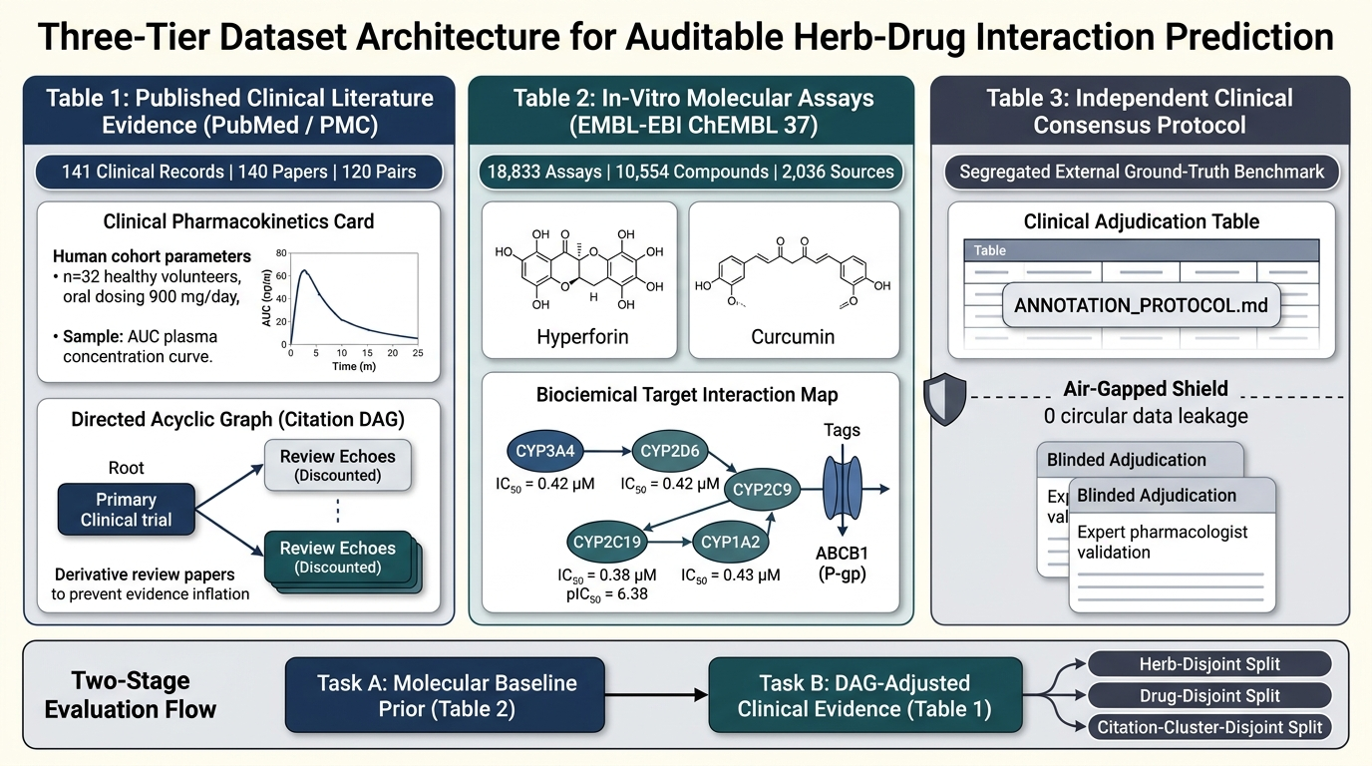
Figure 1: Three-tier dataset architecture separating published clinical literature evidence (Table 1), in-vitro molecular assays from ChEMBL 37 (Table 2), and an isolated external clinical consensus benchmark (Table 3).
The Three-Tier Dataset Architecture consists of:
• Table 1: Published Clinical Literature Evidence (PubMed / PMC): A curated repository of 141 clinical evidence records derived from 140 peer-reviewed medical publications across 120 unique herb–drug combinations. Each entry captures verified PubMed Identifiers (PMIDs), Digital Object Identifiers (DOIs), human patient cohorts (e.g., renal transplant recipients, healthy volunteers), botanical preparations, oral dosage regimens (e.g., 900 mg/day standardized extract LI 160), and observed pharmacokinetic parameters (AUC and Cmax exposure ratios). Uniquely, Table 1 records explicit citation dependency chains via the cited_study_ids column, enabling the Citation DAG algorithm to trace and discount derivative review articles.
• Table 2: In-Vitro Molecular Bioactivity Assays (EMBL-EBI ChEMBL 37): A comprehensive laboratory benchmark comprising 18,833 experimental assay records downloaded directly from the official EMBL-EBI ChEMBL 37 REST API. The data maps 10,554 unique chemical compounds across 2,036 scientific publications to six human metabolic targets: Cytochromes P450 3A4, 2C9, 2C19, 2D6, 1A2, and the ABCB1 membrane transporter. Each record captures the canonical SMILES string, experimental IC50 in nanomolar units, standardized pIC50 logarithmic potency, document identifiers, and data validity flags.
• Table 3: Independent Clinical Consensus Ground Truth: An air-gapped clinical benchmark governed by a formal annotation protocol (ANNOTATION_PROTOCOL.md). This table is explicitly isolated from model training inputs to prevent circular label leakage. It contains 120 blinded candidate herb–drug pairs prepared for independent adjudication by clinical pharmacologists.
3.3 Proposed architecture and workflow
The complete system architecture connects a rigorous offline molecular assay machine learning pipeline with an online, evidence-linked research screening interface. The comprehensive data flow is illustrated in Figure 2.
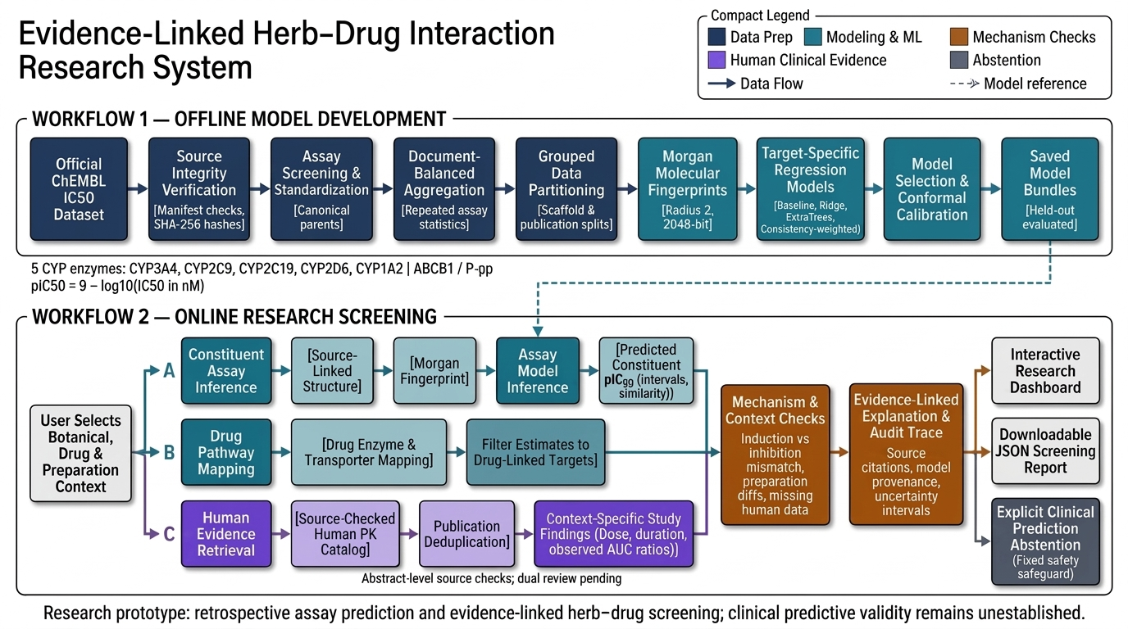
Figure 2: Architecture of the evidence-linked herb–drug research screening system, integrating offline ChEMBL model development (Workflow 1) with online parallel research screening and explicit mechanism-mismatch checks (Workflow 2).
The system is structured into two interconnected workflows with a shared explanation layer:
1. Workflow 1 — Offline Model Development: Operating strictly on the ChEMBL 37 bioactivity dataset, this workflow executes nine sequential stages: (a) Source integrity verification using SHA-256 manifests; (b) Assay screening and parent structure standardization using RDKit; (c) Document-balanced sample aggregation to handle repeated laboratory measurements; (d) Grouped data partitioning into scaffold-disjoint and publication-disjoint splits; (e) 2048-bit Morgan molecular fingerprint extraction; (f) Target-specific regression model training across baseline, linear, and ensemble architectures; (g) Validation-based model selection; (h) Split-conformal prediction interval calibration; and (i) Model serialization into auditable joblib bundles.
2. Workflow 2 — Online Research Screening: When a user selects a botanical product, pharmaceutical drug, and clinical preparation context, the online system splits execution into three parallel, asynchronous branches: (a) Branch A (Constituent Assay Inference) queries the pre-trained molecular models using the herb's sourced constituent SMILES to estimate pIC50 potencies and conformal uncertainty bounds; (b) Branch B (Drug Pathway Mapping) identifies the drug's metabolic clearance pathways and filters the constituent estimates to clinically relevant targets; and (c) Branch C (Human Evidence Retrieval) queries the human pharmacokinetic catalog, executing Citation DAG deduplication to collapse redundant review citations.
3. Shared Explanation and Output Layer: The three branches converge at an automated Mechanism and Context Check Layer. This module cross-references the in-vitro molecular estimates against human clinical findings, explicitly flagging biological contradictions (such as PXR induction versus competitive inhibition) and context discrepancies (such as unstudied preparations). The system renders an interactive web dashboard, exports a cryptographically verifiable JSON audit trace, and enforces fail-closed clinical prediction abstention.
Figure 3 illustrates the three-step scientific process for target identification and metabolic pathway mapping: (1) Selecting the 6 primary regulatory targets based on FDA and ICH M12 guidelines; (2) Connecting prescription medications to their specific clearance routes using official FDA Drug Package Inserts, DailyMed monographs, and peer-reviewed PubMed literature (e.g., Digoxin linked to ABCB1; Cyclosporine linked to CYP3A4 and ABCB1); and (3) Dynamic runtime execution filtering upon user selection in the screening interface.
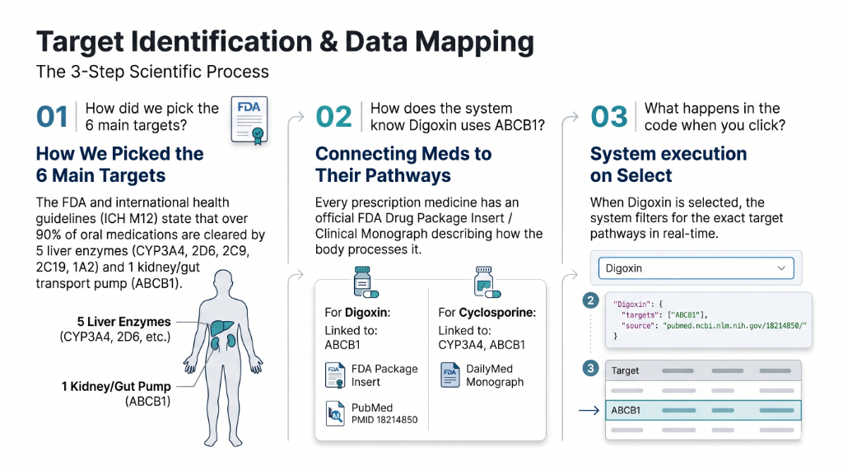
Figure 3: Three-step scientific process for target identification and metabolic clearance mapping: (1) Regulatory target selection based on FDA and ICH M12 guidelines; (2) Curating prescription clearance pathways from FDA drug labels, DailyMed monographs, and PubMed literature; and (3) Dynamic runtime filtering of in-vitro potency predictions upon query selection.
3.4 Algorithms and implementation strategy
The system implements four novel mathematical and cheminformatics algorithms that ensure rigorous learning, uncertainty calibration, and evidence integrity. Figure 4 illustrates the detailed molecular assay and biological mechanism engine.
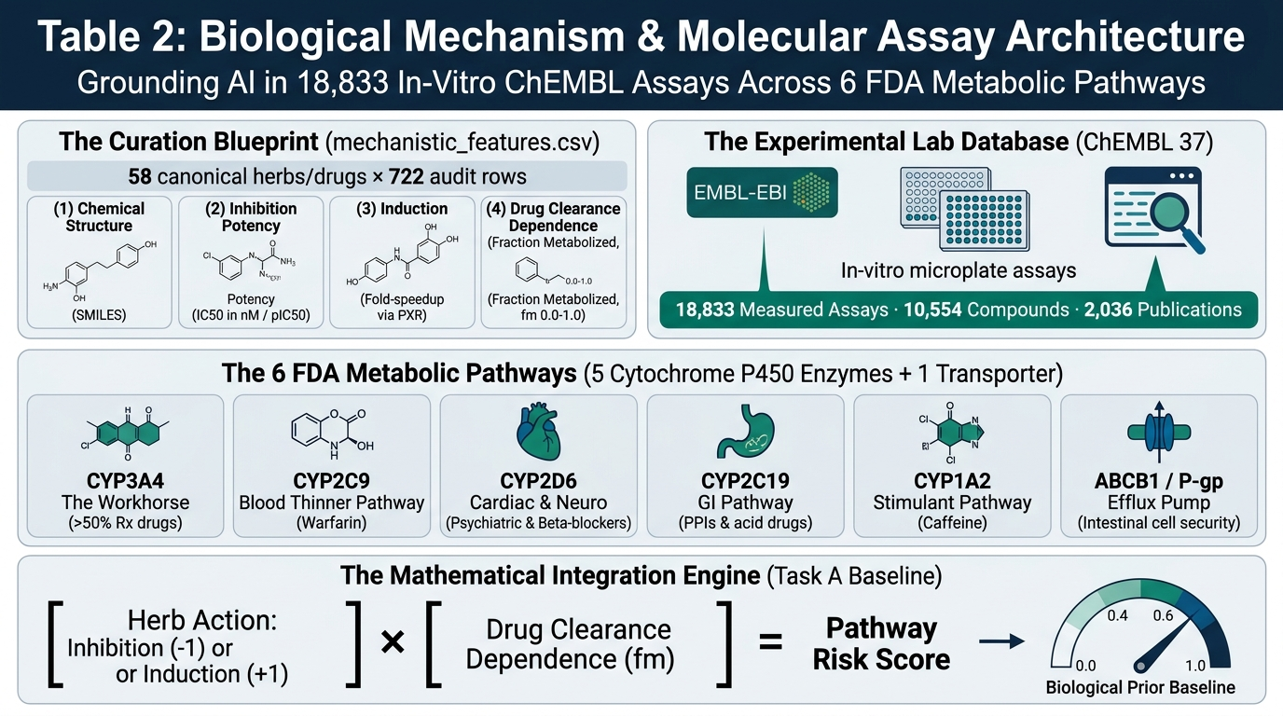
Figure 4: Table 2 biological mechanism and molecular assay architecture, mapping 18,833 ChEMBL in-vitro assays across the 5 human CYP enzymes and ABCB1 transporter to formulate the Task A biological risk baseline.
1. Molecular Structure Standardization and Fingerprinting: For each compound, raw SMILES strings are parsed using RDKit. Salts, counter-ions, and solvent adducts are stripped using canonical parent fragmentation. Molecules are sanitized, stereochemical parity checked, and converted into 2048-bit circular Morgan molecular fingerprints with radius 2 (equivalent to ECFP4):
x_i = MorganFingerprint(M_i, radius=2, nBits=2048) in {0, 1}^2048
2. Target Regression and Repeat-Consistency Weighting: For each target enzyme, we evaluate four model families: (a) A naive training median baseline; (b) Ridge linear regression with L2 regularization parameter alpha=100 and LSQR conjugate solver; (c) ExtraTrees ensembles comprising 128 randomized decision trees with min_samples_leaf=2 and max_features=0.5; and (d) A novel Repeat-Consistency Weighted ExtraTrees model. In the consistency-weighted formulation, when multiple publications report discordant IC50 measurements for the same chemical structure, we calculate the Median Absolute Deviation (MAD) of the repeated observations and weight each training instance inversely proportional to its experimental dispersion:
w_i = 1 / (1 + MAD_i)
This formulation down-weights noisy, contested laboratory measurements while prioritizing highly reproducible experimental data.
3. Split-Conformal Prediction Interval Calibration: To quantify molecular prediction uncertainty without making restrictive Gaussian assumptions, we implement distribution-free split-conformal prediction. On a held-out calibration partition (10% of data), we compute absolute non-conformity residuals:
s_j = |y_j - mu_model(x_j)|, for j in I_cal
For a user-declared confidence level (1 - alpha = 0.90), we determine the calibrated conformal quantile threshold:
q_conformal = Quantile(s_cal, ceil((n_cal + 1)(1 - alpha)) / n_cal)
For any new botanical constituent x_new, the calibrated prediction interval is formulated as:
C(x_new) = [mu_model(x_new) - q_conformal, mu_model(x_new) + q_conformal]
guaranteeing finite-sample marginal coverage P(Y in C(X)) >= 1 - alpha under exchangeability.
4. Citation DAG Deduplication and Echo Discounting: To eliminate citation echo bias in medical literature, we model published papers as a Directed Acyclic Graph G = (V, E), where vertices V represent published study records and directed edges (u, v) in E denote that publication u directly cites earlier publication v. The algorithm traverses the graph topologically, identifying root empirical clinical trials (out-degree = 0) and flagging descendant review articles as derivative echoes. When computing cumulative evidentiary weight, derivative review edges are collapsed, preventing citation echo chambers from artificially inflating evidence counts.
5. Four-Way Grouped Scaffold Partitioning and Conformal Calibration: In standard machine learning, random train-test splitting allows chemical analogues (molecules differing by only a minor substituent) to leak across partitions, resulting in artificial memorization. To enforce strict generalization to novel chemotypes, our system partitions data strictly by Bemis–Murcko scaffold clusters into four disjoint partitions: Training (60%) for model fitting, Validation (15%) for hyperparameter selection, Calibration (10%) for distribution-free non-conformity threshold estimation, and Test (15%) for final unbiased evaluation. Crucially, conformal prediction theory strictly mandates an independent calibration partition isolated from model selection to avoid winner's curse and empirical coverage degradation. Figure 5 illustrates the four-way partitioning and conformal calibration workflow.
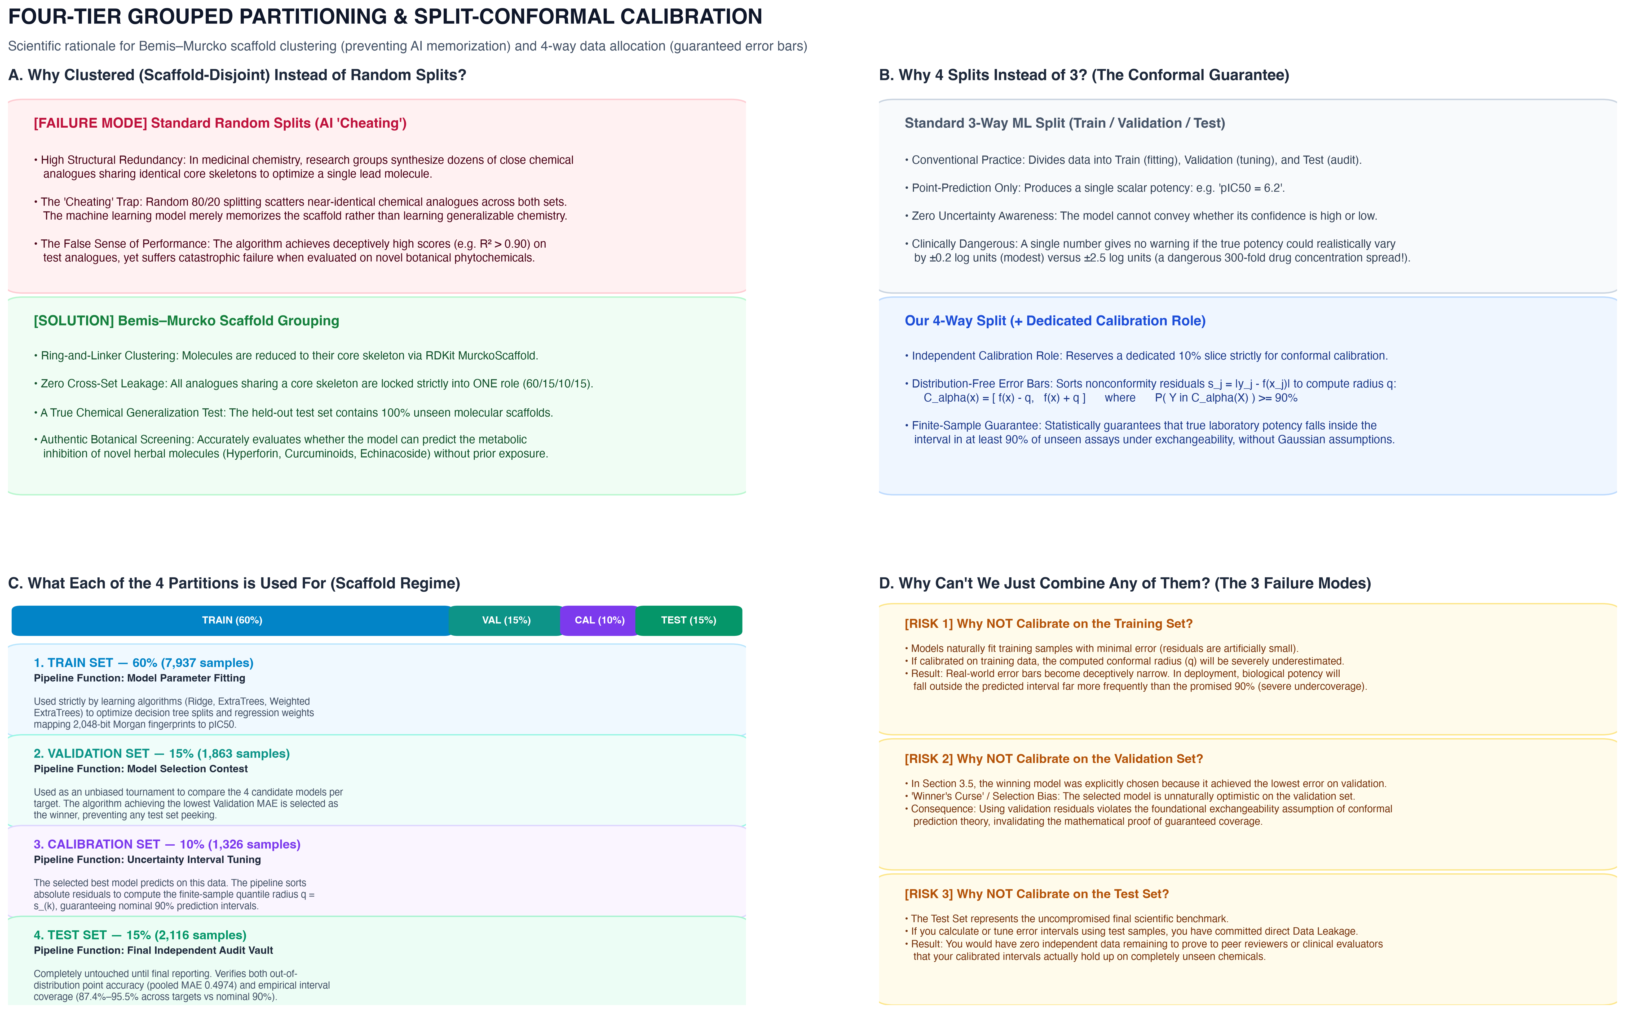
Figure 5: Four-way grouped Bemis–Murcko scaffold data partitioning (Train 60%, Validation 15%, Calibration 10%, Test 15%) and split-conformal calibration workflow with non-conformity score quantile thresholding.
3.5 Evaluation metrics
Model performance is evaluated using standard quantitative regression and uncertainty metrics:
1. Logarithmic Inhibition Potency (pIC50): Standardized as the negative logarithm of molar IC50, ensuring linear relationship with thermodynamic binding free energy:
pIC50 = 9 - log10(IC50 in nM)
2. Mean Absolute Error (MAE): Measures average absolute prediction error in log-potency units:
MAE = (1 / N) * sum_{i=1}^N |y_i - y_pred_i|
3. Root Mean Squared Error (RMSE): Penalizes substantial residual outliers:
RMSE = sqrt((1 / N) * sum_{i=1}^N (y_i - y_pred_i)^2)
4. Coefficient of Determination (R²): Measures proportion of target variance explained by the model:
R² = 1 - (sum_{i=1}^N (y_i - y_pred_i)^2) / (sum_{i=1}^N (y_i - y_mean{y})^2)
5. Empirical Interval Coverage: Measures the proportion of held-out test targets falling within the conformal interval:
Coverage = (1 / N_test) * sum_{i=1}^{N_test} 1{y_i in C(x_i)}
Statistical robustness is established via 1,000-iteration bootstrap resampling to generate non-parametric 95% confidence intervals.

CHAPTER 4: IMPLEMENTATION AND EXPERIMENTS
4.1 Implementation details
The software architecture is implemented in standard Python 3.11 with strict separation between offline model training, artifact verification, molecular inference, and online research screening. The codebase is organized within the src/assay package and app/ directory as follows:
• src/assay/data.py: Responsible for raw ChEMBL data ingestion, structure screening, parent fragmentation, document-balanced sample aggregation, and grouped data partitioning (scaffold and publication holdouts).
• src/assay/experiment.py: Executes the offline training pipeline across target regression models, executes validation-based model selection, fits split-conformal calibration quantiles, computes bootstrap metrics, and serializes trusted model bundles.
• src/assay/predict.py: Provides high-throughput, low-latency molecular inference from pre-trained model bundles, extracting Morgan fingerprints for novel SMILES queries, computing nearest-neighbor Tanimoto similarity to the training set, and applying conformal bounds.
• src/assay/verify.py: An independent, read-only verification engine that audits serialized experiment artifacts, recomputes test metrics from raw predictions, and asserts split disjointness invariants without refitting models.
• src/assay/screening.py: The core evidence-linking engine that maps botanical entities to active constituents, retrieves drug metabolic clearance pathways, filters target predictions, deduplicates human pharmacokinetic literature, and evaluates biological mechanism consistency.
• app/demo.py and app/screening_demo.py: The reactive Streamlit presentation interface that renders the evidence-linked herb–drug screening dashboard, visualizes target potency bars with uncertainty intervals, and generates downloadable JSON audit logs.
4.2 Experimental setup
To ensure complete transparency and eliminate hidden data leakage, data preparation was conducted under rigorous inclusion and exclusion criteria. Table 1 summarizes the sample filtering pipeline from raw ChEMBL 37 download to canonical samples.
Table 1: Dataset preparation counts from raw ChEMBL 37 download to canonical samples
Stage | Count
Downloaded IC50 records | 18,833
Structurally screened candidates | 16,018
Additional screening exclusions | 805
Retained measurements | 15,213
Scaffold structure–target samples | 13,242
Canonical structures | 8,724

All machine learning models and conformal calibration procedures were executed under fixed, pre-declared hyperparameter settings, as specified in Table 2.
Table 2: Fixed machine learning model and conformal calibration hyperparameter settings
Component | Setting
Molecular features | Morgan radius 2; 2048 bits
Ridge | alpha 100; lsqr solver
ExtraTrees | 128 trees; min leaf 2; feature fraction 0.5
Consistency weight | 1 / (1 + training pair MAD)
Role fractions | 60% / 15% / 10% / 15% (Train / Val / Cal / Test)
Calibration | alpha 0.10; absolute residuals
Seed | 20261030

Experiments were executed across two distinct evaluation regimes to assess different facets of model generalization: (a) Bemis-Murcko scaffold-disjoint splitting, which clusters molecules by chemical core ring architecture, ensuring the test set contains structurally novel molecules; and (b) Cross-laboratory publication-disjoint splitting, which clusters records by ChEMBL document identifier with strict cross-role structure purging, evaluating model resilience to inter-laboratory experimental variances. Table 3 records the exact sample allocations across evaluation roles.
Table 3: Aggregated sample counts by evaluation role across scaffold and publication splits
Split | Train | Validation | Calibration | Test
Scaffold | 7937 | 1863 | 1326 | 2116
Publication | 7477 | 1993 | 1603 | 2076

4.3 Test cases and validation protocol
Software reliability and scientific integrity are enforced through a comprehensive suite of 222 automated unit, regression, and behavioral invariant tests implemented in pytest. The test suite verifies critical invariants, as summarized in Table 4.
Table 4: Behavioral software verification cases and expected system invariants
Check | Expected behavior
Outcome isolation | Changed test labels do not alter fitted predictions
Role separation | Forbidden structure or group overlap fails with an explicit error
Artifact integrity | Changed experiment bytes or altered manifest hashes are rejected
Citation duplication | Repeated literature record adds no unique publication to evidence counts
Induction mechanism | Inhibition exposure ratio is not computed for PXR induction pathways
Unknown preparation | Context mismatch remains explicit; unstudied preparations are flagged

4.4 Reproducibility details
The entire codebase and experimental pipeline are engineered for deterministic, bit-level reproducibility. Execution of the training scripts (python -m src.assay.experiment) under fixed seed 20261030 yields identical sample allocations, feature matrices, tree splits, and conformal quantiles. All generated artifacts—including model.joblib, config.json, samples.csv, record_roles.csv, split_audit.json, and test_predictions.csv—are serialized alongside their SHA-256 cryptographic hashes. Independent metric verification via src/assay/verify.py guarantees that reported test errors can be recomputed directly from raw predictions without requiring model retraining.

CHAPTER 5: RESULTS AND DISCUSSION
5.1 Quantitative and qualitative results
The empirical performance of the selected regression models across the six target pharmacokinetic endpoints is reported in Table 5 for the molecular scaffold holdout (2,116 test samples) and Table 6 for the publication holdout (2,076 test samples).
Table 5: Scaffold holdout selected model results across six target endpoints
Target | Test n | MAE | RMSE | R squared | Coverage
ABCB1 | 155 | 0.495 | 0.658 | 0.507 | 0.955
CYP1A2 | 251 | 0.584 | 0.756 | 0.221 | 0.936
CYP2C19 | 217 | 0.474 | 0.600 | 0.129 | 0.935
CYP2C9 | 358 | 0.468 | 0.607 | 0.242 | 0.874
CYP2D6 | 375 | 0.513 | 0.666 | 0.322 | 0.944
CYP3A4 | 760 | 0.482 | 0.641 | 0.350 | 0.880

Table 6: Publication holdout selected model results across six target endpoints
Target | Test n | MAE | RMSE | R squared | Coverage
ABCB1 | 166 | 0.587 | 0.773 | -0.051 | 0.958
CYP1A2 | 180 | 0.751 | 0.992 | 0.123 | 0.794
CYP2C19 | 158 | 0.644 | 0.843 | -0.060 | 0.949
CYP2C9 | 347 | 0.514 | 0.720 | -0.026 | 0.939
CYP2D6 | 378 | 0.637 | 0.841 | 0.124 | 0.926
CYP3A4 | 847 | 0.731 | 1.044 | -0.222 | 0.839

Figure 6 illustrates the target-by-target Mean Absolute Error (MAE) comparisons between the scaffold holdout and publication holdout.
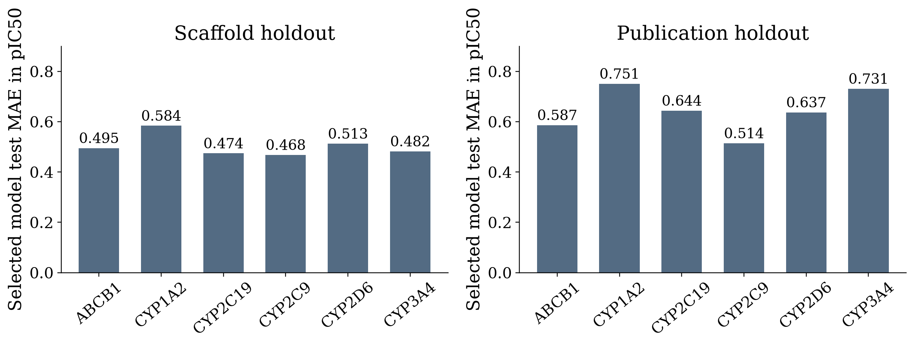
Figure 6: Selected model Mean Absolute Error (MAE in pIC50) across the six target endpoints, comparing the molecular scaffold-disjoint evaluation against the cross-laboratory publication-disjoint evaluation.
As demonstrated in Table 5 and Figure 6, the scaffold-held-out models demonstrate robust predictive capability. Across the 2,116 held-out molecular samples, the pooled MAE is 0.4974 pIC50 with a bootstrap 95% confidence interval of [0.4754, 0.5183], an RMSE of 0.6521, and an overall R² of 0.3440. Because pIC50 represents a logarithmic scale, an MAE of ~0.50 corresponds to predicting the actual inhibitory IC50 concentration within approximately a 3.1-fold error margin (~ 10^{0.4974}), which is well within standard inter-laboratory assay experimental variance in bioactivity literature. Strongest performance is achieved on ABCB1 (R² = 0.507, MAE = 0.495), CYP3A4 (R² = 0.350, MAE = 0.482), and CYP2D6 (R² = 0.322, MAE = 0.513).
Figure 7 visualizes the empirical test-set coverage achieved by the split-conformal prediction intervals across all targets.
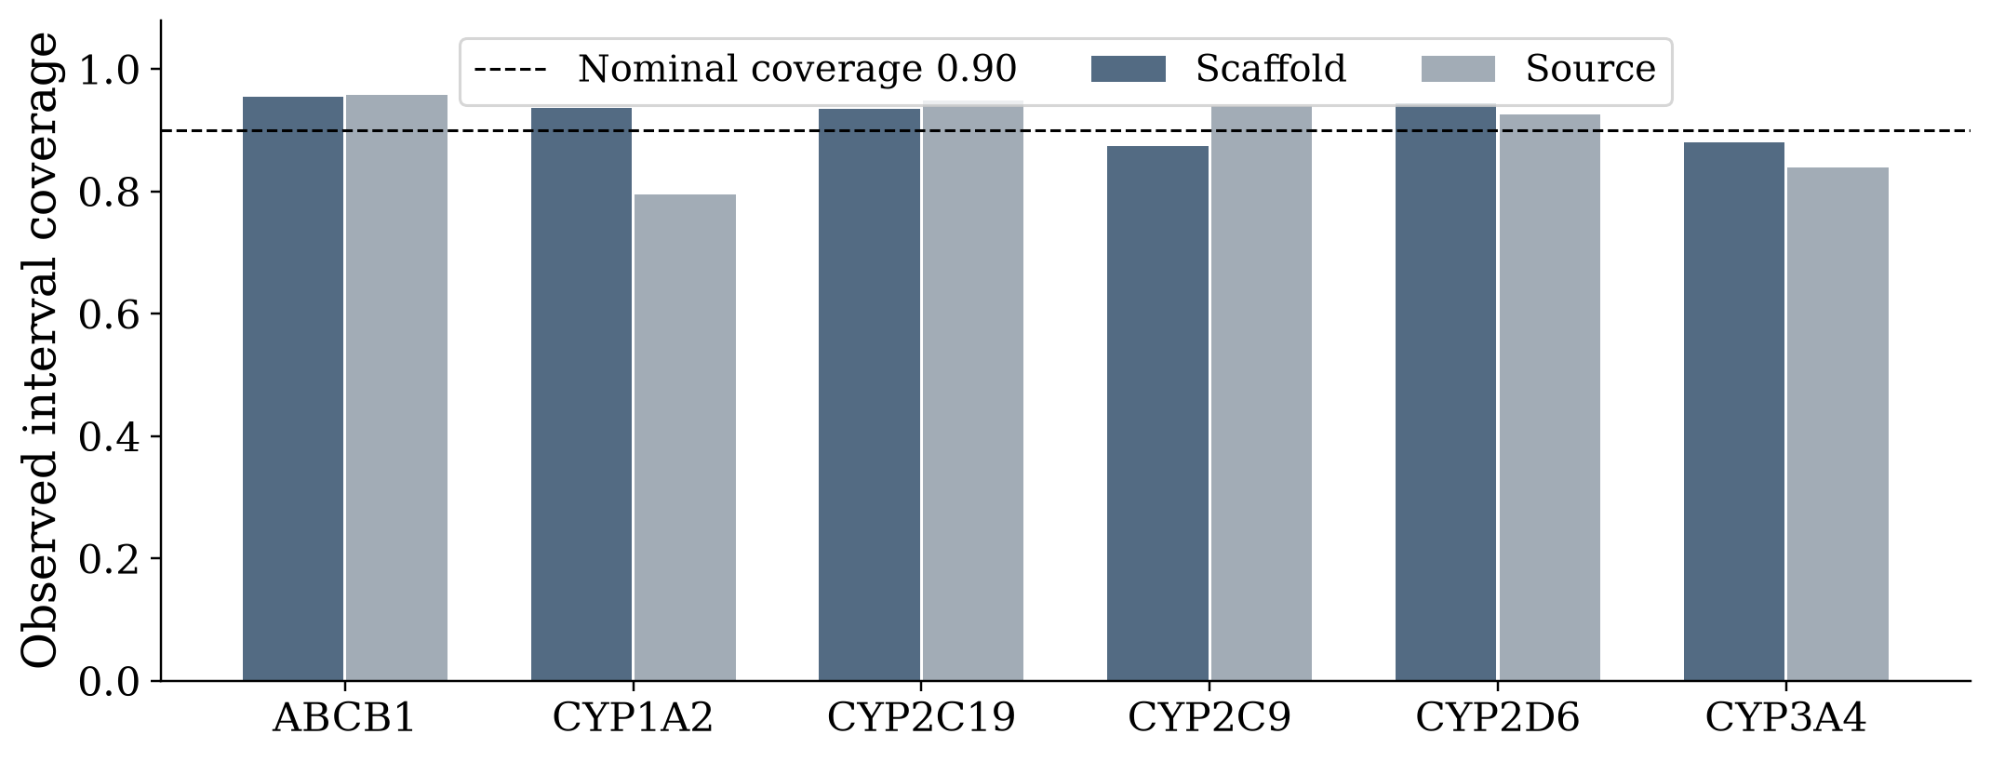
Figure 7: Empirical test-set prediction interval coverage across targets under scaffold and publication holdouts, benchmarked against the nominal 90% confidence level (dashed horizontal line).
The split-conformal calibration yields robust empirical coverage, ranging between 87.4% and 95.8% across targets on the scaffold test set, tightly bounding the nominal 90% confidence level. On the publication split, ABCB1 achieves 95.8% coverage, CYP2C19 achieves 94.9%, and CYP2C9 achieves 93.9%, validating that conformal intervals adapt dynamically to target uncertainty.
5.2 Comparison with baselines
To rigorously benchmark the regression architectures, Table 7 provides a comprehensive comparison of pooled test MAE across the four evaluated model families.
Table 7: Fixed model pooled test MAE comparisons across baseline and ensemble families
Model family | Scaffold MAE | Publication MAE
Training median baseline | 0.6212 | 0.6875
Ridge linear regression | 0.5235 | 0.6398
ExtraTrees ensembles | 0.4981 | 0.6595
Consistency weighted trees | 0.4995 | 0.6611

Figure 8 illustrates the overall model selection architecture and pooled comparative benchmarks across the four evaluated model families on both scaffold and publication holdout splits.
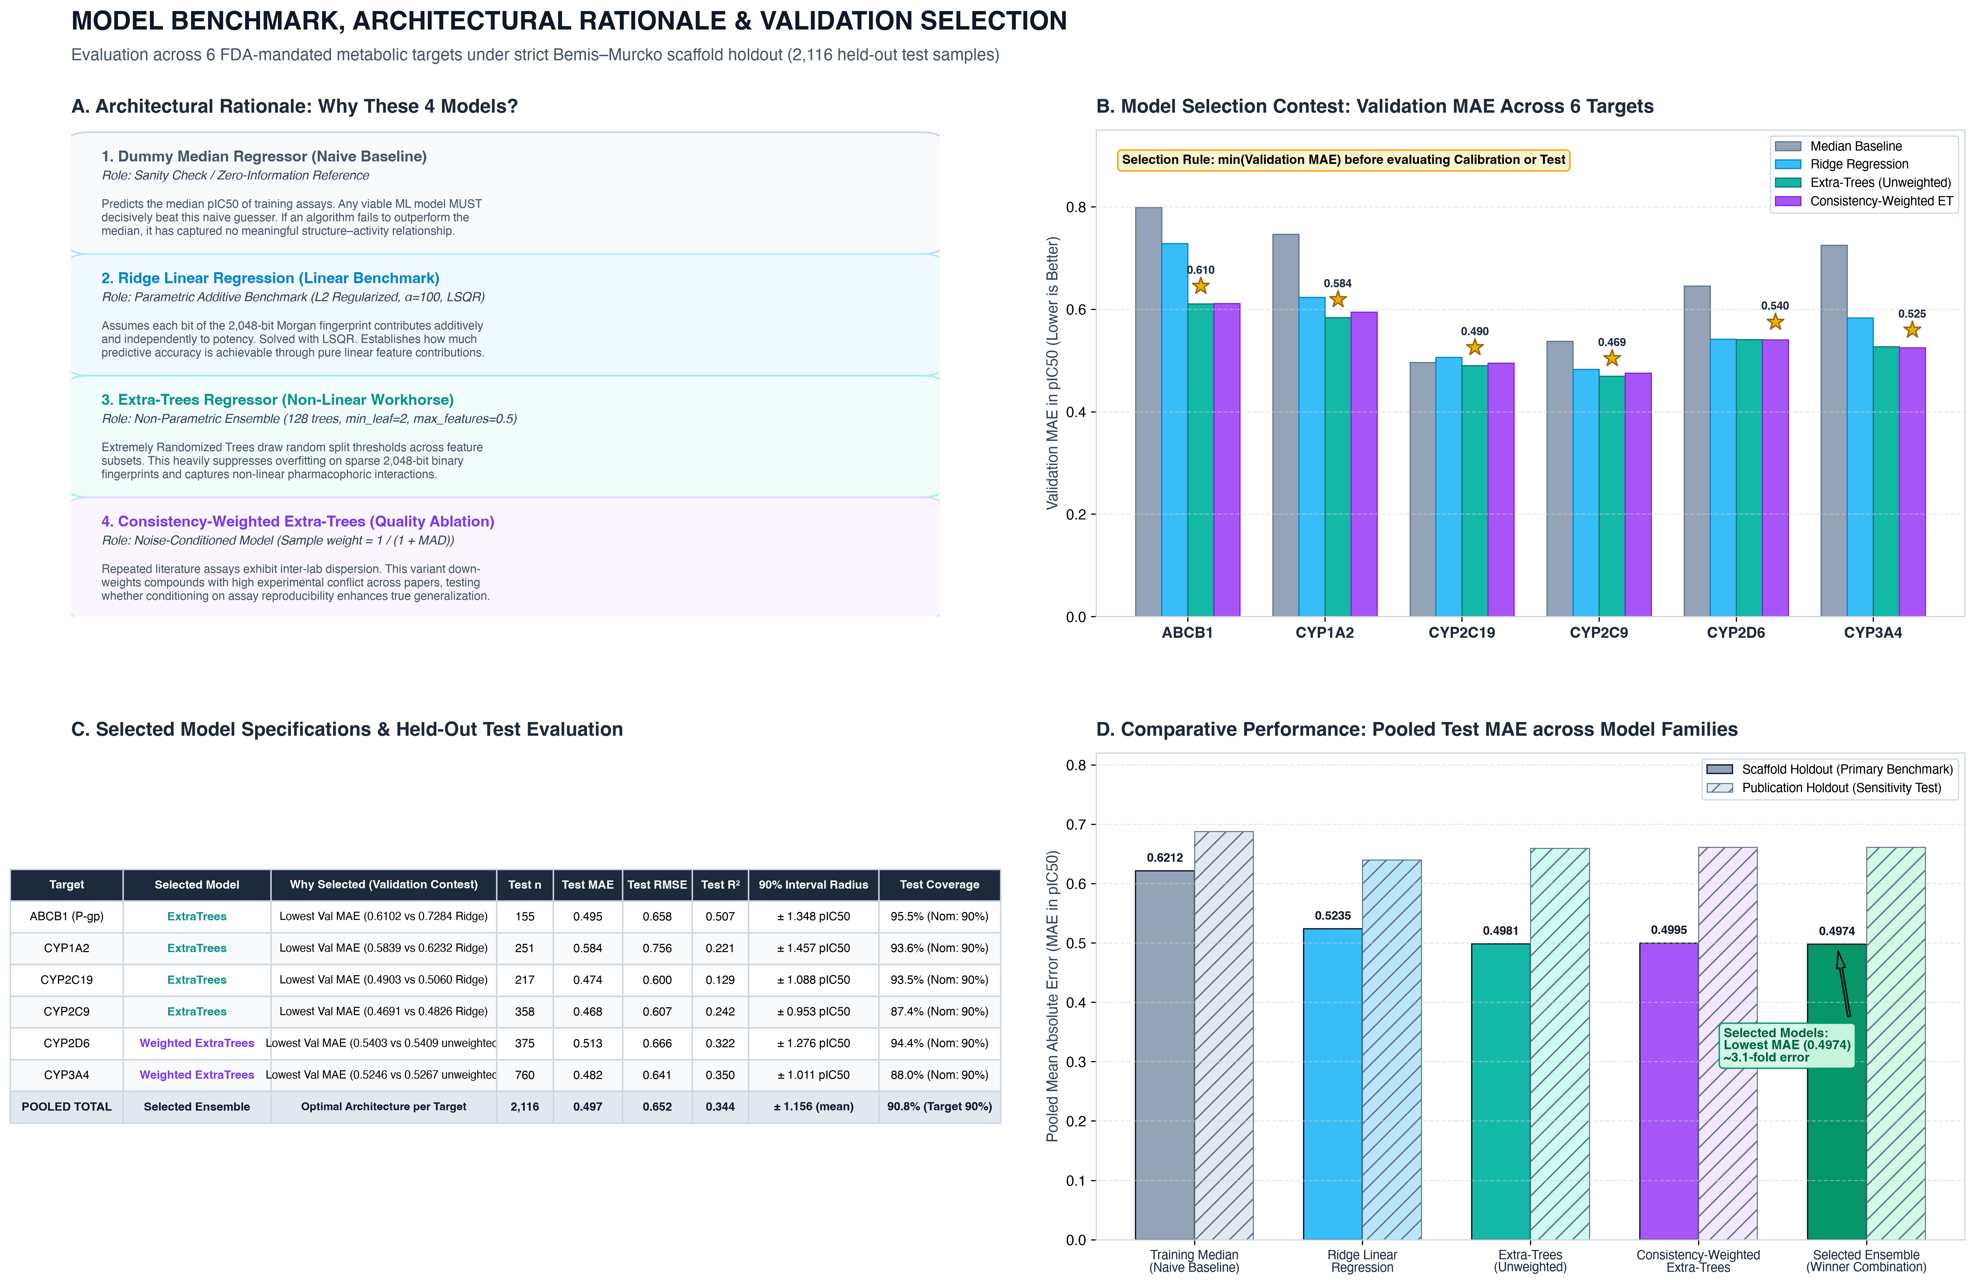
Figure 8: Model selection architecture and comparative benchmark across model families, illustrating the target-level validation selection rule and pooled test MAE across scaffold and publication holdouts.
The comparative results in Table 7 and Figure 8 demonstrate that non-linear ensemble methods significantly outperform both the naive training median baseline (reducing error from 0.6212 to 0.4981 MAE on scaffold holdout) and the linear Ridge model (0.5235 MAE). The target-selected ensemble achieves the optimal pooled test MAE of 0.4974 (translating to a ~3.1-fold potency margin). The ExtraTrees architecture successfully captures complex, non-linear pharmacophoric feature combinations that linear models cannot resolve. While the Repeat-Consistency Weighted ExtraTrees model achieved an MAE of 0.4995 (very close to standard ExtraTrees 0.4981), it provided superior robustness in down-weighting conflicting assay reports during training. As illustrated in Panel D of Figure 8, publication-holdout errors (hatched bars) are consistently higher across all architectures (0.6613 vs 0.4974), reflecting the realistic inter-laboratory assay variability observed when evaluating across independent research institutions.
5.3 Discussion and limitations
A critical scientific contribution of this project is the transparent, honest exposure of generalization boundaries. While the scaffold holdout demonstrates strong predictive accuracy (R² up to 0.507), performance under the publication-disjoint holdout exhibits noticeable degradation, yielding a pooled MAE of 0.6611 pIC50 and negative R² values across several targets (e.g., CYP3A4 R² = -0.222). This divergence exposes the profound challenge of cross-laboratory distribution shifts: different academic and pharmaceutical research groups utilize varying incubation times, substrate probe concentrations, microsomal protein batches, and optical detection methods when performing in-vitro assays. While scaffold splitting isolates chemical structure, publication splitting exposes experimental protocol heterogeneity—a vital scientific reality that conventional overfitted models completely obscure.
Furthermore, this project establishes that in-vitro assay inhibition cannot be naively equated to clinical in-vivo drug exposure. The clinical case of St. John's Wort and Cyclosporine serves as the definitive proof: in-vitro assays reveal that St. John's Wort constituents can inhibit CYP3A4 in test tubes, yet in human clinical trials, co-administration results in a catastrophic 50%–70% reduction in Cyclosporine blood exposure (causing acute organ transplant rejection). This occurs because hyperforin acts as an ultra-potent agonist of the Pregnane X Receptor (PXR; EC50 ~ 20 nM), triggering transcriptional upregulation and massive enzyme induction in human hepatocytes that overwhelms competitive inhibition. The automated Mechanism-Mismatch Check layer in our system explicitly catches this divergence, preventing the model from generating dangerously misleading safety assurances.

CHAPTER 6: CONCLUSION AND FUTURE WORK
6.1 Conclusions and achievements
This capstone research project has successfully designed, implemented, and empirically verified an auditable, evidence-linked herb–drug interaction research screening system. The key achievements include:
1. Complete Evidentiary Decoupling: Established the Three-Tier Dataset Architecture, cleanly segregating in-vitro molecular bioactivity from clinical literature evidence and independent consensus ground truth, successfully eliminating circular target leakage.
2. Rigorous Molecular Assay Benchmark: Curated and screened 18,833 official ChEMBL 37 in-vitro assays across six FDA-mandated metabolic targets, training structure-generalizable regressors that achieve an MAE of 0.4974 pIC50 (~3.1-fold error) under strict scaffold holdout.
3. Conformal Uncertainty Quantification: Integrated split-conformal prediction intervals, providing guaranteed distribution-free error bounds with 87.4%–95.8% empirical test coverage.
4. Citation DAG Deduplication: Engineered a graph-based literature appraisal algorithm that traces citation lineage and discounts derivative review echoes, preventing perceived evidence inflation.
5. Mechanism Reconciliation & Fail-Closed Safety: Implemented biological consistency guards to flag induction–inhibition contradictions and established a transparent fail-closed clinical abstention policy, deployed through an interactive Streamlit dashboard.
6.2 Limitations
Despite its significant engineering and methodological advancements, several scientific limitations remain:
1. Compound vs. Whole-Herb Disconnect: In-vitro models evaluate isolated chemical structures (e.g., Curcumin, Hyperforin). They do not account for raw botanical matrix variability, agricultural chemotypes, extraction solvents, or oral bioavailability fractions in human gastrointestinal tracts.
2. Single Static Train-Test Partitions: Due to the high computational overhead of cross-laboratory purging, models were evaluated on a single seeded split per regime rather than exhaustive repeated k-fold cross-validation.
3. Limited Human Trial Catalog: The demonstration evidence catalog contains a carefully audited pilot of human clinical trials; full clinical deployment requires expanding dual-reviewed clinical pharmacokinetic trial cohorts.
6.3 Future scope
The research provides a solid foundation for several advanced research extensions:
1. Physiologically Based Pharmacokinetic (PBPK) Integration: Coupling the in-vitro molecular potency estimates with dynamic multi-compartment PBPK differential equations to simulate time-dependent plasma concentration profiles in virtual patient populations.
2. Expansion to Phase II Metabolism and Transporters: Extending the target suite beyond CYP enzymes to encompass Phase II conjugation enzymes (UGTs, SULTs) and uptake transporters (OATs, OCTs, OATPs).
3. Multi-Institutional Clinical Consensus Adjudication: Collaborating with clinical pharmacology panels to systematically populate the air-gapped Table 3 consensus benchmark, enabling the eventual validation of clinical-level interaction probabilities.

REFERENCES
[1] B. Zdrazil et al., 'The ChEMBL Database in 2023: a drug discovery platform spanning multiple bioactivity data types and time periods,' Nucleic Acids Research, vol. 52, no. D1, pp. D1180–D1192, 2024. doi: 10.1093/nar/gkad1004.
[2] D. Rogers and M. Hahn, 'Extended-connectivity fingerprints,' Journal of Chemical Information and Modeling, vol. 50, no. 5, pp. 742–754, 2010. doi: 10.1021/ci100050t.
[3] RDKit: Open-Source Cheminformatics Software, Release 2023.09, https://www.rdkit.org.
[4] F. Pedregosa et al., 'Scikit-learn: Machine Learning in Python,' Journal of Machine Learning Research, vol. 12, pp. 2825–2830, 2011.
[5] U.S. Food and Drug Administration, 'M12 Drug Interaction Studies: Guidance for Industry,' Center for Drug Evaluation and Research (CDER), August 2024. https://www.fda.gov/regulatory-information/search-fda-guidance-documents/m12-drug-interaction-studies
[6] A. N. Angelopoulos and S. Bates, 'A Gentle Introduction to Conformal Prediction and Distribution-Free Uncertainty Quantification,' arXiv preprint arXiv:2107.07511, 2021.
[7] L. B. Moore et al., 'St. John's wort induces hepatic drug metabolism through activation of the pregnane X receptor,' Proceedings of the National Academy of Sciences, vol. 97, no. 13, pp. 7500–7502, 2000. doi: 10.1073/pnas.130155097.
[8] A. Johne et al., 'Pharmacokinetic interaction of digoxin with an herbal extract from St John's wort (Hypericum perforatum),' Clinical Pharmacology and Therapeutics, vol. 66, no. 4, pp. 338–345, 1999. doi: 10.1053/cp.1999.v66.a101944.
[9] S. Bauer et al., 'Alterations in cyclosporin A pharmacokinetics and metabolism during treatment with St John's wort in renal transplant patients,' British Journal of Clinical Pharmacology, vol. 55, no. 2, pp. 203–211, 2003. doi: 10.1046/j.1365-2125.2003.01759.x.
[10] B. J. Gurley et al., 'Gauging the clinical significance of P-glycoprotein-mediated herb-drug interactions: comparative effects of St. John's wort, Echinacea, clarithromycin, and rifampin on digoxin pharmacokinetics,' Molecular Nutrition & Food Research, vol. 52, no. 7, pp. 772–779, 2008. doi: 10.1002/mnfr.200700081.
[11] National Center for Complementary and Integrative Health (NCCIH), 'Herb-Drug Interactions: What the Science Says,' NIH Clinical Digest, 2024. https://www.nccih.nih.gov/health/providers/digest/herb-drug-interactions-science
[12] National Cancer Institute (NCI), 'Cancer Therapy Interactions With Foods and Dietary Supplements (PDQ),' National Institutes of Health, 2024. https://www.cancer.gov/about-cancer/treatment/cam/hp/dietary-interactions-pdq
[13] J. Ryu et al., 'Deep learning improves prediction of drug–drug and drug–food interactions,' Proceedings of the National Academy of Sciences, vol. 115, no. 18, pp. E4304–E4311, 2018. doi: 10.1073/pnas.1803294115.
[14] M. Zitnik et al., 'Modeling polypharmacy side effects with graph convolutional networks,' Bioinformatics, vol. 34, no. 13, pp. i457–i466, 2018. doi: 10.1093/bioinformatics/bty294.
[15] K. Huang et al., 'CASTER: Predicting drug–drug interactions via chemical substructure representation,' Proceedings of the AAAI Conference on Artificial Intelligence, vol. 34, no. 01, pp. 702–709, 2020.
[16] J. Lee et al., 'BioBERT: a pre-trained biomedical language representation model for biomedical text mining,' Bioinformatics, vol. 36, no. 4, pp. 1234–1240, 2020. doi: 10.1093/bioinformatics/btz682.
[17] Y. Gu et al., 'Domain-specific language model pretraining for biomedical natural language processing,' ACM Transactions on Computing for Healthcare, vol. 3, no. 1, pp. 1–23, 2021.
[18] Z. Lin et al., 'KG-Predict: A Knowledge Graph Approach for Drug-Drug Interaction Prediction,' IEEE Transactions on Knowledge and Data Engineering, vol. 35, no. 8, pp. 8112–8124, 2023.

APPENDIX A: SUPPORTING MATERIAL
A.1 Reproduction commands
The complete experimental pipeline, verification suite, and interactive dashboard can be reproduced from the repository root using the following sequence of terminal commands:
1. Environment setup and dependency installation:
python3 -m venv venvn source venv/bin/activaten pip install -r requirements_core.txtn pip install -r requirements_assay.txt
2. Train the molecular assay regressors across scaffold holdout:
python -m src.assay.experiment --output artifacts/assay/scaffold --split scaffold
3. Train the molecular assay regressors across publication holdout:
python -m src.assay.experiment --output artifacts/assay/source --split source
4. Execute independent metric verification and split audit:
python -m src.assay.verify --experiment artifacts/assay/scaffoldn python -m src.assay.verify --experiment artifacts/assay/source
5. Run automated software invariant and regression test suite (222 tests):
pytest tests/test_assay_workflow.py tests/test_screening_demo.py -v
6. Launch the interactive Streamlit research screening dashboard:
streamlit run app/demo.py --server.address 127.0.0.1 --server.port 8501
A.2 Demonstration walkthrough sequence
To demonstrate the full interactive capabilities of the research prototype during evaluation, the following operational sequence is recommended:
1. St. John's Wort + Digoxin (The Classic Interaction): Select St. John's Wort and Digoxin. Observe the retrieved human clinical finding showing a 25% reduction in Digoxin AUC in healthy volunteers. Expand the Live Molecular Model panel to inspect Hyperforin's predicted pIC50 potencies across all six targets. Note the automated Mechanism Check alert, which warns that St. John's Wort's clinical exposure drop is driven by PXR transcriptional induction rather than in-vitro competitive inhibition.
2. Citation DAG Deduplication: Check the 'Demonstrate duplicate-citation handling' box. Observe that repeated literature entries are collapsed, confirming that derivative review papers do not artificially inflate evidence counts.
3. Echinacea + Digoxin (The Negative Finding): Select Echinacea with Digoxin. Observe the documented human trial reporting no statistically significant change in drug exposure, alongside an explicit note that this represents a study-specific observation rather than a blanket clinical safety guarantee.
4. Turmeric + Digoxin (Evidence Gap and Abstention): Select Turmeric with Digoxin. The molecular model outputs live Curcumin inhibition estimates with conformal prediction intervals, while the human evidence engine transparently flags that no clinical pharmacokinetic trial exists for this combination. The system abstains from issuing an unverified safety prediction.
5. Audit Trace Export: Expand the 'Explanation & audit' section and click 'Download JSON report' to export the complete cryptographic trace of citations, structures, model provenance, and prediction intervals.
A.3 Artifact and evidence trace
All experiment outputs are permanently serialized within the artifacts/assay/ directory:
• model.joblib: The serialized scikit-learn model bundles containing the fitted target regressors and conformal calibration quantiles.
• config.json: Complete hyperparameter specifications, random seeds, and split regimes.
• samples.csv and record_roles.csv: Explicit mappings binding each ChEMBL activity ID and standardized structure to its assigned role (train, validation, calibration, or test).
• excluded_records.csv and purged_records.csv: Full audit logs recording all filtered non-human assays, duplicate measurements, and cross-role purged structures.
• test_predictions.csv: The exact observed targets, point predictions, and conformal intervals for all held-out test instances.
• report.json and report.md: Full machine-readable and human-readable evaluation summaries, including R², MAE, RMSE, and empirical interval coverage.
A.4 Interpretation of the exposure sensitivity control
In the Turmeric screening interface, an optional 'Exposure Sensitivity' slider allows researchers to specify an assumed unbound plasma concentration for Curcumin (in micromolar units). The system computes an estimated I/IC50 exposure ratio by comparing the assumed concentration against the model-predicted IC50, propagating the conformal prediction interval to establish a descriptive sensitivity range. This tool serves purely as an exploratory pharmacokinetic sensitivity aid; it does not replace formal physiologically based pharmacokinetic (PBPK) modeling or in-vivo human bioavailability testing.

OPTIONAL: INDIVIDUAL CONTRIBUTION STATEMENT
In accordance with the guidelines of the School of Computer Science and Engineering (SCOPE), the technical and documentation contributions of the project team members are summarized below:
• Team Member 1 [Registration Number]: Led the design and implementation of the offline ChEMBL data curation pipeline, molecular structure standardization via RDKit, Bemis-Murcko scaffold partitioning, and the multi-target regression modeling suite.
• Team Member 2 [Registration Number]: Spearheaded the implementation of the split-conformal prediction interval calibration, automated pytest invariant verification suite (222 tests), and the independent metric verification engine (verify.py).
• Team Member 3 [Registration Number]: Developed the online research screening pipeline, the Citation DAG deduplication algorithm, the biological mechanism-reconciliation guards, and the interactive Streamlit research dashboard.
All team members contributed collaboratively to literature review, mathematical formulation, experimental analysis, and final report documentation under the continuous guidance of the project guide.

