**Date:** 15/10/2024

**Roll No. and Name:** 24ITK003 Divy Mevada

**Course Code and Name:** 2CS101 Computer Programming

**Practical No:** 7(a)

**AIM** **:**

Consider a currency system in which there are notes of seven denominations, namely Rs. 1, Rs. 2, Rs. 5, Rs. 10, Rs. 20, Rs. 50 and Rs. 100. A sum of Rs. N is entered as an input. Write a function to compute the smallest number of notes that will combine to give Rs. N.

**Methodology followed:**

#include<stdio.h>

float currency(int n);

float currency (int n)

{

int note[7] = {100,50,20,10,5,2,1};

for(int i =0;i<7;i++)

{

int count=0;

if(note[i] <= n)

{

count = n / note[i];

n = n % note[i];

printf("the required notes of %d is %d\n",note[i],count);

}

}

}

int main()

{

int amount;

printf("Enter the amount : ");

scanf("%d",&amount);

currency(amount);

}

**Theoretical Principles used:**

Use user define function to calculate number of note with help of loops and array

**Output:**

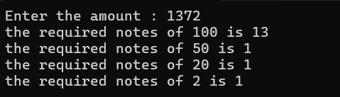

**Practical No:** 7(b)

**AIM** **:**

b. Write a program to find F(n) such that F(n) = 0, if n = 0, F(n) = 1, if n = 1, otherwise F(n) = F(n - 1) + F(n - 2).

**Methodology followed:**

#include<stdio.h>

int f(int x);

int f(int x)

{

if(x==0)

{

return 0;

} else if (x==1)

{

return 1;

}else if(x>1){

return f(x-1) + f(x-2);

}

printf("%d",f(x));

}

int main()

{

int n;

printf("Enter the number : ");

scanf("%d",&n);

int ans = f(n);

printf("%d",ans);

return 0;

}

**Theoretical Principles used:**

Use of recursive function to find fibonacci series with help of conditional statements

**Output:**



**Conclusion :**

Basic knowledge of declare, define and use user-defined functions and recursive functions for modular programming