Data Communication

Topic: OSI Model Simulator
B.Tech Semester IV

Report prepared by:
Patel Jiya 24BCE307
Kharadi Dhara 24BCE309



School of Engineering
Institute of Technology
Nirma University
Ahmedabad 382481

March 2026

Index
Sr. no. | Particulars | Page no.
01 | Abstract | 2
02 | Introduction | 2
03 | Objectives | 3
04 | Theoretical Background  4.1 OSI Model  4.2 Data Encapsulation  4.3 Data Decapsulation  4.4 Importance of OSI Model | 3
05 | System Architecture | 5
06 | Features of the system | 6
07 | Working of the system | 6
08 | Implementation | 7
09 | Screenshots | 8
10 | Project link | 9
11 | Advantages | 9
12 | Limitations | 9
13 | Future Scope | 9
14 | Conclusion | 10
15 | References | 10

OSI MODEL SIMULATOR REPORT

A Detailed Study and Simulation of Data Encapsulation and Decapsulation in the OSI Model

1. Abstract
In modern computer networking, structured communication between systems is essential for reliable data exchange. The OSI (Open Systems Interconnection) model provides a standardized framework that defines how data is transmitted across networks through seven distinct layers.
However, despite its importance, students often struggle to visualize the actual flow of data through these layers. This project presents an OSI Model Simulator, developed to provide a comprehensive and interactive understanding of the processes of data encapsulation and decapsulation.
The simulator is implemented using web technologies such as HTML, CSS, and JavaScript, and demonstrates how data is transformed at each layer during transmission. It acts as an educational tool that bridges the gap between theoretical knowledge and practical visualization.

2. Introduction
Data communication is the backbone of modern digital systems. Whenever a user sends a message, accesses a website, or streams content, data is transmitted across networks following a structured process.
To standardize this process, the OSI model was introduced by the International Organization for Standardization (ISO). It divides communication into seven layers, each responsible for a specific function.
Traditional learning methods focus mainly on memorization of layer names and functions. However, deeper understanding requires visualization of:
- Data transformation across layers
- Header and trailer addition
- Addressing mechanisms
- Protocol interactions
The OSI Model Simulator addresses these challenges by providing a step-by-step graphical representation of how data travels from sender to receiver.

3. Objectives
The main objectives of this project are:
- To provide an in-depth understanding of the OSI model
- To demonstrate encapsulation and decapsulation processes
- To simulate real-world networking parameters
- To develop an interactive educational tool
- To enhance conceptual clarity through visualization

4. Theoretical Background

4.1 OSI Model Overview
The OSI model consists of seven layers:
Name Function
7 | Application | Interface for user applications
6 | Presentation | Data encoding, encryption, compression
5 | Session | Session establishment and management
4 | Transport | Reliable data delivery, segmentation
3 | Network | Logical addressing and routing
2 | Data Link | Physical addressing and error detection
1 | Physical | Transmission of raw bits
Each layer communicates with its corresponding layer on another system using protocols.

4.2 Data Encapsulation (Sender Side)
Encapsulation is the process of adding control information to data as it moves down the OSI layers.
Steps involved:
- Application Layer: Generates raw data
- Presentation Layer: Encodes data
- Session Layer: Adds session details
- Transport Layer: Adds port numbers → Segment
- Network Layer: Adds IP address → Packet
- Data Link Layer: Adds MAC address + FCS → Frame
- Physical Layer: Converts frame into bits
Final Transformation:
Data → Segment → Packet → Frame → Bits

4.3 Data Decapsulation (Receiver Side)
Decapsulation is the reverse process:
- Physical Layer receives bits
- Data Link Layer removes frame header
- Network Layer removes IP header
- Transport Layer extracts segment
- Session and Presentation layers process data
- Application layer delivers final message

4.4 Protocols Used in OSI Layers
- Application: HTTP, FTP, SMTP
- Transport: TCP, UDP
- Network: IP
- Data Link: Ethernet
- Physical: Transmission media standards

4.5 Importance of OSI Model
- Standardizes communication
- Enables interoperability
- Simplifies troubleshooting
- Supports modular design

5. System Architecture
The simulator follows a three-phase architecture:
- Sender Side (Encapsulation)
- Transmission Medium
- Receiver Side (Decapsulation)
The system simulates 14 steps representing each OSI layer’s role.

6. System Features
- Predefined network devices with IP and MAC
- User-defined message input
- Protocol selection (TCP/UDP)
- Encoding methods (UTF-8, ASCII, Base64)
- Step-by-step OSI layer simulation
- Automatic generation of:
  - Port numbers
  - Session IDs
  - MAC/IP addresses
  - Frame Check Sequence (FCS)
- Binary conversion at physical layer
- Visual animation of data transmission
- Reset and replay functionality

7. Working Principle

7.1 Input Phase
User provides:
- Sender device
- Receiver device
- Message
- Protocol and encoding

7.2 Sender Side Processing
Data flows from Layer 7 to Layer 1:
- Data preparation
- Encoding
- Session establishment
- Segmentation
- Routing information
- Framing
- Bit conversion

7.3 Transmission Phase
Data is transmitted as binary across the network medium.

7.4 Receiver Side Processing
Reverse process:
- Bits → Frame → Packet → Segment → Data
- Headers removed
- Data decoded
- Final message delivered

8. Implementation Details
Technologies used:
- HTML – Structure
- CSS – Styling
- JavaScript – Logic and interactivity
Core implementation includes:
- Event-driven simulation
- Dynamic data transformation
- Layer-wise execution

9. Screenshots of the System
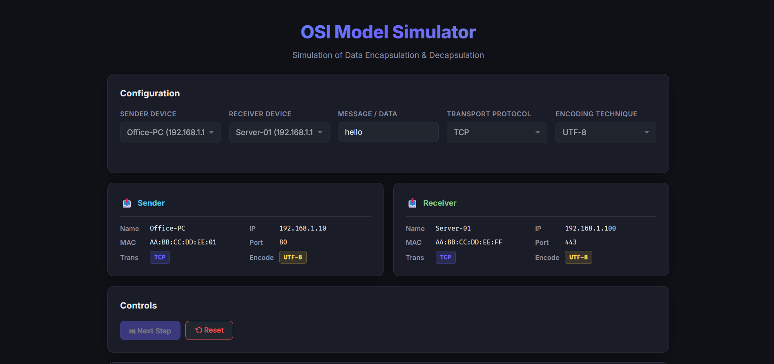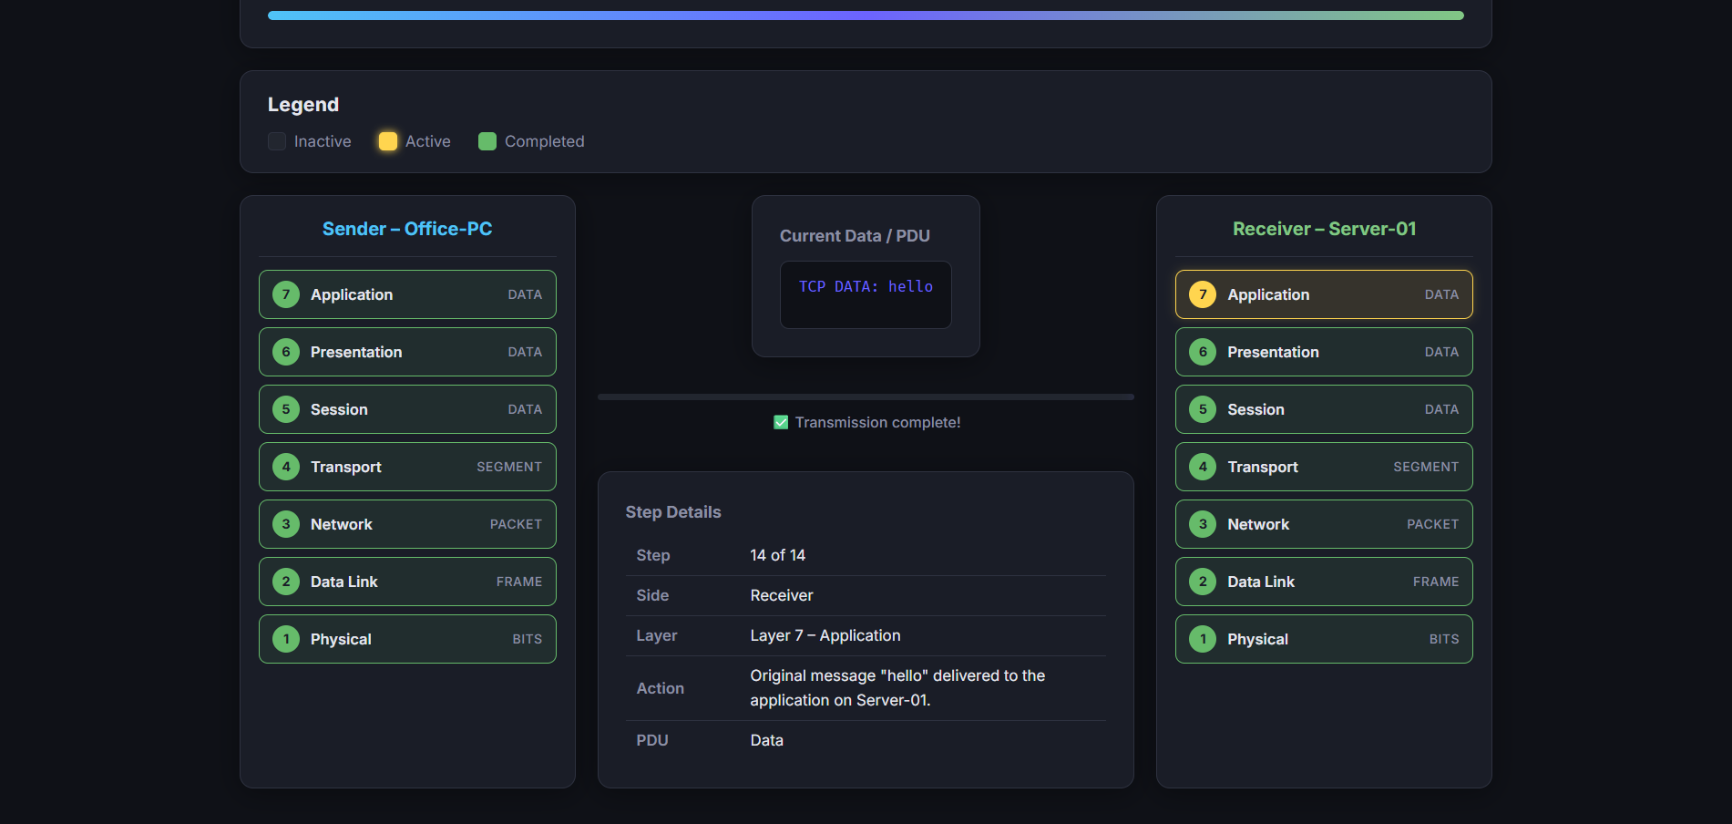

10. Project Website Link
https://github.com/jiyaa-patel/osi-encapsulation-decapsulation
Project URL:
https://osi-encapsulation-decapsulation.vercel.app/

11. Advantages
- Improves conceptual understanding
- Interactive and engaging
- Easy to use
- Lightweight and accessible
- Ideal for academic learning

12. Limitations
- Not a real network simulation
- Limited protocol coverage
- No real-time packet loss handling
- Basic visualization

13. Future Scope
- Real-time packet simulation
- Error handling (packet loss, delay)
- Advanced UI/UX improvements
- Multi-device communication
- Integration with backend networking tools

14. Conclusion
The OSI Model Simulator effectively transforms a complex theoretical concept into an interactive learning experience. By visually demonstrating encapsulation and decapsulation, it enhances understanding of network communication processes.
This project serves as a valuable educational tool for students and provides a strong foundation for advanced networking studies.

15. References
- Data Communications and Networking – Behrouz A. Forouzan
- Computer Networks – Andrew S. Tanenbaum
- ISO OSI Model Documentation
- Online educational resources

