**Name:** Jiyad Khan

**Roll No:** 19I-1771

**Section:** BS-DS (N)

**DAV Assignment 1**

**Question 1:**

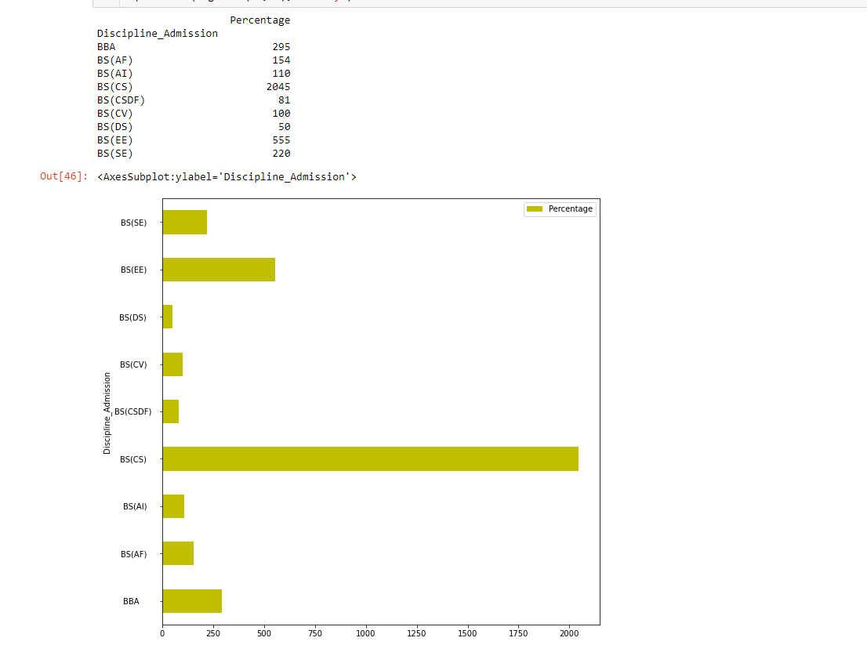

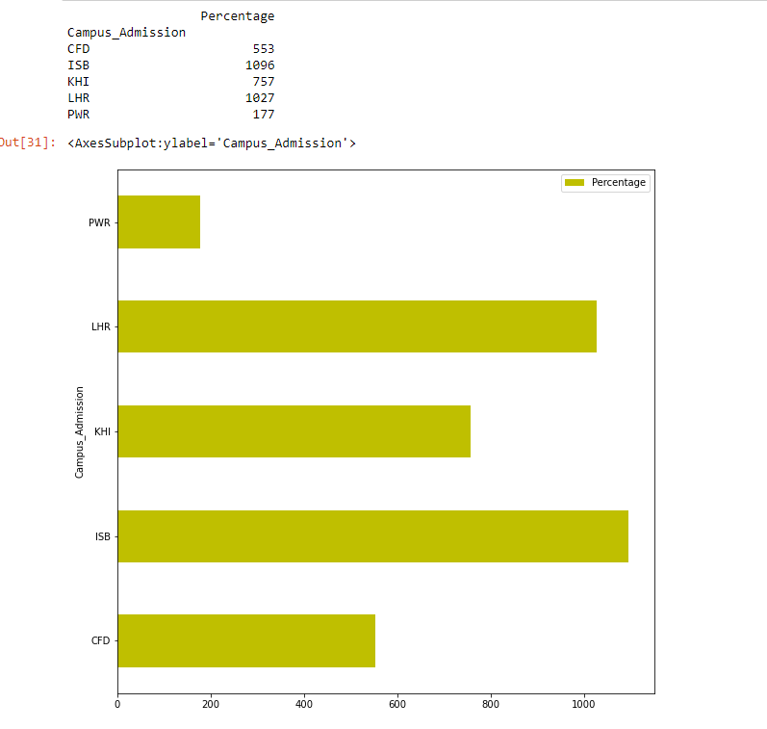

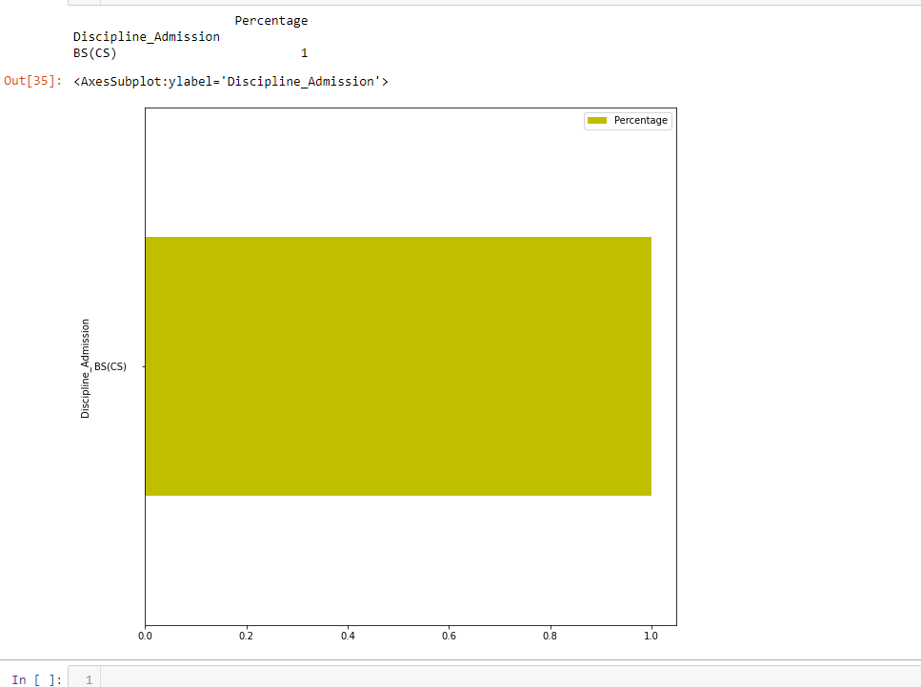

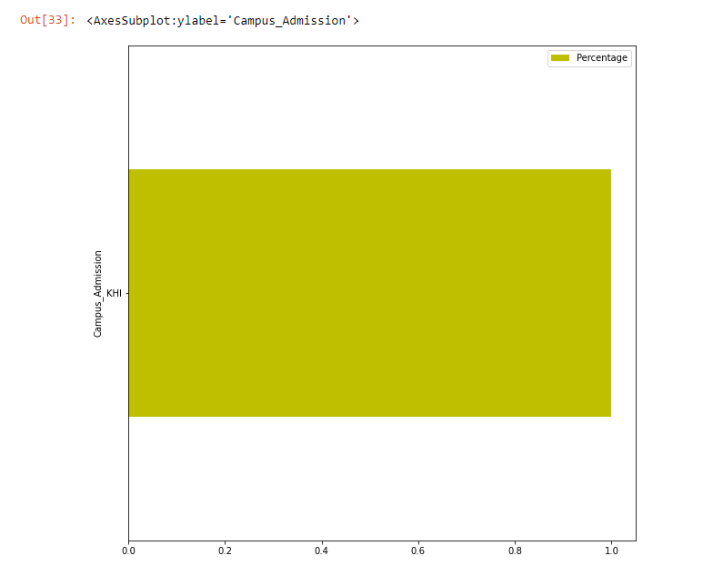

With the given data, the students performing good in Matric/O-level exam have a better chance of getting admission in NUCES.

**Question 2:**

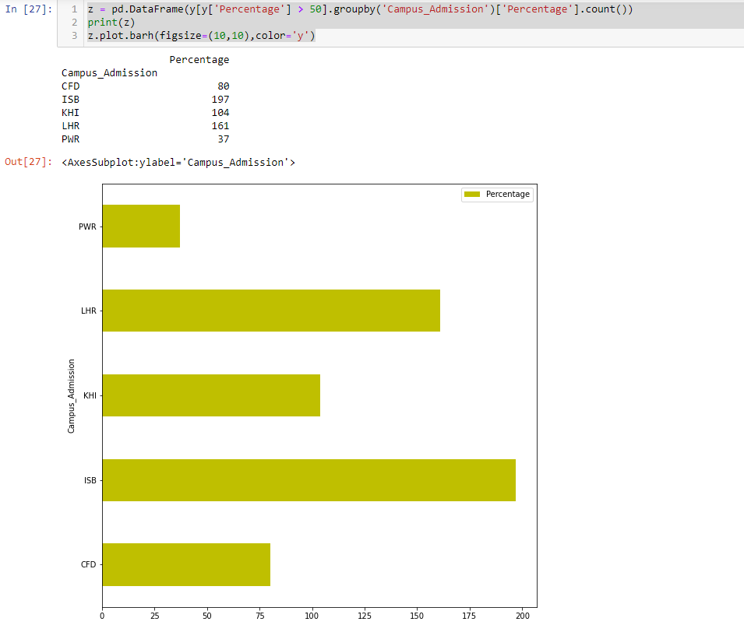

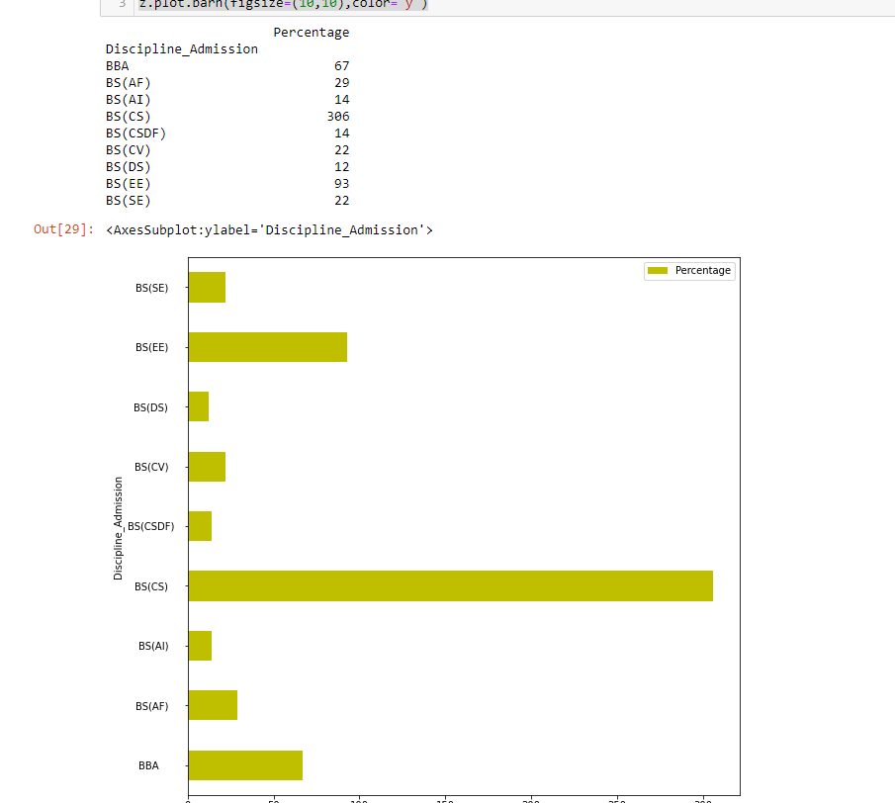

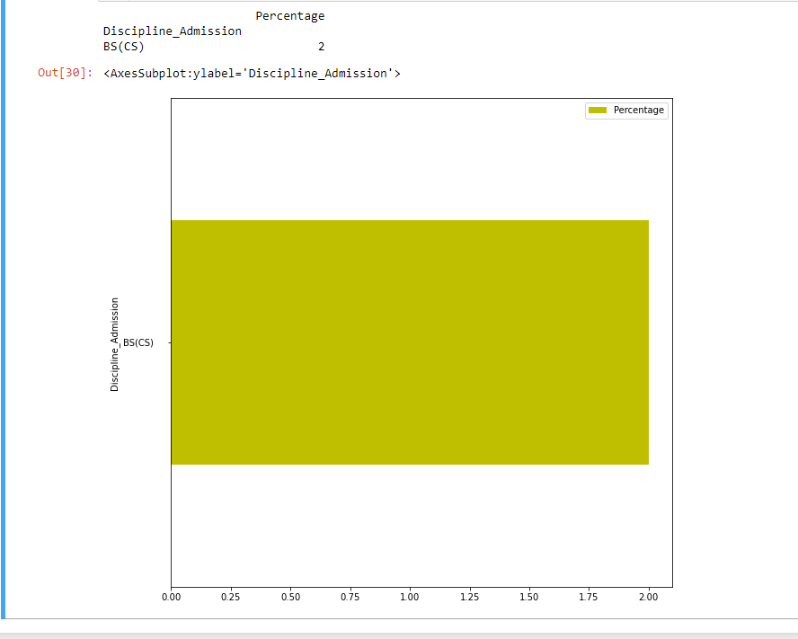

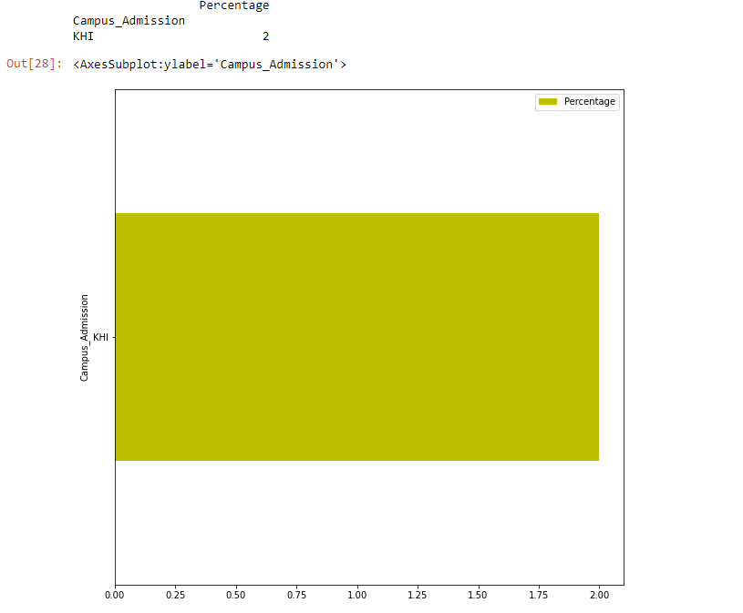

With the given data, the students performing good in FSC/A-level exam have a better chance of getting admission in NUCES.

**Question 3:**

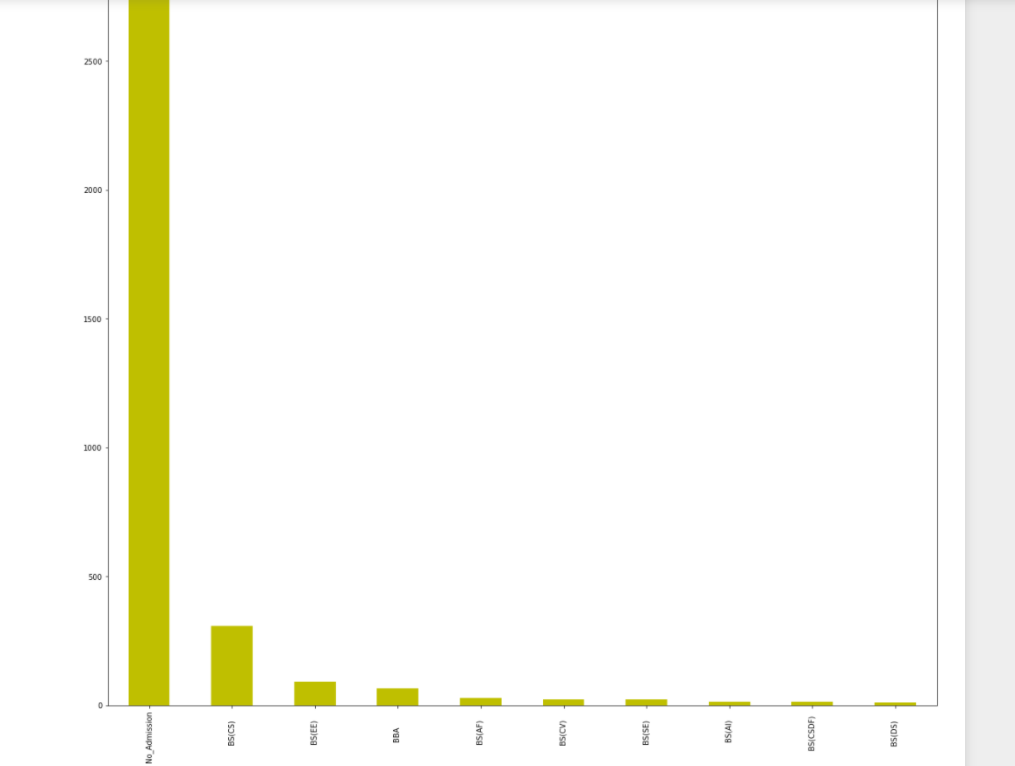

With the given data, the students who could not get the first preference of their choice of discipline doesn’t failed to join NUCES

**Question 4:**

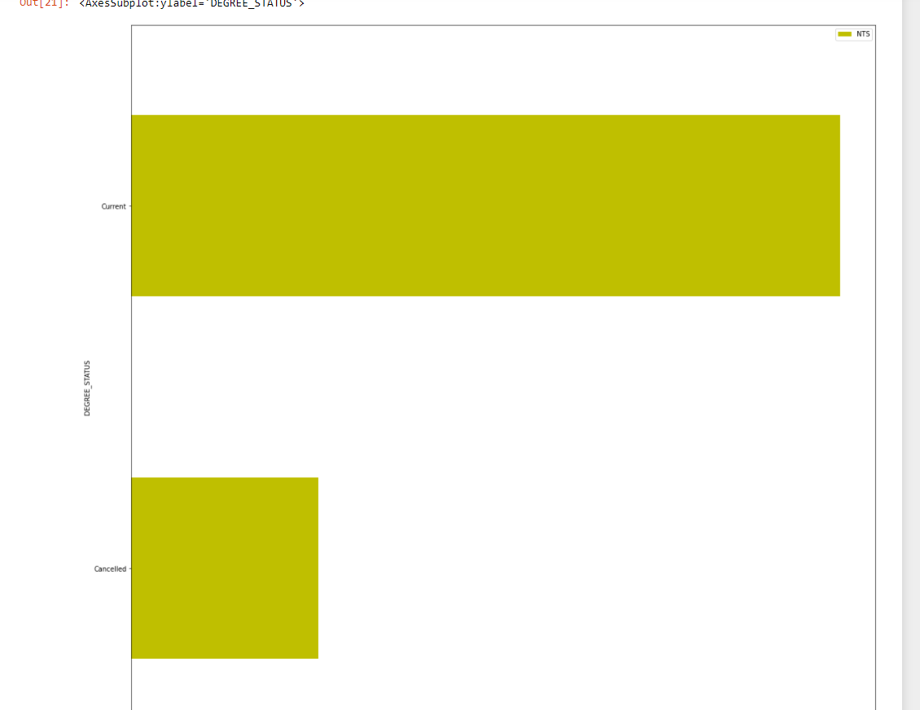

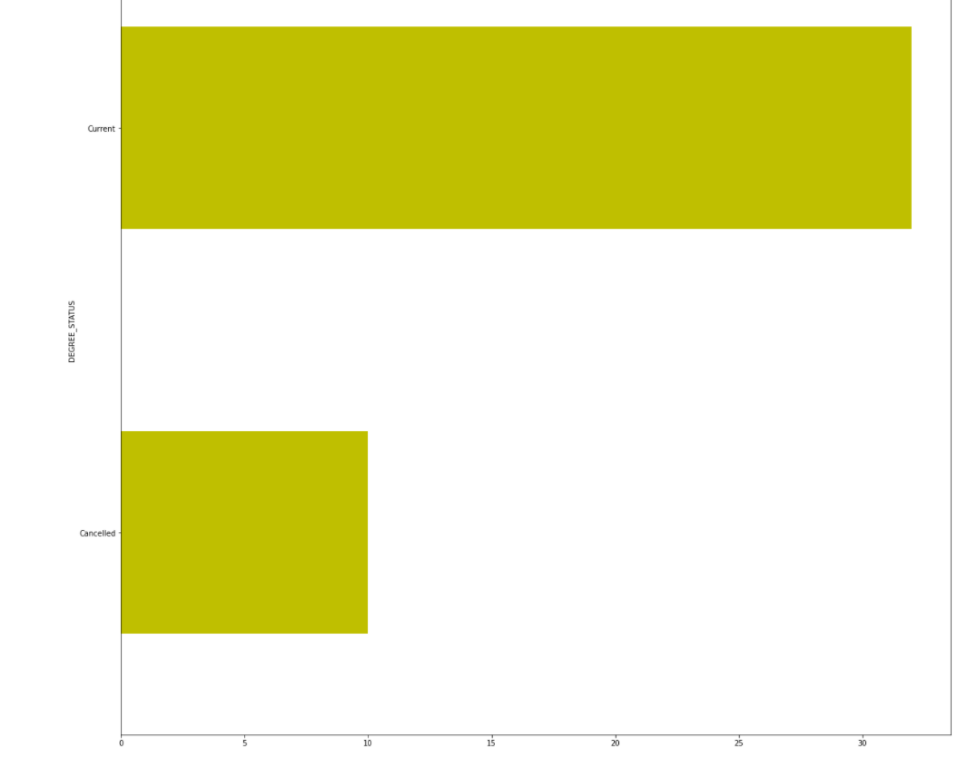

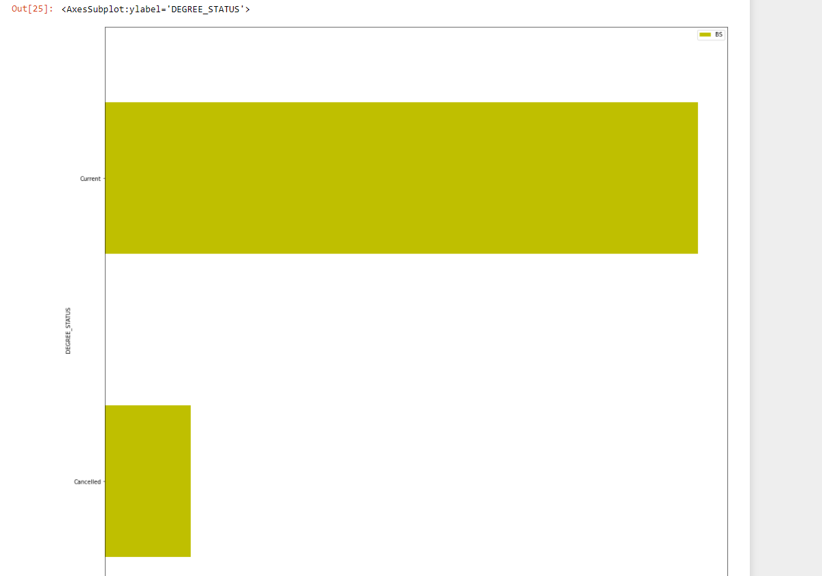

No, NU test have a better chance instead of NTS test of joining NUCES.

**Question 5:**

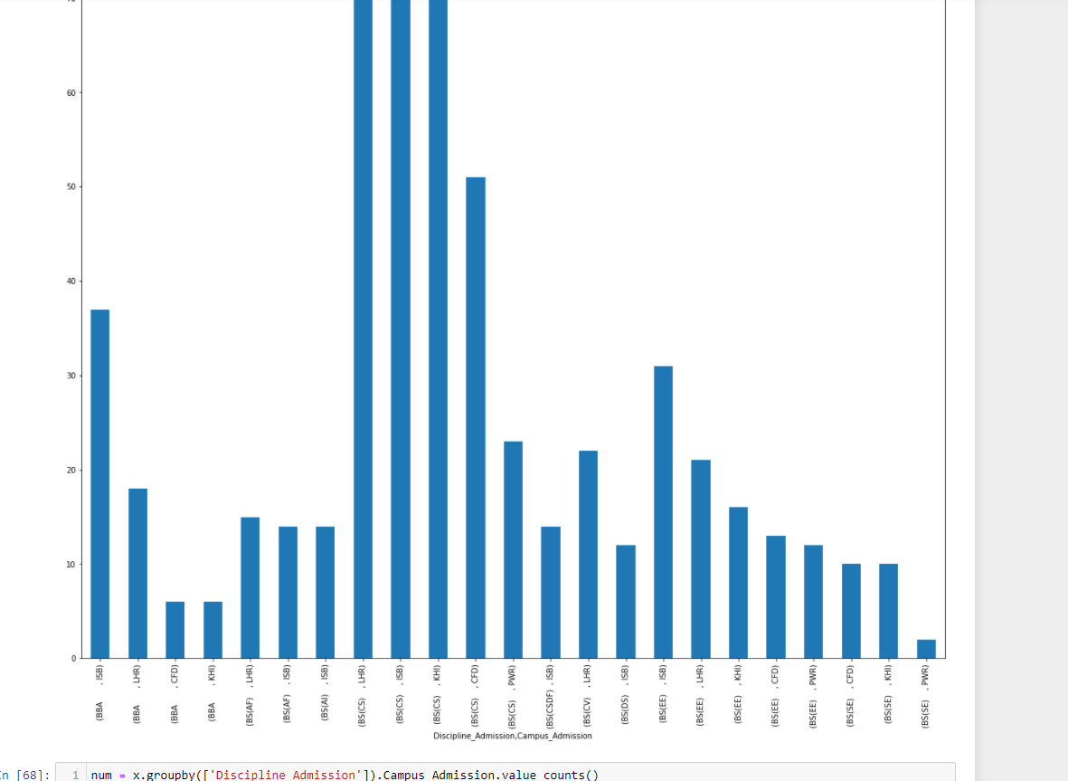

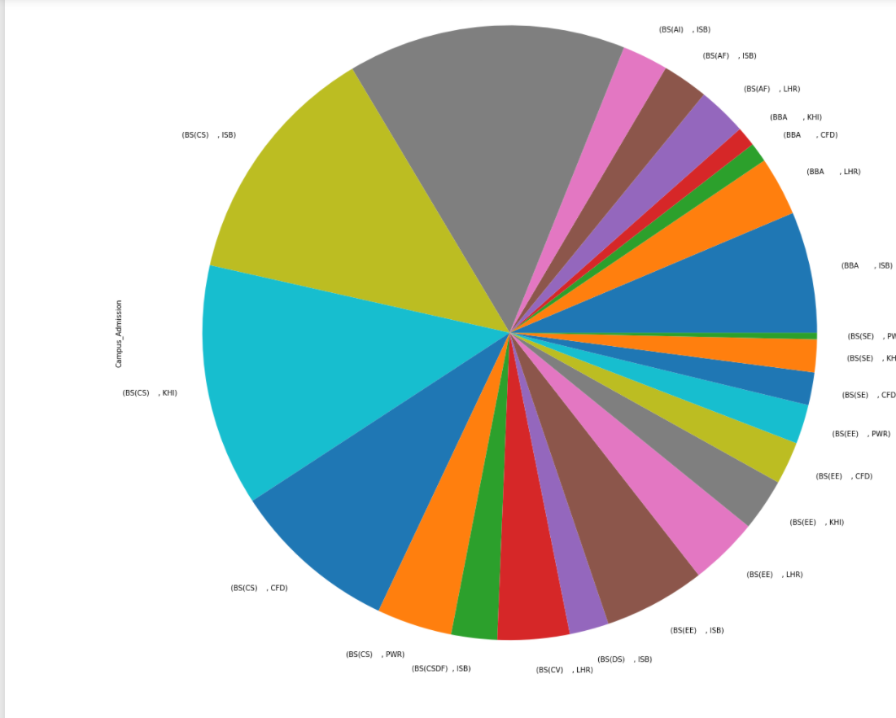

As you see from the graph, that BS CS Program is most popular in all campus.

**Question 6:**

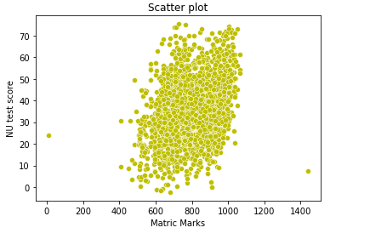

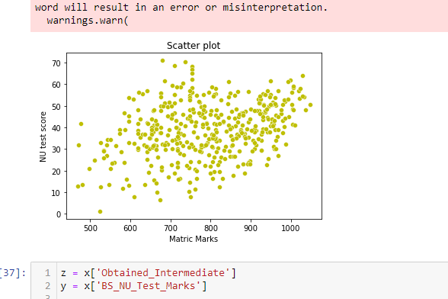

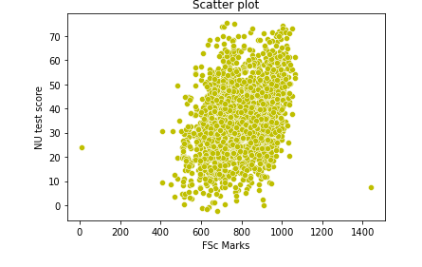

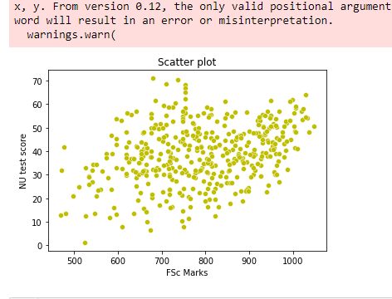

Yes, there is a correlation between the Matric/O-level/F.Sc./A-Level and the NU test score.

**Question 7:**

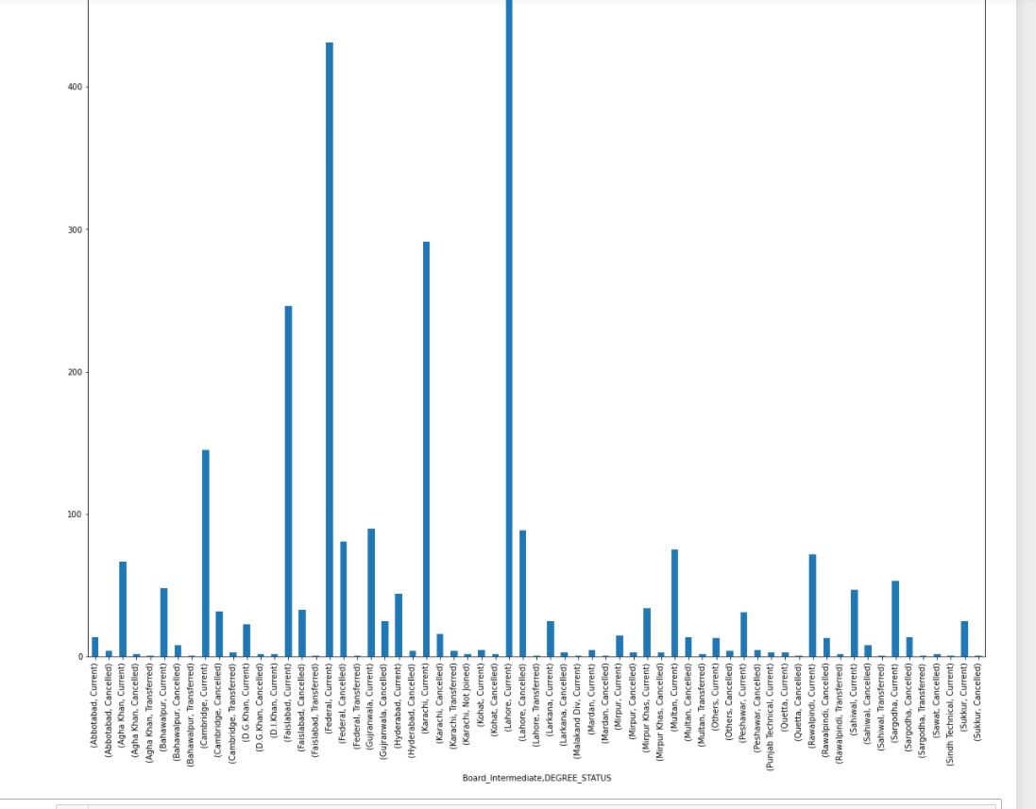

Lahore Intermediate Boards were successful in getting admission in NU.

Question 9:

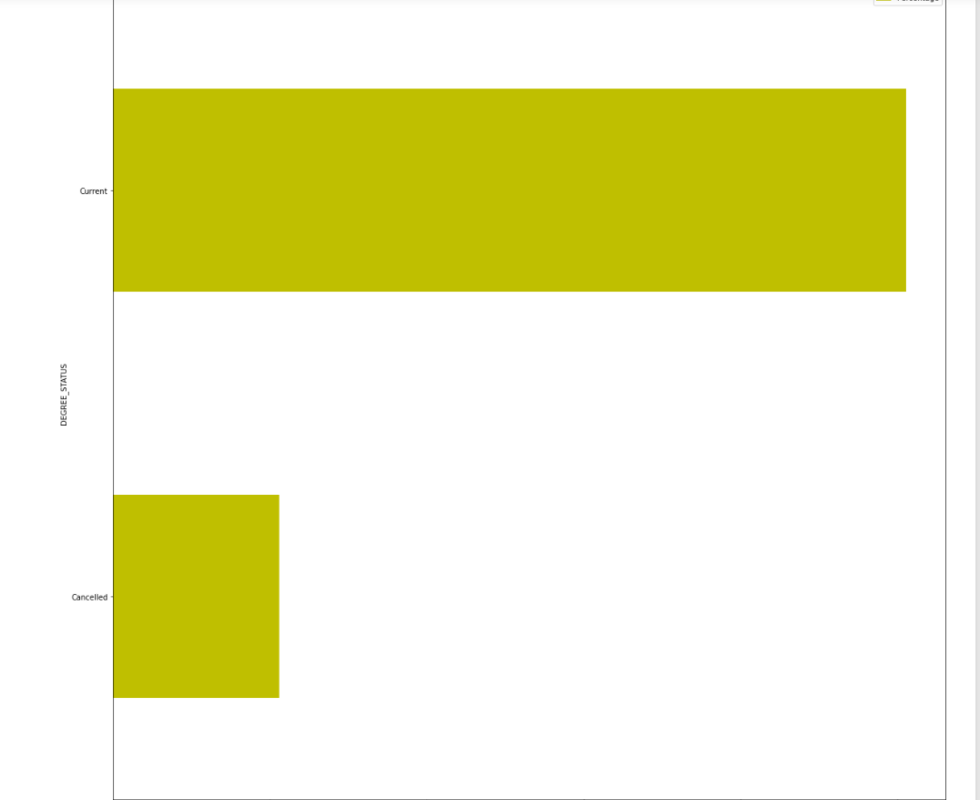

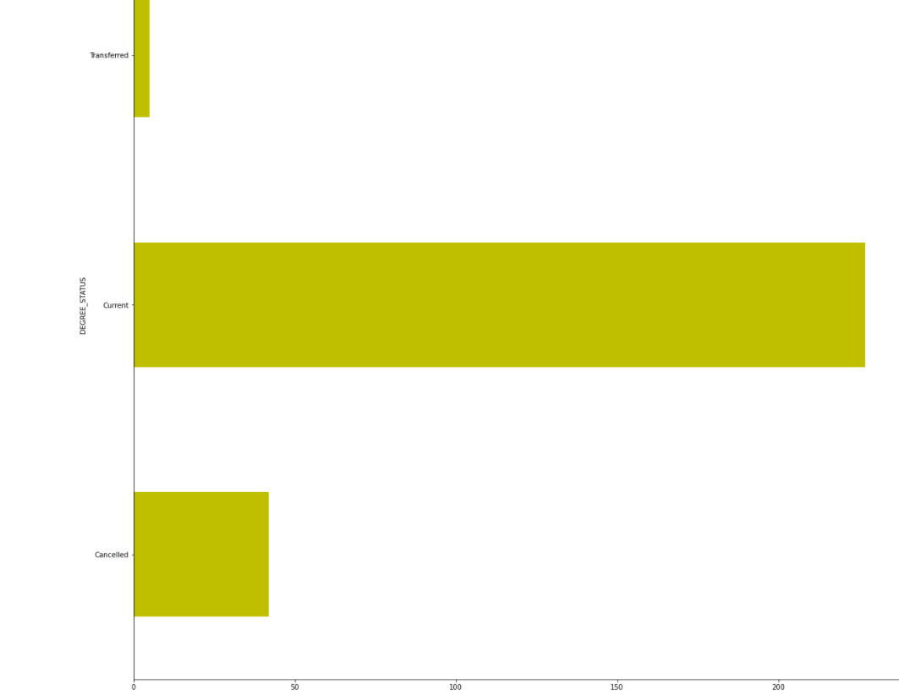

Yes, it is true that NU gives admission to students with at least 70% marks in

F.Sc.

Question 10:

Yes I can accept it from the given data.

