

Software Engineering

Deliverable: 5

**Group Members:**

Saad Ahmed (19I-1705)

Haris Usman (19I-1695)

Jiyad Khan (19I-1771)

**Project Name:**

Library Management System

**SECTION:** N

**DATE OF SUBMISSION:** May 29, 2021

**Library Management System**

**Introduction:**

Our project is Library Management System. Its main purpose is to automate the library so it could work more efficiently. Users could effortlessly check all the available books and could post a request to borrow them from the library. While on other hand administrator can perform operations such as managing user's requests, updating database etc. Existing systems are manual so they are less efficient and is a slow process. Since, this library system is digitized so there will be no physical user engagement.

**Architectural Style (Layered):**

Admin/Client Server

Requests

Books

Edit Database

Create User Account

View Borrowed Books

Borrowed_books

Student

Change Password

Manage Fine

View Requests

Admin

Add/Remove Books

View Fine

Search Books

Return Books

Sign out

Platform Layer

Platform Layer

Our Library Management System is a layered architecture because it has two layers the server layer and the client layer. Server has the database stored while the client requests data from database.

**Complete Product Backlog:**

|  |  |  |  |
| --- | --- | --- | --- |
| **Story ID#** | **User** **Story** | **Estimation** | **Priority** |
| 1 | Creating Account | 4 | 1 |
| 2 | Login | 4 | 2 |
| 4 | Searching a book | 3 | 3 |
| 5 | Borrow and Return book | 4 | 4 |
| 9 | Manage Requests | 6 | 5 |
| 6 | Updating Database | 4 | 6 |
| 8 | Late Penalty | 4 | 7 |
| 10 | Remove Late Penalty | 3 | 8 |
| 3 | Change Password | 3 | 9 |
| 7 | Billing Information | 3 | 10 |
|  | **Total:** | **38** |  |

|  |  |  |
| --- | --- | --- |
| **Sprint-user story** | **Tasks** | **Status** |
| **Sprint-1:**  **User story 1:**  → Create an account  **Sub User Story:**  → Create an account (employee)  **User story 2:**  → Login  **Sub User Story:**  → Login (Employee)  → Login (User)  **User story 3:**  → Searching  **Sub User Story:**  **→** Searching books by user | Task-1  Task-2  Task-3 | Completed within planned time.  Completed within planned time.  Completed within planned time. |
| **Sprint-2:**  **User story 1:**  → Change Password  **Sub User Story:**  → Change Password (User)  → Change Password (Employee)  **User story 2:**  → Billing Information  **User story 3:**  → Borrow a book  **User Story 4:**  **→** Manage Requests  **Sub User story:**  **→** Manage Requests(User)  → Manage Requests (Employee) | Task-1  Task-2  Task-3  Task-4 | Completed within planned time.  Completed within planned time.  Completed within planned time.  Completed within planned time. |
| **Sprint-3:**  **User story 1:**  → Return Books  **User story 2:**  → Updating Database  **Sub User Story:**  → Add Books  → Remove Books  **User story 3:**  → Late Penalty  **User Story 4:**  **→** Remove Penalty | Task-1  Task-2  Task-3  Task-4 | Completed within planned time.  Completed within planned time.  Completed within planned time.  Completed within planned time. |

**Sprint Burn down chart:**

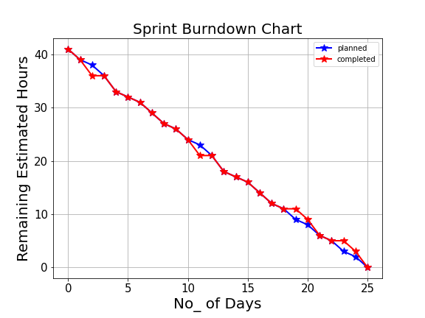

**Trello Screenshot:**

**Sprint-1 (completion):**

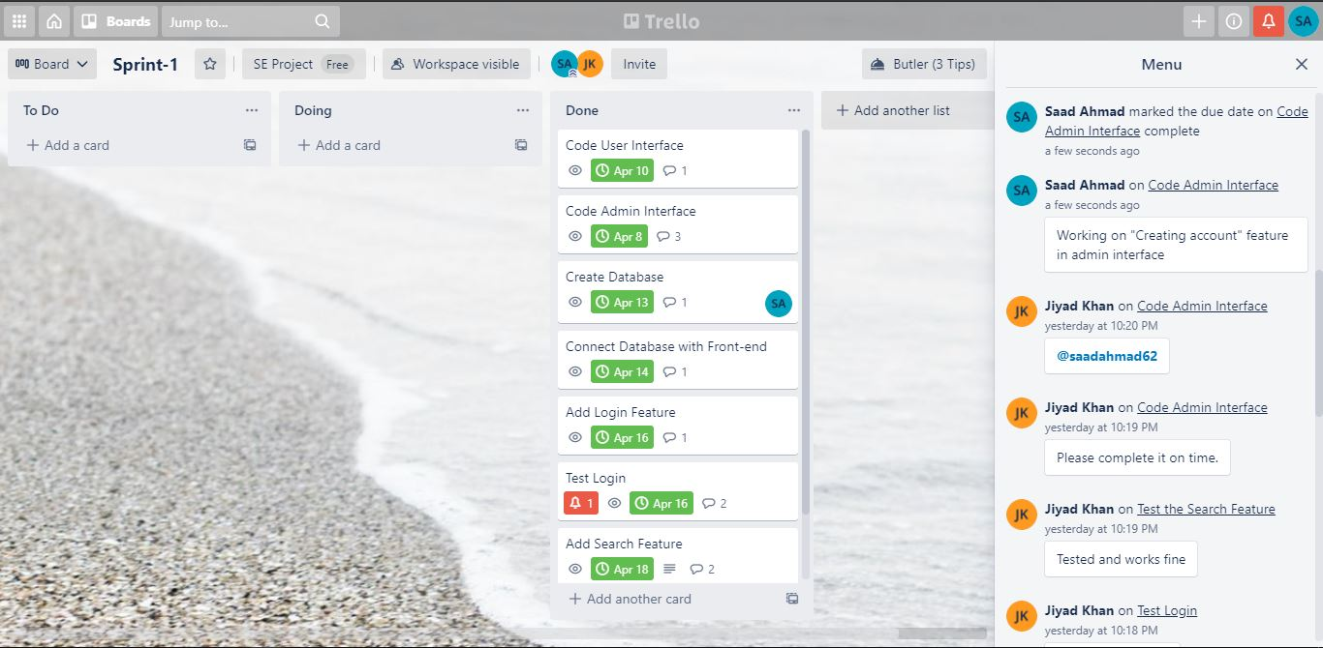

**Sprint-2 (completion):**

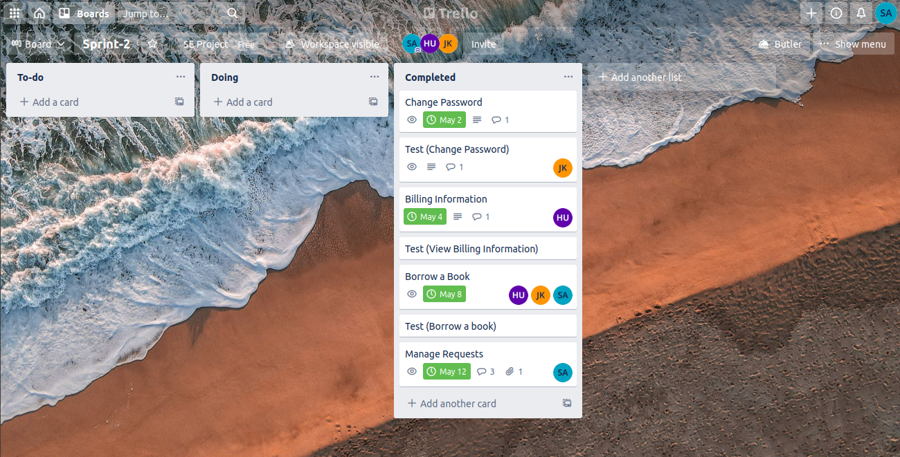

**Sprint-3 (completion):**

