

**Assignment 4**

**Name:** Jiyad Khan

**Roll Number:** 19I-1771

**Course’s Name:** Advanced Statistics

**Submitted To:** Sir Hammad Majeed

**Due Date:** December 9th, 2021.

**Report**

**Question 1:**

**Hypothesis Statements**

NuH= Diabetes and Blood Pressure are independent of each other.

Ha= Diabetes and Blood Pressure are dependent of each other.

Conclusion:

After performing chi-square on given data set we get our p value which is 0.92

As P-value is greater than alpha value, which is 0.05, so we fail to reject the null hypothesis.

**Question 1:**

**Hypothesis Statements**

**Null Hypothesis:** Diabetes and Blood Pressure are independent of each other.

**Alternative Hypothesis:** Diabetes and Blood Pressure are dependent of each other.

**Conclusion:**

In this question, I apply the chi-square on the given dataset, we get

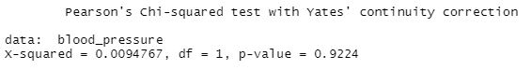

In the output, P-value is 0.9224. Which is greater than the alpha value (alpha value is 0.05). So we fail to reject the Null Hypothesis. And the bar plot of this dataset is

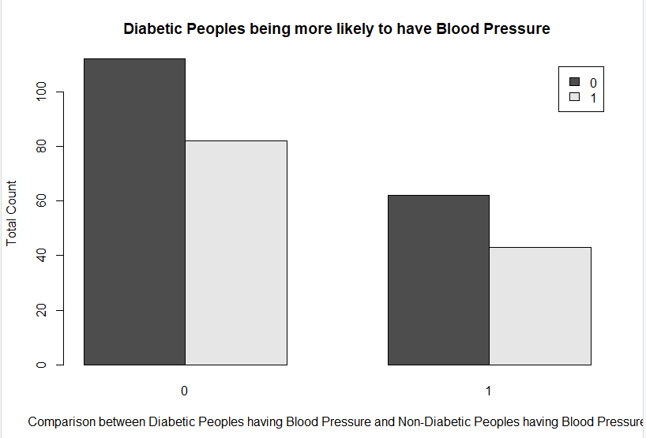

**Question 2:**

**Hypothesis Statements**

**Null Hypothesis:** People having Anemia and Female People are independent of each other.

**Alternative Hypothesis:** People having Anemia and Female People are dependent of each other.

**Conclusion:**

In this question, I apply the chi-square on the given dataset, we get

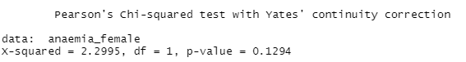

In the output, P-value is a 0.1294. Which is greater than the alpha value (alpha value is 0.05). So we fail to reject the Null Hypothesis. And the bar plot of this dataset is

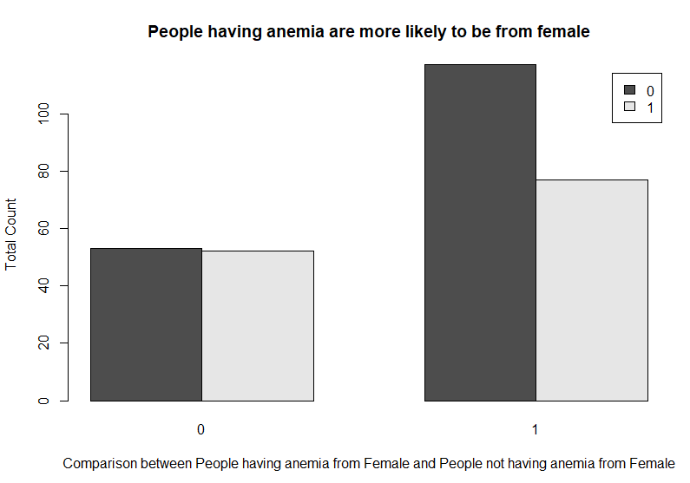

**Question 3:**

**Hypothesis Statements**

**Null Hypothesis:** People having age btw 55 & 65 & have a High blood pressure and Death Event are dependent of each other.

**Alternative Hypothesis:** People having age btw 55 & 65 & have a High blood pressure and Death Event are independent of each other.

**Conclusion:**

In this question, I apply the chi-square on the given dataset, we get

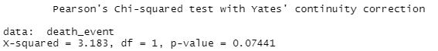

In the output, P-value is a 0.07441. Which is greater than the alpha value (alpha value is 0.05). So we fail to reject the Null Hypothesis. And the bar plot of this dataset is

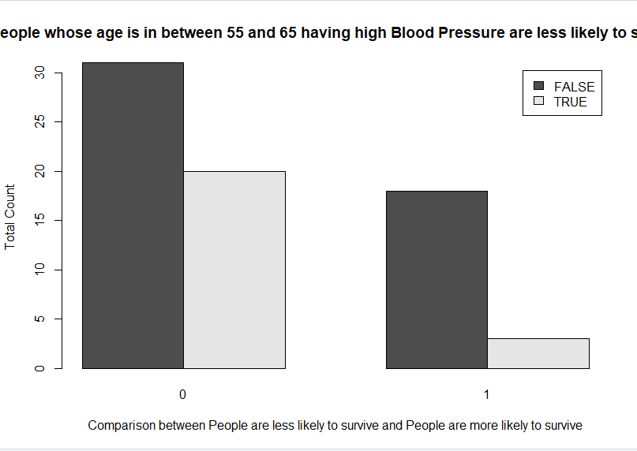

**Question 4:**

**Hypothesis Statements**

**Null Hypothesis:** Diabetes people who smoke and Death Event are dependent of each other.

**Alternative Hypothesis:** Diabetes people who smoke and Death Event are independent of each other.

**Conclusion:**

In this question, I apply the chi-square on the given dataset, we get

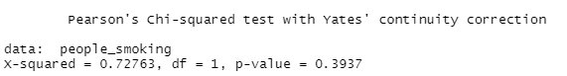

In the output, P-value is a 0.3937. Which is greater than the alpha value (alpha value is 0.05). So we fail to reject the Null Hypothesis. And the bar plot of this dataset is

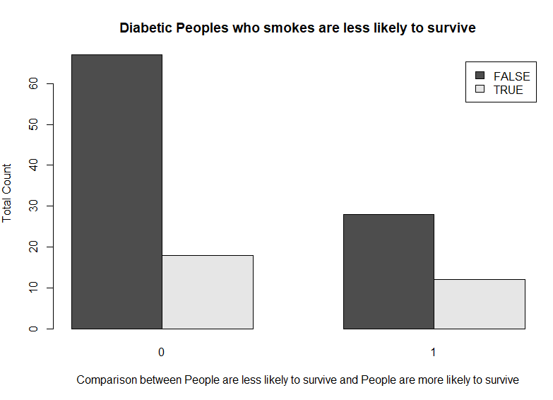

**Question 5:**

**Hypothesis Statements**

**Null Hypothesis:** Male People and Diabetes are independent of each other.

**Alternative Hypothesis:** Male People and Diabetes are dependent of each other.

**Conclusion:**

In this question, I apply the chi-square on the given dataset, we get

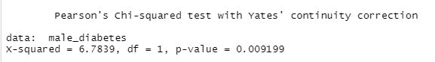

In the output, P-value is a 0.009199. Which is less than the alpha value (alpha value is 0.05). So we reject the Null Hypothesis. And the bar plot of this dataset is

