**Name:** Jiyad Khan

**Roll No:** 19I-1771

**Section:** BS-DS (N)

**Report**

**Question 1:**

For Q1,

Null Hypothesis: Employee working as Police Officer-II get the same Temporary Bonus Pay.

Alternative Hypothesis: Employee working as Police Officer-II get the more Temporary Bonus Pay.

After getting the value t-distribution by using the formula,

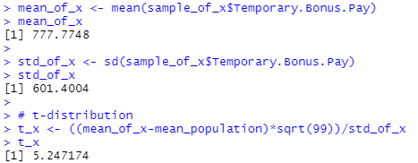

We have the value of t-distribution which is 5.247174.

And also applying the function of t-test, we get an output of

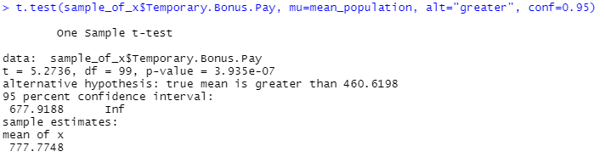

Since t-distribution of the data which is 5.24 which lies outside the critical region which set as 1.65 hence lies in the rejection region. So Null Hypothesis has been rejected and the Employees working as Police Officer-II have a better chance of getting Temporary Bonus Pay.

**Question 2:**

For Q2,

Null Hypothesis: the Employees who get Permanent Bonus Pay are most not likely to be from Public Works - Sanitation Department.

Alternative Hypothesis: the Employees who get Permanent Bonus Pay are most likely to be from Public Works - Sanitation Department.

After getting the value t-distribution by using the formula,

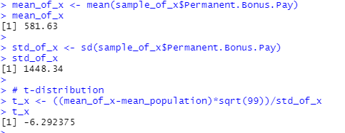

We have the value of t-distribution which is -6.292375.

And also applying the function of t-test, we get an output of

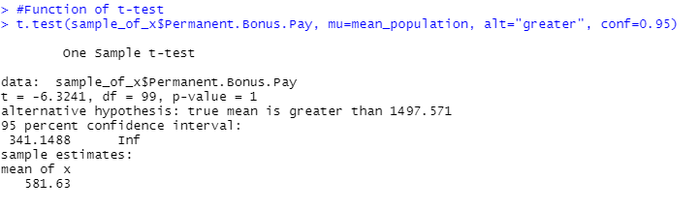

Since t-distribution of the data which is -6.292375 which is lies outside the critical region which set as 1.65 hence lies in the rejection region. So Null Hypothesis has been rejected and the Employees who get Permanent Bonus Pay are most likely to be from Public Works - Sanitation Department.

**Question 3:**

For Q3,

Null Hypothesis: Employees working in Water and Power (DWP) Department have a same chance of being employed overtime

Alternative Hypothesis: Employees working in Water and Power (DWP) Department have a better chance of being employed overtime

After getting the value t-distribution by using the formula,

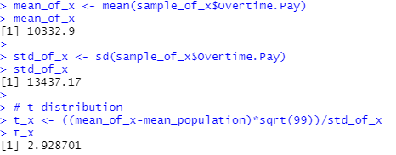

We have the value of t-distribution which is 2.928701.

And also applying the function of t-test, we get an output of

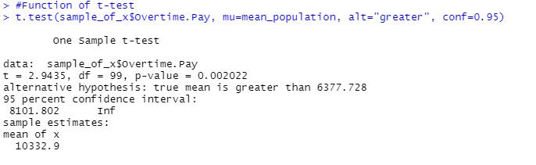

Since t-distribution of the data which is 2.928701 which is lies outside the critical region which set as 1.65 hence lies in the rejection region. So Null Hypothesis has been rejected and the Employees working in Water and Power (DWP) Department have a better chance of being employed overtime.

**Question 4:**

For Q4,

Null Hypothesis: In 2014, employees of Recreation and Parks Department were complaining that they have not been denied the Longevity Bonus Pay.

Alternative Hypothesis: In 2014, employees of Recreation and Parks Department were complaining that they have been denied the Longevity Bonus Pay.

After getting the value t-distribution by using the formula,

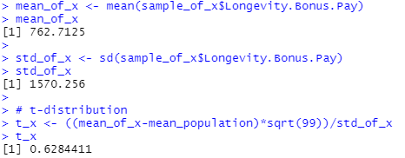

We have the value of t-distribution which is 0.6284411.

And also applying the function of t-test, we get an output of

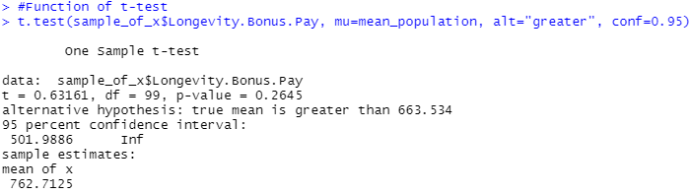

Since t-distribution of the data which is 0.6284411 which is lies inside the critical region which set as 1.65. So Null Hypothesis has fail to reject and In 2014, employees of Recreation and Parks Department were complaining that they have not been denied the Longevity Bonus Pay.

**Question 5:**

For Q5,

Null Hypothesis: Senior Clerk Typist from Harbor (Port of LA) Department has been telling Senior Clerk Typist of Water and Power (DWP) Department that they have no more Average Health Cost than them.

Alternative Hypothesis: Senior Clerk Typist from Harbor (Port of LA) Department has been telling Senior Clerk Typist of Water and Power (DWP) Department that they have more Average Health Cost than them.

After getting the value t-distribution by using the formula,

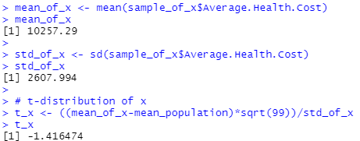

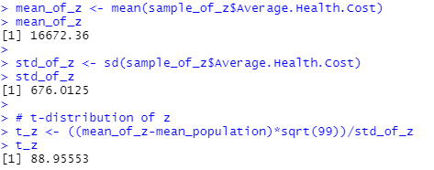

T-distribution of the Harbor (Port of LA) is -1.416474 and t-distribution of the Water and Power (DWP) which is 88.13205.

And also applying the function of t-test, we get an output of

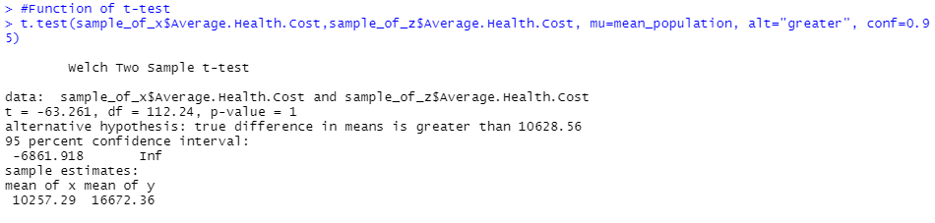

T-distribution of the Harbor (Port of LA) which is -1.416474 is lies inside the critical region and t-distribution of the Water And Power (DWP) which is 88.13205 is lies outside the critical region hence lies in the rejection region. So we have to reject the Null Hypothesis and and proved the claim.