DATABASE MANAGEMENT SYSTEMS PROJECT REPORT

Cybersecurity Incident Management
Database System
Modelling, Correlation, Indexing, Views and Window Functions using MySQL

Submitted in partial fulfilment of the course requirements of
B.Tech Computer Science & Engineering (Data Science)
Submitted by : | Jiya Garg
Roll Number : | 2501420037
Programme : | B.Tech CSE (Data Science), 2nd Year
Semester : | 3
Subject : | Database Management System
Submitted to : | Dr. Swati Gupta
Date of Submission : | November 2026

Table of Contents
1. Problem Statement
2. Objectives
3. Database Schema (All Tables)
4. EER Diagram
5. SQL Queries with Output Screenshots
6. Indexing and EXPLAIN Results
7. Views and WITH CHECK OPTION
8. Window Functions
9. Conclusion

1. Problem Statement
Model a database for cybersecurity incidents, including tables for events, alerts, vulnerabilities, threats and mitigation actions. The following tasks are to be carried out on this database:
- Implement SQL queries to correlate security events, identify attack patterns, assess risk levels and prioritize incident response tasks.
- Identify the weak entity type and create an ER diagram.
- Indexing: Create composite indexes on security events (source_ip, event_time) and (severity, status), and an index on alerts for fast correlation with events. Evaluate range queries on a large events table using EXPLAIN, and explain why an index on a low-cardinality column such as severity alone is less effective.
- Views: Create a view of open critical incidents combining events, alerts, vulnerabilities and the assigned analyst, and a restricted view that shows junior analysts only their permitted incidents. Demonstrate WITH CHECK OPTION and explain how views support security through data hiding.
- Window Functions: Detect brute-force patterns by counting failed logins per source IP using COUNT() OVER (PARTITION BY source_ip ORDER BY event_time), use LAG() to find the time gap between consecutive events from the same IP, and rank incidents by risk score using DENSE_RANK().

In short, a Security Operations Center (SOC) needs one reliable database where raw security events, the alerts they trigger, the weaknesses and threats behind them, the analysts who handle them and the actions taken to fix them are all stored together, so that incidents can be investigated quickly and the most dangerous ones are handled first.

2. Objectives
The objectives of this project are:
- To design a normalized relational database (cybersecurity_db) in MySQL for storing security events, alerts, vulnerabilities, threats, mitigation actions and analysts.
- To enforce data integrity using primary keys, foreign keys, NOT NULL constraints and default values.
- To identify the weak entity (mitigation_action_steps) in the design and represent it correctly in an EER diagram.
- To write SQL queries (joins, GROUP BY / HAVING and CASE) that correlate events with alerts and analysts, detect attack patterns such as repeated failed logins, and assign a risk assessment to every event.
- To improve query performance using composite and single-column indexes, and to verify their use with EXPLAIN.
- To create views that simplify reporting and protect sensitive data, and to demonstrate WITH CHECK OPTION.
- To apply window functions (COUNT() OVER, LAG, DENSE_RANK) for brute-force detection, time-gap analysis and risk ranking.
- To prioritize incident response by ranking incidents from Critical to Low.

3. Database Schema (All Tables)
The database cybersecurity_db was created and selected in MySQL Workbench (MySQL Community Server, connection root@localhost:3306). It contains seven base tables (the seventh, mitigation_action_steps, is the weak entity) and two views. Figure 1 shows the database being selected and Figure 2 lists the objects created in it.
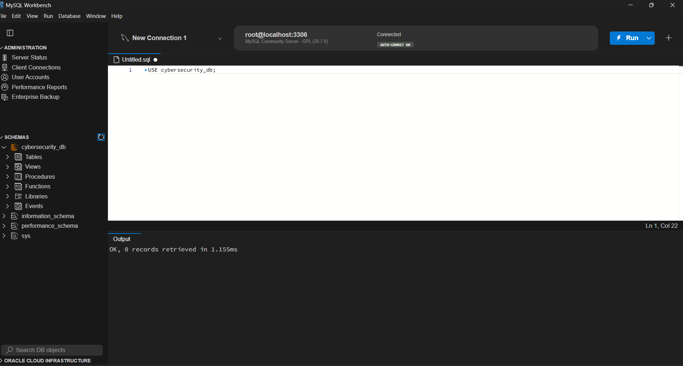
Figure 1: Selecting the database with USE cybersecurity_db
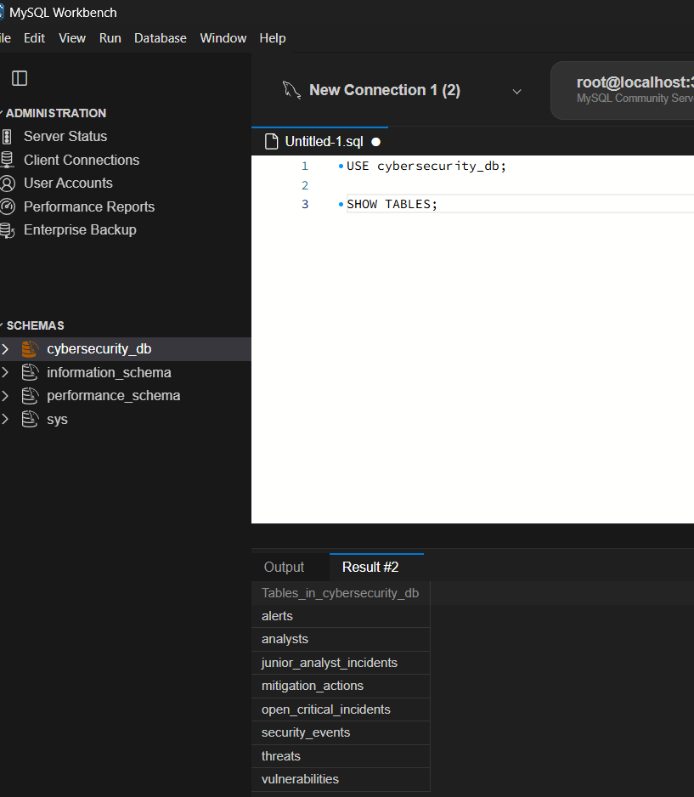
Figure 2: SHOW TABLES: base tables and views in cybersecurity_db
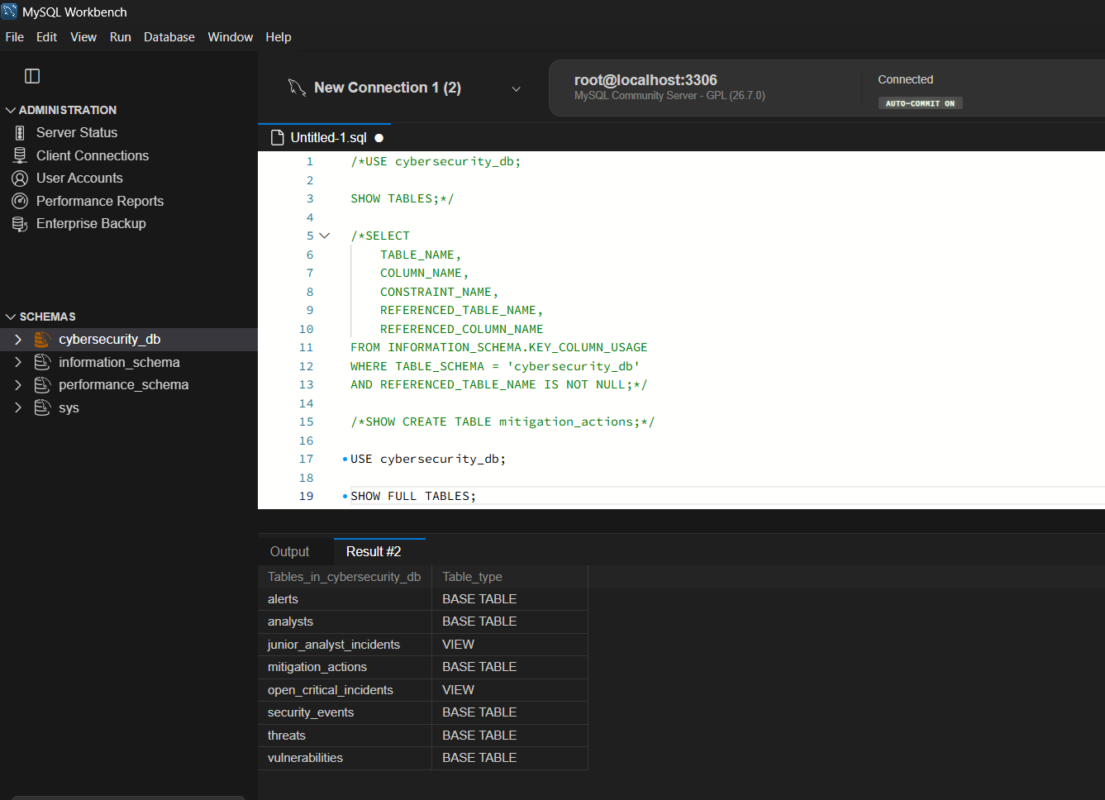
Figure 3: SHOW FULL TABLES: table type (BASE TABLE or VIEW) of each object

3.1 Table: analysts
Stores the SOC analysts who are assigned alerts and carry out mitigation actions.
Column | Data type | Constraint / Description
analyst_id | INT | PRIMARY KEY, AUTO_INCREMENT
analyst_name | VARCHAR(100) | Name of the analyst
team_name | VARCHAR(50) | Team the analyst belongs to (Team Alpha, Team Beta ...)
analyst_level | VARCHAR(30) | Junior / Senior level

3.2 Table: security_events
The central table. Every raw log record (failed login, malware detection, unauthorized access ...) is stored here.
Column | Data type | Constraint / Description
event_id | INT | PRIMARY KEY, AUTO_INCREMENT
source_ip | VARCHAR(45) | IP address that generated the event
event_type | VARCHAR(100) | Type of event, e.g. Failed Login, Malware Detected
severity | VARCHAR(20) | Critical / High / Medium / Low
status | VARCHAR(30) | Open / Investigating / Resolved
event_time | DATETIME | Date and time of the event
asset_group | VARCHAR(50) | Asset group affected (Network / Server / Database); added later with ALTER TABLE, see 3.8

3.3 Table: alerts
An alert is generated for an event and is assigned to an analyst.
Column | Data type | Constraint / Description
alert_id | INT | PRIMARY KEY, AUTO_INCREMENT
event_id | INT | FOREIGN KEY references security_events(event_id)
analyst_id | INT | FOREIGN KEY references analysts(analyst_id); may be NULL
alert_message | VARCHAR(255) | Text of the alert
alert_status | VARCHAR(30) | Pending / Investigating / Resolved

3.4 Table: vulnerabilities
Weaknesses discovered in connection with an event.
CREATE TABLE vulnerabilities (
vulnerability_id INT AUTO_INCREMENT PRIMARY KEY,
event_id INT NOT NULL,
vulnerability_name VARCHAR(150) NOT NULL,
risk_level VARCHAR(20),
description TEXT,
discovered_date DATE,
FOREIGN KEY (event_id) REFERENCES security_events(event_id)
);

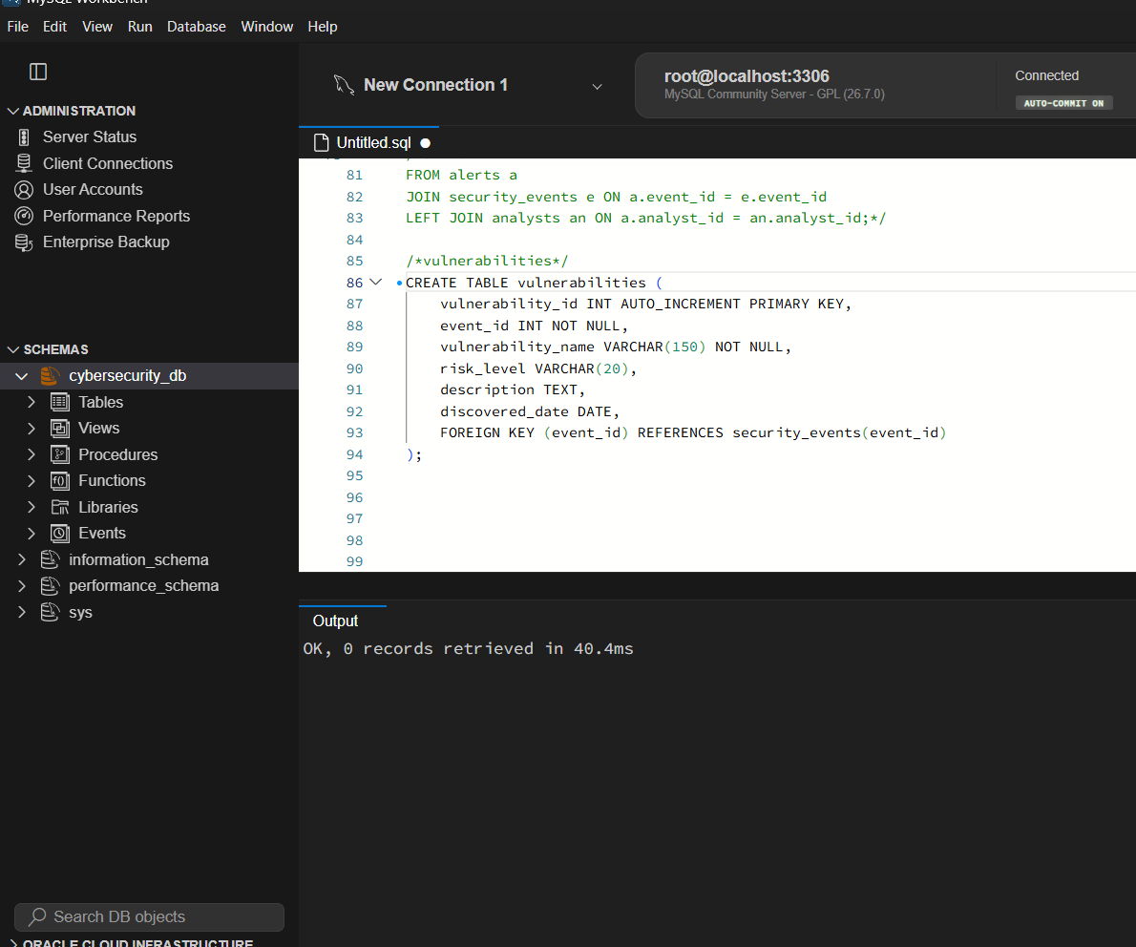
Figure 4: CREATE TABLE vulnerabilities
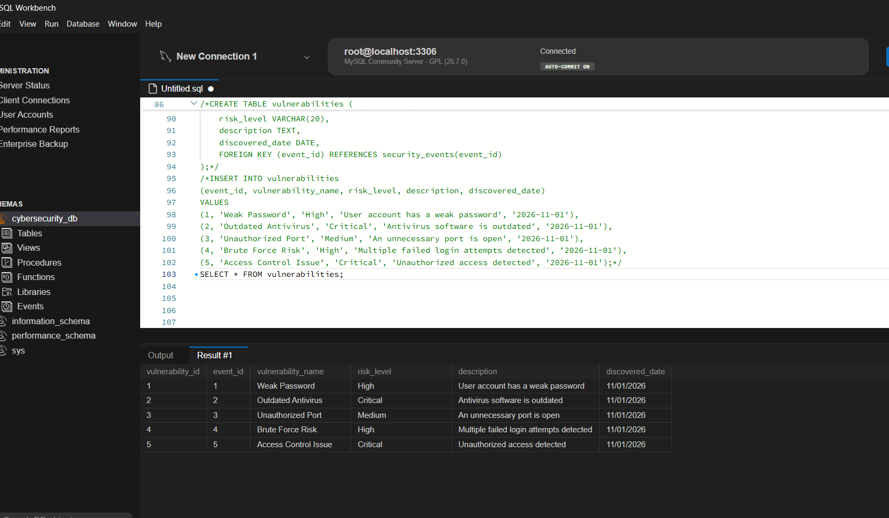
Figure 5: SELECT * FROM vulnerabilities (sample data)

3.5 Table: threats
Attacks or malicious activity identified for an event.
CREATE TABLE threats (
threat_id INT AUTO_INCREMENT PRIMARY KEY,
event_id INT NOT NULL,
threat_name VARCHAR(150) NOT NULL,
threat_type VARCHAR(100),
threat_level VARCHAR(20),
detected_date DATE,
FOREIGN KEY (event_id) REFERENCES security_events(event_id)
);

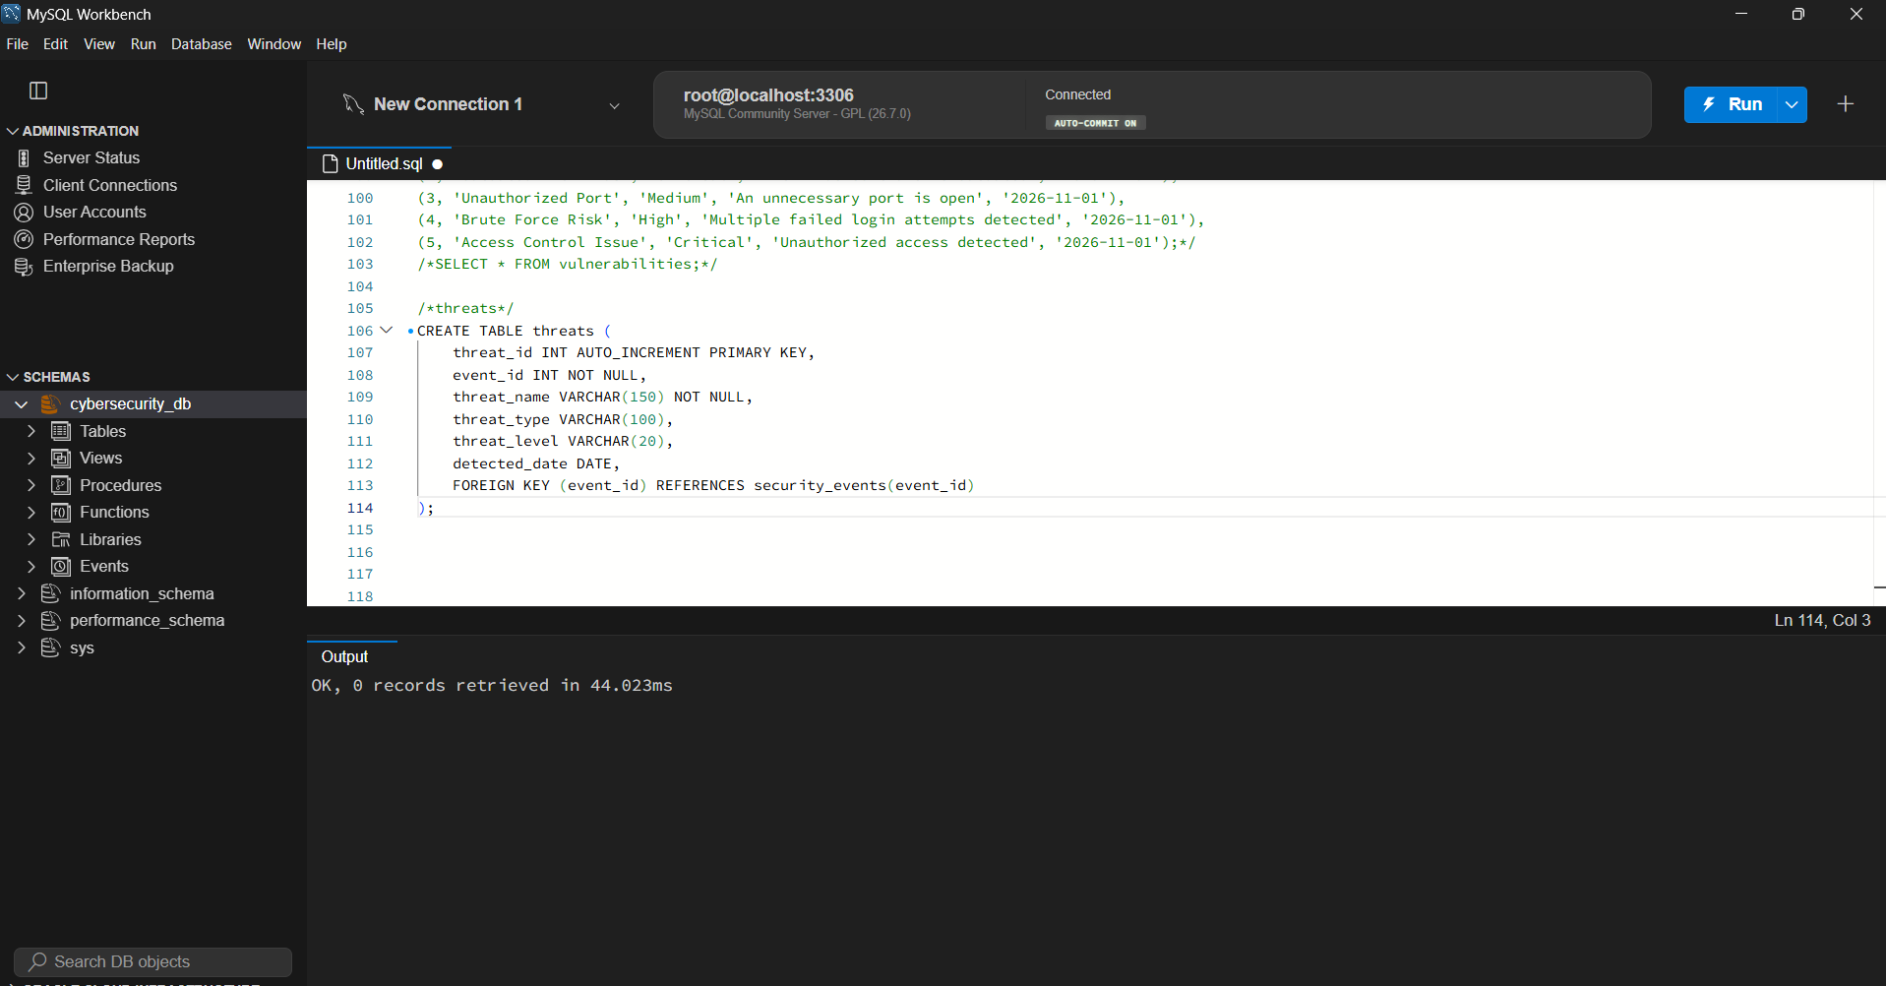
Figure 6: CREATE TABLE threats
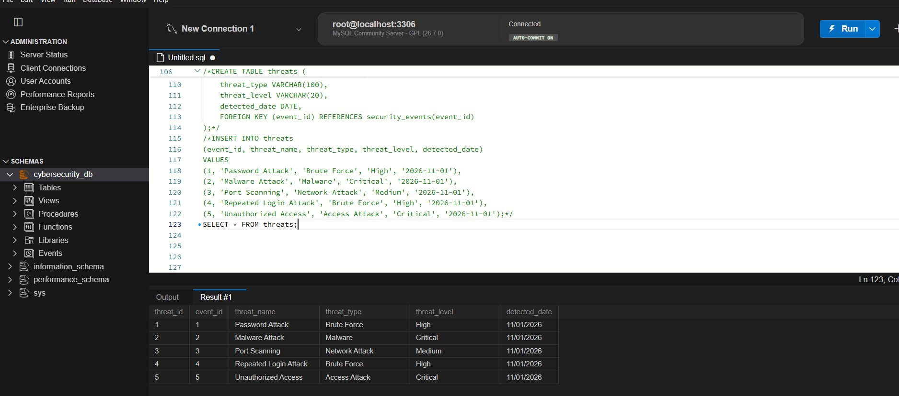
Figure 7: SELECT * FROM threats (sample data)

3.6 Table: mitigation_actions
Actions taken by analysts to resolve an event, such as resetting a password or blocking an IP address. Each action belongs to one security event and may be carried out by one analyst. Every action can in turn be broken into numbered steps, which are stored in the weak-entity table described in 3.7.
CREATE TABLE mitigation_actions (
action_id INT AUTO_INCREMENT PRIMARY KEY,
event_id INT NOT NULL,
analyst_id INT,
action_description VARCHAR(255) NOT NULL,
action_date DATETIME,
action_status VARCHAR(30) DEFAULT 'Pending',
FOREIGN KEY (event_id) REFERENCES security_events(event_id),
FOREIGN KEY (analyst_id) REFERENCES analysts(analyst_id)
);

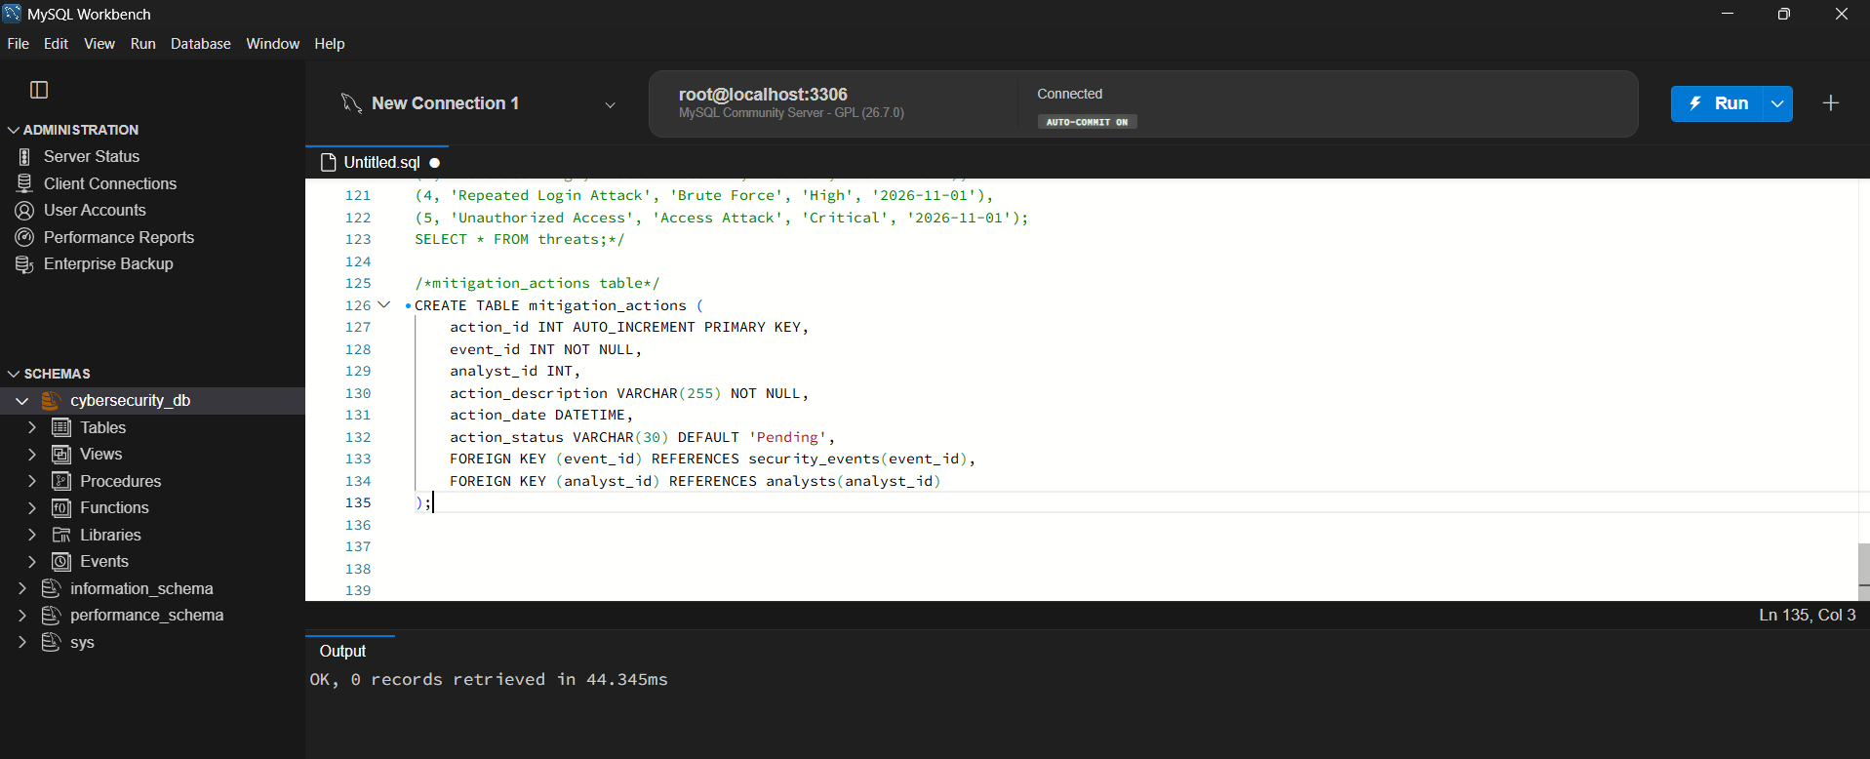
Figure 8: CREATE TABLE mitigation_actions
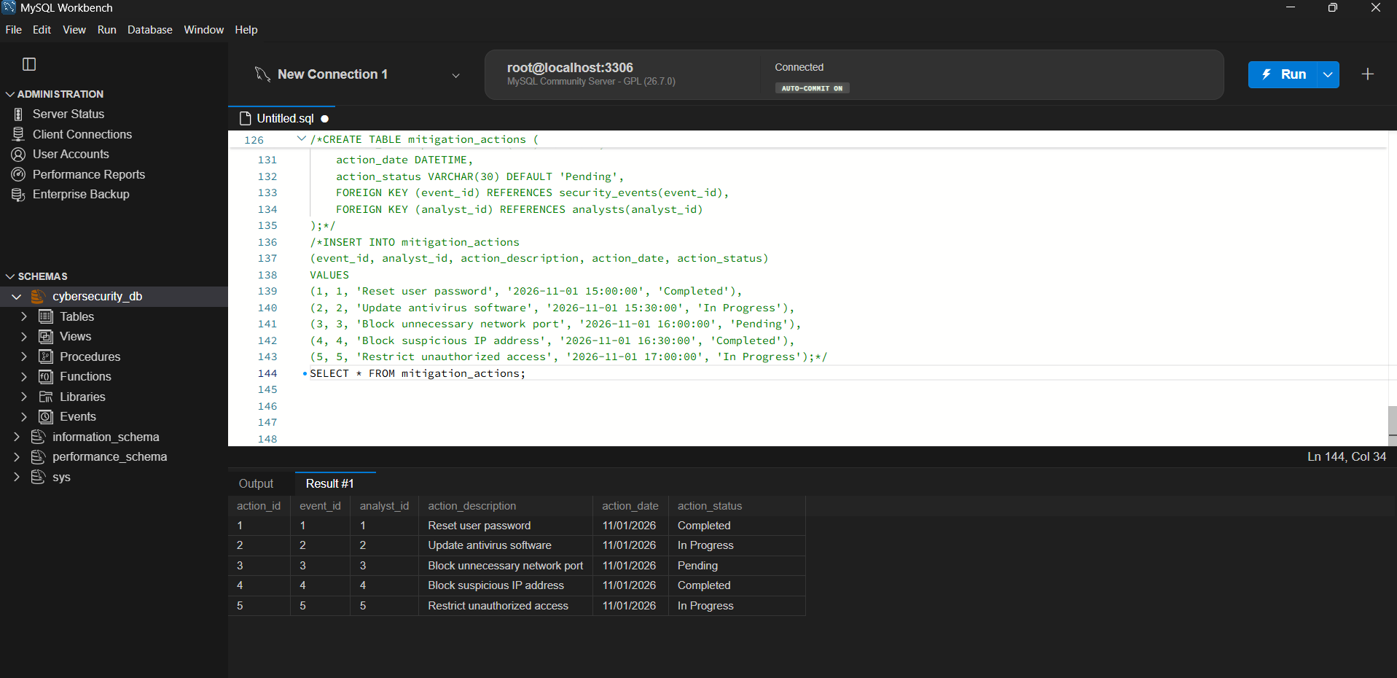
Figure 9: SELECT * FROM mitigation_actions (sample data)

3.7 Table: mitigation_action_steps (weak entity)
Every mitigation action is carried out in several numbered steps, for example "Identify the security issue", "Reset user password", "Verify the account security". A step number such as 2 has no meaning on its own: it only identifies a step inside a particular action. This table is therefore the weak entity of the database (see Section 4). Its primary key is the composite key (action_id, step_no): action_id is the owner key taken from mitigation_actions and step_no is the partial key.
CREATE TABLE mitigation_action_steps (
action_id INT NOT NULL,
step_no INT NOT NULL,
step_description VARCHAR(255) NOT NULL,
step_status VARCHAR(30) DEFAULT 'Pending',
PRIMARY KEY (action_id, step_no),
FOREIGN KEY (action_id)
REFERENCES mitigation_actions(action_id)
);

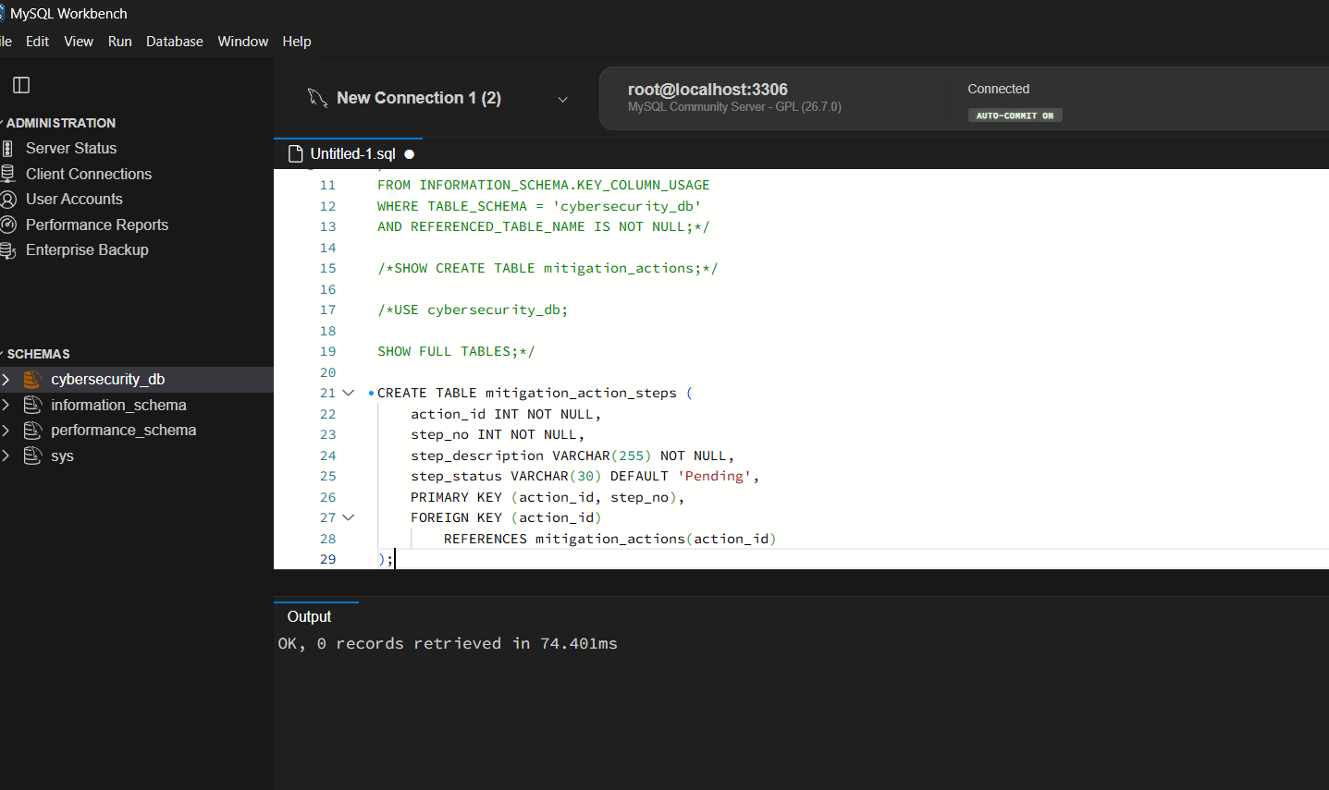
Figure 10: CREATE TABLE mitigation_action_steps
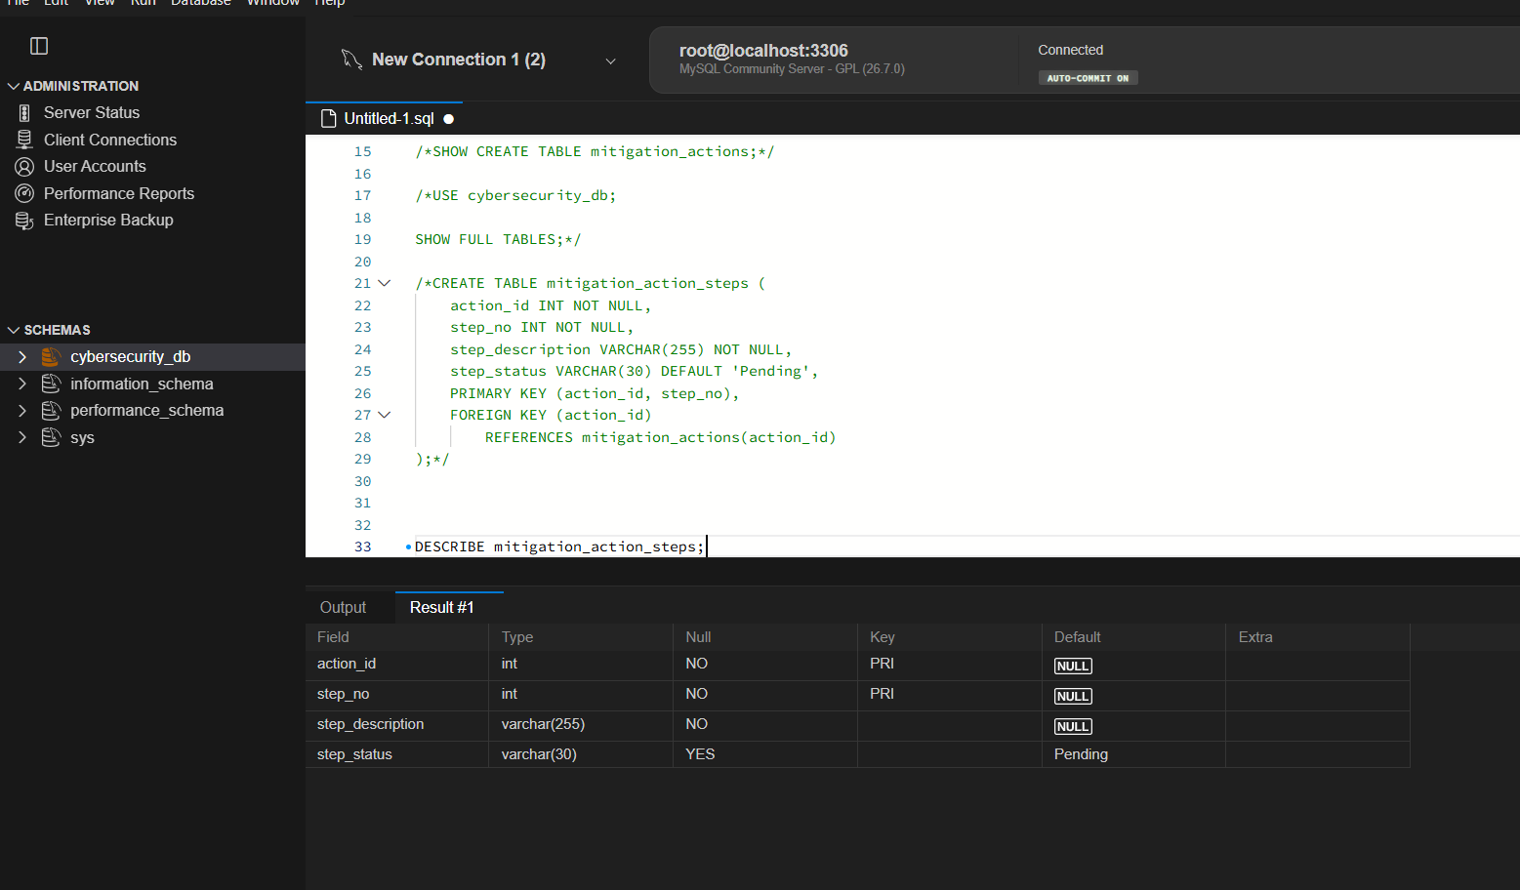
Figure 11: DESCRIBE mitigation_action_steps: composite primary key (action_id, step_no)
INSERT INTO mitigation_action_steps
(action_id, step_no, step_description, step_status)
VALUES
(1, 1, 'Identify the security issue', 'Completed'),
(1, 2, 'Reset user password', 'Completed'),
(1, 3, 'Verify the account security', 'Pending'),
(2, 1, 'Update antivirus software', 'Completed'),
(2, 2, 'Scan the affected system', 'Pending');

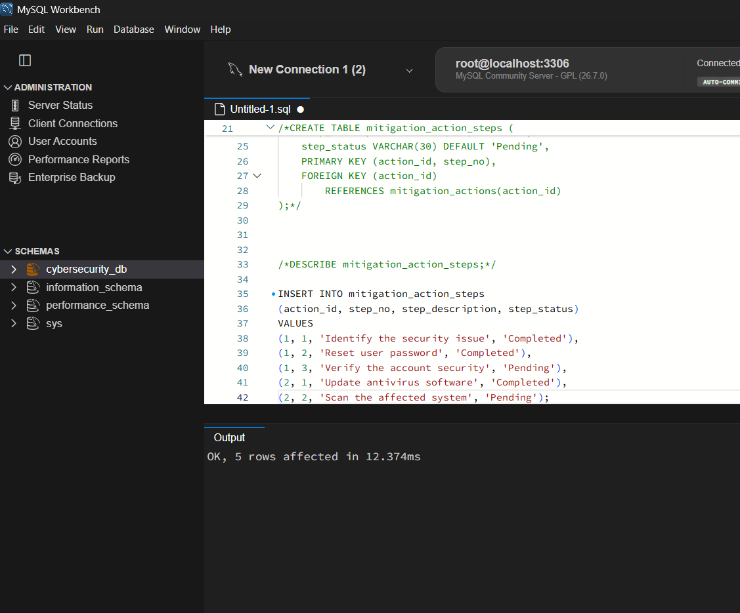
Figure 12: Inserting 5 rows into mitigation_action_steps
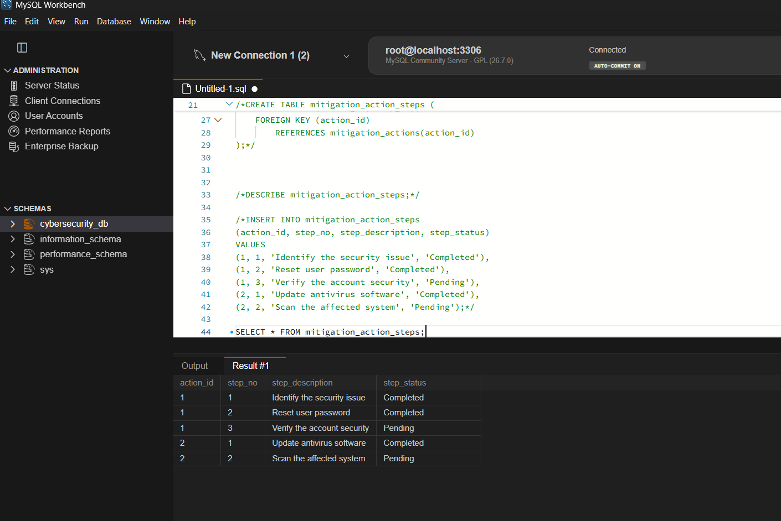
Figure 13: SELECT * FROM mitigation_action_steps (sample data)
Note that step_no restarts from 1 for every action (action 1 has steps 1 to 3, action 2 has steps 1 and 2). The same step_no is allowed under different actions, which is exactly the behaviour of a weak entity: the step is identified only by the combination of its owner and its own number.

3.8 Adding the asset_group column
To rank incidents separately for each group of assets (Section 8.3), a new column asset_group was added to security_events and filled with values for the five events.
ALTER TABLE security_events
ADD asset_group VARCHAR(50);

UPDATE security_events
SET asset_group = CASE
WHEN event_id IN (1, 2) THEN 'Network'
WHEN event_id IN (3, 4) THEN 'Server'
WHEN event_id = 5 THEN 'Database'
END;

SELECT event_id, source_ip, severity, asset_group
FROM security_events;

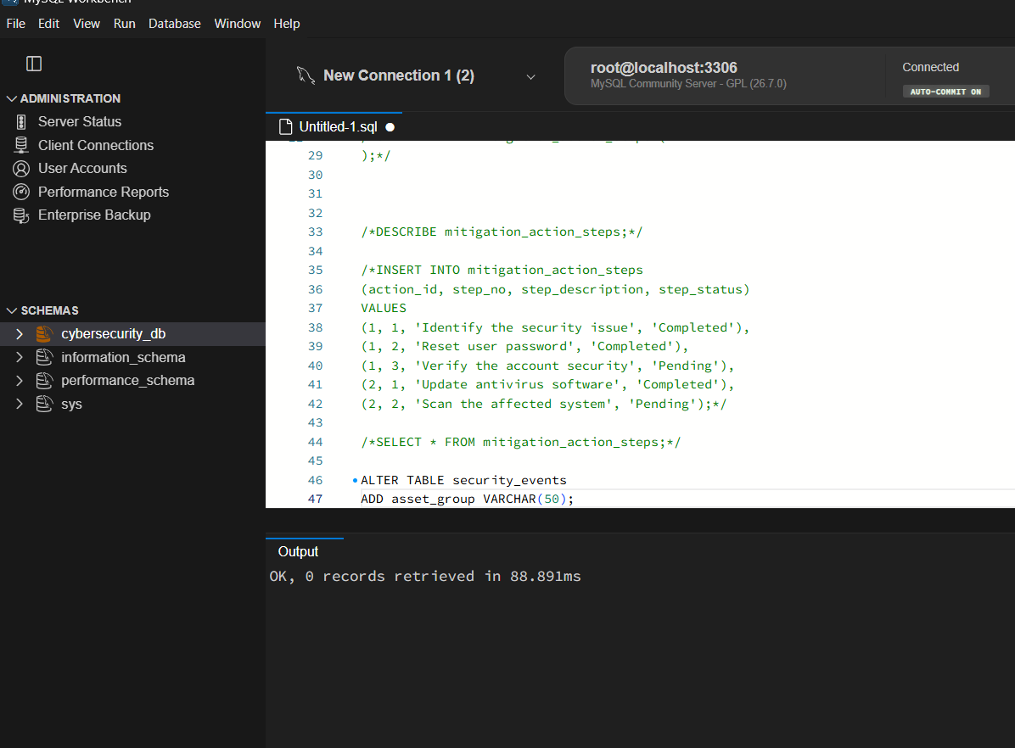
Figure 14: ALTER TABLE security_events ADD asset_group
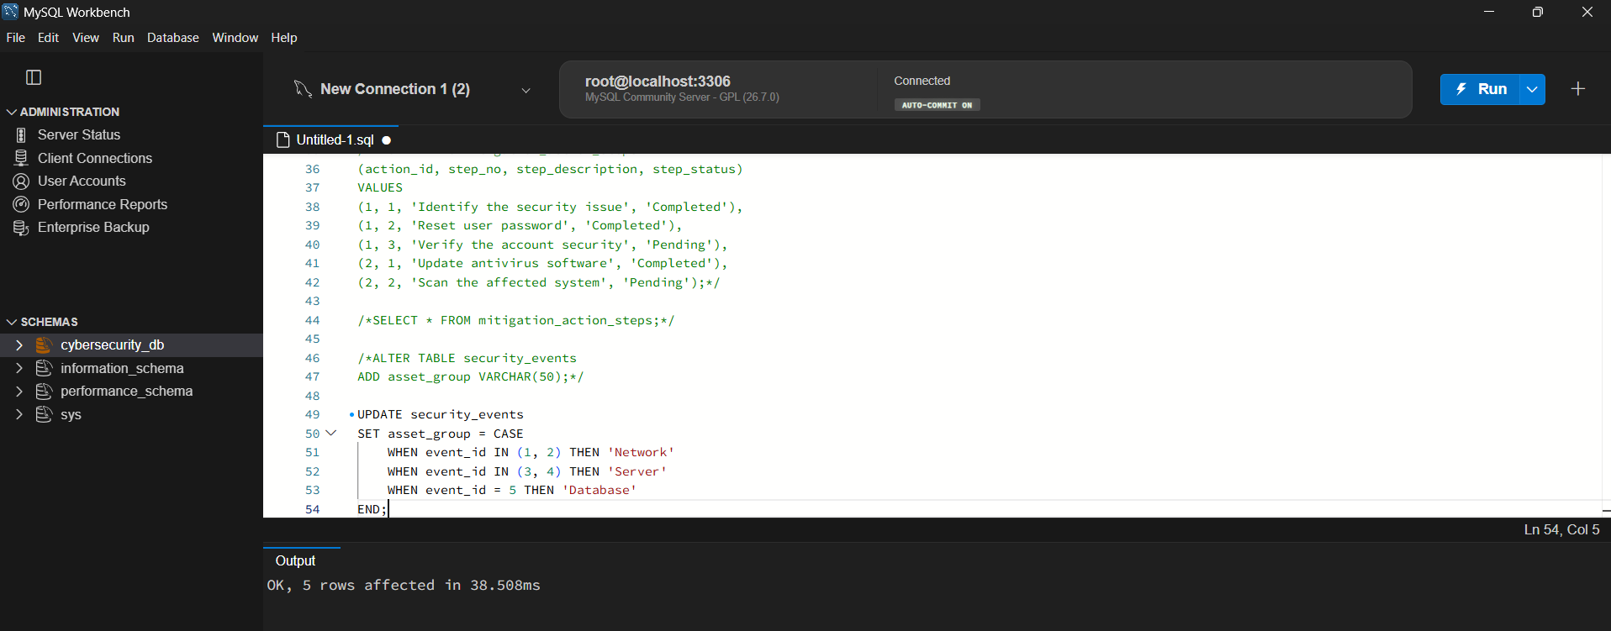
Figure 15: UPDATE: 5 rows affected
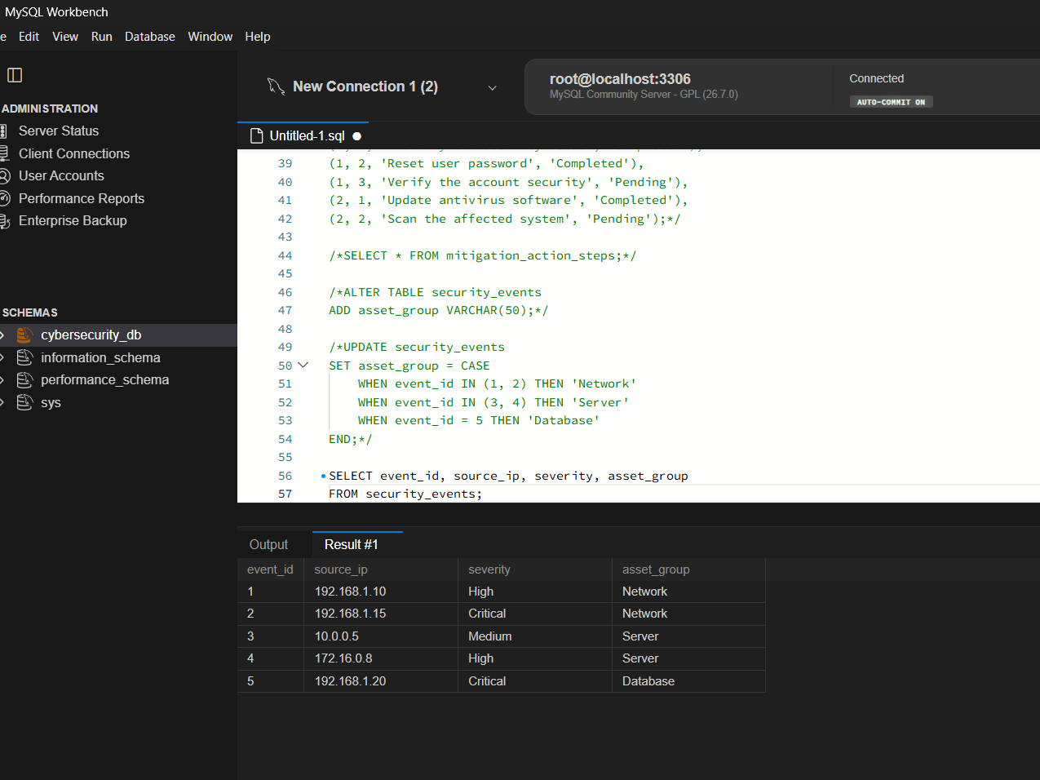
Figure 16: security_events with the new asset_group column

3.9 Foreign key relationships
The foreign keys that tie the tables together were verified using INFORMATION_SCHEMA.KEY_COLUMN_USAGE and SHOW CREATE TABLE (screenshots taken before mitigation_action_steps was added; it adds one more foreign key, mitigation_action_steps.action_id referencing mitigation_actions.action_id).
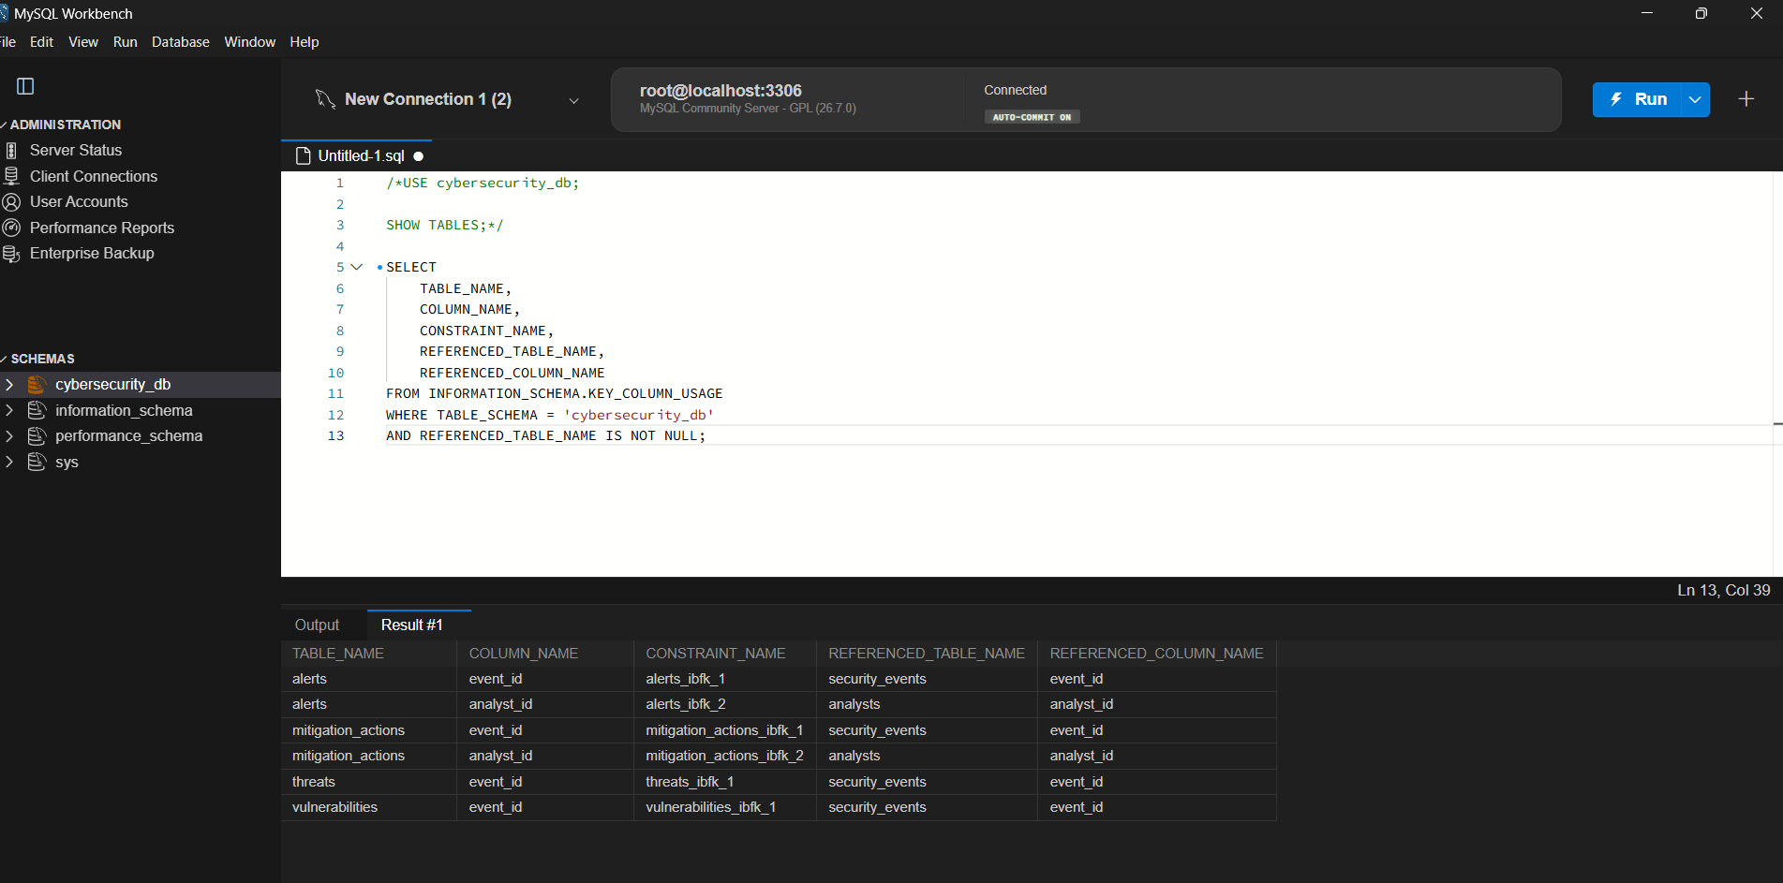
Figure 17: Foreign keys of cybersecurity_db from INFORMATION_SCHEMA
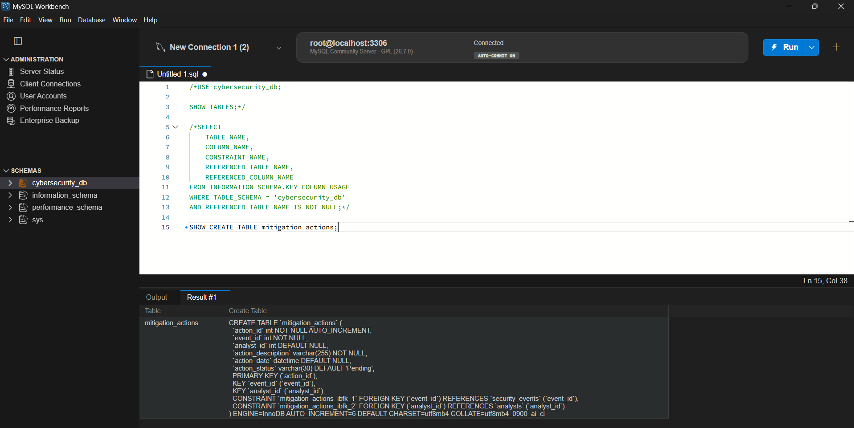
Figure 18: SHOW CREATE TABLE mitigation_actions (InnoDB, utf8mb4)

4. EER Diagram
Figure below shows the Enhanced ER diagram of cybersecurity_db. Entities are drawn as boxes with their attributes, relationships as diamonds, and cardinalities (1 and N) are marked on the connecting lines. The weak entity is drawn with a double border and its identifying relationship with a double diamond.
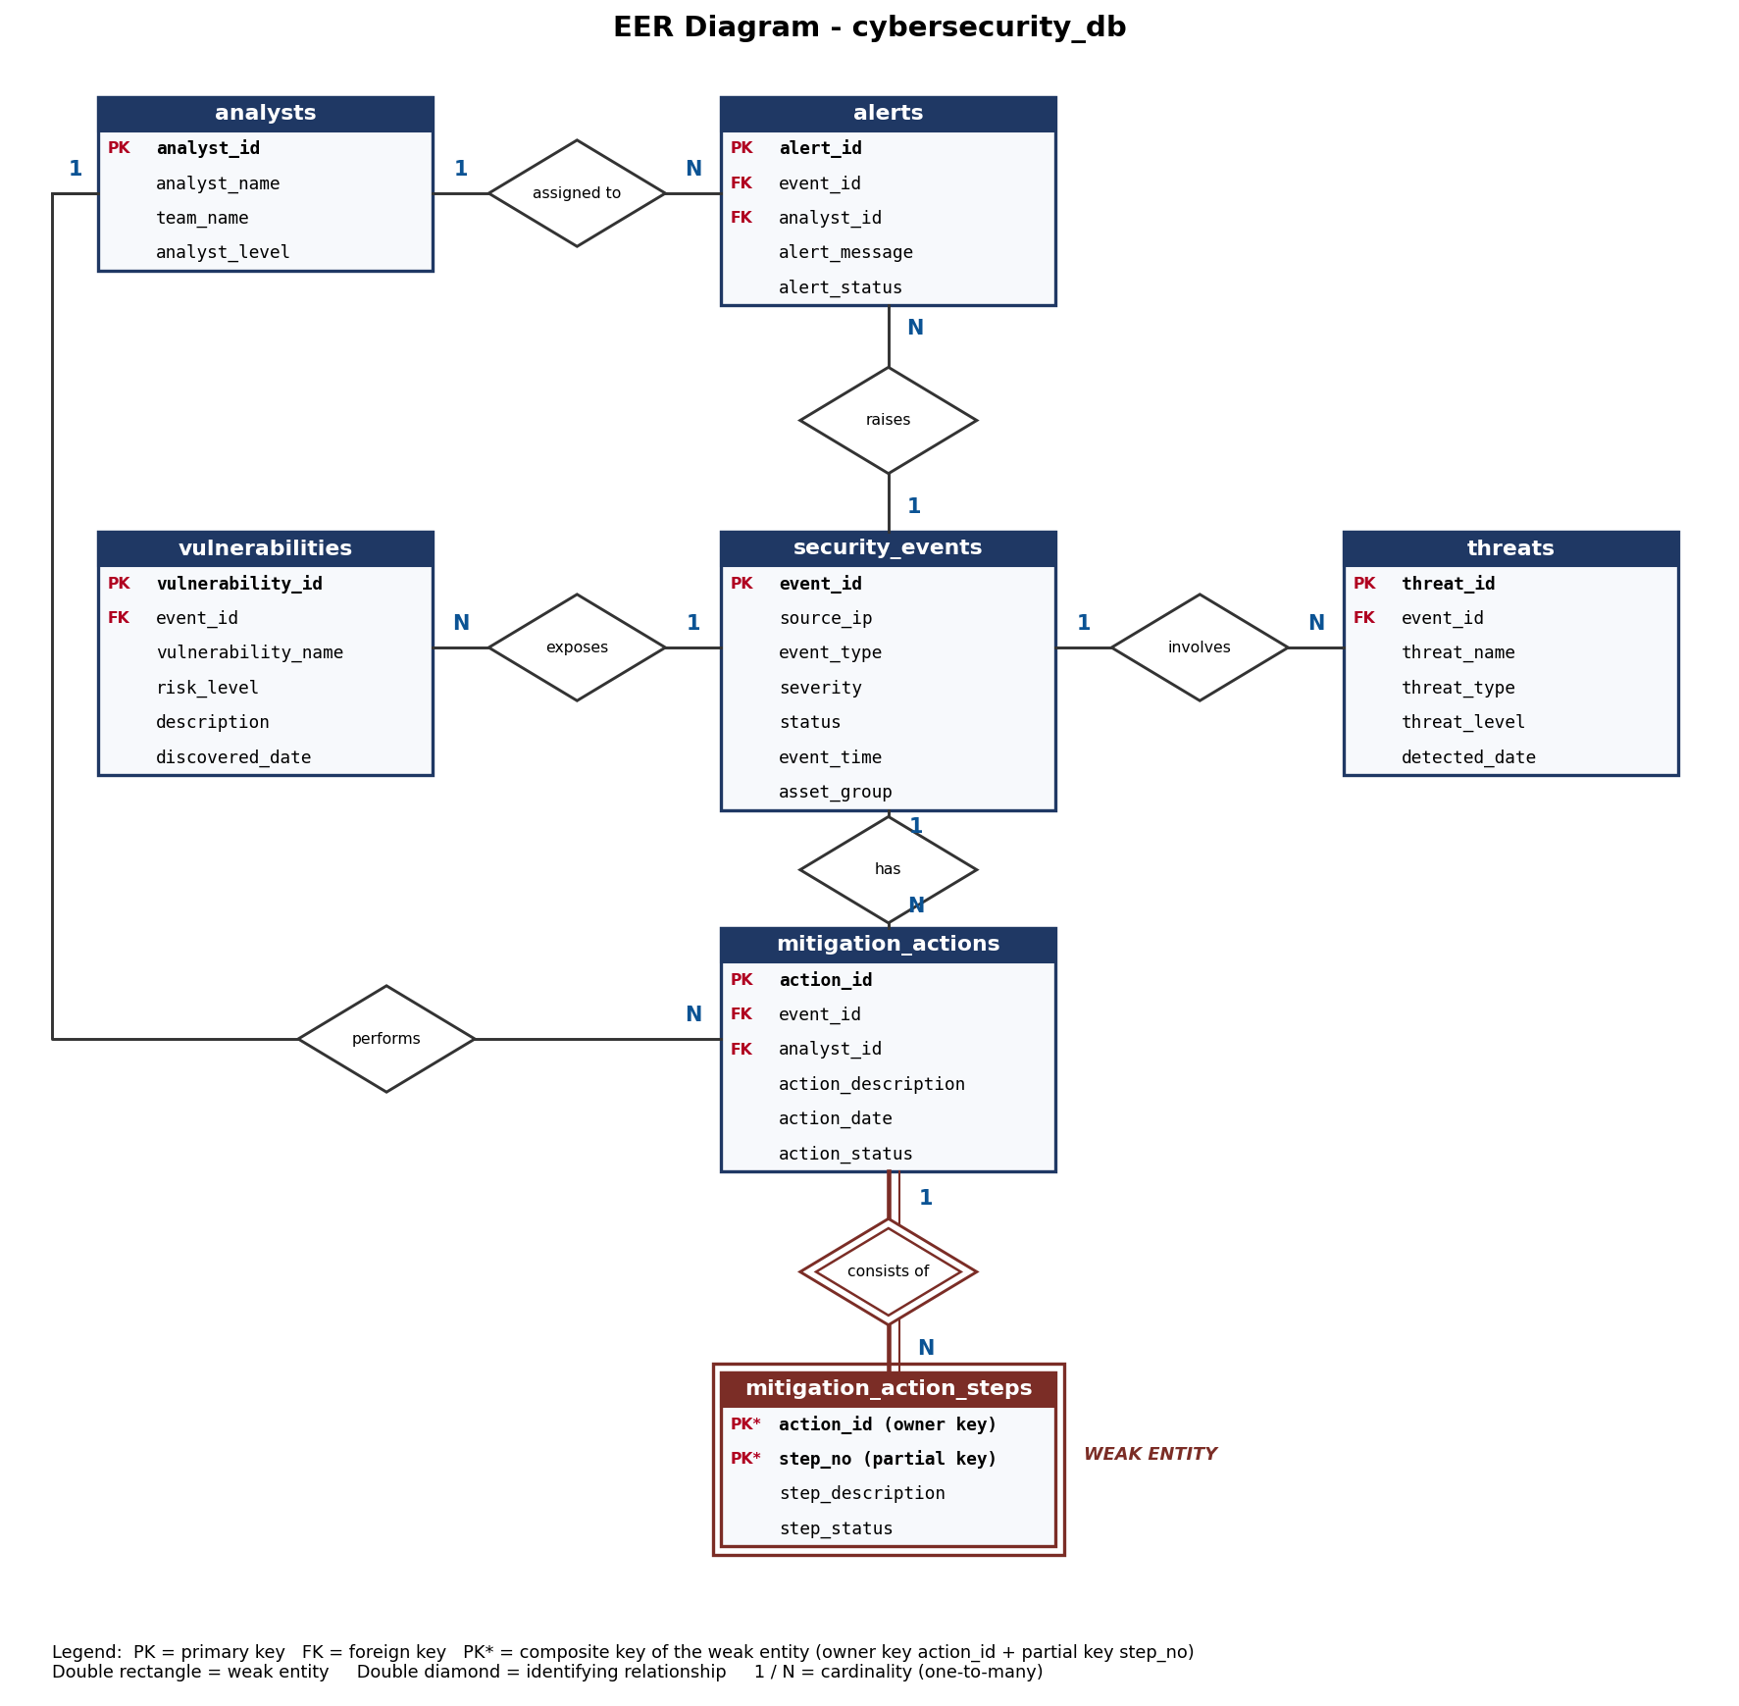
Figure 19: EER diagram of cybersecurity_db (weak entity: mitigation_action_steps)

4.1 Relationships and cardinalities
Relationship | Entities | Cardinality | Foreign key
raises | security_events - alerts | 1 : N | alerts.event_id
assigned to | analysts - alerts | 1 : N | alerts.analyst_id
exposes | security_events - vulnerabilities | 1 : N | vulnerabilities.event_id
involves | security_events - threats | 1 : N | threats.event_id
has | security_events - mitigation_actions | 1 : N | mitigation_actions.event_id
performs | analysts - mitigation_actions | 1 : N | mitigation_actions.analyst_id
consists of (identifying) | mitigation_actions - mitigation_action_steps | 1 : N | mitigation_action_steps.action_id

4.2 Weak entity type
Weak entity: mitigation_action_steps. A weak entity is one that cannot be uniquely identified by its own attributes alone and depends on a strong (owner) entity for its existence. A step number such as "step 2" means nothing by itself; it only identifies a step inside one particular mitigation action. If the action is removed, its steps have no meaning and must disappear with it.
- Owner (strong) entity: mitigation_actions.
- Identifying relationship: "consists of" between mitigation_actions and mitigation_action_steps (double diamond). Participation of the weak entity is total, so action_id is NOT NULL and is a foreign key.
- Partial key: step_no, which is unique only within one action.
- Primary key: the composite key (action_id, step_no), made of the owner key plus the partial key, as shown by DESCRIBE mitigation_action_steps (both columns marked PRI).
The other tables (alerts, vulnerabilities, threats, mitigation_actions) also refer to security_events or analysts through foreign keys, but each of them has its own primary key (alert_id, vulnerability_id, threat_id, action_id) and can be identified independently, so they are strong entities.

5. SQL Queries with Output Screenshots
This section contains the queries used to correlate events, identify attack patterns, assess risk levels and prioritize incident response. Each query is followed by a screenshot of its output from MySQL Workbench.

5.1 Correlating alerts, events and analysts
Alerts are joined with their security events (INNER JOIN) and with the assigned analyst (LEFT JOIN, so that an alert is still shown even if no analyst has been assigned yet).
SELECT a.alert_id, e.source_ip, e.event_type, an.analyst_name, a.alert_status
FROM alerts a
JOIN security_events e ON a.event_id = e.event_id
LEFT JOIN analysts an ON a.analyst_id = an.analyst_id;

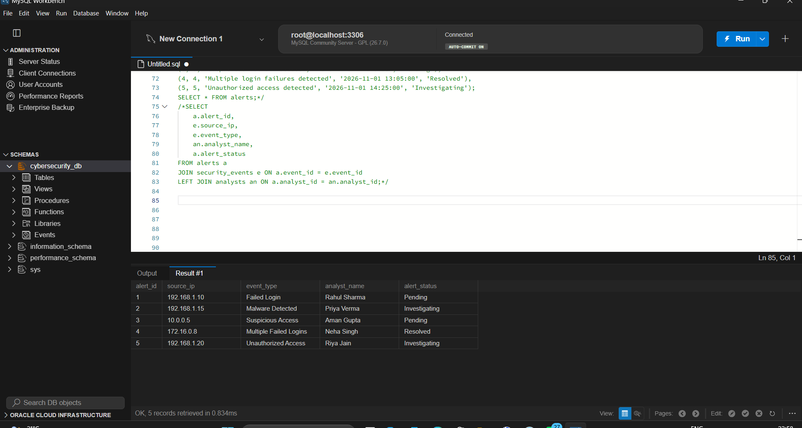
Figure 20: Alerts correlated with events and analysts
Output: all five alerts are listed with the source IP, event type, analyst and alert status, for example alert 2 (192.168.1.15, Malware Detected) is handled by Priya Verma and is Investigating.

5.2 Full incident correlation
A fuller view that brings together the event, its severity, the alert message and the analyst name.
SELECT se.event_id, se.source_ip, se.event_type, se.severity,
a.alert_id, a.alert_message, an.analyst_name
FROM security_events se
INNER JOIN alerts a ON se.event_id = a.event_id
LEFT JOIN analysts an ON a.analyst_id = an.analyst_id;

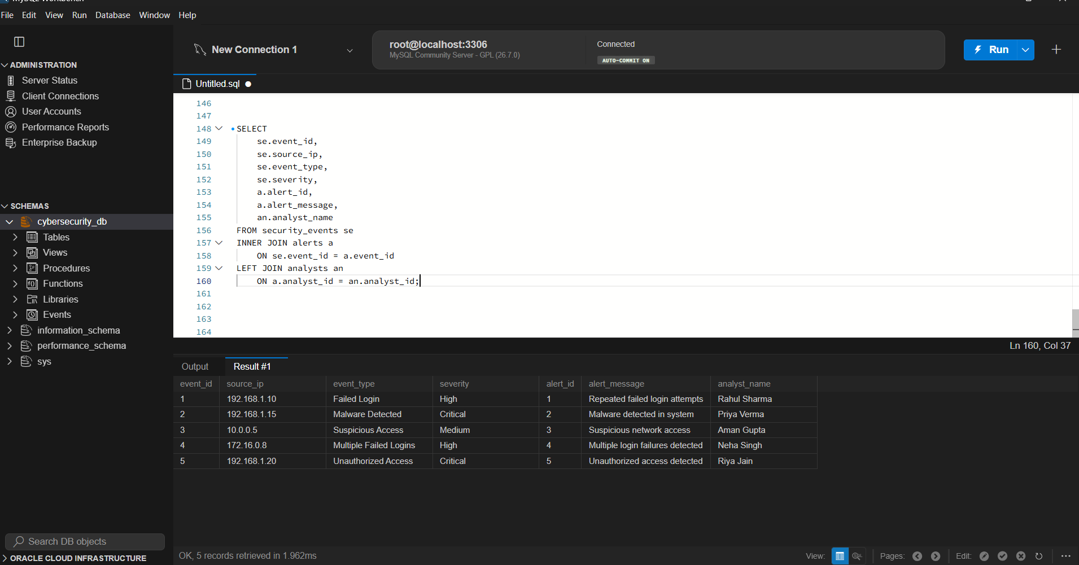
Figure 21: Correlation of security events, alerts and analysts
Output: five correlated incidents. Two events are Critical (Malware Detected and Unauthorized Access), two are High and one is Medium.

5.3 Identifying attack patterns: repeated failed logins
Failed-login events are grouped by source IP. An IP address with many failed attempts is a typical sign of a brute-force attack. The HAVING clause sets the minimum number of attempts to be reported; it can be raised (for example to 5) when the events table holds real, large-volume data.
SELECT source_ip, COUNT(*) AS failed_login_attempts
FROM security_events
WHERE event_type IN ('Failed Login', 'Multiple Failed Logins')
GROUP BY source_ip
HAVING COUNT(*) >= 1;

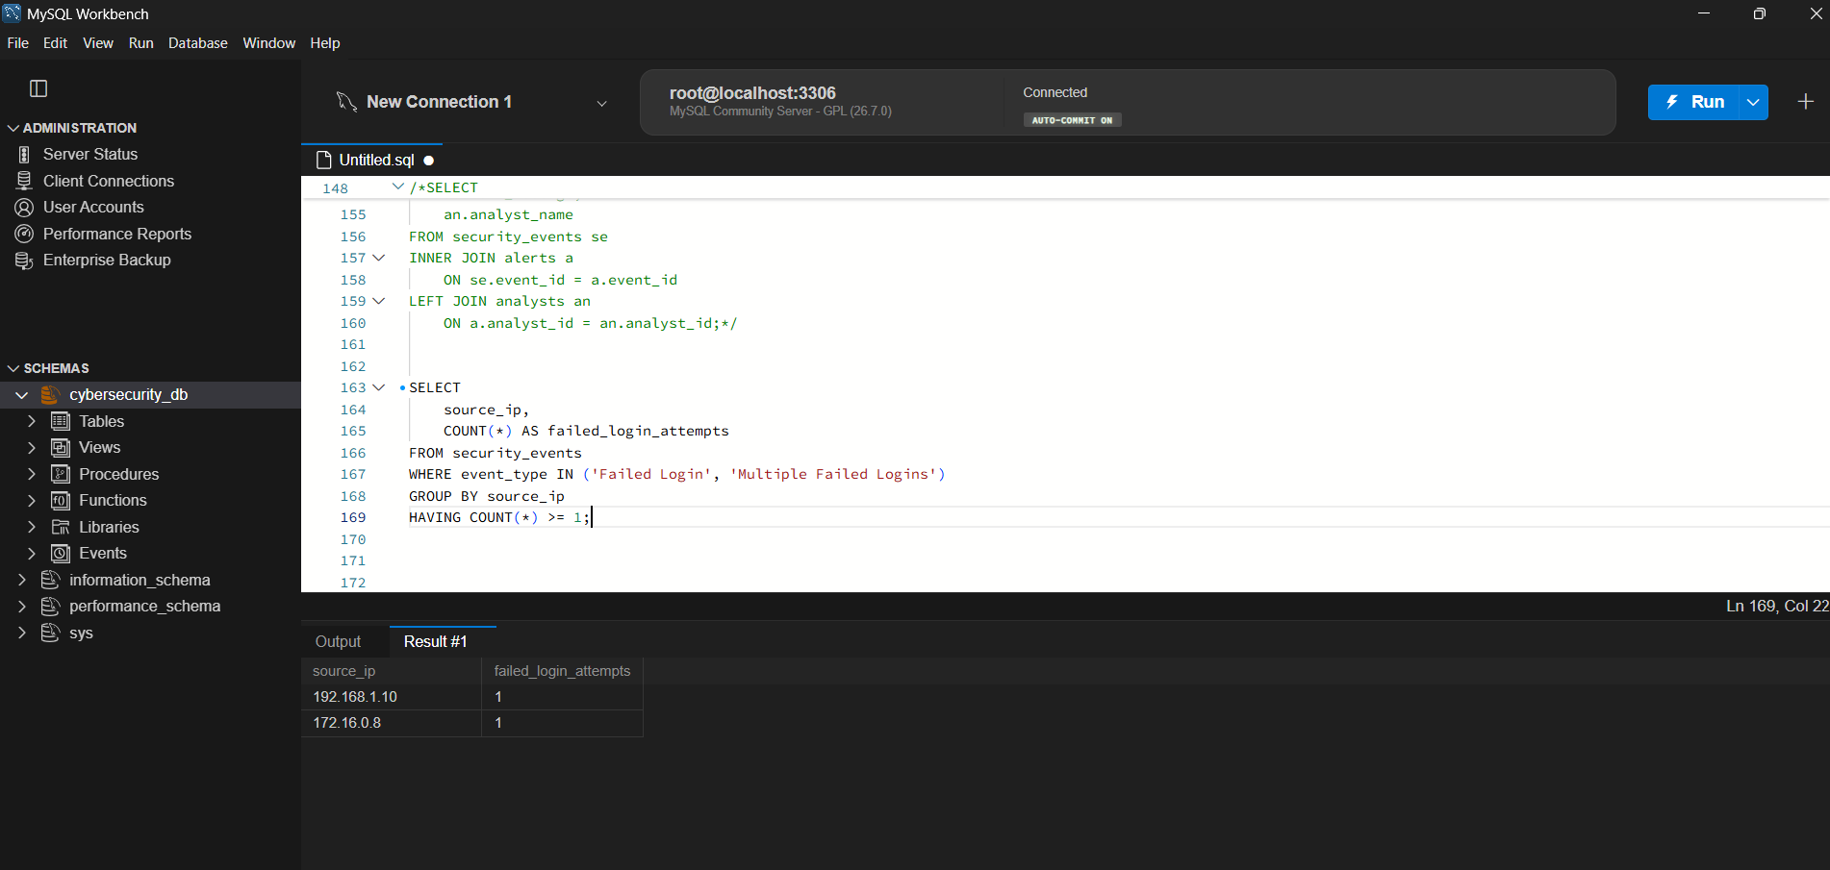
Figure 22: Failed login attempts per source IP
Output: the IP addresses 192.168.1.10 and 172.16.0.8 each have failed-login events recorded and are flagged as suspicious.

5.4 Risk assessment and prioritization of incident response
A CASE expression converts the severity of every event into an action label, and a second CASE in ORDER BY sorts the incidents so that Critical events come first. Analysts therefore always see the most dangerous incidents at the top of the list.
SELECT event_id, source_ip, event_type, severity, status,
CASE
WHEN severity = 'Critical' THEN 'Immediate Action'
WHEN severity = 'High' THEN 'Urgent'
WHEN severity = 'Medium' THEN 'Moderate'
ELSE 'Low Priority'
END AS risk_assessment
FROM security_events
ORDER BY
CASE severity
WHEN 'Critical' THEN 1
WHEN 'High' THEN 2
WHEN 'Medium' THEN 3
ELSE 4
END;

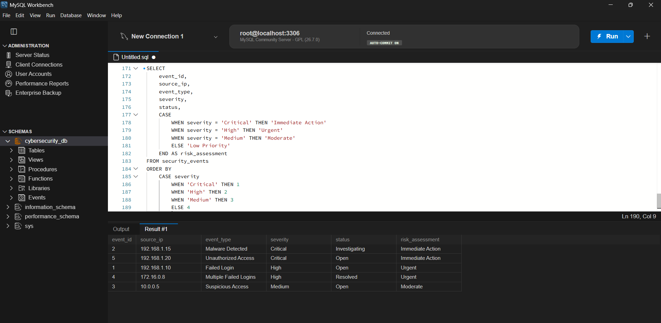
Figure 23: Risk assessment and priority order of incidents
Output: events 2 and 5 (Critical) need Immediate Action, events 1 and 4 (High) are Urgent and event 3 (Medium) is Moderate.

6. Indexing and EXPLAIN Results

6.1 Index creation
Three indexes were created to speed up the most common SOC queries: looking up all events from one IP in a time range, filtering by severity and status (for example "open critical"), and joining alerts to events.
CREATE INDEX idx_source_ip_event_time
ON security_events (source_ip, event_time);

CREATE INDEX idx_severity_status
ON security_events (severity, status);

CREATE INDEX idx_alerts_event_id
ON alerts (event_id);

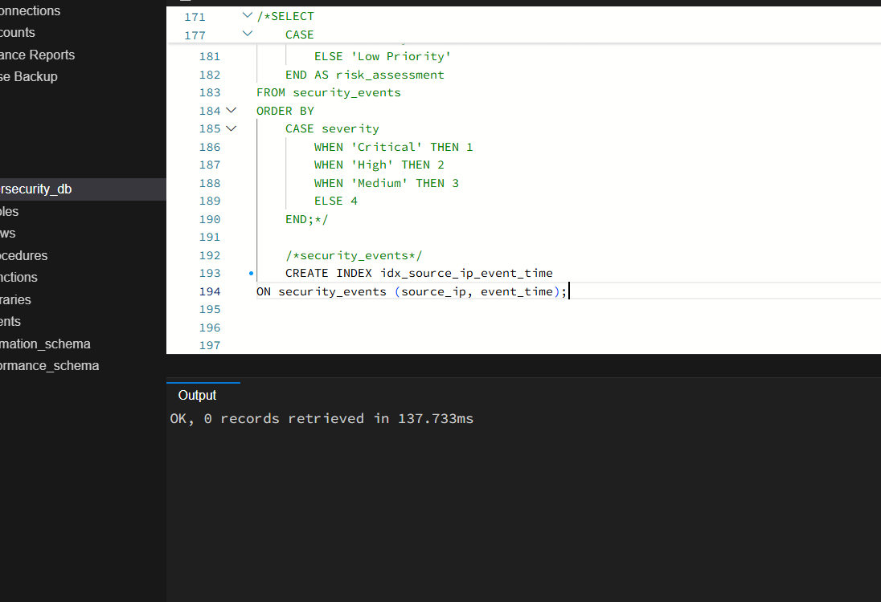
Figure 24: Creating the composite index idx_source_ip_event_time
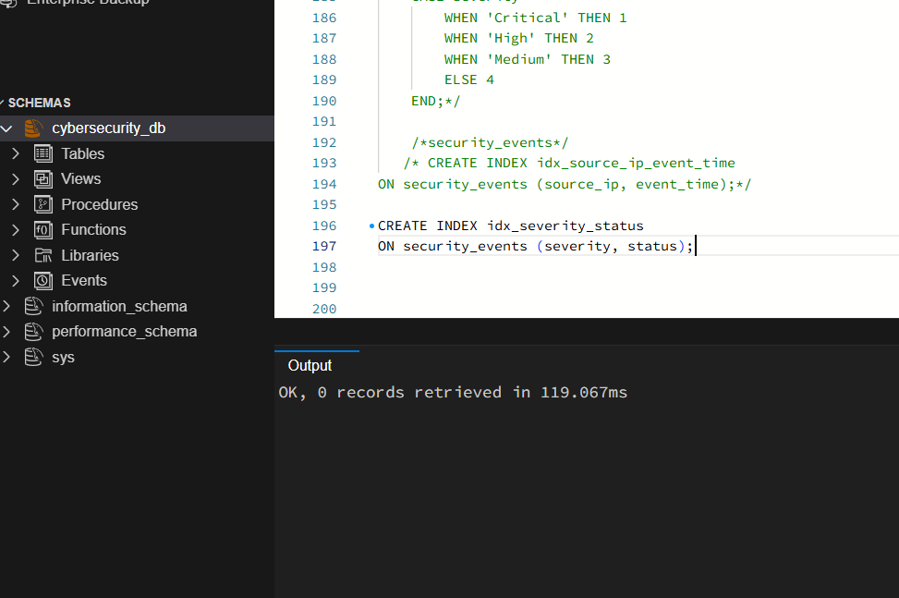
Figure 25: Creating the composite index idx_severity_status

6.2 Verifying the indexes with SHOW INDEX
SHOW INDEX FROM security_events;
SHOW INDEX FROM alerts;

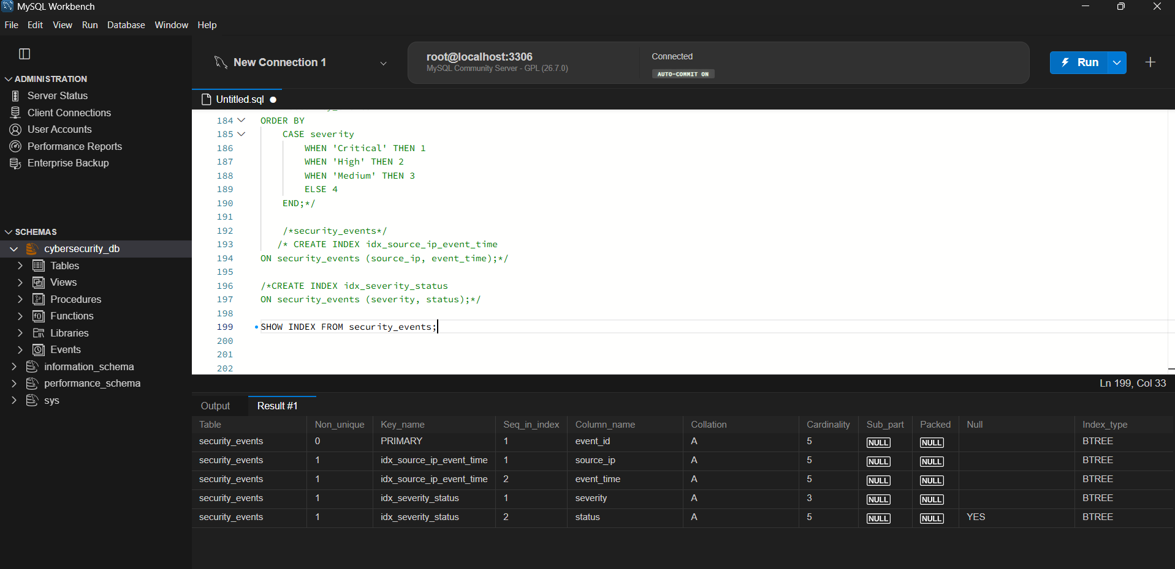
Figure 26: SHOW INDEX FROM security_events
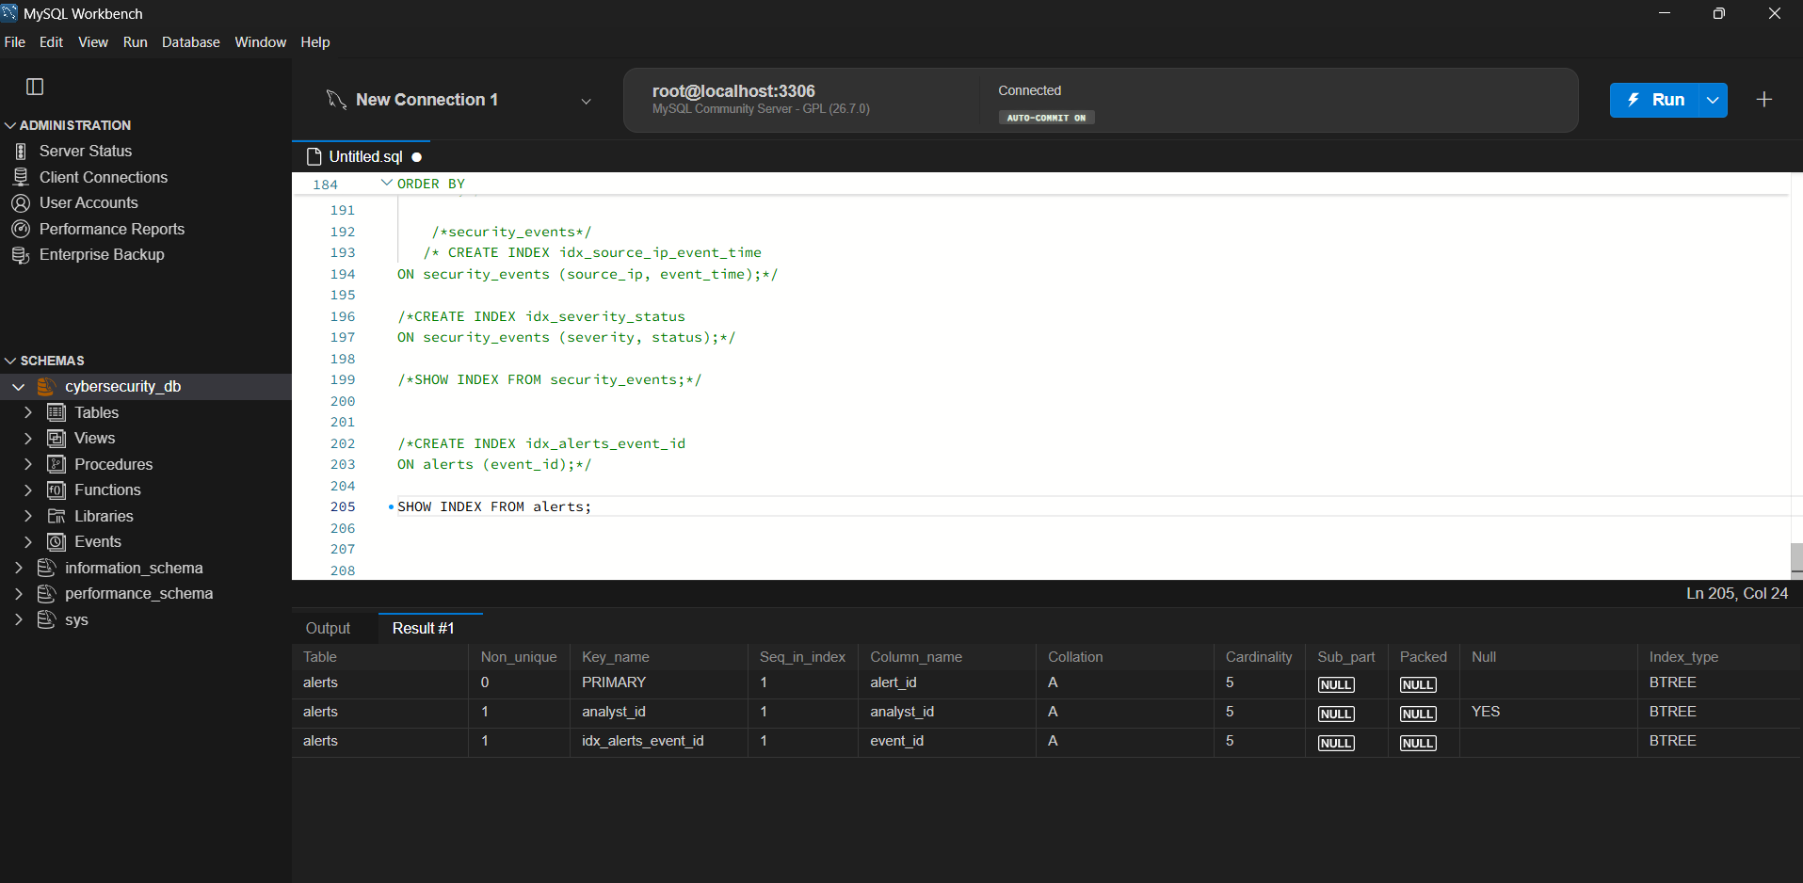
Figure 27: SHOW INDEX FROM alerts (idx_alerts_event_id created)
Both composite indexes on security_events are stored as B-tree indexes, with source_ip first and event_time second in the first index, and severity first and status second in the second. The index idx_alerts_event_id now exists on alerts, next to the primary key and the automatic index on analyst_id. In the output, the Cardinality column shows 5 for source_ip, 3 for severity and 5 for status in the current data.

6.3 EXPLAIN on a range query
EXPLAIN
SELECT *
FROM security_events
WHERE source_ip = '192.168.1.10'
AND event_time BETWEEN '2026-11-01 00:00:00'
AND '2026-11-02 23:59:59';

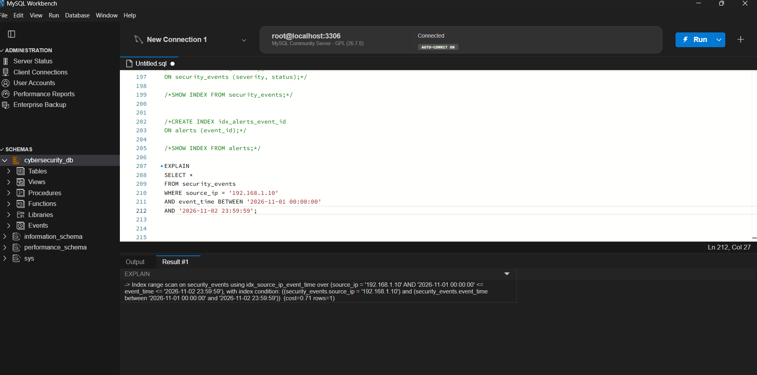
Figure 28: EXPLAIN output for the range query
Result: MySQL chose an index range scan on security_events using idx_source_ip_event_time. The index condition uses both columns: an equality match on source_ip and a range on event_time. The estimated cost is 0.71 and only 1 row is examined.
Without this index, MySQL would have to perform a full table scan and check every row of the table. That is acceptable for five rows, but on a table with thousands or millions of log records it becomes very slow. With the composite index, MySQL jumps directly to the entries for the given IP and reads only the part of the index that falls in the time range, so the number of rows examined stays small however large the table grows. The column order matters: the equality column (source_ip) comes first and the range column (event_time) comes last.

6.4 Why an index on severity alone is less effective
Severity has very few distinct values (Critical, High, Medium, Low), so it is a low-cardinality column. The SHOW INDEX output reflects this: the cardinality of severity is only 3, compared with 5 for source_ip. Each value of severity matches a large share of all the rows. When an index lookup returns a large fraction of the table, the optimizer finds it cheaper to scan the whole table than to jump back and forth between the index and the table rows. An index on severity alone therefore gives little or no benefit and still costs extra space and slows down INSERT and UPDATE operations.
The better design is the one used here: severity as the leading column together with status in the composite index (severity, status). The combination of the two values is more selective than either alone, so a query such as "severity = Critical AND status = Open" can use the index well. In general, low-cardinality columns work best as trailing columns of a composite index, after a more selective column.

7. Views and WITH CHECK OPTION

7.1 View of open critical incidents
This view combines events, alerts, vulnerabilities and the assigned analyst, and shows only incidents that are Critical and still Open. LEFT JOINs are used so that an incident is not lost if it has no alert, vulnerability or analyst yet.
CREATE VIEW open_critical_incidents AS
SELECT se.event_id, se.source_ip, se.event_type, se.severity, se.status,
a.alert_message, v.vulnerability_name, an.analyst_name
FROM security_events se
LEFT JOIN alerts a ON se.event_id = a.event_id
LEFT JOIN vulnerabilities v ON se.event_id = v.event_id
LEFT JOIN analysts an ON a.analyst_id = an.analyst_id
WHERE se.severity = 'Critical'
AND se.status = 'Open';

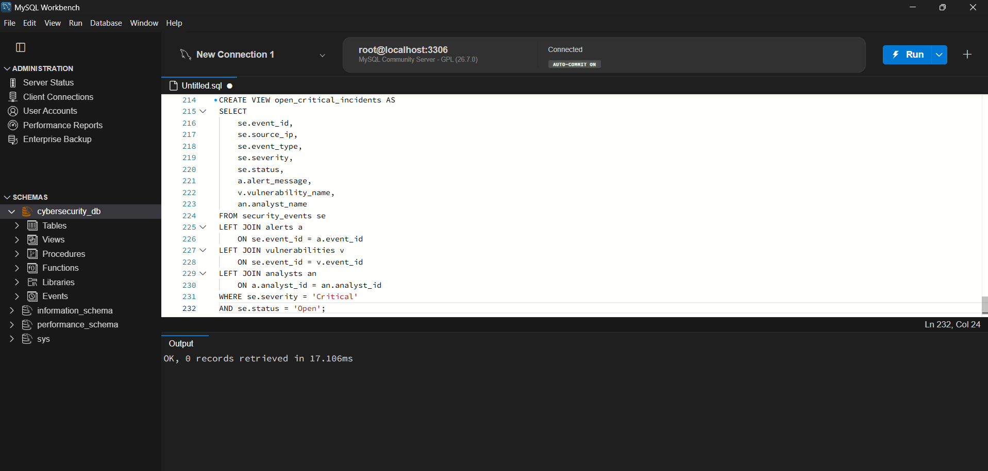
Figure 29: CREATE VIEW open_critical_incidents
SELECT * FROM open_critical_incidents;

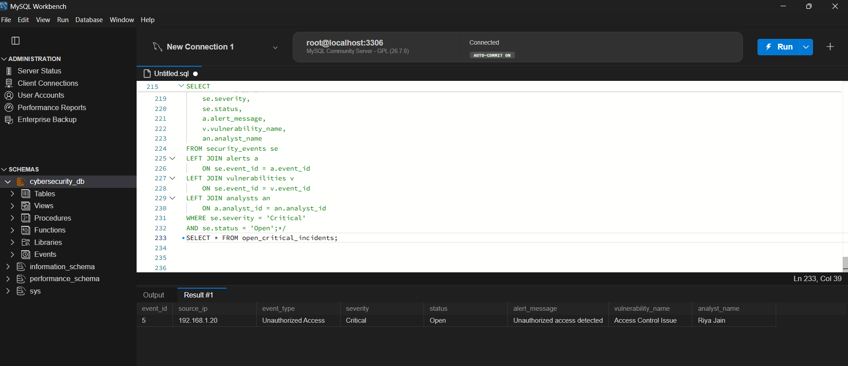
Figure 30: Output of the open_critical_incidents view
Output: only event 5 (192.168.1.20, Unauthorized Access, Critical, Open) is returned, with its alert message, the vulnerability "Access Control Issue" and the analyst Riya Jain. The incident that is Critical but Investigating (event 2) is correctly excluded.

7.2 Restricted view for junior analysts with WITH CHECK OPTION
The second view is a restricted view for junior analysts. It exposes only the incidents handled by junior-level analysts (together with their team) and hides all other rows. WITH CHECK OPTION is added at the end of the definition.
CREATE VIEW junior_analyst_incidents AS
SELECT se.event_id, se.source_ip, se.event_type, se.severity, se.status,
an.analyst_name, an.team_name, an.analyst_level
FROM security_events se
JOIN alerts a ON se.event_id = a.event_id
JOIN analysts an ON a.analyst_id = an.analyst_id
WHERE an.analyst_level = 'Junior'
WITH CHECK OPTION;

SELECT * FROM junior_analyst_incidents;

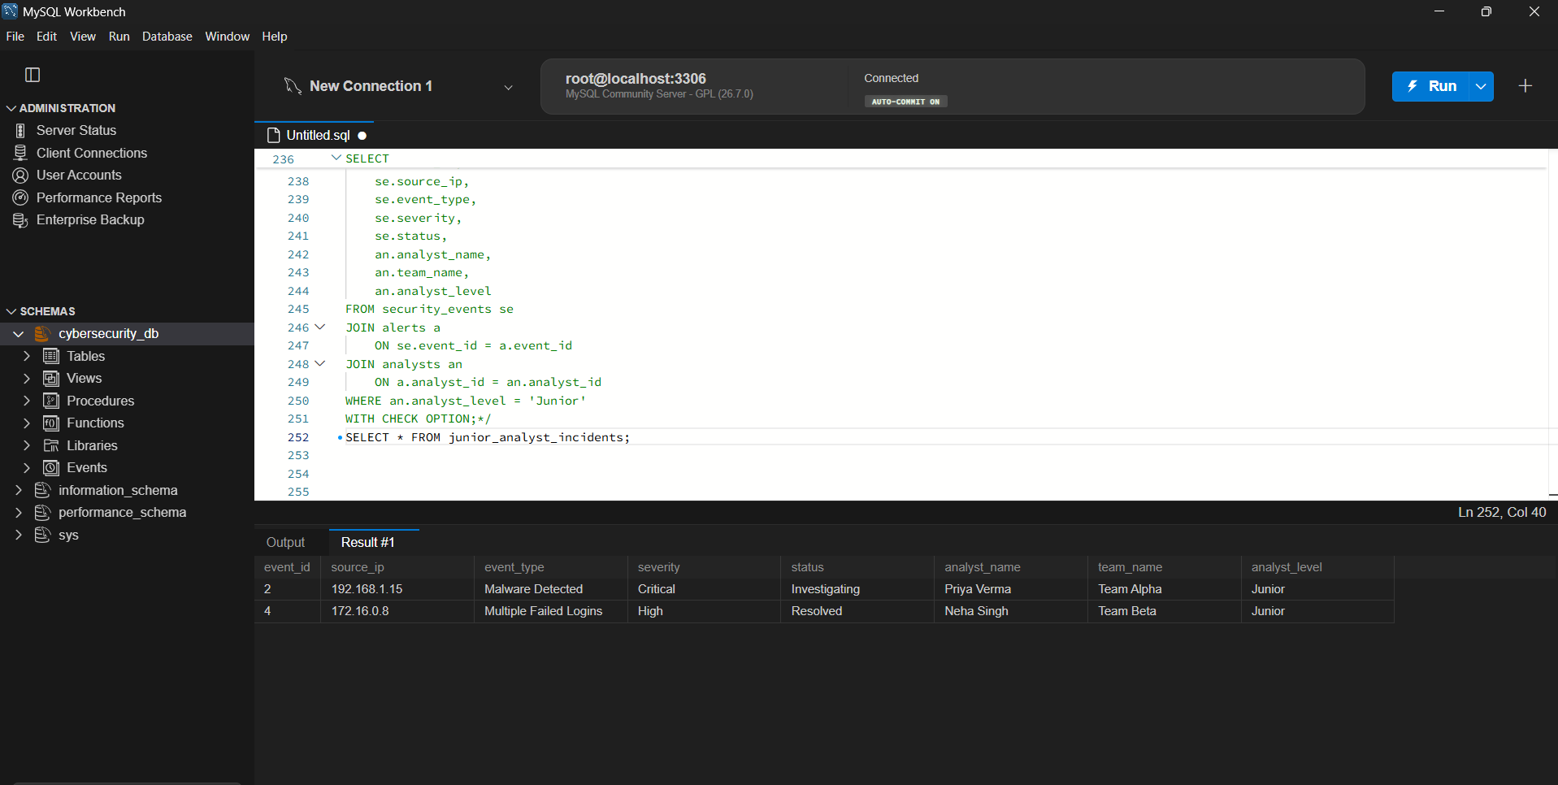
Figure 31: Restricted view junior_analyst_incidents
Output: only the incidents of the two junior analysts are visible: Priya Verma (Team Alpha, event 2) and Neha Singh (Team Beta, event 4). Incidents of senior analysts are not shown at all.

7.3 WITH CHECK OPTION
Normally, a view only filters what is read. WITH CHECK OPTION also controls what is written through the view. When a row is inserted or updated through the view, MySQL checks that the new row still satisfies the view's WHERE condition (here, analyst_level = 'Junior'). If the change would make the row fall outside the view, for example by turning a junior analyst into a senior one through the view, the statement is rejected with a "CHECK OPTION failed" error. This guarantees that a user of the view cannot create or modify data that they themselves would no longer be able to see, and cannot push data out of their permitted scope.

7.4 How views support security (data hiding)
- Row-level hiding: the WHERE clause of the view removes rows that the user must not see (other analysts' incidents, resolved or low-severity events).
- Column-level hiding: only chosen columns are exposed. Sensitive columns of the base tables are simply left out of the view definition.
- Least privilege: users are granted SELECT on the view, not on the base tables, so they can never query security_events, alerts or analysts directly.
- Controlled modification: WITH CHECK OPTION stops writes that fall outside the allowed scope.
- Simplicity and consistency: complex multi-table joins are written once inside the view, so every analyst gets the same, correct result without needing to know the underlying schema.

8. Window Functions

8.1 Brute-force detection with COUNT() OVER
A running count of failed-login events is kept for every source IP, ordered by event time. Each row counts only the failed logins of its own IP up to that moment (a sliding count), so a sudden jump in the count within a short period reveals a brute-force attack.
SELECT event_id, source_ip, event_type, event_time,
COUNT(
CASE
WHEN event_type IN ('Failed Login', 'Multiple Failed Logins')
THEN 1
END
) OVER (
PARTITION BY source_ip
ORDER BY event_time
) AS failed_login_count
FROM security_events
ORDER BY source_ip, event_time;

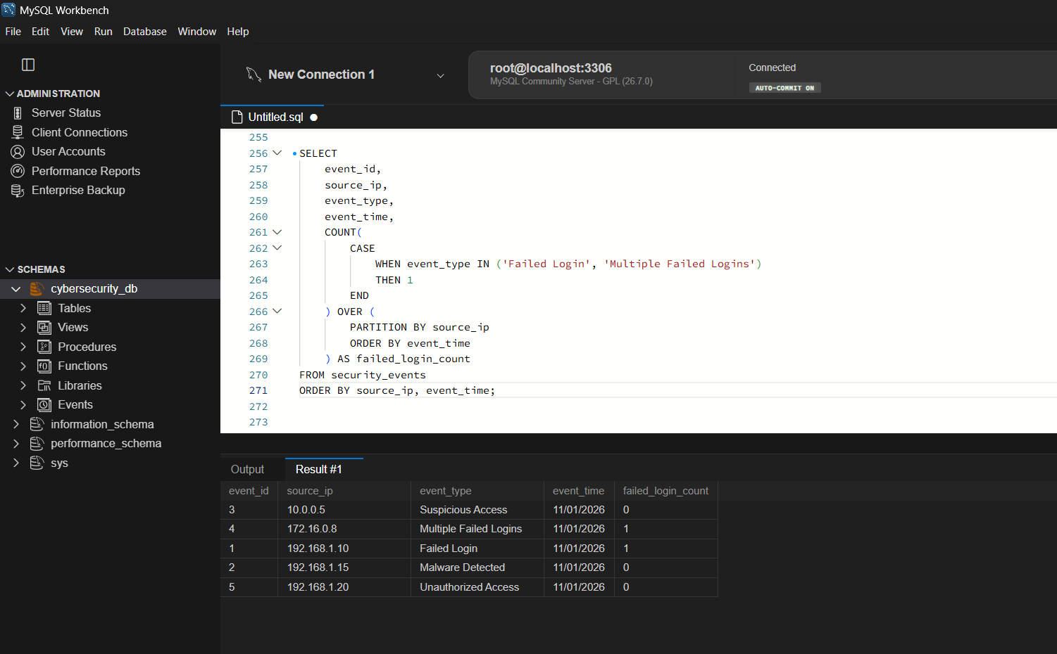
Figure 32: Failed login count per source IP using COUNT() OVER
Output: events 1 (192.168.1.10) and 4 (172.16.0.8) have failed_login_count = 1, while the other IP addresses show 0. In a real SOC log with many events per IP, this count would keep growing for an attacking IP and could be compared with a threshold.
The query above counts all earlier failed logins of the same IP. A real brute-force rule needs a sliding time window, so the frame is restricted to the last 1 hour before the current row using RANGE BETWEEN INTERVAL 1 HOUR PRECEDING AND CURRENT ROW:
SELECT event_id, source_ip, event_type, event_time,
COUNT(
CASE
WHEN event_type IN ('Failed Login', 'Multiple Failed Logins')
THEN 1
END
) OVER (
PARTITION BY source_ip
ORDER BY event_time
RANGE BETWEEN INTERVAL 1 HOUR PRECEDING
AND CURRENT ROW
) AS failed_login_count
FROM security_events
ORDER BY source_ip, event_time;

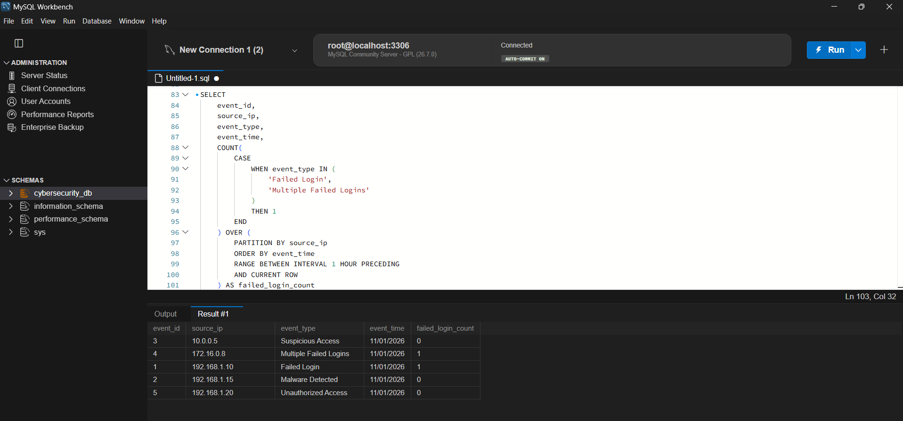
Figure 33: Failed logins per source IP within a sliding 1-hour window
Output: the same counts are returned (1 for 172.16.0.8 and 192.168.1.10, 0 for the others), but now only failed logins that happened within one hour before the current event are counted. If an IP had, say, 10 failed logins within one hour, its count would reach 10 and could be flagged as a brute-force attack.

8.2 Time gap between consecutive events using LAG()
LAG(event_time) returns the time of the previous event from the same source IP. Subtracting it from the current time with TIMESTAMPDIFF gives the gap in minutes. Very small and regular gaps indicate automated attacks.
SELECT event_id, source_ip, event_type, event_time,
LAG(event_time) OVER (
PARTITION BY source_ip
ORDER BY event_time
) AS previous_event_time
FROM security_events
ORDER BY source_ip, event_time;

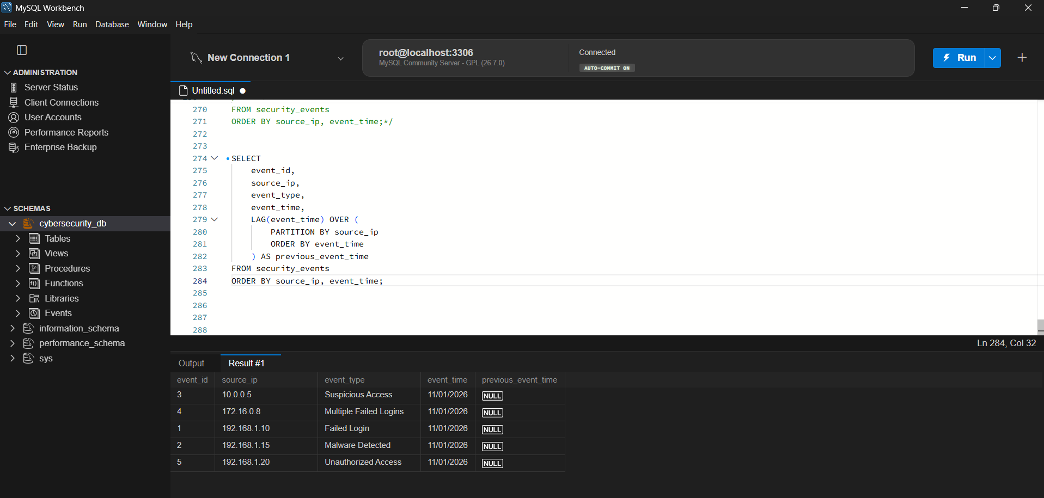
Figure 34: LAG() returning the previous event time per source IP
SELECT event_id, source_ip, event_time,
LAG(event_time) OVER (
PARTITION BY source_ip ORDER BY event_time
) AS previous_event_time,
TIMESTAMPDIFF(MINUTE,
LAG(event_time) OVER (PARTITION BY source_ip ORDER BY event_time),
event_time
) AS time_gap_minutes
FROM security_events;

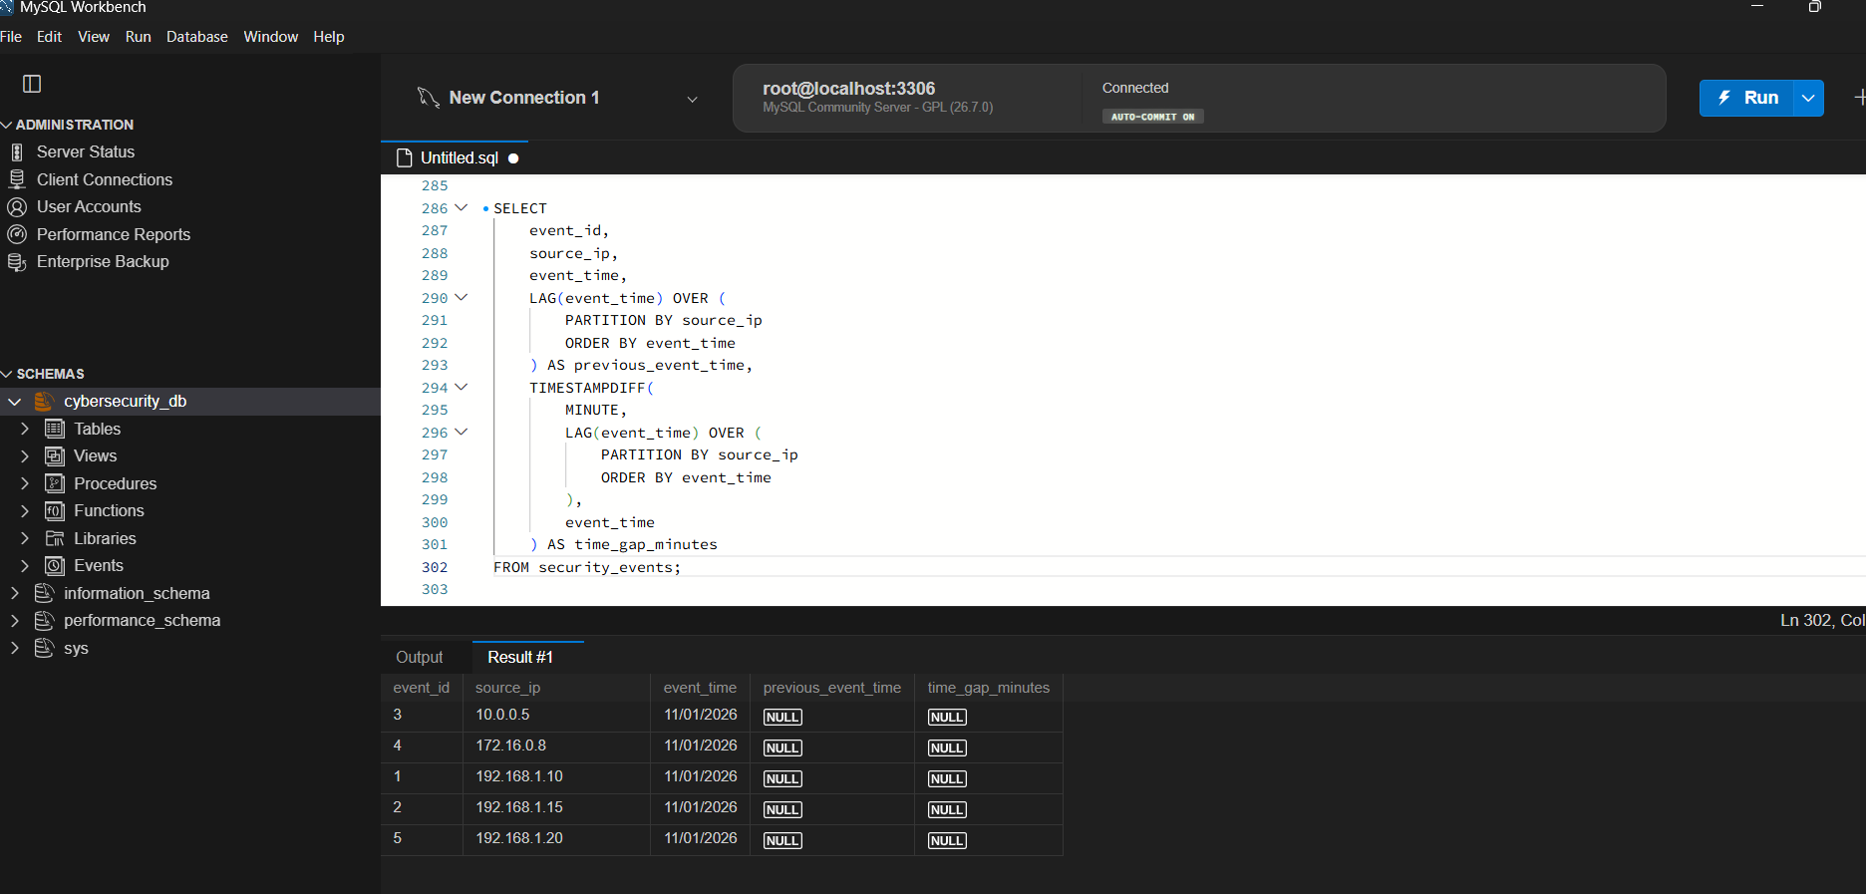
Figure 35: Time gap in minutes between consecutive events of the same IP
Output: previous_event_time and time_gap_minutes are NULL for every row. This is the expected result of the current sample data, because each source IP has only one event, so there is no earlier event from the same IP to compare with. LAG() returns NULL for the first row of every partition. With several events per IP, the column would show the actual gap.

8.3 Ranking incidents by risk score using DENSE_RANK()
(a) Ranking over all incidents.
A numeric risk score is derived from severity (Critical = 100, High = 75, Medium = 50, otherwise 25) and DENSE_RANK() ranks incidents from the highest score down. Incidents with the same score receive the same rank, and the next rank follows without any gap.
SELECT event_id, source_ip, severity,
CASE
WHEN severity = 'Critical' THEN 100
WHEN severity = 'High' THEN 75
WHEN severity = 'Medium' THEN 50
ELSE 25
END AS risk_score,
DENSE_RANK() OVER (
ORDER BY
CASE
WHEN severity = 'Critical' THEN 100
WHEN severity = 'High' THEN 75
WHEN severity = 'Medium' THEN 50
ELSE 25
END DESC
) AS incident_rank
FROM security_events;

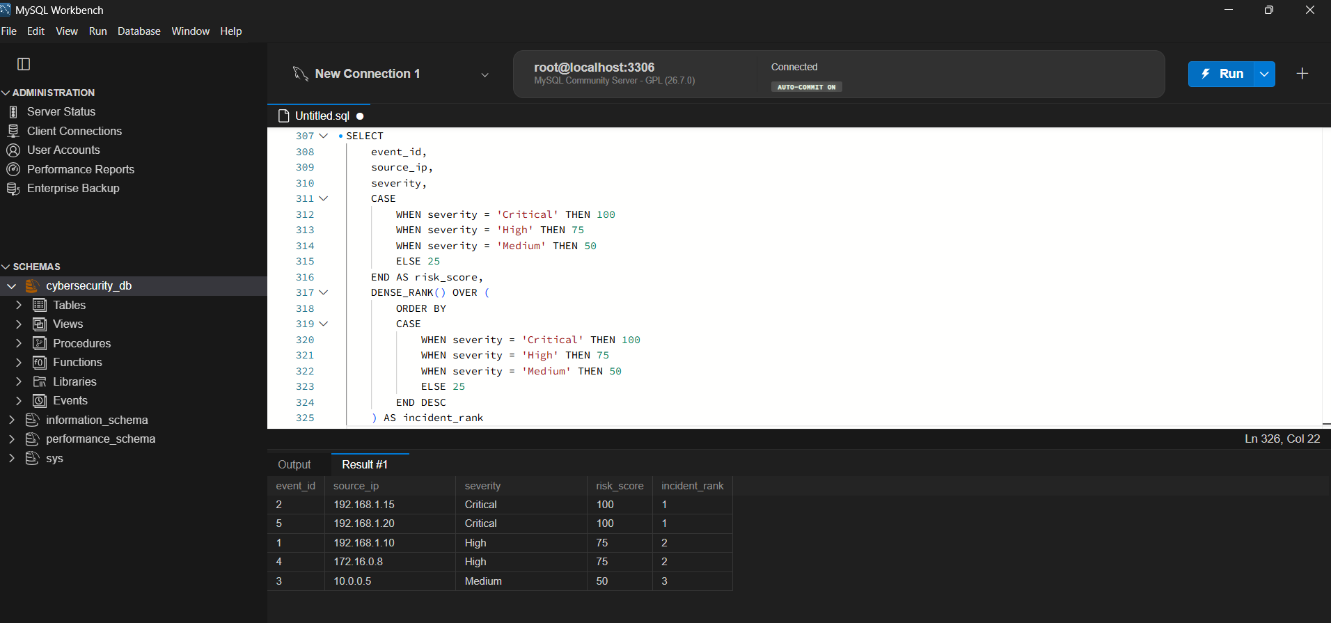
Figure 36: Incidents ranked by risk score using DENSE_RANK()
Output: events 2 and 5 (score 100) both get rank 1, events 1 and 4 (score 75) both get rank 2, and event 3 (score 50) gets rank 3. DENSE_RANK() produces no gap after the tie, unlike RANK(), which would have given rank 5 to the last row. The ranking here is over all incidents together.
(b) Ranking within each asset group. Using the asset_group column added in 3.8, PARTITION BY asset_group restarts the ranking for every asset group, so the highest-risk incident of the Network, Server and Database groups each gets rank 1.
SELECT event_id, source_ip, severity, asset_group,
CASE
WHEN severity = 'Critical' THEN 100
WHEN severity = 'High' THEN 75
WHEN severity = 'Medium' THEN 50
ELSE 25
END AS risk_score,
DENSE_RANK() OVER (
PARTITION BY asset_group
ORDER BY
CASE
WHEN severity = 'Critical' THEN 100
WHEN severity = 'High' THEN 75
WHEN severity = 'Medium' THEN 50
ELSE 25
END DESC
) AS incident_rank
FROM security_events;

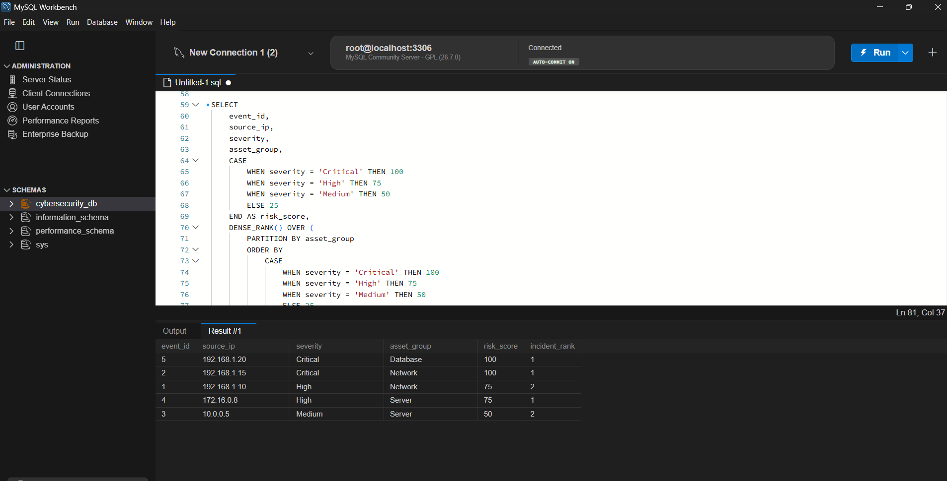
Figure 37: Incidents ranked by risk score within each asset group
Output: in the Network group, event 2 (Critical, 100) is rank 1 and event 1 (High, 75) is rank 2. In the Server group, event 4 (High, 75) is rank 1 and event 3 (Medium, 50) is rank 2. The Database group has a single incident, event 5 (Critical, 100), which is rank 1. This tells the SOC which incident to handle first inside every asset group.

9. Conclusion
In this project, a complete relational database for cybersecurity incident management was designed and implemented in MySQL. The schema consists of seven related tables (security_events, alerts, vulnerabilities, threats, mitigation_actions, mitigation_action_steps and analysts), connected by foreign keys that keep the data consistent. The mitigation_action_steps table was identified as the weak entity because a step number only has meaning inside its parent mitigation action; it uses the composite primary key (action_id, step_no), and the EER diagram shows it with a double rectangle and an identifying relationship.
SQL joins, grouping and CASE expressions were used to correlate events with alerts and analysts, to spot repeated failed logins and to label each event with a risk assessment so that Critical incidents are handled first. Composite indexes on (source_ip, event_time) and (severity, status), and an index on alerts(event_id), were created, and EXPLAIN confirmed that MySQL uses an index range scan instead of scanning the whole table. It was also explained why a low-cardinality column such as severity is a poor choice for a single-column index.
Views were used to give analysts a simple report of open critical incidents and a restricted view for junior analysts, and WITH CHECK OPTION ensures that data written through the view cannot leave its allowed scope, which supports security through data hiding. Finally, window functions (COUNT() OVER with a sliding 1-hour frame, LAG() and DENSE_RANK() partitioned by asset group) were applied to detect brute-force patterns, measure the time between consecutive events and rank incidents by risk score within each asset group.
Overall, the project shows how a well-designed database, supported by proper indexing, views and analytical SQL, can help a Security Operations Center find, prioritize and respond to cyber incidents quickly and safely.

Tools used: MySQL Community Server, MySQL Workbench.

