

District Advisory Committee (DAC)

to SharePoint

Business Requirements Document

Version – 1.2

Published: 09/08/2017

Author: Jerome Glennon

**Requirements Acceptance**

|  |  |  |  |  |  |  |  |  |  |  |  |  |  |  |  |  |  |  |  |  |  |  |  |  |  |  |  |  |  |  |  |  |  |  |  |  |
| --- | --- | --- | --- | --- | --- | --- | --- | --- | --- | --- | --- | --- | --- | --- | --- | --- | --- | --- | --- | --- | --- | --- | --- | --- | --- | --- | --- | --- | --- | --- | --- | --- | --- | --- | --- | --- |
| |  |  |  |  | | --- | --- | --- | --- | | Position | Name | Date | Signature | | Business Sponsor | Bernadette Cardenas |  |  | | Business Owner | Wanda Thomas  Cynthia Nemons  Jesse Marche |  |  | |  |  |  |  | | Project Manager | Wendal Breazeale |  |  | |  |  |  |  | | IT Business Analyst | Jerome Glennon |  |  | | Lead Developer | TBD |  |  | |  |  |  |  | |
| Confidentiality / Security Warning |
| *This is an internal HISD project document, and is not intended for viewing by any parties’ other than HISD employees, or HISD-designated actors that are specifically involved in this project. Intellectual property contained in this document is property of HISD, and is not intended for distribution.* |

**Revision History**

|  |  |  |  |
| --- | --- | --- | --- |
| **Version** | **Date** | **Changed By** | **Description** |
| 1.0 | 09/08/2017 | Jerome Glennon | Initial requirements document the application |
| 1.1 | 11/13/2017 | Jerome Glennon | Changes from meeting with users on 11/10/2017  Updated Sections:  1.3.1.1  1.5.1  2  3.1  3.3.2.5.1  3.4.1.4  3.4.2.1 |
| 1.2 | 02/05/2018 | Jerome Glennon | Updated Exhibit 7.1  Updated Sections:  3.4.1.4 |
|  |  |  |  |
|  |  |  |  |
|  |  |  |  |
|  |  |  |  |

Table of Contents

1. OverView and BackGround 5

1.1. Purpose of this document 5

1.2. Justification 5

1.3. ObjectiveS 5

1.4. Scope 5

1.5. Assumptions 5

2. Overview of the DAC Application 6

2.1. Process Flow 6

2.2. Access 6

3. Business Requirements 6

3.1. Definitions 6

3.2. Security Roles 6

3.3. Data Source / Storage 7

3.4. Administrator View / Functions 8

3.4.1.1. Ability to enter Voting Period 8

3.4.1.2. Ability to Enter Candidate Entry Period 8

3.4.1.3. Ability to Enter Result Release Date 8

3.4.1.4. Ability to Enter Central Office Candidates 8

3.4.3.1. Reports 9

3.5. Principal View / Functions 9

3.5.1.1. Ability to Enter Candidates from their Campus 9

3.5.1.2. Ability to Cast a Vote 10

3.5.1.3. Ability to see Voting Results 10

3.6. Campus Corridnator 10

3.7. Campus based Employees Views / Functions 10

3.7.1.1. Ability to Cast a Vote 10

3.7.1.2. Ability to See Voting Results 10

3.8. Central Office based Employees Views / Functions 11

3.8.1.1. Ability to Cast a Vote 11

3.8.1.2. Ability to See Voting Results 11

4. Technical Specification and Assumptions 11

5. Configuration Data 11

6. Known Constraints 11

7. Exhibits 12

7.1. Exhibit 2.1 12

7.2. Exhibit 3.4 13

7.3. Exhibit 3.4A 13

7.4. Exhibit 3.4B 14

7.5. Exhibit 3.4C 14

7.6. Exhibit 3.5 15

7.7. Exhibit 3.5A 15

7.8. Exhibit 3.5B 16

7.9. Exhibit 3.5C 16

7.10. Exhibit 3.8 16

# OverView and BackGround

## Purpose of this document

* + 1. To capture and requirements for the requested to convert DAC (District Advisory Committee) from a .net Application into a SharePoint Application

## Justification

* + 1. The new DAC application will allow the administrator to manage the application without much involvement from IT.
    2. This puts the responsibility of the application in the hands of the users by making it more efficient and reducing the time spent using the tool and being dependent on other groups.

## ObjectiveS

* + 1. As a part of the SIS project and ODS Sun setting, DAC will be re-implemented and upgraded to function as an application within SharePoint. The current application will be ultimately decommissioned.
       1. Historical data for old app needs to be accessible going back 5 years.

## Scope

* + 1. In Scope: The documented functionality will include the current functionality and may include some of the updated requested functionality.
    2. Out of Scope: TBD

## Assumptions

* + 1. Houston Independent School District (HISD) is using this application as it’s only District Advisory Committee tool.
    2. SharePoint is presumed to be a viable solution to support the reimplemented application.
    3. Security roles will be based on Active Directory groupings.

# Overview of the DAC Application

DAC (District Advisory Committee) is a tool designed to select a campus representative(s) for the advisory committee.  
Every year employees will vote on the DAC committee. Employees at the campus level can only vote for candidates at like campuses (i.e. High School employees can only vote for a candidate at the High school level, Middle School employees can only vote for candidates at the Middle School level, etc.). Voting period start and end date are entered, candidates are entered, and winners are notified by the DAC facilitator to see if they can fulfill the duties required.

Voting data is school year specific.

## Process Flow

* + 1. See Exhibit 2.1

## Access

* + 1. The current application is accessed by all users by using the following URL: <https://apps.houstonisd.org/DAC/Login.aspx>

# Business Requirements

## Definitions

* + 1. Dates – All dates will be displayed in the following format
       1. MM/DD/YYYY
    2. Name Display format
       1. All names displayed in the tool will be “Last Name , First Name, Middle Initial”
    3. Central Based Office – All HISD buildings that are not an actual Campus that have students attending classes.
    4. Exhibits – All exhibits are just “SAMPLES” the final screens may look different but poses the required functionality.

## Security Roles

* + 1. The following groups need to be created in Active Directory under the Groups/AppAuth OU (OU=AppAuth,OU=Groups,DC=AD,DC=HISD,DC=ORG)
       - 1. DAC_Admin
         2. DAC_SC (School Coordinator)
         3. Principal (Generic Group used by all applications) (Already created in AD as of 7/20/2017)

## Data Source / Storage

* + 1. The following data elements will be pulled from the EDW Views provided by the data ware house team
       1. Employee Information
          1. Employee ID
          2. Department ID
          3. Department Name
          4. Last Name
          5. Middle Initial
          6. First Name
    2. The following data elements will be stored in the DAC application data base, data elements type and length should match EDW when applicable. Data is school year specific.
       1. All Records stored should have the following columns
          1. Created by
          2. Created on
          3. Last Updated By
          4. Last Updated on
       2. Candidated Entry Period
          1. Start Date
          2. Start Time
          3. End Date
          4. End Time
          5. School Year
       3. Voting Period
          1. Start Date
          2. Start Time
          3. End Date
          4. End Time
          5. School Year
       4. Results Release Date
          1. Start Date
          2. School Year
       5. List of Candidates
          1. Department Type

High School (Any grade span that ends with grade 12)

Middle School (Any grade span that ends with grades  07 or 08)

Elementary School (Anything containing the following: EE, PK, K -05 or 06)

Central Office

* + - * 1. Department ID
        2. Employee ID
        3. Number of Votes
        4. School Year

## Administrator View / Functions

* + 1. A user with the DAC_Admin role will need the following capabilities within the application

## Ability to enter Voting Period

* + - * 1. Start Date
        2. Start Time
        3. End Date
        4. End Time
        5. Exhibit 3.4A

## Ability to Enter Candidate Entry Period

* + - * 1. Start Date
        2. Start Time
        3. End Date
        4. End Time
        5. Exhibit 3.4A

## Ability to Enter Result Release Date

* + - * 1. Start Date
        2. Start Time
        3. Exhibit 3.4A

## Ability to Enter/Modify Central Office and Last Minute Candidates

* + - * 1. Ability to search for a active Central Office employee to be added by the following

Employee ID

Department Name

Employee Name

* + - * 1. Ability to search any school campus for eligible candidates to be added by the following

Campus ID

Employee ID

Employee Name

* + - * 1. Ability to add more than one employee as a candidate if they are listed in the same department
        2. Eligibilty fo Campus candidtates

See section 3.5.1.1

* + - * 1. Eligibility for central office candidates

Non IT employees at the Central Office must have the following attributes

A pay grade in the following range (25 – 37, A, B) and

Department ID is not a Campus

IT employees at the Central Office must have the following attributes

A pay grade in the following range (06 -17) and

A JobFamilyCode in ('INFO TECH','CUST SRVS’)

* + - * 1. Candidates can only be entered during the candidate entry period from section 3.4.1.2
        2. Candidates can be added or deleted
        3. Exhibit 3.4B
    1. Sample Dashboard Page Exhibit 3.4

## Reports

* + - * 1. Candidate List and Results

Search Criteria

School Year

Location

Category Group

Display Values

Location

Category Group

Employee ID (Note: This field is only visible for Admin roles)

Candidate Name

Department Name

# Votes (Group Header)

Group by

Location

Category Group

# Votes

Candidate Name

Exhibt 3.4C

## Principal View / Functions

* + 1. A user with the Principal role will need the following capabilities within the application

## Ability to Enter Candidates from their Campus

* + - * 1. Ability to enter each of the following candidate types for their campus only from active employees

One candidate of “Campus Based Professional” type

Any employee with the following attributes:

Must have one of the job codes listed in Exhibit 3.5.1 (Note: This should be stored in a table structure so it can be easily added to.)

One candidate of “Classroom Teacher” Type (Regular/Vocational/ROTC teachers)

Any employee with the following attributes:

jobfunctionnatural Key is one of the below

TCH

TEL

TSC

TPK

TEA ELEM

TEA PREK

TEA SEC

Not in one of the JobFamily below

ARTS

COMP

PE

READING

SalaryPlanTypeNaturalKey in ('RO1','RO5','RT1','RT2','RT3','RT4','RT5','VT1','VT3')

Multiple self nominated candidates

Any employee from either list in 3.5.1.1.1.1 or 3.5.1.1.1.2

Candidates can only be entered during entry period from section 3.4.1.2

Exhibit 3.5

## Ability to Cast a Vote

* + - * 1. Ability to cast a vote for one candidate in each category

Classroom Teacher

Campus Based Professionals

If vote is cast for one category but not the other category, ability to cast vote for the open category till voting period ends.

* + - * 1. Voting is active during the voting period set in section 3.4.1.1
        2. Candidates to select from are only from their Department Type as defined in 3.3.2.5.1
        3. Once Votes are cast voting is locked and user should get the following message

“You have already cast your votes for the xxxx-xxxx school year, thank you for your vote. Results will be available starting on xx/xx/xxx @x:xxAM/PM”

* + - * 1. Exhibits 3.5A, 3.5B, 3.5C

## Ability to see Voting Results

* + - * 1. Ability to see the voting results report from section 3.4.3.1
        2. Report is active after the release date set in section 3.4.1.3
    1. Sample Dashboard Exhibit 3.4

## Campus Corridnator

* + 1. A user with the DAC_SC role will need the following capabilities within the application (This role is a proxy for the Principal)
       1. Same access as 3.5
       2. The Principal of the campus must designate someone to have the DAC_SC role using the security request process.
    2. Sample Dashboard Exhibit 3.4

## Campus based Employees Views / Functions

* + 1. Employees based at a campus will need the following access

## Ability to Cast a Vote

* + - * 1. Same as section 3.5.1.2

## Ability to See Voting Results

* + - * 1. Same as section 3.5.1.3
    1. Sample Dashboard Exhibit 3.4

## Central Office based Employees Views / Functions

* + 1. Employees based at the Central Office will need the following access

## Ability to Cast a Vote

* + - * 1. Ability to cast a vote for one Cental Office based employee
        2. Voting is active during the voting period set in section 3.4.1.1
        3. Candidates to select from are only from their Department Type as defined in 3.4.1.4
        4. Once Vote is cast voting is locked and user should get the following message
        5. “You have already cast your votes for the xxxx-xxxx school year, thank you for your vote. Results will be available starting on xx/xx/xxx @x:xxAM/PM”
        6. See Exhibits 3.8, 3.5C

## Ability to See Voting Results

* + - * 1. Same as section 3.5.1.3
    1. Sample Dashboard Exhibit 3.4

# Technical Specification and Assumptions

* 1. Reports
     1. All reports will be exportable to Excel
  2. Application should work with HISD’s current browser standards for PC and Mobile Devices
  3. Application is only accessible while on the HISD secured network
  4. Voting data is School Year specific and historical data to be maintained for 5 years going forward.

# Configuration Data

* 1. Security Groups in Active Directory
     1. Users will be added to the appropriate group for access and maintained by 2nd tier support group
  2. Control Group for Campus Based Professionals (See Exhibit 3.5.1)

# Known Constraints

* + 1. Dedicated development resources
    2. Dedicated UAT resources

# Exhibits

## Exhibit 2.1



## Exhibit 3.4

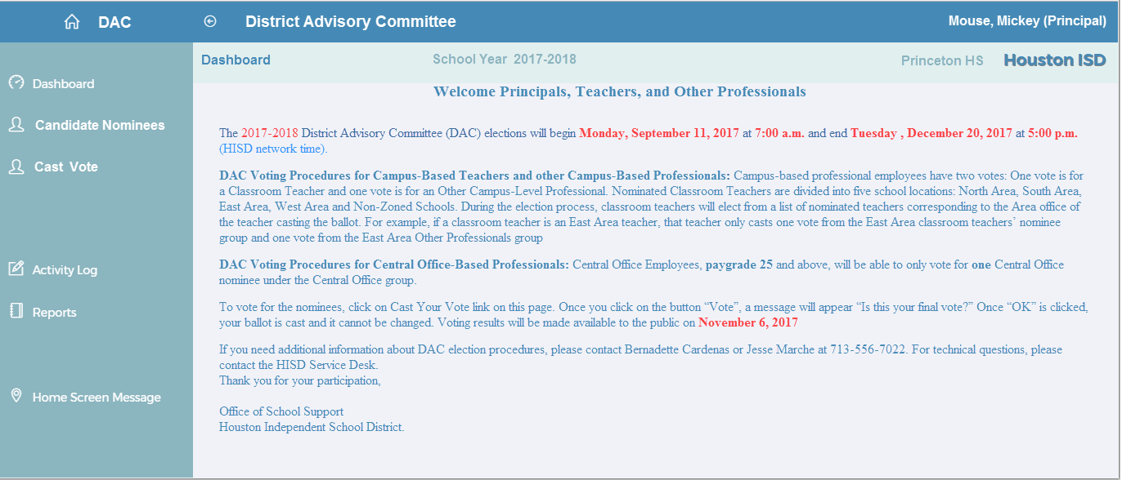

## Exhibit 3.4A

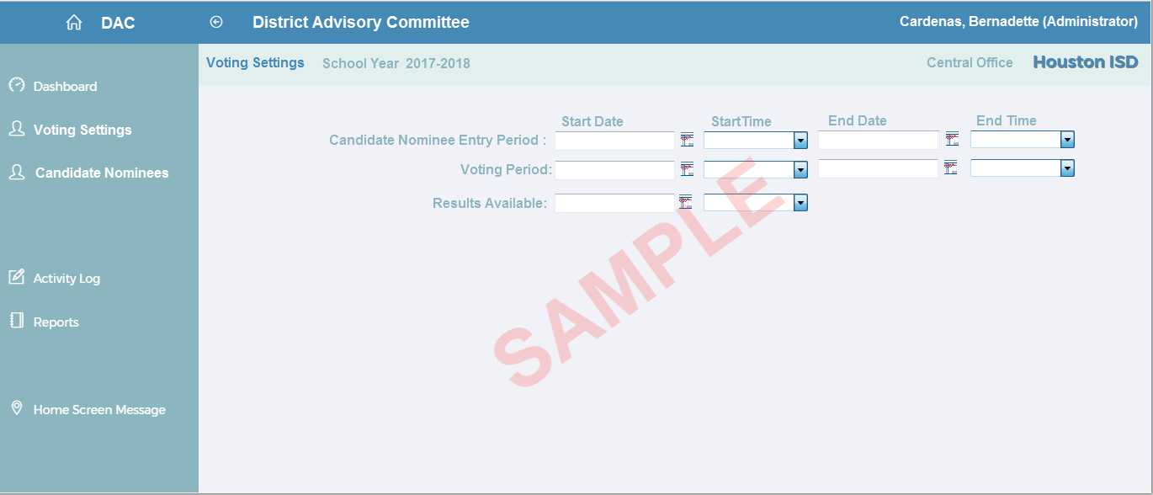

## Exhibit 3.4B

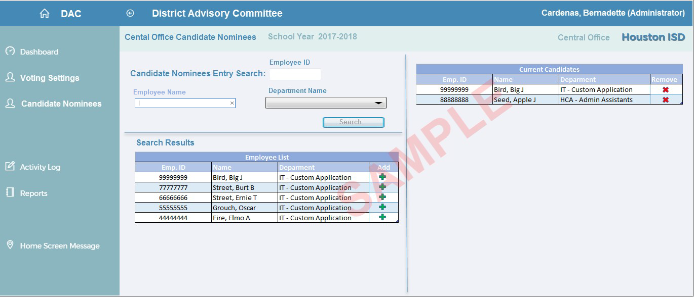

## Exhibit 3.4C

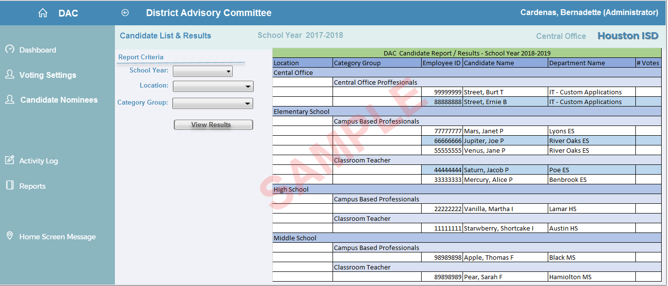

## Exhibit 3.5

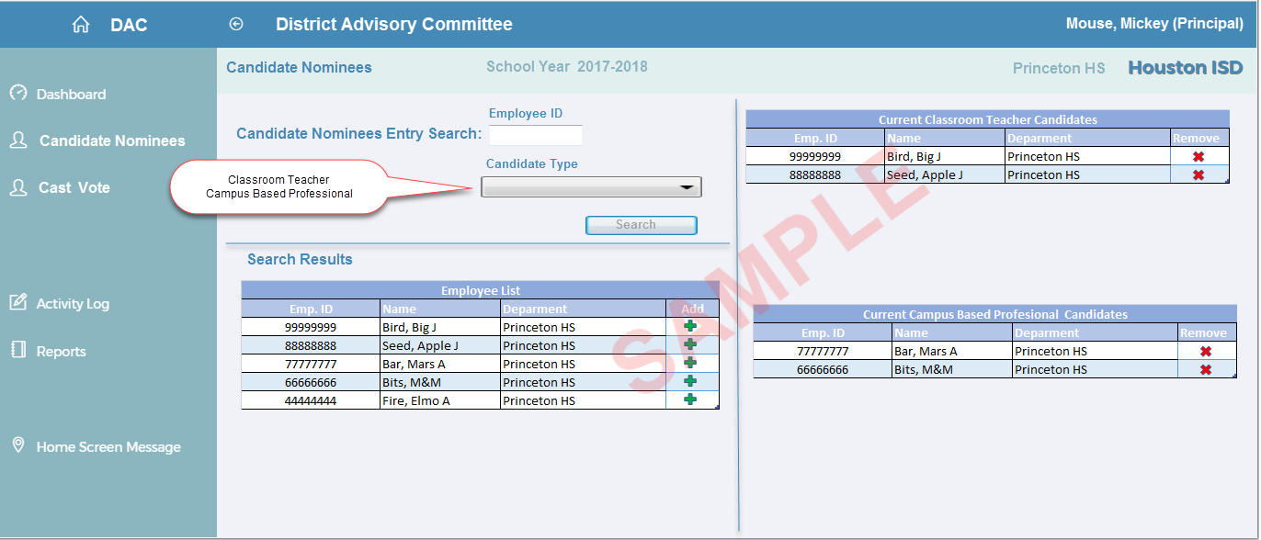

## Exhibit 3.5A

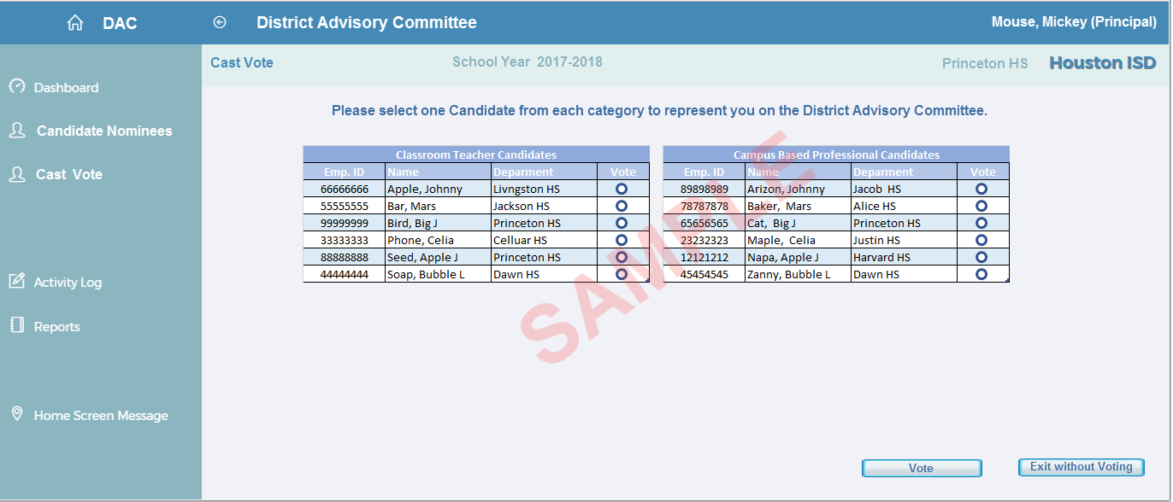

## Exhibit 3.5B

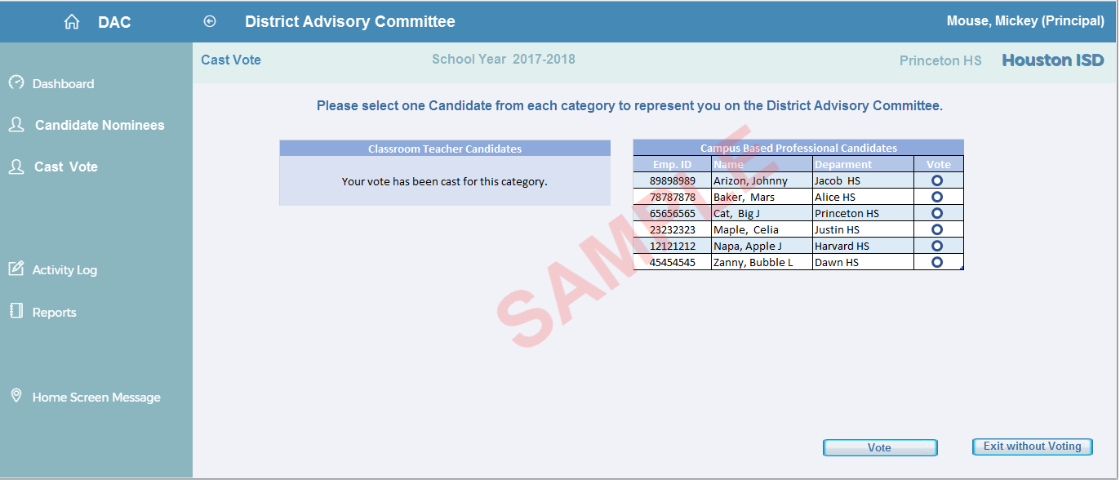

## Exhibit 3.5C

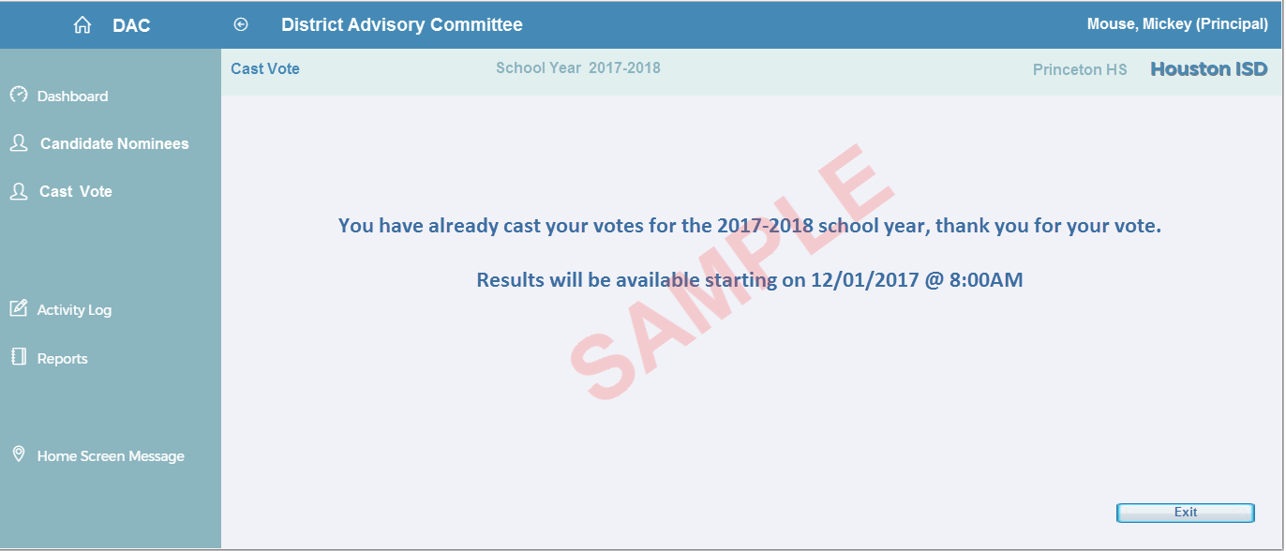

## Exhibit 3.5.1

|  |  |  |  |  |  |
| --- | --- | --- | --- | --- | --- |
| **JobCodeNaturalKey** | **JobCode** | **JobCodeDescription** | **JobCodeShortDescription** | **JobFamilyNaturalKey** | **JobFunctionNaturalKey** |
| 30002728 | 30002728 | 008 Counselor | CA0008 | NC | CSL |
| 30002737 | 30002737 | 020 Principal | CA0020 | MGMT | PRINCIPAL |
| 30003772 | 30003772 | At Risk Prog Admin | SB0185 | SBP | MISC/OTHER |
| 30002408 | 30002408 | Campus Education Tech-10M | AC0181 | ACADEMICS | INS |
| 30002409 | 30002409 | Campus Education Tech-11M | AC0183 | ACADEMICS | INS |
| 30002410 | 30002410 | Campus Education Tech-12M | AC0185 | ACADEMICS | INS |
| 30002577 | 30002577 | Campus Grant Admin | AC1160 | ACADEMICS | GRANT/FUND |
| 30003651 | 30003651 | Campus Instruc Tech Spclst | IT0843 | INFO TECH | INS |
| 30003652 | 30003652 | Campus Instruc Tech Spclst | IT0845 | INFO TECH | INS |
| 30000241 | 30000241 | CATE, Counselor 11M | 255 | NC | CSL |
| 30000916 | 30000916 | CATE, Counselor 12M | 976 | NC | CSL |
| 30000143 | 30000143 | Coord, Instr II QIE Magnet | 152 | NC | COOR |
| 30000957 | 30000957 | Coord, Instr II QIE Magnet | 1152 | NC | COOR |
| 30001072 | 30001072 | Coord, Instr II QIE Magnet | 2152 | NC | COOR |
| 30002240 | 30002240 | Coord, Tchr 11M | 182052 | NC | COOR |
| 30000046 | 30000046 | Coord, Title I (RT) | 48 | NC | COOR |
| 30000628 | 30000628 | Coord, Title I (RT) 11M | 674 | NC | COOR |
| 30001702 | 30001702 | Counselor, 10M - Title 1 | 40005 | NC | CSL |
| 30001703 | 30001703 | Counselor, 11M - Title 1 | 40007 | NC | CSL |
| 30001265 | 30001265 | Counselor, 12 M | 6055 | NC | CSL |
| 30000113 | 30000113 | Counselor, Bilingual-Sec. 11M | 122 | BIL | CSL |
| 30001061 | 30001061 | Counselor, Bilingual-Sec. 11M | 2055 | BIL | CSL |
| 30000112 | 30000112 | Counselor, ELE Bilingual 10M | 121 | BIL | CSL |
| 30000062 | 30000062 | Counselor, Elementary 10M | 65 | NC | CSL |
| 30000938 | 30000938 | Counselor, Elementary-11M | 1065 | NC | CSL |
| 30000424 | 30000424 | Counselor, Secondary 10M NSB | 462 | NC | CSL |
| 30000934 | 30000934 | Counselor, Secondary-10M SB | 1055 | NC | CSL |
| 30000052 | 30000052 | Counselor, Secondary-11M | 55 | NC | CSL |
| 30001150 | 30001150 | Dean of Instructn Elem Sch 11M | 3151 | NC | DEAN |
| 30000048 | 30000048 | Dean of Instructn Elem Sch 12M | 51 | NC | DEAN |
| 30000956 | 30000956 | Dean of Instructn High Sch 11M | 1151 | NC | DEAN |
| 30000142 | 30000142 | Dean of Instructn High Sch 12M | 151 | NC | DEAN |
| 30001071 | 30001071 | Dean of Instructn Mddl Sch 11M | 2151 | NC | DEAN |
| 30001199 | 30001199 | Dean of Instructn Mddl Sch 12M | 4151 | NC | DEAN |
| 30000323 | 30000323 | Dean of Students High Sch 11M | 352 | NC | DEAN |
| 30000907 | 30000907 | Dean of Students High Sch 12M | 965 | NC | DEAN |
| 30001018 | 30001018 | Dean of Students Mddl Sch 11M | 1352 | NC | DEAN |
| 30001110 | 30001110 | Dean of Students Mddl Sch 12M | 2352 | NC | DEAN |
| 30002515 | 30002515 | High School Graduation Coach | AC0815 | ACADEMICS | MISC/OTHER |
| 30002413 | 30002413 | Instructional Spclst-10M | AC0201 | ACADEMICS | INS |
| 30002414 | 30002414 | Instructional Spclst-11M | AC0203 | ACADEMICS | INS |
| 30002415 | 30002415 | Instructional Spclst-12M | AC0205 | ACADEMICS | INS |
| 30000053 | 30000053 | Librarian | 56 | NC | LIB |
| 30000936 | 30000936 | Librarian 12M | 1057 | NC | LIB |
| 30000066 | 30000066 | Nurse | 69 | NC | NSE |
| 30000941 | 30000941 | Nurse, 11.5M | 1069 | NC | NSE |
| 30001137 | 30001137 | Principal, Asst Elem 11.5M | 3051 | NC | ASST PRIN |
| 30000932 | 30000932 | Principal, Asst Elem 11M | 1051 | NC | ASST PRIN |
| 30001234 | 30001234 | Principal, Asst Elem 12M | 5051 | NC | ASST PRIN |
| 30001291 | 30001291 | Principal, Asst High Sch 11.5M | 7051 | NC | ASST PRIN |
| 30001060 | 30001060 | Principal, Asst High Sch 11M | 2051 | NC | ASST PRIN |
| 30001344 | 30001344 | Principal, Asst High Sch 12M | 9051 | NC | ASST PRIN |
| 30000637 | 30000637 | Principal, Asst HS 11M- Term | 683 | NC | ASST PRIN |
| 30001263 | 30001263 | Principal, Asst Middle S 11.5M | 6051 | NC | ASST PRIN |
| 30001194 | 30001194 | Principal, Asst Middle Sch 11M | 4051 | NC | ASST PRIN |
| 30001320 | 30001320 | Principal, Asst Middle Sch 12M | 8051 | NC | ASST PRIN |
| 30000636 | 30000636 | Principal, Asst MS 11M- Term | 682 | NC | ASST PRIN |
| 30001059 | 30001059 | Principal, Elementary School | 2050 | MGMT | PRINCIPAL |
| 30001319 | 30001319 | Principal, High School | 8050 | MGMT | PRINCIPAL |
| 30003386 | 30003386 | Principal, Hrly | H31785 | MGMT | PRINCIPAL |
| 30001343 | 30001343 | Principal, HS | 9050 | MGMT | PRINCIPAL |
| 30001323 | 30001323 | Principal, HS(Temp Assignment) | 00805T | NC | PRINCIPAL |
| 30001233 | 30001233 | Principal, Middle School | 5050 | MGMT | PRINCIPAL |
| 30001370 | 30001370 | Principal, MS/ES | 10050 | NC | PRINCIPAL |
| 30003059 | 30003059 | School Business Mgr | FA0585 | FIN & ACCT | SCH BUSMGM |
| 30003058 | 30003058 | School Business Mgr-10M | FA0581 | FIN & ACCT | SCH BUSMGM |
| 30003459 | 30003459 | Social Srvcs Specialist-11M | HM0208 | HM & SS | SOCIAL WRK |
| 30003450 | 30003450 | Social Worker, 10M - Title 1 | HM0185 | HM & SS | SOC WORKER |
| 30003451 | 30003451 | Social Worker, 11M - Title 1 | HM0187 | HM & SS | SOCIAL WRK |
| 30003452 | 30003452 | Social Worker, 12M - Title 1 | HM0189 | HM & SS | SOCIAL WRK |
| 30003441 | 30003441 | Social Worker-10.5M | HM0152 | HM & SS | SOCIAL WRK |
| 30003440 | 30003440 | Social Worker-10M | HM0151 | HM & SS | SOCIAL WRK |
| 30003442 | 30003442 | Social Worker-11M | HM0153 | HM & SS | SOCIAL WRK |
| 30003444 | 30003444 | Social Worker-12 M | HM0155 | HM & SS | SOCIAL WRK |
| 30003395 | 30003395 | Substitute Principal | H31794 | MGMT | PRINCIPAL |

## Exhibit 3.8

