

High Frequency Word Evaluation

to SharePoint

Business Requirements Document

Version – 1.7

Published: 08/04/2017

Author: Jerome Glennon

**Requirements Acceptance**

|  |  |  |  |  |  |  |  |  |  |  |  |  |  |  |  |  |  |  |  |  |  |  |  |  |  |  |  |  |  |  |  |  |  |  |  |  |
| --- | --- | --- | --- | --- | --- | --- | --- | --- | --- | --- | --- | --- | --- | --- | --- | --- | --- | --- | --- | --- | --- | --- | --- | --- | --- | --- | --- | --- | --- | --- | --- | --- | --- | --- | --- | --- |
| |  |  |  |  | | --- | --- | --- | --- | | Position | Name | Date | Signature | | Business Sponsor | Carley Colton |  |  | | Business Owner | Carley Colton |  |  | |  |  |  |  | | Project Manager | Wendal Breazeale |  |  | |  |  |  |  | | IT Business Analyst | Jerome Glennon |  |  | | Lead Developer | Praveen Morthala |  |  | |  |  |  |  | |
| Confidentiality / Security Warning |
| *This is an internal HISD project document, and is not intended for viewing by any parties’ other than HISD employees, or HISD-designated actors that are specifically involved in this project. Intellectual property contained in this document is property of HISD, and is not intended for distribution.* |

**Revision History**

|  |  |  |  |
| --- | --- | --- | --- |
| **Version** | **Date** | **Changed By** | **Description** |
| 1.0 | 6/2/2017 | Jolié V. Tillman | Initial requirements document the application |
| 1.1 | 8/1/2017 | Jerome Glennon | 1st Revision  Removal of Use Cases and put in separate document  Section 5.0 created |
| 1.2 | 8/22/2017 | Jerome Glennon | Section 5.4.1.4 Updated  Section 5.8.1.5 Updated |
| 1.3 | 8/25/2017 | Jerome Glennon | Section 5.4.1.3.3. Updated |
| 1.4 | 9/21/2017 | Jerome Glennon | Updates based on business owner feed back  Section 2 Updated with Scoring Criteria  Section 5.8.1.4.4.2 Updated |
| 1.5 | 11/01/2017 | Jerome Glennon | Section 7.2 added |
| 1.6 | 02/23/2018 | Jerome Glennon | Exhibit 2.6 Added  Section 5.8.1.4 Updated  Exhibit 5.8.1 Added  Exhibit 5.8.1A Renamed from 5.8.1  Exhibit 5.8.1B Renamed from 5.8.1A |
| 1.7 | 3/6/2018 | Jerome Glennon | Section 5.4.1.1.7 Updated  Section 5.4.1.2.3 Added |

Table of Contents

1. OverView and BackGround 5

1.1. Purpose of this document 5

1.2. Justification 5

1.3. ObjectiveS 5

1.4. Scope 5

1.5. Assumptions 5

2. Overview of the HFWE Application 6

2.1. Users and High-level Workflow 6

2.2. Access 6

2.3. HFWE Administrations 7

3. Current Usage and Configuration 7

3.1. Current / Impacted Business Process 7

3.2. Current Data Flow 7

4. Future Usage and Configuration 9

4.1. Future Business Process 9

4.2. Future Data Flow 9

5. Business Requirements 9

5.1. Definitions 9

5.2. Security Roles 10

5.3. Data Source / Storage 10

5.4. Administrator View / Functions 11

5.4.1.1. Ability to enter list(s) of words to be tested on 11

5.4.1.2. Ability to set up test window(s) 12

5.4.1.3. Ability to see all Elementary Schools within in the district 12

5.4.1.3.1. Ability to see all 1st and 2nd Grade Teachers on a Campus 12

5.4.1.3.2. Ability to see all students assigned to 1st and 2nd grade Teachers at the campus 13

5.4.1.3.3. Ability to see all students detail testing information 13

5.4.1.3.5. Ability to unlock a test score for student(s) 14

5.4.1.4. Reports 14

5.5. Schools Office View / Functions 15

5.5.1.1. Reports 15

5.6. Pricipal View / Functions 15

5.6.2.1. Ability to see all 1st and 2nd Grade Teachers on their Campus 15

5.6.2.2. Ability to see all students assigned to 1st and 2nd grade Teachers 15

5.6.2.3. Abitlity to See all Student Detail Results 15

5.6.2.4. Ability to unlock a test score for student(s) 15

5.6.2.5. Reports 15

5.7. School Coordinator View / Functions 16

5.7.2.1. Same as 5.6.2 16

5.8. Teacher View / Functions 16

5.8.1.2. Ability to see view all students assigned to the teacher for grades 1 and 2 16

5.8.1.3. Ability to see all students detail testing information 16

5.8.1.4. Ability to record results of administered test for each student per test window 16

5.8.1.5. Reports 17

6. Technical Specification and Assumptions 17

7. Configuration Data / Statistics 17

8. Known Constraints 17

9. Exhibits 18

9.1. Exhibit 5.4.1 18

9.2. Exhibit 5.4.1A 18

9.3. Exhibit 5.4.1B 19

9.4. Exhibit 5.4.1C 19

9.5. Exhibit 5.4.1D 20

9.6. Exhibit 5.4.1E 20

9.7. Exhibit 5.4.1F 21

9.8. Exhibit 5.4.1G 22

9.9. Exhibit 5.4.1H 23

9.10. Exhibit 5.4.1I 24

9.11. Exhibit 5.6 25

9.12. Exhibit 5.8.1 25

9.13. Exhibit 5.8.1A 26

9.14. Exhibit 5.8.1B 27

# OverView and BackGround

## Purpose of this document

* + 1. To capture and requirements for the requested to convert HFWE (High Frequency Word Evaluation) from a .net Application into a SharePoint Application

## Justification

* + 1. The new HFWE application will decrease work and streamline the process for teachers that facilitate high-frequency word evaluations. It will also allow the administrator to manage the application without much involvement from IT.
    2. This puts the responsibility of the application in the hands of the users by making it more efficient and reducing the time spent using the tool and being dependent on other groups.

## ObjectiveS

* + 1. As a part of the SIS project and ODS Sun setting, HFWE will be reimplemented and upgraded to function as an application within SharePoint. The current application will be ultimately decommissioned.
    2. The objective of this document is to detail functionality of the existing HFWE application, and future requested functionality of the upgraded HFWE.

## Scope

* + 1. In Scope: The documented functionality will include the current functionality and may include some of the updated requested functionality.
    2. Out of Scope: At present, any future functionality that does not include technical functionality or ease of use will be considered out of scope and will be listed in the Future Requirements section of this document.

## Assumptions

* + 1. Houston Independent Campus District (HISD) is using this application as it’s only high frequency word evaluation tool.
    2. SharePoint is presumed to be a viable solution to support the reimplemented application.
    3. The security provisioning the original application will be based on Active Directory security and roles.

# Overview of the HFWE Application

High Frequency Words are words which occur most frequently in written material.

HFWE was designed to provide first and second grade teachers with a tool to test their students on high frequency words.

As a part of HISD’s first and second grade promotion standards, students must receive pass the High Frequency Word Evaluation by successfully reading words aloud and scoring within the criteria set by the district as follows:

|  |  |  |  |  |  |
| --- | --- | --- | --- | --- | --- |
| Grade | Language | Number of Words on List | Number of Words Assessed | Number of words Scored as Correct to Pass | Minimum Percetage to Pass |
| First | English | 125 | 75 | 60+ | 80% |
| Spanish |
| Dual | 250 | 150 | 40% |
| Second | English | 200 | 100 | 80+ | 80% |
| Spanish |
| Dual | 400 | 200 | 40% |

## Users and High-level Workflow

* + 1. All users (Teachers, Coordinators, Principals, Administrators and SSO/SIOs) are given access at the beginning of the year.
    2. Students are tested 3 times during the school year, and once during the summer. These tests are called administrations and are facilitated once in early-mid November, once early-mid February and once mid-late April.
       1. The Summer administration occurs during 2 days of the last week of summer school.
    3. During each test window evaluation, they must pass by at least 80%.
       1. The HFWE Administrator determines the test window.
       2. Teachers evaluate students during the school year and summer session. Teacher’s also view student and classroom data and reports.
       3. Other roles have access to view assigned data by class, campus, region or district year-round.
          1. Coordinator’s evaluate students, view campus data and reports.
          2. Principal’s view campus data, and reports.
          3. SSO/SIO’s view region/administrative district data and reports.
          4. Administrators view district data and reports.
    4. Students that did not pass during any of the 3 administrations during the regular school year can be retested during the summer administration.

## Access

* + 1. The current application is accessed by all users by using the following URL: <https://apps.houstonisd.org/HFWE/>
    2. Teachers and Coordinators currently access the HFWE Handbook, Network Security Form, and Testing Packets on the HISD Hub.

## HFWE Administrations

* + 1. An administration is a 2-week date range upon which the evaluation will occur. These dates are selected by the HFWE Administrator and will be configured in the application.
    2. There are 3 administrations during the school year and one during summer.
       1. The first administration is 2 weeks.
       2. The second and third administrations are 1 week.
       3. The summer administration is 2 days, selected by campus.

# Current Usage and Configuration

## Current / Impacted Business Process

HFWE is currently used by Teachers, Principals, Coordinators, SSOs/SIOs and Administrators to view and/or enter evaluation results/information.

* + 1. Administrators send administration dates and words to Custom Applications Team ~2 weeks prior to the administration.
    2. Custom Applications sets up administration dates and words in HFWE using a script.
    3. Administrators log in prior to the administration and check to makes sure the dates and words are correct.
    4. HFWE Coordinators print off test packets for their campuses and deliver to Teachers.
    5. During the Administration period, teachers evaluate students that are eligible for evaluation. They enter their results and save the evaluation which triggers the results to be locked.
       - 1. Note: Some students are exempt.
    6. Teachers may also go back to make corrections during the current administration, but not for previous administrations.
    7. During the administration, Principals and Coordinators may log in to HFWE to view campus and student/teacher results.
    8. During and after the administration, SSOs/SIOs may log in to view district wide reports for their geographical region.
    9. During and after the administration, Administrators log in and make sure teachers are entering their information.

## Current Data Flow

* + 1. The subsequent figure describes HFWE’s current data flow. HFWE is not receiving student, campus and teacher data directly from SAP and SIS but, indirectly through ODS.

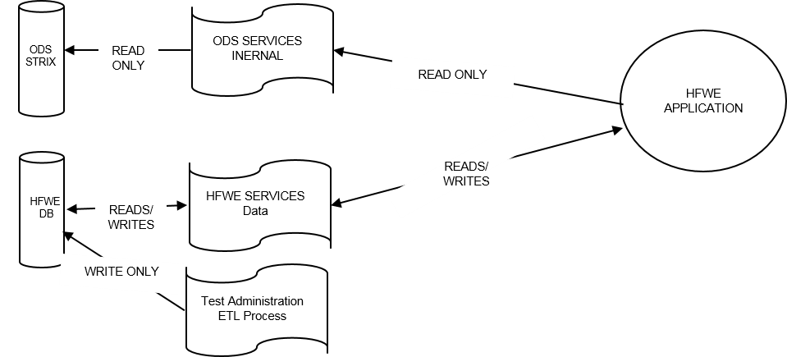

# Future Usage and Configuration

## Future Business Process

* + 1. Administrators will enter administration dates and words any time before the administration.
    2. Teachers will review the words to be evaluated during the school year.
    3. During the Administration period, teachers evaluate students that are eligible for evaluation. They will enter their results real-time via computer/iPad. They will save the evaluation and the evaluation will be locked.

Note: Some students are exempt.

* + 1. Teachers may contact their Admin or HFWE Coordinator to edit erroneous evaluations any time before the end of the school year.
    2. During the administration, Principals and Coordinators may log in to HFWE to view campus and student/teacher results.
    3. During and after the administration, SSOs/SIOs may log in to view district wide reports for their geographical region.
    4. During and after the administration, Admins log in and make sure teachers are entering their information.

## Future Data Flow

* + 1. HFWE currently possesses ODS dependencies for student and campus data. The anticipated/future HFWE data flow will be via EDW views.
       1. In the future, EDW will have the ability to pull data from HFWE to fulfill power user requirements and display student results on A4E.

The future data flow diagram will be provided by the EDW team.

# Business Requirements

## Definitions

* + 1. 1st or 2nd Grade Teacher
       1. Any teacher that teachers a 1st or 2nd grade.
    2. SSO – Student Support Officer / Student Improvement Officer
       1. <https://connectia.houstonisd.org/team/a4esp/a4esppor/CIL_View/SitePages/Home.aspx>
    3. Dates – All dates will be displayed in the following format
       1. MM/DD/YYYY
    4. Name Display format
       1. All names displayed in the tool will be “Last Name , First Name”
    5. Exhibits – All exhibits are just “SAMPLES” the final screens may look different but pocess the required functionality.

## Security Roles

* + 1. The following groups need to be created in Active Directory under the Groups/AppAuth OU (OU=AppAuth,OU=Groups,DC=AD,DC=HISD,DC=ORG) (Note: Created already as of 7/20/2017)
       1. HFWE_Admin
       2. HFWE_SC (School Coordinator)
       3. HFWE_SO (Schools Office, used for SIO..Etc.)
       4. Teacher (Generic Group used by all applications) (May already be created)
       5. Principal (Generic Group used by all applications) (May already be created)

## Data Source / Storage

* + 1. The following data elements will be pulled from the EDW Views provided by the data ware house team
       1. Student Information
          1. Student ID
          2. First name
          3. Last Name
          4. Grade Level
          5. Section ID
          6. Course ID
       2. Teacher Information
          1. Employee ID
          2. Campus ID
          3. Campus Name
          4. Fist Name
          5. Last Name
          6. Course ID
          7. Section ID
       3. Principal Information
          1. First Name
          2. Last Name
          3. Employee ID
          4. Campus ID
          5. Campus Name
       4. HFWE_SC
          1. Employee ID
          2. First Name
          3. Last Name
       5. HFWE_Admin
          1. Employee ID
          2. First Name
          3. Last Name
       6. HFWE_SO
          1. Employee ID
          2. First Name
          3. Last Name
          4. School Office
          5. District
    2. The following data elements will be stored in the HFWE application data base, data elements type and length should match EDW when applicable.
       1. All Records stored should have the following columns
          1. Created by
          2. Created on
          3. Last Updated By
          4. Last Updated on
       2. List(s) of English words for 1st Grade
       3. List(s) of English words for 2nd Grade
       4. List(s) of Spanish words for 1st Grade
       5. List(s) of Spanish words for 2nd Grade
       6. Students test results including the following elements
          1. Teacher ID
          2. Student ID
          3. Campus ID
          4. Test window ID
          5. Date Given
          6. Each word results
          7. Reading Accuracy Percentage
          8. Students overall average per test
       7. Time frame(s) for test windows per school year

## Administrator View / Functions

* + 1. A user with the HFWE_Admin role will need the following capabilities within the application

## Ability to enter list(s) of words to be tested on

* + - * 1. A list of English words for 1st grade
        2. A list of English words for 2nd grade
        3. A list of Spanish words for 1st grade
        4. A list of Spanish words for 2nd grade
        5. Ability to mark a single word per list as a practice word
        6. Each list created should have the following data elements

Grade Level

School year

Language Type

Name

Recommend name convention school year plus grade plus language (i.e. 2018_G1_E)

* + - * 1. A list can only be edited by an administrator

Deleteing a word – Can only take place if the list has never been used yet (There are no recorded scores for a student using the word in the list)

Editng a word – A word can be edited for misspellings or changed at any time. ( Note: If changed to a new word and the list has already been used it will effect any recorded results)

* + - * 1. Exhibits

5.4.1 – List View

5.4.1A – List Edit

## Ability to set up test window(s)

* + - * 1. There are 4 test windows per school year

First

Second

Third

Summer

* + - * 1. Each test windows will have the following data elements

TW_ID

Internal ID not used for display

Name

Drop down of 5.4.1.2.1… Names

Start Date

Entered by user

End Date

Entered by user

Grade Level

Entered by user

English List ID

Select from a dropdown created by section 5.4.1.1 based on Grade Level

Spanish List ID

Select from a dropdown created by section 5.4.1.1 based on Grade Level

School Year

Stamped with current school year

Status

Active – Within the testing window dates (5.4.1.2.2.3 , 5.4.1.2.2.4)

Not Active – Outside of the testing window dates (5.4.1.2.2.3 , 5.4.1.2.2.4)

Exhibits

5.4.1B - Administration List View

5.4.1C – Administration List Edit

* + - * 1. Editing a Test Window

A test windows Start Date can be changed if the Start Date has not yet occurred

A test window End Date can be changed at any time during the current school year (This is to allow to have a test window extended)

Word list assignment can be changed if the Start Date has not yet occurred

Grade Level can be changed if the Start Date has not yet occured

## Ability to see all Elementary Schools within in the district

## Ability to see all 1st and 2nd Grade Teachers on a Campus

Teacher List Data elements

Employee Id

Full Name

Teacher Grade

Totals for the current testing period

The following data elements will always show the current testing windows values

%DNM (Total # of students Failed / Total # of students * 100)

% Met (Total # of students Passed / Totla # of students * 100)

# Students Tested

# Students Not Tested

# Students Exempt

Total # of Students in the Grade

## Ability to see all students assigned to 1st and 2nd grade Teachers at the campus

Student List Data elements

Student ID

Full Name

Grade

Results for current testing window

Pass, Fail or Exempt

## Ability to see all students detail testing information

Student Detail Data elements

Student Information

Student ID

Full Name

Grade

School Name and Number

Teacher ID

Teacher Full Name

Test List

Administration Session

Administration Date (Date scores where entered, the create date of the record)

Grade

Exempt Indicator

Language of Test Given

School Name / Number

Teacher ID

Teacher Full Name

Total # of Words tested

Total # of Words Correct

Total # of Words Incorrect

Accuracy Level percentage ( Total # of words correct / Total # of words on test)

Word detail list for selected Admin. Date

List of words that where tested

Indicate Which Words Passed

Indicate Which Words Failed

Ability to Print Student summary page with information within 5.4.1.3.3

See Exhibit 5.4.1G

Ability to Print a report of just the words missed for the test window in view

See Exhibit 5.4.1H

* + - * 1. Exhibits

5.4.1D – Teacher List

5.4.1E – Student List

5.4.1F – Student Detail

5.4.1G – Student Summary Sheet

5.4.1H – Student Word Missed Study Sheet

## Ability to unlock a test score for student(s)

An Administrator can unlock any test even if it is outside the test window period.

## Reports

* + - * 1. Teacher Results

Ability to see data for all schools for a choosen Test Administration Window

Ability to limtit report to just one school

Ability to limit report to just one SSO District

Ability to extract the report to excel

Report Elements

SSO District

School Id / Name

Employee ID (Teacher)

Teacher Name ( Last, First)

Grade

Language Type ( Type of test given)

# of Studnets in the class

# of Exempt students

# of Students Not Tested

# Passed

# Failed

% Passed ( # of Students Passed / # of students in the class - ( # of students Exempt + # of students Not Tested)))

% Failed ( # of Students Failed / # of students in the class - ( # of students Exempt + # of students Not Tested)))

Total line at a Teacher Level for each of the columns

Total line at the School level for each of the columns

Report should be sorted by the following

SSO District (Ascending)

School Id / Name (Ascending)

Grade

Teacher Name

Exhibits

5.4.1I – Sample Report

## Schools Office View / Functions

* + 1. A user with the HFWE_SO role will need the following capabilities within the application

## Reports

* + - * 1. Same as 5.4.1.4 with the following exception

User can only see schools assigned to their District

## Pricipal View / Functions

* + 1. A Principal must be a Principal of an Elementary School with 1st and 2nd grade to have access to the tool
    2. A user with the Principal role will need the following capabilities within the application

## Ability to see all 1st and 2nd Grade Teachers on their Campus

* + - * 1. Teacher List Data elements

Same as 5.4.1.3.1.1

## Ability to see all students assigned to 1st and 2nd grade Teachers

Student List Data elements

Same as 5.4.1.3.2.1

## Abitlity to See all Student Detail Results

Student Detail Data Elements

Same as 5.4.1.3.3.1.

Word detail list

Same as 5.4.1.3.3.1.3.

* + - * 1. Exhibits

Same as 5.4.1.3.4

## Ability to unlock a test score for student(s)

* + - * 1. A Principal can unlock a test **only** during the testing window period.

Exhibit 5.6

## Reports

* + - * 1. Same as 5.4.1.4 with the following exception

User can only see the school they are assigned to

## School Coordinator View / Functions

* + 1. A coordinator cannot be a coordinator at more than one campus
    2. A user with the HFWE_SC role will need the following capabilities within the application

## Same as 5.6.2

## Teacher View / Functions

* + 1. A teacher must teach 1nd or 2rd Grade to have access to the tool
       1. A user with the Teacher role will need the following capabilities within the application

## Ability to see view all students assigned to the teacher for grades 1 and 2

* + - * 1. Same as 5.4.1.3.2 just for the individual Teacher

## Ability to see all students detail testing information

* + - * 1. Same as 5.4.1.3.3

## Ability to record results of administered test for each student per test window

Ability to select which test was administered

English

Spanish

Dual (This is made up of both English and Spanish Lists assigned to the test windows)

Exhibit 5.8.1

Ability to mark a student as “EXEMPT” from the test period

If Exempt all test scores for test should be cleared before saving and not required.

* + - * 1. Ability to enter results per word for selected test in 5.8.1.4.1.1

Ability to mark all test words as Correct (Not including the Practice word)

Ability to mark all test works as Incorrect (Not including the Practice word)

All words on test must have a Pass or Fail denoted in order to be saved (including practice word)

* + - * 1. Ability to edit entered scores for a student during the testing window

Until the testing window is closed

Until the teacher marks the test as finalized and results are locked

Scores are Locked once 5.8.1.4.3.1.1 and 5.8.1.4.3.1.2 are satisfied.

* + - * 1. Ability to mark the test results as finalized

Results are locked once saved if finalized is selected

Student is marked Passed based on percentage outlined in section 2.0 otherwises marked Failed

* + - * 2. Do not allow to Save the test results unless all scores are entered including practice word.
        3. Ability to Print results with header information
        4. Exhibits

Exhibit 5.8.1A

## Reports

* + - * 1. Same as 5.4.1.4 with the following exception

Teacher can only see their data

* + - * 1. Words Missed

Ability to see all missed words for a Test Administration Window

Ability to extract the report to excel

Report Elements

School Id / Name

Employee ID (Teacher)

Teacher Name ( Last, First)

Grade

Language Type ( Type of test given)

# of Students Testest

Administartions Session

Administration Window ( Start date and end date)

List of Words that where not answered incorrect

Percentage that the word was inccorect ( Total # of times the word was incorrect / Total # of students tested)

Report should be sorted by the following

Percentage Incorect (Ascending)

Exhibits

5.8.1B – Sample Report

# Technical Specification and Assumptions

* 1. Reports
     1. All reports will be exportable to Excel
  2. Application should work with HISD’s current browser standards for PC and Mobile Devices
  3. Application is only accessible while on the HISD secured network

# Configuration Data / Statistics

* 1. Security Groups in Active Directory
     1. Users will be added to the appropriate group for access and maintained by 2nd tier support group
  2. Data Statistics

|  |  |
| --- | --- |
| Number of 1st and 2nd Grade Teachers | 176 |
| Average Number of Students per teacher | 210 |
|  |  |

# Known Constraints

* + 1. Dedicated development resources
    2. Dedicated UAT resources

# Exhibits

## Exhibit 5.4.1

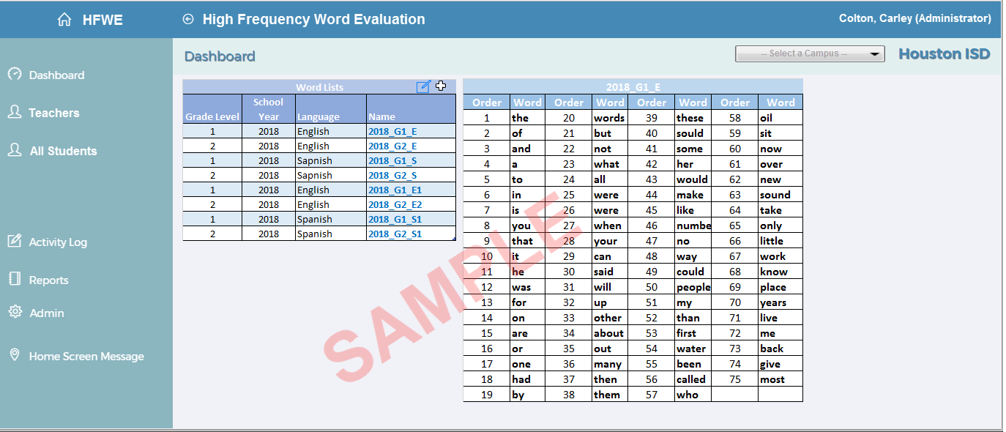

## Exhibit 5.4.1A

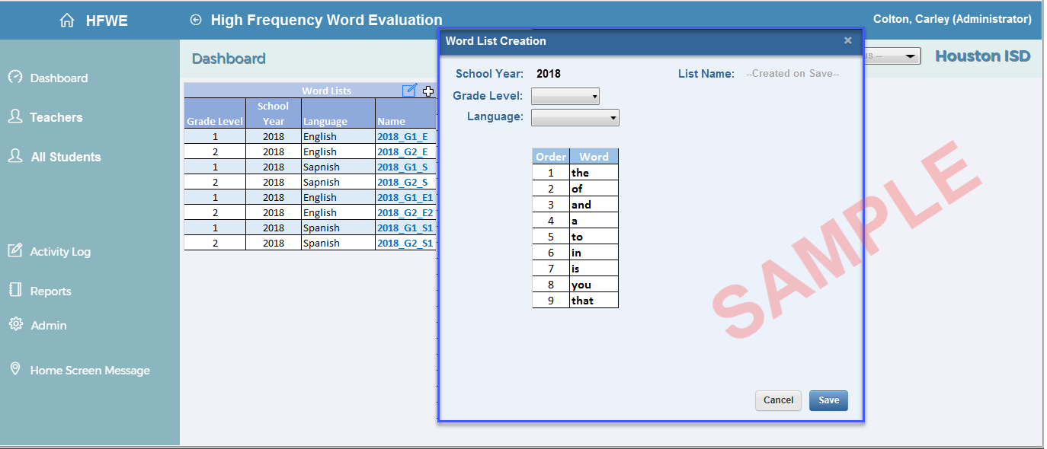

## Exhibit 5.4.1B

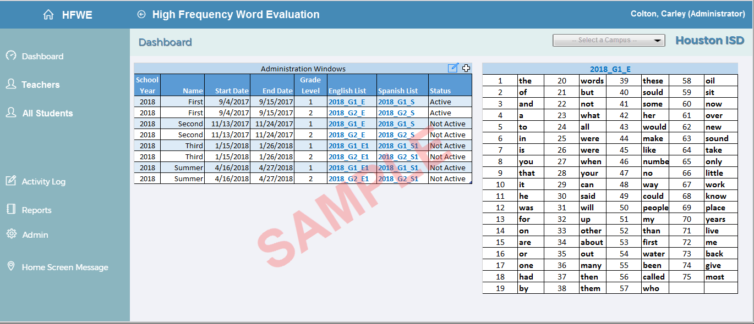

## Exhibit 5.4.1C

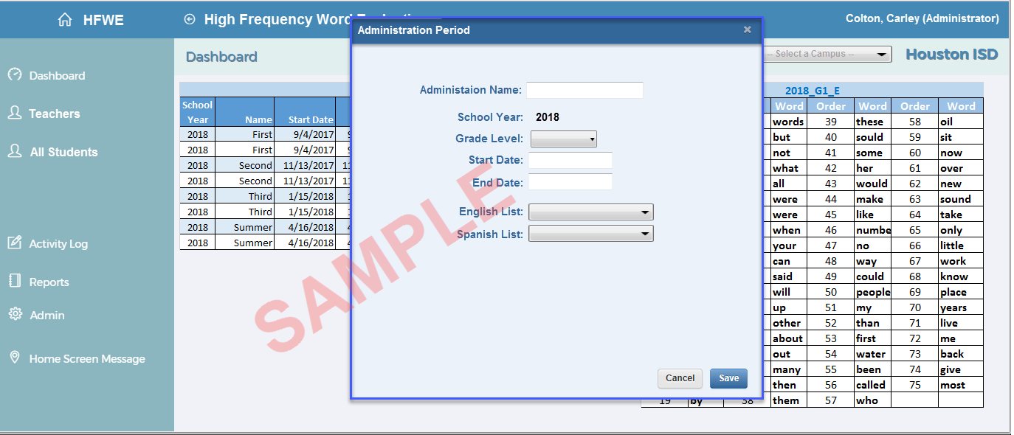

## Exhibit 5.4.1D

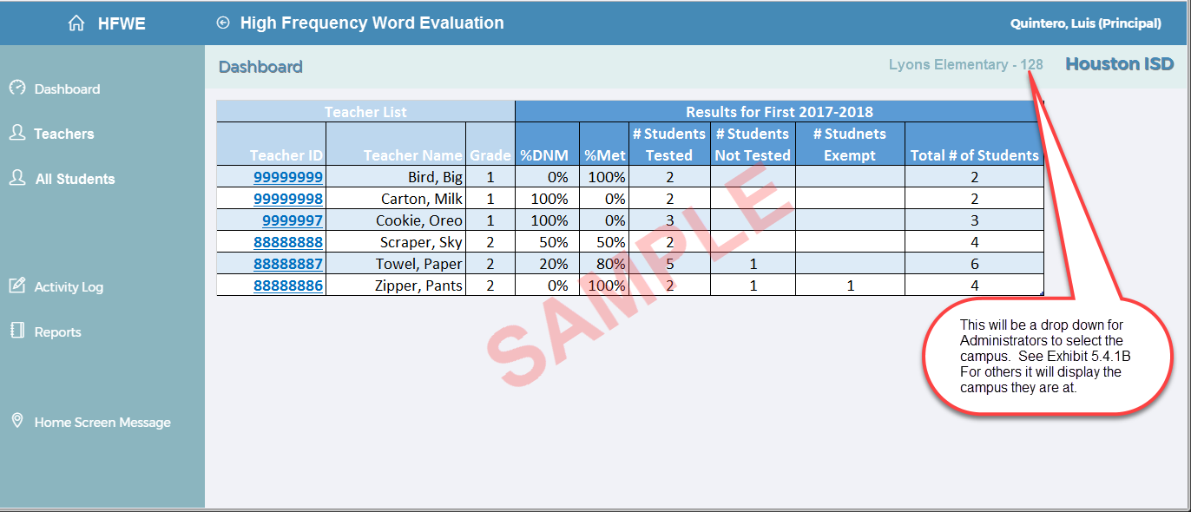

## Exhibit 5.4.1E

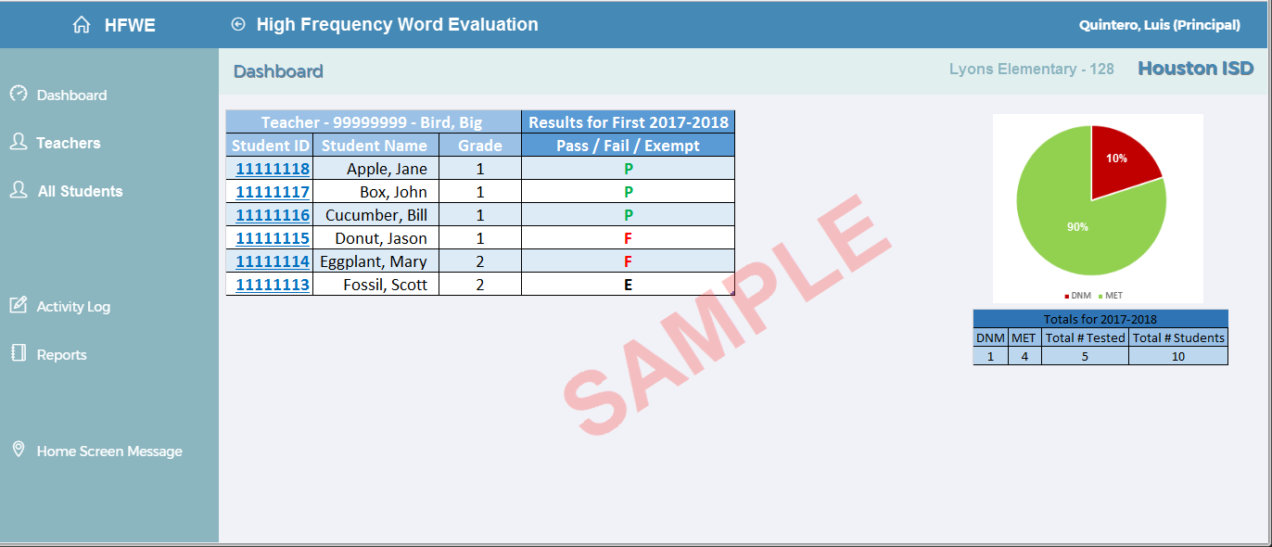

## Exhibit 5.4.1F

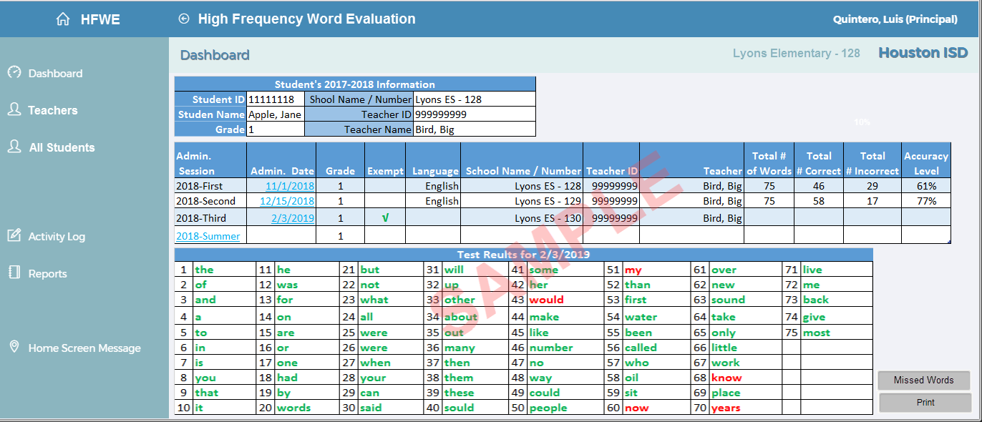

## Exhibit 5.4.1G

|  |  |  |  |
| --- | --- | --- | --- |
| Houston Independent School District | | | |
| High Frequency Word Evaluation | | | |
| Student Summary History Sheet | | | |
|  |  |  |  |
| Student ID: | 11111118 | School Id / Name: | 128 - Lyons ES |
| Student Name: | Apple, Jane | Teacher ID: | 999999999 |
| Grade: | 1 | Teacher Name: | Bird, Big |

|  |  |  |  |  |  |  |  |  |  |  |  |
| --- | --- | --- | --- | --- | --- | --- | --- | --- | --- | --- | --- |
| **Admin.  Session** | **Admin. Date** | **Grade** | **Exempt** | **Language** | **School Name / Number** | **Teacher ID** | **Teacher** | **Total #  of Words** | **Total  # Correct** | **Total  # Incorrect** | **Accuracy  Level** |
| 2018-First | 11/1/2018 | 1 |  | English | Lyons ES - 128 | 99999999 | Bird, Big | 75 | 46 | 29 | 61% |
| 2018-Second | 12/15/2018 | 1 |  | English | Lyons ES - 129 | 99999999 | Bird, Big | 75 | 58 | 17 | 77% |
| 2018-Third | 2/3/2019 | 1 | **√** |  | Lyons ES - 130 | 99999999 | Bird, Big |  |  |  |  |
| 2018-Summer |  | 1 |  |  |  |  |  |  |  |  |  |

The Student **DOES NOT** meet the HISD 2019 Grade 1 English High Frequency Word Evaluation Standards based on there 77% Accuracy Level, the goal is 80% or better.

The Student **DOES** meet the HISD 2019 Grade 1 English High Frequency Word Evaluation Standards based on there 80% Accuracy Level, the goal was 80% or better.

## Exhibit 5.4.1H

|  |  |  |  |
| --- | --- | --- | --- |
| Houston Independent School District | | | |
| High Frequency Word Evaluation | | | |
| Student Word Missed Study Sheet | | | |
|  |  |  |  |
| Student ID: | 11111118 | School Id / Name: | 128 - Lyons ES |
| Student Name: | Apple, Jane | Teacher ID: | 999999999 |
| Grade: | 1 | Teacher Name: | Bird, Big |
|  |  |  |  |
| Administration Session: | 2018- Second | Aministration Date: | 12/15/2018 |
|  |  |  |  |
| Words Missed: | would |  |  |
|  | my |  |  |
|  | now |  |  |
|  | know |  |  |
|  | years |  |  |

## Exhibit 5.4.1I

|  |  |  |  |  |  |  |  |  |  |  |  |  |
| --- | --- | --- | --- | --- | --- | --- | --- | --- | --- | --- | --- | --- |
|  |  |  |  |  |  | Totals by Session ( - Session Name - ) | | | | | Percentages  (Exempts and Not Tested are excluded from %s) | |
| SSO District | School Id - Name | Employee Id | Teacher Name | Grade | Language | # of Students in Class | # of  Exempt | # of Students Not Tested | # Passed | # Failed | % Passed | % Failed |
| SSO - North 2 | 128- Lyons Elementary | 86954 | Loa, Jose | 1 | English | 5 | 2 | 1 | 1 | 1 | 50% | 50% |
|  |  | 1084 | Marek, Anna Marie | 1 | Spanish | 6 | 0 | 2 | 2 | 2 | 50% | 50% |
|  |  | 105428 | Pierce, Cessna | 1 | Dual | 7 | 3 | 0 | 2 | 2 | 50% | 50% |
|  |  |  | Grade Totals | 1 | All | 18 | 5 | 3 | 5 | 5 | 50% | 50% |
|  |  | 32387 | Diaz, Miguel | 2 | Dual | 9 | 5 | 0 | 4 | 0 | 100% | 0% |
|  |  | 88265 | Durate, Nadia | 2 | English | 8 | 1 | 3 | 2 | 2 | 50% | 50% |
|  |  | 69270 | White, Constance | 2 | Spanish | 5 | 2 | 1 | 2 | 0 | 100% | 0% |
|  |  |  | Grade Totals | 2 | All | 22 | 8 | 4 | 8 | 2 | 80% | 20% |
|  |  |  | School Totals | All | All | 40 | 13 | 7 | 13 | 7 | 65% | 35% |

## Exhibit 5.6

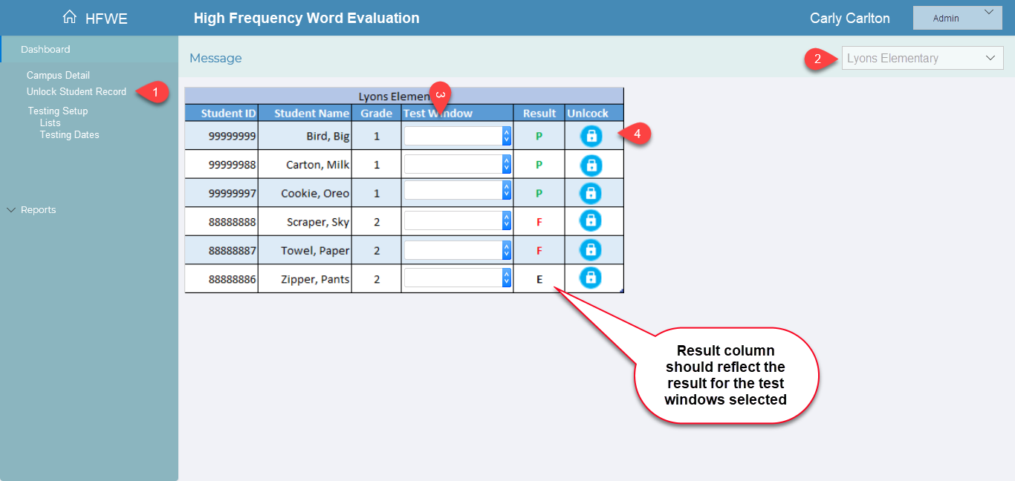

## Exhibit 5.8.1

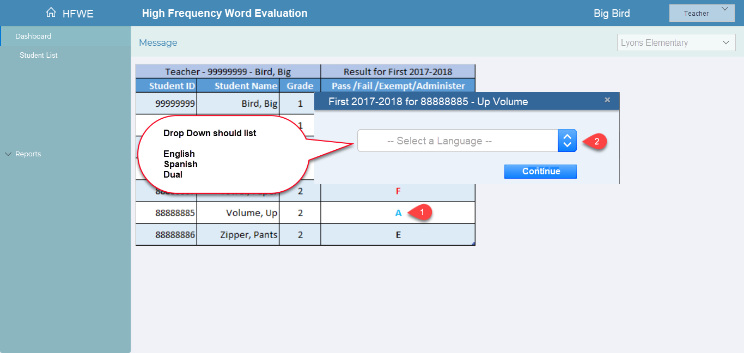

## Exhibit 5.8.1A

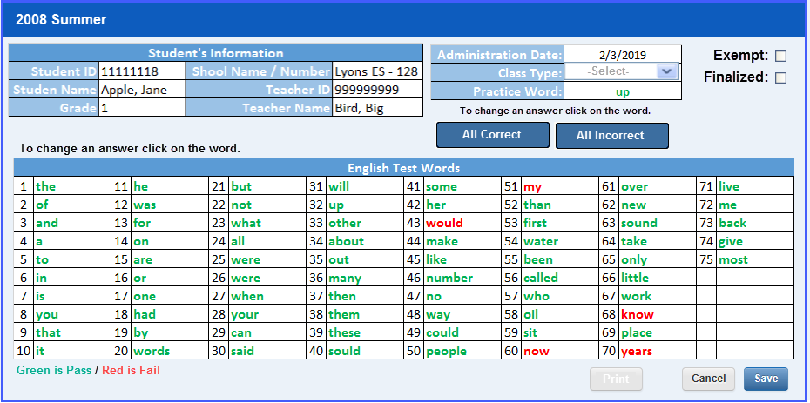

## Exhibit 5.8.1B

|  |  |
| --- | --- |
| Words Missed Summary Report | |
| School Id / Name: | 128 - Lyons ES |
| Teacher ID: | 999999999 |
| Teacher Name: | Bird, Big |
| Grade: | 1 |
| Language: | English |
| Total # of Students Tested | 10 |
| Administration Session | 2018-First |
| Administration Window | 9/4/2017 - 9/15/2017 |
|  |  |
| **Word** | **Percentage Incorrect** |
| too | 9.84% |
| me | 13.93% |
| so | 14.75% |
| big | 16.39% |
| play | 17.21% |
| boy | 18.03% |
| cut | 19.67% |
| girl | 19.67% |
| ask | 20.49% |
| like | 20.49% |
| him | 21.31% |
| sit | 22.13% |
| keep | 22.95% |
| make | 22.95% |
| them | 22.95% |
| been | 24.59% |
| school | 24.59% |
| old | 24.59% |
| next | 24.59% |