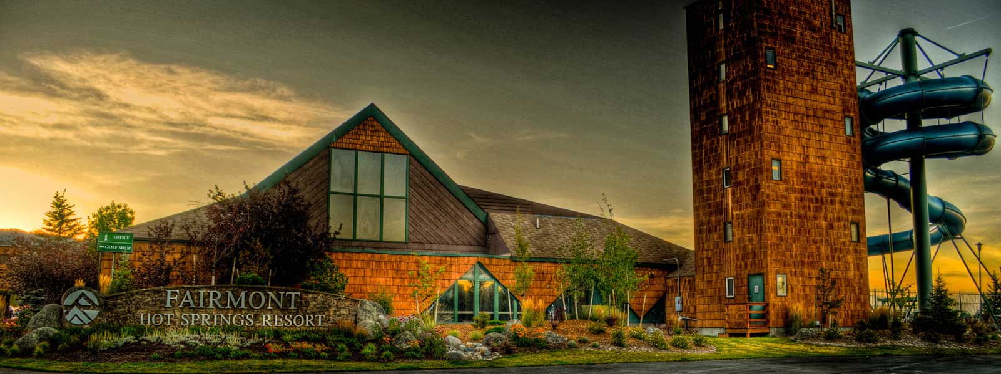
59th Rocky Mountain Regional Safety Rendezvous

Fairmont Hot Springs

July 19 - 21, 2017

Fairmont, MT

“Safety – don’t get in hot water!”
RMRSR Registration Fees
Registration is required to attend any function of the Rendezvous.

Single Registration $285.00

2nd Person Registration……………………………………………………………………………. .$185.00

Couple Registration.. $370.00

Family Registration $475.00
Meal / Functions
Please list number of registrants planning to attend meals.

Wednesday, July 19
01:00 – 05:30 p.m. Golf at Old Works Golf Course
04:00 – 08:00 p.m. Registration Open
03:30 p.m. Booth Set-up by Vendors
06:30 – 08:00 p.m. Reception at Pool Patio

Thursday, July 20
07:00 – 09:00 a.m. Registration Open
07:00 a.m. Opening Breakfast _______

09:00 – 10:00 a.m. Session I
10:30 – Noon Session II
Name Badges
Please print name as you wish it to appear on name badge.

12:00 p.m. Lunch _______
01:30 – 02:45 p.m. Session III
03:00 – 05:00 p.m. Session IV
06:00 p.m. Dinner in the Pavilion _______
Horse Drawn Wagon Ride _______
“Lady of the Rockies” Bus Ride _______

Friday, July 21

07:30 a.m. Breakfast _______

09:00 – 10:00 a.m. Session V
10:30 – 11:30 a.m. Session VI
Noon Lunch _______

Name: ______________________________________ Spouse / Guest Name: ___________________________________

Name: ______________________________________ Spouse / Guest Name: ___________________________________

Name: ______________________________________ Spouse / Guest Name: ___________________________________
Company: ___________________________________ Phone Number: ______________________________

Address: ____________________________________ Fax Number: ______________________________

Email: ______________________________________

Lodging: Registrants make their own reservations at Fairmont Hot Springs
(P: 800-332-3272, F: 406-797-3260, Website: fairmontmontana.com). Refer to” Safety Rendezvous” when making your reservation. Block expires June 19, 2017.
(406-443-2100).

Make checks payable to MCM. MCM, 501 N. Sanders #201, Helena, MT 59601 (406)442-6600 karen@mttrucking.org

Refund Policy: Refund of registration fee, minus a $30.00 administrative fee, will be made if notified no later than July 12, 2017.

