RMRSR SPONSORSHIP OPPORTUNITIES
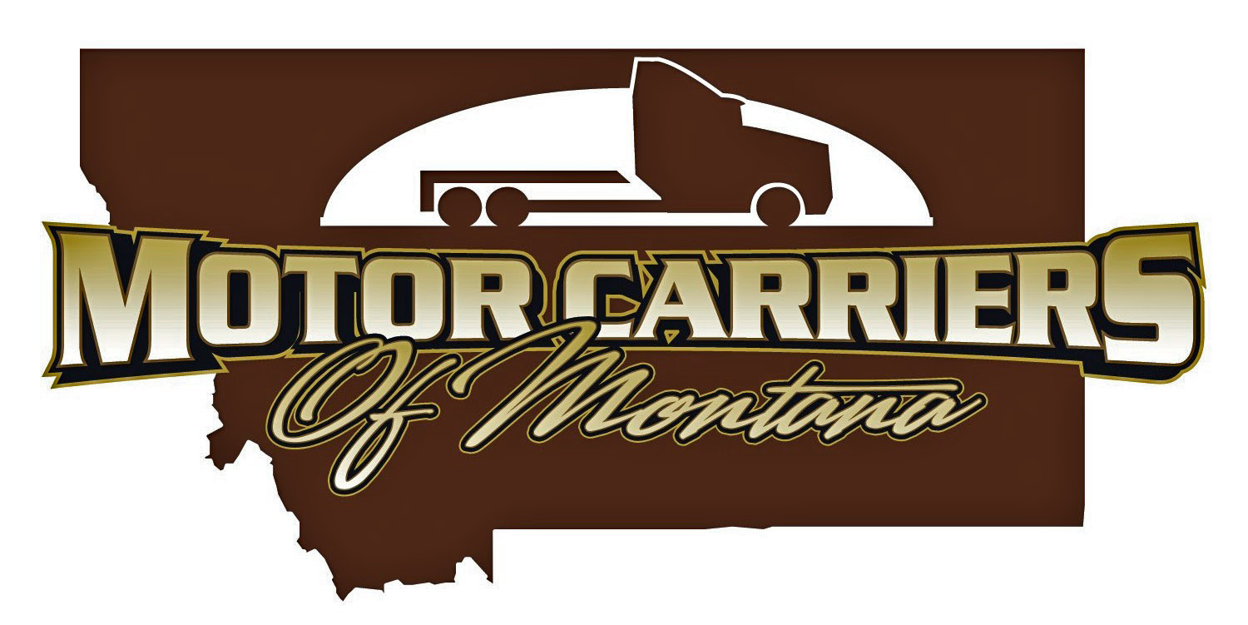

Motor Carriers of Montana – 59th Annual RMRSR “Safety – don’t get in hot water!”
July 19-21, 2017
Fairmont Hot Springs Resort in Fairmont, MT
July 11-12, 201
**IMPORTANT**
We need your sponsorship support to help with the cost of this event.

PLATINUM SPONSOR $1000

GOLD SPONSOR $500

Sponsor one of the following:
Safety Supervisor of the Year Lunch
Outdoor BBQ & Evening Entertainment

You will receive the following as a Platinum sponsor:
One RMRSR Registration
Golf Hole Sponsor – 24” X 18” sign identifying your company posted at the golf course.
Special company signage at your sponsored event
Power Point presentation during your sponsored event
Company recognition in the RMRSR publications

Sponsor one of the following:
Wednesday Night Cocktail Reception
Opening Breakfast
General RMRSR Lunch
Friday Breakfast
Friday Lunch and Speaker

You will receive the following as a Gold sponsor:
One RMRSR Registration
Special company signage at your sponsored event
Power Point presentation during your sponsored event
Company recognition in the RMRSR publications

Sponsor one of the following:
Breakout Sessions

You will receive the following as a Silver sponsor:
Special company signage at your sponsored event
Power Point presentation during your sponsored event
Company recognition in the RMRSR publications
Sponsor one of the following:
Breaks

You will receive the following as a Bronze sponsor:
Special company signage at your sponsored event
Company recognition in the RMRSR publications

SILVER SPONSOR $250

BRONZE SPONSOR $100
YES, I would like a display table at the RMRSR. Cost: $250.00
(Display Table includes all meals for 1 attendee. Additional meal vouchers available for $100.00)

YES, I would like to place a business card ad in the program. Cost: $40.00
(Please attach your business card to this form and return to MCM)
YES, I would like to contribute a door prize.
The door prize is: I will bring door prize to RMRSR Y N
____________________________________________ I will mail door prize to MCM Y N

* * * * * * * * * * * * * * * * * * * * * * * * * * * * * * * * * * * * * * * * * * * * *
COMPANY NAME ____ ________________

CONTACT PERSON __________

ADDRESS __________

CITY __ STATE _______ ZIP ____

E-MAIL __ PHONE __________

For all sponsorship or advertising questions contact the MCM office at 406-442-6600 or karen@mttrucking.org (501 N Sanders, Suite #201, Helena MT. 59601)

