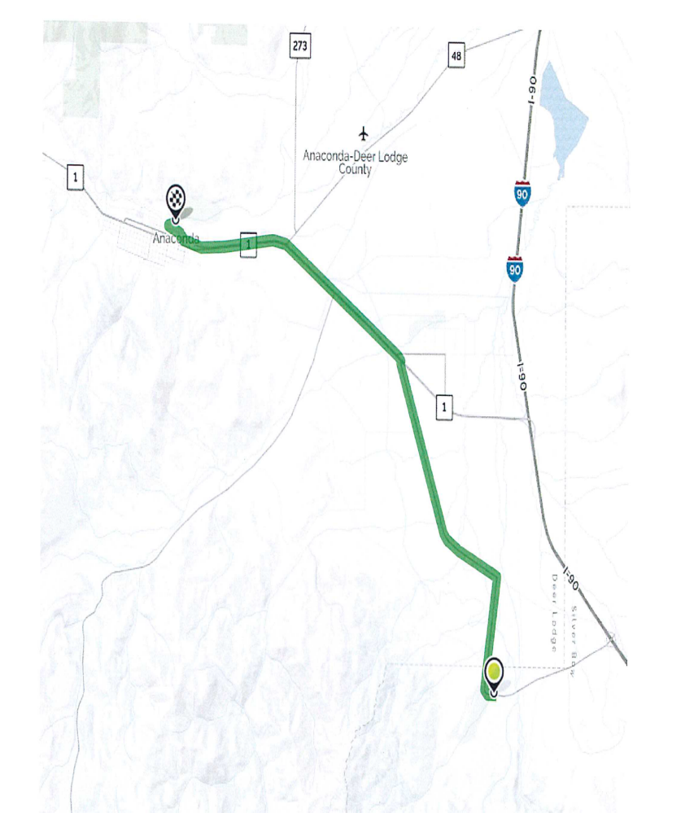
Directions to Old Works Golf Course

1. Start out going west on Fairmont Road toward German Gulch Road 1.77 mi

2. Turn left onto Crackerville Road 3.65 mi

3. Turn left onto MT-1 4.87 mi

4. Turn right onto Jefferson Way 0.04 mi

5. Take the 1st left onto E. Pennsylvania Street 0.38 mi

6. Take the 2nd right onto Pizzini Way 0.20 mi

7. Turn right onto Benton Ave. 0.7 mi

8. Old Works Golf Course will be on the right.

