Kevin C. Park
Recovery Specialist

Kevinpark100@yahoo.com - (801) 759-3296

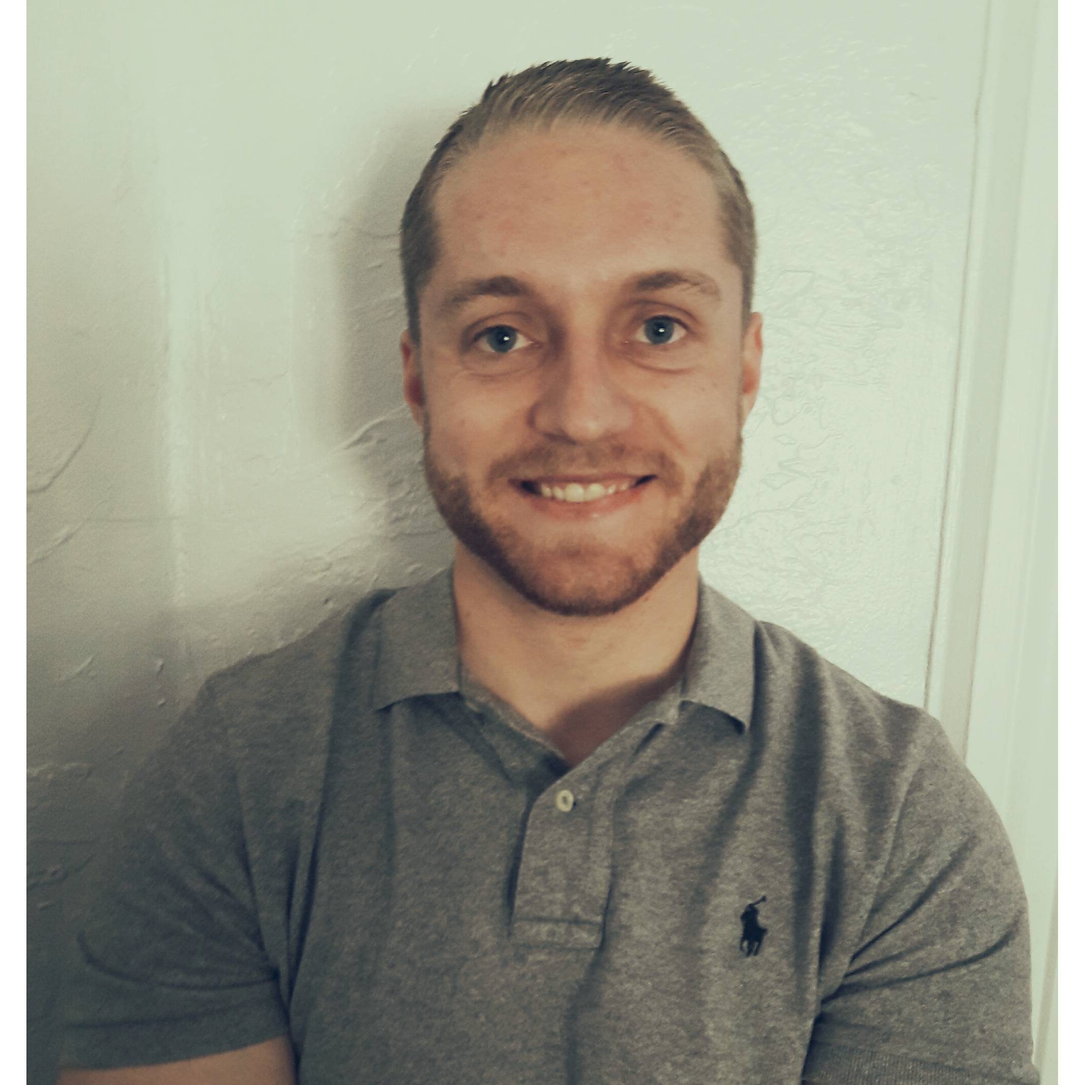  Objective | Hello, I am a tenacious person who is direct! I can do anything I set my mind to and will keep trying despite any obstacle. I am very organized! I have a lot of energy and I love people. My goal is to one day own my own business. I have many interesting idea's to make peoples life easier and hopefully happier. I want a job where I can learn a lot and be apart of a passionate team who are excited about the work they do. I am also looking for something long term, that also helps me grow as both a professional and a person. I love working directly with customers, negotiating resolutions concerning their accounts, while obtaining necessary information to find the best solution for each situation.
Skills | · Leadership  · Strong Managerial and Administration Knowledge  · Excellent communication and negotiation skills  · Excellent Knowledge of FDCPA regulations and  state laws.  · Highly self-motivated and Good Motivator  · Sharp problem solver  · Consistent with obtaining monthly goals and top  performance level  · Large cash and check deposits  · Expert skip tracing skills using Lexis Nexis, TLO, Equifax  and other tools  · Office & team management  · Courteous demeanor  · Skilled at multitasking
Experience | Assistant Manager, Collector & Legal Assistant, 11/2011 to 03/2015  LAW OFFICE OF STEPHEN B. ELGGREN – Sandy, UT  I managed a large number of non-litigation and litigation charged off accounts.  Contacted customers and negotiated best solutions for their accounts.  Skip traced to find phone numbers, location of individuals, and assets.  Recommended and prepared liens, levy's, garnishments, writ of executions, followed by checking on status/results. Assisted the office manager, attorney, legal team, forwarders, clients, and creditors daily. Exceeded office goals and expectations.  Successfully developed "Polices & Procedures" for the office which resulted in a positive outcome.  Worked with upper management to ensure appropriate changes were made to improve work environment and productivity.  Trained newly hired employees while also providing up training and guidance when needed to my fellow coworkers within the work environment.  Collector, 01/2015 to 08/2015  NEXSTEP MEDICAL DETOX – Orem, UT  In charge of managing and collecting on all past due accounts. Contacted costumers and negotiated best resolutions for their accounts. File and fix claims with customers insurance providers.  Mail and email demand letters. Update current statuses. Along with keeping account logs balanced. Prepared monthly reports for office manager and owners using different types of software.  Collector, Recovery Specialist, 05/2015 to Present  Crest Financial – Draper, UT  In charge of account managing of the in house past due accounts. Communicating with customers through outbound & inbound calls, emails, letters then negotiating to collect on past due balances. While building a positive rapport with customer. Scheduling smart and secure payment arrangements. Ran daily reports, along with updating numbers, organizing and maintaining accounts. Creating Exel and Google spread sheets, making daily follow ups on assigned accounts and assisting co-workers and management within and outside of the collections department.  Recovery Specialist, 03/01/2017 to 05/19/2017  The Equitable Finance Company– Murray, UT  I managed many of the branches past due accounts and negotiated resolutions specialized to the customers and company needs offering hardship programs as needed. I initiated legal action when the situation called for it. By doing so I prepared the necessary documents such as affidavits military and otherwise, summons, SCRA (Service members civil relief act). Writs of garnishment and execution, liens. Court running and corresponding with process servers to get service of documents completed.  Other responsibilities summarized:  Collections  Repossessions  Legal filings.
Education | HIGH SCHOOL DIPLOMA: GENERAL STUDIES, 2011  Granite Peaks High School - South Salt Lake, UT  General Studies: Salt Lake Community College

