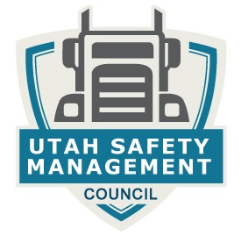

Safety Management Council
Meeting

Date:

Thursday,
June 1,2017
11:00am

Location:

“UTA Training Room”
4181 West 2100 South
West Valley City, Utah

Speaker:

Toby Eborn
National Recruiting Consultant
DriveTeks

Topic:

"Changes in Recruiting, and Changing Your Approach”*

* Toby will be discussing how to develop a successful driver recruiting and retention program for your company. There will be time for questions. This will be very informative. Look forward to seeing you Thursday, June 1st.

---+*/-+9
9-+
*Co

