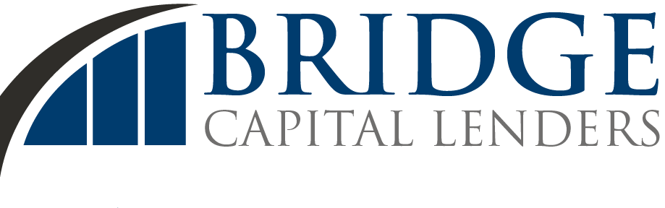

May 16, 2017

**[Client Name]**

**[Address]**

Dear _________,

Congratulations on your decision to apply for business funding with Bridge Capital Lenders!

The approval process starts with your signed application. Please complete all the boxes in the application, then sign and return so we can give you a no-obligation proposal.

Once we get your application and the supporting documents, here’s what you can expect:

1. You have three options for your account review by our underwriter. The simplest and quickest is to use DecisionLogic. For other options, see the attached Bank Access form.
2. Within one business day, you should receive a call from our Customer Service Representative.
3. If there are concerns regarding your application, our underwriting team or your Customer Service Representative will contact you for clarification and resolution.
4. We will send you a Purchase and Sale Agreement of Future Receivables (“PSAFR”) for your signature.
5. When you sign and return the agreement, we will work to resolve any outstanding issues and if there are none, we will wire the purchase money to your designated account one business day.

In the interim, please do not hesitate to contact us with any questions that may arise. We’re here to help.

Sincerely,

Salesperson Name

Salesperson Title