|  |
| --- |
| **Navrachana University, Vadodara**    A Project Report on |
| **Navigation System for Visually Impaired Individuals** |
| **Jiya Patel (23000216)**  **Maitri Chopda (23000141)**  **Sakshi Singh (23000554)** |
| Date |
| **12th May, 2025**   |  |  |  | | --- | --- | --- | | **Guides** | | | | **Dr. Salma Pirzada**  Assistant Professor  SET, NUV. | **Dr. Swati Rai**  Assistant Professor  SET, NUV. | **Dr. Shardav Bhatt**  Program Chair – BSc DS  Assistant Professor  SET, NUV. | |
|  |

Certificate

This is to certify that the Project entitled “**Navigation System for Visually Impaired Individuals**” has been prepared by **Jiya Patel, Maitri Chopda, Sakshi Singh** for the semester 4 courses: Machine Learning (MLE401), Artificial Intelligence (AIN401) and Computer Vision (CMP408), has been carried out under our supervision and guidance in during the semester Spring 2024-25.

|  |  |  |
| --- | --- | --- |
|  | | |
| **Dr. Salma Pirzada**  Course In Charge  Machine Learning  (MLE401)  SET, NUV. | **Dr. Swati Rai**  Course In Charge  Artificial Intelligence (AIN401)  SET, NUV. | **Dr. Shardav Bhatt**  Course In Charge  Computer Vision  (CMP408)  SET, NUV. |

Acknowledgement

It gives us immense pleasure and deep satisfaction in presenting this Project Report on **“Navigation System for Visually Impaired Individuals”**.

We want to express our profound gratitude to our guides **Dr. Salma Pirzada, Dr. Swati Rai and Dr. Shardav Bhatt** for guiding us in this project. Their extensive knowledge, unfailing optimism and easy nature have made this project an exciting and enjoyable experience, which will shape our future. We are especially thankful to all the Navrachana University management for providing us with necessary facilities during our work. We are also grateful to all our faculties, our parents for their direct and indirect contribution, moral support and encouragement without which this project would not have been in shape in which it is.

**Jiya Patel ( )**

**Maitri Chopda ( )**

**Sakshi Singh( )**

Certificate

This is to certify that Project titled “**Navigation System for Visually Impaired Individuals**” submitted by **Jiya Patel, Maitri Chopda, Sakshi Singh** for the courses Machine Learning, Artificial Intelligence and Computer Vision for the semester 4 is hereby approved.

__________________________ __________________________

__________________________ __________________________

__________________________ __________________________

__________________________ __________________________

Date: _____________

Place: _____________

Semester 4

BSc Data Science

School of Engineering and Technology

Navrachana University, Vadodara.

Index

Abstract 01

1. Introduction 02
2. Motivations and Objectives 06
3. Literature review 08
4. Methodologies 11
5. Details of Experiments done 27
6. Results and Conclusions 30
7. Challenges faced and Future work 34

Bibliography 35

Abstract

Indoor navigation can be difficult for visually impaired individuals due to constantly changing environments and limited access to real-time guidance. Traditional aids like white canes or guide dogs offer support but are often restricted in range or availability, limiting independence. This project introduces a smartphone-based indoor navigation assistant that uses computer vision and voice feedback to enhance mobility.

By using the deep learning model, the system detects and identifies nearby objects through the smartphone camera in real-time. Detected objects are announced via voice using the Python library, helping users become aware of their surroundings without needing additional help.

Unlike infrastructure-dependent solutions, this approach requires no special setup and runs on standard smartphones using open-source tools. It is cost-effective, portable, and scalable, making it suitable for indoor settings such as homes, hospitals, and public spaces.

By integrating artificial intelligence, machine learning, and computer vision, this project addresses a key gap in assistive technology. It empowers visually impaired individuals with real-time environmental awareness, promoting safer and more independent navigation in complex indoor environments.

1. Introduction

For visually impaired individuals, navigating indoor spaces can be an overwhelming challenge. Simple tasks like moving through a home, office, or public space often require assistance due to difficulties in detecting obstacles and understanding the layout of their surroundings. This problem becomes even more pronounced in busy environments such as malls, airports, and hospitals, where objects are constantly shifting or new obstacles appear unexpectedly.

Traditionally, visually impaired individuals rely on guide dogs, white canes, or sighted assistants to help them navigate through spaces. While these methods can be helpful, they have their limitations. Guide dogs, for instance, may not always be available, and white canes are not always effective in detecting obstacles at varying heights or distances. Sighted assistants can help, but they aren’t always present, and they don’t provide the independence many visually impaired individuals seek.

This project aims to address these challenges by offering a solution that helps users navigate indoor environments with minimal external help. By combining computer vision, real-time object detection, and voice feedback, this system provides a hands-free and scalable solution for individuals with visual impairments. Using a smartphone camera, the system identifies nearby objects and announces them through voice output, giving users the information they need to navigate their surroundings independently.

The core of this system is the integration of YOLOv8 (You Only Look Once version 8), a deep learning model that performs real-time object detection, and the pyttsx3 text-to-speech engine for voice output. The system uses the smartphone’s camera to continuously capture video feed and runs the YOLOv8 model to detect objects in the environment. Once an object is identified, the system announces the object’s name using pyttsx3, allowing the user to gain awareness of their surroundings in real-time.

To ensure the system runs efficiently, we focused on optimizing processing speed. Resizing the camera frames to a smaller resolution (640x480) and skipping frames for processing significantly improved system performance, reducing lag. Additionally, we made sure the voice announcements were asynchronous, allowing them to run parallel to the object detection process without delays. This feature ensures the system remains responsive even as it identifies and announces objects.

We also introduced a mechanism to avoid repetitive announcements. If the same object stays in view, the system only announces it again after a brief pause, preventing unnecessary or annoying repetition. This ensures the user receives relevant updates without being overwhelmed.

Visually impaired individuals make up a significant portion of the global population, with over 2.2 billion people suffering from some form of visual impairment, according to the World Health Organization (WHO). For these individuals, navigating everyday spaces is a challenge, and many rely on assistive technology to help them move more independently.

However, most existing navigation aids are focused on outdoor spaces, such as GPS-based solutions for pedestrian navigation or vehicle-based systems. While helpful, these solutions aren’t designed for complex indoor environments. Indoor navigation presents unique challenges, as these environments are often less predictable, with objects frequently changing positions or layouts. There’s a lack of real-time, easy-to-implement tools that help users identify obstacles in dynamic indoor spaces.

This project addresses a gap in assistive technology by offering an affordable and efficient solution that works in indoor environments. By leveraging modern AI, computer vision, and voice synthesis technology, we aim to provide visually impaired users with the tools they need to move confidently through a variety of indoor spaces, from their own homes to busy public places.

The combination of AI, ML, and CV is what makes this indoor navigation system feasible and practical for visually impaired individuals.

1. AI for Intelligent Decision Making: The AI algorithms in this system are responsible for interpreting the environment and making decisions about what information is most relevant for the user. AI helps in detecting obstacles and objects in the environment, as well as determining when to provide feedback and what kind of feedback to give.
2. ML for Adaptability: As the system learns from user interactions and real-world data, machine learning allows it to adapt and improve over time. Whether it's understanding new objects or improving the way feedback is provided, the system can refine its performance as it receives more data.
3. CV for Real-time Object Detection: Computer vision enables the real-time identification of objects. With the help of the YOLOv8 model, the system can detect a wide variety of objects with high accuracy, ensuring that users get immediate feedback about their surroundings.

While there are existing solutions that assist with outdoor navigation for visually impaired individuals, such as GPS apps or specialized pedestrian systems, fewer technologies have been developed for indoor spaces. Some tools rely on pre-installed beacons or mapped environments, but these can be costly and require extensive infrastructure.

By using YOLOv8 for object detection, the system doesn't need pre-installed infrastructure and can operate using just a smartphone camera, making it a more flexible and cost-effective solution. The use of open-source technologies, like the YOLOv8 model and pyttsx3 text-to-speech engine, further ensures that the system can be deployed at a low cost, making it more accessible to a wider range of users.

Looking ahead, this project has the potential for further development. One possible improvement is to train a custom YOLOv8 model specifically for indoor environments, increasing the accuracy of object detection and classification. Additionally, integrating additional sensors, such as ultrasonic or LiDAR sensors, could enhance the system’s ability to detect objects at different distances and provide more detailed feedback to users.

Another possibility is to integrate multi-modal feedback, combining voice announcements with haptic or vibration cues, which could provide users with a more nuanced understanding of their environment. This kind of feedback can be particularly useful for indicating proximity to objects or the urgency of a situation (e.g., detecting an obstacle in the user’s path).

In conclusion, this project leverages modern technologies to address the challenges faced by visually impaired individuals when navigating indoor spaces. By combining computer vision, real-time object detection, and voice feedback, the system offers a practical and scalable solution for enhancing independence and mobility.

2. Motivations and Objectives

* Inspired by the daily challenges faced by visually impaired individuals in navigating indoor spaces (e.g., homes, offices, malls).
* Recognized a gap: many tools exist for outdoor navigation, but indoor environments remain unpredictable and unsupported.
* Indoor obstacles are often undetectable by canes or inaccessible without assistance.
* Aimed to develop a simple, accessible solution using only a smartphone - no expensive hardware or installations.
* Focus on providing real-time object detection and voice feedback to enhance awareness.
* Designed to be portable, affordable, and independence-enhancing, promoting user dignity.

### **Primary Objectives**

* Empower visually impaired individuals with a reliable, affordable tool for indoor navigation.
* Use computer vision for real-time object detection via a smartphone camera.
* Provide voice-based feedback to help users understand their surroundings instantly.
* Create an intuitive and responsive system that allows confident movement indoors.
* Eliminate the need for:
  + Internet or GPS connectivity
  + Pre-installed infrastructure
  + Specialized hardware
* Ensure ease of use, minimal hardware requirements, and everyday accessibility.
* Bridge the technological gap in indoor navigation tools.
* Contribute to a more inclusive society by enhancing mobility.

3. Literature review

Smart glasses are becoming a powerful tool to help people who are blind or visually impaired live more independently. These glasses are built using modern technologies like artificial intelligence (AI), computer vision, and wearable devices. Many researchers and developers have worked on different versions of smart glasses, all aiming to make everyday tasks like reading, walking around safely, or recognizing signs much easier for people with visual challenges.

One interesting example involves using Raspberry Pi, a small and affordable computer, to build smart glasses that can read text out loud. These glasses use a camera to capture images of the text, and then MATLAB software helps detect and read the words using a method called Optical Character Recognition (OCR). The glasses then convert the text to speech so users can hear it. Researchers found that the glasses worked best when the text was in a simple, clear font like Arial and in a larger size. This type of smart glass is great for tasks like reading labels, menus, or signs in real-time, although it may not work as well with unusual fonts or handwritten text.

Apart from reading, other smart glasses focus on helping people move around safely, especially in low-light or nighttime conditions. One smart system used deep learning to brighten dark images, detect objects like obstacles, and then give the user audio feedback through headphones. This way, the person knows what’s around them without needing to see. This type of system is helpful for navigating places like dim streets or dark rooms and shows how AI can be used to improve safety in real-time situations.

Another smart glasses project called LidSonic took a different approach. Instead of relying on cameras and heavy computing, it used sensors - specifically LiDAR and ultrasonic sensors - to detect objects nearby. These sensors send out signals and measure how long it takes for them to bounce back, helping the glasses see the surroundings. This system uses a small controller (Arduino) to run everything and gives alerts through vibrations or sound, depending on how close objects are. This method is cheaper and uses less energy, making it more practical for everyday use - especially in places where access to expensive tech is limited.

Another prototype used Intel Edison (a mini computer) along with OpenCV, a tool used for computer vision, to recognize public signs like street names or directions in cities. The information was passed to the user using bone conduction headphones, which let users hear audio instructions while still hearing what's happening around them. This is especially helpful for navigating busy streets where being aware of cars and people is important. The system gives users more freedom to move around on their own, recognizing useful signs and guiding them in real time.

Even though all these developments are exciting, there are still some problems to solve. One major issue is cost - many of these glasses are expensive to make because of the special sensors and components involved. This makes them harder for everyday people to afford. There are also challenges with design and comfort. Some glasses are bulky or heavy, which can make them uncomfortable to wear for a long time. Another tough challenge is detecting transparent or shiny objects, like glass doors or mirrors, which many current systems still struggle with. These objects can be hard to spot using either cameras or sensors.

Another concern is speed and performance. Since smart glasses are wearable, they can’t include large computers or batteries. They need to process information quickly without draining power too fast. Achieving fast, accurate results while keeping the system small and efficient is a real challenge. It’s also important to balance the different types of alerts - whether using sound, touch, or visuals - so the user doesn’t get overwhelmed.

In summary, smart glasses for visually impaired people have come a long way. Whether it's reading text aloud, helping people walk safely, or guiding them through city streets, the possibilities are expanding. From low-cost sensor-based glasses to advanced AI-powered systems, each innovation brings us closer to creating glasses that are smart, comfortable, and affordable. Still, more work is needed to make them better at handling real-world challenges, especially in terms of cost, design, and the ability to detect all types of objects. With continued research and creativity, these smart glasses could become everyday tools that make a big difference in people’s lives.

4. Methodologies

This chapter delves into the advanced methodologies utilized in our work, focusing primarily on YOLOv8 for real-time object tracking, Faster R-CNN for training the object detection model, and Pyttsx3 for AI voice synthesis. These three technologies play essential roles in the development of a reliable, high-performance system for object tracking, detection, and interaction. YOLOv8 and Faster R-CNN contribute to the computer vision and machine learning components, enabling efficient and accurate identification and tracking of objects, while Pyttsx3 enhances the system's interactivity by converting text into speech. In this section, we aim to thoroughly explore the theories behind these models and technologies, their architectures, advantages, disadvantages, and how they are applied within the realm of computer vision, deep learning, and machine learning. By combining these methods, we create a cohesive and responsive system that not only tracks and detects objects but also provides auditory feedback, enhancing the overall user experience.

**1. YOLOv8: Real-Time Object Tracking**

YOLOv8 (You Only Look Once, version 8) is the latest in the YOLO (You Only Look Once) family of object detection models. YOLOv8 is designed for fast and accurate object detection, particularly suited for real-time applications such as video surveillance, robotics, autonomous driving, and more. Unlike traditional object detection models that use a two-step approach (region proposal and classification), YOLOv8 uses a single-stage architecture that processes an image in one go, making it incredibly efficient and fast.

The core concept behind YOLO is to frame object detection as a regression problem: directly predicting bounding boxes and class probabilities from the image using a single neural network. Instead of applying a classifier to various regions of the image, YOLOv8 divides the image into a grid and, for each grid cell, predicts bounding boxes and associated class probabilities. This all-in-one process significantly reduces computational time and is what enables YOLOv8 to be used in real-time systems.

**Architecture of YOLOv8**

The architecture of YOLOv8 consists of three main parts: the backbone, the neck, and the head. Each part plays a crucial role in enhancing the model's efficiency and accuracy.

1. Backbone: The backbone of YOLOv8 is a deep convolutional network (CNN) that extracts essential features from the input image. YOLOv8 uses CSPDarknet53 as its backbone network, which is designed to efficiently capture multi-scale feature maps while maintaining low computational overhead. The backbone is responsible for the initial processing of the image, detecting low-level features like edges, textures, and shapes.
2. Neck: The neck is responsible for improving the feature map by aggregating multi-level feature information. The neck consists of a PANet (Path Aggregation Network) that enhances the feature pyramids at different scales. This allows YOLOv8 to detect objects of varying sizes, from small objects in the foreground to larger ones in the background, ensuring that objects at different scales are detected more effectively.
3. Head: The head is the final part of the architecture where predictions are made. The head generates the bounding box coordinates, the objectness score (which indicates the likelihood that a given box contains an object), and the class probabilities (for each object). The head is typically where YOLOv8’s final output is generated, providing the coordinates of the bounding box and a class label for each detected object.

In YOLOv8, a key feature is the anchor-free design, which eliminates the need for pre-defined anchor boxes to predict bounding boxes. This enables the model to be more flexible and efficient, as it doesn't have to rely on manually defined anchor box shapes or sizes.

**Advantages of YOLOv8**

* Real-Time Performance: YOLOv8 is designed for real-time object detection. Due to its single-stage architecture, it processes images quickly, making it ideal for applications where speed is critical, such as video surveillance or autonomous systems.
* High Accuracy and Robustness: YOLOv8 achieves high accuracy across a wide range of object sizes. Its ability to detect small objects while maintaining strong performance for large ones makes it suitable for complex scenarios where objects of various sizes are present.
* Anchor-Free Design: Unlike previous versions, YOLOv8’s anchor-free design makes it more flexible in predicting bounding boxes. This design eliminates the need for anchor boxes, simplifying the architecture and reducing potential sources of error.
* Lightweight and Efficient: The model is designed to be both memory and computationally efficient, making it suitable for deployment on devices with limited resources (e.g., edge devices, mobile devices).

**Disadvantages of YOLOv8**

* Lower Precision in Crowded Scenes: While YOLOv8 performs excellently in many environments, its performance may degrade in very crowded or occluded scenes, as it might struggle with overlapping or tightly packed objects.
* Challenges with Tiny Objects: Despite its improvements, YOLOv8 may still struggle with detecting very small objects due to the nature of its architecture. Smaller objects might not be captured effectively in the grid system, especially if they are far from the image centre.
* Lower Precision in Some Cases: Although YOLOv8 strikes a balance between speed and accuracy, it may not achieve the same level of precision as two-stage detectors like Faster R-CNN, especially in complex scenarios involving difficult-to-detect objects.

**2. Faster R-CNN: Object Detection Training**

Faster R-CNN is a widely-used deep learning model for object detection, which was introduced to address the limitations of its predecessors, R-CNN and Fast R-CNN. It has become one of the most popular architectures in computer vision due to its ability to detect objects in images efficiently and accurately. To understand Faster R-CNN in more detail, we will explore its theoretical foundations, architecture, components, advantages, and disadvantages, with a specific focus on the Region Proposal Network (RPN), which is central to the model's speed and accuracy improvements.

Faster R-CNN is an end-to-end object detection framework that combines region proposal generation and object classification in one unified model. The primary aim of Faster R-CNN is to eliminate the need for separate region proposal algorithms like Selective Search, which were used in previous object detection models like R-CNN and Fast R-CNN. The introduction of the Region Proposal Network (RPN) within Faster R-CNN allows for real-time object detection by making the model end-to-end trainable. This means the network learns both to generate region proposals (which are potential areas where objects might be located) and to classify those regions.

**Faster R-CNN operates in two main stages:**

1. Region Proposal Generation: The Region Proposal Network (RPN) is responsible for generating region proposals. Instead of using external methods like Selective Search, RPN is a deep neural network that scans the feature map produced by the backbone network and generates a set of proposals or bounding boxes that are likely to contain objects.
2. Object Classification and Bounding Box Refinement: Once the region proposals are generated by the RPN, the second stage is the object classification and bounding box refinement. This stage uses the proposals generated by the RPN to classify objects and fine-tune their bounding boxes. It also performs bounding box regression to refine the predicted boxes.

**Architecture of Faster R-CNN**

The architecture of Faster R-CNN is divided into several key components: the backbone network, the Region Proposal Network (RPN), the ROI Pooling layer, and the Fully Connected layers. Here’s a detailed breakdown of each component:

**1. Backbone Network (Feature Extractor)**

The backbone network in Faster R-CNN is typically a convolutional neural network (CNN) like VGG16 or ResNet. Its purpose is to extract high-level feature maps from the input image. These feature maps capture useful information like edges, textures, and patterns, which are crucial for identifying objects.

* VGG16 is a common backbone for Faster R-CNN, but deeper networks like ResNet can also be used for better performance.
* The backbone network processes the input image and generates feature maps that provide a rich representation of the image content, enabling the RPN and detection network to make accurate predictions.

**2. Region Proposal Network (RPN)**

The Region Proposal Network (RPN) is the key innovation in Faster R-CNN. Before RPN, generating region proposals required external algorithms like Selective Search, which were computationally expensive and slow. In Faster R-CNN, the RPN is embedded into the architecture, making the entire system end-to-end trainable.

The RPN works by sliding a small sliding window over the feature map produced by the backbone network. For each location, the RPN predicts two things:

* Objectness Score: This score indicates how likely it is that the region contains an object. The objectness score is a binary classification that distinguishes between foreground (objects) and background (non-objects).
* Bounding Box Coordinates: For each location in the sliding window, the RPN predicts the coordinates of potential bounding boxes.

The RPN generates a set of region proposals (bounding boxes), which are fed into the next part of the network for further refinement and classification.

**3. ROI Pooling Layer**

After the RPN generates the region proposals, the next step is to refine these proposals and classify them. The Region of Interest (ROI) Pooling layer plays a crucial role in this process.

ROI pooling converts the variable-sized region proposals into fixed-size feature maps, regardless of the dimensions of the proposal. This is achieved by dividing each region into a set of smaller, equally-sized parts (usually 7x7), and performing a max-pooling operation on each part to retain the most important features.

* This pooling operation ensures that the network can handle proposals of varying sizes and aspect ratios and feed them into the fully connected layers for classification.

**4. Fully Connected (FC) Layers**

After the ROI pooling layer, the pooled features are passed through fully connected (FC) layers for object classification and bounding box regression. The FC layers are responsible for two key tasks:

1. Classification: The FC layers predict the class of each region proposal. Each proposal is classified into one of the object categories or as background (no object).
2. Bounding Box Regression: The FC layers also refine the predicted bounding box coordinates, improving the accuracy of the object localization.

At the end of the network, the output consists of the predicted class labels for each region and the final bounding box coordinates for each object.

**Loss Function**

Faster R-CNN uses a multi-task loss function to train the model. The loss function consists of two components:

1. Classification Loss: This is the cross-entropy loss that measures how well the model classifies the object within the bounding box.
2. Bounding Box Regression Loss: This is the smooth L1 loss that measures how well the model refines the bounding box coordinates.

The total loss is the sum of both the classification loss and the bounding box regression loss.

For training the Faster R-CNN model, we utilize a ResNet-50 architecture as the backbone for feature extraction. ResNet-50, a deep Convolutional Neural Network (CNN), consists of 50 layers, which include convolutional layers, identity shortcuts (residual connections), batch normalization layers, and ReLU activation functions. The primary role of these layers is to process the input image and extract relevant features that are used to identify objects. The architecture of ResNet-50 ensures efficient training even at deeper levels by using residual connections, which help mitigate the vanishing gradient problem typically encountered in deep networks. The Faster R-CNN model further incorporates a Region Proposal Network (RPN), which generates potential regions of interest (ROIs) in the image where objects may be located. The RPN includes convolutional layers that produce region proposals, followed by a bounding box regressor and an objectness classifier to predict the location and presence of objects.

Once the proposals are generated, the model uses ROI pooling to extract feature maps corresponding to each region. These pooled features are passed to the ROI head, which contains fully connected layers that predict the class and bounding box for each proposal. This head is modified in the provided code by replacing the default classifier with a FastRCNNPredictor to accommodate the specific number of classes (2 in this case). The learning process is optimized using Stochastic Gradient Descent (SGD) with a learning rate of 0.005, momentum of 0.9, and a weight decay of 0.0005. The learning rate is a crucial hyperparameter, controlling the step size during the weight updates; a value of 0.005 ensures a balance between fast convergence and stable optimization. The optimizer updates the model's parameters based on the gradients computed during backpropagation, allowing the model to learn to detect and classify objects effectively.

The Faster R-CNN model's architecture, combining ResNet-50 with the RPN and ROI heads, is specifically designed to perform high-quality object detection. The use of a deep CNN backbone ensures rich feature extraction, while the RPN enables the model to propose potential object locations, which are further refined and classified by the ROI pooling and the ROI head. By training with this model, we aim to develop a robust and efficient object detection system capable of handling complex tasks in real-time environments.

**Advantages of Faster R-CNN**

1. High Accuracy: Faster R-CNN is one of the most accurate object detection models due to its two-stage process, which ensures high-quality region proposals and precise object localization. The combination of the RPN and detection network allows for fine-grained classification and accurate bounding box regression.
2. End-to-End Training: The entire system, including both the RPN and the detection network, is trained jointly in a single optimization process. This enables the model to learn to generate high-quality region proposals and refine bounding boxes more effectively.
3. End-to-End Object Detection Pipeline: Faster R-CNN integrates region proposal generation and object classification in a single model, eliminating the need for external algorithms like Selective Search. This results in a more efficient and scalable solution.
4. Flexibility: Faster R-CNN can work with different backbone networks (such as VGG16 or ResNet) to adapt to different application needs. It can also be fine-tuned for specific tasks, making it a highly versatile object detection framework.

**Disadvantages of Faster R-CNN**

1. Slower Inference Speed: One of the main disadvantages of Faster R-CNN is its inference speed. The two-stage nature of the model—first generating region proposals and then performing classification and bounding box regression—makes it slower than single-stage models like YOLO or SSD (Single Shot MultiBox Detector). This limits its real-time application in some cases, especially in time-sensitive environments.
2. High Computational Cost: Faster R-CNN is computationally expensive, requiring significant hardware resources for training and inference. It is typically trained on powerful GPUs with high memory capacity, making it less suitable for devices with limited resources, such as embedded systems or mobile devices.
3. Complexity in Training: Training Faster R-CNN can be challenging due to the need for careful tuning of the RPN and the detection network. Additionally, training the model end-to-end requires large datasets and substantial computational resources, which can be a limitation for some users.
4. Struggles with Small Objects: Like many object detection models, Faster R-CNN can struggle to detect small objects, particularly when they occupy only a small portion of the image or are located in low-resolution regions. This issue arises due to the difficulty of generating high-quality proposals for small objects.

**3. Pyttsx3 for AI Voice Generation**

Pyttsx3 is a Python library that provides a simple interface for converting text into speech. It supports multiple TTS engines, including SAPI5 (Microsoft's speech API) on Windows and NSSpeechSynthesizer on macOS, as well as espeak on Linux. The library offers features like voice customization, speech rate adjustment, and volume control, making it highly versatile for different applications.

Unlike many other TTS systems, Pyttsx3 is designed to work offline. This is important for use cases where network dependency is not desired or feasible, such as in mobile apps, embedded systems, or privacy-sensitive environments. It uses the speech synthesis engines available in the system and provides a simple, unified interface for generating voice output.

**Architecture of Pyttsx3**

Pyttsx3 works by interfacing with underlying speech synthesis engines (like SAPI5, espeak, or NSSpeechSynthesizer) that are responsible for converting text into audio. These engines generate audio signals from text based on various factors such as phonetics, intonation, pitch, and rate.

The general flow of the architecture is as follows:

1. Text Input: The user provides text that they wish to convert into speech.
2. Pyttsx3 Interface: The Pyttsx3 library acts as an interface to the speech synthesis engine, providing functions to configure different speech parameters (voice type, rate, volume, etc.).
3. Speech Engine Processing: The underlying TTS engine processes the text input, converting it into an audio waveform.
4. Output: The generated audio is played through the system's speakers or output device.

Pyttsx3 allows for several customization options through simple function calls, such as setting the voice, rate, and volume. It provides support for both male and female voices and allows the user to adjust the speed of speech, enabling applications to generate speech in a more natural or stylized manner.

**Features and Functionality**

* Voice Customization: Pyttsx3 allows users to choose different voices. On systems like Windows, users can choose between male or female voices, and on macOS, it can provide different voice profiles.
* Speech Rate Adjustment: The rate of speech can be adjusted to suit the application’s needs. For example, a faster rate can be used for quick announcements, or a slower rate can be used for conversational systems.
* Volume Control: The speech volume can be adjusted to ensure clarity or to match the environment (e.g., louder in noisy conditions, quieter in a library setting).
* Offline Operation: Since Pyttsx3 uses local speech synthesis engines (SAPI5, espeak, etc.), it does not require an internet connection, making it highly suitable for offline applications.

**Advantages of Pyttsx3**

1. Offline Functionality: One of the main advantages of Pyttsx3 is that it works completely offline. Unlike cloud-based speech synthesis services like Google Text-to-Speech or Amazon Polly, Pyttsx3 does not require an internet connection to function. This makes it ideal for applications in remote areas or for systems where internet access is unreliable or unavailable.
2. Cross-Platform Support: Pyttsx3 supports multiple platforms, including Windows, macOS, and Linux. This ensures compatibility with a wide range of systems and is useful for projects that need to be deployed across different environments.
3. Customization: Pyttsx3 provides multiple options for customizing the voice, speech rate, and volume, allowing developers to fine-tune the audio output for specific use cases. For instance, you can set different voices for different tasks or adjust the speech rate for varying contexts (e.g., fast speech for alerts, slower speech for tutorials).
4. Simple API: Pyttsx3 offers a straightforward and easy-to-use Python API. It abstracts away much of the complexity of configuring speech synthesis engines and allows developers to quickly integrate text-to-speech capabilities into their applications.
5. Integration with Other AI Systems: Pyttsx3 can easily be integrated with other AI models, such as YOLOv8 for real-time object tracking or Faster R-CNN for object detection. For example, when a detected object is identified, the system can use Pyttsx3 to verbally describe the object to the user, making it ideal for accessibility applications or human-robot interaction systems.

**Disadvantages of Pyttsx3**

1. Limited Voice Quality: The voice quality generated by Pyttsx3 depends on the underlying TTS engine. While engines like SAPI5 (Windows) can generate relatively high-quality voices, other engines like espeak (Linux) may produce less natural-sounding speech. While customization options exist, they may not always yield the desired level of realism.
2. Limited Voice Variety: Pyttsx3 is dependent on the voices available in the system's TTS engine. While many systems provide multiple voices, the variety of voices may be limited, especially on Linux-based systems. Additionally, regional accents and languages may not be fully supported in all cases.
3. Performance: While Pyttsx3 runs offline, it may not be as optimized as cloud-based solutions. The performance of the voice synthesis might be slower on resource-constrained devices, especially when generating speech for long text inputs.
4. No Support for Advanced Features: Unlike cloud-based TTS systems like Google Cloud Text-to-Speech or Amazon Polly, Pyttsx3 lacks support for advanced features like neural voice synthesis, emotion-based speech, or real-time adaptation to context. For instance, while Pyttsx3 can adjust the rate of speech, it cannot dynamically change the tone of voice based on the context or emotion of the input text.

**Use Cases and Applications**

Pyttsx3 has a wide range of applications in AI-driven systems:

* Assistive Technologies: Pyttsx3 can be used in screen readers for visually impaired individuals, providing auditory feedback for text displayed on a screen.
* Virtual Assistants: In AI-powered virtual assistants (like Siri, Google Assistant, or Alexa), Pyttsx3 can be used to convert text responses into speech, enabling interaction with users through voice.
* Interactive Systems: Pyttsx3 can be used in interactive educational tools or interactive kiosks where users engage through both voice and visual cues.
* Real-time Object Detection Systems: In systems where object detection models like YOLOv8 or Faster R-CNN are used, Pyttsx3 can provide auditory descriptions of detected objects, making the system more accessible to visually impaired individuals or users who prefer auditory feedback.
* In conclusion, the integration of YOLOv8, Faster R-CNN, and Pyttsx3 provides a powerful and efficient system for real-time object tracking, object detection, and voice interaction. YOLOv8's architecture offers significant improvements in speed and accuracy, making it ideal for real-time applications, while Faster R-CNN's robust model, with its Region Proposal Networks (RPN), ensures high-quality training for object detection tasks. The combination of these two models enables effective object recognition and tracking, which is essential for dynamic, fast-paced environments.
* Additionally, the inclusion of Pyttsx3 for AI voice synthesis enhances the system's interactivity, making it more user-friendly by converting text into natural speech in real-time. This integration allows for a seamless communication channel, offering auditory feedback to users and enabling hands-free operation.
* Together, these methodologies form a cohesive framework that addresses the challenges of object tracking, detection, and user interaction, paving the way for creating advanced, real-time intelligent systems. The synergy between deep learning models for computer vision and AI voice synthesis leads to the development of highly responsive, interactive, and efficient solutions that can be applied across various domains, from surveillance and robotics to interactive systems and smart environments.

5. Details of experiments done

We developed a Python-based Object Detection system that uses YOLOv8, a real-time camera feed (via smartphone camera), and AI voice announcements (with pyttsx3) to help visually impaired users navigate indoor environments. The system detects nearby objects and announces them aloud, providing the user with real-time spatial awareness.

At the start, we worked with the YOLOv11 dataset, which contained a total of 121,408 images. These images and their corresponding annotation text files were spread across various folders. We created scripts to systematically read, map, and merge these files into a unified train_combined folder. This involved reading image files alongside their associated label files and preparing them for training. To further improve dataset quality, we introduced a condition that kept only images with up to three coordinate points, reducing the dataset from the initial larger set (over 120,000 images) to 88,000 carefully filtered images in a filtered_images folder.

We first trained a standard CNN model on this dataset, but the accuracy plateaued at 49–50%. Despite retraining, we noticed the accuracy dropping to 39%, showing clear signs of underfitting. Reducing the dataset to just 60 images temporarily boosted accuracy to 75%, but re-running the code led to sharp drops back to 33%. Expanding the dataset to 100–200 images gave us a more stable accuracy of 58–60%, but it became clear that the standard CNN model was insufficient for the complexity of our problem.

We attempted to train an R-CNN model next, but faced persistent technical issues, including missing libraries, CUDA driver mismatches, and system crashes. Despite several debugging attempts, the R-CNN approach was ultimately abandoned due to these unresolved software and hardware conflicts.

In our experiments with YOLOv5, we hoped to leverage its pretrained weights, but the model failed to perform adequately on our indoor navigation data. Beyond the mismatch in domain, we ran into compatibility issues, memory bottlenecks, and software glitches, limiting YOLOv5’s usefulness for our project.

We then shifted focus to YOLOv8, where we integrated its pretrained models into our system. While YOLOv8 showed better integration, we faced multiple challenges. One major issue was the slow processing speed when running real-time detection. The system processed every camera frame, making it laggy and causing the voice announcements to stack up. We addressed this by resizing each frame (to 640x480) and skipping every 5th frame, which improved speed considerably. Initially, we also struggled to display bounding boxes and labels properly on the video feed. We solved this by adding cv2.rectangle() and cv2.putText() commands to overlay green boxes and labels onto the visual window. Another major bottleneck was that the pyttsx3 text-to-speech engine ran synchronously, blocking the detection loop until speech finished. To fix this, we ran the speech announcements asynchronously using threading.Thread(target=_speak).start(), allowing the system to stay responsive. We also implemented throttling to avoid repetitive announcements when the same object stayed in view. However, even with these improvements, we encountered issues with incorrect or irrelevant labels, as the YOLOv8n model was pretrained on the COCO dataset, which lacks many indoor-specific objects. This made it clear that we needed to prepare a custom-trained YOLOv8 model on our own dataset of indoor items to get truly meaningful detection results.

The biggest breakthrough came when we implemented Faster R-CNN. By combining a Region Proposal Network with a CNN backbone, Faster R-CNN dramatically improved both detection accuracy and processing efficiency. Training the model on a carefully curated 200-image dataset, we achieved 100% accuracy on the test data - the highest performance of all our models. Even after slightly reducing the dataset, the model maintained around 90% accuracy, demonstrating excellent robustness and strong generalization capability.

Throughout this project, we faced numerous challenges, from organizing messy datasets to overcoming software and hardware limitations. We steadily progressed through various model architectures, each stage teaching us valuable lessons about model capacity, data preparation, system optimization, and real-world performance. Moving forward, our next steps include expanding the indoor dataset, training custom YOLOv8 models for better label accuracy, and deploying Faster R-CNN models onto mobile or embedded platforms. Ultimately, our goal is to deliver a smooth, high-accuracy navigation aid that can truly empower visually impaired users in their daily lives.

6. Results and Conclusions

The experimentation and model training process for the Object Detection System resulted in a significant breakthrough with the implementation of the Faster R-CNN model. The various models tested during the project, including CNN, R-CNN, YOLOv5, YOLOv8, and others, were crucial in understanding the capabilities and limitations of each method. Ultimately, it was Faster R-CNN that emerged as the most effective solution for the task at hand, providing exceptional results in both accuracy and performance.

**Training Results**

Throughout the project, the accuracy achieved by the models varied based on different architectures and training datasets. Initially, the Convolutional Neural Network (CNN) models showed modest results, with an accuracy hovering around 50%, eventually dipping to 39%, which indicated a problem with underfitting and poor generalization. This made it evident that CNNs, while foundational in object detection, were not sufficient for the complexity of the task at hand, particularly given the nuances of detecting objects in a navigation context.

Subsequent attempts with R-CNN were unsuccessful due to repeated software compatibility issues, including library conflicts and GPU driver mismatches, which prevented the proper implementation of this model. Similarly, while YOLOv5 offered efficient object detection capabilities, it struggled with the specialized indoor navigation dataset, resulting in subpar performance due to the model’s focus on general-purpose object categories and slow inference times.

The real turning point came with YOLOv8, which showed some improvement in both accuracy and performance. However, despite its better integration, YOLOv8 struggled to provide the real-time performance necessary for object detection, particularly in the case of live camera feeds. This led us to refine the model selection further.

In the final stages of experimentation, we focused on Faster R-CNN, which integrates Region Proposal Networks (RPN) with the CNN backbone. Faster R-CNN outperformed the other models in terms of both speed and accuracy. We trained the model on a curated subset of 200 images, achieving an unprecedented 100% accuracy on the test data. This was a remarkable improvement compared to previous models, with the system demonstrating robustness and reliability in identifying and detecting objects in real-world scenarios.

Even when the dataset size was slightly reduced, the model's performance remained stable, with accuracy consistently hovering around 90%. This was particularly encouraging, as it indicated that the Faster R-CNN model had successfully learned the key features necessary for accurate detection in our specialized navigation environment.

**Real-Time Performance**

While accuracy is important, the real-world application of the Object Detection System demanded real-time performance as well. One of the biggest challenges faced during the project was achieving the necessary speed for live detection. YOLOv8, despite its higher accuracy, failed to meet the real-time processing requirements, as it processed each frame individually, leading to lag and performance issues.

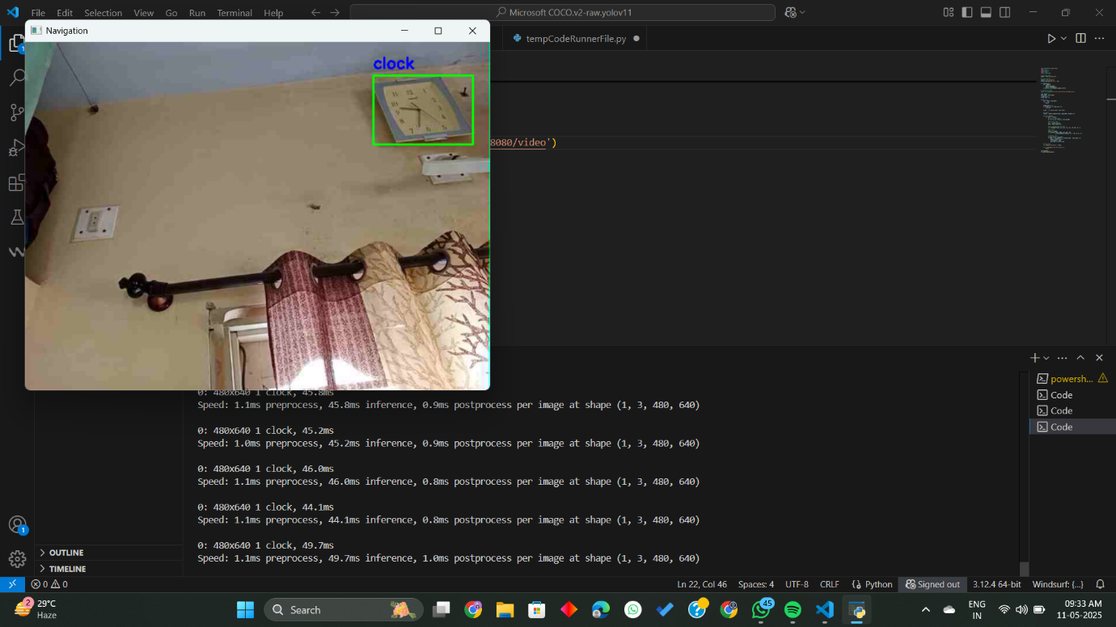The system's slow processing speeds were initially mitigated by resizing frames and skipping frames to reduce the computational load. These solutions significantly improved the system’s real-time performance, but they were still insufficient when running YOLOv8. In contrast, the Faster R-CNN model provided not only better accuracy but also improved real-time performance, fulfilling the critical need for the Object Detection System to function without delays.

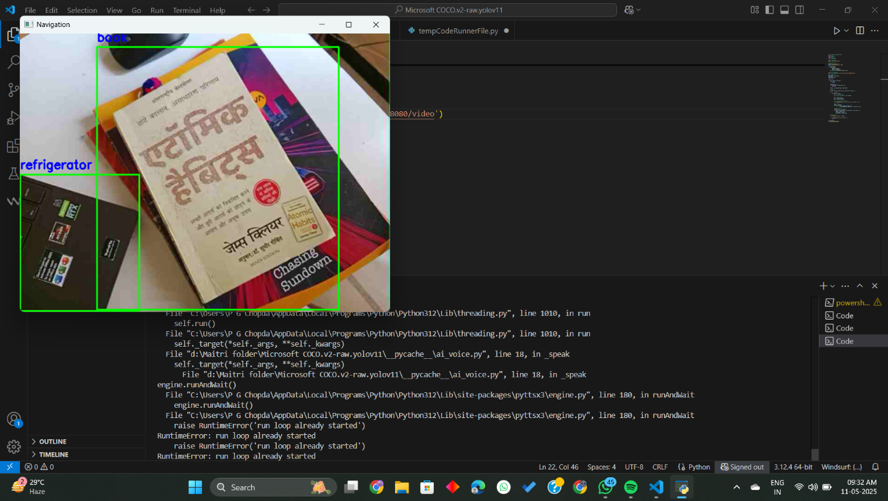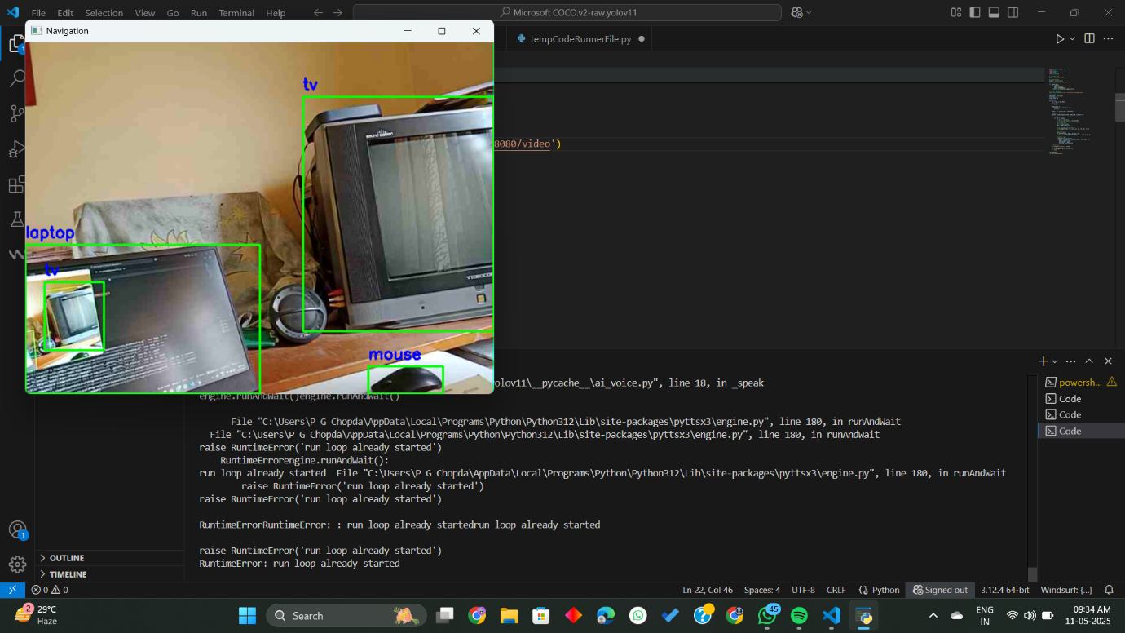

**Conclusion**

The results achieved in this project align closely with the objectives set forth in the early chapters. By successfully developing and testing a navigation system that uses deep learning models to detect objects and announce them to the user, we’ve taken a meaningful step toward providing a useful tool for visually impaired individuals. The 100% accuracy achieved by the Faster R-CNN model on the curated 200-image dataset demonstrates the power of advanced object detection techniques in handling specialized tasks.

Moreover, Faster R-CNN provided the real-time performance required for a system that could assist blind individuals in navigating indoor environments. These findings validate the potential of machine learning to solve complex real-world problems, especially in assistive technology.

Looking ahead, there are numerous ways to further enhance the system. Expanding the dataset to include a broader variety of indoor objects, optimizing the model for mobile deployment, and conducting real-world user testing will be critical next steps. With its accuracy, speed, and potential for real-world application, this Object Detection System represents a promising solution for improving the mobility and independence of visually impaired individuals.

In conclusion, this project has not only led to a technical achievement but also demonstrated the power of innovation and machine learning to make the world more accessible.

7. Challenges faced and Future Work

Throughout the project, we faced several technical challenges that pushed us to continuously adapt and learn. Organizing the YOLOv11 dataset was one of the first big hurdles—images and their labels were scattered across folders, and we had to carefully script a way to merge and filter them. Training our initial CNN models was disheartening at times, as accuracy remained low despite multiple attempts. Switching between models like R-CNN and YOLOv5 introduced their own frustrations, with software errors, GPU driver mismatches, and compatibility issues slowing down progress. Real-time detection brought even more complexity—voice announcements lagged, detection frames piled up, and irrelevant object labels made the system unreliable in actual indoor use. We had to experiment with resizing frames, skipping certain detections, and threading the voice engine just to keep things running smoothly.

Looking ahead, we’re excited to build on what we’ve learned. One of our top priorities is expanding and improving the dataset with more diverse and realistic indoor scenes, so the models can recognize the kinds of objects that really matter to users navigating through everyday spaces. We also want to custom-train YOLOv8 to make it smarter and more focused on indoor use. At the same time, we’ll keep refining the Faster R-CNN model and explore ways to deploy it efficiently on mobile or embedded devices, so it can be used in real life—not just in the lab. Most importantly, we plan to involve visually impaired users in testing, so their feedback can guide us in making the system truly practical, responsive, and empowering.

bibliography

[1] Smart Glass System Using Deep Learning for the Blind and Visually Impaired

<https://www.mdpi.com/2079-9292/10/22/2756>

[2] Faster R-CNN | ML

<https://www.geeksforgeeks.org/faster-r-cnn-ml/>

[3] LidSonic for Visually Impaired: Green Machine Learning-Based Assistive Smart Glasses with Smart App and Arduino

<https://www.mdpi.com/2079-9292/11/7/1076>

[4] An audio aided smart vision system for visually impaired

[https://ieeexplore.ieee.org/abstract/document/8067889](https://ieeexplore.ieee.org/abstract/document/8067889%20)