|  |  |  |  |
| --- | --- | --- | --- |
| **Sr. no.** | **Name** | **Nationality** | **Address** |
| 1 | Prof. Vina Lomte | An Indian National | Flat 1205,Gwing, 38 Park Majestic, Wadachi Wadi rd, Undri Pune -411060 |
| 2 | Tanishka Sinha | An Indian National | 101,Sinhgad girls hostel, ambegao bk, Pune , 411041 |
| 3 | Jiya Shakur Shaikh | An Indian National | 101,Sinhgad girls hostel, ambegao bk, Pune , 411041 |
| 4 | Manjeet Kour | An Indian National | 101,Sinhgad girls hostel, ambegao bk, Pune , 411041 |
| 5 | Prachi Pachang | An Indian National | S.No. 14/1; Flat No.19, Shivganga Apartment, Chinchwadenagar, Chinchwad Pune 411033 |
| 6 | Sayali Pawar | An Indian National | Atul Nagar phase 1, Rathod Building plat no 102, Aditya Gardan City, Near RMD college warje Pune 411058 |

COMPLETE SPECIFICATION

# ABSTRACT

The current number of working mothers has greatly increased. Subsequently, baby care has become a daily challenge for many families. Thus, most parents send their babies to their grandparents' house or to baby care houses. However, the parents cannot continuously monitor their babies' conditions either in normal or abnormal situations. Therefore, an Internet of Things-based Baby Monitoring System (IoT-BBMS) is proposed as an efficient and low-cost IoT-based system for monitoring in real time. We also proposed a new algorithm for our system that plays a key role in providing better baby care while parents are away. In the designed system, Node Micro-Controller Unit (NodeMCU) Controller Board is exploited to gather the data read by the sensors and uploaded via cloud. The proposed system exploits sensors to monitor the baby's vital parameters, such as ambient temperature, moisture, crying, feeding and android app controlled moving wheels. The proposed system claims that a feeding arm for milk and moving wheels can be controlled via android app.  Finally, the baby monitoring system is proven to work effectively in monitoring the baby's situation and surrounding conditions according to the prototype.

# FIELD OF THE INVENTION

Our Invention is related to a Smart Cradle using IOT Based Technique.

# BACKGROUND OF THE INVENTION

As we are very well aware of how parents face issues to look after their infants. Especially, when both the parents are working. It is impossible for a parent to give 100% attention to the infant . Thus, to overcome problems like this we need to develop a system which could help Parents to have a watch on the Baby and can get message alerts about the same.

Thus, we have proposed a system to design called Smart Cradle System which would help a parent to look after the infant by monitoring continuously from any place. It is an efficient and basic prototype to take care of a child. This system has all required features to keep the baby protected.

In order to make the system we need technologies and methodologies like IOT, modules like Arduino, Temperature sensor, Wet sensor, Robotic arm, PIR Sensor, Sound Sensor, Node MCU, PIC controller, Bluetooth, Cloud and Motor driver to control the wheels of cradle.

It gives all the motion that can be given by the mother with the voice and temperature sensor control through mobile. The device can be used in any height within a range and can be moved from one placed to another by wheels attached to the frame.

An instant mobile notification will be generated if any unusual activity is detected in the Android Mobile Application which has been developed. It has UI controls which consist of the function of controlling the feeding mechanism of the cradle and controls the speed of the wheels and direction of the wheels. This System will absolutely cope with the child and supply fundamental support. Clinical blunders could be forestalled by building a more secure medical care framework.

Furthermore, some parents place their baby in a separate room. Therefore, parents could not hear the baby crying and could not be there to ease their baby back to sleep in the middle of the night. Other parents may be occupied with house chores. Thus, because they cannot hear their baby crying, they cannot attend to them immediately. Sometimes, the baby only needs a little distraction to return to deep sleep. Several types of baby cradles are available in stores, but they are expensive, and not everyone can afford them.

In addition, the existing automatic cradles in the literature have many limitations in terms of functionality, cost, and communication technology support. To the best of our knowledge, no previous studies have developed a smart cradle with IoT support from scratch, similar to that in the present study.

Most available automated cradles are designed to rock non-stop. However, the rocking movement can make the baby nauseous and uncomfortable. Thus, allowing the automated cradle to rock the baby to sleep in the middle of the night is also a problem.

Our system provides the health monitoring , infant feeding using a Robotic Arm , UI based android app which helps to manage the speed of cardle and feeding the infant other health related monitoring results can be seen on UI Interface such as temperature, wetness and crying of infant.

# PRIOR ART SEARCH

In earlier inventions automatic swinging of cradle, humidity detection, crying analysis, temperature detection, automatic swinging toy(s), video monitoring system, health monitoring system (blood pressure, oxymeter, pulsemeter, heart beats), mini fan, musical toy, alert messages sent to parents when the child needs immediate care from parents has been proposed in previous papers.

In our paper we are adding an assistive robotic arm which is used for feeding milk to the child when the baby is hungry and we have added smart wheels which can travel from one place to another automatically with the help of an application. we are using Arduino uno for implementing our project which saves data directly to the cloud with the help of Bluetooth connection.

# OBJECTIVES OF THE INVENTION

1. An Internet of Things-Based Baby Monitoring System (IOT-BBMS) is proposed as an efficient and low-cost IOTbased system for monitoring in real time. We also proposed a new algorithm for our system that plays a key role in providing better baby care while parents areaway. However, the parents cannot continuously monitor their babies' conditions either in normal or abnormal situations.
2. The other objective of the invention is to provide a are moving gigantically towards tech freak society, the apprehension about losing our classification turns into a preeminent issue. It very well may be as our actual personality or monetary confirmation character.
3. The other objective of the invention is to provides association ought to have an moisture sensor, It is used to detect wet condition in the crib. When the baby wets the crib due to urine, it will send the feedback to Arduino and Arduino will do the further processing.
4. The other objective of the invention is to provide a Robotic Arm which can be helpful to feed the milk to the infant which is made up of various servo motors which is easily handled by android application.
5. The other objective of the invention is to provide a remote control wheel is defined as any mobile device that is controlled by a means that does not restrict its motion With an origin external to the device. This is often a radio control device, cable between control and wheel or an infrared or Bluetooth controller. It provides motion to the wheels of cradle which can be controlled using an android application the direction is controlled with the help of application.
6. The other objective of the invention is to provide a system a sound sensor that helps to sense the baby cry and it gets activated and notifies it to the PIC Controller about the baby cry and furthermore it sends the notification on infant parent’s phone about crying.

SUMMARY OF THE INVENTION

In this modern era, parents are busy building their lifestyle, carrier etc. As we know it has now become hard because parents have to take care of their children simultaneously, which paves a lot of work pressure and family pressure especially for women. Health of the child is affected and better care has also reduced. So, in order to handle such situation, we use temperature, Humidity, sound Sensor. The conditions of the external atmosphere help to detect increased body temperature, babies voice while crying and their movements while they are continuously moving and also indicates the time for the diaper to be changed. If there are any abnormal activities are observed in baby’s atmosphere. An alert message is sent to the parents.

In common, to soothe and make the baby sleep cradle is being used. But even guardian must have a close monitoring until the baby falls asleep. The conventional cradle which is not equipped with battery or adapter that automates the cradle automatically . Rural and non-developed area use conventional cradle because of their economic cost.

Manpower is required continuously to take care of their child which serves as its major disadvantage and such conventional cradle may also cause discomfort to the baby. So,we are in need for an automated cradle which can take care of the child with a battery or electrical power source. Besides, this automated cradle carries extra features or function which is beneficial for parents. Ample time is not given to take care of our children in this industrious world because in professional life people are not getting enough time for taking care of their children.

Overall cost of the invention:

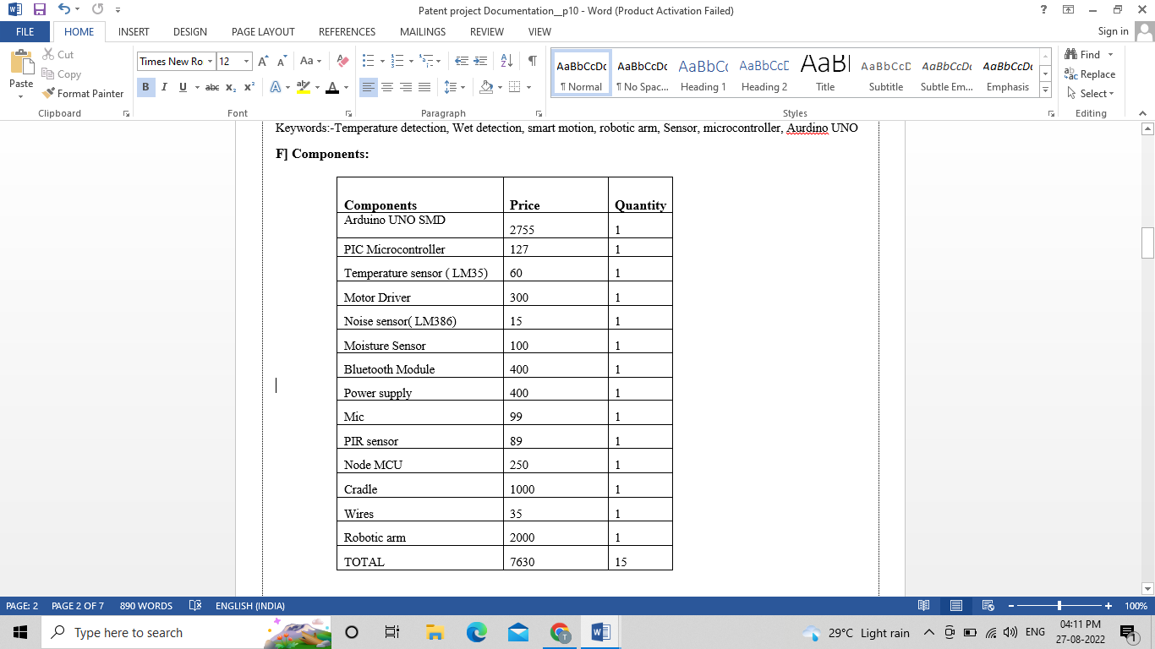

# BRIEF DESCRIPTION OF THE INVENTION

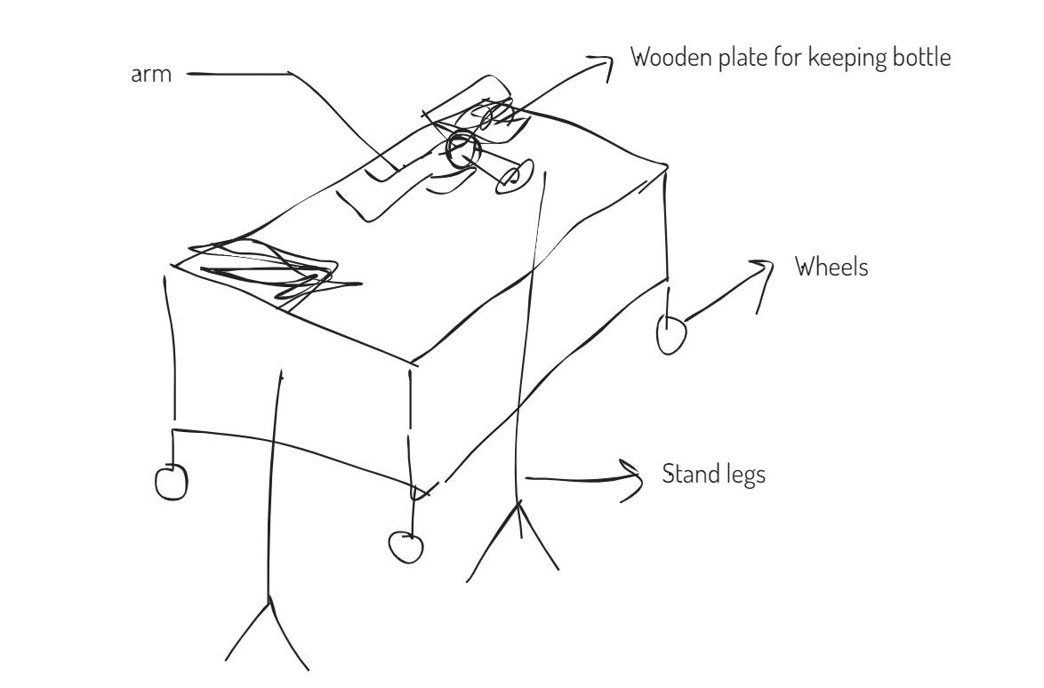

Fig 1: System model of smart cradle

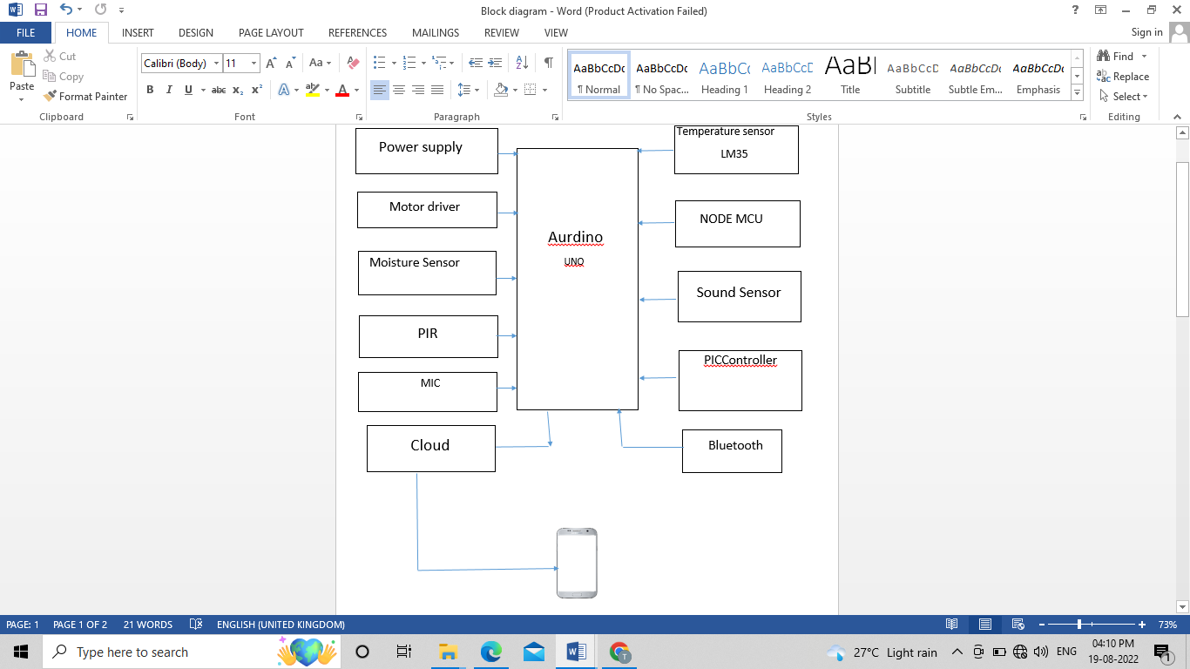

Fig 1.1: Block diagram of smart cradle

This automated cradle carries extra features or function which is beneficial for parents. We have used the various sensors such as temperature sensor , wetness sensor, sound sensor , pic controller, Arduino and Robotic arm.

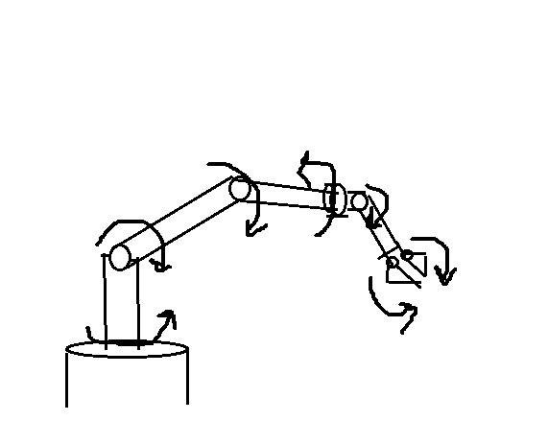

Fig 2 : Robotic arm used in system

Robot Arm design classified into two parts, the mechanical design parts and installation. The Robot Arm will have 5 outputs which consist of grip, wrist, base, elbow and shoulder. The robot has a round and rectangular foundation capable of microcontroller was preferably used because it is low cost. We also created a mobile application that will be connected to the Arduino UNO (master) controller via HC-05 Bluetooth (slave)module. Controlling or guiding the arm are going to be done by using the smartphone application application.

# DESCRIPTION OF THE INVENTION

FIG.1: In the fig1 we have described the full architecture of the system . We have used a robotic arm to feed the infant , different kind of sensors and a moving wheel controlled with the application.

Components used in the system are as follows:

**Arduino Uno :** It is a microcontroller board based on ATmega328P (datasheet). It has 14 digital input/output pins, 6 analog input, a 16 MHz quartz crystal, a USB connection, a power jack an ISCP header and a reset button.

arduino has been used for the quickly developed interactive objects, taking input from variety of switches or sensors and controlling a variety of outputs such as automate the motor and detect the temperature sounds and light

**PIC Controller:** The PIC Controller receives the baby cry signal from the sound sensor and it has two main functions as following.

1. To activate the GSM Module.
2. To upload the information about the baby cries to the Node MCU.

**Node MCU:** The baby cry signals uploaded from the PIC Controller is to be uploaded on to the cloud to access the information about the baby if the parents are not able to see information at the real time.

**Cloud Server:** A cloud server will be given to the parents so that they can access the virtual network to see the live video which will be stored in the cloud server.

**Sound Sensor:** The sound sensor helps to sense the baby cry and it gets activated and notifies it to the PIC Controller about the baby cry.

**GSM:** The GSM will send the baby cry information to the parents through SMS. As soon as it receives the baby cry signal it will send the SMS to the parents number which is being registered while coding.

**Moisture Sensor:** It is used to detect wet condition in the crib. When the baby wets the crib due to urine, it will send the feedback to Arduino and Arduino will do the further processing.

**PIR Sensor :**The PIR sensor has been used to detect the baby movement and procured from the local store.

**Motor:** A regular DC motor will be used.

**Power Supply:** About +5V of power is used.

FIG 2: The arm has 5 degrees of freedom. For the first 3 axis, the waist, the shoulder and the elbow, I used the MG996R servos, and for the other 2 axis, the wrist roll and wrist pitch, as well as the gripper I used the smaller SG90 micro servos.

For powering the servos we need 5V, but this must come from an external power source because the Arduino is not able to handle the amount of current that all of them can draw. The power source must be able to handle at least 2A of current. So once we have connected everything together we can move on to programing the Arduino and make the Android app.

The robot arm changes its position in 4-axis with 6 servo motors at a specified position to match the mobile application specifications. The robot is projected to have a static base and adjustable arm body with the help of servo motors fixed to adjust the arm position. Each servo motor is set apart as mechanical connections of arm which then compatible with it, on the smartphone app namely for the; waist, shoulder, elbow, wrist toll, wrist pitch and grip

FIG 3: A remote control cradle(Also known as RCV) is always controlled by a human and takes no positive action autonomously. It is vital that a wheel should be capable of proceeding accurately to a target area; manoeuvring within that area to fulfill its mission and returning equally accurately and safely to base. In this project we are using Bluetooth wireless technology to control our cradle which is a very simple communication.

Figure 3 represents the 3D design of the model which is done by SOLIDWORKS. It shows that the model of vehicle consists of a frame, four servo motor horns, four dc gear motors, four wheels and four servo motors. DC gear motors are attached with servo motor horns and directly connected to the wheels. Servo motors are attached at the four corners of the vehicle which are associated with four servo motor horns. With the help of servo motor horns, wheels of the vehicle can be turned as per requirement (i.e., 45 0 , 60 0 or 900) and hence, 360 0 rotation, parallel parking or 4WS can be achieved.

Figure 3 demonstrates about the control circuit diagram of the vehicle. This diagram provides a mapping for the controlling equipment about their functioning sequences. It shows the electrical circuit connection between the controlling components. DC gear motors are connected with the motor driver and the motor driver is connected with the Arduino. Four wheels of vehicle are attached with four dc gear motors and the wheels get powered by battery with the help of dc gear motors.

For the angular rotation of wheels, four servo motors are used. These servo motors are directly connected with the Arduino to transmit signal to the servo motor horns as well as the wheels. Following is a block diagram which represents the control unit of this vehicle and also shows the connections between the components of the control unit and their relations. In case of real-life application of the vehicle, this control unit will be replaced by an Electronic Control Unit or ECU. In a word, control unit is the main functional module of the vehicle and this unit ensures the effective controlling operation of the vehicle.

The easiest way to save data to the cloud from an Arduino is to transmit that data directly to a cloud API using Ethernet or WiFi. An Arduino can also communicate that data to another device using serial or Bluetooth connections, and that device then saves the data to the cloud.

WE CLAIMS:

1. Our invention “Smart Cradle” is a modern IOT based device which helps to monitor health of infant, feed the infant and mobile application based moving wheels. We also proposed a new algorithm for our system that plays a key role in providing better baby care while parent’s areaway. However, the parents cannot continuously monitor their babies' conditions either in normal or abnormal situations.
2. Our system provide a remote control wheel is defined as any mobile device that is controlled by a means that does not restrict its motion with an origin external to the device. This is often a radio control device, cable between control and wheel or an infrared or Bluetooth controller. It provides motion to the wheels of cradle which can be controlled using an android application the direction is controlled with the help of application
3. We could identify wetness of the infant crib using android application using wetness sensor and Arduino. Moisture sensor is used for detecting the wetness of the crib , when crib is wet, the notification is send to the parents mobile. The cradle is designed in such a way that to make baby more comfort.
4. We propose a system which can be controlled by android application and which has a feeding arm which is made up of which is made up of various servo motors which is easily handled by android application.
5. Temperature can be scaled using android application when the temperature extends the normal temperature notification would be sent to parent’s. Temperature sensor is used in this system to provide the data about baby's body temperature.
6. Crying of baby can be recognized using android application which will help the mother to reach out to infant whenever she is not at home. The smart cradle integrates a noise sensor which is used for detecting the kid's crying activity and in respond to that it will automatically start swinging the cradle to pacify the child.
7. The data is stored on android application using cloud and parent’s could easily monitor the infant health from anywhere. All the data which is been taken from the sensors/modules will be stored in Cloud (Google Firebase) & analyzed at regular intervals.

Applications:

1. The Arduino is the heart of the system and it is used to monitor all the activities the cradle can be used in maternity hospital to take care of number of babies as it is difficult for limited number of hospital staff to take care of all the babies, in such scenario the smart baby cradle can be used to help the hospital staff for taking care of babies.
2. It can be useful for parents when both mother can father are working. It can also be used in metropolitan household as house spaces are small and parents are within the reach of the cradle. The cradle also helps in reducing risk related to babies.
3. Any activity of baby will send SMS alerts to the parents. Activity of baby includes action like crying, urine and other movements and also when the baby is awake from the sleep.
4. Mother of infant could move wherever she wants easily and it will reduce the work of mother.
5. Proper feeding shall be done with the help of robotic arm which can move in 360 degree of freedom. Parents do not have to worry about the infant’s hungriness.