VELOOP REWARDS
Deliverable 10 — Logical Data Model
Data Analyst Internship — Task 01 · Jiya Tejwani · 2026-10-21
DATA AUTHENTICITY NOTICE — This model is designed over SIMULATED / FICTIONAL data. Entity names and keys describe a proposed analytics schema, not a confirmed VELOOP production database. Proposed entities do not exist yet.

1. Overview
The VELOOP analytics model has ten entities. Six already exist in the supplied simulated data (users, sessions, feature_events, task_activity, daily_activity, milestones); four are proposed to close the monetisation gap (rewards_ledger, wallet_transactions, withdrawals, referrals). The design is user-centric: a single users table is the hub, and almost every other entity is a one-to-many child of it. The proposed monetisation entities form a traceable chain from an earning action through to a payout.

2. Entities & Primary Keys (H1)
Entity | Grain (1 row =) | Primary Key | Status
users | 1 user | user_id | Existing
sessions | 1 session | session_id | Existing
feature_events | 1 event | event_id | Existing
task_activity | 1 task attempt | activity_id | Existing
daily_activity | 1 user-day | (user_id, activity_date) — composite | Existing
milestones | 1 milestone | (user_id, milestone_type) — composite | Existing
rewards_ledger | 1 reward entry | reward_id | Proposed
wallet_transactions | 1 transaction | txn_id | Proposed
withdrawals | 1 withdrawal | withdrawal_id | Proposed
referrals | 1 referral | referral_id | Proposed

3. Foreign Keys & Cardinality (H2)
Foreign key (child → parent) | Cardinality | Status
sessions.user_id → users.user_id | 1 : many | Existing
feature_events.user_id → users.user_id | 1 : many | Existing
feature_events.session_id → sessions.session_id | 1 : many | Existing
task_activity.user_id → users.user_id | 1 : many | Existing
task_activity.session_id → sessions.session_id | 1 : many | Existing
daily_activity.user_id → users.user_id | 1 : many | Existing
milestones.user_id → users.user_id | 1 : many | Existing
milestones.session_id → sessions.session_id (nullable) | 1 : many (optional) | Existing
rewards_ledger.user_id → users.user_id | 1 : many | Proposed
rewards_ledger.activity_ref → task_activity.activity_id | 1 : many | Proposed
wallet_transactions.user_id → users.user_id | 1 : many | Proposed
wallet_transactions.reference_id → rewards_ledger / withdrawals | 1 : many | Proposed
withdrawals.user_id → users.user_id | 1 : many | Proposed
referrals.referrer_user_id → users.user_id | 1 : many | Proposed
referrals.referred_user_id → users.user_id | 1 : 0..1 | Proposed

4. Relationship Types (H3)

One-to-many (the dominant pattern)
One user has many sessions, events, task attempts, daily rows, milestones, rewards, wallet transactions, withdrawals and referrals. One session has many events and task attempts. This is the backbone of the model.

One-to-one / one-to-zero-or-one
referrals.referred_user_id → users is 1:0..1 — a given user is the referred party in at most one referral. There are no strict 1:1 relationships in the current design.

Many-to-many (resolved)
The “a user refers other users” relationship is conceptually many-to-many on the users table itself. It is resolved by the referrals associative entity, which carries both referrer_user_id and referred_user_id as foreign keys back to users — the standard way to model a self-referencing M:N relationship.

Event relationships
feature_events is the finest grain. Each event references both a user and a session, and rolls up into sessions (per-session counts) and daily_activity (per-user-day counts). milestones are first-time events derived from the same stream.

Transaction relationships
The proposed monetisation entities form a lineage: task_activity → rewards_ledger → wallet_transactions → withdrawals. A completed task triggers a reward-ledger entry, which credits a wallet transaction, whose balance can fund a withdrawal. The reference_id / activity_ref / reversal_ref keys make every value movement traceable back to its cause — essential for reconciliation and reversal handling.

5. Entity-Relationship Diagram (H4)
Teal entities exist in the supplied data; amber entities are proposed. Crow’s-foot notation marks the “many” end of each relationship.
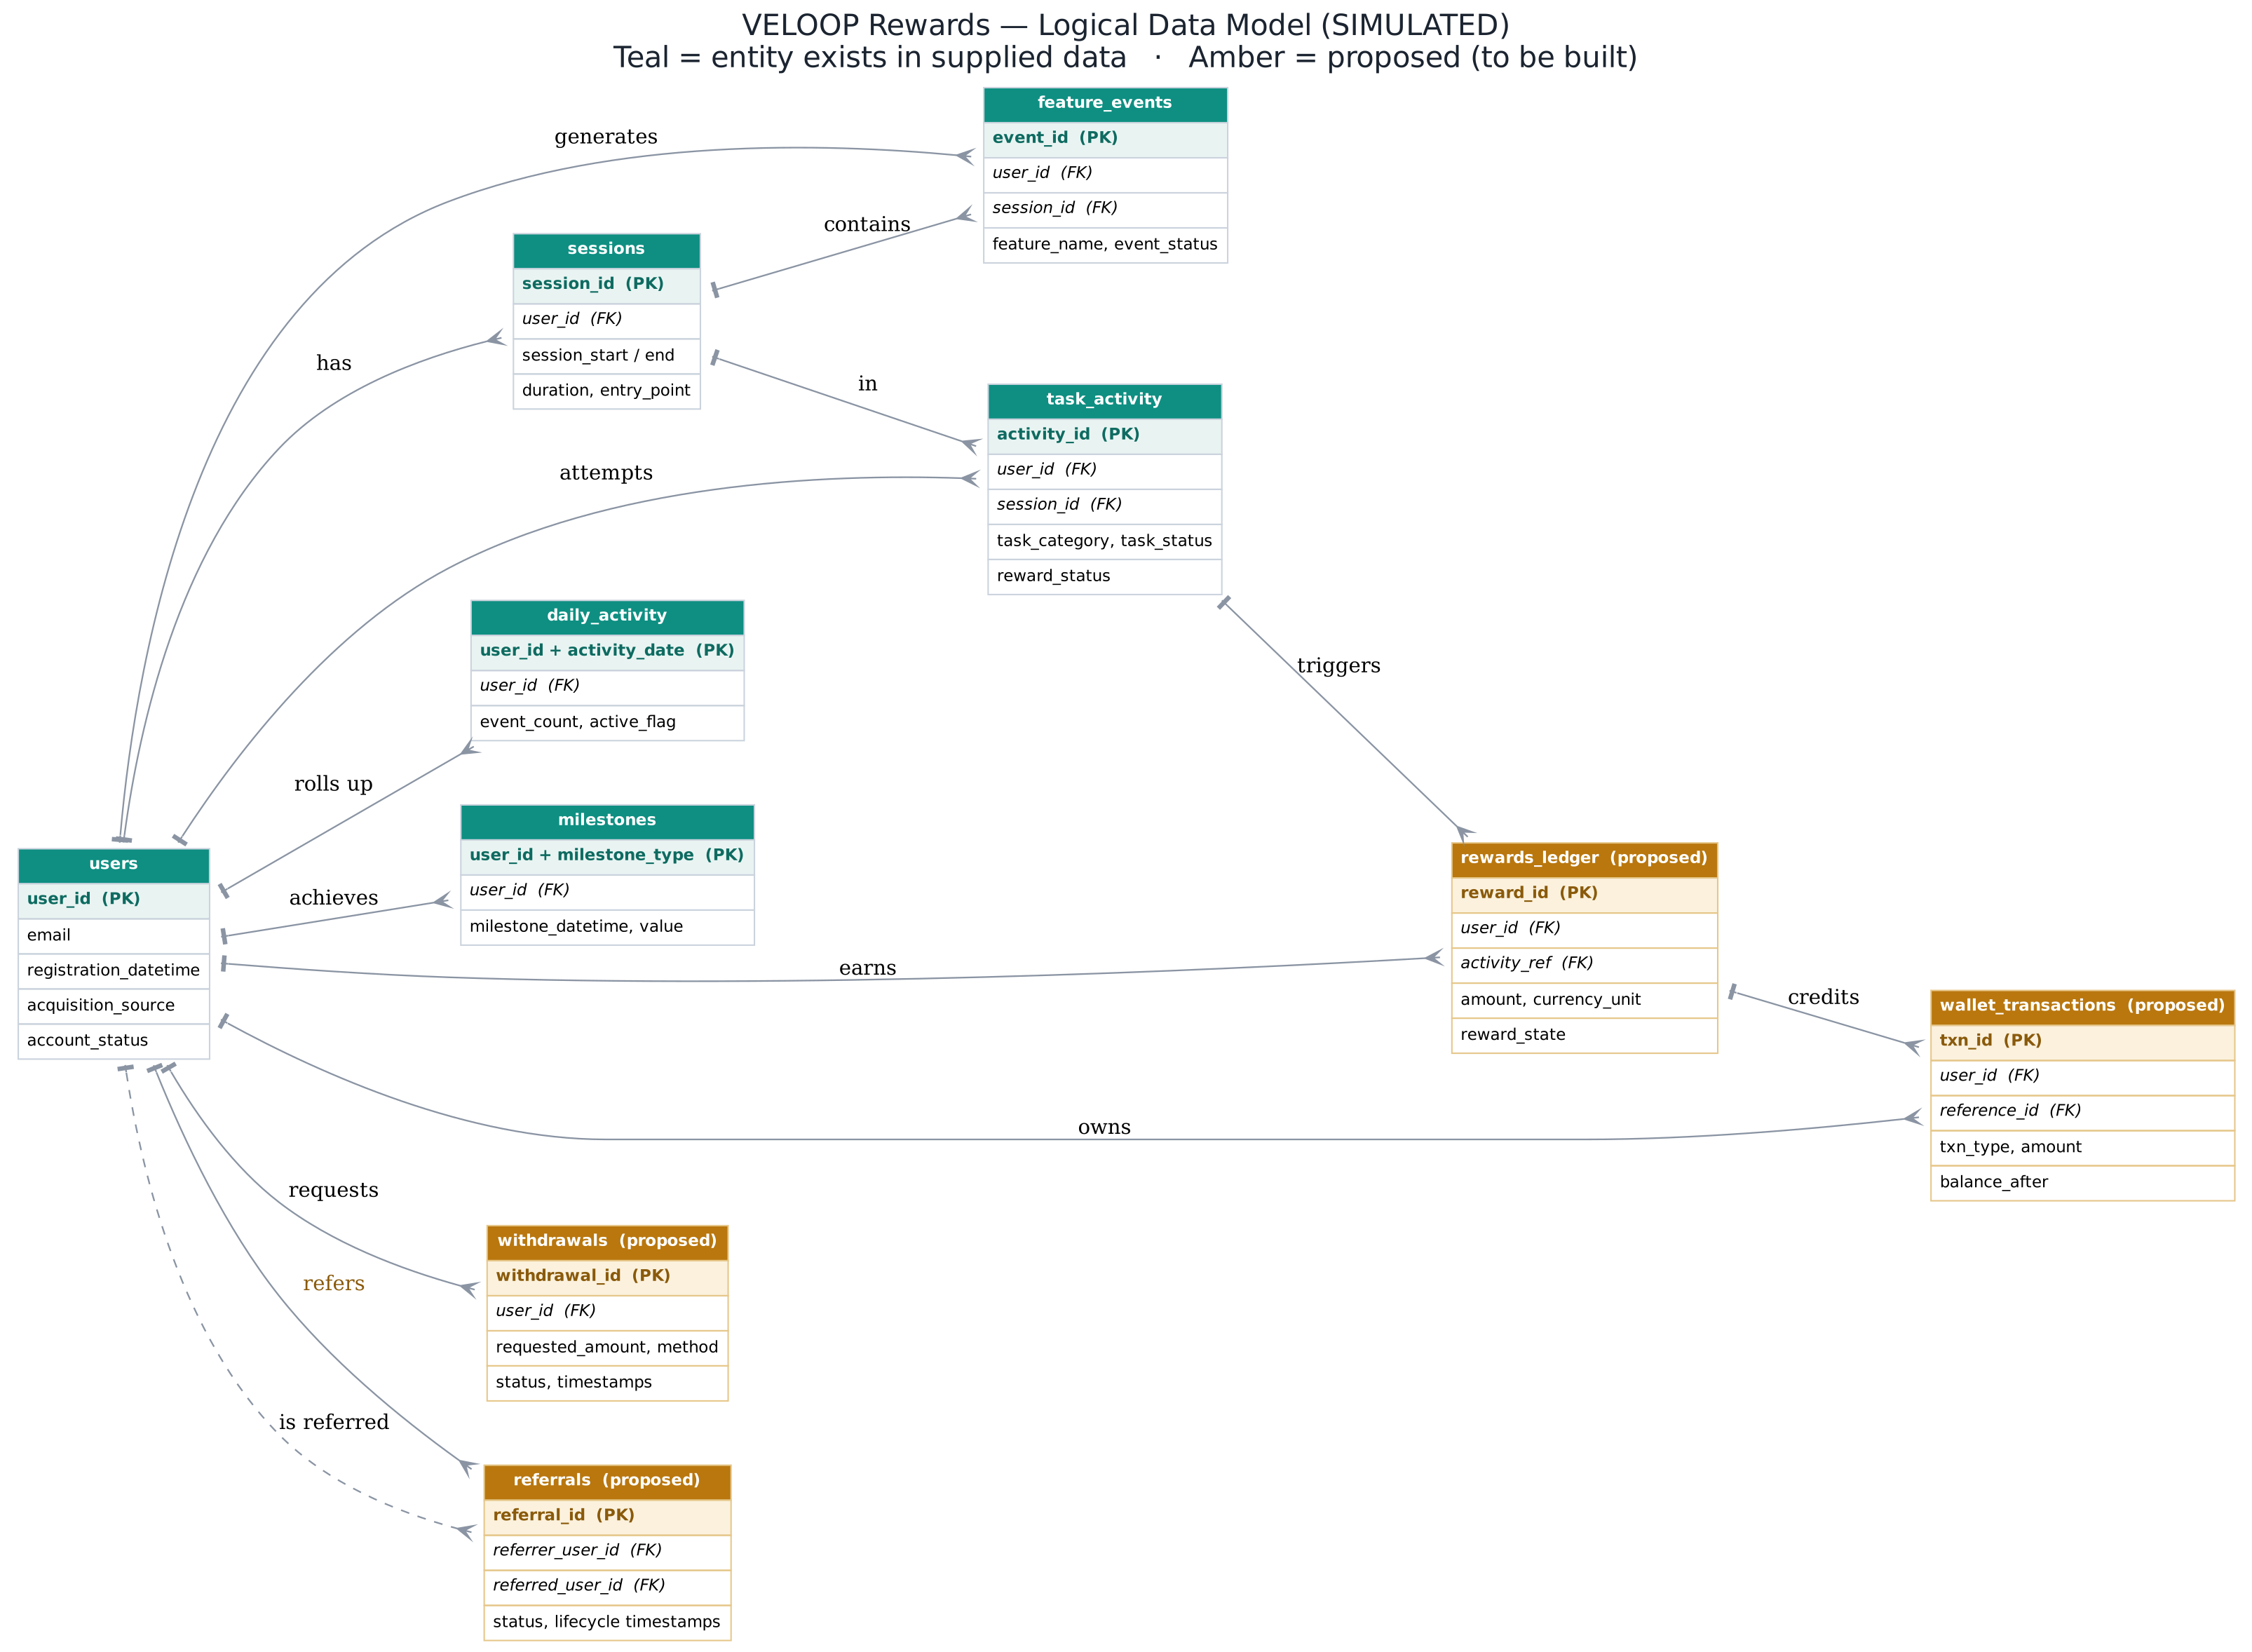

6. Integrity Note
Within the File-2 behavioural dataset, every foreign key above validates with zero orphan records (verified in Deliverable #12). However, the two supplied files are different simulated populations, so these relationships hold within File 2 only — the File-1 users table cannot be joined to File-2 behaviour on user_id. A single, stable, app-wide user_id is the prerequisite (recorded as a To-Be-Verified item in the Source & Verification Register, #19).

