VELOOP REWARDS
Deliverable 16 — Data Pipeline & Operating Model
Data Analyst Internship — Task 01 (Work Package O) · Jiya Tejwani · 2026-10-23
DATA AUTHENTICITY NOTICE — Based on SIMULATED / FICTIONAL data. No figure here represents actual VELOOP users, earnings, withdrawals, revenue, retention or performance. Proposed structures do not exist yet; unverified facts are marked To-Be-Verified.

1. Objective & Principle
Design a practical analytics flow for a developing product. The guiding principle is right-sizing: do not recommend expensive infrastructure because it sounds professional. The architecture below is lean enough for VELOOP's current stage and scales only where justified by real volume.

2. Architecture
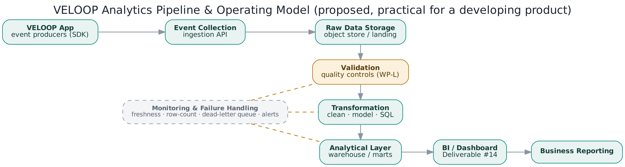

3. Stage-by-Stage Documentation
Stage | What it does | Practical approach (right-sized) | Owner
Source systems / event producers | The app and backend services emit events via a lightweight SDK | Thin client + server SDK; no heavyweight agent | Engineering
Collection | An ingestion endpoint receives events | A single managed ingestion API; batch where possible | Engineering
Raw data storage | Immutable landing zone for raw events | Cheap object storage (append-only), partitioned by date | Data Eng
Validation | Quality controls applied before modelling | The WP-L control framework at ingestion (schema, dedup, enums) | Data / Eng
Transformation | Clean, deduplicate, model into entities | SQL / dbt-style models; no bespoke engine | Data
Analytical layer | Modelled tables & marts for querying | One analytical warehouse (start small, scale on volume) | Data Eng
Dashboard / BI | Serves the dashboards (#14) | A single BI tool reading the analytical layer | Analytics
Business reporting | Scheduled reports for stakeholders | Generated from the same marts; no duplicate logic | Analytics

Refresh
Daily batch is sufficient for the current stage; move specific high-value events (e.g. withdrawals) to near-real-time only when payout monitoring justifies it. Dashboards state their own refresh cadence (see #14).

Monitoring & failure handling
- Freshness and row-count monitors per dataset, compared to a rolling baseline.
- A dead-letter queue for events that fail validation, so nothing is silently dropped.
- Alerts to the owning team on failures; dashboard refresh holds if an upstream check fails, rather than publishing bad data.

Ownership (operating model)
Engineering owns event production and collection; Data Engineering owns storage, validation and the analytical layer; Analytics owns the dashboards and reporting. Each stage has a single accountable owner (table above) so failures have a clear escalation path.

