Module 5) HTML5

1)What are the new tags added in HTML5?

The tags are using in HTML5 are:-

<figure>

<article>

<details>

<main>

<section>

<nav>

<footer>

<header>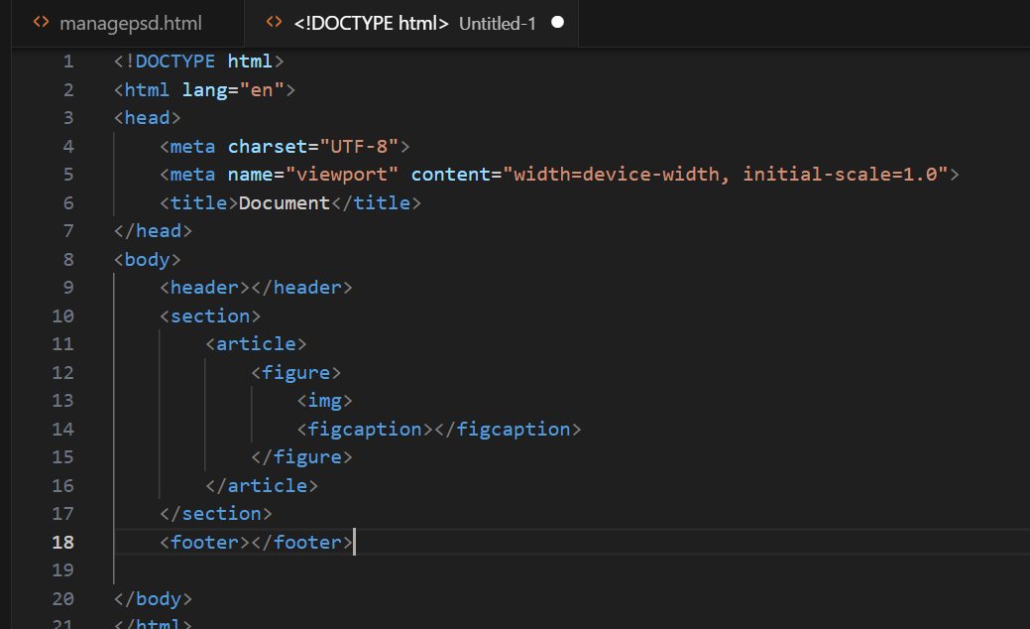

2) How to embed audio and video in a webpage?

First create a audio or video tag. Then copy the embed link

Of video or audio and paste on src”= . 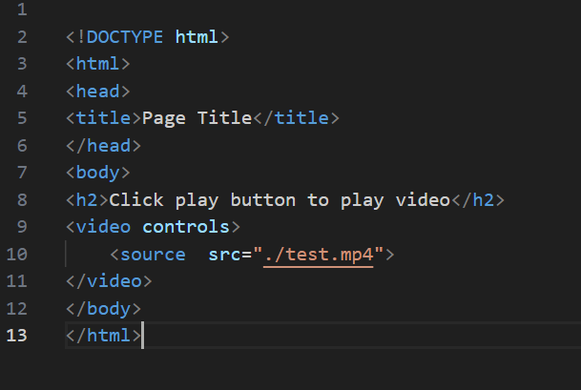

3) Semantic element in HTML5?

Semantic elements in HTML5:-

<Header>

<div class=Header>

<article>

<div class=article>

<footer>

<div class=footer>

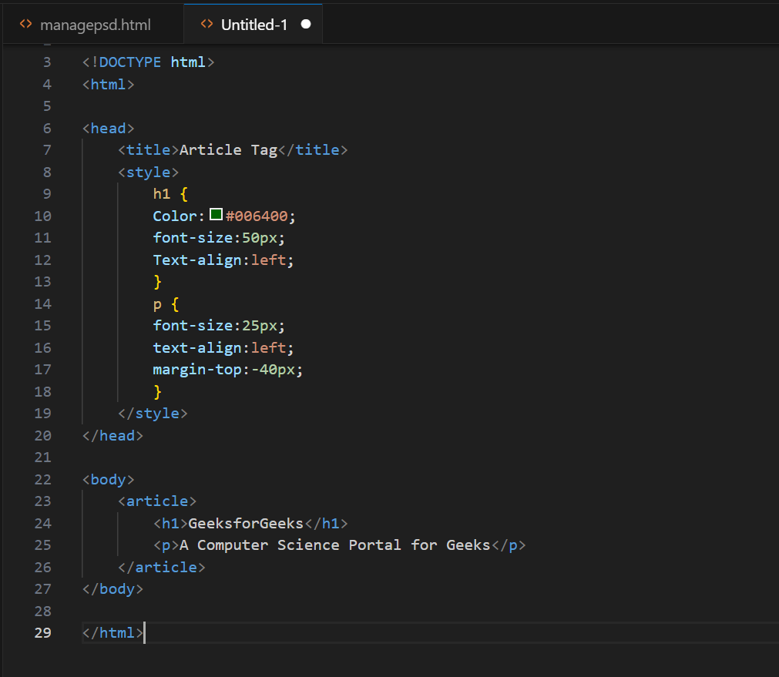

4) Canvas and SVG tags

Canvas and SVG tags are mostly use on clear the picture quality.

<Canvas>:-

Canvas tag is transparent the contain for graphics.

Canvas element must have and id attributes so it can be

Referred to bt Javascript.

Canvas id=”my canvas”

Width =

Height =

Style=

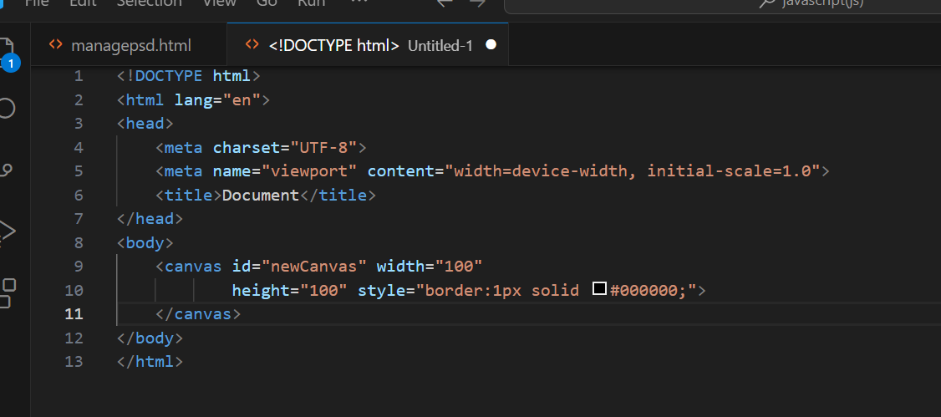

<Svg>:-

Svg tag stands for scalable vector graphics.

