# Breast Cancer Recurrence

Submission Date: 12th April, 2022

Course: COMP377 (Section 001)

Instructor: Arindam Das

Group 2

Team Members:

| Name | ID |
| --- | --- |
| Marianne Palmer | 301122149 |
| Ting Li | 301025864 |
| Hong Viet Nguyen | 301086374 |
| Jiye Yu | 301116244 |
| Yash Sanjaykumar Kachhiyapatel | 301171192 |

**Front-end Libraries:**

* **React** - <https://reactjs.org/>
* **Bootstrap** - <https://getbootstrap.com/>
* **Axios** - <https://www.npmjs.com/package/axios>

**Backend Libraries**

* **Flask** - <https://flask.palletsprojects.com/>
* **Scikit-learn -** <https://scikit-learn.org/stable/>

**DataSet**: <https://datahub.io/machine-learning/breast-cancer#python>

**Description of the selected dataset**:

We are going to use the Breast Cancer dataset to predict the recurrence and non-recurrence condition of the treated patients.

This dataset contains breast cancer data obtained from the University Medical Centre, Institute of Oncology, Ljubljana, Yugoslavia. There are 286 cases and described in 9 attributes, we are going to analyze these data and build the machine learning model for the prediction.

The accuracy has been approved by the other researchers which is over 66%, including

· Accuracy range: 66%-72% – Clark,P. & Niblett,T. (1987).

· Test results were given: 65%-72% accuracy range – Tan, M., & Eshelman, L. (1988).

· Accuracy range was 68%-73.5% – Cestnik,G., Konenenko,I, & Bratko,I. (1987).

· Assistant-86: A Knowledge-Elicitation Tool for Sophisticated Users. In I.Bratko & N.Lavrac (Eds.) Progress in Machine Learning, 31-45, Sigma Press. – Assistant-86: 78% accuracy

**Features**:

1. Class (target class to determine recurrence/not recurrence)

2. age

3. menopause

4. tumor-size

5. inv-nodes

6. node-caps

7. deg-malig

8. breast

9. breast-quad

**User Guide:**

1. Run the flask API file for the backend, which lets user to create lightweight RESTful APIs
2. Using Spyder

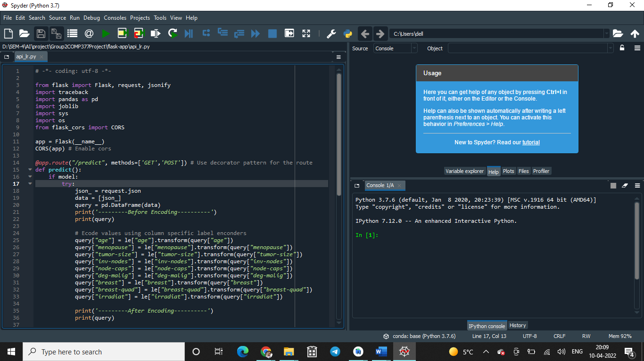

1. Using VS Code
2. Shift + Control + P (Shift + Command + P for Mac) > select Python select Interpreter > select your virtual environment

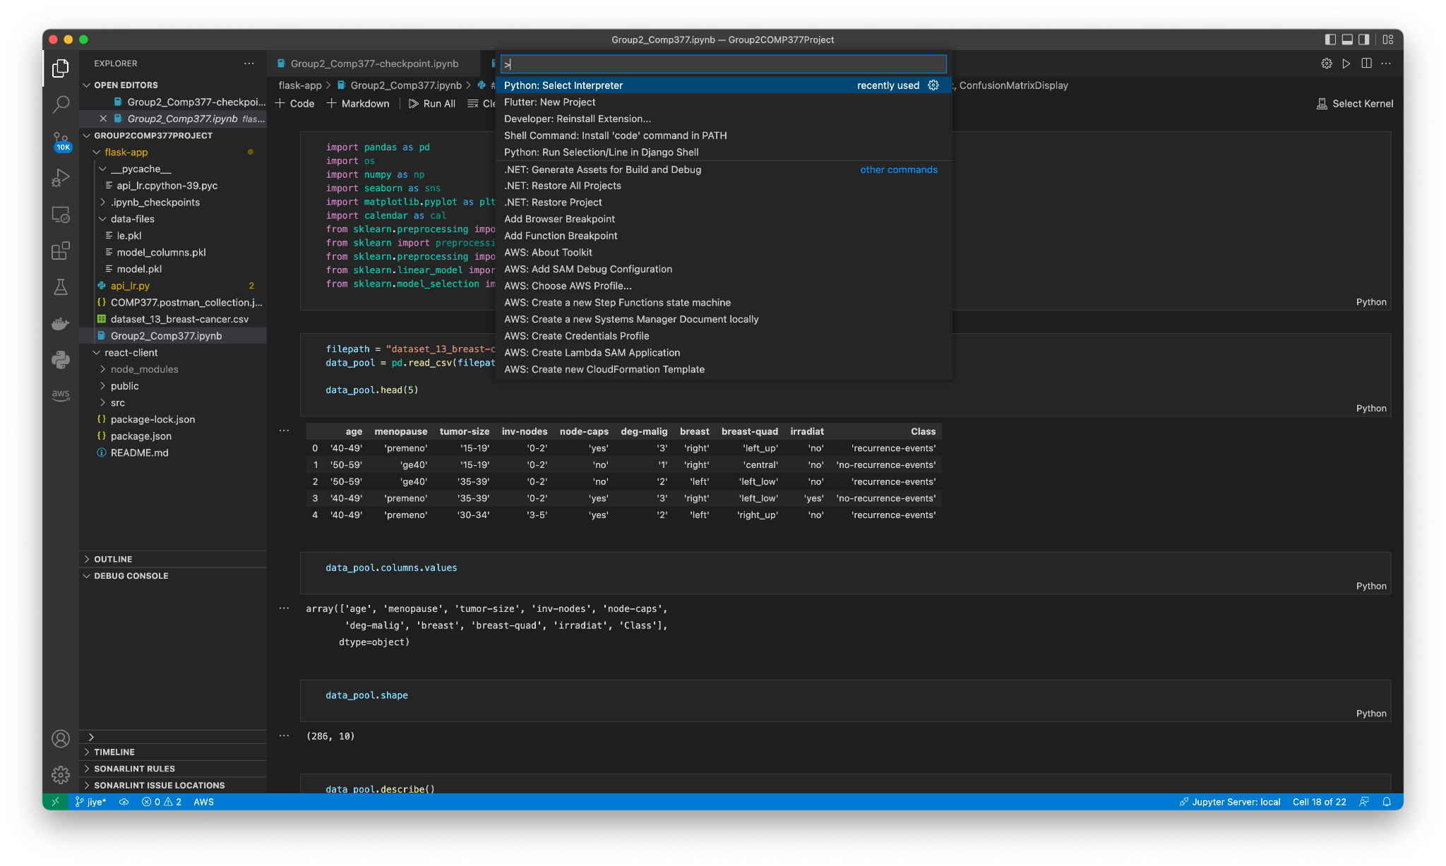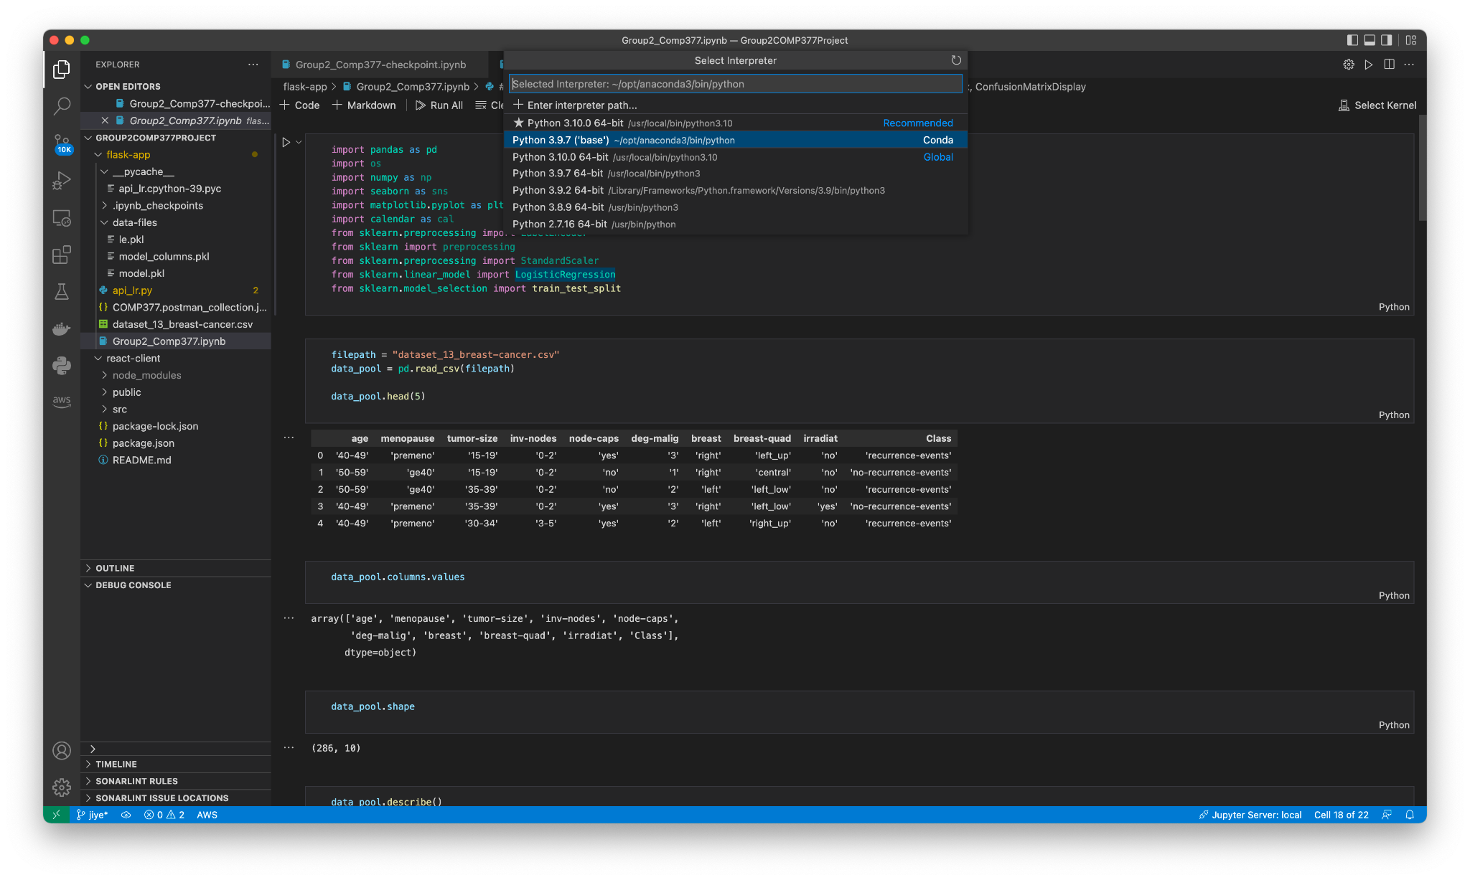

1. Install **pip install flask** if you do not have it

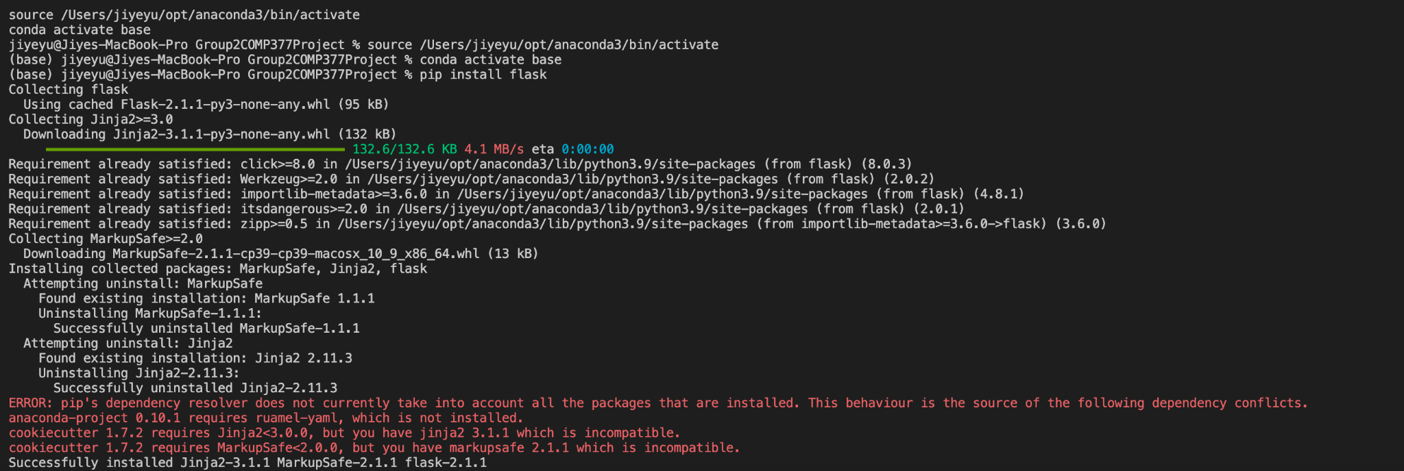

1. Go to flask-app using command **cd flask-app**
2. Run the backend using command **python api_lr.py**

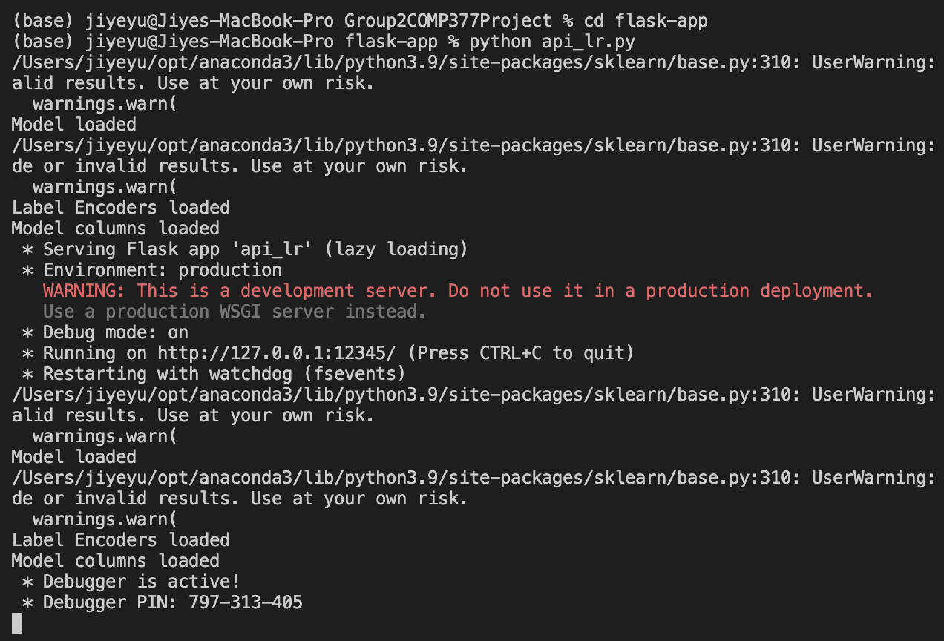

1. For the user interface, run frontend, which is a react application.
2. For that, just run “**npm install**”, to install dependencies. And then “**npm start**” to run the project. Then see the result at “localhost:3000” port.

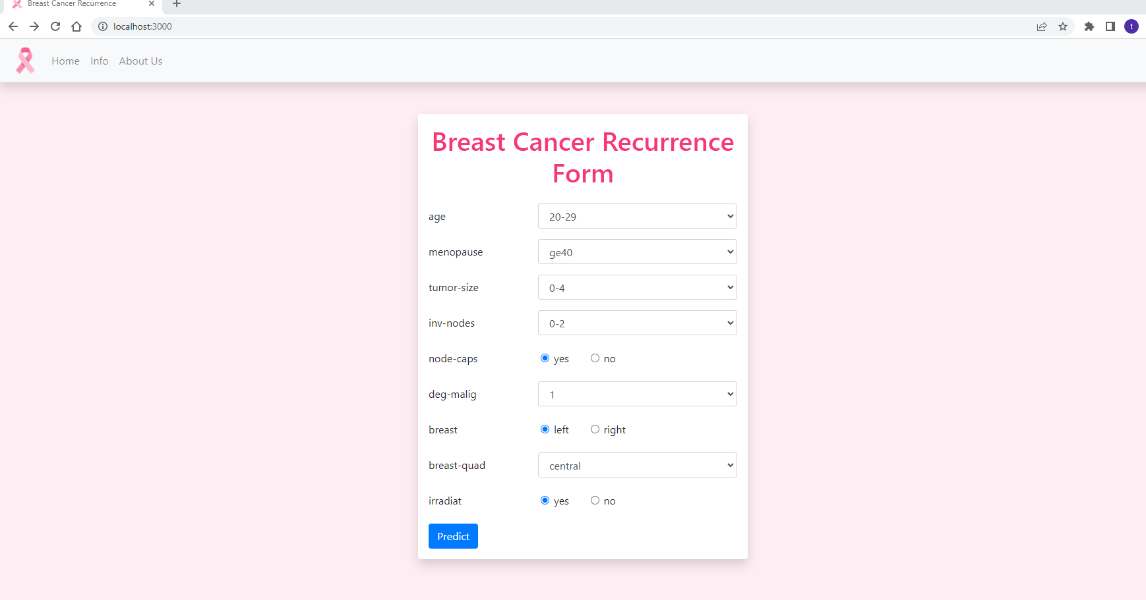

1. User can fill the form to see the predicted result of Breast Cancer.

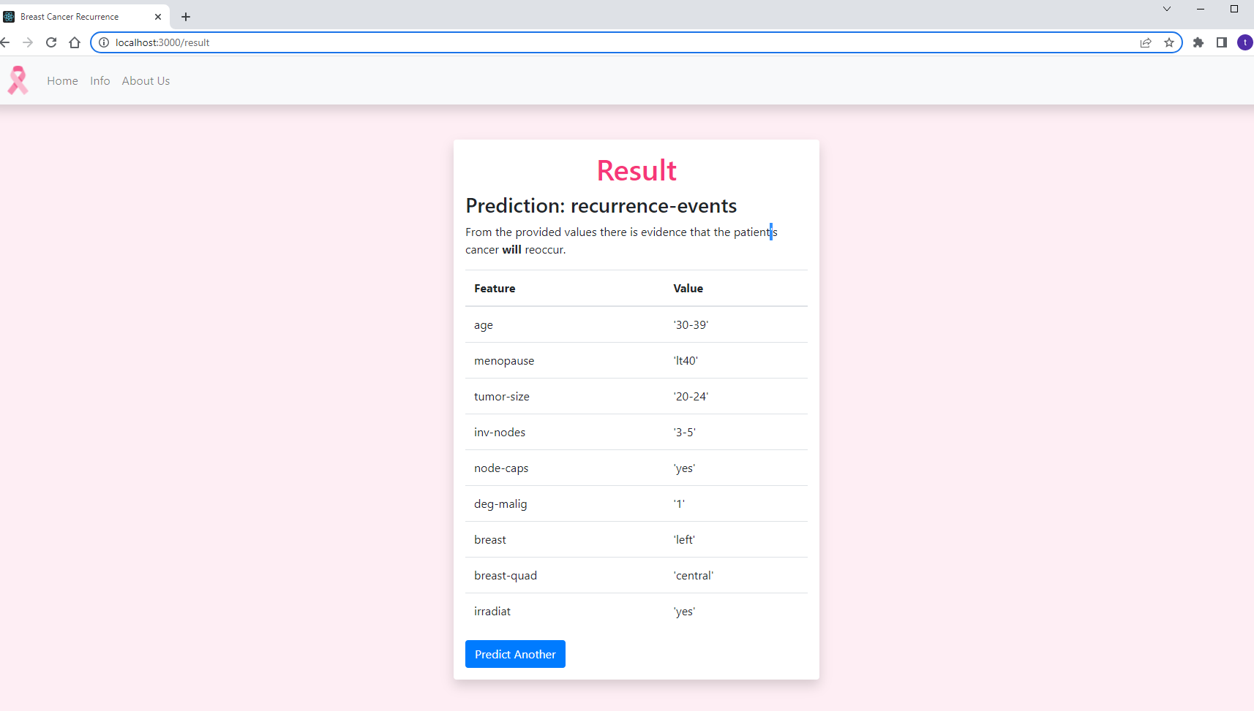

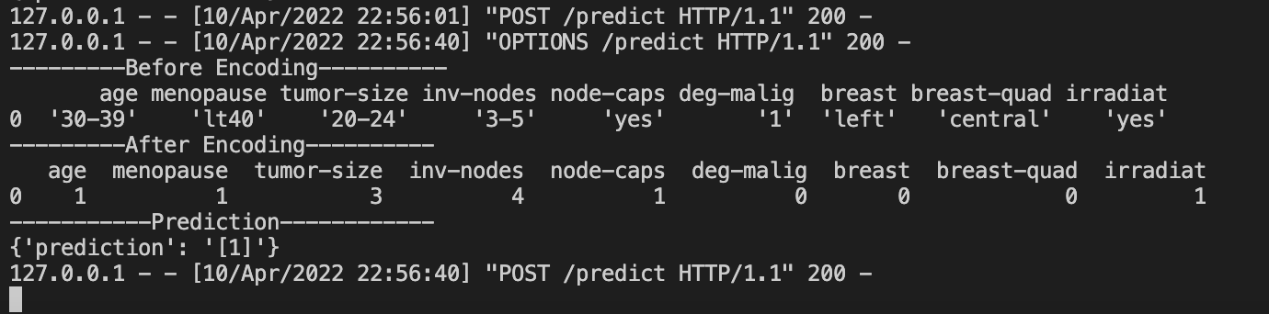

**Postman**

