Measure Energy consumption

Introduction

Measuring energy consumption is a critical aspect of managing and optimizing energy use in various settings, from households and businesses to industrial facilities and entire cities. Monitoring energy consumption provides valuable insights into where energy is being used, how efficiently it's being utilized, and how to make informed decisions to reduce costs, environmental impact, and improve overall energy sustainability. In this introduction, we'll explore the key concepts and methods involved in measuring energy consumption.  
  
1. Why Measure Energy Consumption:  
   - **Cost Management:** Monitoring energy usage helps control expenses, as energy bills often represent a significant portion of operating costs for households, businesses, and organizations.  
   - **Environmental Impact:** Reducing energy consumption can lower greenhouse gas emissions and contribute to environmental sustainability.  
   - **Efficiency Improvement:** Measuring energy usage allows for the identification of inefficiencies, enabling improvements in energy utilization.  
   - **Resource Planning:** Data on energy consumption helps in planning for future energy needs, such as capacity expansion or conservation efforts.  
  
2. Units of Measurement:  
   - Energy consumption is typically measured in units like kilowatt-hours (kWh) for electricity and British thermal units (BTUs) or joules for other forms of energy such as natural gas, oil, or coal.  
  
3. Energy Sources:  
   - Energy consumption can be categorized by sources, such as electricity, natural gas, gasoline, diesel, renewable sources (solar, wind), and more.  
  
4. Measurement Devices:   
   - Various devices and technologies are used to measure energy consumption. Common examples include:  
     -Electricity Meters: Installed by utilities to measure electrical energy consumption in homes and businesses.  
     - Gas Meters: Measure natural gas consumption for heating, cooking, and other purposes.  
     - Smart Meters: Advanced digital meters that provide real-time data and enable remote monitoring.  
     - Energy Auditing Tools: Specialized equipment to assess energy usage in industrial settings or buildings.  
  
5. Data Collection and Monitoring:   
   - Collecting energy consumption data is essential for analysis and decision-making. This can be done manually by reading meters, or automatically through smart metering systems and sensors.  
   - Energy management software and platforms are used to monitor and analyze data, providing insights into patterns and anomalies.  
  
6. Energy Efficiency Metrics:  
   - Efficiency metrics like Energy Performance Indicators (EPIs) or Energy Intensity Ratios (EIRs) are used to evaluate how effectively energy is being utilized in a given context.  
  
7. Energy Conservation and Optimization:  
   - Once energy consumption is measured, it's possible to identify areas for improvement. Strategies may include retrofitting buildings with energy-efficient equipment, adjusting processes, and implementing conservation measures.  
  
8. Regulatory Compliance:  
   - In many regions, there are regulations and standards related to energy consumption reporting and reduction targets, which require accurate measurement and reporting.  
  
9. Continuous Improvement:   
   - Energy consumption measurement is an ongoing process. Regular monitoring and analysis help in making informed decisions to reduce energy waste and costs over time.  
  
10. Future Trends:  
   - The field of energy consumption measurement is evolving with the advent of smart grids, Internet of Things (IoT) devices, and advanced data analytics, enabling more precise and real-time insights into energy usage.

Scope of the project :

       The scope of a project focused on measuring energy consumption can vary widely depending on its objectives, scale, and the context in which it is implemented. Below are some key aspects to consider when defining the scope of such a project:

1. Objective and Purpose:  
   - Clearly define the primary objectives of the project. Is it aimed at reducing energy costs, improving energy efficiency, meeting regulatory requirements, or achieving environmental sustainability goals?  
  
2. Scale and Location:  
   - Determine the scale of the project. Will it focus on a single household, a commercial building, an industrial facility, or an entire city? The scope may also be determined by geographical location.  
  
3. Types of Energy:  
   - Specify the types of energy to be measured, such as electricity, natural gas, water, or renewable energy sources like solar or wind. The project scope may encompass multiple energy sources.  
  
4. Data Collection Methods:  
   - Define the methods and technologies to be used for data collection. This could include installing meters, sensors, or utilizing smart metering systems, as well as data logging and monitoring tools.  
  
5. Data Analysis and Reporting:   
   - Determine how the collected data will be analyzed and reported. Will it involve real-time monitoring, periodic reports, or both? Identify key performance indicators (KPIs) and energy efficiency metrics to be used.  
  
6. Budget and Resources:   
   - Establish a budget for the project, considering the costs of equipment, technology, labor, and ongoing operational expenses. Allocate necessary resources, including personnel and expertise.  
  
7. Timeline and Milestones:   
   - Develop a project timeline with specific milestones and deadlines. This helps in tracking progress and ensures that the project stays on schedule.  
  
8. Stakeholders and Partnerships:   
   - Identify all stakeholders involved, including decision-makers, end-users, and regulatory bodies. Establish partnerships with utility companies, energy consultants, or technology providers if necessary.  
  
9. Energy Efficiency Measures:   
   - Determine whether the project will include recommendations or actions to improve energy efficiency based on the collected data. These measures might involve equipment upgrades, behavior changes, or process optimizations.  
  
10. Data Privacy and Security:  
    - Address data privacy and security concerns by establishing protocols for data handling, storage, and access to ensure compliance with relevant regulations.  
  
11. Scalability and Future Expansion:   
    - Consider the scalability of the project. Can it be expanded to include additional buildings, facilities, or energy sources in the future?  
  
12. Communication and Education:   
    - Develop a plan for communicating project goals, progress, and outcomes to stakeholders and end-users. Consider providing training or educational materials on energy conservation.  
  
13. Regulatory Compliance:   
    - Ensure that the project complies with any local, regional, or national regulations related to energy measurement and reporting.  
  
14. Sustainability Goals:   
    - If relevant, align the project with broader sustainability goals, such as reducing carbon emissions or achieving energy independence.  
  
15. Risk Assessment and Mitigation:   
    - Identify potential risks and challenges associated with the project and develop mitigation strategies to address them.  
  
16. Monitoring and Maintenance:   
    - Plan for the ongoing monitoring and maintenance of measurement equipment to ensure data accuracy and project sustainability.  
  
17.Evaluation and Reporting:  
    - Establish criteria for evaluating the project's success and create a framework for reporting results to stakeholders and the public.  
  
The scope of a project to measure energy consumption should be well-defined and aligned with its overarching goals and objectives. It is essential to carefully plan and manage such projects to maximize their effectiveness in reducing energy costs, improving efficiency, and contributing to sustainability efforts.

Base paper research

Estimation of energy consumption in machine learning by Eva García-Martín

published in the year 2019

Project design steps

Designing a project to measure energy consumption involves several key steps to ensure its success. Here's a structured approach to help you plan and execute such a project effectively:  
  
1. Define Project Objectives:  
   - Clearly articulate the specific goals and objectives of your project. Are you measuring energy consumption to reduce costs, improve efficiency, meet regulatory requirements, or achieve sustainability targets? Be specific about what you aim to accomplish.  
  
2. Identify Stakeholders:   
   - Determine all the stakeholders involved in the project, including decision-makers, end-users, and regulatory authorities. Understanding their needs and expectations is crucial for project success.  
  
3. Scope and Scale:   
   - Define the scope of the project. Will it focus on a single building, a group of buildings, an industrial facility, or a broader geographical area? Specify the scale and boundaries of your project.  
  
4. Select Measurement Metrics:   
   - Decide on the metrics and units for measuring energy consumption. Common units include kilowatt-hours (kWh) for electricity, British thermal units (BTUs) for heating, and gallons or cubic meters for water.  
  
5. Data Collection Methods:   
   - Choose the appropriate data collection methods and technologies. This may involve installing meters, sensors, or leveraging existing smart metering systems. Ensure that the chosen methods align with your project's objectives and budget.  
  
6. Data Management and Storage:   
   - Establish a system for managing and storing the collected data securely. Consider cloud-based solutions, data warehouses, or dedicated software systems for data organization.  
  
7. Data Analysis and Reporting:   
   - Develop a plan for data analysis. Identify key performance indicators (KPIs) and energy efficiency metrics to measure and report on. Decide whether you'll provide real-time monitoring or periodic reports.  
  
8. Budget and Resources:   
   - Create a budget that covers all project expenses, including equipment, technology, labor, and ongoing operational costs. Allocate the necessary human and financial resources to ensure the project's success.  
  
9. Technology Selection:   
   - Choose the appropriate technology and equipment for data collection and analysis. Ensure they are reliable, accurate, and compatible with your goals and infrastructure.  
  
10. Regulatory Compliance:  
    - Familiarize yourself with relevant local, regional, and national regulations related to energy measurement and reporting. Ensure that your project complies with these regulations.  
  
11. Risk Assessment and Mitigation:   
    - Identify potential risks and challenges associated with the project and develop mitigation strategies to address them. This may include technical failures, data security issues, or unexpected changes in energy consumption patterns.  
  
12. Data Privacy and Security:  
    - Establish protocols for data privacy and security to protect sensitive information. Ensure that data is accessible only to authorized personnel and that it is encrypted and stored securely.  
  
13. Project Timeline:   
    - Develop a project timeline with specific milestones and deadlines. This will help you track progress and ensure that the project stays on schedule.  
  
14. Communication and Education:   
    - Plan for effective communication with stakeholders and end-users. Consider providing training or educational materials on energy conservation and the benefits of the project.  
  
15. Evaluation and Reporting:   
    - Establish criteria for evaluating the project's success and impact. Regularly review and report on progress and outcomes to stakeholders and the public.  
  
16. Continuous Improvement:   
    - After the initial implementation, continue to monitor and analyze data to identify opportunities for further energy conservation and optimization.  
  
**17. Sustainability Goals:**  
    - If relevant, align your project with broader sustainability goals, such as reducing carbon emissions or achieving energy independence.  
  
18. Documentation:   
    - Maintain comprehensive documentation throughout the project, including equipment manuals, data collection protocols, and reports. This will be valuable for future reference and audits.

Architecture

.

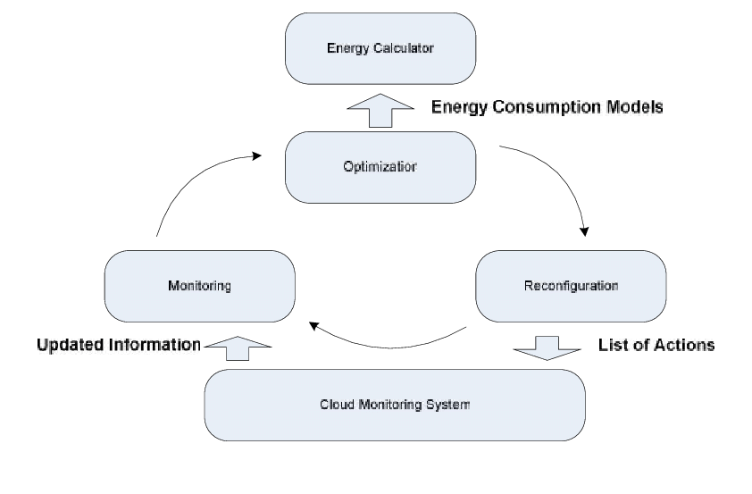

 Conclusion:

           Measuring energy consumption is fundamental for managing energy resources effectively, reducing costs, and mitigating environmental impact. It plays a crucial role in energy management strategies for individuals, businesses, and society as a whole, contributing to a more sustainable and efficient energy future.

|  |  |  |
| --- | --- | --- |
|  | |  |
|  |