

Secondary Two SBGE

Geography

Geographical Investigation
2022

Class: xxx
Group Leader: xxx
Group Members:
xxx

Choose ONLY 1: Urban Planning OR Transport Planning

An existing area of your neighbourhood needs improvement.
The URA wants to consult the residents before it decides to develop / improve the area so as to ensure that the final development will adequately address the needs of the community to improve their lives/wellbeing.
Task
1. Select your area of study
2. Using the Design Thinking process:
- Investigate the needs of the residents/users through observations and interviews
- Analyse the data
- Sketch your proposed design to collect feedback from the residents/users
- Propose a final land use OR transport design
- Create a model of your proposed land use OR transport design

Stage 1: Empathise (Week 4)

Area: Plot of land along Upp. Thomson Road

State one reason for your choice: The area has very good accessibility as there are pre-existing transport facilities such as MRT stations and bus stops nearby, hence the area is optimal for building of amenities as it will be convenient for people to reach the amenities.

Design a simple questionnaire to find out the needs of the target audience (see sample below). Send out the online questionnaire to your target group by utilizing social media, or asking your parents to help send to fellow neighbours in the estate.
- Make sure that your questionnaire is written in proper English.
- Collect results from at least 20 residents (use online survey or ask family members)

Questionnaire (Google Form) is attached in Google Classroom.
Interview Sample:

Date: ______ Time: _____ Location:______

Personal Information of Interviewee:
Gender:
Age group:

Community Needs:
- What are the main (physical) issues / challenges in this neighborhood / area?
- Why are these posing a problem?
- Who are the main users?
- What can be done to solve the problem?

Thank you for your time

Activity 1: Identifying the needs (Fieldwork 1)
Observation & Fieldwork
Make observations and record them below.
- existing land use /transport, condition of the area/building, accessibility, etc…
- Tips: Take photos for reference/improvement.

- accessibility
  - MRT stations (Marymount CC16, Upp. Thomson TE8)
  - bus stops (Opp Shunfu Est, Opp St Theresa’s Hme)
- condition of area
  - litter strewn around
  - lots of budding trees
  - not very maintained, thick grass

Secondary Data Collection
Suggestion: Use Google Earth/Maps to find out what are the amenities nearby (within 1km) so as to avoid uneconomic duplication. List them below.
Refer to URA’s Masterplan to find out future plans for this area.

- MRT Station
- Bus Stops
- School
- Preschool
- Shopping Mall
- Fire Station
- Gas Station
- Nursing Home
- Park
- Parking Spaces
- Bank
- Restaurants / F&B
- Supermarket

Stage 2: Define (Week 5-6)

Activity 2: Defining the Problem / Challenges Through POVs

Using what you have gathered in the interviews, restate them into various perspectives or Points-of-View (POV).

This allows you to identify the problems (top 3 identified in Activity 1) according to the needs of the target group in the community.
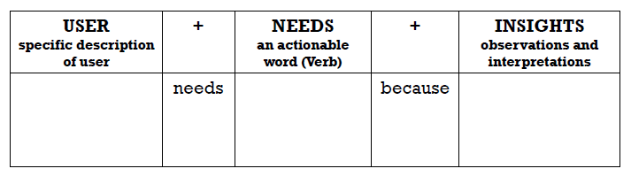
Table from Design Thinking: Developing 21st Century Skills and Competencies (Lai, 2007)
Target group | POV
elderly | - the elderly are more prone to illnesses, so they require healthcare facilities to cater to their needs  - some of the elderly may be limited in movement; healthcare facilities need to be in the vicinity

Target group | POV
disabled children | - many neighbourhood playgrounds are not very disabled-friendly and these children should deserve to enjoy the same fun as others

Target group | POV
teenagers | - a sports facility would allow them to exercise & de-stress  - through having fun and to live a healthy lifestyle

Decide which Target Group you would like to work with and explain your choice. (ONE group only)

Chosen target group: Elderly

- Bishan is an older housing estate
  - Tend to have more elderlies
  - Elderlies will need more specialised care
  - Because many of them are likely to have chronic diseases
  - This also means that the frequency of visiting healthcare facilities is high
  - Therefore there is high demand for elderly healthcare

Stage 3: Ideate (Week 7)

Activity 3: Generating Solutions / Prototype Design

Based on your selected POVs, brainstorm possible creative ways in which they can be addressed through your land use or transport design.

- elderly rehabilitation centre
- includes elderly rehabilitation department as well as 24/7 emergency department to cater to unforeseen accidents
- elderly population is physically weaker and are prone to movement accidents
- with a 24/7 rehabilitation centre, it would be much more convenient for an elderly patient to be admitted
- elderly chronic diseases care centre
- chronic diseases are common in the elderly
- since the area chosen is mostly inhabited by the elderly, the centre should be established for elderlies to visit frequently for regular checkups and treatments without travelling long distances
- elderly mental health institution
- mental illnesses are common among the elderly as they become frustrated over the loss of the ability to live independently
- provision of a mental health institution would greatly benefit the elderly, more so in a society which tends to stigmatise mental health complications
- integrated nursing home with specialised medical care facilities
- some elderlies require specialised care and need to stay in nursing homes
- establishing such a nursing home would provide care for the elderlies, with the added benefit of specialised medical care to provide treatment for the elderlies
- comprehensive elderly care centre
- an elderly care centre that offers specialised care targeting common illnesses among elderlies
- can be helpful to those with weaker health, and require more medical services
- the area chosen has no large hospitals nearby (the closest one being Mt. Alvernia Hosp.)
  - this hospital is a private hospital and the cost of medical services is much more expensive

Select ONE design that best addresses the needs of your target audience.

Explain how your proposed design meets the needs of your target audience.
- Wide range of specialised medical services
  - The medical services offered target common illnesses elderlies may be diagnosed with
  - Coupled with the wide range, many elderlies’ medical needs can be fulfilled at the proposed elderly healthcare centre
  - Specialised services ensure the ability of the healthcare centre to deal with more severe conditions
- Elderly-friendly facilities
  - Examples include:
  - Handrails → provide support for elderlies who are physically weaker to walk safely
  - Anti-slip mats in toilets → ensure that elderlies, who cannot afford a fall, will not slip and fall easily in an area that tends to be slippery
  - Ramps → some elderlies may be on wheelchairs due to injuries or permanent conditions, as such ramps make the healthcare centre more accessible

Stage 4: Sketch of land use OR transport design and Feedback Collection (by Week 8) Date: 29/3

Activity 4A: Creating a Sketch of your Design
Create a sketch of the proposed design on A3/A4 paper.
Be neat and as detailed as possible.
Suggest a suitable title for your design.
[Sketch is attached at the back of this document.]

Activity 4B: Feedback on your Design (Fieldwork 2)
Collect feedback on your proposed design.
Collect online feedback from your target group or ask your family members (see sample Questions below)
[Survey is attached in Google Classroom.]
- On a scale of 1 (being the least) to 5 (being the most), how much do you think this proposed design will meet your needs?

- Why do you think so?

- Any suggestions for improvements to our proposed design?

Activity 4C: Creating a Model (By Week 9)

- Amend your proposed design by incorporating the feedback collected.
- Build a model of your proposed design using recycled material, on a A2 or A3 size base. You can consult the teachers in MakerSpace too.

Stage 5: Presentation (Term 2 Week 4) Date: _________

Activity 5A: Presentation (Ppt slides and model)

- Area chosen: location, nearby facilities, pix of area, number of many people surveyed, etc
- Analyse information gathered at interviews
- Explain the POVs
- Explain how your proposed design meets the needs of your target audience (Do not propose shopping centres, multi-purpose buildings. Focus on the specific needs of your target audience)
- Be creative.
- Include references to books and websites you researched to get ideas
  - Urban Redevelopment Authority., URA Space. Retrieved from https://www.ura.gov.sg/maps/.
  - Travel Triangle (2022). Things To Do In Marymount[,] Singapore. Retrieved from https://traveltriangle.com/blog/things-to-do-in-marymount-singapore-bdp/.

Activity 5B: Final Individual Reflection

Reflect on the process of doing this investigation. (Please do not merely describe how you did your investigation. See Rubrics below.)
- If you would do this investigation again, explain how you would do it differently.
- Explain how the 3 Geographical concepts (place, space and sustainability) are affected/enhanced by your final product.

Reflection to be type-written, font size 12, not more than 250 words.

Types of submission | Weightage | Requirements
Group Presentation | 15 % | - Powerpoint presentation
Prototype | 10 % | - Model (A2 or A3 size base)
Final Individual reflection | 5 % | - Typewritten, font size 12, not more than 250 words
Total | 30%

Rubrics

PRESENTATION (15 marks)
 | 1m | 2m | 3m
Empathise | - Students demonstrate little to no empathy for the user(s) (e.g. students did not learn from a user, or relied on personal opinions or assumptions). | - Students describe empathy by providing one or more examples of an emotion, a physical necessity, or a behaviour. | - Students demonstrate empathy for the user(s) by providing two or more examples of emotions, physical necessities and behaviours that include inferences about the user(s) needs.
Define | - Students do not clearly re-frame the original challenge in terms of user needs. | - Students re-frame the original challenge, but the description of the user, need, and / or insight are too general or vague to provide much focus. | - Students clearly reframe the original challenge by listing the needs of a specifically defined user.
Ideate | - The students’ ideas do not clearly relate back to a user need. | - The students’ ideas lack originality and remain in a narrow range (either mostly practical, or mostly impractical). | - Students brainstorm a diverse range of ideas, most of which demonstrate understanding of the user need identified in the Define state.
Content and Data Analysis | - Design problem and solution not clearly presented. Not able to demonstrate how the solution addresses the problem.  - A limited solution that is unable to address the problem identified | - Design problem and solution are somewhat clearly presented.  - Able to demonstrate to some extent how the solution addresses the problem.  - A plausible solution that will probably work but has some weaknesses. | - Design problem and solution are clearly presented.  - Able to demonstrate how the solution addresses the problem.  - An effective and innovative solution that works and satisfies the problem identified.
Oral presentation | - Unclear delivery  - Displays mild tension  - Tendency to drone | - Clear delivery  - Some variety in tone  - Audience attention is not sustained | - Clear, fluent, articulate delivery  - Use of tone is appropriate, effective and varied

Final Product/Prototype (10 marks)
1 – 4m | 5 – 7m | 8-10m
- Students create a prototype that is incomplete and is unable to demonstrate the key feature(s) of the chosen idea.  - Potential user(s) are unable to interact with it or give feedback on how the prototype can be further improved.  - During feedback stage, students in the group do not capture any feedback given by user(s), hence unable to demonstrate understanding on how the improvements can help the prototype better address user need(s). | - Students create a prototype that is slip-shod and is unable to demonstrate the key feature(s) of the chosen idea.  - Potential user(s) have little or no interaction with it or give feedback on how the prototype can be further improved.  - During feedback stage, students in the group capture little feedback given by people, hence unable to demonstrate understanding on how the improvements can help the prototype better address user need(s). | - Students create a prototype that demonstrates the key feature(s) of the chosen idea.  - Potential user(s) are able to have interaction with it and give feedback on how the prototype can be further improved.  - During feedback stage, students in the group capture feedback given by user(s) and they demonstrate understanding on how these improvements can help the prototype better address user need(s).

FINAL INDIVIDUAL REFLECTION (5 marks)
1 – 2m | 3 – 4m | 5m
- merely describes the investigation process  - Does not elaborate the Geographical concepts  - Little evidence of thinking skills | - Describes how challenges were handled  - Some attempt to elaborate the Geographical concepts  - Some evidence of thinking skills (eg improvements to the investigation process) | - State and elaborate the benefit/ lesson learnt clearly  - Show a good grasp of the 3 Geographical concepts  - Insightful suggestions for improvements to the process
Source: Incorporated from Stanford School (2017)

References
Lai, J. (2007). Design Thinking: Developing 21st Century Skills and Competencies. National Institute of Education.

Stanford University. (2017). A Virtual Crash Course in Design Thinking. Retrieved from https://dschool.stanford.edu/resources-collections/a-virtual-crash-course-in-design-thinking
Sketches [Floorplan]

Original Draft
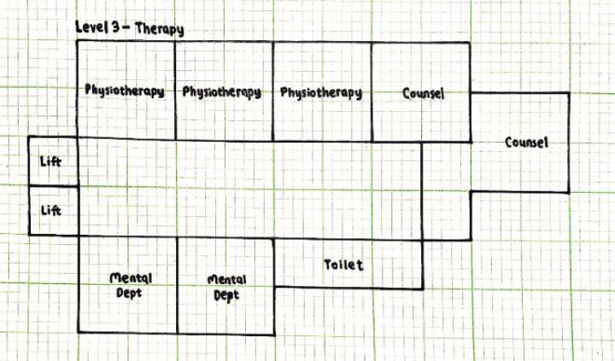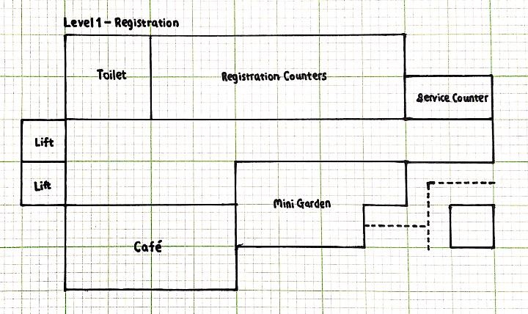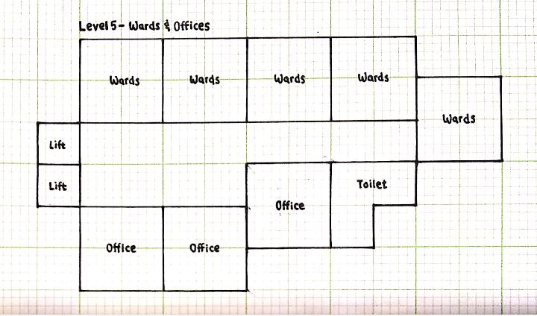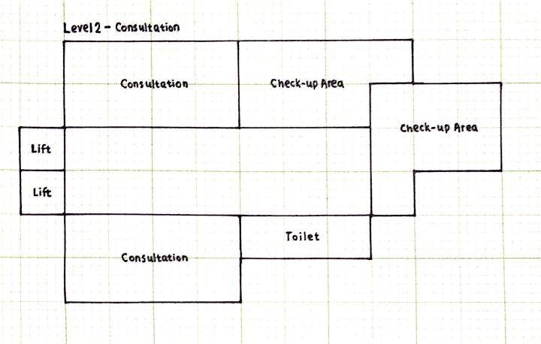

Final Draft


