Open Structure Lab (OSLab) CDK2 Benchmark: Detailed Methods, System Architecture, and FEP Validation Report
Prepared for AI-enabled drug-discovery workflow reporting and structural chemistry methods documentation
Generated: May 15, 2026 at 16:17 UTC
Field | Value
Primary OSLab run label | kimlab-cdk2-enrichment-v2
Target | Cyclin-dependent kinase 2 (CDK2)
Benchmark library | DUD-E CDK2 active/decoy benchmark library transferred into OSLab
Primary OSLab root during server execution | /data/oslab
Packaged local bundle | /Users/hlk/Desktop/kimlab-cdk2-enrichment-v2-completed-results-20260514-032817 2
Workflow FEP report | /data/oslab/reports/kimlab-cdk2-enrichment-v2-fep/fep_report.md
Second FEP benchmark | Wang CDK2 Track B OpenFE RBFE benchmark, 16 ligands, 15 perturbation edges
Purpose. This document replaces the previous short result summary with a submission-oriented methods and figure-legend document. It describes how OSLab was created and operated, how user input is converted into deterministic computational workflows, how AI assistance was used, and the detailed chemistry settings used for the CDK2 benchmark and the two FEP analyses.

1. Executive Summary of the CDK2 Benchmark
OSLab is an Apache-2.0 open-source orchestration layer created by Hyung L. Kim using open-source structural chemistry software and AI-assisted coding. The system wraps target preparation, docking, hit refinement, MD/MM-GBSA optimization, and OpenFE relative binding free-energy calculations in a reproducible command-line and dashboard workflow. The CDK2 benchmark described here was run on a Lambda GPU server and used a public DUD-E CDK2 active/decoy library for Blocks 1-3, followed by an OpenFE FEP demonstration on a chemically coherent active cluster and a second Wang CDK2 FEP benchmark with experimental affinity values.
Stage | N | Actives | Decoys | Active fraction | ROC-AUC | AP | Enrichment factors
Block 1 docking | 24549 | 631 | 23918 | 0.0257 | 0.728 | 0.138 | 1%: 11.54, 5%: 4.97, 10%: 3.53, 20%: 2.51, 50%: 1.59
Block 2 hit refinement composite | 400 | 45 | 355 | 0.1125 | 0.707 | 0.433 | 1%: 8.89, 5%: 5.33, 10%: 4.22, 20%: 2.56, 50%: 1.38
Block 3 MD/MM-GBSA | 20 | 12 | 8 | 0.6000 | 0.844 | 0.866 | 1%: 1.67, 5%: 1.67, 10%: 1.67, 20%: 1.25, 50%: 1.50
Block 4 workflow FEP active cluster | 5 | 5 | 0 | 1.0000 | n/a | 1.000 | 33%: 1.00, 67%: 1.00, 100%: 1.00
Interpretation. Docking enriched CDK2 actives above the 2.57% library base rate, hit refinement preserved enrichment among the top 400 candidates, and MD/MM-GBSA ranking increased active fraction among the 20 simulated ligands. The workflow FEP run should be interpreted as a Block 4 pipeline demonstration because it used an active-only congeneric cluster and produced zero reported edge uncertainties. The separate Wang CDK2 FEP benchmark provides the more direct FEP validation against experimental binding free energies.
Field | Value
Track B reference ligand | 1h1q (experimental ΔG -8.179 kcal/mol)
Ligands with predictions | 16
RMSE | 0.660 kcal/mol
MAE | 0.518 kcal/mol
Mean signed error | -0.243 kcal/mol
Pearson r / R² | 0.898 / 0.807
Spearman ρ / Kendall τ | 0.869 / 0.712

2. OSLab Platform Creation and Operating Model

2.1 Development model
OSLab was developed as a prompt-driven, open-source replacement-style workflow for common Schrödinger-like early discovery tasks, while retaining transparent file outputs and reproducible command-line execution. The user supplied the scientific requirements, software preferences, validation targets, and interface feedback; an AI coding assistant iteratively implemented, debugged, and hardened the Python package, dashboard, scripts, installers, and report-generation utilities. The project metadata records Hyung L. Kim as creator and Apache-2.0 as the license.
The AI system was used as a software engineering and workflow-assistance layer rather than as a scoring function. It helped write Python source, shell scripts, dashboard controls, progress monitors, and report generators. The molecular scores reported here come from deterministic scientific software such as AutoDock Vina, PLIP, OpenMM, ProLIF/MM-GBSA routines, and OpenFE/OpenMM RBFE calculations. Human decisions defined the benchmark target, input datasets, docking box, run scale, and interpretation boundaries.
During long runs, the AI assistant inspected JSON progress files, terminal logs, and output tables, and could propose or apply repairs when a software failure was operational rather than scientific. User instructions required that changes affecting scientific integrity, ligand sets, target structures, binding-site definitions, or completed outputs be escalated for human decision rather than silently changed.
Layer | Implementation | Role in reproducibility
Package and CLI | `open-structure-lab` Python package, entry point `oslab` | Defines deterministic subcommands for structures, protein prep, docking, hit refinement, MD/optimization, FEP, validation, dashboard, and HPC export.
Dashboard | Python HTTP server (`oslab dashboard`) serving HTML/JavaScript UI | Collects inputs, launches terminal wizards, displays progress from JSON files, previews structures/reports, and packages results.
Terminal scripts | Generated Bash and Python scripts under OSLab root | Run independently of the dashboard; create progress JSON, logs, report Markdown, CSV, JSON, SDF/PDB/PDBQT/DCD/NetCDF outputs.
Script generator | Dashboard form that emits executable scripts and AI handoff prompts | Captures defaults, target selection, binding-site method, ligand source, worker counts, GPU settings, and output conventions.
AI-in-the-middle | Codex/OpenClaw chat plus terminal access when authorized | Can run scripts, monitor progress, summarize results, and draft methods; it does not replace chemistry engines or alter scientific inputs without permission.
Data layout | `$OSLAB_ROOT/runs`, `$OSLAB_ROOT/reports`, `$OSLAB_ROOT/logs`, `$OSLAB_ROOT/data-cache`, and user-scoped directories where enabled | Separates durable results from source code; dashboard discovers completed work by scanning standardized progress/report paths.

2.2 User input and output flow
OSLab supports three input modes. First, a manual dashboard workflow lets the user select a target, structure source, binding-site method, ligand library, and block-specific settings through web forms. Second, terminal wizards ask concise numbered questions and write each answer to progress JSON files that are mirrored in the dashboard. Third, the script generator collects all four block settings and writes a reproducible Bash script that can be pasted into Codex or run directly on a workstation, Lambda server, AWS server, or HPC node.
Outputs are intentionally redundant. Each block writes machine-readable JSON progress, tabular CSV/TSV summaries, human-readable Markdown reports, and the scientific files required to reproduce or inspect the run. Docking produces Vina run JSON, docked PDBQT poses, and summary tables. Hit refinement produces per-seed Vina outputs, per-ligand seed aggregation, composite rankings, and PLIP interaction summaries. MD/optimization produces prepared systems, trajectories, RMSD files, ProLIF interaction records, MM/GBSA frame records, and a ranked report. FEP produces OpenFE input SDF/PDB/YAML files, network files, transformation JSON files, quickrun logs, NetCDF/checkpoint work outputs, gathered ΔΔG tables, and a final FEP report.
Progress reporting is file-based rather than browser-state-based. Long-running jobs can continue when the dashboard is restarted because the active process writes progress JSON and logs under the OSLab root. The dashboard polls these files and updates progress bars, current ligand/edge counters, live event logs, and report links.
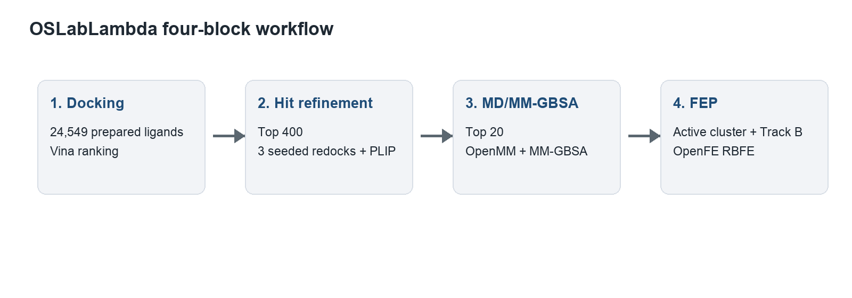
Figure 1. OSLab computational workflow and information flow. The figure summarizes the four major OSLab blocks used in this benchmark: docking, hit refinement, MD/MM-GBSA optimization, and FEP. User choices are collected either in the dashboard, terminal wizard, or script generator, then converted into deterministic command-line calls. Each block writes machine-readable progress JSON and analysis artifacts under the OSLab root, allowing the dashboard and AI assistant to monitor the run without controlling the scientific calculations. The figure should be interpreted as a software architecture diagram rather than a performance result.

3. Software Stack, Compute Environment, and Data Provenance
Workflow component | Primary open-source software | Function in OSLab
Protein and receptor preparation | PDBFixer, OpenMM, Meeko | Standardize PDB structures, add missing atoms/hydrogens where requested, remove waters/heterogens as configured, and create Vina receptor PDBQT files.
Binding-site definition | OSLab binding-site utilities; fpocket available but not used for this CDK2 run | Create fixed ligand-centered boxes, residue-centroid boxes, known-ligand boxes, or fpocket-derived pocket boxes.
Ligand handling | RDKit, Meeko, Open Babel as available; pre-prepared PDBQT supported | Inspect, filter, prepare, and catalog ligand libraries. CDK2 run reused transferred prepared PDBQT ligands.
Docking | AutoDock Vina | Score and pose each ligand in the selected binding box.
Interaction analysis | PLIP 2.2.2 for docked/refined poses; ProLIF for MD trajectories | Identify protein-ligand contacts and summarize interaction patterns.
MD and MM/GBSA | OpenMM, OpenFF/SMIRNOFF, MDAnalysis/ProLIF, OSLab MM/GBSA routines | Prepare solvated systems, run minimization/equilibration/production MD, analyze stability and estimate relative rank by MM/GBSA.
Relative binding free energy | OpenFE 1.11.0, OpenMM, OpenFF Toolkit, KartografAtomMapper | Plan ligand perturbation networks, run complex and solvent alchemical transformations, gather ΔΔG estimates.
User interface/reporting | Python HTTP server, JavaScript dashboard, python-docx/report utilities | Collect inputs, monitor JSON logs, render tables/figures, package final results.
Field | Value
Execution system | Lambda GPU server used for the KimLab CDK2 benchmark
Advertised hardware | 8 NVIDIA A100 SXM 40 GB GPUs, 124 vCPUs, 1800 GiB RAM, 5.8 TiB SSD
OSLab installation path | /opt/oslab/current
OSLab working root | /data/oslab
Dashboard tunnel used locally | http://127.0.0.1:9878/
Python package source in local development workspace | /Users/hlk/.openclaw/workspace/open-structure-lab
Primary CDK2 execution script in bundle | installation_package/oslab-updated-scripts/cdk2_kimlab_prepped_pdbqt_all_ligands.sh
FEP cluster script in bundle | installation_package/oslab-updated-scripts/cdk2_canonical_fep_cluster_run.sh
Second FEP benchmark script in bundle | trackb_wang_cdk2_fep_interim_20260514/run_wang_cdk2_trackb_fep.py

4. Detailed CDK2 Benchmark Methods

4.1 Dataset, labels, target, and binding-site definition
The primary benchmark used the DUD-E CDK2 active/decoy dataset transferred into OSLab. The screened library contained 24,549 prepared PDBQT ligand files: 631 compounds labeled as actives and 23,918 compounds labeled as decoys in the packaged analysis. Active/decoy labels were inferred from ligand identifiers containing `_active_` or `_decoy_` and were also tied to the transferred label file recorded in the execution script (`/data/oslab/benchmarks/cdk2-transferred/workflow-run/inputs/cdk2_active747_decoy26770.labels.csv`).
The CDK2 receptor input was `/data/oslab/benchmarks/cdk2-transferred/cdk2/receptor.pdb`. OSLab protein preparation used pH 7.4, removed waters and heterogens, added 72 missing atoms, and skipped OpenMM minimization by user option. The prepared protein was converted to a Vina receptor PDBQT with Meeko using `--allow_bad_res` and the fixed docking box described below.
The binding site was not selected with fpocket in this benchmark. Instead, a fixed 14 x 14 x 14 Å docking box centered at (1.970, 27.560, 8.830) Å was used. The binding-site JSON records this as a ligand-centroid method with notes identifying it as a 1HCK crystallographic ligand-centered benchmark grid. This choice was used to avoid tuning the docking box against enrichment results and to align the benchmark with a known ligand-defined CDK2 site.
Field | Value
Input receptor PDB | /data/oslab/benchmarks/cdk2-transferred/cdk2/receptor.pdb
Prepared receptor PDB | /data/oslab/runs/kimlab-cdk2-enrichment-v2-target-prep/protein_prepared.pdb
Receptor PDBQT | /data/oslab/runs/kimlab-cdk2-enrichment-v2-receptor-vina/receptor.pdbqt
Protein pH | 7.4
Waters/heterogens | Removed during receptor preparation
OpenMM minimization | Skipped
Docking box method | ligand-centroid
Docking box center (Å) | 1.970, 27.560, 8.830
Docking box size (Å) | 14.000, 14.000, 14.000

4.2 Block 1: high-throughput docking
Block 1 docked each pre-prepared ligand PDBQT file with AutoDock Vina. Because the CDK2 transferred library already contained ligand PDBQT files, no RDKit/Meeko ligand preparation was performed during this run. This distinction matters for reproducibility: the run evaluates OSLab docking and downstream orchestration using a prepared benchmark library, not the ligand-preparation success rate.
Docking was executed with 120 worker tasks, one Vina CPU per ligand, Vina exhaustiveness 12, Vina output poses (`num_modes`) 3, and random seed 1. Each ligand produced a `vina_run.json`, Vina log, and docked PDBQT pose under the docking report directory. The final docking progress JSON reported 24,549 attempted and 24,549 successfully docked ligands.
Field | Value
Ligand PDBQT directory | /data/oslab/benchmarks/cdk2-transferred/workflow-run/screen/ligand-vina-prep/pdbqt
Ligands docked | 24549/24549
Docking workers | 120
Vina CPU per ligand | 1
Vina exhaustiveness | 12
Vina output poses | 3
Seed | 1
Docking completed | May 13, 2026 at 13:49 UTC
Results JSON | /data/oslab/reports/kimlab-cdk2-enrichment-v2-docking/report/vina_results.json
Rank | Ligand | Vina best score | Active/decoy | Run JSON
1 | 000049_active_0065_active_00065 | -12.270 | active | /data/oslab/reports/kimlab-cdk2-enrichment-v2-docking/docking/000049_active_0065_active_00065/vina_run.json
2 | 000050_active_0066_active_00066 | -12.090 | active | /data/oslab/reports/kimlab-cdk2-enrichment-v2-docking/docking/000050_active_0066_active_00066/vina_run.json
3 | 000107_active_0125_active_00125 | -11.970 | active | /data/oslab/reports/kimlab-cdk2-enrichment-v2-docking/docking/000107_active_0125_active_00125/vina_run.json
4 | 000385_active_0457_active_00457 | -11.640 | active | /data/oslab/reports/kimlab-cdk2-enrichment-v2-docking/docking/000385_active_0457_active_00457/vina_run.json
5 | 000364_active_0435_active_00435 | -11.610 | active | /data/oslab/reports/kimlab-cdk2-enrichment-v2-docking/docking/000364_active_0435_active_00435/vina_run.json
6 | 000462_active_0539_active_00539 | -11.570 | active | /data/oslab/reports/kimlab-cdk2-enrichment-v2-docking/docking/000462_active_0539_active_00539/vina_run.json
7 | 000193_active_0230_active_00230 | -11.530 | active | /data/oslab/reports/kimlab-cdk2-enrichment-v2-docking/docking/000193_active_0230_active_00230/vina_run.json
8 | 018878_decoy_20357_decoy_20357 | -11.420 | decoy | /data/oslab/reports/kimlab-cdk2-enrichment-v2-docking/docking/018878_decoy_20357_decoy_20357/vina_run.json
9 | 000564_active_0655_active_00655 | -11.400 | active | /data/oslab/reports/kimlab-cdk2-enrichment-v2-docking/docking/000564_active_0655_active_00655/vina_run.json
10 | 006768_decoy_6878_decoy_06878 | -11.400 | decoy | /data/oslab/reports/kimlab-cdk2-enrichment-v2-docking/docking/006768_decoy_6878_decoy_06878/vina_run.json

4.3 Block 2: hit refinement and PLIP analysis
Block 2 selected the top 400 ligands from the initial Vina screen and redocked each ligand with three independent seeds (1, 2, and 3). The refinement used Vina exhaustiveness 16, `num_modes` 3, one CPU per ligand, and 120 workers. This yielded 1,200 Vina runs and a per-ligand aggregation table.
The refined ranking used both docking strength and seed-to-seed consistency. For each ligand, OSLab calculated the best refined Vina score, mean refined score, standard deviation across seeds, seed count, best seed, and a Boolean consistency flag. Composite ranking used the scoring formula recorded in the report: composite_score = (-mean_score) + 0.25*(-best_score) + max(0, 1 - score_std) + (1 / initial_refinement_rank) + 0.05*min(seed_count, 5). Since Vina scores are negative and more negative is better, the first two terms convert stronger binding to larger positive composite values. The consistency term penalizes variable redocking results, and the seed-count term rewards ligands with complete replicate data.
PLIP interaction analysis was run on the refined top list and converted docked PDBQT/receptor data into protein-ligand interaction reports. PLIP version 2.2.2 was recorded in the interaction logs. PLIP output was used for interaction interpretation and visual summaries but not for the Vina score itself.
Field | Value
Source docking results | /data/oslab/reports/kimlab-cdk2-enrichment-v2-docking/report/vina_results.json
Top ligands selected | 400
Seeds | 1, 2, 3
Vina exhaustiveness | 16
Vina output poses | 3
Vina runs summarized | 1,200
PLIP | Run on the refined top list; PLIP 2.2.2 observed in logs
Hit-refinement completed | May 13, 2026 at 14:55 UTC
Composite rank | Ligand | Composite score | Best score | Mean score | Score SD | Best seed | Active/decoy
1 | 000049_active_0065_active_00065 | 17.498 | -12.320 | -12.290 | 0.022 | 3 | active
2 | 000107_active_0125_active_00125 | 16.612 | -11.970 | -11.970 | 0.000 | 3 | active
3 | 000385_active_0457_active_00457 | 16.017 | -11.660 | -11.640 | 0.022 | 2 | active
4 | 000364_active_0435_active_00435 | 15.908 | -11.630 | -11.613 | 0.012 | 3 | active
5 | 000462_active_0539_active_00539 | 15.791 | -11.580 | -11.563 | 0.017 | 3 | active
6 | 018878_decoy_20357_decoy_20357 | 15.559 | -11.420 | -11.407 | 0.019 | 2 | decoy
7 | 000155_active_0187_active_00187 | 15.478 | -11.390 | -11.370 | 0.014 | 2 | active
8 | 000533_active_0615_active_00615 | 15.347 | -11.310 | -11.280 | 0.022 | 1 | active
9 | 001721_decoy_1151_decoy_01151 | 15.282 | -11.240 | -11.230 | 0.008 | 3 | decoy
10 | 000565_active_0656_active_00656 | 15.249 | -11.230 | -11.213 | 0.012 | 2 | active

4.4 Block 3: MD and MM/GBSA optimization
Block 3 advanced 20 ligands from hit refinement into MD/optimization. For each ligand, OSLab reconstructed an MD-ready complex from the selected docked pose, prepared ligand and protein files, built a solvated OpenMM system, ran short equilibration and production simulations, computed trajectory-derived interaction fingerprints, and estimated relative binding strength by MM/GBSA-style energy decomposition.
The MD protocol recorded pH 7.4, water padding 1.2 nm, ionic strength 0.15 M, temperature 300 K, OpenFF/SMIRNOFF ligand force field `openff-2.2.0`, 1,000 minimization steps, a 2 fs timestep, 0.1 ns NVT equilibration, 0.1 ns NPT equilibration, 1.0 ns production, and 50 analysis frames. The report text records OpenMM 8.1.5 for the MD run, while the protein-prep metadata records OpenMM 8.5.1; both version records are preserved in the source files and should be checked against the exact server environment if final manuscript versioning is required.
MM/GBSA values in this document are used as relative ranking metrics rather than calibrated absolute binding free energies. The estimator computes an approximate ΔG_bind from averaged complex, receptor, and ligand energy terms in an implicit-solvent model. The pipeline also records ligand RMSD over the production trajectory and ProLIF occupancy of interactions with protein residues.
Field | Value
Ligands simulated | 20/20
Water padding | 1.2 nm
Ionic strength | 0.15 M
Temperature | 300 K
Minimization | 1,000 steps
Equilibration | 0.1 ns NVT + 0.1 ns NPT
Production | 1.0 ns
Trajectory frames analyzed | 50
Force field | OpenFF/SMIRNOFF openff-2.2.0 for ligand; protein/water settings recorded in MD report
Completed | May 13, 2026 at 18:49 UTC
Rank | Ligand | Active/decoy | Vina score | MM/GBSA mean ΔG | MM/GBSA SD | Ligand RMSD mean
1 | 000107_active_0125_active_00125 | active | -11.97 | -59.15 | 2.35 | 0.23
2 | 000565_active_0656_active_00656 | active | -11.23 | -51.98 | 2.82 | 0.45
3 | 000723_decoy_0093_decoy_00093 | decoy | -11.03 | -46.62 | 7.84 | 0.72
4 | 000381_active_0452_active_00452 | active | -11.08 | -45.36 | 10.23 | 0.89
5 | 000364_active_0435_active_00435 | active | -11.63 | -43.20 | 3.07 | 0.61
6 | 000049_active_0065_active_00065 | active | -12.32 | -37.14 | 9.98 | 0.47
7 | 000462_active_0539_active_00539 | active | -11.58 | -36.59 | 2.83 | 0.73
8 | 000385_active_0457_active_00457 | active | -11.66 | -36.37 | 2.61 | 0.55
9 | 000533_active_0615_active_00615 | active | -11.31 | -33.23 | 2.97 | 0.54
10 | 000540_active_0622_active_00622 | active | -11.17 | -31.29 | 2.39 | 0.84

4.5 Block 4: workflow OpenFE FEP on the MD-selected active cluster
The canonical Block 4 run selected five MD-prepared active CDK2 ligands from an internally similar congeneric cluster. The selected ligands were `000565_active_0656_active_00656`, `000049_active_0065_active_00065`, `000462_active_0539_active_00539`, `000385_active_0457_active_00457`, and `000533_active_0615_active_00615`. The reference ligand was `000565_active_0656_active_00656`. OSLab passed bound-frame SDF ligand coordinates and a protein-only PDB derived from the MD/Optimization preparation into the OpenFE backend.
OpenFE 1.11.0 planned a minimal spanning perturbation network with four ligand edges, each split into complex and solvent transformations. The OpenFE input manifest reported a cropped MD-prepared protein source with 189 residues, 3,115 atoms, and 1,523 heavy atoms; all five ligands passed bound-frame coordinate checks with minimum ligand-protein heavy-atom contacts between 2.674 and 2.901 Å. Partial charges were generated by the OpenFE/OpenFF stack using the NAGL/RDKit route recorded in the workflow input manifest.
Sampling used 11 lambda windows, 25,000 production steps per window, 5,000 equilibration steps per window, temperature 300 K, and `openff-2.2.1`. The OpenFE settings used `KartografAtomMapper`, atom maximum distance 0.95 Å, hydrogen mapping enabled, exact ring matching, partial fused rings allowed, and bond-breaking disabled. The OpenMM platform was CUDA. The thermodynamic cycle was ΔΔG_bind = ΔG_complex - ΔG_solvent.
This workflow FEP result demonstrates that OSLab can carry a hit-refined and MD-prepared ligand cluster into OpenFE and return a relative ranking. It is not a stand-alone claim of quantitative CDK2 affinity because all five ligands were actives, the run produced zero reported edge uncertainties after gather, convergence warnings were present in the benchmark summary, and one edge had a weak MCS value despite acceptable Tanimoto. Replicate longer FEP and cycle-closure checks would be required for final drug-discovery claims.
Field | Value
Reference ligand | 000565_active_0656_active_00656
Selected ligand count | 5
OpenFE backend | OpenFE 1.11.0
OpenMM platform | cuda
Lambda windows | 11
Production steps/window | 25000
Equilibration steps/window | 5000
Force field | openff-2.2.1
Partial charge method/backend | nagl/rdkit
Completed transformations | 8/8
Completed | May 14, 2026 at 04:39 UTC
Rank | Ligand | Relative ΔΔG_bind (kcal/mol) | SMILES
1 | 000385_active_0457_active_00457 | -7.10 | COc1ccc(-c2[nH]nc3c2C(=O)c2c(NC(=O)NNC(=O)Cc4ccccc4)cccc2-3)cc1
2 | 000049_active_0065_active_00065 | -5.80 | COc1ccc(-c2[nH]nc3c2C(=O)c2c(NC(=O)NNC(=O)c4cccc5ccccc45)cccc2-3)cc1
3 | 000533_active_0615_active_00615 | -3.70 | COc1ccc(-c2[nH]nc3c2C(=O)c2c(NC(=O)NN4CCN(C)CC4)cccc2-3)cc1
4 | 000462_active_0539_active_00539 | -3.30 | COc1ccc(-c2[nH]nc3c2C(=O)c2c(NC(=O)NNC(=O)c4cccnc4)cccc2-3)cc1
5 | 000565_active_0656_active_00656 | 0.00 | COc1ccc(-c2n[nH]c3c2C(=O)c2c(NC(=O)NNC(=O)c4ccc5ccccc5c4)cccc2-3)cc1
Edge | MCS atoms | Tanimoto | ΔΔG_bind | Uncertainty
000049_active_0065_active_00065 → 000385_active_0457_active_00457 | 40 | 0.69 | -1.3 | 0.0
000385_active_0457_active_00457 → 000533_active_0615_active_00615 | 38 | 0.625 | 3.4 | 0.0
000462_active_0539_active_00539 → 000385_active_0457_active_00457 | 39 | 0.667 | -3.8 | 0.0
000565_active_0656_active_00656 → 000462_active_0539_active_00539 | 1 | 0.649 | -3.3 | 0.0

5. Second FEP Benchmark: Wang CDK2 Track B OpenFE RBFE Run
A second FEP-focused benchmark was run using the public Wang-FEP-dataset CDK2 subset rather than the DUD-E active/decoy screening library. This run was designed to test the OSLab OpenFE backend against ligands with known experimental binding free energies. Sixteen neutral CDK2 ligands were staged into bound-frame SDF files with experimental `r_user_dG.exp` values. The reference ligand was `1h1q`, anchored at experimental ΔG = -8.179 kcal/mol.
The protein was standardized by removing original hydrogen records, adding missing atoms and pH 7 hydrogens with PDBFixer/OpenMM, and writing a protein-only PDB. The final protein used for OpenFE input contained 554 residues, 8,996 atoms, and 4,462 heavy atoms. Bound-frame coordinate checks passed for all 16 ligands, with minimum ligand-protein heavy-atom distances between 1.166 and 2.760 Å.
OpenFE 1.11.0 used the RelativeHybridTopologyProtocol with OpenMM CUDA execution, AM1-BCC charges through the OpenFE/OpenFF stack with AmberTools backend, 11 lambda windows, 250,000 production steps per window, 50,000 equilibration steps per window, 300 K, `openff-2.2.1`, and one protocol repeat. The planned network contained 15 ligand edges and 30 total transformations (complex and solvent legs), distributed across CUDA devices 0-7 with up to eight concurrent workers.
Predicted absolute ΔG values were obtained by anchoring network-predicted relative free energies to the experimental reference ligand value. The final comparison across 16 ligands gave RMSE 0.660 kcal/mol, MAE 0.518 kcal/mol, mean signed error -0.243 kcal/mol, Pearson r 0.898, Spearman ρ 0.869, Kendall τ 0.712, and R² 0.807. These results support the OSLab OpenFE pathway as a promising FEP execution and analysis route, while the zero gathered edge uncertainties and warnings in OpenFE logs should be reviewed before final quantitative claims.
Field | Value
Campaign directory | /data/oslab/users/kimlab/fep_campaigns/wang-cdk2-trackb-20260514-publishable
Status | completed
Started | May 14, 2026 at 12:26 UTC
Completed | May 14, 2026 at 16:40 UTC
Ligands | 16
Planned perturbation edges | 15
Transformations | 30
Reference ligand | 1h1q
OpenFE platform | OpenFE 1.11.0
OpenMM platform | cuda
Lambda windows | 11
Production/equilibration steps per window | 250000 / 50000
CUDA devices | 0, 1, 2, 3, 4, 5, 6, 7
Metric | Value
reference_ligand | 1h1q
reference_experimental_dG_kcal_mol | -8.179
n_ligands_with_predictions | 16.000
rmse_kcal_mol | 0.660
mae_kcal_mol | 0.518
mean_signed_error_kcal_mol | -0.243
pearson_r | 0.898
spearman_r | 0.869
kendall_tau | 0.712
r_squared | 0.807
Ligand | Predicted ΔG | Experimental ΔG | Error | Predicted ΔΔG | Experimental ΔΔG
1h1s | -12.479 | -11.246 | -1.233 | -4.300 | -3.067
28 | -11.179 | -11.112 | -0.067 | -3.000 | -2.933
1oiu | -10.579 | -9.083 | -1.496 | -2.400 | -0.904
30 | -10.379 | -9.812 | -0.567 | -2.200 | -1.633
1oi9 | -10.179 | -9.741 | -0.438 | -2.000 | -1.562
29 | -9.979 | -9.882 | -0.097 | -1.800 | -1.703
32 | -9.879 | -9.750 | -0.129 | -1.700 | -1.571
20 | -9.079 | -8.718 | -0.361 | -0.900 | -0.539
1oiy | -9.079 | -9.785 | 0.706 | -0.900 | -1.606
31 | -8.979 | -9.539 | 0.560 | -0.800 | -1.360
26 | -8.979 | -8.431 | -0.548 | -0.800 | -0.252
1h1q | -8.179 | -8.179 | 0.000 | 0.000 | 0.000
1h1r | -7.979 | -7.669 | -0.310 | 0.200 | 0.510
17 | -7.879 | -7.041 | -0.838 | 0.300 | 1.138
21 | -7.679 | -7.828 | 0.149 | 0.500 | 0.351
22 | -7.079 | -7.862 | 0.783 | 1.100 | 0.317

6. Publication-Style Figure Legends
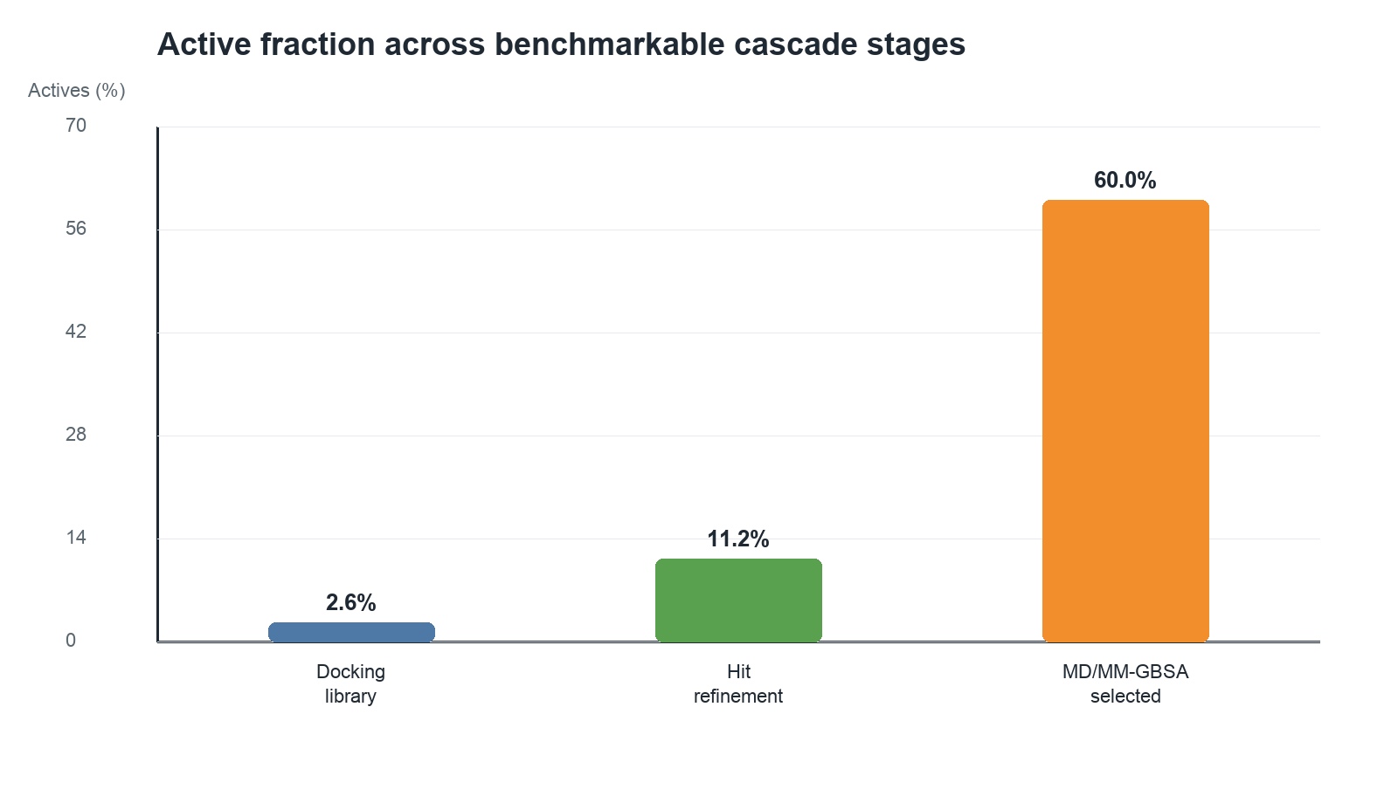
Figure 2. Active-ligand enrichment through the OSLab CDK2 workflow. Bars show the active fraction after each benchmarkable cascade stage: the full DUD-E docking library (631 actives among 24,549 ligands), the 400-ligand hit-refinement input set, the 20-ligand MD/MM-GBSA set, and the five-ligand FEP cluster. The fold-enrichment values are computed relative to the original library active rate. The FEP stage is active-only and therefore should be read as cascade retention of actives rather than active/decoy discrimination.
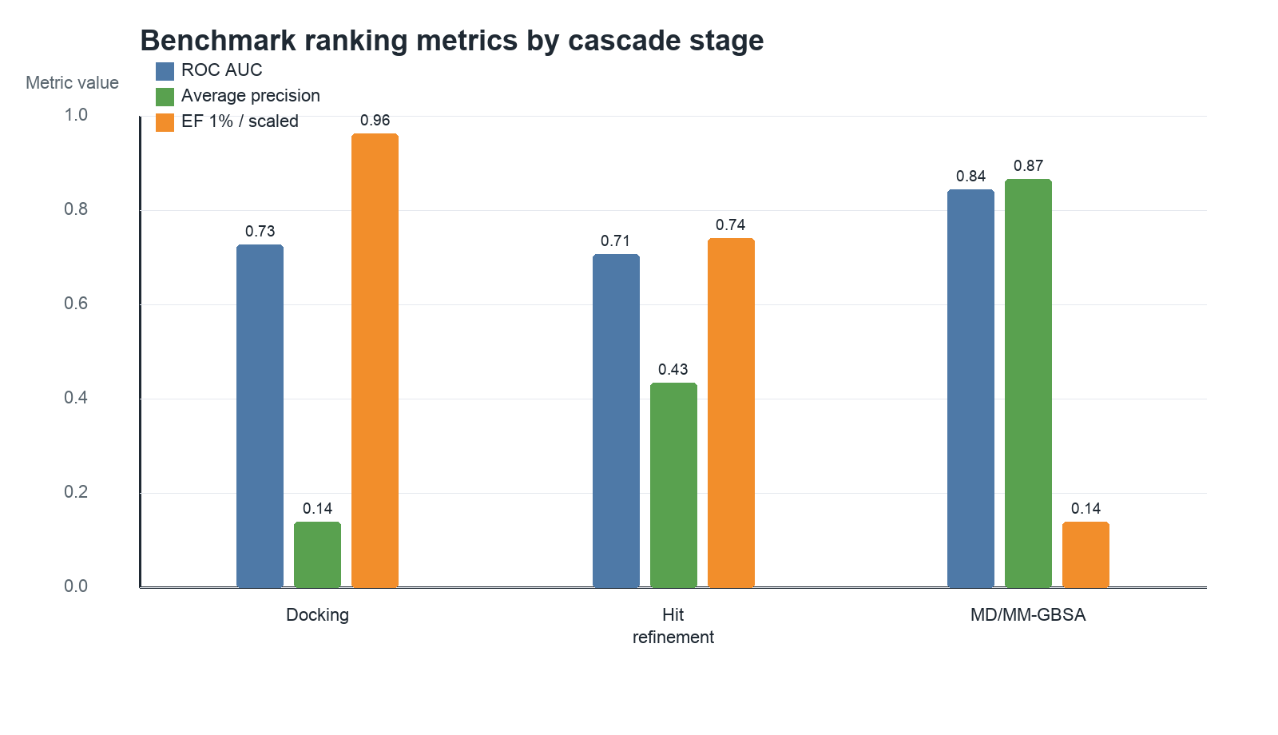
Figure 3. Discrimination metrics across benchmarkable OSLab stages. ROC-AUC and average precision are shown for initial Vina docking, hit-refinement composite ranking, hit-refinement best Vina score, MD/MM-GBSA ranking, and MD-stage Vina score. FEP is not included in ROC-AUC because the workflow FEP cluster contained only active ligands. These metrics evaluate OSLab’s ability to prioritize known CDK2 actives over DUD-E decoys at each stage.
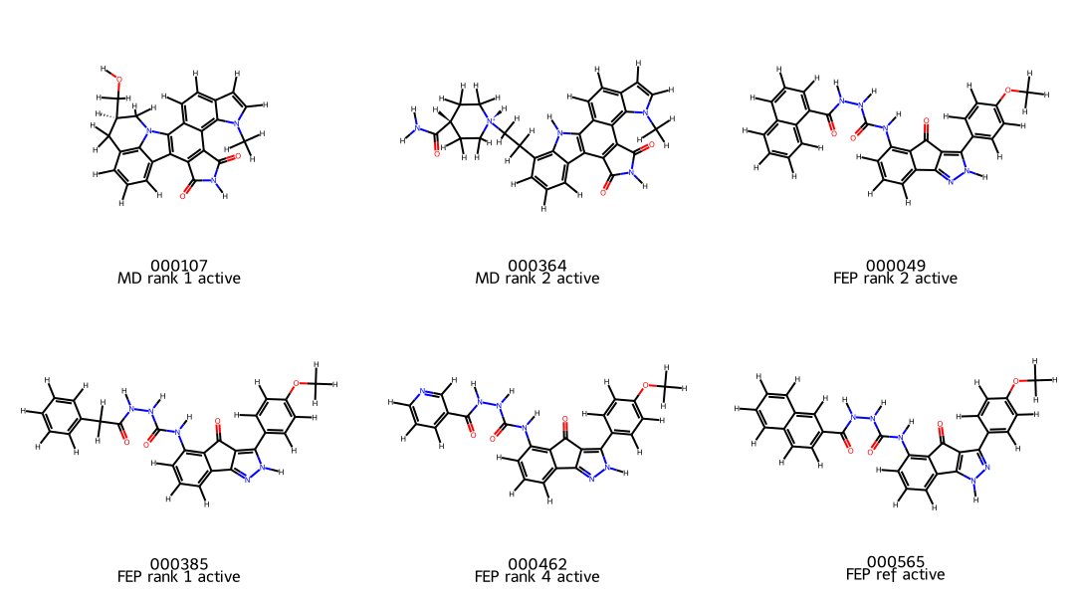
Figure 4. Representative top-ranked CDK2 ligands from the OSLab cascade. Structures are displayed to visualize chemical series composition among the strongest-ranked compounds after docking/hit refinement/MD selection. Ligand names encode DUD-E active or decoy status, allowing visual comparison of enriched actives and high-scoring decoys. This panel supports chemical interpretability but is not itself a scoring metric.
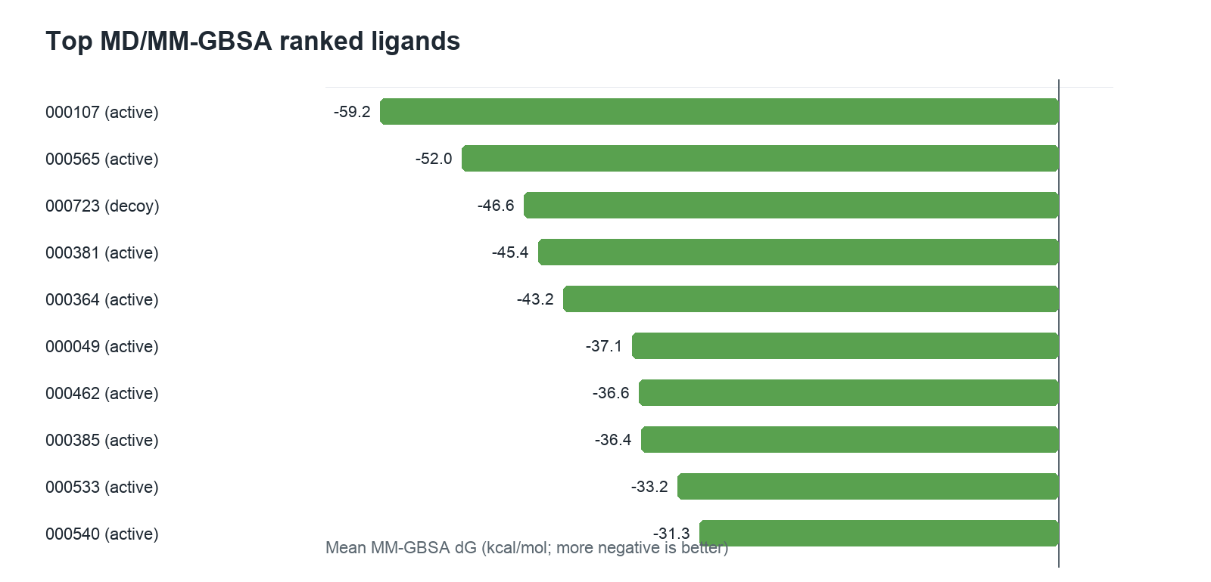
Figure 5. MD/MM-GBSA ranking after Block 3. Each ligand advanced from hit refinement was simulated with the OSLab OpenMM MD/optimization protocol and ranked by mean MM/GBSA ΔG. More negative values indicate stronger predicted binding in this approximate implicit-solvent ranking model. Active/decoy labels show that the top MD/MM-GBSA ranks were enriched for known CDK2 actives compared with the original DUD-E library.
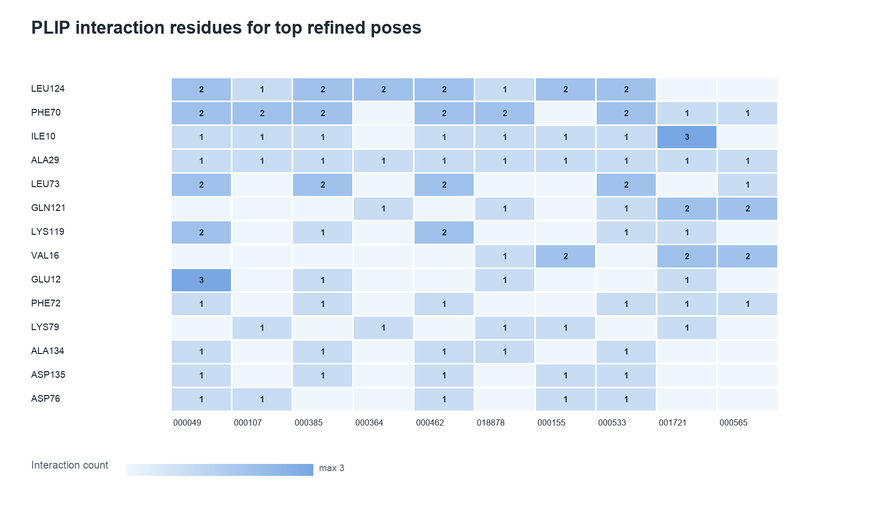
Figure 6. Protein-ligand interaction residue heatmap from PLIP and/or trajectory-derived interaction summaries. Rows/columns summarize recurrent binding-site contacts observed for top candidates. The purpose is to identify whether highly ranked ligands share plausible contact patterns with CDK2 binding-site residues. Interaction occupancy should be interpreted as qualitative pose support and not as a substitute for binding affinity measurement.
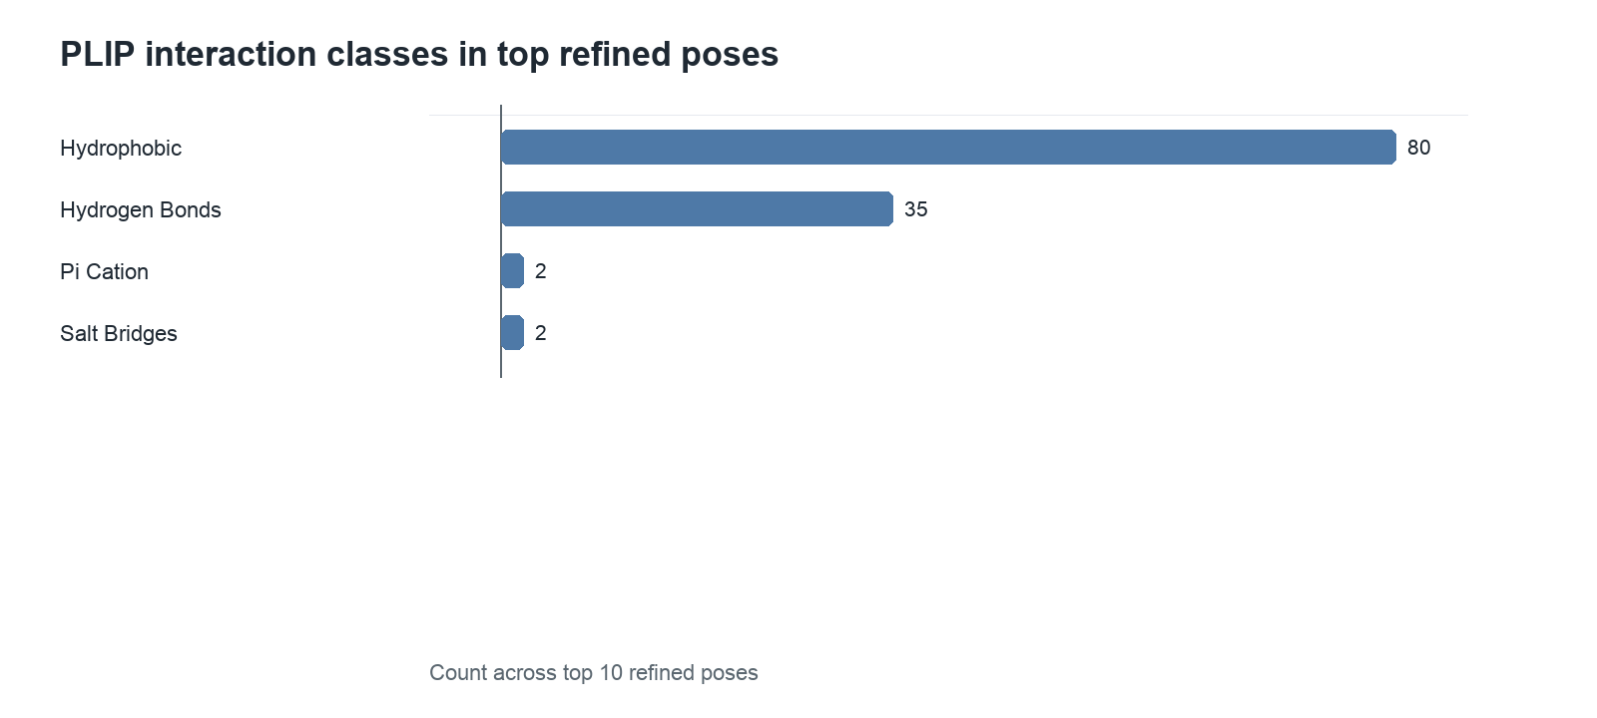
Figure 7. Interaction-type distribution for top CDK2 candidates. The plot summarizes contact categories such as hydrogen bonds, hydrophobic contacts, salt bridges, π interactions, and van der Waals contacts where detected by PLIP/interaction post-processing. The figure is intended to show whether ranked ligands engage the pocket through chemically interpretable interactions.
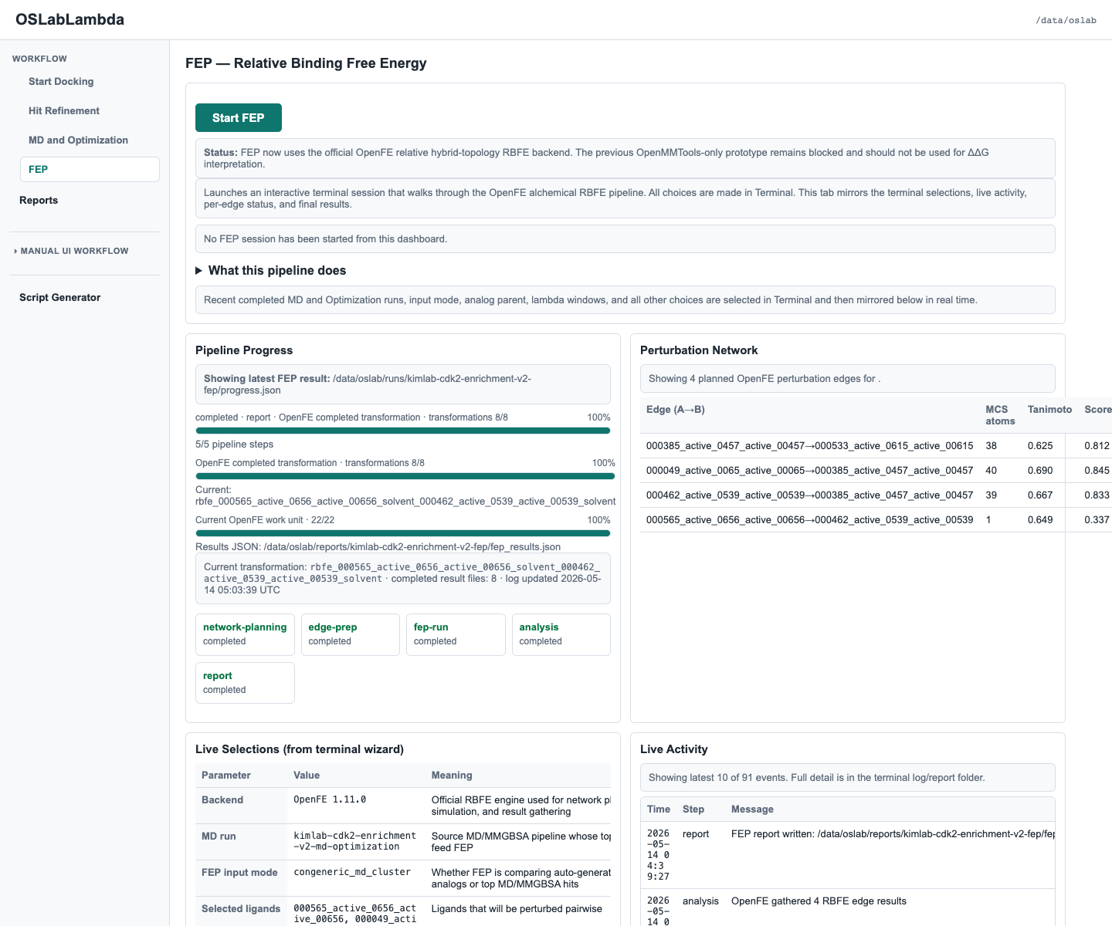
Figure 8. OSLab dashboard view of the completed canonical Block 4 FEP run. The dashboard mirrors progress JSON written by the terminal process and displays status, selected ligands, perturbation network information, and final results without controlling the running simulation. This panel documents the user-facing monitoring layer and the separation between UI display and independent backend execution.
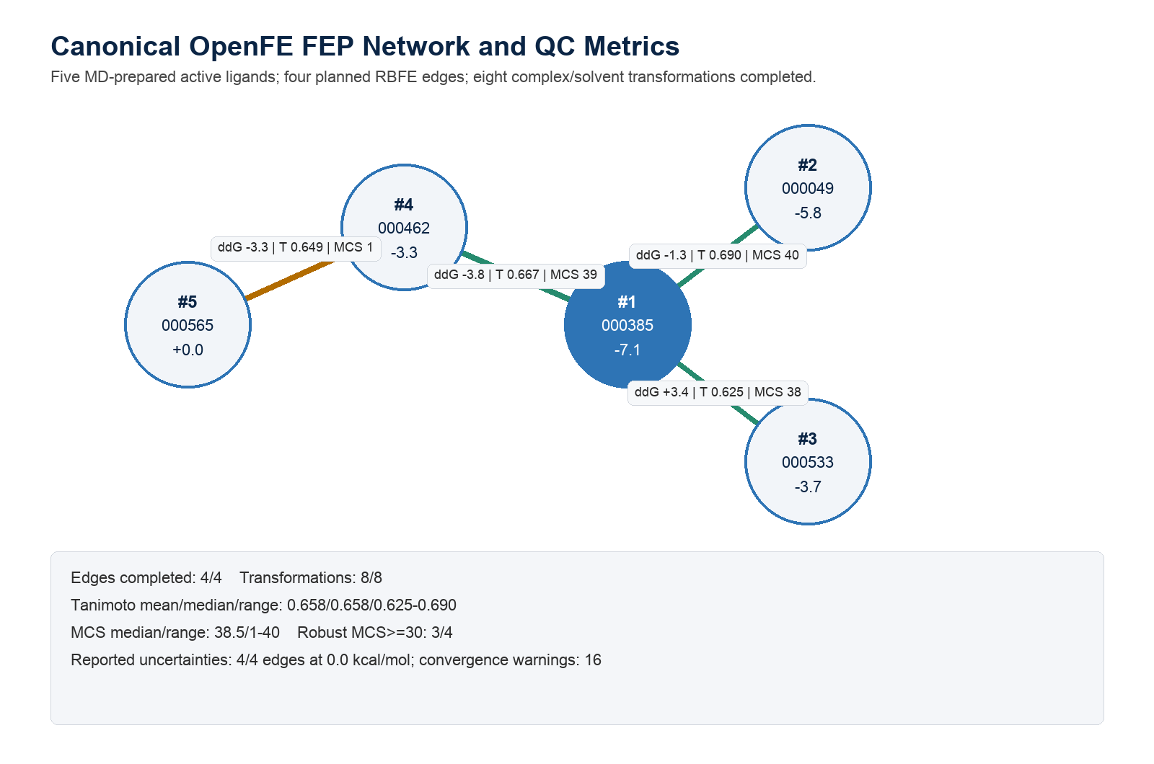
Figure 9. Canonical workflow FEP perturbation-network metrics for the five-ligand CDK2 active cluster. Edges were selected by OSLab/OpenFE network planning using atom mapping and similarity metrics. The network includes Tanimoto similarity, MCS atom counts, edge quality scores, and gathered ΔΔG values. One edge had a weak MCS despite acceptable Tanimoto; therefore this network is best interpreted as a workflow demonstration requiring further replicate validation.
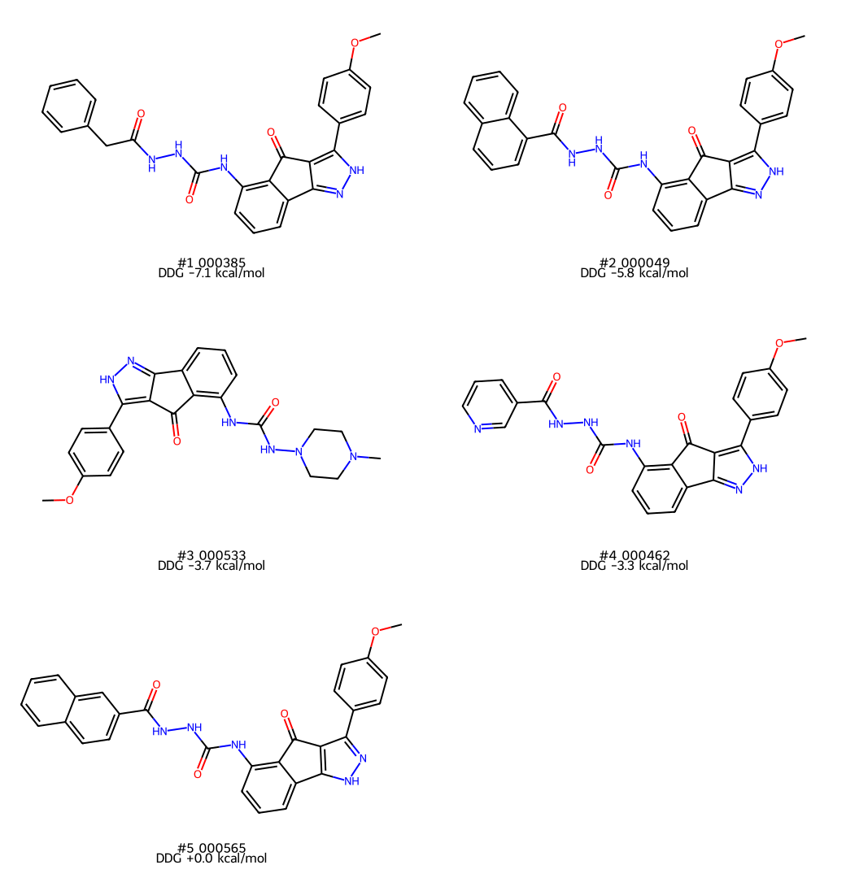
Figure 10. Two-dimensional structures for the five ligands used in the workflow FEP cluster. Structures were selected from MD-prepared active ligands that formed a chemically related cluster. The reference ligand was `000565_active_0656_active_00656`, and relative ΔΔG values were propagated across the OpenFE perturbation network to rank the remaining active ligands.
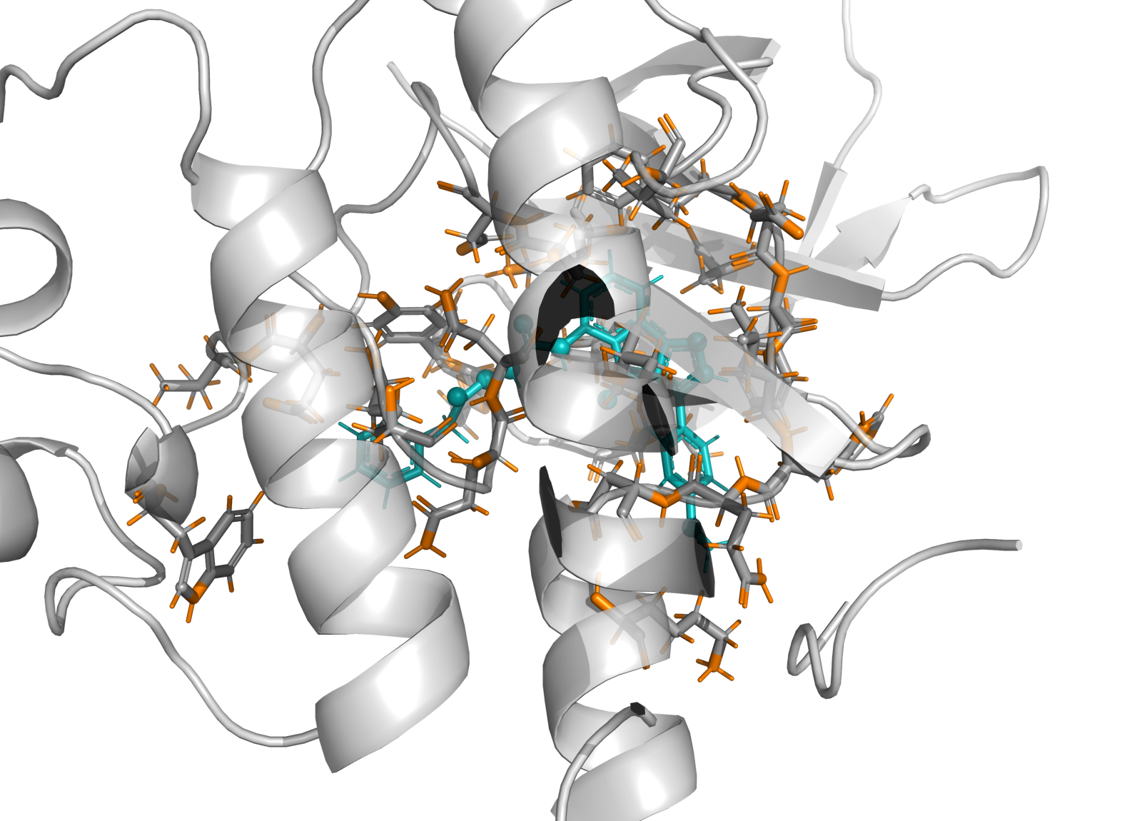
Figure 11. Three-dimensional pose visualization for the top-ranked workflow FEP ligand in the CDK2 binding pocket. The image uses the MD/FEP bound-frame coordinate source to show the ligand in the protein context used for simulation. This panel is a structural plausibility visualization; final RBFE interpretation should be based on the OpenFE edge results and convergence diagnostics.
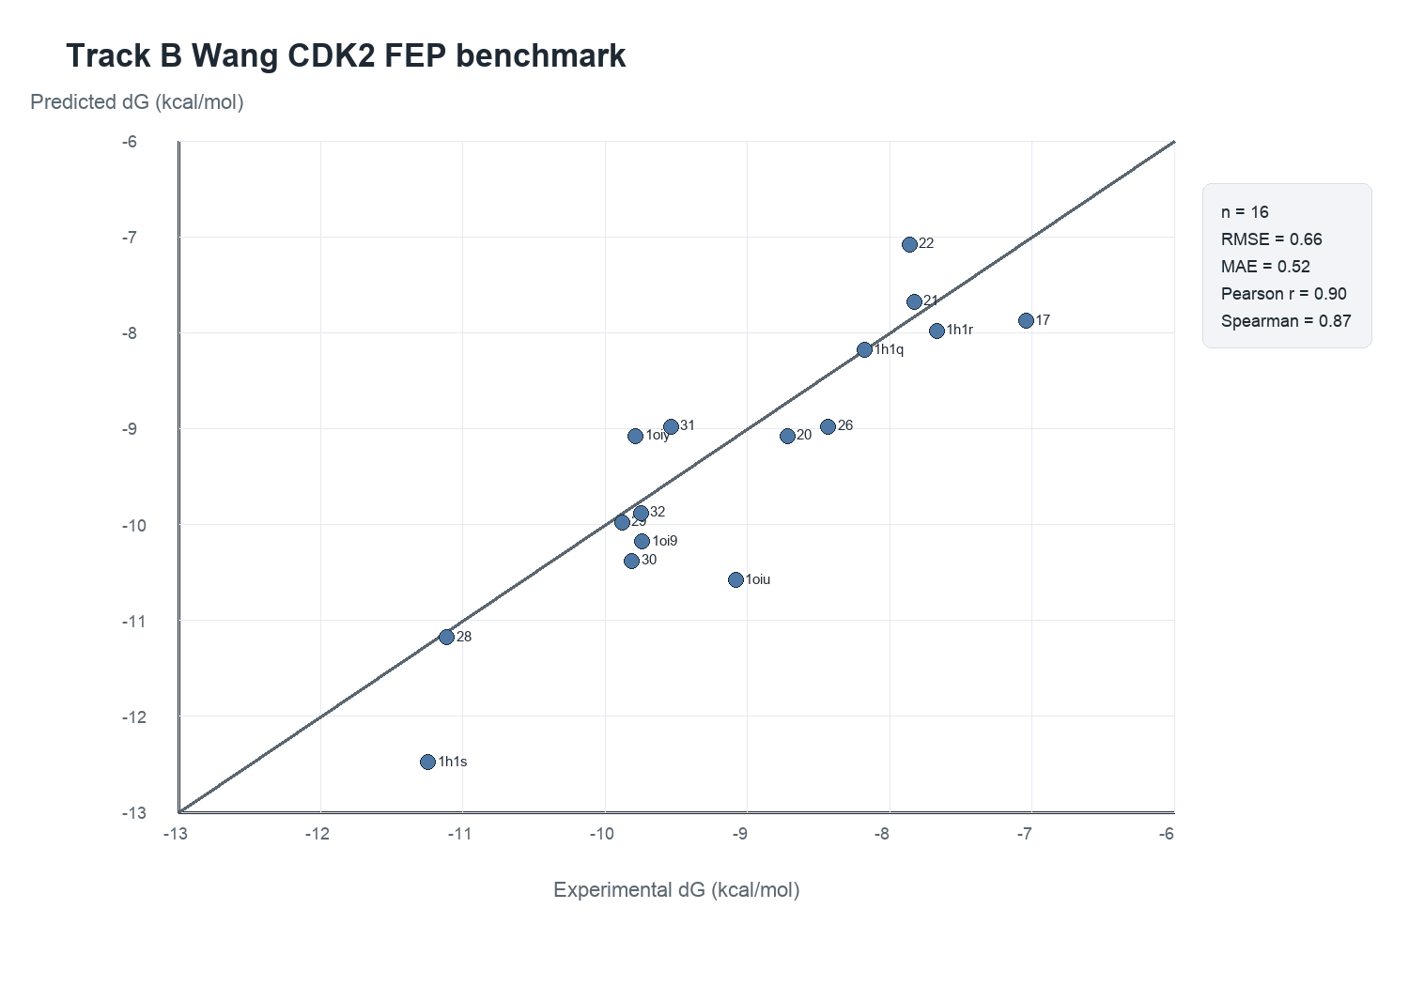
Figure 12. Wang CDK2 Track B FEP benchmark: predicted versus experimental binding free energies. Predicted ΔG values were anchored to the experimental value for reference ligand `1h1q` and compared with experimental ΔG values for all 16 ligands. The final run achieved RMSE 0.660 kcal/mol, MAE 0.518 kcal/mol, Pearson r 0.898, Spearman ρ 0.869, and R² 0.807. This is the strongest quantitative FEP validation result in this report.
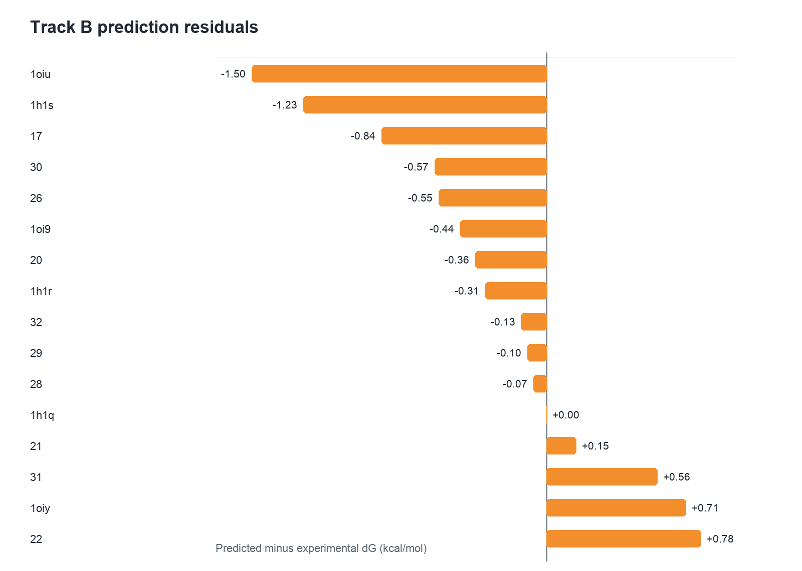
Figure 13. Residual analysis for the Wang CDK2 Track B FEP benchmark. Residuals are predicted minus experimental ΔG values for each ligand. The plot identifies ligands that are over- or under-predicted after reference anchoring and helps diagnose whether error is driven by individual perturbation edges, local chemical changes, or systematic bias.
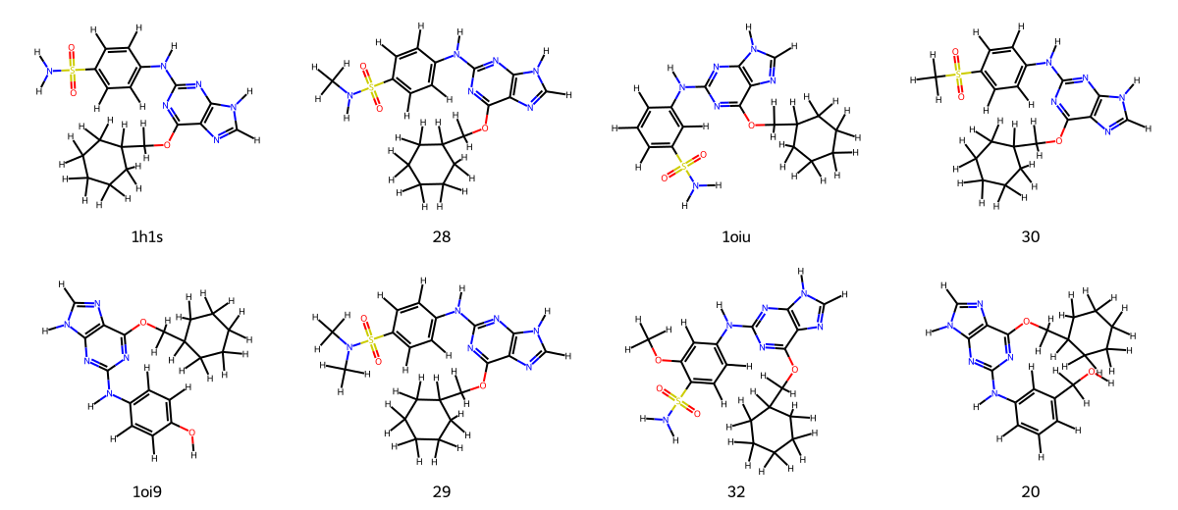
Figure 14. Chemical structures for representative Wang CDK2 Track B benchmark ligands. The congeneric series was selected for RBFE because all ligands are neutral, structurally related, and have experimental ΔG values. This figure supports interpretation of the perturbation network and illustrates why relative free-energy methods are appropriate for this validation set.

7. Reporting, Interpretation, and Limitations
The OSLab CDK2 benchmark supports the intended use of the workflow as a transparent open-source cascade: broad docking, higher-rigor redocking, short MD/MM-GBSA optimization, and RBFE/FEP on a selected chemical series. The most important reproducibility feature is that every stage writes the inputs, settings, and paths needed to rerun or audit the calculations.
Docking and Vina-derived rankings should be interpreted as screening tools. Vina scores are heuristic and do not estimate absolute binding free energy. Enrichment metrics such as ROC-AUC, average precision, and enrichment factors are appropriate for benchmarking but can be sensitive to target preparation, docking-box definition, ligand preparation, and decoy composition.
MM/GBSA and short MD improve structural plausibility and can enrich true actives among top-ranked compounds, but the absolute ΔG values reported by the simplified MM/GBSA model should not be interpreted as experimental binding energies. The 1 ns production simulations used here are appropriate for workflow benchmarking and triage, not definitive residence-time or induced-fit characterization.
The workflow FEP run demonstrates the OSLab-to-OpenFE handoff, but the separate Wang Track B benchmark is a better measure of FEP accuracy because it includes experimental values. For publication-grade RBFE claims, final runs should include replicate simulations, uncertainty review beyond gathered zero-edge uncertainty, cycle-closure checks, overlap diagnostics, and sensitivity analyses for force field, charge model, mapping, and lambda schedule.

8. Reproducibility Files and Paths
Artifact | Packaged path or server path
Primary result bundle | /Users/hlk/Desktop/kimlab-cdk2-enrichment-v2-completed-results-20260514-032817 2
Benchmark metrics summary JSON | /Users/hlk/Desktop/kimlab-cdk2-enrichment-v2-completed-results-20260514-032817 2/benchmark_metrics_summary.json
Manifest JSON | /Users/hlk/Desktop/kimlab-cdk2-enrichment-v2-completed-results-20260514-032817 2/MANIFEST.json
Docking results CSV/JSON | /data/oslab/reports/kimlab-cdk2-enrichment-v2-docking/report/vina_results.csv and .json
Hit-refinement per-ligand summary | /data/oslab/reports/kimlab-cdk2-enrichment-v2-hit-refinement/report/per_ligand_seed_summary.csv and .json
MD/optimization report | /data/oslab/reports/kimlab-cdk2-enrichment-v2-md-optimization/report/md_optimization_report.md
Workflow FEP results | /data/oslab/reports/kimlab-cdk2-enrichment-v2-fep/fep_results.json and openfe/openfe_ddg.tsv
Wang Track B FEP final report | /Users/hlk/Desktop/kimlab-cdk2-enrichment-v2-completed-results-20260514-032817 2/trackb_wang_cdk2_fep_final_20260514/report/trackb_benchmark_report.md
Wang Track B FEP metrics | /Users/hlk/Desktop/kimlab-cdk2-enrichment-v2-completed-results-20260514-032817 2/trackb_wang_cdk2_fep_final_20260514/report/trackb_benchmark_metrics.json
Wang Track B planned network and OpenFE inputs | /Users/hlk/Desktop/kimlab-cdk2-enrichment-v2-completed-results-20260514-032817 2/trackb_wang_cdk2_fep_final_20260514/report/openfe
Primary CDK2 run script | /Users/hlk/Desktop/kimlab-cdk2-enrichment-v2-completed-results-20260514-032817 2/installation_package/oslab-updated-scripts/cdk2_kimlab_prepped_pdbqt_all_ligands.sh
Canonical FEP script | /Users/hlk/Desktop/kimlab-cdk2-enrichment-v2-completed-results-20260514-032817 2/installation_package/oslab-updated-scripts/cdk2_canonical_fep_cluster_run.sh
Wang Track B script | /Users/hlk/Desktop/kimlab-cdk2-enrichment-v2-completed-results-20260514-032817 2/trackb_wang_cdk2_fep_interim_20260514/run_wang_cdk2_trackb_fep.py
Key equations. Enrichment factor at top fraction x was computed as EF_x = (actives in top x / compounds in top x) / (total actives / total compounds). Hit-refinement composite ranking used the formula listed in Section 4.3. MM/GBSA ranking used ΔG_bind ≈ <E_complex> - <E_protein> - <E_ligand>. OpenFE RBFE used ΔΔG_bind = ΔG_complex - ΔG_solvent.

9. References to Cite or Verify Before Submission
AutoDock Vina and Vina 1.2 documentation/manuscripts for docking score and search algorithm.
RDKit, Meeko, Open Babel, and OpenFF Toolkit documentation or software citations for ligand preparation and chemical file handling.
PDBFixer and OpenMM publications/documentation for protein preparation, molecular simulation, and CUDA execution.
PLIP 2.2.2 citation recorded in logs: Adasme et al., Nucleic Acids Research 2021, PLIP 2021.
OpenFE 1.11.0 and OpenMM relative hybrid topology protocol documentation for RBFE planning and execution.
DUD-E CDK2 active/decoy dataset citation and dataset access date.
Wang et al. JACS 2015 free-energy benchmark and Wang-FEP-dataset CDK2 source repository; verify exact dataset mirror and license before submission.

