CDK2 OSLab Four-Block Benchmark Report
  - Docking, hit refinement, MD/MM-GBSA optimization, and OpenFE FEP results from the kimlab-cdk2-enrichment-v2 run
Generated | 2026-05-13 22:13 local time
Source system | OSLabLambda service instance, /data/oslab, dashboard forwarded locally at http://127.0.0.1:9878/
Lambda hardware | 8 x NVIDIA A100 SXM 40 GB, 124 vCPUs, 1800 GiB RAM, 5.8 TiB SSD
Run family | kimlab-cdk2-enrichment-v2
Benchmark set | CDK2 active/decoy library: 24,549 ligands, 631 actives, 23,918 decoys
Install package | /Users/hlk/Desktop/kimlab-cdk2-enrichment-v2-completed-results-20260514-032817/installation_package/oslab-updated-scripts-install-package-20260514.zip
Design preset | standard_business_brief: Letter page, 1 in margins, Calibri 11 pt, blue heading hierarchy, fixed-width tables

Primary conclusion
All four blocks completed. The cascade strongly enriched labeled CDK2 actives from a 2.57% active baseline to 11.25% in the 400-compound refinement set and 60.0% in the 20-compound MD/MM-GBSA set. The canonical FEP block (kimlab-cdk2-enrichment-v2-fep) completed a five-ligand congeneric active-cluster OpenFE RBFE network, finishing 8/8 complex/solvent transformations and ranking 000385_active_0457_active_00457 as the strongest relative binder. The FEP result is an integrated workflow result; final quantitative publication claims require experimental affinity correlation, longer replicate sampling, and resolved uncertainty diagnostics.

Summary Results
- Block 1 docking screened 24,549 ligands and gave ROC-AUC 0.728, average precision 0.138, EF@1% 11.54, EF@5% 4.97, and EF@10% 3.53.
- Block 2 hit refinement redocked 400 selected ligands across seeds 1, 2, and 3 (1,200 Vina runs). The composite ranking produced ROC-AUC 0.707 and AP 0.433 within this enriched subset.
- Block 3 MD/MM-GBSA completed all 20 selected ligands. Ranking by mean MM/GBSA ddG produced ROC-AUC 0.844; the top two MM/GBSA ligands were labeled actives.
- Block 4 FEP completed 4 ligand edges and 8 OpenFE transformations on a five-ligand congeneric active cluster. Edge Tanimoto values had mean 0.658 and range 0.625-0.690; 3/4 edges had MCS >= 30. Relative to reference 000565_active_0656_active_00656, the FEP ranking placed 000385_active_0457_active_00457 first and 000565_active_0656_active_00656 last.
Figure 1. Active fraction after benchmarkable cascade stages through MD/MM-GBSA. FEP is omitted because Block 4 used an active-only congeneric RBFE subset; its 100% active composition reflects input selection rather than enrichment performance.
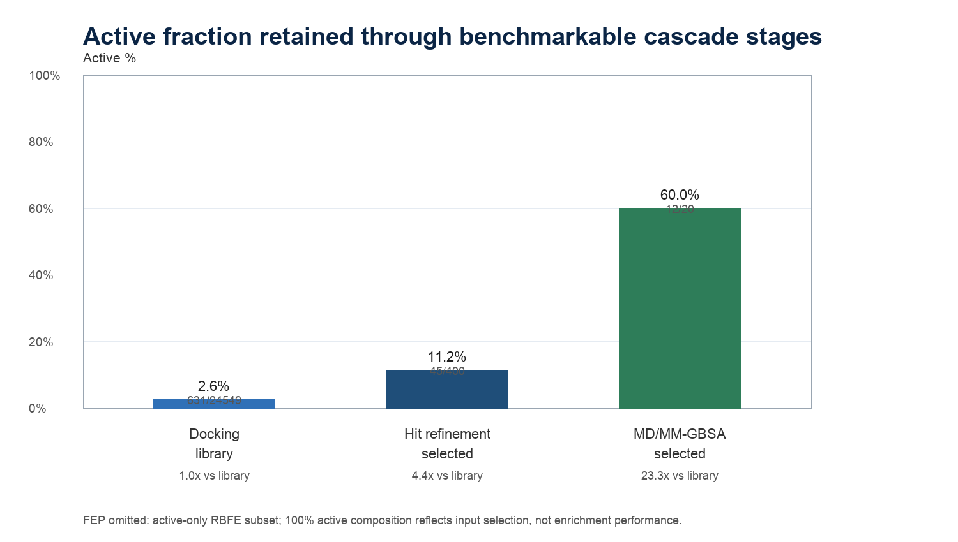
Figure 2. ROC curves for docking, hit-refinement composite ranking, and MD/MM-GBSA ranking. FEP is omitted because Block 4 is an active-only congeneric RBFE stage.
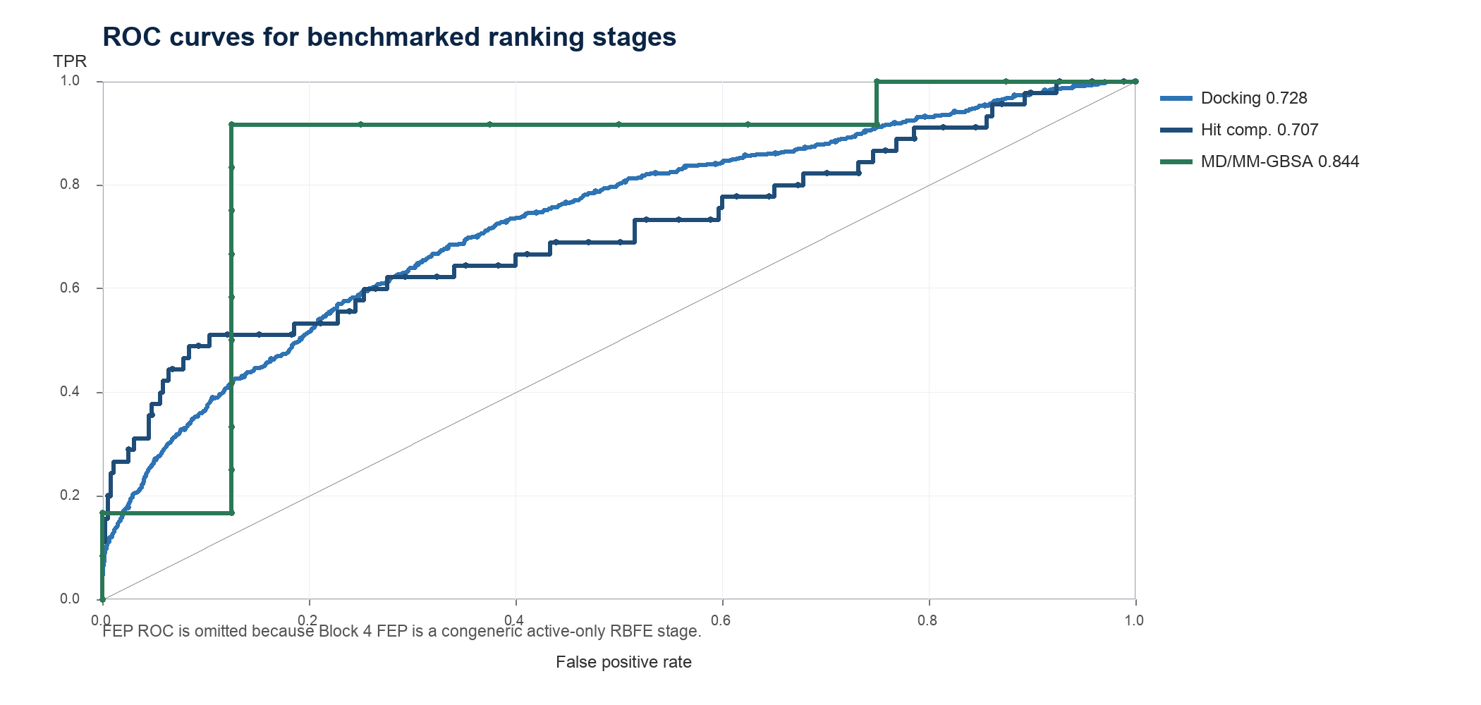
Figure 3. OSLabLambda dashboard showing the canonical Block 4 FEP run with four planned ligand edges and 8/8 OpenFE transformations complete.
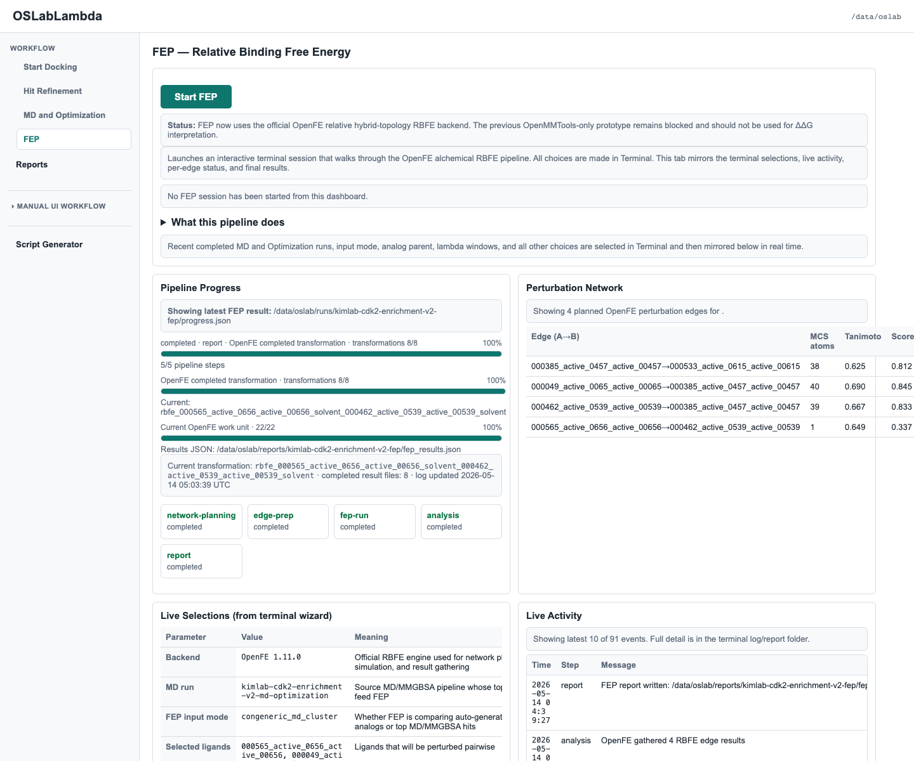
Figure 4. Canonical OpenFE FEP network with edge-level mapping and quality-control metrics.
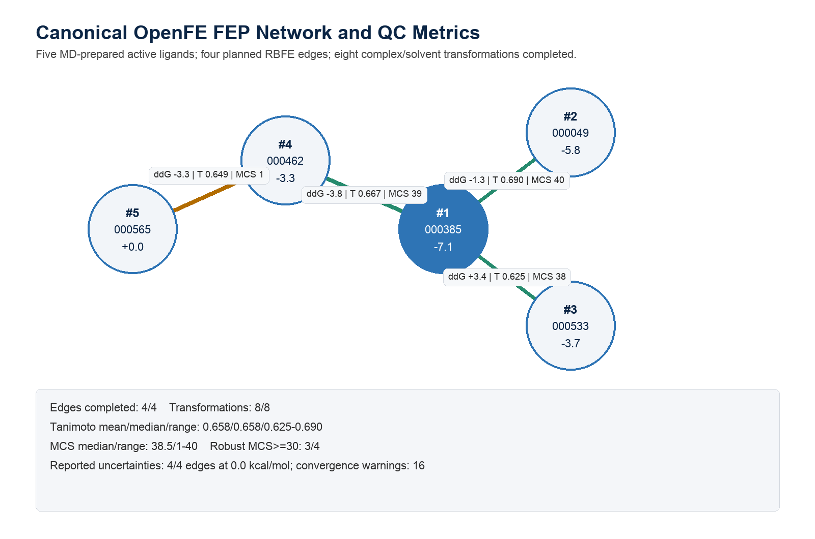
Figure 5. Two-dimensional structures of the five FEP ligands ranked by predicted relative ddG.
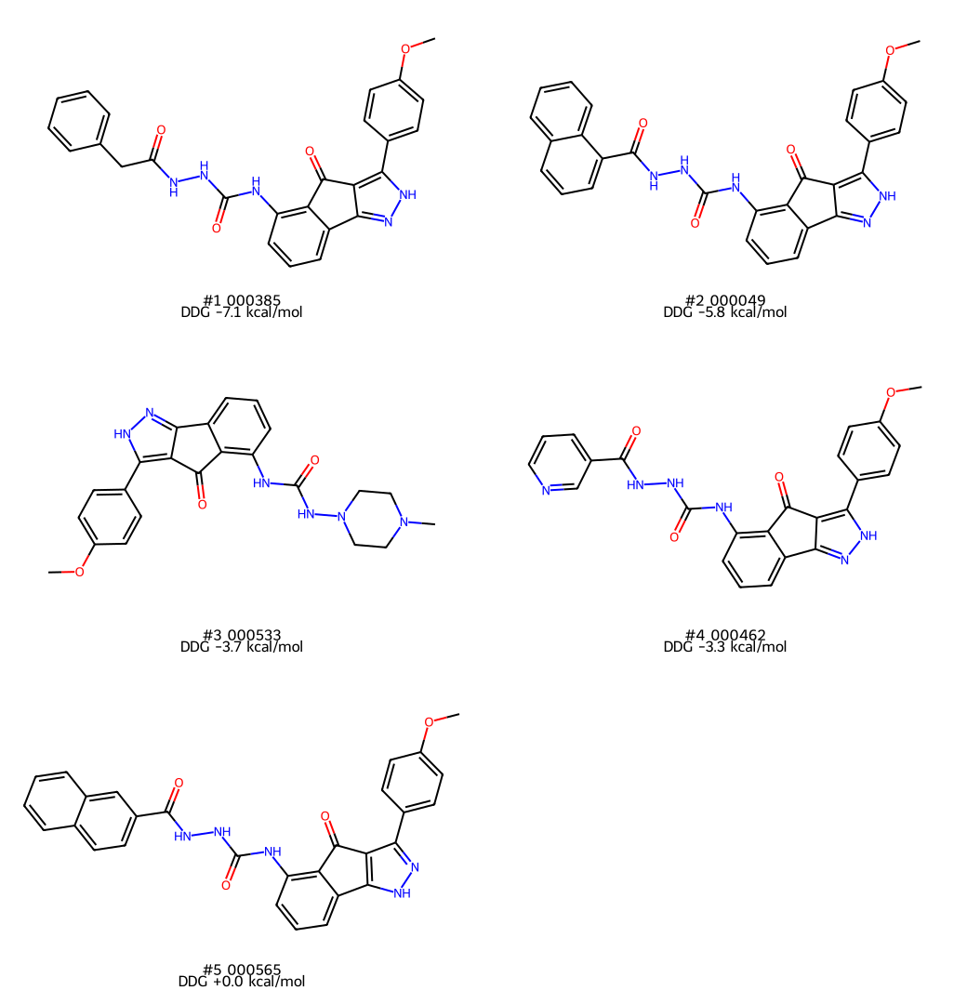
Figure 6. Three-dimensional binding pose for the top FEP-ranked ligand, with CDK2 shown as cartoon and nearby pocket residues as sticks.
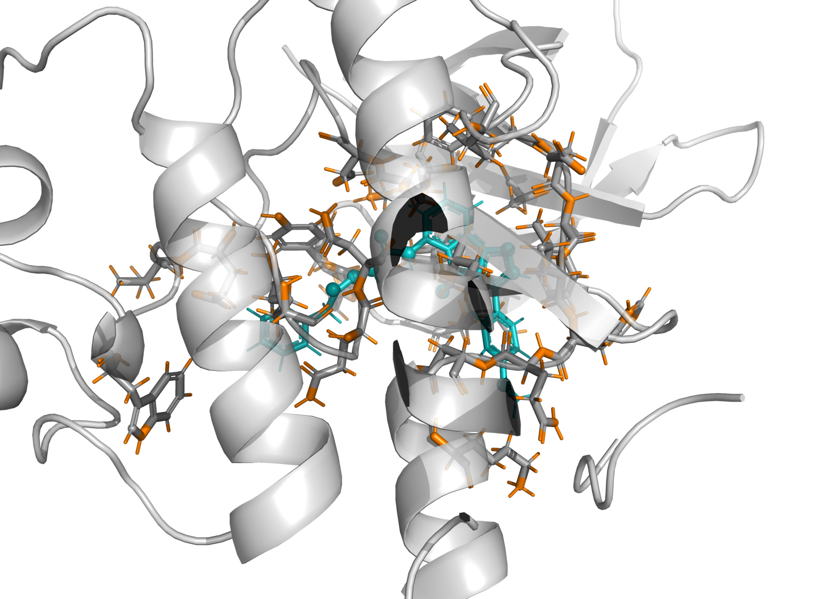

Block Completion
Block | Scale | Ranking endpoint | Best or leading result | Status
1. Docking | 24,549 ligands | AutoDock Vina best score, lower is better | 000049_active_0065_active_00065 (-12.27 kcal/mol) | completed
2. Hit refinement | 400 ligands x 3 seeds = 1,200 runs | Composite hit score, higher is better | 000049_active_0065_active_00065 (-12.32 kcal/mol best seed) | completed
3. MD/MM-GBSA | 20 ligands | Mean MM/GBSA ddG, lower is better | 000107_active_0125_active_00125 (-59.15 kcal/mol) | completed
4. FEP | 5 ligands, 4 completed edges | OpenFE relative ddG within a congeneric active cluster, lower is better | 000385_active_0457_active_00457 (-7.1 kcal/mol relative to reference network) | completed

Benchmark Metrics
Metrics were calculated from the ranked outputs of each block using the ligand ID labels as ground truth. For docking, hit refinement, and MD/MM-GBSA, lower Vina or MM/GBSA scores were treated as better except for the hit-refinement composite score, where higher is better. EF@x% uses the top ceiling(N*x) entries, with a minimum of one compound.
Ranking | N | Active/decoy | Active % | ROC-AUC | AP | EF@1% | EF@5% | EF@10%
Docking, Vina best | 24,549 | 631/23918 | 2.57% | 0.728 | 0.138 | 11.54 | 4.97 | 3.53
Hit refinement, composite | 400 | 45/355 | 11.25% | 0.707 | 0.433 | 8.89 | 5.33 | 4.22
Hit refinement, best Vina | 400 | 45/355 | 11.25% | 0.678 | 0.405 | 8.89 | 5.33 | 4.00
MD/MM-GBSA, mean ddG | 20 | 12/8 | 60.00% | 0.844 | 0.866 | 1.67 | 1.67 | 1.67
FEP, relative ddG | 5 | 5/0 | 100.00% | active-only | active-only | not defined | not defined | not defined

Because Block 4 FEP was deliberately restricted to a congeneric active-only RBFE series, ROC-AUC, average precision, and enrichment factor are not mathematically defined for that section. The FEP benchmarking emphasis is therefore edge completion, mapping quality, sampling extent, uncertainty behavior, and internal ranking spread.
FEP metric | Value | Interpretation
Ligands | 5 | 5/5 labeled actives; no FEP decoys by design
Edges completed | 4/4 | Network execution success rate
Transformations completed | 8/8 | Complex plus solvent OpenFE transformations
Sampling | 11 windows; 25,000 prod steps/window | 2,200,000 aggregate production integration steps
Tanimoto | mean 0.658; median 0.658 | range 0.625-0.690
MCS atoms | median 38.5; range 1-40 | 3/4 edges MCS >= 30; 1 weak edge
Relative ddG spread | 7.1 kcal/mol | top-vs-second separation 1.3 kcal/mol
Uncertainty/convergence | 4/4 zero-uncertainty edges | 16 convergence warnings; 3 negative-uncertainty warnings

Block 1: Docking
The first-pass docking block screened 24,549 ligands using AutoDock Vina. The active baseline was 2.57%. The top 1% contained 73 actives among 246 compounds, corresponding to EF@1% 11.54. The first seven ranked compounds were labeled actives; the first decoy appeared at rank 8.
Rank | Ligand | Label | Best Vina
1 | 000049_active_0065_active_00065 | active | -12.270
2 | 000050_active_0066_active_00066 | active | -12.090
3 | 000107_active_0125_active_00125 | active | -11.970
4 | 000385_active_0457_active_00457 | active | -11.640
5 | 000364_active_0435_active_00435 | active | -11.610
6 | 000462_active_0539_active_00539 | active | -11.570
7 | 000193_active_0230_active_00230 | active | -11.530
8 | 018878_decoy_20357_decoy_20357 | decoy | -11.420
9 | 000564_active_0655_active_00655 | active | -11.400
10 | 006768_decoy_6878_decoy_06878 | decoy | -11.400

Block 2: Hit Refinement
The hit-refinement block selected 400 ligands from docking and redocked each with seeds 1, 2, 3. The composite ranking retained 45 actives (11.25%) and achieved EF@5% 5.33 within the enriched 400-ligand subset. Relative to the full library baseline, the selected 400-ligand set was 4.38-fold enriched for actives.
Composite hit score formula: (-mean_score) + 0.25*(-best_score) + max(0, 1 - score_std) + (1/initial_refinement_rank) + 0.05*min(seed_count, 5). This is a practical triage score, not a physical energy.
Rank | Ligand | Label | Composite | Mean Vina | Best Vina | SD
1 | 000049_active_0065_active_00065 | active | 17.498 | -12.290 | -12.320 | 0.022
2 | 000107_active_0125_active_00125 | active | 16.612 | -11.970 | -11.970 | 0.000
3 | 000385_active_0457_active_00457 | active | 16.017 | -11.640 | -11.660 | 0.022
4 | 000364_active_0435_active_00435 | active | 15.908 | -11.613 | -11.630 | 0.012
5 | 000462_active_0539_active_00539 | active | 15.791 | -11.563 | -11.580 | 0.017
6 | 018878_decoy_20357_decoy_20357 | decoy | 15.559 | -11.407 | -11.420 | 0.019
7 | 000155_active_0187_active_00187 | active | 15.478 | -11.370 | -11.390 | 0.014
8 | 000533_active_0615_active_00615 | active | 15.347 | -11.280 | -11.310 | 0.022
9 | 001721_decoy_1151_decoy_01151 | decoy | 15.282 | -11.230 | -11.240 | 0.008
10 | 000565_active_0656_active_00656 | active | 15.249 | -11.213 | -11.230 | 0.012

Block 3: MD/MM-GBSA Optimization
The MD/MM-GBSA block selected 20 ligands from the hit-refinement ranking and completed all simulations. The selected subset contained 12 actives and 8 decoys. Ranking by mean MM/GBSA ddG improved discrimination within this small subset, with ROC-AUC 0.844 and AP 0.866.
The leading MM/GBSA ligand was 000107_active_0125_active_00125 with mean ddG -59.15 kcal/mol and ligand RMSD 0.23 Angstrom. The top three by MM/GBSA were two actives followed by one decoy.
Rank | Ligand | Label | Vina | Mean ddG | SD ddG | RMSD A
1 | 000107_active_0125_active_00125 | active | -11.970 | -59.154 | 2.346 | 0.230
2 | 000565_active_0656_active_00656 | active | -11.230 | -51.984 | 2.818 | 0.454
3 | 000723_decoy_0093_decoy_00093 | decoy | -11.030 | -46.620 | 7.844 | 0.724
4 | 000381_active_0452_active_00452 | active | -11.080 | -45.364 | 10.231 | 0.887
5 | 000364_active_0435_active_00435 | active | -11.630 | -43.201 | 3.072 | 0.610
6 | 000049_active_0065_active_00065 | active | -12.320 | -37.141 | 9.984 | 0.465
7 | 000462_active_0539_active_00539 | active | -11.580 | -36.594 | 2.833 | 0.726
8 | 000385_active_0457_active_00457 | active | -11.660 | -36.375 | 2.608 | 0.548
9 | 000533_active_0615_active_00615 | active | -11.310 | -33.232 | 2.968 | 0.540
10 | 000540_active_0622_active_00622 | active | -11.170 | -31.294 | 2.395 | 0.840

Block 4: FEP
The canonical FEP block (kimlab-cdk2-enrichment-v2-fep) used five chemically related MD-prepared active ligands: 000565_active_0656_active_00656, 000049_active_0065_active_00065, 000462_active_0539_active_00539, 000385_active_0457_active_00457, 000533_active_0615_active_00615. The reference ligand was 000565_active_0656_active_00656. OpenFE completed 4 ligand edges and 8 total complex/solvent transformations on the CUDA OpenMM platform.
Rank | Ligand | Label | Relative ddG
1 | 000385_active_0457_active_00457 | active | -7.1
2 | 000049_active_0065_active_00065 | active | -5.8
3 | 000533_active_0615_active_00615 | active | -3.7
4 | 000462_active_0539_active_00539 | active | -3.3
5 | 000565_active_0656_active_00656 | active | 0.0

Ligand A | Ligand B | ddG | Err | Tanimoto | MCS | Status
000049_active_0065_active_00065 | 000385_active_0457_active_00457 | -1.3 | 0.0 | 0.690 | 40 | completed
000385_active_0457_active_00457 | 000533_active_0615_active_00615 | 3.4 | 0.0 | 0.625 | 38 | completed
000462_active_0539_active_00539 | 000385_active_0457_active_00457 | -3.8 | 0.0 | 0.667 | 39 | completed
000565_active_0656_active_00656 | 000462_active_0539_active_00539 | -3.3 | 0.0 | 0.649 | 1 | completed

FEP interpretation
The FEP network is chemically coherent for a workflow benchmark: three of four network edges have Tanimoto 0.625-0.690 and MCS 38-40, and all eight complex/solvent transformations completed. One edge still has MCS=1 despite Tanimoto 0.649, all gathered uncertainties are 0.0 kcal/mol, and the sampled production length is short. Treat this as an integrated congeneric RBFE workflow result and prioritization signal; final quantitative manuscript claims require longer replicate sampling and experimental affinity correlation.

Methods

OSLabLambda platform
OSLabLambda is a prompt-generated, terminal-driven drug-discovery workflow platform developed and configured through Codex-guided iterations. The platform separates the user interface from execution: the browser dashboard provides run launch controls, progress bars, live selections, reports, and result paths, while the terminal workflow performs the actual docking, refinement, MD/MM-GBSA, and OpenFE FEP commands.
The service instance used here was exposed to the local browser at http://127.0.0.1:9878/ and stored working data under /data/oslab. The active code installation was mounted under /opt/oslab/current, with environment-specific tools in micromamba environments, including an OpenFE RBFE environment and an open-structure-lab execution environment. Runs were written under /data/oslab/runs/<run-label>/progress.json and result artifacts under /data/oslab/reports/<run-label>/, allowing every dashboard panel and manuscript table to be regenerated from machine-readable outputs.
The Lambda service instance was provisioned with 8 NVIDIA A100 SXM 40 GB GPUs, 124 vCPUs, 1800 GiB RAM, and 5.8 TiB SSD. GPU execution was used for OpenMM/OpenFE where available through the CUDA platform. The FEP script exposed CUDA_VISIBLE_DEVICES=0,1,2,3,4,5,6,7 and used mixed precision unless overridden by environment variables.
The installation package used for this report is included in the desktop result bundle at /Users/hlk/Desktop/kimlab-cdk2-enrichment-v2-completed-results-20260514-032817/installation_package/oslab-updated-scripts-install-package-20260514.zip. It contains the canonical CDK2 FEP cluster-run script, the CDK2 ligand-preparation workflow script, the OpenFE charge-metadata patch, and notes describing run parameters and QC metrics. The package is intended to reproduce the Block 4 configuration on an OSLabLambda instance with the same /data/oslab layout.

Benchmark set and labels
The benchmark used the CDK2 active/decoy library transferred into the OSLab instance. A total of 24,549 ligand records were present in the docking results: 631 labeled actives and 23,918 labeled decoys. Labels were inferred from ligand identifiers containing '_active_' or '_decoy_'. These labels were used only for retrospective benchmarking and not for ranking.
The active/decoy benchmark statistics were calculated at each block using the ranked set available to that block. Docking metrics summarize the full transferred library. Hit-refinement and MD/MM-GBSA metrics are conditional on the selected subsets that advanced from prior stages. FEP metrics are active-only RBFE quality metrics because the FEP series was intentionally constrained to matched active analogs rather than a classifier-style active/decoy list.

Docking
Docking used receptor PDBQT input recorded at /data/oslab/runs/kimlab-cdk2-enrichment-v2-receptor-vina/receptor.pdbqt and ligand PDBQT files from the transferred CDK2 benchmark library. The binding site was defined by the ligand-centroid method with center coordinates (1.970, 27.560, 8.830) Angstrom and box dimensions (14.0, 14.0, 14.0) Angstrom. Vina parameters were exhaustiveness 12, num_modes 3, cpu 1, and seed 1. Compounds were ranked by best Vina score, with more negative scores considered better.

Hit refinement
The hit-refinement block selected 400 ligands from the first-pass docking list using OSLab's scaffold-aware hit selection and redocked each selected ligand across seeds 1, 2, 3. Redocking used exhaustiveness 16, num_modes 3, cpu 1, and 120 worker(s). PLIP interaction analysis was configured for the post-redocking composite top list with plip_top_n 20.
For each ligand, redocking scores were summarized across seeds. The OSLab composite score used for ranking was: (-mean_score) + 0.25*(-best_score) + max(0, 1 - score_std) + (1/initial_refinement_rank) + 0.05*min(seed_count, 5). The formula rewards stronger mean Vina score, a strong best-seed pose, low seed-to-seed variance, high initial docking rank, and complete seed coverage.

MD/MM-GBSA optimization
The MD/MM-GBSA block selected the top 20 ligands from the hit-refinement per-ligand summary. Preparation used pH 7.4, water padding 1.2 nm, ionic strength 0.15 M, temperature 300.0 K, 1000 minimization steps, and SMIRNOFF force field openff-2.2.0. The prepared systems were cropped at 15.0 Angstrom with a maximum solvated-system size of 200,000 atoms.
OpenMM simulations used a 2.0 fs timestep, temperature 300.0 K, 0.1 ns NVT equilibration, 0.1 ns NPT equilibration, 1.0 ns production, and trajectory saving every 5000 steps. The representative simulation record reported OpenMM 8.5.1.dev-f7fa0c2 on platform CUDA. MM/GBSA analysis was configured for 100 frames with force field openff-2.2.0; the representative record sampled 90 frames.

FEP
The FEP block used OpenFE 1.11.0 with 11 lambda windows, 25000 production steps per window, 5000 equilibration steps per window, and OpenMM platform cuda. Input ligands were written to /data/oslab/reports/kimlab-cdk2-enrichment-v2-fep/openfe/inputs/ligands_bound_frame.sdf; the protein input was a cropped MD-preparation-derived structure containing 189 residues and 3115 atoms. Coordinate checks showed minimum protein contacts from 2.901 to 2.811 Angstrom. Partial charges were assigned with nagl/rdkit; the OpenFE runner was patched so the generated transformation metadata records the same charge method used in planning.
The generated OpenFE network used KartografAtomMapper with atom_max_distance 0.95 Angstrom, hydrogen mapping enabled, exact ring matches only, partial fused rings allowed, and bond breaking disabled. A minimal spanning network connected both non-reference ligands to the reference ligand. The generated OpenFE protocol object recorded amber/ff14SB.xml, amber/tip3p_standard.xml, amber/tip3p_HFE_multivalent.xml, amber/phosaa10.xml, amber/lipid17_merged.xml, small-molecule force field openff-2.2.1, PME nonbonded treatment with 0.9 nm cutoff, TIP3P dodecahedral solvation with 1.0 nm padding, 11 replicas/windows, replica exchange sampling, 5000 minimization steps, 0.02 ns equilibration, 0.10 ns production, 4 fs timestep, and CUDA compute.

Benchmark metric definitions
ROC-AUC was computed as the pairwise probability that a randomly chosen active ranked ahead of a randomly chosen decoy, assigning 0.5 credit for ties. Average precision was computed from the precision at each active-ligand rank. Enrichment factor at fraction x was computed as (actives in the top ceiling(N*x) / ceiling(N*x)) divided by the active fraction in the evaluated list. Downstream block metrics are conditional on each block's selected subset and should not be read as full-library metrics unless explicitly stated as cascade active fraction.

Limitations and Publication Readiness
- The docking and hit-refinement metrics are appropriate benchmark summaries for the screened CDK2 active/decoy library, but they still depend on the label quality and the pose/score assumptions of Vina.
- The MD/MM-GBSA and FEP metrics are conditional on small selected subsets. They are useful for testing cascade behavior and prioritization, but they are not full-library validation metrics.
- The canonical FEP block uses a chemically coherent active cluster and completed all planned transformations. It is still not definitive quantitative RBFE validation because all edge uncertainties are reported as 0.0 kcal/mol, estimator warnings occurred, one network edge has MCS=1, the run used a single repeat, and the production length was only 0.10 ns per window.
- The OpenFE runner records the actual NAGL/RDKit charge method in the generated transformation metadata. AmberTools AM1-BCC was not available as an OpenFF toolkit backend on this instance.
- A publication-ready FEP campaign would add experimental affinity values for the same congeneric series, production-length sampling, replicate repeats or independent seeds, cycle-closure edges, overlap/convergence diagnostics, explicit software version capture for Vina/PLIP/OpenMM/OpenFE/OpenFF, and a predefined acceptance criterion for excluding failed mappings.

Source Files
Artifact | Path
Docking results | /data/oslab/reports/kimlab-cdk2-enrichment-v2-docking/report/vina_results.json
Hit refinement summary | /data/oslab/reports/kimlab-cdk2-enrichment-v2-hit-refinement/report/per_ligand_seed_summary.json
MD progress/results | /data/oslab/runs/kimlab-cdk2-enrichment-v2-md-optimization/progress.json
FEP results | /data/oslab/reports/kimlab-cdk2-enrichment-v2-fep/fep_results.json
FEP ddG TSV | /data/oslab/reports/kimlab-cdk2-enrichment-v2-fep/openfe/openfe_ddg.tsv
OSLabLambda dashboard screenshot | /Users/hlk/Desktop/oslab_cdk2_report_work/oslab_fep_dashboard_canonical.png
FEP 2D/3D structure figures | /Users/hlk/Desktop/oslab_cdk2_report_work/fep_2d_ligand_structures.png; /Users/hlk/Desktop/oslab_cdk2_report_work/fep_best_ligand_3d_pose.png
Installation package | /Users/hlk/Desktop/kimlab-cdk2-enrichment-v2-completed-results-20260514-032817/installation_package/oslab-updated-scripts-install-package-20260514.zip
Local metrics trace | /Users/hlk/Desktop/oslab_cdk2_report_work/benchmark_metrics_summary.json

