**Diary Probe 1: Li Qing's Workday Journal**  
**Date:** September 13, 2024 (Weekday)  
**Garden Status:** Balcony Garden

**Morning**  
Like most mornings, I only had a few minutes to check on my plants before heading out. The weather has been a bit dry lately, so I quickly gave them some water. I really wish I had a feature that could remind me when to water each plant, especially since they all have different needs. For someone like me, who’s always short on time, this would be super helpful.

**Noon**  
I had a little free time at work, so I looked up some tips on caring for potted plants.

**Evening**  
I got home pretty late and didn’t have much energy to work on my garden. But I still took a moment to snap a picture of my gardenia, which is about to bloom. I want to share it with my friends.

**Diary Probe 2: Li Qing's Weekend Journal**  
**Date:** September 16, 2024 (Weekend)  
**Garden Status:** Balcony Garden

**Morning**  
It’s the weekend, and I finally had a few hours to spend on my garden. I pruned my hydrangeas and gave them some fertilizer. This made me realize that I’m often unsure of the best time to fertilize my plants.

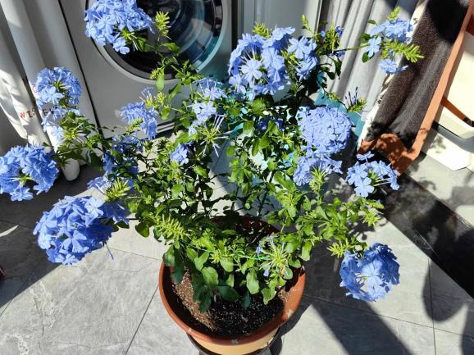

**Afternoon**  
I took some photos of the garden to show off my latest work. The gardenia has bloomed, and I snapped lots of pictures of its pale white flowers and posted them on social media.

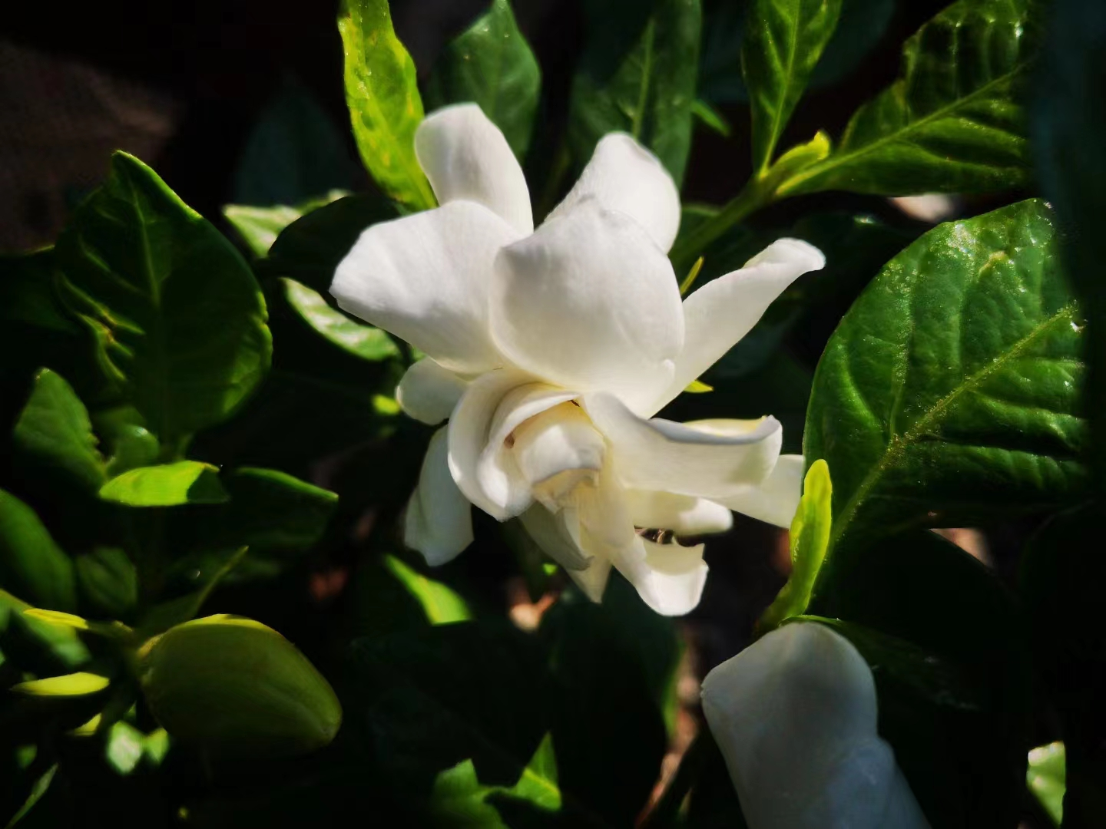

**Evening**  
Lying on my balcony’s lounge chair and smelling the flowers is such a relaxing way to end the day. This is why I love my balcony garden. I’m even thinking of getting more flowers, so I can have something blooming all the time.

**Diary Probe 3: Grandma Zhang's Journal**  
**Date:** August 27, 2024  
**Garden Status:** Large Yard

**Morning**  
Like usual, I spent quite a while in the garden this morning. I needed to prepare for transplanting some vegetable seedlings. When I first started, I messed up a lot of seedlings, but now I’m pretty good at it and can finish before it gets too hot.

**Afternoon**  
I spent the afternoon resting at home, flipping through some gardening books. I used to look things up online, but I find it a bit tricky to get the right answers sometimes.

**Evening**  
In the evening, I had a chat with my neighbor about her garden. She told me she’s been planting some new flowers this year and asked if I wanted any extra seedlings. Of course! In return, I plan to share some of my jasmine plants with her after they finish blooming. They were a gift from my son, and their little white flowers are so lovely.

**Conclusions based on the data collected**

**1. User Needs and Functional Requirements**

**Watering reminder function**: Li Qing mentioned that due to the different types of plants, each plant has different watering needs, and she often doesn't have time to take care of them carefully. If the app can provide personalized watering reminders for plants, generating automatic reminders for users according to plant species, weather and environmental conditions, it will greatly enhance the usefulness of the app.

**Fertilizer recommendations**: Li Qing also mentioned that she was not sure when to fertilize her plants. The app can provide plant-specific fertilizer recommendations to help users optimize maintenance according to season, weather conditions, or the needs of specific plants.

**Knowledge base and learning resources**: Grandma Zhang mentioned that she often looks through gardening books and has trouble finding answers online. The app could include an easy-to-understand knowledge base with guides to growing and caring for plants to help users quickly access the information they need.

**2. Social and Sharing Features**

**Garden photo sharing**: Li Qing and Grandma Zhang both mentioned that they like to share their garden photos with others. The app could include a convenient photo uploading and sharing feature that would allow users to easily show off their garden results, get likes, comments, and other interactions.

**Community Interaction**: Grandma Zhang's record mentions that she interacts and shares plants with her neighbors. This shows that an interest-based community interaction feature can enhance user stickiness by allowing users to not only use the app in isolation, but also to communicate, share and exchange plants with other gardening enthusiasts through the app.

**3. User Time Management and Ease of Use**

**Time management tools**: Li Qing has very little time to take care of her garden during weekdays, which suggests that the app should support users who have limited time. The app can simplify the operation and provide quick gardening management tools, such as automatic generation of task lists and quick checking of plant status, to save users' time.

**Weekend in-depth usage scenario**: Li Qing has more time to take care of her garden on weekends than on weekdays. The application can consider designing “weekend mode” or “rest day activity suggestions” for users to help them participate in gardening more deeply when they have free time.

**4. Older users' needs**

**Easy-to-use interface**: Grandma Zhang is an older user who has difficulty finding answers online, suggesting that the application needs to design an intuitive, simple user interface for older users, with easy-to-access features and clear instructions.

**Neighborhood Interaction Functions**: Grandma Zhang's behavior of sharing plants with her neighbors also provides inspiration for the app to design neighborhood social or exchange functions that help users easily share and exchange plants or gardening experiences to enhance the sense of community.