Assignment 5: Data Visualization

Jinglin Zhang

Spring 2023

## OVERVIEW

This exercise accompanies the lessons in Environmental Data Analytics on Data Visualization

## Directions

1. Rename this file <FirstLast>_A05_DataVisualization.Rmd (replacing <FirstLast> with your first and last name).
2. Change “Student Name” on line 3 (above) with your name.
3. Work through the steps, **creating code and output** that fulfill each instruction.
4. Be sure your code is tidy; use line breaks to ensure your code fits in the knitted output.
5. Be sure to **answer the questions** in this assignment document.
6. When you have completed the assignment, **Knit** the text and code into a single PDF file.

## Set up your session

1. Set up your session. Load the tidyverse, lubridate, here & cowplot packages, and verify your home directory. Upload the NTL-LTER processed data files for nutrients and chemistry/physics for Peter and Paul Lakes (use the tidy NTL-LTER_Lake_Chemistry_Nutrients_PeterPaul_Processed.csv version) and the processed data file for the Niwot Ridge litter dataset (use the NEON_NIWO_Litter_mass_trap_Processed.csv version).
2. Make sure R is reading dates as date format; if not change the format to date.

#1   
library(tidyverse)

## ── Attaching core tidyverse packages ──────────────────────── tidyverse 2.0.0 ──  
## ✔ dplyr 1.1.0 ✔ readr 2.1.4  
## ✔ forcats 1.0.0 ✔ stringr 1.5.0  
## ✔ ggplot2 3.4.1 ✔ tibble 3.1.8  
## ✔ lubridate 1.9.2 ✔ tidyr 1.3.0  
## ✔ purrr 1.0.1   
## ── Conflicts ────────────────────────────────────────── tidyverse_conflicts() ──  
## ✖ dplyr::filter() masks stats::filter()  
## ✖ dplyr::lag() masks stats::lag()  
## ℹ Use the ]8;;http://conflicted.r-lib.org/conflicted package]8;; to force all conflicts to become errors

library(lubridate)  
library(here)

## here() starts at C:/Users/wwwla/Documents/EDA-Spring2023

library(cowplot)

##   
## 载入程辑包：'cowplot'  
##   
## The following object is masked from 'package:lubridate':  
##   
## stamp

getwd()

## [1] "C:/Users/wwwla/Documents/EDA-Spring2023"

lake.chem.nut <- read.csv("~/EDA-Spring2023/Data/Processed_KEY/NTL-LTER_Lake_Chemistry_Nutrients_PeterPaul_Processed.csv",stringsAsFactors = TRUE)  
litter.mass <- read.csv("~/EDA-Spring2023/Data/Processed/NEON_NIWO_Litter_mass_trap_Processed.csv",stringsAsFactors = TRUE)  
#2   
is.Date(lake.chem.nut$sampledate)

## [1] FALSE

is.Date(litter.mass$collectDate)

## [1] FALSE

lake.chem.nut$sampledate <- ymd(lake.chem.nut$sampledate)  
litter.mass$collectDate <- ymd(litter.mass$collectDate)  
is.Date(lake.chem.nut$sampledate)

## [1] TRUE

is.Date(litter.mass$collectDate)

## [1] TRUE

## Define your theme

1. Build a theme and set it as your default theme. Customize the look of at least two of the following:

* Plot background
* Plot title
* Axis labels
* Axis ticks/gridlines
* Legend

#3  
mytheme <- theme(  
 plot.background = element_rect(fill = "lightgray"),  
 plot.title = element_text(size = 16, face = "bold"),  
 axis.text = element_text(color = "black"),   
 axis.line = element_line(colour = "black", size = 0.5),  
 legend.position = "top",  
 legend.text = element_text(size = 10)  
 )

## Warning: The `size` argument of `element_line()` is deprecated as of ggplot2 3.4.0.  
## ℹ Please use the `linewidth` argument instead.

theme_set(mytheme)

## Create graphs

For numbers 4-7, create ggplot graphs and adjust aesthetics to follow best practices for data visualization. Ensure your theme, color palettes, axes, and additional aesthetics are edited accordingly.

1. [NTL-LTER] Plot total phosphorus (tp_ug) by phosphate (po4), with separate aesthetics for Peter and Paul lakes. Add a line of best fit and color it black. Adjust your axes to hide extreme values (hint: change the limits using xlim() and/or ylim()).

#4   
ggplot(lake.chem.nut, aes(x = po4, y = tp_ug)) +  
 geom_point() +  
 xlim(0,45) +  
 labs(x = "phosphate", y = "total phosphorus") +  
 geom_smooth(method = lm, se = FALSE, colour = "black")

## `geom_smooth()` using formula = 'y ~ x'

## Warning: Removed 21947 rows containing non-finite values (`stat_smooth()`).

## Warning: Removed 21947 rows containing missing values (`geom_point()`).

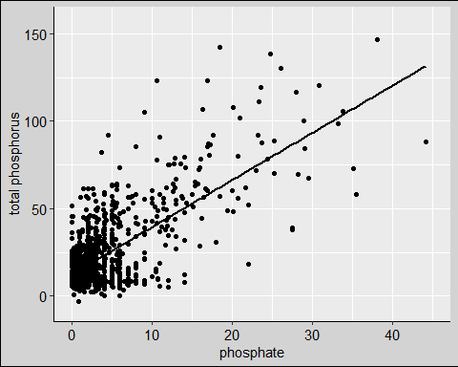

1. [NTL-LTER] Make three separate boxplots of (a) temperature, (b) TP, and (c) TN, with month as the x axis and lake as a color aesthetic. Then, create a cowplot that combines the three graphs. Make sure that only one legend is present and that graph axes are aligned.

Tip: R has a build in variable called month.abb that returns a list of months;see <https://r-lang.com/month-abb-in-r-with-example>

#5   
lake.T <- ggplot(lake.chem.nut,   
 aes(x = factor(month, levels = 1:12, labels = month.abb),   
 y = temperature_C, color = lakename)) +  
 scale_x_discrete(drop = FALSE) +  
 geom_boxplot() +  
 labs(x = "month", y = "Temperature")  
  
lake.TP <- ggplot(lake.chem.nut,   
 aes(x = factor(month, levels = 1:12, labels = month.abb),   
 y = tp_ug, color = lakename)) +  
 scale_x_discrete(drop = FALSE) +  
 geom_boxplot() +  
 labs(x = "month", y = "Total Phosphorus") +  
 theme(legend.position = "none")  
  
lake.TN <- ggplot(lake.chem.nut,   
 aes(x = factor(month, levels = 1:12, labels = month.abb),   
 y = tn_ug, color = lakename)) +  
 scale_x_discrete(drop = FALSE) +  
 geom_boxplot() +  
 labs(x = "month", y = "Total Nitrogen") +  
 theme(legend.position = "none")  
  
legend <- get_legend(  
 lake.T +   
 guides(color = guide_legend(nrow = 2)) +   
 theme(legend.position = "right")  
)

## Warning: Removed 3566 rows containing non-finite values (`stat_boxplot()`).

plot1 <- plot_grid(lake.T + theme(legend.position = "none"),   
 lake.TP + theme(legend.position = "none"),   
 lake.TN + theme(legend.position = "none"),   
 nrow = 3)

## Warning: Removed 3566 rows containing non-finite values (`stat_boxplot()`).

## Warning: Removed 20729 rows containing non-finite values (`stat_boxplot()`).

## Warning: Removed 21583 rows containing non-finite values (`stat_boxplot()`).

plot_grid(plot1, legend, nrow = 1, rel_widths = c(3, 1))

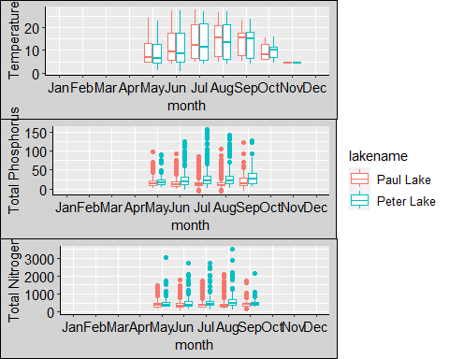

Question: What do you observe about the variables of interest over seasons and between lakes?

Answer: during the summer, the temperature of two lakes are similar, but TP and TN in Peter Lake are generally higher than them in Paul Lake.

1. [Niwot Ridge] Plot a subset of the litter dataset by displaying only the “Needles” functional group. Plot the dry mass of needle litter by date and separate by NLCD class with a color aesthetic. (no need to adjust the name of each land use)
2. [Niwot Ridge] Now, plot the same plot but with NLCD classes separated into three facets rather than separated by color.

#6  
litter.mass %>%   
 filter(functionalGroup == "Needles") %>%   
 ggplot(aes(x = collectDate, y = dryMass, color = nlcdClass)) +  
 geom_point()

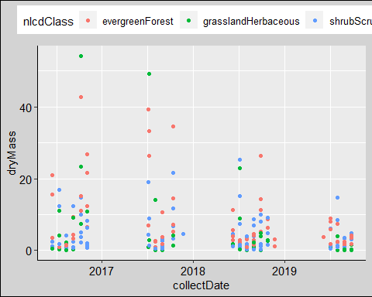

#7  
litter.mass %>%   
 filter(functionalGroup == "Needles") %>%   
 ggplot(aes(x = collectDate, y = dryMass)) +  
 geom_point() +  
 facet_wrap(vars(nlcdClass))

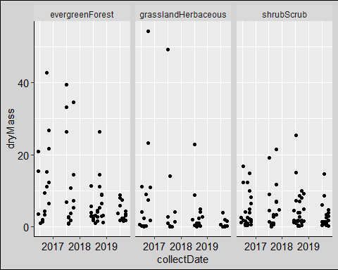 Question: Which of these plots (6 vs. 7) do you think is more effective, and why?

Answer: the second one, because it shows the trend of drymass more clearly than the 6th, there are too many points appear in a single grapth that make me hard to catch informations.