1. .Build Hadoop Environment

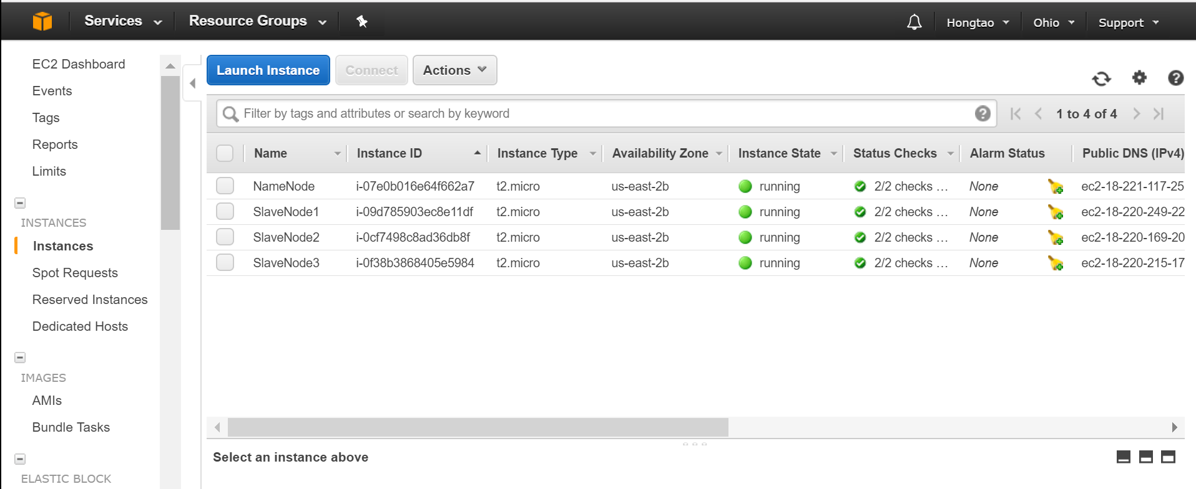

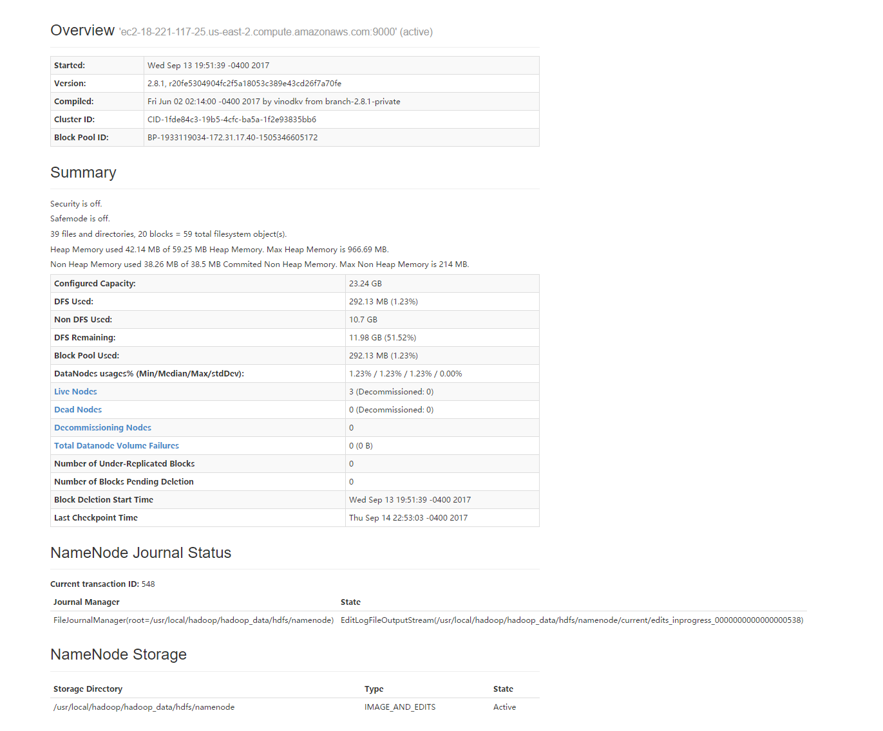

1. Hw1

Hw1 is similar to tutorial of Hadoop mapreduce.



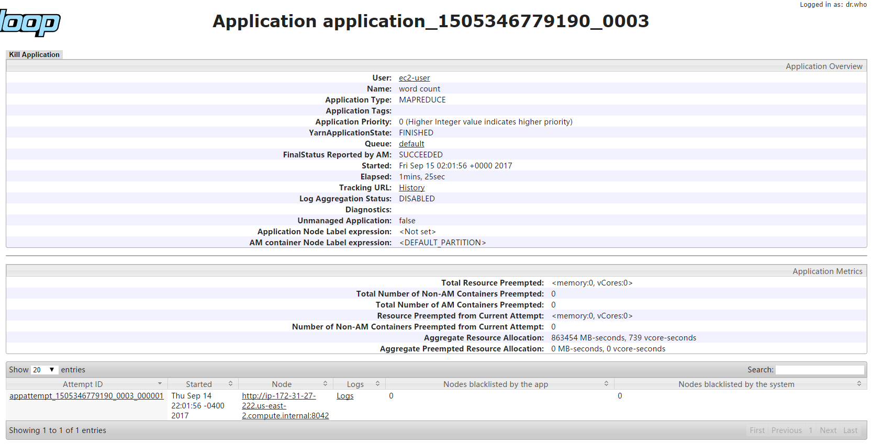

1. Hw2

Assign two strings to last and current words, combine them together as a key in map method.

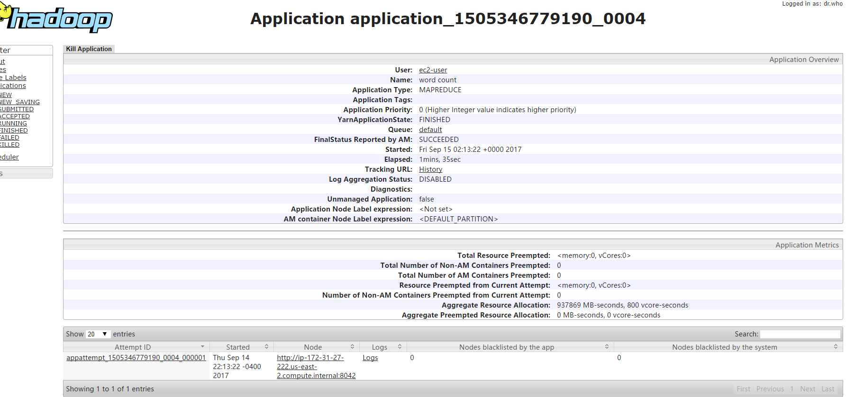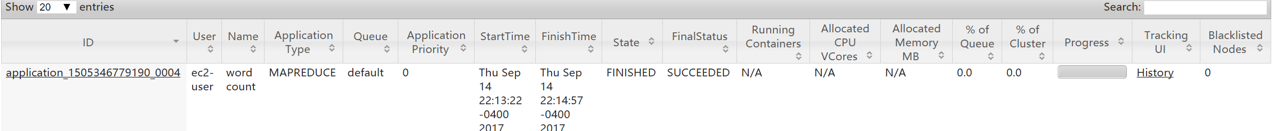

1. Hw3

Extract word-patterns txt into the cache. In the setup method of mapper class, read the cache file and turn it to the hashset. If the bibles words are contained in the hashset, then count the number of that word in the map method.

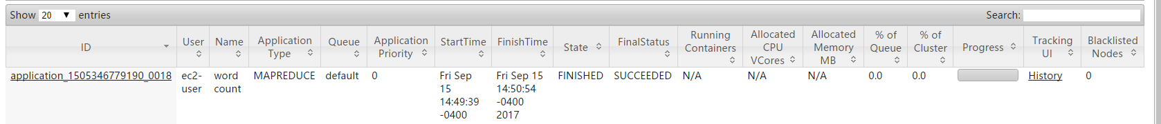

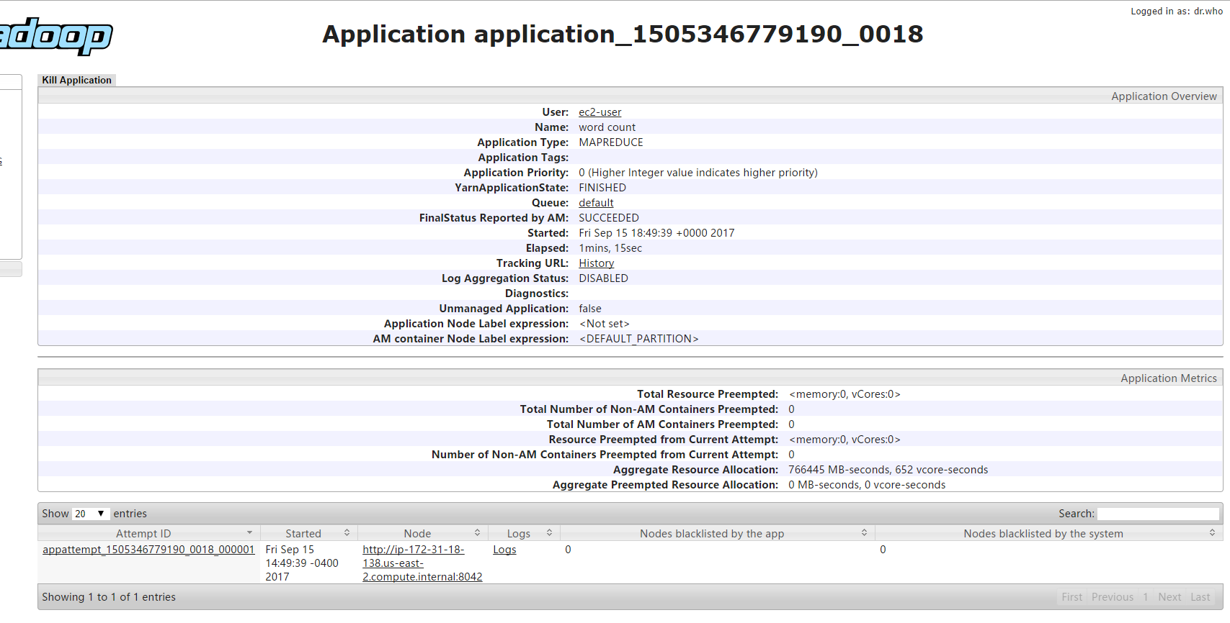

1. Solution Link:

https://github.com/jizhitao/wordcount